


Open Food Innovation University (OFINU)

Study module
“Milk processing technology”
WORKBOOK
for students

2024
Summary

The workbook is elaborated within the project “Open Food Innovation University" (OFINU), being in implementation with support of the European Union Erasmus+ Programme.
Overall objective of the project - to modernise food innovation and technology related higher education in Uzbekistan and Tajikistan, thereby increasing the quality and ensuring relevance of the higher education to the needs of the socio-economic growth of the countries concerned and especially of their regions.

Full partners:
- Lead partner: Latvia University of Life Sciences and Technologies
- Uzbekistan: Samarkand Agro-innovations and Research University, Andijan Institute of Agriculture and Agro-technologies
- Tajikistan: Technological University of Tajikistan, Kulob Institute of Technology and Innovation Management, Isfara Branch of the Technological University of Tajikistan
- Slovakia: Slovak University of Agriculture in Nitra

Associated partners in Uzbekistan:
- A group of companies "AGROMIR"
- "Navigul" MCHJ QK
- “Samarqand don mahsulotlari” JC (Samarkand grain products)

Associated partners in Tajikistan:
- CJSC “Combinati Shiri Dushanbe”
- LTD "Orion Rustam"
- Association of Entrepreneurs of Khatlon

The project implementation period: 01/02/2024 - 31/01/2027.

Funded by the European Union. Views and opinions expressed are however those of the authors only and do not necessarily reflect those of the European Union or the European Education and Culture Executive Agency. Neither the European Union nor the granting authority can be held responsible for them.

Partner universities and their academic staff, involved in the development of the study course:
P1 LBTU. Latvia University of Life Sciences and Technologies
Jelena Zagorska - milk processing technology.
Tatjana Kince - dairy processing equipment.
Evita Straumite - sensory evaluation of dairy products.
Egita Sproge - HACCAP.
Sandra Muižniece-Brasava - dairy processing equipment; packaging.
P2 SAMARU. Samarkand Agroinnovations and Research University
Shakhista Ishniyazova - milk processing technology.
Jurabek Nuraliev - dairy processing equipment.
P3 AIAA. Andijan Institute of Agriculture and Agro-technologies
Rakhim Mirzaev - milk processing technology.
P4 TUT. Technological University of Tajikistan
Khurshed IKROMI - milk processing technology.
P5 KITIM. Kulob Institute of Technology and Innovation Management
Mirzo AZIZOV - milk processing technology.
P6 BTUTI. Branch of the Technological University of Tajikistan in the city of Isfara
Kimyohon Musayamova - milk processing technology.
P7 SUA. Slovak University of Agriculture in Nitra
Miroslav Šlosár - microbiology of dairy products.
Content
Course Schedule 7
Theme 1 12
Chemical composition and quality of milk 12
Laboratory work 15
Analysis of the chemical composition of milk 15
Laboratory work 19
Milk protein coagulation techniques 19
Laboratory work 23
Microbiological quality analysis and milk storage temperature 23
Laboratory work 28
The importance of milk quality 28
Theme 2 33
Milk processing – different treatment methods of milk and cream 33
Laboratory work 36
Milk separation, standardisation and thermal treatment 36
Practical work 42
MILK PROCESSING TECHNOLOGY – equipment: separators 42
Practical work 44
MILK PROCESSING TECHNOLOGY – equipment: heat exchangers 44
Practical work 46
MILK PROCESSING TECHNOLOGY – equipment: HEAT EXCHANGER SCHEME 46
Theme 3 48
Fermented dairy products: production and quality evaluation 48
Laboratory work 53
Study of evaluation of fermented milk quality 53
Laboratory work 55
Determination of quality parameters of fermented dairy products 55
Practical works 58
Equipment for production fermented products 58
Laboratory work 61
Study of whey separation influencing factors 61
Theme 4 68
Butter and ice cream: production technology and quality evaluation 68
Laboratory work 72
Butter production and butter quality control 72
Laboratory work 79
Ice cream preparation 79
Theme 5 87
Cheese: classification, production technology and quality assessment 87
Laboratory work Acid cheese production 89
Laboratory work 93
Effect of different factors on milk clotting time 93
Laboratory work 96
Semi – hard cheese production 96
Theme 6 108
Milk products with long shelf life 108
Practical works 110
Equipment for the production of dry and canned milk 110
Laboratory work 114
Milk powder quality control 114
Theme 7 116
By-products: quality parameters, processing options 116
Laboratory work 117
By-products processing and quality control 117
Theme 8 121
HACCP in dairy processing companies 121
Practical work 125
Assessment of potential hazards in milk processing 125

Theme of the study course
The study module “Milk processing technology” includes the following topics: technological process and equipment, packaging materials and equipment, raw materials and product quality evaluation, including sensory evaluation. Quality management assurances in milk processing. A lecturer with knowledge in the specific field is involved in the implementation of each section in order to achieve the goal of the study module.

Learning methods
The main pedagogical methods taught are as follows: learner-centred approach, competence-based approach, experiential learning, cooperative learning, and interactive learning. The training includes practicing methods, as well as an introduction to modern learning analytics, which can be used to support the engagement and responsibility of a student, and to support assessment.
Highly appreciated are the knowledge and skills to produce and deliver classes and lectures in the distance learning format, because the application of this method broadens the availability of the experts and worldwide knowledge (inviting entrepreneurs, foreign academic staff etc. as lecturers), can be applied in the case of double diploma studies, provide opportunity to study for persons having limited possibilities to take part in full-time studies (young mothers, students with disabilities). Distance learning is very effective for specific courses when the participation of lecturers from foreign partner universities is crucial and discussions between students with diverse experiences and visions are needed to explain and demonstrate possibilities and various solutions and options. The first feedback from the academic staff who have introduced the new methods has demonstrated positive effects, such as:
1) Transformation of teaching approaches at faculties.
2) The learner-centred approach has empowered students to take charge of their own learning, leading to increased engagement and motivation.
3) Students have become more proactive in seeking knowledge and are more participative in class discussions.
4) The use of digital tools for interactive learning has made classes more dynamic and accessible – the students can access learning materials from anywhere, leading to increased flexibility and convenience.
5) The collaborative nature of some of these methods has also led to increased interaction and rapport between the faculty and the students.
Master classes – open lecture discussions, involving internal and external stakeholders, is a new form of teaching and communication of higher education to the society, adopted at the involved UZ universities during the implementation of the project.

Course Schedule
Thematic Study Plan for the “Milk Processing Technology” Module
Date, Time | Study form | Theme | Lecturer
Theme 1 - Chemical composition and quality of milk
1st day | Lecture  (1h) | 1. L. Preliminary lecture.
1st day | Lecture  (2h) | Synthesis and secretion of milk, composition (milk of different agricultural animals), production (breakdown by country, production volumes, prices) (2 h, T).
1st day | Laboratory work  (4h) | L. w. Analysis of the chemical composition of milk (protein, fat, lactose, dry matter content by different methods) (3 h, T).
2nd day | Lecture  (4h) | Characteristics of individual milk ingredients (water, protein (distribution techniques), lipids, lactose, vitamins, minerals, enzymes, bactericides and antibodies) (4 h, T).
2nd day | Laboratory work  (3h) | L. w. Milk protein coagulation techniques (3 h, T).
3rd day | Lecture  (2h) | 2. L. Milk quality, regulatory legislation, internal company standards and requirements.
3rd day | Laboratory work  (2h) | L. w. Microbiological quality analysis (total, enterobacteria, lactic acid bacteria) and milk storage temperature.
4th day | Lecture  (2h) | L. Milk sensory, physicochemical and microbiological indicators, quality factors. Quality control needs and capabilities.
4th day | Laboratory work  (3h) | L. w. The importance of milk quality (acidity, pH determination, freezing temperature, antibiotic presence with different method).
 | Seminar  (1h) | Evaluation of results obtained during laboratory work.
Theme 2 - Milk processing – different treatment methods, milk and cream
5th day | Lecture  (2h) | 3. L. Mechanical (cooling, filtration, separation, bactofugation, microfiltration, standardisation, decontamination) and heat treatment (types, meaning, affecting milk ingredients) of milk (2 h, T).
5th day | Laboratory work  (3h) | L. w. Milk separation, standardisation, calculations, determination of fat content, preparation of normalized mixture, homogenisation (3 h, T)
6th day | Lecture  (3h) | General equipment (tanks, meters, pumps washing) L.: Machinery for mechanical and thermal treatment of milk, principle of operation (3 h, T.e). (L)
6th day | Laboratory work (3h) | Machinery for mechanical and thermal treatment of milk, principle of operation (3 h, T.e). T.eL)
7th day | Lecture  (2h) | 4. L. Acquisition of heat-treated milk and cream (2 h, T).
7th day | Laboratory work (5h) | L. w.: Calculation of heat treatment regimes, verification of effectiveness and impact on milk quality (2 h T, 3 h T.e.).
Theme 3 - Fermented dairy products: production and quality evaluation
8th day | Lecture  (3h) | 5. L. Characteristics of technology, main components of acid milk drinks (3 h, T).
8th day | Laboratory work  (5h) | L. w. Verification of starter and the effects of various factors on the quality of acid milk products, analysis of lactic acid bacteria (5 h, T).
9th day | Lecture  (2h) | 6. L. Manufacture of dairy products (2 h, T).
9th day | Laboratory work  (3h) | L. w. Assessment of factors affecting whey synthesis, assessment of the quality of cottage cheese (3 h, T).
9th day | Laboratory work  (1h) | L.w. Sensory evaluation of fermented dairy products.
10th day | Lecture  (2h) | Equipment for production fermented products (2 h, T.e.) (L).
10th day | Laboratory work  (2h) | Equipment for production fermented products (2 h, T.e.) (2h).
10th day | Seminar  (2 h) | Evaluation of laboratory work results, discussion.
11th day | Excursion | Visit to a milk processing company: fermented dairy products.
Theme 4 - Butter and ice cream: production technology and quality evaluation
12th day | Lecture  (2h) | 7. L. Packaging materials, equipment, principles (2 h, T.e.) for dairy products (liquid and paste).
12th day | Laboratory work  (2h) | L. w. Selection and machinery of packaging materials for products (2 h, T.e.).
13th day | Lecture  (1h) | 8. L. Classification of ice cream, raw materials, recipes, calculations, production, ice cream equipment (1 h, T).
13th day | Laboratory work  (3h) | L. w. Ice cream preparation and quality assessment (3 h, T).
13th day | Laboratory work  (2h) | L. w. Principles for the operation of refrigeration and refrigeration equipment (2 h, T.e.).
14th day | Lecture  (4h) | 9. L. Classification, quality and production of butter and its products, butter-making facilities (2 h, T +2 h, T.e.).
14th day | Laboratory work  (3h) | L. w. Preparation and quality assessment of butter (3 h, T).
Theme 5 - Cheese: classification, production technology, quality assessment
15th day | Lecture  (6h) | 10. L. Cheese, manufacturing processes, assistive products, equipment (4 h, T+ 2 h, T.e.).
15th day | Seminar  (2h) | Cheese variation students reports.
16th day | Lecture  (2h) | 11. L. Cheese production technology, biochemical processes for cheese ripening (4 h, T).
16th day | Laboratory work  (4h) | L. w. Preparation of cheese, evaluation of cheese quality and microflora (2 h+2h, T).
17th day | Lecture  (2h) | 12. L. Packing, types, materials, equipment of preserved butter, cheese and milk (2 h, P).
17th day | Laboratory work (3h) | L. w. Fresh cheese production (3 h, T).
17th day | Laboratory work (2h) | L. w. Product packaging solutions (2 h, P).
18th day | Lecture  (4h) | 15. L. Principles, methods, standards (4 h, S) for the sensory evaluation of milk products.
18th day | Laboratory work  (4h) | L. w. Sensory evaluation of dairy products (4 h, S).
19th day | Excursion | Visit to a milk processing company: cheese production.
Theme 6 - Milk products with long shelf life
20th day | Lecture  (4h) | 13. L. Milk conservation technology, plants (2 h, T +2 h, T.e).
20th day | Laboratory work  (4h) | L. w. Operation of evaporation and drying equipment, newest solutions (2 h, T.e).  L. w. Evaluation of the quality of condensed milk (2 h, T).
Theme 7 - By-products: quality parameters, processing options
21th day | Lecture  (2h) | 14. L. By-products of the milk industry, processing technologies and plants (2 h, T).
21th day | Laboratory work  (3h) | L. w. Principles for the operation of membrane equipment and use of derived products to create new products (3 h, T).
Theme 8 - HACCP in dairy processing companies
22th day | Practical work  (8h) | 16. P. w. Product safety, definition and monitoring of control and critical control points (8 h, H).  8. Test

Theme 1

Chemical composition and quality of milk
Theoretical materials
Chemical composition of milk
Synthesis and secretion of milk, composition (milk of different agricultural animals), production (breakdown by country, production volumes, prices).
Milk is defined as the secretion of the mammary glands of mammals, its primary natural function being:
• nutrition,
• development,
• and providing immunity to the young for some time after birth.

- Plasma - all components without fats dissolved in water.
- Serum solution where all components are dispersed in water.
- Chemical composition of milk.
Table 1.1.
Nutritional composition of milk from different mammalian species
(per 100 g) (Muehlhoff et al., 2013)
Parameter | Cow | Camel | Buffalo | Sheep | Human
Water (g) | 87.7 | 84.8 | 83.2 | 82.1 | 87.5
Lactose (g) | 4.7 | 4.2 | 4.4 | 5.1 | 6.9
Total protein (g) | 3.3 | 3.9 | 4.0 | 5.6 | 1.0
Total fat (g) | 3.3 | 5.0 | 7.5 | 6.4 | 4.4
Calcium (mg) | 112 | 154 | 191 | 190 | 32
Phosphorus (mg) | 91 | 132 | 185 | 144 | 14
Potassium (mg) | 145 | 186 | 112 | 148 | 51
Magnesium (mg) | 11 | 8 | 12 | 18 | 3
Sodium (mg) | 42 | 66 | 47 | 39 | 17
B1 (thiamine) (mg) | 0.04 | 0.01 | 0.05 | 0.07 | 0.01
B2 (riboflavin) (mg) | 0.2 | 0.12 | 0.11 | 0.34 | 0.04
B6 (mg) | 0.04 | 0.05 | 0.33 | 0.07 | -
Retinol (μg) | 35 | - | 69 | 64 | 60
Carotenes (μg) | 16 | - | - | - | 7
E (tocopherol) (mg) | 0.08 | 0.15 | 0.19 | 0.11 | 0.08

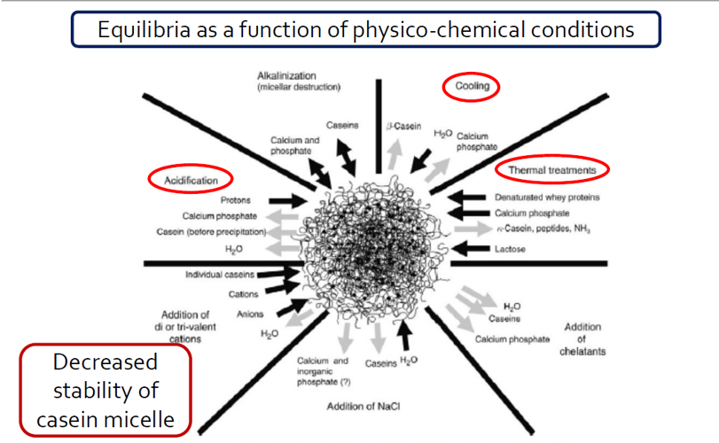
Fig. 1.1. Protein precipitation and coagulation techniques https://link.springer.com/article/10.1007/s13594-015-0220-y
Abnormal substances in milk
- antibiotics and others medicaments,
- pesticides,
- disinfection and cleaning agents,
- preservatives,
- neutralising substances (H₂O₂, sodium),
- heavy metals,
- mycotoxins.

Table 1.2.
Physico-chemical parameters of cow’s milk https://www.legislation.gov.uk/eur/2004/853/annex/III/section/IX
No. | Parameters | Value
1 | acidity | 16-18 ºT
2 | pH | 6,5 – 6,7
3 | density | 1028 to 1032 kg/m³
4 | freezing point | –0,52 ºC to –0,59 ºC
5 | somatic cell count | > 400 000 /mL

Raw bulk milk:
• Colony forming unit, 30ºC 1 mL milk not more than 100 000*,
• Milk free from inhibitor, including antibiotics.

Laboratory work

Analysis of the chemical composition of milk

1. Determination of fat content

Separation of fat from milk in butyrometer by centrifuging after dissolving the protein with sulphuric acid, the separation being aided by the addition of a small quantity of amyl alcohol.

Procedure:
Add 10 mL sulphuric acid to the butyrometer followed by 10.77 mL of well-mixed milk. Avoid wetting the neck of the butyrometer. Next add 1 mL of amyl alcohol, insert stopper and shake the butyrometer carefully until the curd dissolves and no white particles can be seen. Place the butyrometer in the water bath at 65 ºC and keep it there for more than 5 minutes. The butyrometer must be placed in the centrifuge with the scale pointing towards the centre of the centrifuge. Spin for 5 min at 1000 rpm. Remove the butyrometers from the centrifuge.
(Note: When transferring the butyrometers from the centrifuge, make sure that the butyrometers are held all the time with the NECKS POINTING UP).
The fat column should be read from the lowest point of the meniscus of the interface of the acid-fat to the 0-mark of the scale and read the butterfat percentage.
The butyrometers should be emptied into a special container for the very corrosive liquid of acid-milk, and the butyrometers should be washed in warm water and dried before the next use.
2. Determination of protein content

Procedure:
20 mL of the milk measured into the conical flask, 2-3 drops of phenolphthalein solution is added and then slowly from the burette, 0.1 M NaOH under continuous mixing until a faint pink colour appears. Then add to the conical flask 4 mL of formaldehyde solution, mix well and slowly from the burette, 0.1 M NaOH under continuous mixing, until a faint pink colour appears that persists for 30 seconds.
Protein content is obtained using the equation:
%=volume of 0.1 M NaOH (in mL) x 0.959
3. Determination of density of milk

Procedure
The temperature of the milk should be around 20 ºC prior to density measurement. Mix the milk sample gently and pour it gently into a measuring cylinder. Let the aerometer sink slowly into the milk. Read and record the last aerometer degree (kg m⁻³) just above the surface of the milk. If the temperature of the milk is different from the calibration temperature (calibration temperature may be 20 ⁰C) of the aerometer, calculate the temperature correction.
European standards expect milk to have a specific gravity of 1027 -1029 kg m⁻³ which implies an aerometer reading range of 27–29 ºA. If the reading is consistently lower than expected and the milk supplier disputes any wrong doing arrange to take a genuine sample from the supplier (i.e. inspect milk right from source).

4. Determination of freezing point of milk

The freezing point of a solution depends on the number of particles in the solvent (water phase of milk), rather than the kind of particles. Water without solutes will freeze at 0° C. The presence of any solutes will depress the freezing point below 0°C. The freezing point of milk depends upon the concentration of water-soluble components.
As milk is more diluted, the freezing point will raise closer to zero. The current official freezing point limit (-0.520 °C).
Pure distilled water freezes at 0ºC under normal atmospheric pressure. Milk freezes at a temperature slightly lower than that of water due to the soluble constituents such as lactose, soluble salts, etc., which lower or depresses the freezing point.
The freezing point of cow milk ranges from -0.515º to -0.550º C. The addition of 1% water to milk will raise the freezing point by 0.006 ºC.
Despite the variation in the normal freezing point of milk, it is one of the most constant physical properties of milk. It is therefore considered to be very useful in detecting adulteration of milk with water. The instrument used to determine the freezing point of milk is known as cryoscope. It gives fairly accurate results within a short period. Certain cryoscope indicates the percentage of adulterations (addition of pure water) to milk and the test is considered quite useful for the milk industry.
Procedure
Put the milk sample with pipette into the tube ~ 2.2 mL, then put tube to the CrioStar socket. To start measuring, select with the arrow „Start measurement” and press Enter. The measurements will start, and values will change, the curve will be created. The temperature will be presented on the vertical axis, but time on the horizontal axis. To stop measuring, Enter should be pressed one more time. When the freezing point is detected, for example -0,557 °C, the CrioStar starts looking for Plato’s regime.
5. Determination of titratable acidity

Titratable acidity is expressed in different units; in Latvia we use Therner degree. Therner’s degree is the amount in millilitres of a 0.1 M naOH required to titrate 100 mL of the product to standard pink colour and expressed in ºT (Therner) degree.
Procedure
Take 10 mL of the milk into a conical flask, add 20 mL of distillate water and 2-3 drops of phenolphthalein and then slowly titrate with 0.1 M NaOH under continuous mixing, until a faint pink colour appears that persists for 30 seconds.
Titratable acidity is obtained using the equation:
ºT=volume of 0.1 M NaOH (ml) x 10
6. Determination of pH
Procedure
Put a clean and dry electrode into milk and press the Read button on the screen of the pH-meter. When the small signal is heard, read the result on the screen.

7. Calculation of total solids and not fat solids content in milk

Calculation of Solids-not-fat:
SNF=(D+2)/4+0,225*F
SNF- Solids not fat, %
D-density of milk sample 20 °C, °A
F-fat content, %

Calculation of total solids:
TS=(4.9*F+D+0.5)/4
TS – total solids

8. Milk composition testing by Milkoscan MarsTM
Procedure
Gently mix the milk sample prior to pouring it into a beaker (around 50 mL). The sample is placed in an apparatus Milkoscan sampler. Students press the Read button and wait 45 seconds before the results appear on the apparatus’ screen.

Results
Table 1.3.
Chemical composition of analysed milk sample
Sample | Fat content, % | Protein content, % | Density of milk, kg/m³ | Freezing point of milk, ̊C | Total solids | Non Fat Solids | Acidity of milk, °T | pH
Conclusions:

Approved by
(Name, surname, signature)
Date

Laboratory work

Milk protein coagulation techniques

1. Precipitation of casein from milk with acids

With organic acids
Procedure
Weigh the empty beaker and record the weight. 250 g of milk is measured into a 400 mL beaker. The pH and milk appearance should be recorded. Milk is heated up to 35 ºC. Add 10 mL of 10% acetic acid solution, and allow the milk to sit for 5 minutes. During coagulation, the temperature should be maintained. Coagulation time is measured. The casein will precipitate into heavy white curds.
Take cheesecloth or an appropriate material bag to cover the top and 2 inches down the sides of a beaker. Using the rubber band, fasten the cheesecloth over the top of the beaker. Pour the curdled milk into the beaker, collecting the curds (casein) in the cheesecloth and allowing the whey to drain off into the bottom of the beaker.
Gather up the cheesecloth with the casein and squeeze the casein until almost dry and then spread out the cheesecloth to let the casein dry for 5 minutes.
Weigh the precipitate together with the cheesecloth, subtracting 18 g (the weight of the cheesecloth) from the total weight and record your results.
The pH of whey and protein structure evaluation should be recorded.

With inorganic acids
Procedure
Weigh the empty beaker and record the weight. 250 g of milk is measured into a 400 mL beaker. The pH and milk appearance should be recorded. Milk is heated up to 35 ºC. Add 10 mL of 10% hydrochloric acid solution, and allow the milk to sit for 5 minutes. During coagulation, the temperature should be maintained. Coagulation time is measured. The casein will precipitate into heavy white curds.
Take cheesecloth or an appropriate material bag to cover the top and 2 inches down the sides of a beaker. Using the rubber band, fasten the cheesecloth over the top of the beaker. Pour the curdled milk into the beaker, collecting the curds (casein) in the cheesecloth and allowing the whey to drain off into the bottom of the baker.
Gather up the cheesecloth with the casein and squeeze the casein until almost dry and then spread out the cheesecloth to let the casein dry for 5 minutes.
Weigh the precipitate together with the cheesecloth, subtracting 18 g (the weight of the cheesecloth) from the total weight and record your results.
The pH of whey and protein structure evaluation should be recorded.

2. Enzymatic coagulation of casein from milk with rennet
Procedure
Weigh the empty beaker and record the weight. 250 g of milk is measured into a 400 mL beaker. The pH and milk appearance should be recorded. Milk is heated up to 35 ºC. Add 0.5 mL of 40% CaCl₂ and 1 mL of 1% rennet solution, stir slowly for 2 minutes, and allow the milk to coagulate. Coagulation time is measured. The casein will precipitate into a soft coagulum.
Take cheesecloth or an appropriate material bag to cover the top and 2 inches down the sides of a beaker. Using the rubber band, fasten the cheesecloth over the top of the beaker. Pour the curdled milk into the beaker, collecting the curds (casein) in the cheesecloth and allowing the whey to drain off into the bottom of the baker.
Gather up the cheesecloth with the casein and squeeze the casein until almost dry and then spread out the cheesecloth to let the casein dry for 5 minutes.
Weigh the precipitate together with the cheesecloth, subtracting 18 g (the weight of the cheesecloth) from the total weight and record your results.
The pH of whey and protein structure evaluation should be recorded.

3. Precipitation of casein from milk with calcium chloride
Procedure
Weigh the empty beaker and record the weight. 250 g of milk is measured into a 250 mL beaker. The pH and milk appearance should be recorded. Milk is heated up to 90 ºC holding for 5 minutes. Add 2 mL of 40% CaCl₂ solution, stir slowly for 1 minute, and allow the milk to coagulate at the same temperature. Coagulation time is measured. The casein will precipitate into the different sizes of protein grains
Take cheesecloth or appropriate material to cover the top and 2 inches down the sides of a beaker. Using the rubber band, fasten the cheesecloth over the top of the beaker. Pour the curdled milk into the beaker, collecting the curds (casein) in the cheesecloth and allowing the whey to drain off into the bottom of the beaker.
Gather up the cheesecloth with the casein and squeeze the casein until almost dry and then spread out the cheesecloth to let the casein dry for 5 minutes.
Weigh the precipitate together with the cheesecloth, subtracting the weight of the cheesecloth from the total weight and record your results.
The pH of whey and protein structure evaluation should be recorded.

4. Denaturation of whey proteins
Procedure
Weigh the empty beaker and record the weight. 400 g of whey is measured into a pot. The pH and whey appearance should be recorded. Whey is heated up to 90 ºC holding 30 minutes. Denatured whey proteins will precipitate into light flakes (see at the bottom on the beaker).
Take cheesecloth or an appropriate material bag to cover the top and 2 inches down the sides of a beaker. Using the rubber band, fasten the cheesecloth over the top of the beaker. Pour the whey into the beaker, collecting the whey proteins in the cheesecloth and allowing the clarified whey to drain off into the bottom of the beaker.
Gather up the cheesecloth with the whey proteins and squeeze the whey proteins until almost dry and then spread out the cheesecloth to let the protein dry for 5 minutes.
Weigh the protein together with the cheesecloth, subtracting the weight of the cheesecloth from the total weight and record your results.
The pH of whey and protein structure evaluation should be recorded.

5. Precipitation of casein from milk with a lactic acid bacteria starter
Procedure
Weigh the empty beaker and record the weight. 250 g of curdled milk (milk is fermented at 30 ºC for 12 hours) is measured into a 250 mL beaker. The pH and curdled milk appearance should be recorded. The curdled milk is heated up to 48 ºC, slowly stirred, and the protein allowed to precipitate for 5 minutes.
Take cheesecloth or an appropriate material bag to cover the top and 2 inches down the sides of a beaker. Using the rubber band, fasten the cheesecloth over the top of the beaker. Pour the content of the sample into the beaker, collecting the curds (casein) in the cheesecloth and allowing the whey to drain off into the bottom of the beaker.
Gather up the cheesecloth with the casein and squeeze the casein until almost dry and then spread out the cheesecloth to let the casein dry for 5 minutes.
Weigh the precipitate together with the cheesecloth, subtracting the weight of the cheesecloth from the total weight and record your results.
The pH of whey and protein structure evaluation should be recorded.

Results

The study of protein coagulation/denaturation techniques
Table 1. 4.
Comparison of different protein coagulation/denaturation techniques
Product | The weight of product, g | Coagulation/denaturation of proteins |  |  |  | Mass |  | Whey
Product | The weight of product, g | Coagulation agent | Time, s | acidity of coagulum, °T | Characterisation of mass | g | % | g | % | °T

Conclusions:

Approved by
(Name, surname, signature)
Date

Laboratory work

Microbiological quality analysis and milk storage temperature
Influence of milk quality and microbiological quality of milk
Students work in a group; students receive raw milk obtained from a milk processing company. 200 mL of milk for 1 sample, for 1 student. Students choose 1 sample from Table 1. The samples should be prepared according to the following scheme (see Table 1.5.).
Table 1. 5.
Samples preparation
Samples | Milk, mL | YF-L811, mL | H₂O₂, mL | Antibiotics | Sodium, mL | Formalin, mL | NH₃OH, mL
1 | 200 | 10 | -
2 | 200 | 10 | 0,6
3 | 200 | 10 |  | 1 tablet
4 | 200 | 10 |  |  | 0.6
5 | 200 | 10 |  |  |  | 0.6
6 | 200 | 10 |  |  |  |  | 0.6

Milk samples should be stored at 20 ºC temperature for 2 hours. After 2 hours, microbiological parameters should be detected.
1. Total plate count detection at 30 °C
The total plate count (TPC) is suitable for estimating bacterial populations in most types of dairy products, and it is a reference method to be used to examine raw and pasteurised milk.
The test employs dilution techniques for easy quantification of the microorganisms. The appropriate dilutions of the milk sample are mixed with a sterile nutrient medium that can support the growth of the microorganisms, when incubated at a suitable temperature. Each bacterial colony that develops on the plate is presumed to have grown from one bacterium or clump of bacteria in the inoculums. The total number of colonies counted on the plates multiplied by the dilution factor represents the number of viable microorganisms present in the sample tested.
Procedure
Samples must be tested within 36 hours after the initial collection, and the time of plating must be recorded. Mark each plate with sample number, dilution, and other desired information before making dilutions.
Before opening a sample container, remove from the closure all obvious materials that could contaminate the sample. If desired, wipe the tops of unopened sample containers with a sterile cloth or paper towel saturated with 70% ethyl alcohol. Invert filled retail containers containing air space 25 times or until the contents are homogeneous. To ensure a homogeneous sample, where no air space is present, open the container aseptically and pour the product from the filled carton into a sterile container. The interval between mixing and removing the test aliquot must not exceed 3 minutes. Immediately before transferring the test portions of milk and of dilutions thereof, shake the container, making around 20 complete up-and-down (or back-and-forth) movements of about 30 cm in 7 seconds. Mechanical shaker may be used, if desired, to shake the dilution blanks uniformly for 15 seconds.
Dilution of samples
For TPCs, select dilution(s) so that the total number of colonies on a plate is between 30 and 100. For example, where a TPC is expected to reach 3000, prepare plates containing 10⁻² dilutions.
Use a sterile pipette for initial and subsequent transfers from the same container, if the pipette is not contaminated. If the pipette becomes contaminated before transfers are completed, replace it with another sterile pipette. Dilution procedure is given in 1.2.figure.
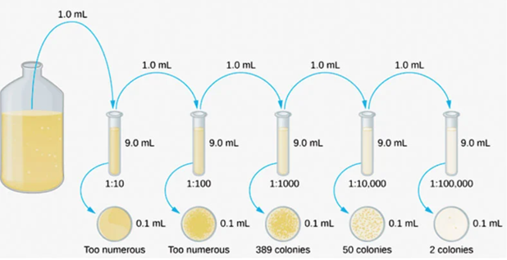
Fig. 1.2. Sample dilution scheme https://examtube.in/post/serial-dilution
Precautions to be taken
Do not prepare or dispense dilutions or pour plates in direct sunlight. When removing a sterile pipette from the pipette container, do not drag the pipette tip over the exposed exteriors of the pipettes remaining in case because the exposed ends of such pipettes are subject to contamination. Do not wipe or drag the pipette across the rims and necks of vials or dilution bottles. Do not insert the pipette more than 2.5 cm below the surface of the sample or dilution. Draw test portions above the pipette graduation; then raise the pipette tip above the liquid level and adjust to the desired mark by allowing the lower side of the pipette tip to touch the inside of the container so that drainage is complete and excess liquid does not adhere when the pipette is removed from the sample or dilution bottle. Do not flame sterile pipettes.
When delivering a diluted sample of a dairy product, hold the pipette at an angle of about 45 degrees while the tip is touching the inside bottom of a Petri dish or the inside neck of a dilution bottle. Lift the cover of the Petri dish just high enough to insert the pipette. Deposit the sample away from the centre of the dish to aid in mixing the sample with medium. Allow 2 to 4 seconds for the diluted milk or cream to drain from the graduation mark to the rest point in the pipette tip; then, holding the pipette in a vertical position, touch its tip once against a dry spot on Petri dish or on the inside of the dilution bottle neck. Do not blowout. When 0.1 mL quantities are measured, hold the pipette as directed and let the diluted sample drain to the proper graduation point but do not retouch the pipette to the plate. After depositing the test portions in each series of plates, pour the medium.
Plating. Melt the required amount of medium (Plate count agar - PCA) quickly in boiling water, but avoid prolonged exposure to unnecessarily high temperatures during and after melting. Discard melted nutrient agar that develops a precipitate. Cool the melted medium promptly to approximately 45 °C. Wipe water from the outside of the medium bottles before pouring. Introduce 12 to 15 mL of liquefied medium at 44 to 46 °C into each plate by gently lifting the cover of the Petri dish high enough to pour the medium. Carefully avoid spilling the medium on the outside of the container or on the inside of the plate lid when pouring. As each plate is poured, thoroughly mix the medium with the test portions in the Petri dish by rotating the dish first in one direction and then in the opposite direction, rotating and tilting the dish by hand or using mechanical rotators. Take care not to splash the mixture over the edge. Having done so, spread the mixture evenly over the bottom of the plate, allow it to solidify on a plain surface. After solidification, invert the plates to prevent spreading colonies from developing because of accumulated moisture, and place the plates in the incubator.
Incubating. Incubate plates at 30 °C for 48 hrs for TPC.
Counting of colonies on agar plates. Count the plates after the desired incubation period. Record the dilutions used and number of colonies counted on each plate. If it is impossible to count at immediatly after the required incubation, store the plates at 0 to 4.4 °C, butfor no longer than 24 hours.
Count colonies with the aid of magnification under uniform and properly controlled artificial illumination. Plates should be examined in subdued light. Routinely use a colony counter equipped with a guide plate ruled in square centimetres.
Calculating and recording of microbial counts. When calculating the TPC, report only the first two significant digits to avoid creating a fictitious impression of precision and accuracy.

Table 1.6.
Total plate count
Sample number | Total plate count
1
2
3
Mean
Conclusions

2. Lactic acid bacteria count
Procedure
Samples preparation is the same as it was described for TPC.
Melt the required amount of medium (de Man Rogosam Sharpe agar - MRS) quickly in boiling water, but avoid prolonged exposure to unnecessarily high temperatures during and after melting. Discard melted nutrient agar or tryptone dextrose agar that develops a precipitate. Cool the melted medium promptly to approximately 45 °C.
Wipe water from the outside of the medium bottles before pouring. Introduce 12 to 15 mL of liquefied medium at 44 to 46 °C into each plate by gently lifting the cover of the Petri dish high enough to pour the medium. Carefully avoid spilling the medium on the outside of the container or on the inside of the plate lid when pouring. As each plate is poured, thoroughly mix the medium with the test portions in the Petri dish by rotating the dish first in one direction and then in the opposite direction, rotating and tilting the dish by hand or using mechanical rotators. Take care not to splash the mixture over the edge. Having done so, spread the mixture evenly over the bottom of the plate, allow it to solidify on a plain surface. After solidification, invert the plates to prevent spreading colonies from developing because of accumulated moisture, and place the plates in the incubator.
Incubating. Incubate plates at 37 °C for 48 hrs for LAB in aerobic conditions. Plates must reach the temperature of incubation within 2 hrs.
Counting of colonies on agar plates. Count the plates after the desired incubation period. Record the dilutions used and number of colonies counted on each plate.
Calculating and recording of microbial counts. When calculating the LAB, report only the first two significant digits to avoid creating a fictitious impression of precision and accuracy.
Table 1.7.
Lactic acid bacteria count
Sample number | LAB plate count
1
2
3
Mean
Conclusions

Approved by
(Name, surname, signature)
Date
Date ___________________

Laboratory work

The importance of milk quality
1. Detection of inhibitors
Different methods are used to detect inhibitors. In the current laboratory work the following methods will be used:
- Test with the indicator resazurin;
- Delvotest SP;
- Charm test.
Inhibitors detection with the indicator resazurin
For the detection of inhibitors, using the indicator resazurin, a pure culture of Streptococcus thermophilus susceptible to inhibitors is added to pasteurised and cooled milk. In the absence of inhibitors in the milk, the microorganisms multiply and the reductase they release reduces the indicator resazurin. If there are inhibitors in the milk, then the reproduction of Streptococcus thermophilus is inhibited, and at the same time the reduction of the indicator is inhibited.
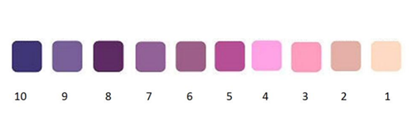
Fig. 1.3. Explanation of the results obtained by the test the indicator resazurin
Procedure
Pour 10 mL of the milk to be tested into a clean test tube and close it not too tightly with a rubber stopper.
The contents of the test tube are heated to 85-90 °C in a water bath for 10 minutes, then milk should be cooled to 43-45 °C. Add 0.3 ml of Streptococcus thermophilus with a sterile pipette. The contents of the test tube are mixed and kept at a temperature of 42-43 °C for 2 hours.
After 2 hours, pour 1 mL of 0.05% resazurin solution into the test tube, the temperature of which should not be lower than 18-20 °C. The contents of the test tube are thoroughly mixed and kept at a temperature of 42-43 °C for 15 minutes.
In the absence of inhibitors, the contents of the tube are pink or white. If the milk contains inhibitors, the contents of the tube will be steel blue, blue violet or violet in colour.

Delvotest SP
The "Delvotest SP" test is intended for the detection of antibiotics in milk. This method also uses an antibiotic-sensitive test culture of Bacillus stearothermophilus var calidolactis.
The method is based on the colour change of the culture medium containing Bacillus stearothermophilus var calidolactis from purple to yellow, as a result of spore reproduction. The medium contains spores of Bacillus stearothermophilus var calidolactis and the purple dye. In the antibiotic-free milk, spores multiply rapidly and release various metabolic products into the environment, incl. also lactic acid. As the concentration of acids increases, the colour of the medium changes from purple to yellow. If the milk sample contains antibiotics, the spore reproduction is inhibited and the colour of the culture medium does not change. The violet-yellow colour of the culture medium indicates the presence of antibiotics in milk in small concentrations, which are below the permissible concentration of the detection threshold.
The multiply of spores in milk depends on the incubation temperature and holding time of the samples. Temperatures that are too high or too low slow down these processes. Failure to observe the temperature may affect the sensitivity of the test to detect antibiotics.
Procedure
Each student receives 1 sealed ampoule with a medium for determining the presence of antibiotics in milk. Carefully, without completely tearing off the aluminium foil cap, open the ampoule. Measure 0.1 mL of the analysed milk with a pipette and pour it into the ampoule. Seal the ampoule with an aluminium foil cap, label it and place it in an incubator at a temperature of 64±0.5 °C. The ampoule is kept in the incubator for 3 hours (minimum analysis time is 2 h 45 min). At the end of the analysis, evaluate the colour of the medium in the ampoule. A yellow colour indicates that the sample does not contain antibiotics. A yellow-violet colour indicates the presence of antibiotics in the sample, but their content is close to the allowed concentration of inhibitors in milk. A purple colour indicates that the sample contains antibiotics.
The results of the analyses must be read immediately after removing the ampoule from the incubator.
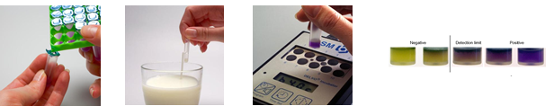
Fig. 1.4. Procedure and results of Delvotest https://device.report/delvotest

Charm MRL
With the help of this test, the presence of certain antibiotic residues in milk can be detected within a few minutes. This test is used in milk processing companies as a routine method for indirect testing of milk quality. If positive results are found, the milk sample should be examined with the help of the Delvotest SP test, in order to obtain more objective and representative analysis results.
The Charm MRL Beta-lactam and Tetracycline Test uses receptors that bind beta-lactam and tetracycline drugs. As milk flows through the test strip, a beta-lactam line forms at the BL position and a tetracycline line forms at the TE position when the sample contains no beta-lactam or tetracycline drugs. A weaker intensity BL or TE line forms when beta-lactam and/or tetracycline is present in the sample. The BL and TE lines are compared to the C (control) line that is designed to discriminate beta-lactams/tetracycline close to the MRLs. If both the BL and TE lines are darker than or equal to the C line, the sample is negative. If either the BL or TE line is lighter than the C line, or the BL or TE line does not form, the sample is positive (Fig. 3.1.).
Procedure. The student receives the strip and, after carefully opening the packaging, places it in the ROSA incubator with the wider end downwards in the incubator. Using a disposable pipette to measure 0.3 mL of milk, and on the strip close to the inscription Peel to Here, drop a sample of milk into the incubator. Tightly seal the tape around the edge of the strip, close the incubator lid and tighten the latch, from this moment ROSA starts an automatic 8-minute countdown.
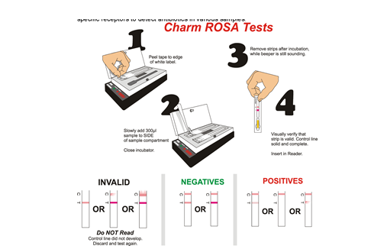
Fig. 1.5. Sample preparation for the Charm MRL test https://www.tirlanfarmlife.com/shop/product/Charm-Antibiotic-Test-Strip-Incubator-and-Test-Strips/B9125033
After 8 minutes, the ROSA incubator signals the end of the incubation, a yellow light comes on. Carefully, without compressing the sample, remove it from the incubator. Compare the results of the removed strip with the examples given in Fig. 1.5.
2. Milk coagulation test
Procedure
10 mL of milk is heated to 35 °C and 2 mL of 0.02% enzyme preparation solution is added. The mixture is carefully mixed and coagulation at 35 °C, fixing the coagulation time. Every 2-3 minutes, the contents of the test tube are examined, observing changes in the viscosity of the milk. The end of clotting is determined by the consistency of the formed clot. Depending on the duration of coagulation, milk is divided into:
1) Fast curdling, clot formation time up to 600 seconds;
2) Normal clotting, clot formation time from 600 to 900 seconds;
3) Slow curdling, clot formation time over 900 seconds.
Students make a conclusion about the suitability of milk for curdling, waiting for the results of the fermentation-coagulation test.
3. Detection of the presence of certain detergents in milk
In some cases, the detection of the presence of certain detergents helps to reveal the sources of the entry of inhibitors.
3.1.Detection of hydrogen peroxide in milk
Milk with hydrogen peroxide added is adulterated. Hydrogen peroxide is added to milk to neutralise it and prevent a faster increase in acidity. The detection method is based on the ability of hydrogen peroxide to release free iodine from KJ, which gives a blue colour with starch. The sensitivity of the method is 0.001% hydrogen peroxide.
Procedure
Add 1 mL of milk in a tube, and without mixing add 2 drops of H2SO4 and 0.2 mL of solution of KJ and starch. Observe change of colour in a tube after 10 minutes. Blue colour testifies for H2O2 presence in the milk sample.
3.2. Detection of formaldehyde in milk
The method is based on the reaction of colours with formaldehyde in an acidic environment. Formaldehyde is added to milk to preserve it.
Procedure
Add 2 mL of milk in a tube, and without mixing along the tube wall add 2 mL of mixture of H₂SO₄ and HNO₃. Observe the change of colour in a tube. Violet and dark blue colours testify about formaldehyde presence in the milk sample.

3.3. Detection of soda in milk
The method is based on the colour change of bromothymol blue by adding it to milk containing soda. The sensitivity of the method is 0.05% added sodium carbonate or bicarbonate. Soda is added to milk to reduce its acidity
Procedure
Add 5 mL of milk in a tube, and without mixing along the tube wall add 7-8 drops of bromothymol blue dye solution. Observe the colour changes in a tube. A green colour indicates the presence of soda in the milk sample.
3.4. Detection of urea in milk
Procedure
Pour 5 mL of milk into a test tube and add 5 mL of Nesler reagent. The appearance of a distinct yellow colour indicates the presence of added urea, whereas the development of slightly yellow colour is due to natural urea in the milk.

Table 1.8.
Quality of the analysed milk sample
Sample | The presence of inhibitors | The presence of antibiotics |  | Suitability for cheese production | The presence |  |  |  | The alcohol test
Sample | The presence of inhibitors | Delvotest | Charm test | Suitability for cheese production |  |  |  |  | The alcohol test
 |  |  |  |  | H₂O₂ | soda | formalin | urea | The alcohol test

Conclusions:

Approved by
(Name, surname, signature)
Date

Theme 2

Milk processing – different treatment methods of milk and cream
Theoretical materials
- Cooling
- Filtration
- Bactofugation
- Deaeration
- Homogenisation
- Separation
- Heat and pressure treatment
During bactofugation it is possible to split 95-98% of microorganisms, two-phase bactofugation 99.5%;
Composition of bactofugate:
•98.1% anaerobic microorganism spores;
•95.1% aerobic microorganisms spores;
•92.2% lactic acid bacteria.
Deaeration - separation of volatile compounds from milk
Concentration of air in cream, causing:
– inaccurate in-line fat standardisation,
– incrustation of cream heaters,
– 'pre-churning' resulting in loss of yield in butter production
Separation - exposing milk to centrifugal force produces products with a significantly different fat content, such as cream and skimmed milk.
The effectiveness:
• size of fat globules,
• cleanliness and freshness,
• supply intensity,
• temperature,
• fat content.
Standardisation - regulation of fat content in milk, cream or other products. Principle of the standardisation process is given in Fig. 2.1.
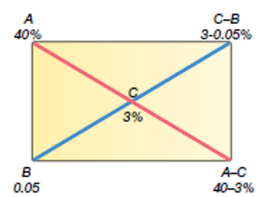
Fig. 2.1. Batch standardisation
https://dairyprocessinghandbook.tetrapak.com/chapter/pasteurized-milk-products
Homogenisation primarily causes the break up of fat globules into much smaller ones; see figure 4. Consequently, it diminishes creaming and may also diminish the tendency of globules to clump or coalesce. Essentially all homogenised milk is produced by mechanical means. The milk is forced through a small passage at high velocity. The disintegration of the original fat globules is achieved by a combination of contributing factors such as turbulence and cavitation. The net result is a reduction of the fat globules to approximately 1mm in diameter, which is accompanied by a four- to six-fold increase in the fat/plasma interfacial surface area. The newly created fat globules are no longer completely covered with the original membrane material. Instead, they are coated with a mixture of proteins adsorbed from the plasma phase.
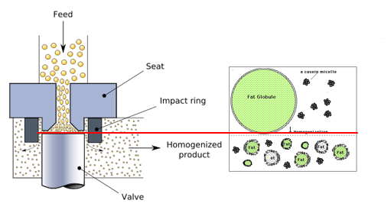
Fig. 2.2. Homogenisation
https://en.wikipedia.org/wiki/Homogenization_%28chemistry%29
Membrane technology is a proven separation method used on the molecular and ionic levels. In the dairy industry, the membrane technology is principally associated with:
• Reverse Osmosis (RO) – concentration of solutions by removal of water,
• Nanofiltration (NF) – concentration of organic components by removal of part of monovalent ions like sodium and chlorine (partial demineralisation),
• Ultrafiltration (UF) – concentration of large and macro molecules,
• Microfiltration (MF) – removal of bacteria, separation of macromolecules.
Thermal treatment
The purpose of heat treatment is to minimise the microorganisms in the milk, to eliminate all pathogens, to inactivate enzymes, while trying to maintain the nutritional and biological value of the milk at the same time.
- Pasteurization – 63-95 ºC, 15 sec-30 min.
- Sterilisation - 120-130 ºC, 10-20 min.
- Ultrahigh-temperature heating- 135-138 ºC, 3-5 s.
Changes in the composition of milk caused by an increase in temperature may be reversible or irreversible. Here we are mainly interested in the irreversible or slowly reversible reactions; such changes hardly occur with heat treatments of lower intensity than low pasteurisation.
- The amount of colloidal phosphate increases and the [Ca2+] decreases.
- Lactose isomerises and partly degrades to yield, for instance, lactulose and organic acids.
- Phosphoric esters, those of casein in particular, are hydrolysed. Phospholipids are also split. Consequently, the amount of inorganic phosphate increases.
- The pH of the milk decreases, and the titratable acidity increases.
- Most of the serum proteins are denatured and thereby rendered insoluble
- Part of the serum protein (especially of β-lactoglobulin) becomes covalently bound to κ-casein and to some proteins of the fat globule membrane.
- Enzymes are inactivated.
- Reactions between protein and lactose occur, Maillard reactions in particular. This involves the loss of available lysine.
- Free sulfhydryl groups are formed. This causes, for instance, a decrease of the redox potential.
- Casein micelles become aggregated. Aggregation may eventually lead to coagulation.
- Several changes occur in the fat globule membrane.
- Some vitamins are degraded.

Laboratory work

Milk separation, standardisation and thermal treatment

Methods and Procedures
1. Milk separation
Students share the duties: head of the process, operator, laboratory assistant, bookkeeper, and the persons responsible for cleaning (at least 2 students).
The separator is ready for the process. Students weigh the milk and record it in the table, students analyse the milk composition, especially the fat concentration, using the Milkoscan Mars TM analyser.
Milk should be warm (temperature around 40 ºC) prior to separation. Please also weigh the dishes for skimmed milk and cream. Switch on the separator and pour in the separator basin milk. During the separation process, the milk flow can be changed in the separator.
At the end of separation, please add 1 L of skimmed milk into the separator basin to remove cream traces from the separator bowl.
After separation, the skimmed milk and cream composition and density should be analysed, as well as the weight will be determined for both products.
The Skimmed milk and cream density is measured:
The temperature of the skimmed milk or cream should be around 20 ºC prior to the density measurement. Mix the sample gently and pour it gently into a measuring cylinder. An aerometer with a scale of up to 1000 kg m⁻³ (940-1000) has been used to determine the cream density, but the aerometer with the scale of 1000 - 1040 kg m⁻³ is used for skimmed milk. Let the aerometer to sink slowly into the sample. Read and record the last aerometer degree (kg m⁻³) just above the surface of the milk. If the temperature of the milk is different from the calibration temperature (calibration temperature may be 20 ⁰C) of the aerometer, calculate the temperature correction.
The data obtained are used to calculate the milk yield for 1 kg of cream production, as well as the loss of milk has been determined during the separation in kg and %.
Equations for calculation of milk yield and losses
Yield= milk/cream
where:
Yield – the milk yield for 1 kg cream production;
Milk – the amount of milk, kg;
Cream – the amount of milk, kg.
Losses (kg) = Milk - (Cream + Skimmed milk)
When the separator is fully stopped, disconnect the power supply to the separator. The separator should be dissembled prior to cleaning (please do it in a sink). Separator parts should be washed with detergent and in hot water. At least all parts of the separator should be wiped and kept dry.

Table 2.1.
The summary of the separation process
Parameters | Results
Milk
Amount of milk, kg
Fat content, %
Skimmed milk
Amount of skimmed milk, kg
Fat content, %
Density, kg/m3
Cream:
Amount of cream, kg
Fat content, %
Density, kg/m3
The milk yield for 1 kg cream production
Milk losses during separation, kg
Milk losses during separation, %
Conclusions

2. Standardisation
Students have the following products for the standardisation task: drinking milk (fat content %, density 1028 kg m⁻³), skimmed milk (fat content was determined in the separation task), and cream (fat content was determined in the separation task). The students calculate the necessary amount of ingredients for 100 g of standardised milk/cream production with the following fat content:
1%, 1.5%, 3.5%, 6%, 10% and 12%
The students choose one of the proposed options. The calculation should be done using a rectangle method given in the lectures or equations (see below).
The cream calculation for a standardised mixture
$Mc= \frac{Ms (Fs-Fm)}{Fc-Fp}$,
where:
M_{c} - the amount of cream, g;
M_{s} - amount of the standardised mixture, g;
F_{s} - fat content in the standardised mixture, %;
F_{c} - fat content in cream, %;
F_{p} - fat content in milk, %.
Milk calculation for a standardised mixture
M_{m}=M_{s}-M_{c}
where:
M_{m} - the amount of milk, g;
M_{s} - the amount of the standardised mixture, g;
M_{c} - the amount of cream, g.

The cream calculation for a standardised mixture
$Msm= \frac{Ms (Fp-Fs)}{Fm-Fsm}$
where:
M_{sm} - the amount of skimmed milk, g;
M_{s} – the amount of the standardised mixture, g;
F_{s} - fat content in the standardised mixture, %;
F_{sm} - fat content in standardised milk, %;
F_{p} - fat content in milk, %.
Milk calculation for a standardised mixture
M_{m}=M_{s}-M_{sm}
where:
M_{m} -the amount of milk, g;
M_{s} - the amount of the standardised mixture, g;
M_{c} - the amount of cream, g.

After calculation, carefully weigh the calculated products in a baker (precisely +0.01 g), gently mix, and heat up to 45 ºC. The fat content in a standardised mixture should be measured using a milk analyser.
If the result differs by more than 0.5%, students should repeat the calculation, sample preparation, and fat content determination.
The students make conclusions about the standardisation and its influencing factors.
The prepared samples should be used for the completion of the 3rd task.
Conclusions

4. The study of milk quality and parameters changes during the thermal treatment
Students choose one of the proposed parameters for the thermal treatment:
- 60 ºC 15 sec.;
- 72 ºC 15 sec.;
- 78 ºC 15 sec.;
- 80 ºC 5 sec.;
- 85 ºC 5 sec.;
- 90 ºC 5 min.
Before the treatment, the pH and acidity (ºTh) should be measured. Students heat the samples to the chosen temperature and hold for some time (proposed holding time). After the treatment, the samples are cooled down until the temperature is around 20 ºC. If tap water is used for cooling, please ensure that during the cooling process no water drops get into the product. After cooling, milk pH and acidity are measured.
pH determination
Put clean and dry electrodes into the milk and press the Read button on the screen of the pH meter. When the sound signal is heard, read the result on the screen.
Acidity determination
Take 10 mL of the milk into a conical flask, add 20 mL of distillate water, and 2-3 drops of phenolphthalein and then slowly titrate with 0.1 M NaOH under continuous mixing until a faint pink colour appears and persists for 30 seconds.
Titratable acidity is obtained from the equation:

ºT=volume of 0.1 M NaOH (in ml) x 10
The results are summarised in the table.
After the thermal treatment, the presence of phosphatase and peroxidase should be measured.
Determination of phosphatase
2 mL of milk, and 1 mL of sodium phenolptaleinphosphate are added into a tube. After the addition of the chemicals, the content of the tube is mixed carefully and closed with the cork. Put the tube into a water bath at a temperature of 40-45 ºC and after 10 minutes evaluate the sample colour. If the colour of the sample turns slightly pink or dark red, the milk sample includes phosphatase.
Determination of peroxidase
Place 5 mL of milk into a tube and add 5 drops of KJ starch solution, and 5 drops of H₂O₂. Shake the content of the tube carefully. If the colour of the sample doesn't change, the presence of peroxidase has not been observed in the sample. All results should be summarised in the table.

Table 2.2.
The summary of the thermal treatment process
Sample (milk or cream) | Fat content, % | Thermal treatment parameters | Prior thermal treatment |  | After thermal treatment |  | Presence of
Sample (milk or cream) | Fat content, % | Thermal treatment parameters | pH | ºTh | pH | ºTh | phosphatase | peroxidase
 |  | 60 ºC 15 s.
 |  | 72 ºC 15 s.
 |  | 78 ºC 15 s.
 |  | 80 ºC 5 s.
 |  | 85 ºC 5 s.
 |  | 90 ºC 5 min.
Conclusions

Approved by
(Name, surname, signature)
Date

Practical work

MILK PROCESSING TECHNOLOGY – equipment: separators

The aim of the work is to gain knowledge of basic milk processing equipment: the separator. The group of students is divided into teams and each team analyees the importance of components and equipment in the implementation of processes.

Materials
Students get acquainted with the separation equipment, the components, and the principles of operation.

Procedures and Results
The results obtained in the experiments should be reflected in the table 2.3.
Table 2.3.
Results of experiments
Illustration, Questions | Comparable equipment
Illustration, Questions | 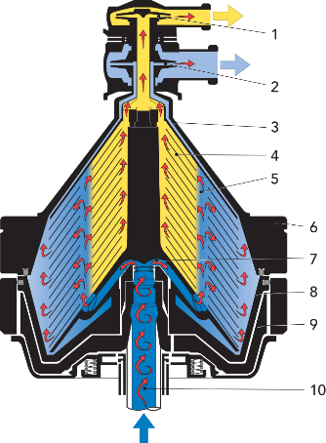 | 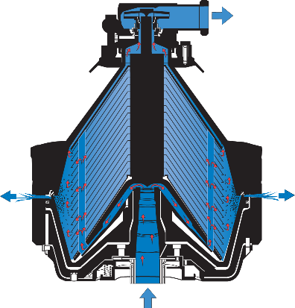  ⁸
Name the main parts.
Operating principle.
What are the 3 main differences?

How often should the machine be washed?
Can device shortening happen automatically?

What is the spindle speed of each machine?

Into how many fractions is the product divided?

What do both machines have in common?

Conclusion
During the practical activities, students acquire and consolidate knowledge and skills in the operation of equipment.

Approved by
(Name, surname, signature)
Date

Practical work

MILK PROCESSING TECHNOLOGY – equipment: heat exchangers
The aim of the work is to gain knowledge about basic milk processing equipment: heat treatment equipment. The group of students is divided into teams and each team analyses the importance of components and equipment in the implementation of processes.

Materials
Students get acquainted with heat treatment equipment, its components, and the principles of operation.

Procedures and Results
The results obtained in the experiments should be reflected in the table 2.4.
Table 2.4.
Results of experiments
Illustration, Questions | Comparable equipment
Illustration, Questions | Heat exchanger (plate) | Heat exchanger (tube)
Illustration, Questions | 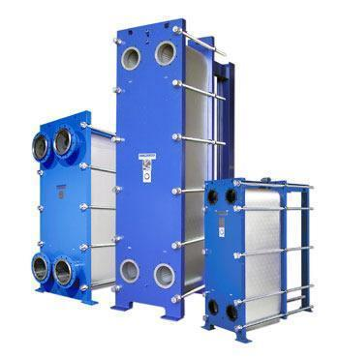  https://www.indiamart.com/proddetail/plate-type-heat-exchanger-11738602830.html | 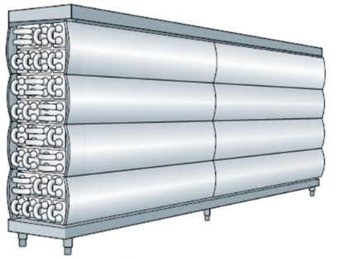  https://dairyprocessinghandbook.tetrapak.com/chapter/heat-exchangers
Main parts

What products are they used for?

How many sections does it consist of?

What temperature is used for heat treatment?

What is the heating/cooling environment?

How can the pasteurisation/sterilisation result be ensured?

Conclusions
During the practical activities, students acquire and consolidate knowledge and skills in the operation of equipment.

Approved by
(Name, surname, signature)
Date

Practical work

MILK PROCESSING TECHNOLOGY – equipment: HEAT EXCHANGER SCHEME
The aim of the work is to gain an understanding of the sections of the plate heat exchanger, its importance and necessity. As well as being able to draw the processes that take place in the plate heat exchanger at a given list of temperatures.

Materials
Students are divided into groups and given the following text tasks:

- Tasks: Draw an expanded diagram of the plate heat exchanger by sections.
Initial milk temperature 5 ° C, fat content 3.9%; separation at 42 °C, homogenisation at 42 °C, pasteurisation of milk with a fat content of 2.5% at a temperature of 77 °C and cooling to a temperature of 7 °C.

- Tasks: Draw an expanded diagram of the plate heat exchanger by sections.
Initial milk temperature 15 °C, homogenisation 42 °C, pasteurisation of skim milk at 72 °C and cooling to 4 °C.

- Tasks: Draw an expanded diagram of the plate heat exchanger by sections.
Initial milk temperature 10 °C, fat content 3.9%; separation at 42 °C, pasteurisation of milk with a fat content of 2.5% at 77 °C, homogenisation at 60 °C, and cooling to 25 °C.

- Tasks: Draw an expanded diagram of the plate heat exchanger by sections.
Initial milk temperature 4 °C, fat content 4.2%; separation at 42 °C, homogenisation at 60 °C, pasteurisation of milk with a fat content of 2.5% at 74 °C and cooling to 8 °C.

- Tasks: Draw an expanded diagram of the plate heat exchanger by sections.
Initial milk temperature 30 °C, fat content 4.8%; separation at 42 °C, homogenisation at 60 °C, pasteurisation of milk with a fat content of 2.5% at 74 °C, homogenisation at 67 °C, and cooling to 25 °C.

Procedures and Results
The solution of each task should be shown in the picture, where you can see the representation of the heat exchanger by sections, and the drawing of the temperatures on the scale whiletaking into account the temperatures specified in each task.
For instance:

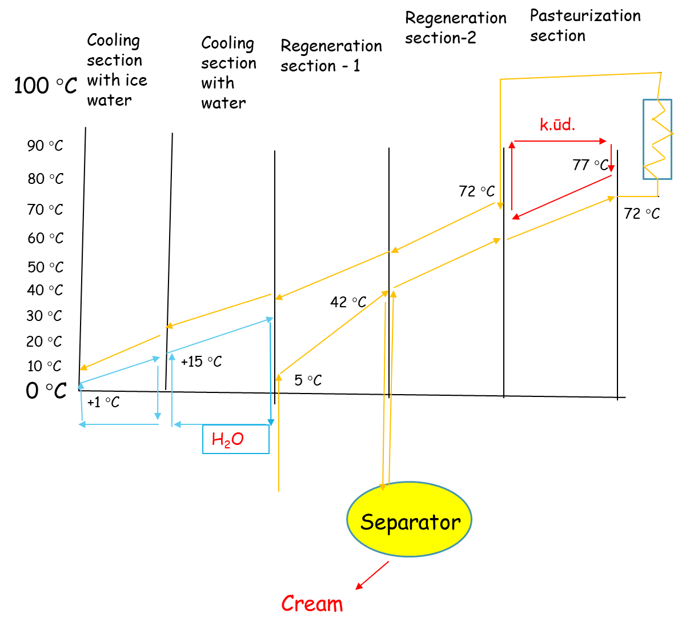
Conclusions
During the practical activities, students learn and strengthen knowledge and skills in the operation process and the importance of the plate heat exchangers.

Approved by
(Name, surname, signature)
Date

Theme 3

Fermented dairy products: production and quality evaluation
Theoretical materials
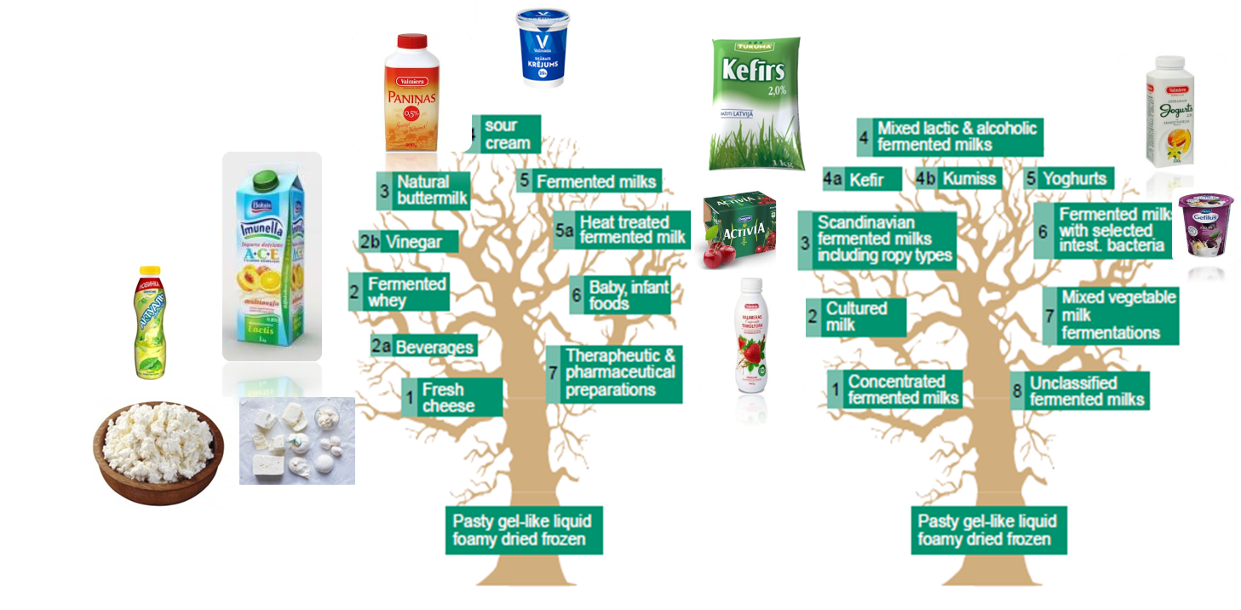
Fig. 3.1 Fermented dairy products
Starter is the basis of dairy product production.
Starter culture microorganisms inoculum, which ensure taste, aroma and texture of the product. As an instrument against undesirable microorganisms (Enterobacteriaceae, Bacillus spp., Staphylococcus aureus, Clostridium turobutyricum, bacteriophage).
Role of starter:
• Prevention of food spoilage and extension of shelf life, assurance of food safety;
• Formation of desirable sensory properties;
• Formation of desirable therapeutic and functional properties;
• Control and regulation of the technological process;
• Better economy of technological process, shorter fermentation time;
• Decreased use of some chemical additives;
- Better nutritional value (vitamins, lactose, digestibility).

Starter quality:
• Hygienic criteria: strains are not infectious or toxicogenic, do not produce antibiotics – are safe (GRAS - Generally Recognised and Safe);
• Contain declared number of live microorganisms: during fermentation are metabolically active, to overgrow the autochthonous microbiota and direct the fermentation in desired way;
• Different forms: liquid, frozen, lyophilised;
• Different ways of manipulation: revitalisation, pre-fermentation, direct inoculation;
• Producer specification.

Starter characterisation:
• Ecological approach: isolation of certain strains from ecological niches, where we want to use them (milk, non milk product);
• Testing technological properties: certain conditions, acid production, enzyme activity;
• Compatibility test: mixed cultures;
• Bacteriophage sensitive;
• General characteristics;
• Successful in medium with sugars, proteins, vitamins and low oxygen concentration.
Starters could be:
• Mono strain: one strain of certain species;
• Multi strains: more strains of one species;
• Multi strains mix: more different strains of different species;
• Mixed: species/strains partially known or unknown.
Table 3.1.
Examples of starter mixtures
Genus | Species | Subspecies | Strain
Lactobacillus | delbrueckii | Subsp. bulgaricus | GLB 44
Enterococcus | faecium | / | LMG11423
Lactobacillus | acidophilus | / | LA5
Bifidobacterium | animalis | subsp. lactis | BB12
Kluyveromyces | lactis | / | M-I2
Penicillium | camemberti | / | ATCC 10387

Starter according to temperature:
• Mesophilic: 10-40 °C, optimum ~30 °C
- Yeast
- Moulds
- Lactobacilus lactis subsp. lactis/cremoris, Leuconostoc, Lact. Lactis dyacetylactis, Lactobacillus casei
• Thermophilic: 20-50 °C, optimum 37-42 °C
- Lactobacillus, Streptococcus, Bifidobacterium, Propionibacterium
Starters according to final metabolic products of lactose:
• Homofermentative
• Heterofermentative
Starters according microorganisms:
• Lactic acid bacteria and other bacteria
• Yeats
• Moulds
Table 3.2.
Fermented products - production parameters
Product | ºC | Starter | h | ºT
Kefir | 18-22 | Lactococcus lactis, Lactococcus cremoris, Leuconostoc, Lactobacillus kefir, Lactobacillus casei, Acetobacter aceti, Candida kefir, Kluyveromyces marxianus u.c. | 8-16 | 85-120
Kefir* | 18-22 | Lactococcus lactis, Lactococcus cremoris, Leuconostoc, Lactobacillus kefir, Lactobacillus casei, Acetobacter aceti, Candida kefir vai Kluyveromyces marxianus, Lactobacillus acidophilus, Bifidobacteria ssp. | 8-16 | 85-120
Sour milk | 20-24 | Lactococcus diacetylactis, Lactococcus lactis | 7-16 | 75-80
Yogurt | 42-45 | Lactobacillus delbrueckii subsp. bulgaricus, Streptococcus thermophilus | 3-6 | 90-100
Yogurt* | 42-45 | Lactobacillus delbrueckii subsp. bulgaricus, Streptococcus thermophilus, Lactobacillus acidophilus, Bifidobacteria ssp. | 3-6 | 80-120
Ryazhenka | 18-24 | Lactococcus diacetylactis, Lactococcus lactis | 8-12 | 90-95
Lakto* | 36-38 | Lactobacillus acidophilus, Streptococcus thermophilus, Bifidobacteria ssp. | 4-6 | 80-130
Butter milk | 20-24 | Lactococcus diacetylactis, Lactococcus lactis | 8-12 | 80-120

Table 3.3.
Characterisation of microorganisms
Microorganisms | Optimal temperature, °C | Max NaCl konc, % | Lactic acid production, %
L. lactis | 25-30 | 4-6.5 | 0.5-0.7
L. cremoris | 25-30 | <4 | 0.5-0.7
L. diacetylactis | 25-30 | 4-6.5 | 0.3-0.6
Leuc. cremoris | 20-25 | - | 0.2-0.4
Lb. helveticus | 40-45 | 2 | 2.0-2.7
Lb. lactis | 40-45 | 2 | 1.2-1.5
Lb. bulgaricus | 40-45 | 2 | 1.5-2.0
Lb. acidophilus | 35-40 | 2 | 1.5-2.0
Str. thermophilus | 40-45 | 2 | 0.7-0.8
Bifidobacteria | 37 | - | 0,4-0,9
•Cottage cheese is a fresh, soft, unripened cheese made from sweet, pasteurised skimmed milk by lactic culture with or without the addition of rennet.
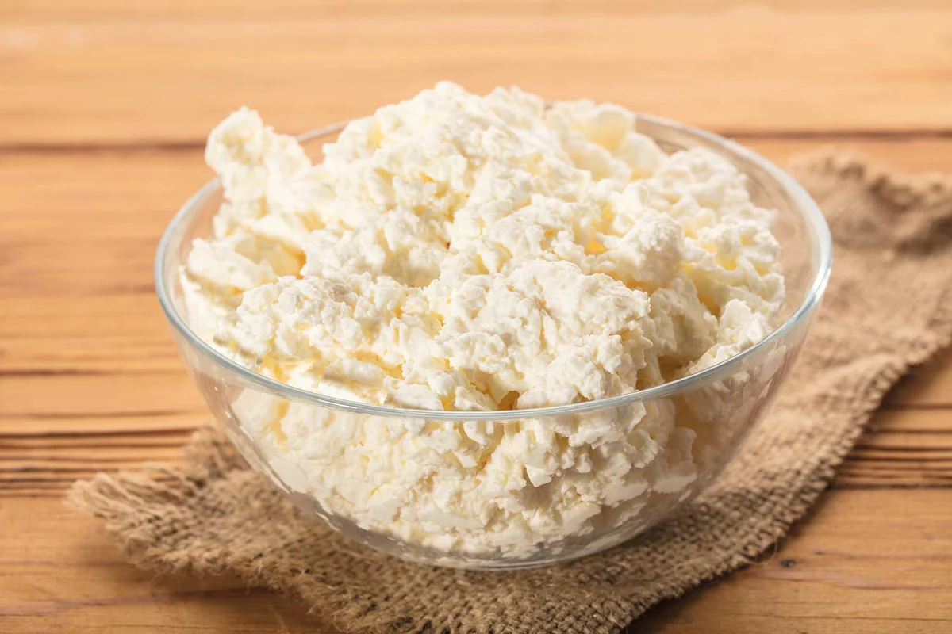
Fig. 3.1 Cottage cheese
https://cheesemaking.com/products/cottage-cheese-recipe

Table 3.4.
Cottage cheese characterisation
Cottage cheese | Fat content, % | Max water content, % | Max acidity, T
low fat | - | 80 | 240
table | 2 | 75-80 | 235
with high fat content | 5 | 75 | 230
with very high fat content | 9-18 | 65-73 | 200-215

Laboratory work

Study of evaluation of fermented milk quality
Fermented dairy product production
Students receive chilled, skimmed milk obtained from the retail seller, homogenised and pasteurised at 90 °C for 5 minutes. Additionally, milk samples should be pasteurised (90 ºC for 5min.) and cooled prior to the experiments. 200 mL milk for 1 sample. The samples should be prepared according to the following scheme (see table 3.5.).
Table 3.5.
Sample preparation
Amount of milk | YF-L811, g | CHN 22 | Kefir
200 mL | 0.1 |  | +
200 mL | 0.1
200 mL | 0.1 |  | +
200 mL | 0.1
Then heat 400 mL of milk at 43/20/18 ºC before using a water bath to inoculate it with the starter culture. The milk samples are incubated at 43/20/18 ºC temperature for 4 to 6 hours until the pH of coagulum reaches pH 4.6. To understand the influence of the different starters on properties of the fermented product samples, the pH of the samples should be measured during fermentation. Determine the pH of the samples prior to the incubation and every hour during the fermentation. The pH of samples is checked using a pH-meter ‘3520 pH Meter’ Jenway. All measurements are done in triplicate. Analysed parameters are summarised in table.
Table 3.6.
Summary of analysed yogurt parameters
Samples | pH | Sugar concentration | Water holding capacity | Sensory evaluation
During fermentation
After fermentation
After maturation
During storage
When the pH of the samples reaches pH 4.6, stir the samples and cool them to 10-15 ºC using a water bath. Mature the samples at 4-6 ºC for 10-12 hours in the refrigerator.
Students will summarise the pH and viscosity data of analysed samples, and also the results of the sensory evaluation using descriptive statistical methods. The comparison between data obtained from all yogurt samples with different starters will be made and explanations and conclusions will be drawn.
Conclusions

Approved by
(Name, surname, signature)
Date

Laboratory work

Determination of quality parameters of fermented dairy products
1. Determination of the acidity of fermented products
Add to a conical flask 10 mL of the product and 20 mL of deionised water, 2-3 drops 1% phenolphthalein solution in alcohol, mix it well and titrate with 0.1 M NaOH until a pale pink colour persists for 30 seconds. Acidity is expressed in °Th (Thorner degree). The acidity is calculated based on the equitation:
°Th =volume of used o.1 M NaOH (counted in mL) *10
2. Determination of fat content of fermented milk
Weigh 1 g of the product into the butyrometer, and add 10 mL of sulphuric acid (ρ=1.81 g/cm³) into the butyrometer by letting it slowly flow down the glass walls. Add 1 mL of amyl alcohol using a pipette. Clean the neck of the butyrometer. Close the butyrometer tightly using a clean, dry stopper. Shake the butyrometer and invert it in a water bath at 65-75 °C for 5 minutes. Mix the butyrometer from time to time. Centrifuge for 5 min at 1200 rpm in the Gerber centrifuge. Remove the butyrometer from the centrifuge and adjust the meniscus to accomplish the reading. The sample must be 65 °C when reading the fat percentage. If the centrifuge is not adjusted to the right temperature, the butyrometer must be heated in a water bath.
Adjust the bottom meniscus to zero on the butyrometer's scale using a stopper. Read out the fat content from the low part of the upper meniscus. Express the fat content to an accuracy of 0.05%. Measurements are carried out in duplicate.
3. Determination of amount of separating whey
Carefully mix the samples of fermented milk and pour into a special graduated tube to the 10 mL border, close with a stopper. Put the tube into a water bath for 10 minutes at 30-35 °C, further centrifuge the tubes for 30 min at 1500 rpm, then students examine the content of the tube and determine the amount of separated whey in mL.
4. Determination of phosphatase
Measure 2 mL of fermented milk into a tube and 2 mL of deionised water, 2 mL of sodium phenolphthalein phosphate. Shake the tube and leave it in a water bath at 40-45 °C. After 1 hour, examine the colour of the product. If colour doesn’t change it is free from phosphatase. If the sample dyes from pale rose to dark pink, the sample contains phosphatase. If the change of the colour is observed during 10 minutes of tube incubation, further examination of the test tube isn't necessary.

Table 3.7.
Comparison of the acidity in milk during fermentation
Starter | Amount of added starter, g | Incubation temperature, C | Acidity |  |  |  |  | Characteristic of coagulum
 |  |  | 0 | 30 min | 60 min | 90 min | 120 min | consistency | Aroma + taste | Acidity, °Th
Sample:

Table 3.8.
Study of evaluation of fermented milk quality
Acidity, °Th | Fat content, % | Amount of separating whey | Presence of phosphatase

5. Sensory evaluation of fermented dairy products

10-point Line scale
TRAY NO. _____________________________________
Please mark the intensity of the sensory property of the fermented samples presented on the Line scale and write the sample number below the marking.
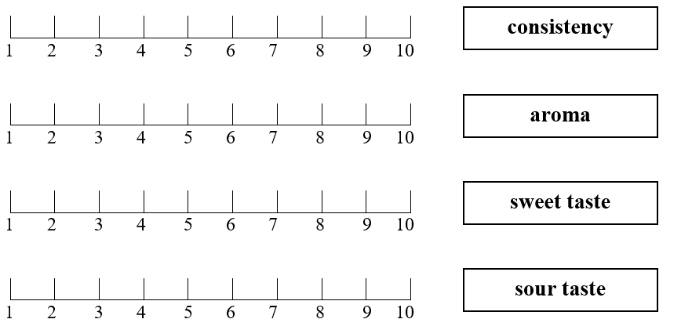
Conclusions

Approved by
(Name, surname, signature)
Date

Practical works

Equipment for production fermented products
The aim of the work is to gain knowledge about sour milk production equipment. Compare the equipment used for the production of different types of sour milk products. The group of students is divided into teams, and each team analyses the set of equipment necessary for the production of a specific sour milk, and then presents it to the other groups.

Materials
Students, considering the information according to the production technology of sour milk products, try to find the equipment to achieve the required result. By lining up the equipment to achieve a result. Provide a brief explanation of what each chosen device provides.

Procedures and Results
As a result, it is necessary to draw a diagram (or assemble a diagram from equipment stencils, if such have been prepared) in order to create different production lines of sour milk products.
Such as the following:
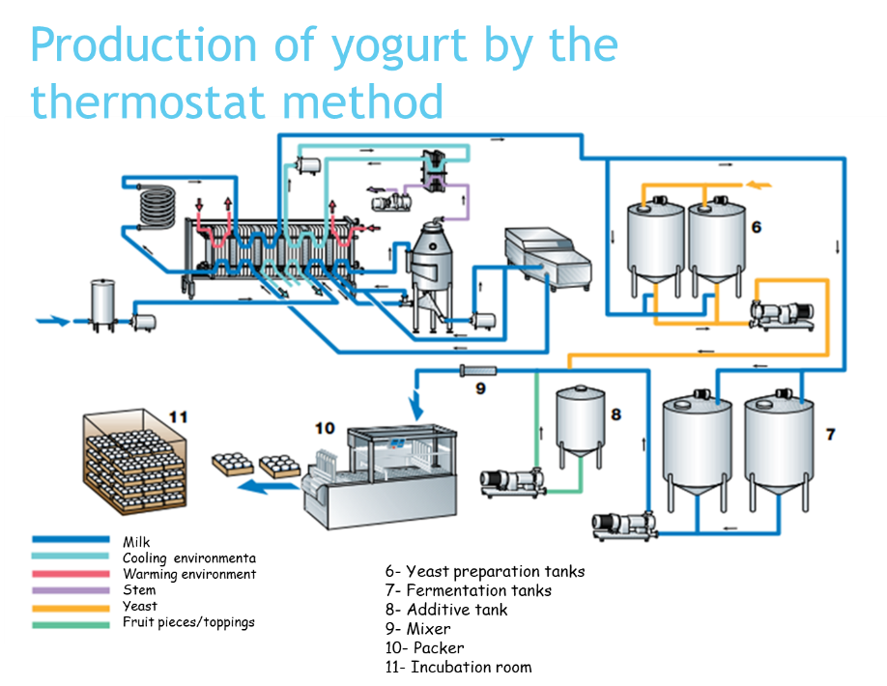

OR
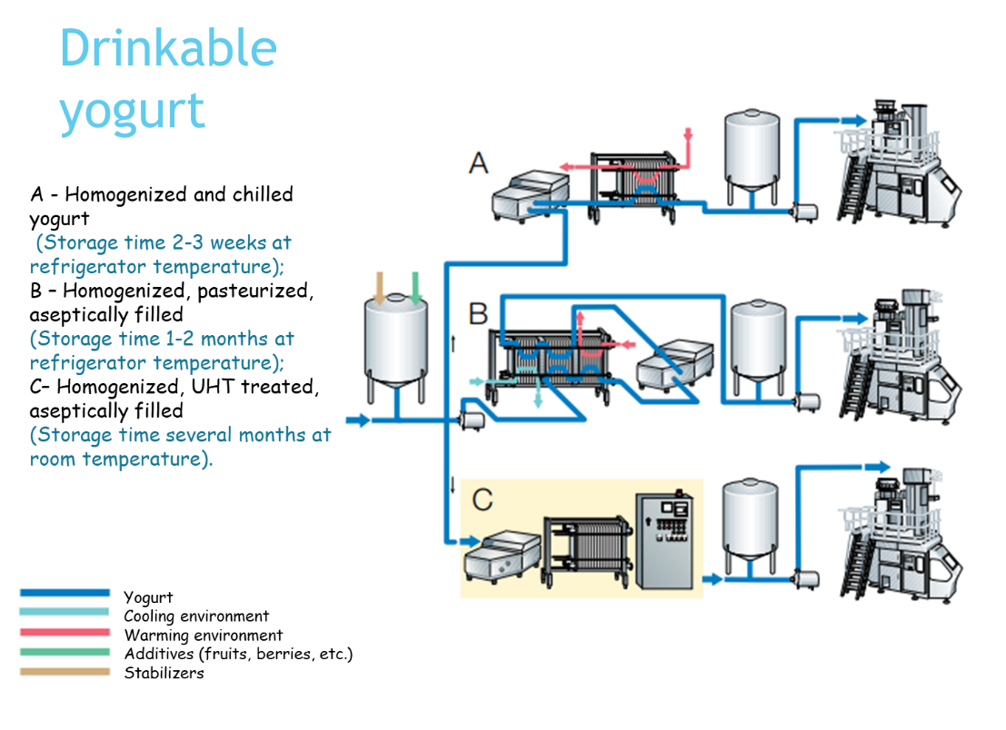

OR
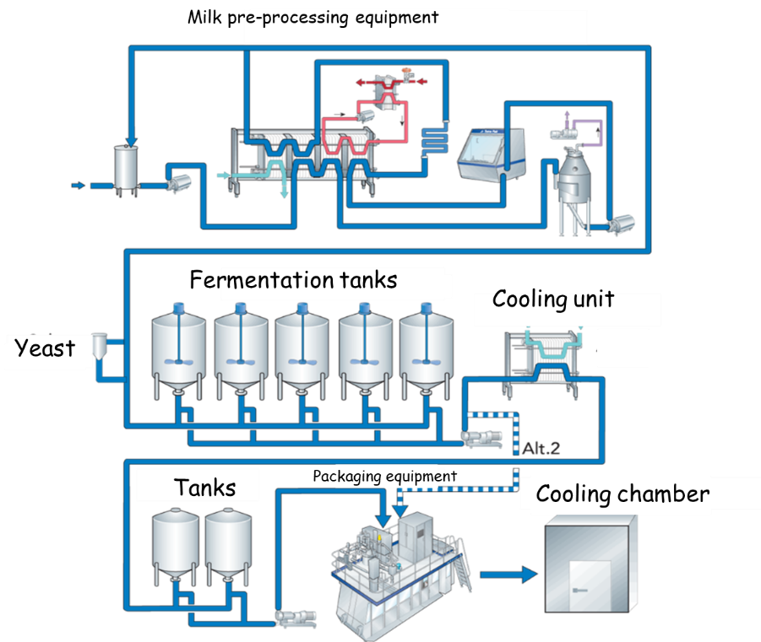

OR
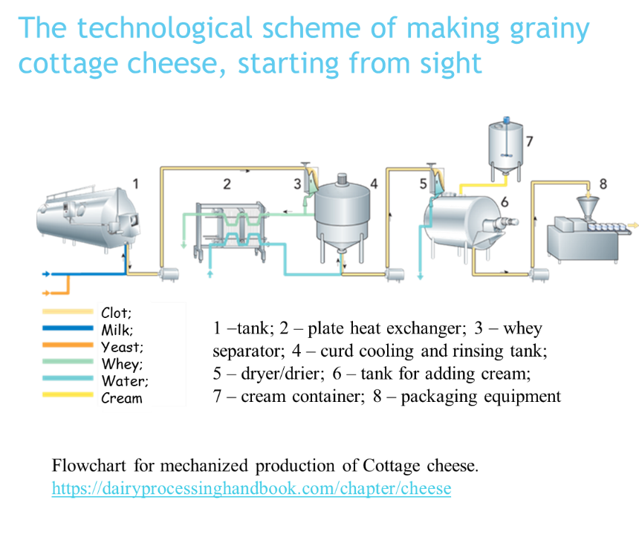
Conclusions
During the practical activities, students acquire and strengthen knowledge and skills in the operation of equipment, as well as the understanding of equipment flow lines in the production of sour milk products. Students explain their work.

Approved by
(Name, surname, signature)
Date

Laboratory work

Study of whey separation influencing factors
1. Impact of pasteurisation regime
At the laboratory, the student takes two beakers with a clot. The day before, the milk was pasteurised in different conditions:
Unpasteurised
- 63 °C, 30 minutes;
- 72 °C, 20-25 seconds;
- 78 °C, 20-25 seconds;
- 80-85 °C, 20-25 seconds;
- 90-95 °C, 20-25 seconds.
After the heat treatment, the milk was cooled down to 30 °C, 5 mL of 40% CaCl₂ and starter culture (mesophile lactic starter) were added to it. The milk was fermented for 16 hours.
Weigh the beakers with clot and cut it with a knife into1-2 cm cubes. Then put the beaker into the water bath (45-50 °C) and heat it for 10-15 min. After it, pour the whole mass from the beaker through the flannel into a funnel located in the measuring cylinder.
Wait for whey to exude. After 1 min. set the amount of whey, and then after each 10 minutes set the amount of whey (for 1 h). After 1h, put 100g weight and extrude it for more 30 minutes. The retention rate (mL/h) is the amount of whey extruded after 1 hour, the total amount of whey will be extruded after 90 min.
The fat content (add 10 mL sulphuric acid to the butyrometer followed by 10.77 mL of well mixed whey. Avoid wetting the neck of the butyrometer. Next, add 1 mL of Amyl alcohol, insert a stopper and shake the butyrometer carefully until curd dissolves and no white particles can be seen. Place the butyrometer in the water bath at 65 °C and keep it there for more than 5 minutes. The butyrometer must be placed in the centrifuge with the stem (scale) pointing towards the centre of the centrifuge. Spin for 5 minutes, 1000 turnaround min⁻¹. Remove the butyrometer from the centrifuge. Put the butyrometer in a water bath maintained at 65 °C for 5 minutes before taking the reading. The fat column should be read from the lowest point of the meniscus of the interface of the acid-fat to the 0-mark of the scale and read the butterfat percentage. The butyrometer should be emptied into a special container for the corrosive liquid of acid-milk, and the butyrometers should be washed in warm water and dried before the next use.
The acidity of whey (10 mL of whey measured into the conical flask, 20 mL of distillate water, 2-3 drops of Phenolphthalein is added and then slowly from the burette 0.1 N Sodium hydroxide (NaOH) under continuous mixing, (until a faint pink colour appears) should be determined.
2. Impact of coagulation techniques
At the laboratory, the students takes two beakers with a clot. The Day before, the milk was pasteurised in different conditions:
Unpasteurised
- 63 °C, 30 minutes;
- 72 °C, 20-25 seconds;
- 78 °C, 20-25 seconds;
- 80-85 °C, 20-25 seconds;
- 90-95 °C, 20-25 seconds.
After heat treatment, the milk was cooled down to 30 °C, 5 mL of 40% CaCl₂, 1 mL of rennet and the starter culture (mesophile lactic starter) were added to it. The milk was fermented for 16 hours.
Weigh the beakers with clot, then cut it with a knife into 1-2 cm cubes. After it, pour the whole mass from the beaker through the flannel into a funnel located in the measuring cylinder. Wait for whey to exude. After 1 minute, set the amount of whey, and then after each 10 minutes set the amount of whey (for 1 h.). After 1hour put 100 g weight and extrude it for 30 more minutes. The retention rate (mL/h) is the amount of whey extruded after 1 hour, the total amount of whey will be extruded after 90 minutes. The content of the fat and acidity of whey should be determined as described previously.
The results are put into table 3.9.
Table 3.9.
Impact of milk pasteurisation regime and coagulation technique on the whey separation
Pasteurisation regime | Coagulation technique | The whey amount, mL |  |  |  |  |  |  | Retention rate (ml/h) | Total amount of whey, (mL)
 |  | 1 | 10 | 20 | 30 | 40 | 50 | 60 | Retention rate (ml/h) | Total amount of whey, (mL)

3. Curd quality control
Determination of fat content
Use cream butyrometers. Weigh 5 g of cottage cheese in a butyrometer and add 5 mL of distilled water, 10 mL of H2SO4 (density=1.81-1.82) and 1 mL of isoamyl alcohol. The fat meters are closed with stoppers, shaken and placed in a water bath at 65-70 °C. During the heating, they are shaken several times until all proteins are completely dissolved. The further course of determining the analysis is as for milk.
Determination of acidity
Weigh 5 g of cottage cheese in a porcelain bowl, add 30-40 mL of distilled water (35-40 °C) and crush the mixture well with a pestle. Add 2-3 drops of 1% phenolphthalein solution in alcohol and titrate with 0.1 M NaOH solution, stirring evenly with a glass stylus until the mixture develops a light pink (pink) colour that does not disappear within 2 minutes.
For the cottage cheese, the acidity in °T is calculated by multiplying the amount of NaOH (mL) used for titration by 20.
Determination of moisture content
Weigh two sheets of foil measuring 100 x 100 mm. Weigh 4 g of cottage cheese on one with an accuracy of 0.01 g, cover with a second sheet of foil, then set aside 10 mm wide edges. To increase the evaporation surface, the analysed sample is pressed down between two metal or wooden surfaces to a 0.8 - 0.9 mm thick layer (with a rolling pin, roll out the corresponding thickness, trying to achieve an even distribution of curd throughout the foil package).
After pressing, the package is opened and placed in a drying cabinet at 130 °C for 30 minutes. After 30 minutes, the package is removed, placed in a desiccator until it cools completely and weighed. The water content in the cottage cheese is calculated based on the formula:
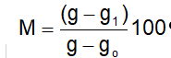
where: M - curd moisture content, %;
g - foil mass together with cottage cheese until drying, g;
g1 - foil mass together with curd after drying, g;
go - foil mass, g.
The table summarises data only for the analysed curd sample.

Study of whey separation in different conditions
Table 3.10.
Impact of milk pasteurisation regime and coagulation technique on the whey separation
Pasteurisation regime | Coagulation technique | The whey amount, ml |  |  |  |  |  |  | Retention rate (mL/h) | Total amount of whey, (mL)
Pasteurisation regime | Coagulation technique | 1 | 10 | 20 | 30 | 40 | 50 | 60 | Retention rate (mL/h) | Total amount of whey, (mL)
Sensory evaluation of cottage cheese

JAR (Just about Right) test
TRAY NO. _____________________________________
Select and write on the right-hand side of the scale the sensory properties that are specific to the cottage cheese.
Please, evaluate the sensory properties of the cottage cheese samples using the JAR (Just About Right) test.
Please, indicate your opinion about the cottage cheese samples sensory properties, marking the squared box that matches your preference and liking.
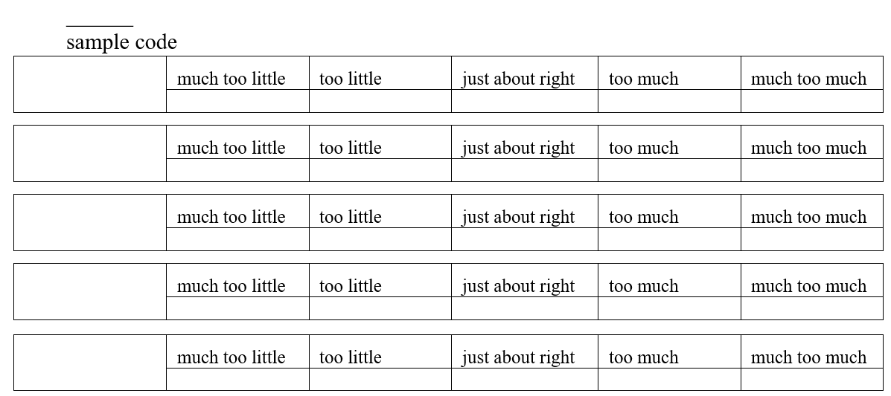
7-point Hedonic scale
TRAY NO. _____________________________________
Please evaluate the overall liking of the cottage cheese samples. Indicate how much you like or dislike each sample by checking (V or X) the appropriate phrase.
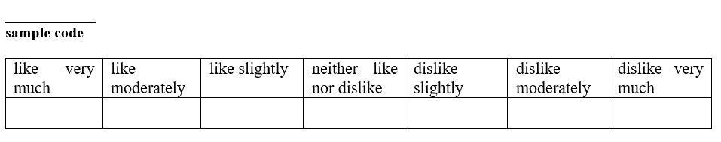
Conclusions

Approved by
(Name, surname, signature)
Date

Theme 4

Butter and ice cream: production technology and quality evaluation
Theoretical materials
Butter is a dairy product made from the churned cream, with a fat content of at least 80% and water content of no more than 16%. Butter should contain only dairy fats.
Table 4.1.

Butter and other similar products

Product | Dairy fats, % | Other fats and oils, %
Butter and other dairy products | 100 | -
Mixed fat products | 15-80 | 20-85
Margarine and other similar products | >3 | <97
Table 4.2.
Butter and other products with high fat content
Fat content, % | Names
80-95 | butter
>62-<80 | blended spread
60-62 | reduced fat butter
>41-<60 | reduced fat blended spread
39-41 | low fat butter
<39 | low fat blended spread

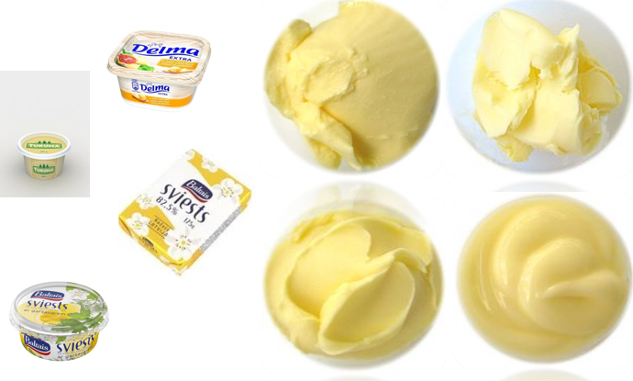
Fig. 4.1. Butter and other similar products

Table 4.3
Butter quality parameters
Parameter | Content, %
Parameter | Butter | Sour cream butter
Carbohydrates | 1.23 | 1.33
Proteins | 1.25 | 1.31
Non-fat dry matter | 2.51 | 2.66
Acid number (mg/g fats) | 1.22 | 1.77
Melting point (°C) | 24.87 | 24.37
Diacetyl (mg 100g⁻¹) | 0.35 ± 0.2 | 2.20 ± 0.4

Ice cream classification
- Ice cream made exclusively from milk products (milk, cream, butter, yogurt, whey ets.),
- Ice cream containing vegetable fat (olive, palm etc. oils),
- Sherbet ice cream made of fruit juice with added milk fat and milk solids-non-fat,
- Water ice cream made of water, sugar and fruit concentrate.

 |  | 
  ¹⁷ |   ¹⁷ | 

Fig.4.2. Types of ice creams
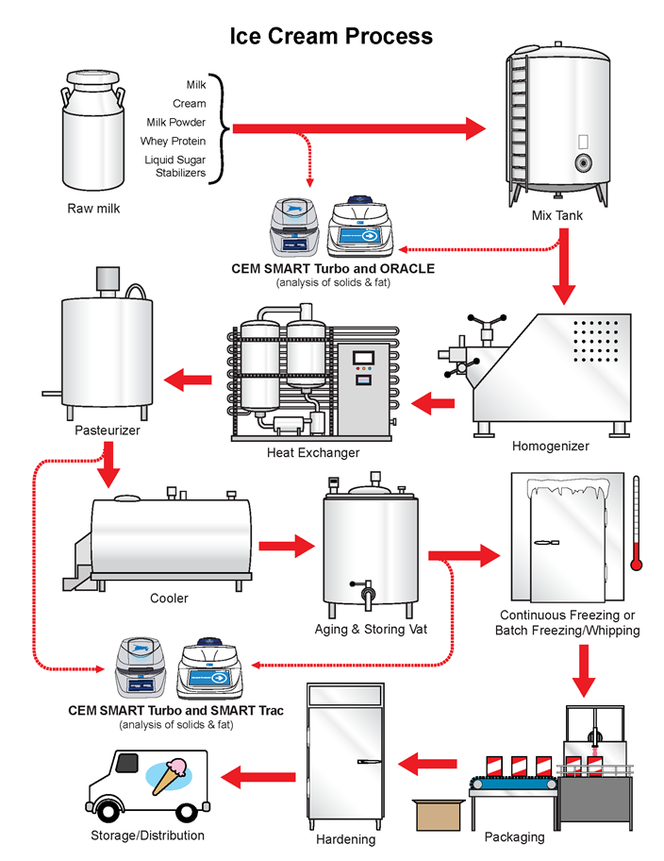
Fig.4.3. Ice cream production

Laboratory work

Butter production and butter quality control
Task1. Butter production
Procedure
Students receive pasteurised and ripened sweet cream suitable for butter production. The students evaluate the cream’s aroma and flavour, weigh the product, determine the fat content, temperature and acidity of the cream, and also analyse the weight of 100 mL cream prior to the churning process.
The cream plasma acidity is determined by calculation, knowing the cream fat content and acidity.
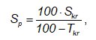
where: S_{p} – cream plasma acidity, °T;
S_{kr} – cream acidity, °T;
T_{kr} – cream fat content, %.
Pour the cream into butter churn, put on a churning lid, verify the action of the butter churn and start the churning process.
The determination of cream volume changes during churning process and obtaining butter grains
The churning process continues for 15 minutes. After 1 minute of churning, the students stop the butter churn, open the lid and take a whipped cream sample (100 mL) and weigh it. The determination of the volume changes is done until the appearance of butter grain.
The churning process is stopped when the size of butter grain is 3-5 mm and the buttermilk is well extracted. The students pour the buttermilk, weigh it and determine the fat content, acidity and temperature of the product.
Determination of the buttermilk fat content. Carefully pipette or dispense 10 mL of sulphuric acid into the butyrometer. Carefully add 10.77 mL of milk to the butyrometer by letting it to flow slowly down the glass walls.
In order to not mix with the acid, pipette or dispense 1 mL of amyl alcohol. Clean the neck of the butyrometer. Close the butyrometer tightly using a clean, dry stopper. Shake and invert the butyrometer several times until the milk has been absorbed by the acid.
Place the butyrometer in a water bath at 65-75 °C for 5 minutes. Centrifuge for 5 minutes at 1200 rpm in the Gerber centrifuge. Remove the butyrometer from the centrifuge and adjust the meniscus to obtain a reading. The sample must be 65 °C when reading the fat percentage. If the centrifuge is not adjusted to the right temperature, the butyrometer must be heated in a water bath.
Adjust the bottom meniscus to zero on the butyrometer's scale using a stopper. Read out the fat content from the low part of the upper meniscus. Read the fat content result with an accuracy of 0.05%. The amount of fat varies from 0.4-0.7%. If the fat content is higher than 0.7%, the students will also know the factors influencing butter production in the laboratory and will be able to draw conclusions about the churning process and obtain results.
Determination of buttermilk acidity
Add to a conical flask 10 mL of milk and 20 mL of deionised water, 2-3 drops 1% phenolphthalein solution in alcohol, mix well and titrate with 0.1 M NaOH until a faint pink colour persists for 30 seconds. The acidity is expressed in °Th (Thorner degree). The acidity measured according to equation:
°Th= volume of used 0.1 M NaOH (counted in mL) × 10
The changes of cream volume during churning are calculated:
where: V – changes of volume, %;
m_{kr} - 100 mL cream weight prior churning, g;
m_{kr1}- 100 mL cream weight after churning, g.
Butter grains washing and butter treatment
The Students analyse the taste and smell of the butter grains and decide whether the butter grains need to be washed. If the students detect an untypical aroma or taste, they need carry out the grain washing procedure, but if the butter grains have a pleasant taste and smell such a procedure isn't necessary. Wash the grains with pasteurised water. The water temperature must be 1-2 ºC below than analysed buttermilk temperature. If the grains are very soft and sticky, the water temperature decreases by 1-2 ºC and hold grains 5 minutes in water prior to washing. If the grains are hard, the water temperature needs to be increased by 1-2 ºC.
The washing process is as follows: add water, hold the grains for a few minutes and stir the grains with the water. Continue washing until no buttermilk is extracted and the water added is pure. After the washing, the butter grains are removed from the churn and treated with a spoon until the butter has the classical texture properties. Treat the curds until the structure of the butter is acceptable and drops of water or buttermilk can't be seen in the butter. Pack the butter, weigh it and put it in the fridge. Washing of butter churn
After the churning process, the churn needs to be washed with a cleaning solution. Carefully rinse and drain.
The students summarise the information about the churning process in the table.

Table 4.4.
Summary of butter production
No. | Indices | Parameters
1. | Cream:  amount, kg  temperature, °C  fat content, %  acidity, °T  cream plasma acidity, %  taste, smell, colour
2. | 100 mL cream weight, g
3. | The changes of cream weight during churning, g:  after 1 min  after 2 min  after 3 min  after 4 min  after 5 min
4. | The changes of cream volume during churning, %:  after 1 min  after 2 min  after 3 min  after 4 min  after 5 min
5. | Buttermilk:  amount, kg  temperature, °C  acidity, °T  fat content, %
6. | Butter outcome, kg
7. | Water dispersion
8. | Butter evaluation by score

Task 2. Butter quality analyses
Procedure
Butter sensory evaluation
Students evaluate the sensory properties of the butter produced: aroma and taste, texture and body by scores according to the dairy products’ sensory evaluation standard. Each student individually evaluates butter using a 5-point system, corresponding to explanations given in the table.
Table 4.5.
Butter evaluation by scores
Butter sample | Aroma and taste | Consistency | Texture (include also water dispersion evaluation) | Appearance
Explanations of the 5-point evaluation - see in table.
Table 4.6.
Evaluation of butter
Characteristics of evaluation | Reduction in points | Points
Excellent | 0 | 5
Good | 1 | 4
Satisfactory (small defects) | 2 | 3
Poor (conspicuous defects) | 3 | 2
Very poor (strong defects) | 4 | 1
Note: if a student evaluates the sensory attributes of the butter scoring 3 or fewer points, the student must explain the assessment in mentioned defects.

Determination of water content
Weigh the vessel and weight 10 g of sand and add 5 g of butter. Carefully mix the content of the vessel and the students put the vessel into the oven at 102 ºC for 2 hours. After 2 hours take the package from the oven, cool down and weigh it using balance. The moisture content is calculated using equation:
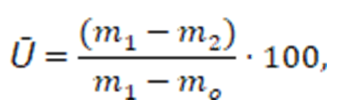
where: Ū – water content in butter, %;
mo – weight of vessel with sand, g;
m₁ – weight of vessel with sample prior to heating, g;
m2 – weight of vessel with sample after heating, g.
Determination of water dispersion
Using a sharp knife or other suitable technique, cut butter samples on two sides. Take a special indicator paper, put it on the surface of the cut butter. Take off the paper and evaluate water dispersion on 5-point system using the testing scale.
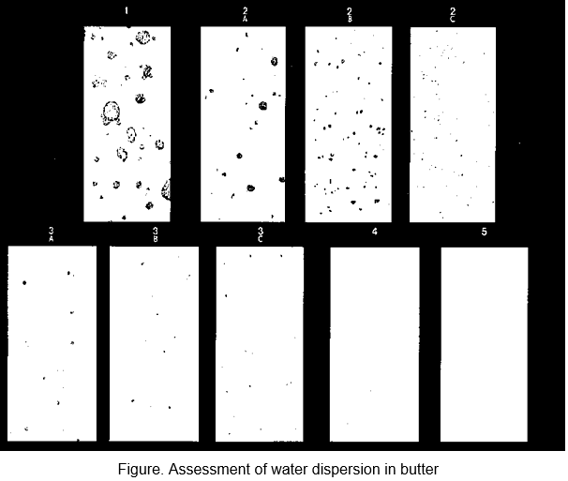
Fig.4.4. Water dispersion in butter
Determination of solids-non-fat in butter
Weigh a vessel with glass stick and filter paper. Take off the filter paper and weigh 5 g of butter into a vessel using a glass stick. Put the vessel into an oven at 102 ºC for 30 minutes. After 30 minutes take out the vessel from the oven, cool down and add 20 mL ether or petrol, using a stick carefully mix the content of the vessel and hold for 3 minutes. Pour the fat-ether or fat-petrol solution until sediment level in the vessel and repeat procedure twice. After that weigh the vessel with filter paper and the glass stick.
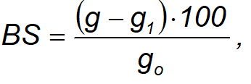
Where, BS – solids-non-fat content, %;
g – weight of vessel with sample after solvent evaporation, g;
g₁ – weight of vessel, filter paper and glass stick, g;
g_{o} – weight of butter, g.

2.5. Determination of fat content
The determination of butter fat content by a classical method (using extraction) is time consuming. In that case it is possible to make a calculation knowing the solids-non-fat and water content in butter using the following equations:
$Ts=100-(Ū+BS)$
Where, T_{s} – fat content in butter, %;
Ū – water content, %.
Determination of plasma acidity
Weigh 100 g of butter into laboratory flask. Put the flask into a water bath at 55-60 °C temperature and hold until the butter completely melts. Take out the flask from the water bath and hold for 5 minutes at the room temperature. Carefully pour the layer of melted fats and lower the layer into the butyrometer and close it with a cork. Centrifuge for 5 minutes at 1200 rpm in the Gerber centrifuge. After centrifugation put the butyrometer into the glass with cold water and hold it till fat crystallisation occurs. Open the butyrometer and pour plasma into the flask. To 100 mL flask pour 5 mL of plasma, add 2-3 drops of 1% phenolphthalein solution in alcohol and titrate 0,1 M NaOH (sodium hydroxide) up to a pale pink colour.
Acidity is expressed in °Th (Thorner degree). The acidity is counted according to equation:
°Th= volume of used 0.1 M NaOH (counted in mL) × 20
Determination of peroxidase test
Measure 3-5 mL of butter plasma into a tube and add 2-3 mL of deionised water and 5 drops of KJ and 5 drops of 0.5% H₂O₂. Shake the tube and examine the colour of the tube. If the colour of the tube doesn’t change, the sample is free from peroxidase. If the sample dyes dark blue to black, the sample contains peroxidase.
Conclusions

Approved by
(Name, surname, signature)
Date

Laboratory work

Ice cream preparation
Materials. Ice cream mixes were produced from the following ingredients: cream, condensed milk, sugar, milk and water.
Preparation of ice cream
The proportions of the main ingredients in the ice cream samples are according to table 4.7.
In the ice cream preparation, first, dry components were weighed and mixed, then liquid and dry components were combined into an ice cream mix. The obtained mix was pasteurised at 85 °C for 20 ± 5 seconds, then cooled down and maturated for 8 hours at 5 ± 1 °C. The main technological operation – freezing, when the ice cream mix was being frozen and whipped at the same time, the ice cream machine Taylor model 142 (Taylor, USA) at –8 ± 2 °C was used. Then the ice cream was placed into plastic containers (500 mL). The ice-cream was hardened at –20 ± 2 °C for 6 hours.
Table 4.7.
Recipe of ice creams
Raw materials | Calculation for 1 kg of ice cream
Raw materials | Cream ice cream | Premium | Milk | Aromatised
Milk with fat content 3.2% | 500 | 450 | 730 | 500
Cream 40% | 189 | 250 | 29.1 | 30
Butter | - | 43.2 | - | -
Condensed milk/milk powder* | 219 | 56.0* | 48.6* | 49.6*
Stabiliser | 3.0 | 3.0 | 3.0 | 15.0
Sugar | 49 | 155 | 150 | 15.3
Jam |  |  |  | 223.5
Water | 40.00 | 42.8 | 39.3 | 146
Total | 1000 | 1000 | 1000 | 1000

Table 4.8.
Calculations of ice cream formulation
Raw materials | Calculation for 1 kg of ice cream
Raw materials | g
Raw materials | Amount | Fats | Non-fat solids | Sugars | Solids
Milk with fat content of 3.2%, non-fat solids 8.00% | 500
Cream 40%, non-fat solids, 5.6% | 189
Condensed milk/milk powder* | 219
Stabiliser | 3.0
Sugar | 49
Water | 40.00
Total | 1000
Conclusions:

Approved by
(Name, surname, signature)
Date
Packaging materials, equipment and principles for dairy products (liquid and paste)
As you can see, the range of dairy products is wide and the packages are different. Therefore, different packaging materials and different packaging technologies are used in their packaging.
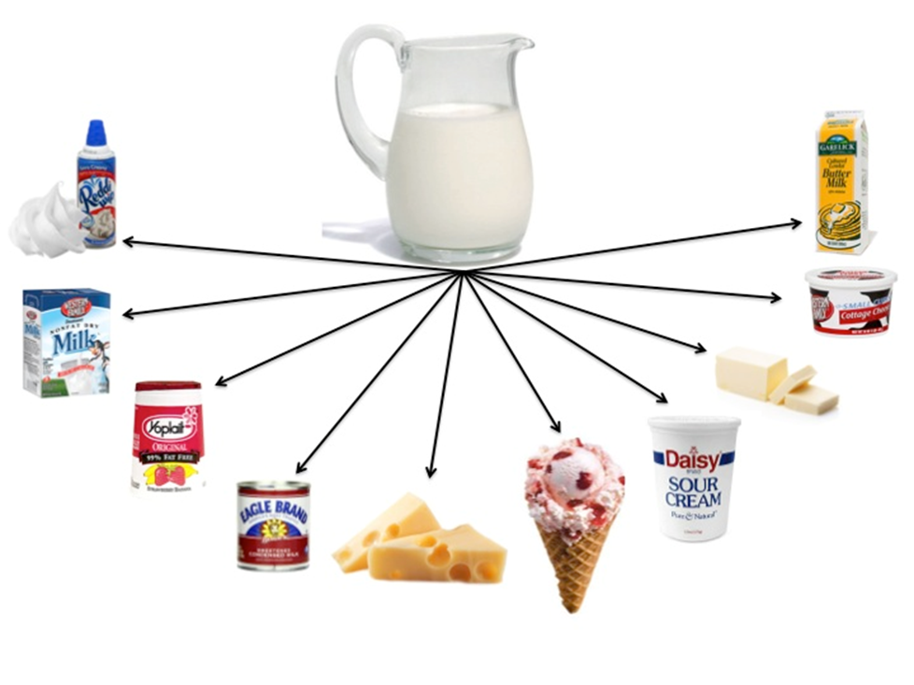
Fig. 4.5. Products produced from milk
https://newmexico.agclassroom.org/matrix/lesson/print/246/
Both single-layer and multi-layer packaging materials are used for packaging. If it is necessary to extend the shelf life, then multilayer packaging materials with high gas barrier properties are used, which allows products to be packed in vacuum (VP) and modified atmosphere packaging (MAP).

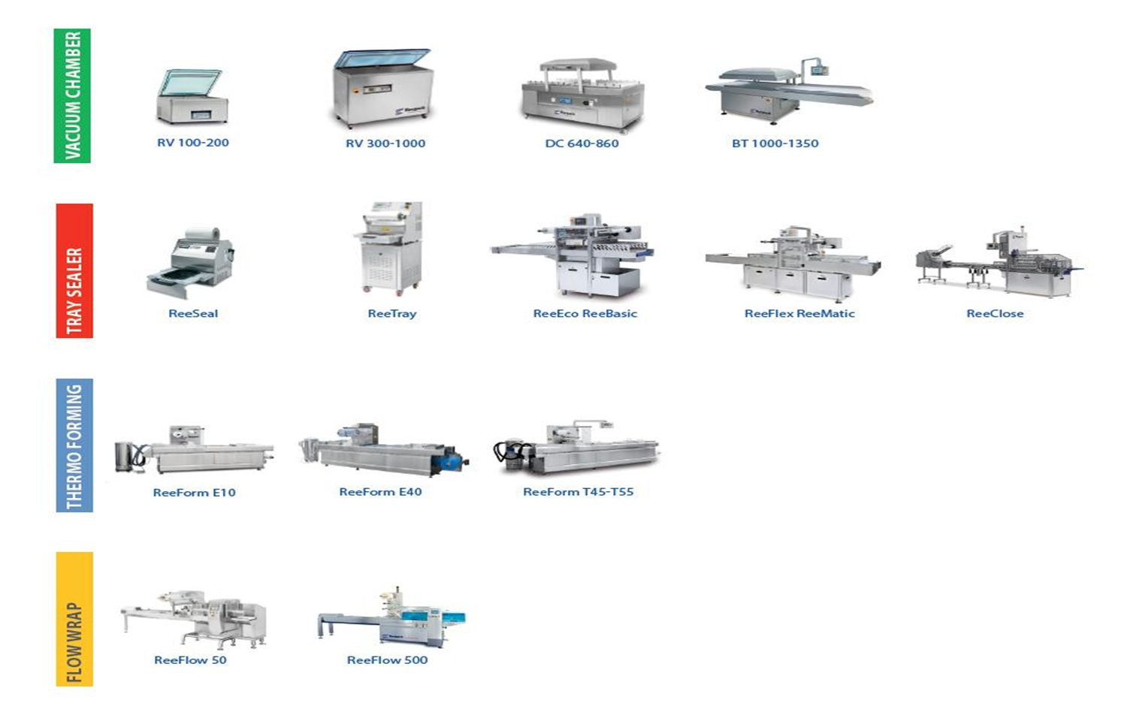
Fig. 4.6. The most typical packaging equipment used for products
https://gpnuy.com/project/tffs-spapor-bassa/
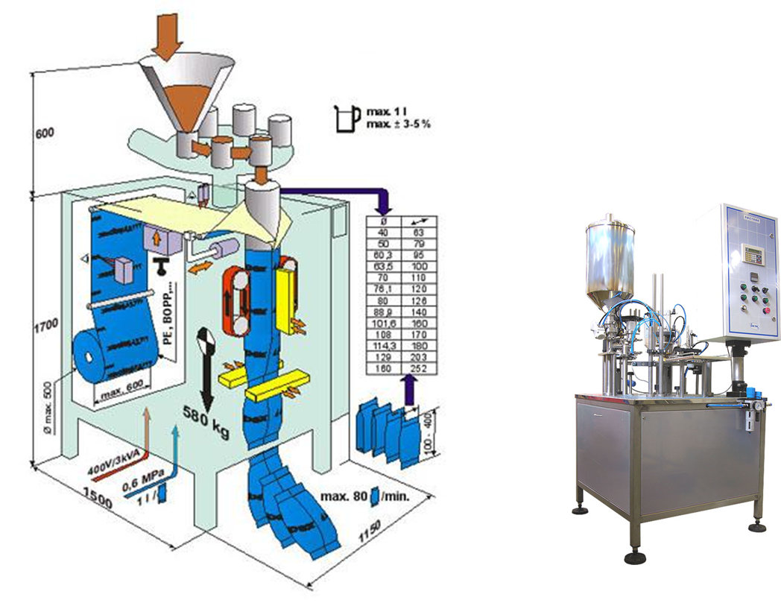
Fig. 4.7. The most typical packaging equipment used for products https://www.triapex.cz/en/packaging-machines/hv4-14
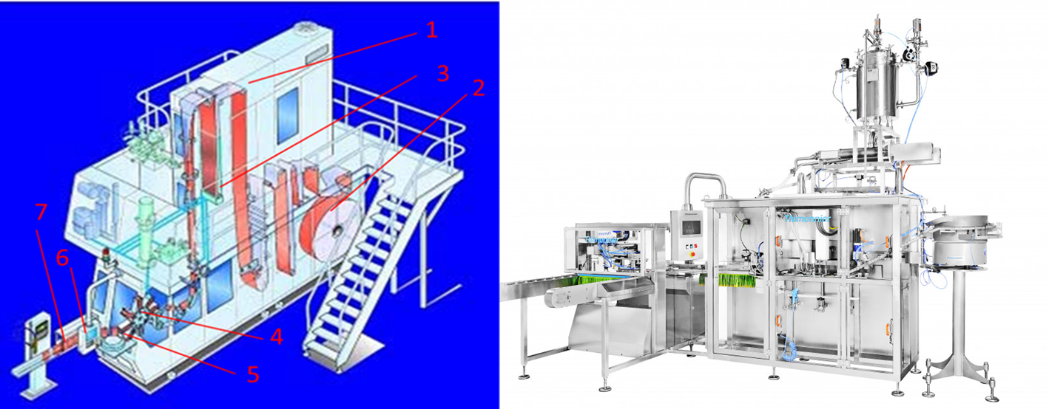
Fig. 4.8. The most typical packaging equipment used for products
https://www.researchgate.net/publication/228611726_Towards_Object-Oriented_Modeling_of_Complex_Mechatronic_Systems_for_the_Manufacturing_Industry/figures?lo=1 https://fud-tech.eu/portfolio-items/stavpaku-doypack-pouch-pilditaji/
Chamber type machines and tray sealers are usually used by smaller production companies, while flow-wrap and flow-packs (horizontal and vertical) as well as thermoforming machines are usually used by larger capacity companies because of the high output of these machines.
All packaging equipment and technologies have their pros and cons, therefore, when choosing equipment, some aspects should be evaluated.

PRACTICAL WORK
Selection and machinery of packaging materials for products
The aim of the workshop is to analyse the packaging as an added value to the product, because the packaging often plays an important role in the choice of a product. The group of students is divided into teams, and each team analyses products packaged using different packaging solutions, paying significant attention to packaging design.
Materials
In the seminar, we’ll use either different prototypes of packaged products or photos found on Internet with different packaged products. Each group of students will analyses three different packages. And the characteristics are given in table 4.9.
Procedures and Results
The results obtained should be reflected in table 4.9.
Table 4.9.
Characteristic parameters | Samples
Characteristic parameters | Product No. 1 | Product No. 2 | Product No. 3
Packaging material
Packaging shape
What information is printed on the package?
Does the packaging contain information about the recyclability of the packaging?
What can be done to make the packaging more attractive?
Are there any flaws or gaps in the information printed on the package? If so, which ones?

Conclusions:
After completing the table, different groups of students compare the results. If possible, each group presents and justifies its performance.
During the workshop, students acquire skills in characterising packages and analysing situations, as well as experience of working in groups.

Approved by
(Name, surname, signature)
Date

Theme 5

Cheese: classification, production technology and quality assessment
Theoretical materials
Cheese classification criteria
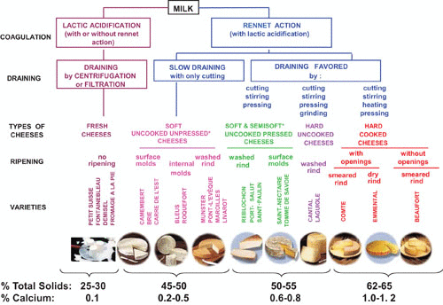
Fig. 5.1. Cheese classification criteria
https://journals.asm.org/doi/10.1128/microbiolspec.cm-0003-2012

Table 5.1.
Cheese classification according to fat and moisture content
Moisture content, % | Name | Fat content in dry basis, % | Name
< 41 | Extra hard | > 60 | High fat
49 – 56 | Hard | 45 – 60 | Full fat
54 – 63 | Semi-hard | 25 – 45 | Medium fat
61-69 | Semi-soft | 10-25 | Low fat
>67 | Soft | <10 | Skim
Cheese production technology
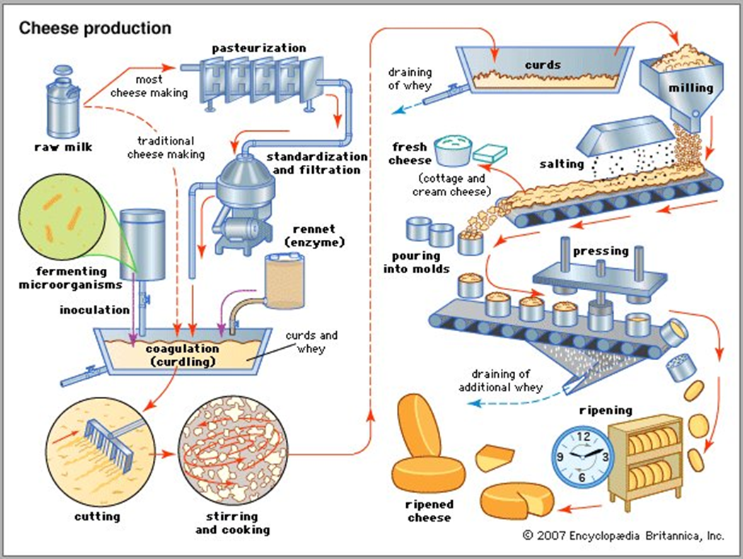
Fig. 5.2. Cheese production technology https://www.britannica.com/topic/cheese-making

Laboratory work Acid cheese production
Materials
Raw milk, rennet, CaCl2, starter, citric acid, etc.
Janu cheese
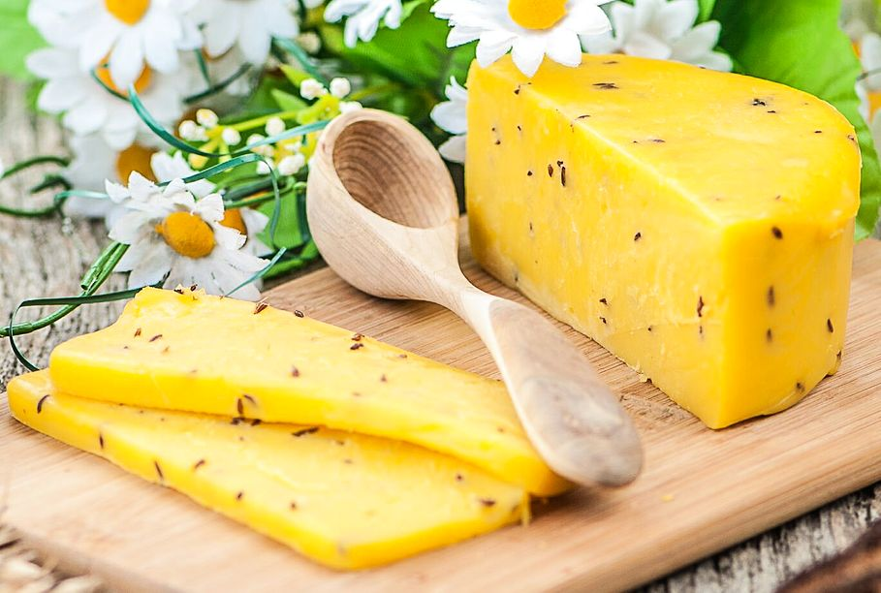
Fig. 5.3. Janu cheese
https://www.lsm.lv/raksts/dzive--stils/vecaki-un-berni/22.06.2023-klasiska-janu-siera-recepte-laiks-izmeginat.a282512/
Table 5.2.
Necessary ingredients for Janu cheese
Product | Amount | Unit
Milk | 4 | kg
Cottage cheese | 1 | kg
Eggs | 4 | pieces
Butter | 0.2 | kg
Salt | 1.2 | g
Cumin | 20 | g
Heat milk to 80 °C while continuously mixing it, then add cottage cheese, continue heating and mixing until the temperature reaches 80-85 °C, while green and clear whey are arising. The cheese mass with whey should be put into a pot with applied filter material, as a result the cheese mass and whey should be divided. The cheese mass is put into the pot where butter is melted. Then put whipped eggs, salt and cumin (which should be poured with hot water). The mass should be heated and intensively mixed till it is homogeneous and viscous. Then the hot mass should be put into a form and weighted down. The prepared cheese should be sensory evaluated (taste, flavour, consistency, aroma).
Dessert cheese
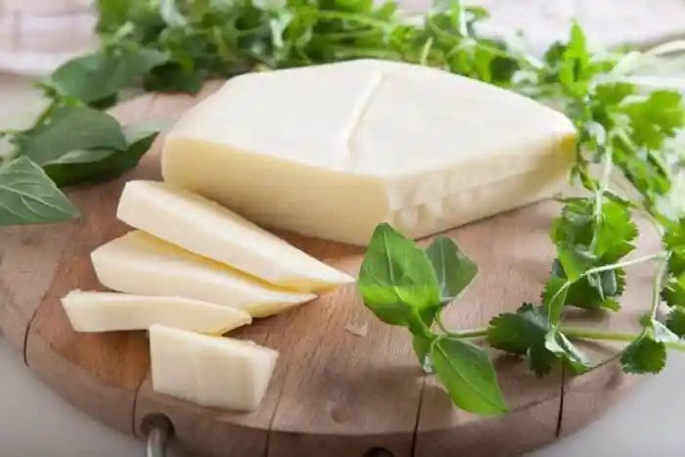
Fig. 5.4. Dessert cheese
https://fondeco.ru/lv/chto-prigotovit-iz-suluguni-bystro-chto-prigotovit-s-syrom/
Table 5.3.
Necessary ingredients for dessert cheese
Product | Amount | Unit
Milk | 2 | kg
Lemon | 4 | pieces

Heat milk to 80 °C while continuously mixing it, then add juice of 4 lemons - add it very carefully in small amounts, continue heating and mixing till the green and clear whey are arising. The cheese mass with whey should be put into the pot with applied filter material, as a result the cheese mass and whey should be divided, but don’t press on it. After 40 minutes, the cheese mass should be put into a form and weighted down. The prepared cheese should be sensory evaluated (taste, flavour, consistency, aroma).

Students’ cheese
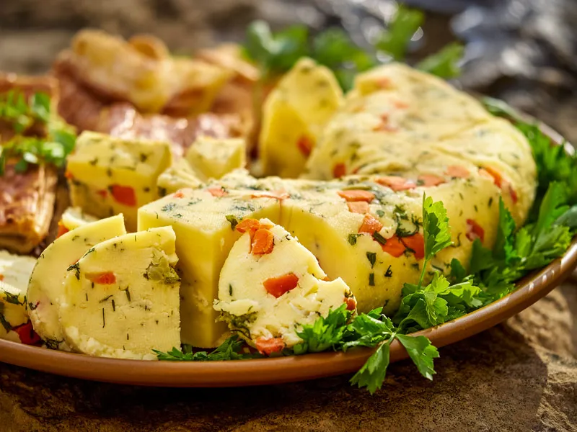
Fig. 5.5. Students’ cheese
https://www.garsigalatvija.lv/page/25/?attachment_id
Table 5.4.
Necessary ingredients for Students’ cheese
Product | Amount | Unit
Milk | 2 | kg
Vinegar | 10 | mL
Heat milk to 80 °C while continuously mixing it, then add vinegar (~10 mL), add it very carefully in small amounts, continue heating and mixing till the green and clear whey are arising. The cheese mass with whey should be put into the pot with applied filter material, as a result the cheese mass and whey should separate, don’t press on it. After 40 minutes, the cheese mass should be put into a form and weighted down.

Soft cheese
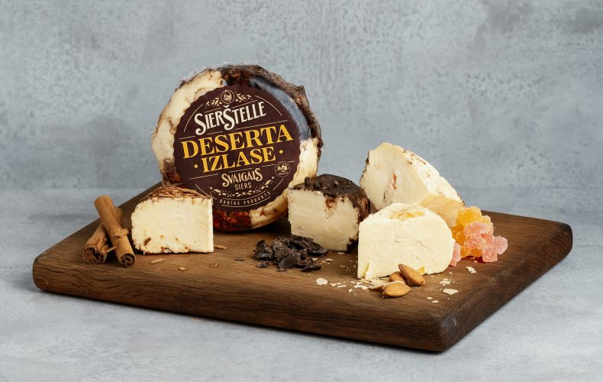
Fig. 5.6. Soft cheese
https://skolenuekskursijas.lv/apskates-vieta/siera-razotne-sierstelle/
Table 5.5.
Necessary ingredients for soft cheese
Product | Amount | Unit
Milk | 2 | kg
Sour cream | 500 | mL
Heat milk to 80 °C while continuously mixing it, then add sour cream - add it very carefully in small amounts, continue heating and mixing till the green and clear whey are arising. The cheese mass with whey should be put into the pot with applied filter material, as a result the cheese mass and whey should separate, don’t press on it. After 40 minutes, the cheese mass should be put into a form and weighted down.
Conclusions

Approved by
(Name, surname, signature)
Date

Laboratory work

Effect of different factors on milk clotting time
1. The influence of pH
Into 4 beakers, pour 50 mL of milk and add a different amount of 0,1 M H₂SO₄: 0; 1.0; 1.5; 2.0 mL; determine the pH and heat the samples in the water bath to 35 ºC. Reaching the temperature, add 1 mL of 1% rennet solution to each beaker. Stir the content of the beaker gently for around 30 seconds and leave it to coagulate. Students measure the time necessary for the coagulation of the milk. The results are summarised in the table and the data are illustrated in a chart, too.
Table 5.6
The influence of pH on milk coagulation
Amount of 0,1 M H₂SO₄, mL | pH | Coagulation time, min
0
1
1.5
2

2. The influence of renneting temperature
Into 3 beakers pour 50 mL of milk and heat to 25, 35, 50 ºC. Reaching the temperature, add 1 mL of 1% rennet solution to each beaker. Stir the content of the beaker gently for around 30 seconds and leave it to coagulate. Students measure the time necessary for the coagulation of the milk.
Results are summarised in the table and data are illustrated in a chart, too.
Table 5.7.
The influence of renneting temperature on coagulation time
Temperature, ºC | Coagulation time, min
25
35
50

3. The influence of calcium concentration
Into 4 beakers pour 50 mL of milk and add a different amount of 5% CaCl₂ solution - 0; 0.1; 0.2; 0.3 mL, which corresponds to CaCl₂ concentration - 0; 10; 20; 30 g/100 l of milk.
Heat the samples in the water bath to 35 ºC. Reaching the temperature, 1 mL of 1% rennet solution is added to each beaker. Stir the content of the beaker gently for around 30 seconds and leave to coagulate. Students measure the time necessary for the milk coagulation. The results are summarised in the table and the data are illustrated in a chart too.
Table 5.8.
The influence of the amount of calcium chloride on coagulation time
CaCl₂, g/100 l milk | Coagulation time, min.
0
10
20
30
4. The influence of pasteurisation temperature
Without CaCl₂ addition
Into 3 beakers pour 50 mL milk. Each sample heats in the water bath to different temperatures: 72 ºC, 80 ºC and 90 ºC. Reaching the temperature, hold samples for around 15 seconds. After pasteurisation, the samples cool down to renneting temperature (35 ºC) and 1 mL of 1% rennet solution is added to each beaker. Stir the of content of the beaker gently for around 30 seconds and leave to coagulate at 35 ºC. Students measure the time necessary for the milk to coagulate.
The obtained results are summarised in the table and the data are illustrated in a chart, too.
With CaCl₂ addition
Into 3 beakers pour 50 mL of milk. Each sample is heated in the water bath to different temperatures: 72 ºC, 80 ºC and 90 ºC. Reaching the temperature, hold the samples for around 15 seconds. After pasteurisation, the samples cool down to renneting temperature (35 ºC) and 0.2 mL of 5% CaCl₂ solution and 1 mL of 1% rennet solution is added to each beaker. Stir the content of the beaker gently for around 30 seconds and leave to coagulate at 35 ºC. Students measure the time necessary for the milk to coagulate.
The obtained results are summarised in the table and the data are illustrated in a chart, too.
Table 5.9.
The influence of pasteurisation temperature on milk renneting
Pasteurisation | Renneting time, min.
temperature, ºC | Without CaCl₂ | With CaCl₂
72 ºC 15 s.
80 ºC 15 s.
90 ºC 15 s.
unpasteurised milk
Students collect results from all examinations and make conclusions about the influence of the pH, the amount of calcium chloride, the renneting temperature, and the pasteurisation temperature on coagulation time.
Conclusions

Approved by
(Name, surname, signature)
Date

Laboratory work

Semi – hard cheese production
Holandes cheese is the main representative of the class of semi - hard cheeses in the Baltic States and can be characterised by:
- the use of fresh pasteurised cow’s milk, the milk normally being partly skimmed;
- milk clotting by means of rennet;
- the use of, preferably, mixed – strain starters consisting of mesophilic lactococci
- and usually leuconostics that generally produce CO₂;
- water content in the fat – free cheese below 63%;
- pressing the cheese to obtain a closed rind;
- acidification mainly in the curd block after separation of the whey during pressing, holding and the first hours of bringing;
- salting after pressing, usually in brine;
- absence of an essential surface flora;
- being at least somewhat matured (for 4 weeks) and thus undergone significant proteolysis.
Consequently, the cheese normally has a semi - hard consistency and a smooth texture, usually with small holes; the flavour intensity varies widely. After prolonged natural ripening, the consistency will be hard and the formation of amino acid crystals is common.
Procedure
Students receive pasteurised and ripened milk suitable for cheese production. The milk should be weighed and the acidity of milk should be detected. Pour 45 kg of milk into the cheese vat, stirring it constantly for even heat distribution.
The milk should be heated to 32 °C, then mixed – the starter culture should be added (the amount of the starter should be previously calculated taking into account the activity units of the starter). The starter should be dissolved in 100 mL of milk.
Then 40 % CaCl₂ should be added approximately 30 minutes before adding the rennet (coagulant), 30-40 g of dry CaCl₂ for 100 kg of milk. After adding the CaCl₂ solution, the milk should be well mixed.
Before coagulant/rennet is added, the milk acidity should be detected - it should be 19-20°T. For coagulation as dry as liquid rennet can be used, the amount of rennet depends on the rennet activity units. Rennet should be mixed with 50 ml of deionised water.
A good quality coagulum has been formed at 32-33 °C temperature after, 20-30 minutes. Renneting should be stopped when the rennet is firm, elastic, and the whey is clear. Cut the llot with special horizontal and vertical knives, continue stirring slowly. Cubes of 4-6 mm size should be formed during this process. Immediately after cutting, the curd grains are very sensitive to mechanical treatment, for this reason the stirring has to be gentle. It must, however, be fast enough to keep the grains suspended in the whey. Sedimentation of the curd in the bottom of the vat causes the formation of lumps. This puts a strain on the stirring mechanism, which must be very strong. The curd of low-fat cheese has a strong tendency to sink to the bottom of the vat, which means that the stirring must be more intense than for the curd with high fat content. Lumps may influence the texture of the cheese as well as cause loss of casein in the whey.
The acidity of the whey should be detected. The grain formation time is 10-15 minutes.
After grain formation, 30-40% of the whey should be released from the cheese vat and continue to process the cheese grains for 20-35 minutes. The whey acidity, after clot cutting, should be 12-13°T, before the second heating - 13-15°T. The acidity of whey cannot decrease more than 2 °T from the clot cutting and the second heating time period. If the acidity of the milk increases more, the second heating should be shorter and 10-15% of 65-70 °C deionised water should be added to the cheese grains.
The acidity of whey should be detected before the second heating. The second heating regimes are 40 °C temperature and 10-15 minutes. To improve the cheese structure and increase in the water content, a salt solution (15%) could be added, previously discharge vat for 20-30% of the whey.
The grains should be mixed for 5-30 minutes. Normal grains are elastic. The total duration time of the curd and cheese grains processing is 60-70 minutes.
As soon as the required acidity and firmness of the curd have been attained – and checked by the producer – the residual whey is removed from the curd in various ways depending on the type of the cheese.
The curd was collected in cheese cloths while still in the whey and then transferred to a large mould on a special drainage material and pressed by weight of 1 kg per 1 kg of cheese. When the cheese is pressed, the whey is drained off. The cheese should be pressed for 15-20 minutes. At the end of pressing, the pressure should be increased to 4 kg per 1 kg of cheese. The amount of whey should be weighed.
The cheese is then placed into special equipment and pressed for 5-10 minutes. The cheese should be pressed for 90 minutes (45 min for one part, 45 for the other) with pressure of 20-30 kg per 1 kg of cheese.
Weigh the cheese and put into the refrigerator in brain (20-22%) for 24 hours. Following it, leave the cheese for 48-64 hours in a refrigerator, then it should be treated with disinfectant and packaged. The cheese should be ripened for 2 weeks at 10-12 °C.
All results should be summarised in the table 5.19.

Table 5.19.
The main parameters of cheese technological process
Title | Characteristic
Pasteurised milk
amount, kg
acidity, ºT
Starter
amount, g/100 kg milk
Added to milk
CaCl₂, g/100 kg milk
Coagulant/rennet, g/100 kg milk
Renneting/Clot formation
Acidity before renneting, ºT
temperature, ºC
time, min
Clot and cheese grain processing
Clot cutting and cheese making time, min
Cheese grain processing before second heating, min
Whey
Acidity after clot cutting, ºT
Acidity before second heating, ºT
Acidity after second heating, ºT
Fat content (after second heating), %
amount, kg, % from milk amount
Second heating
temperature, ºC
time, min
amount of added water, kg
Grain processing time after second heating, min
Salt amount added to grains, g/100 kg milk
Cheese formation time, min
Cheese pressing time, min
Brining/salting
brine concentration, %
temperature, ºC
time, h
Cheese after salting/brining
amount, kg
Yield of cheese
kg milk/ kg cheese after pressing
Losses, kg, %
Laboratory work
Evaluation of cheese quality
1. Chemical composition of cheese
Detection of fat content
Add 10 mL sulphuric acid (ρ-1.50-1.55 kg m⁻³) to the milk butyrometer, then add 2 g of grated cheese followed by 10 mL of sulphuric acid (ρ-1.50-1.55 kg m⁻³). Avoid wetting the neck of the butyrometer.
Next, add 1 mL of Amyl alcohol, insert a stopper and shake the butyrometer carefully until the cheese dissolves and no white particles can be seen. Place the butyrometer in the water bath at 70 ºC and keep it there for ~1 hour until the cheese parts are dissolved. The butyrometer must be placed in the centrifuge with the stem (scale) pointing towards the centre of the centrifuge.
Spin for 5 min 1000 turnaround min⁻¹. Remove the butyrometers from the centrifuge. Put the butyrometers in a water bath maintained at 75 ºC for 5 minutes. before taking the reading. (Note: When transferring the butyrometers from the centrifuge into the water bath, make sure that the butyrometers are all the time held with the NECK POINTING UP).
The fat column should be read from the lowest point of the meniscus of the interface of the acid-fat to the 0-mark of the scale and read the butterfat percentage.
The butyrometers should be emptied into a special container for the very corrosive liquid of acid-milk, and the butyrometers should be washed in warm water and dried before the next use.
The fat content should be calculated according to the following equitation:
$T= \frac{X ×11}{m}$
where: T – fat content in cheese, %;
X – reading of the butyrometer, %;
M – cheese weight, g;
11 – coefficient
The fat content in the cheese dry matter should be calculated according to the following equitation:
$Ts= \frac{T ×100}{100-W}$

where: T_{s} – fat content in dry matter;
W- water content in cheese, %.
Detection of moisture content
Weigh a 100*100 mm foil, then weigh 4 g of grated cheese (with an accuracy of 0.01 g), close with one foil and return the 10 mm edges, then, for smooth sample dispersion, press the cheese, then open the package and put it in the oven at 130 °C, after 40 min take out the package and put it into the desiccator.
The water content should be calculated according to the following equitation:
$W= \frac{g-g1}{g-g0} ×100$
where: w – water content in cheese, %;
g – mass of foil and cheese before drying, g;
g₁ mass of foil and cheese after drying, g;
g₀ – mass of foil, g.
2 Sensory evaluations of cheese
Sensory evaluation of cheese
In each evaluation group - 4-5 experts; for each group - 4-5 cheese samples (one or two producers and differently prepared, for example sliced, and cubed). The cheese samples removed from original packaging and placed in transparent zip bags. Each sample is coded with three randomised numbers.
Table 5.20.
Cheese sensory evaluation table 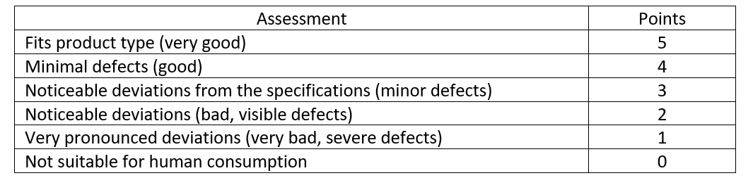
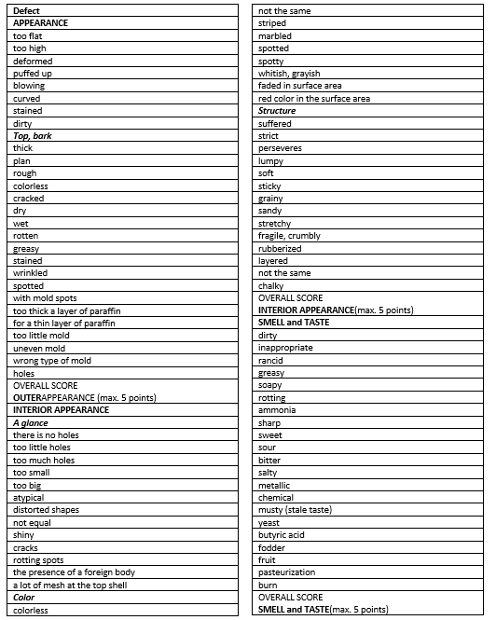
COMMON ASSESSMENT 14-15 – very good quality 11-13 – good quality 9-10 – average quality less than 8 – inadequate quality

Please, evaluate given cheese samples and fill each expert group Table 5.21.
Table 5.21.
Cheese sensory evaluation summary
Sample code | Appearance | Interior appearance | Smell and taste | TOTAL

Conclusions

Approved by
(Name, surname, signature)
Date
Practical work
Packing, types, materials, equipment of preserved butter, cheese and milk
Multi-layer packaging materials are used for cheese packaging. If it is necessary to extend the shelf life, then multilayer packaging materials with high gas barrier properties are used, which allows products to be packed in vacuum (VP) and modified atmosphere packaging (MAP).
Three packaging technologies are mainly used for dairy products packaging: air, vacuum and MAP packaging. When packing products in an air environment, the packaging materials do not have specific characteristics. When packing in vacuum or MAP, it is important that the packaging materials have high gas barrier properties. Multi-layer films. Practically all the other films used for dairy products packaging are designed as strong oxygen and water-vapour barriers. In order to fully achieve these requirements, films with good barrier properties for oxygen and water vapour respectively are combined.
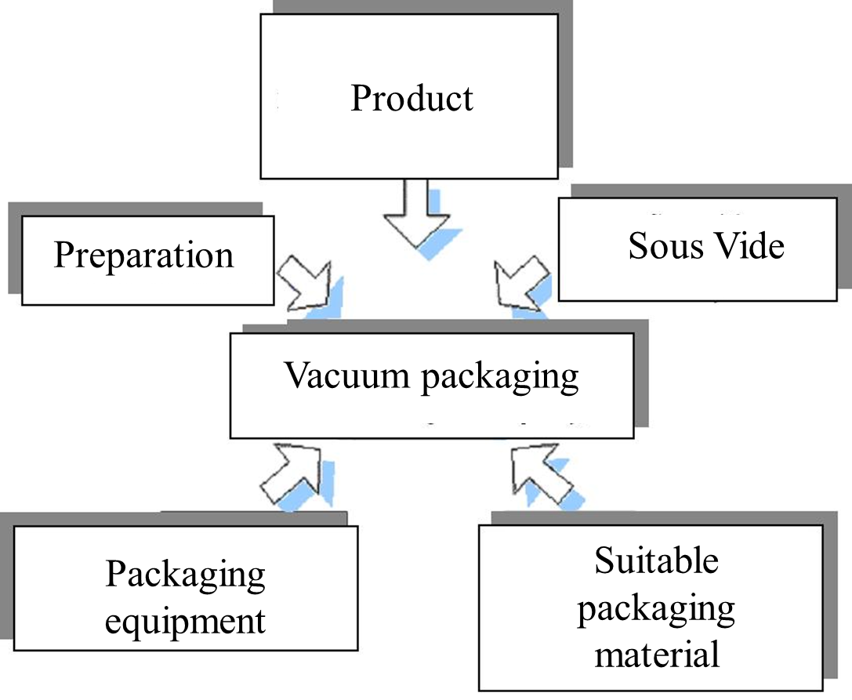
Fig. 5.7. The vacuum packaging process was influenced by these aspects
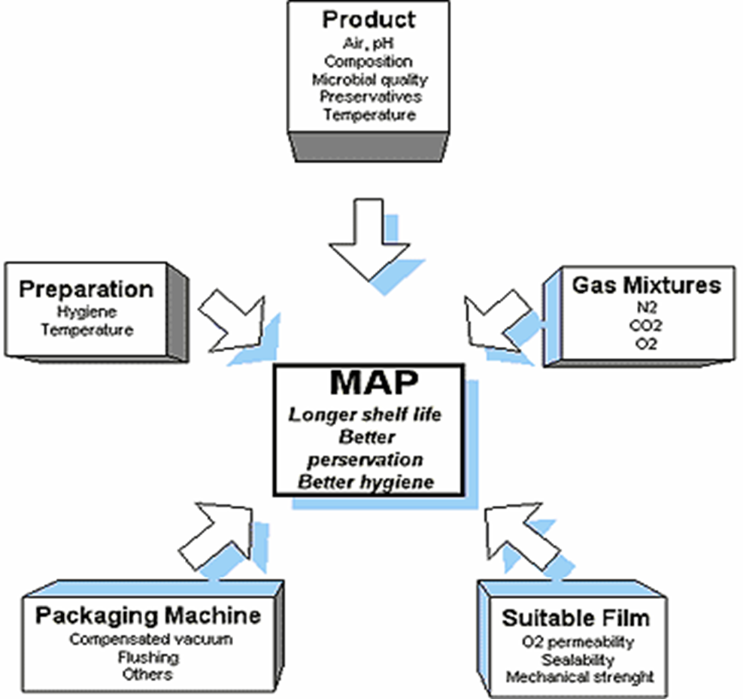
Fig. 5.8. MAP process was influenced by these aspects

Fig.5.9. The most typical packaging equipment used for products
Chamber type machines and tray sealers are usually used by smaller production companies, while flow-rap and flow-packs (horizontal and vertical) as well as thermoforming machines are usually used by larger capacity companies because of the high output of these machines.
All packaging equipment and technologies have their pros and cons, therefore, when choosing equipment, some aspects should be evaluated.
PRACTICAL WORK (package)
The aim of the work is to learn skills in cheese packaging using different packaging technologies (packaging in air, vacuum, modified gas composition (MAP)) with different packaging equipment using various packaging equipment (simple sealer and chamber-type vacuum packaging equipment etc.). Experiments with different vacuum depths were carried out during vacuum packing. The group of students is divided into teams and each team packs products using different solutions.
Materials
Products prepared in previous experiments or raw materials purchased at the discretion of the teacher.
Pulsed simple hermetically sealing equipment. Ready-made pillow packages made of multi-layer packaging material with high barrier properties.
Procedures and Results
The results obtained in the experiments should be reflected in table 5.22.
Table 5.22.
Parameters | packaging in AIR | packaging in vacuum | packaging in MAP
Characteristics of the multi-layer packaging material
Which packaging solution is more suitable for packaging? Describe why?
How well the sealing went (excellent, good, bad)
What is this shape of packaging?
What is the sealing time (sec.) and temperature of the package?
Is it possible to close the package non-hermetically? Will it affect the expiration date?
How eco-friendly is the chosen packaging? How sustainable is the chosen packaging?

Conclusions
After packaging the products, different groups of students compare the results. If possible, each group packs 5 packages of each type, and then observes and determines the quality of the products during storage over the course of the study.
During practical operation, students learned the skills of working with packaging equipment and packaging technologies.

Approved by
(Name, surname, signature)
Date

Theme 6

Milk products with long shelf life
Theoretical materials
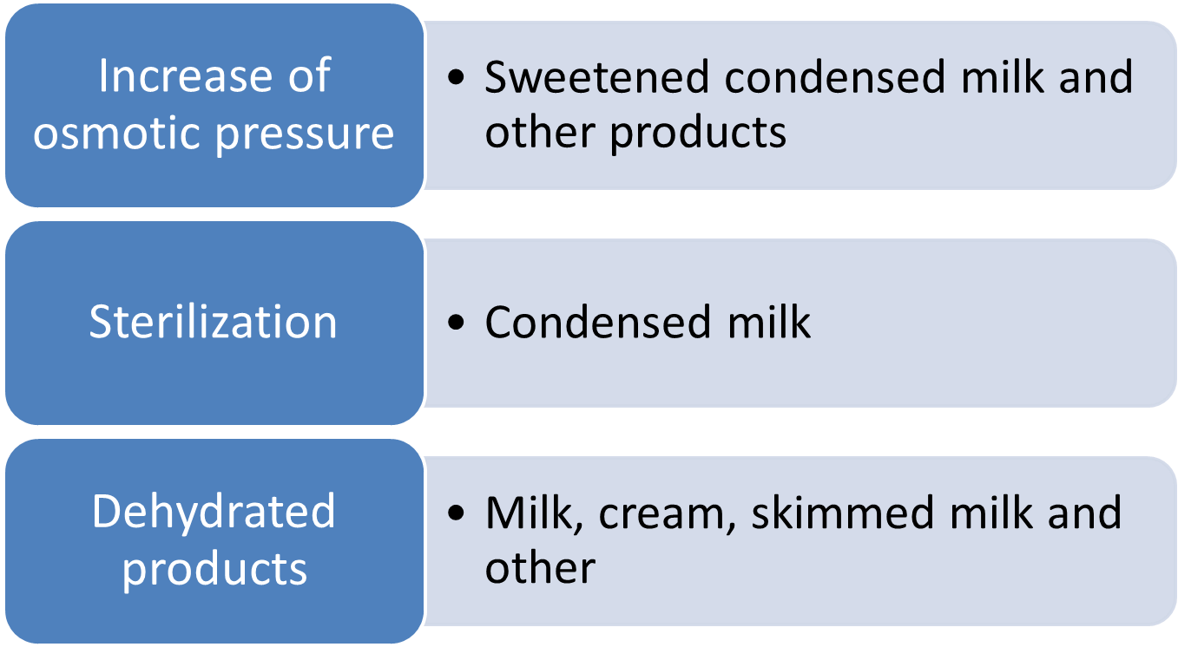
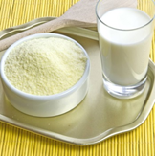
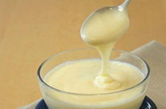 | 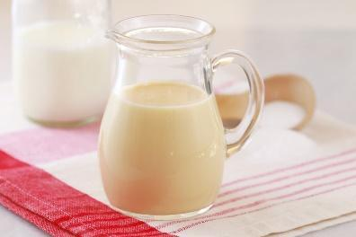
Fig. 6.1. Characteristics of dry dairy products
https://www.thespruceeats.com/homemade-condensed-milk-521028
https://www.biggerbolderbaking.com/how-to-make-condensed-milk/
https://konsonet.eu/milk-powder-full-cream-26-fat-25-protein/

Table 6.1.
Characteristics of milk powder
Parameters | Value
Parameters | Milk (spray drying) |  | Skimmed milk
Parameters | 1 | 2 | Milk (spray drying) |  | Roller drying
Parameters | 1 | 2 | 1 | 2 | 2
Max water, % | 4.0 | 4.0 | 4.0 | 5.0 | 5.0
Fat content, % | min. 25.0 | min. 25.0 | max 1.5 | max 1.5 | max 1.5
Min. protein content, % | - | - | 32.0 | - | -
Min. lactose content, % | - | - | 50.00 | - | -
Max solubility, cm³
premium | 0.2 | 0.3 | 0.2 | 0.4 | 1.5
1st class | - | 0.4 | - | - | -
Max acidity, °T | 20 | 21 | 20 | 21 | 21

Table 6.2.
Different dehydrated dairy products
cream | milk | skimmed milk | whey | whey proteins | lactose
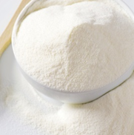 | 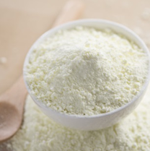 | 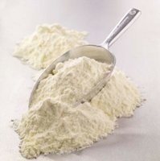 | 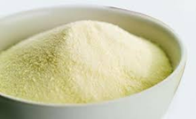 | 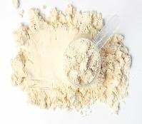 | 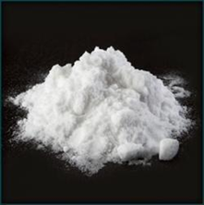
https://www.adpi.org/ingredient-resource-center/cream-powder/
https://www.21food.com/products/skimmed-milk-powder-instant-fu-2199460.html
https://thewholesaler.in/products/milk-powder-skimmed-milk
https://www.food-safety.com/articles/6184-whey-powder-and-food-safety-risks-a-lesson-in-validation-and-verification
https://lifespa.com/health-topics/immune-support/the-benefits-of-undenatured-whey-protein-powder/
https://www.indiamart.com/proddetail/lactose-monohydrate-200-mesh-26216665112.html

Practical works

Equipment for the production of dry and canned milk
The aim of the work is to gain knowledge about milk products with long shelf life equipment. Compare the equipment used for the production of different types of products. The group of students is divided into teams, and each team analyses the set of equipment necessary for the production of specific milk products with long shelf life, and then presents it to the other groups.

Materials
Students, considering the information according to the production technology of milk products with long shelf life, try to find the equipment to achieve the required result. The students give a brief explanation of what each selected device provides.

Procedures and Results
As a result, it is necessary to draw a diagram (or assemble a diagram from equipment stencils, if such have been prepared) in order to create different production lines of milk products with long shelf life.
For example the following:
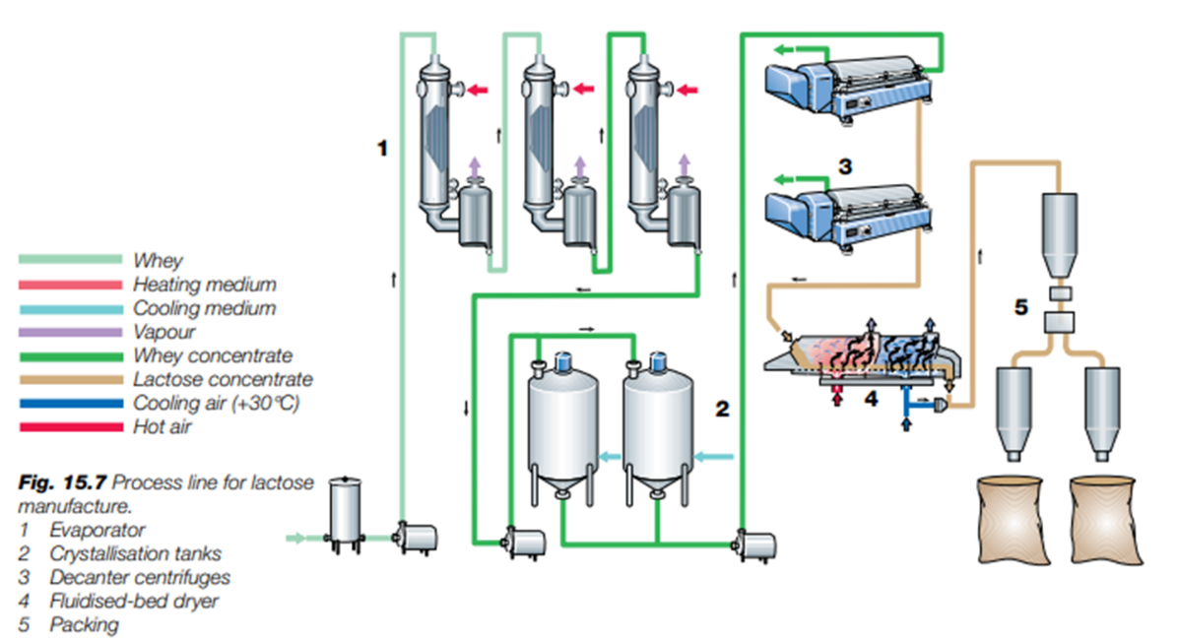¹³

OR

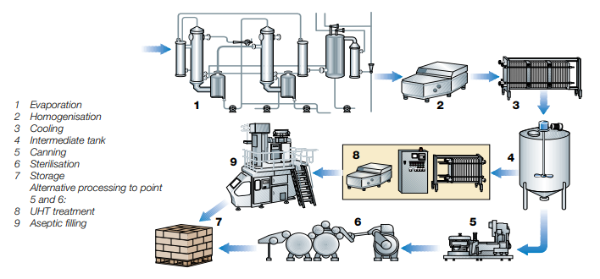¹³
Figure. Process line for unsweetened condensed milk

OR
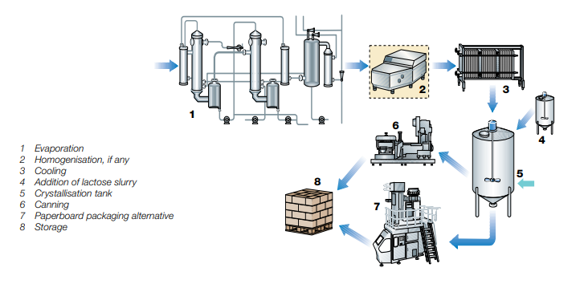¹³
Fig 6.2.. Process line for sweetened condensed milk

Compare two types of sterilisation:
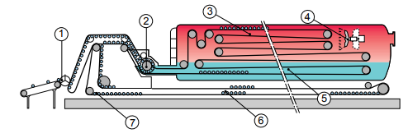 | 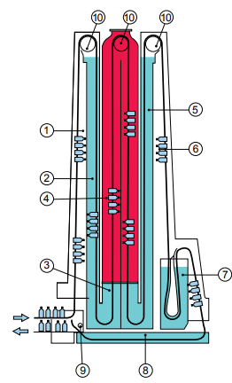
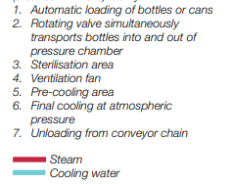 | 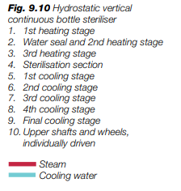
¹³
Conclusions
During practical activities, students acquire and strengthen knowledge and skills in the operation of equipment, as well as understanding of equipment flow lines for the production of milk products with long shelf life. Students explain their work

Approved by
(Name, surname, signature)
Date

Laboratory work

Milk powder quality control
Materials
Milk, cream, whey powder
Methods and Procedures
The quality, chemical composition and stability analysis of reconstituted milk
1. Obtaining reconstituted milk
Students get 20 g of milk powder. Each student should prepare milk with solids non-fat 8.5%. The solid content of milk powder is 96%. Students should calculate the amount of water to dissolve 20 g of milk powder.
The calculated amount of water should be heated to 35-40 ⁰C, then poured it into the measuring cylinder. Add milk powder and mix until it is fully dissolved (~20-25 min.).
2. The quality control of reconstituted milk. The following parameters should be controlled in the reconstructed milk:
Acidity
10 mL of milk is measured into a conical flask, 20 mL of distilled water, 2-3 drops of Phenopthalein is added. Titrate the solution from the burette using 0.1 N Sodium hydroxide (NaOH) continuously mixing, until a pink colour appears.
The number of mL of Sodium hydroxide solution multiplied by 10 expresses the acidity level of the milk in Thorner degree.
pH
Rinse the electrode in water. Remove water from electrodes. Place the electrode in your sample (50 mL), press Run, Enter and then Run, wait a while, and read pH from the display and record the result in a notebook.
Density
Mix the milk sample slowly and pour it gently into a measuring cylinder (300 mL). Let the aerometer sink slowly into the milk. Read and record the last aerometer degree (kg m⁻³) just above the surface of the milk. If the temperature of the milk is different from the calibration temperature (Calibration temperature may be 20 ⁰C) of the aerometer, calculate the temperature correction. Latvian standards expect milk to have a specific gravity of 1027 -1032 kg m⁻³ which implies an aerometer reading range of 27.0–32.0 ºA.
Freezing point
Put the milk sample with a pipette into the tube ~ 2.2 mL, then place the tube in the CrioStar socket. To begin the measurement, choose with an arrow “Start measurement” and press Enter. The measurements will start, and values will change, the curve will be created. The temperature will be presented on the vertical axis, but time on the horizontal axis. To stop the measurement, press Enter one more time. When a freezing point is detected, for example -0.557 °C, the CrioStar starts looking for a Plato regime.
The Alcohol Test
The test is done by mixing equal amounts of milk and ethanol solution in Petri plate. If the tested milk is of good quality, there will be no coagulation, clotting or precipitation, but it is necessary to look for small lumps. For routine testing, 2 mL milk is mixed with 2 mL of 68 % alcohol.
Presence of phosphatase in milk
Add 2 mL of milk and 1 mL of Na phenol phosphate in a tube, then close it with a cork and mix the solution. Mark the tube and put it into a water bath (40-45 °C temperature). Evaluate the colour of tube solution after 10 minutes and after 1 hour.
The pink or red colours indicate phosphatase presence in the milk, if the tube colour has not changed phosphatase is not present in the milk.
Detection of the undissolved amount reconstituted milk
Reconstituted milk (10 mL) is poured into the graduated tube. Put on the cover and place itin the water bath (35 °C) and heat for 10 minutes. Then put the tube to the centrifuge and centrifuge for 10 minutes. Following it, evaluate the amount of precipitate in the tube. The amount of the precipitate should be measured as 1 % of undissolved particles that is equal to 1 mL of precipitate. The acceptable amount of precipitate is 0.2%.
Table 6.3.
Milk powder characteristics
Sample | pH | Acidity, °T | Density, kg/m³ | Freezing point, °C | Thermostability | Presence of phosphatase | Amount of precipitate
Conclusions

Approved by
(Name, surname, signature)
Date

Theme 7

By-products: quality parameters, processing options
Theoretical materials
During cheese, butter, cottage cheese, casein production not all dry matter is used.
Some dry matter moves to the by-products:
• Skimmed milk (70%),
• Buttermilk (70%),
• Whey (50%).
Table 7.1.
By -products characterisation
Parameter | milk | skimmed milk | butter milk | whey
Dry matter | 12.3 | 8.75 | 9.2 | 5.2-7.5
Proteins | 3.2 | 3.2 | 3.2 | 0.8-0.9
Lactose | 4.8 | 4.8 | 4.7 | 3.8-4.7
Fats | 3.6 | 0.05 | 0.6 | 0.1-0.7
Minerals | 0.7 | 0.7 | 0.7 | 0.5-0.7

Butter milk and skimmed milk are used for:
• Fat content regulation;
• Products and drinks;
• Canned food;
• Cheese;
• Cottage cheese and desert;
• Casein production.

Whey is used for:
• Whey cream;
• Whey drinks;
• Whey concentrate;
• Fraction products;
• Glucose-galactose syrup;
• Biologically active compounds.

Laboratory work

By-products processing and quality control
1. Ultrafiltration
- Turn on the computer and equipment for UF and the cooler (shown in photos 1; 2).

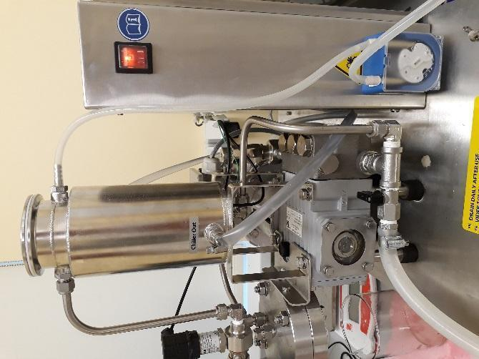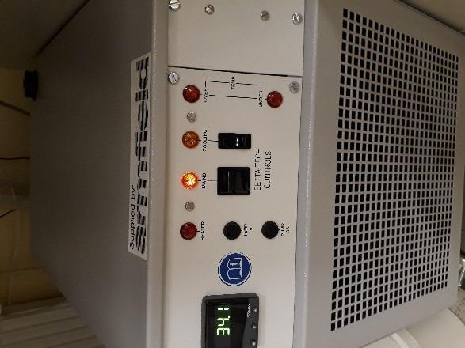
1.
2.
- Open the program SHORTCUT (Standard Unit) Authors photo



- Turn on Power (3) 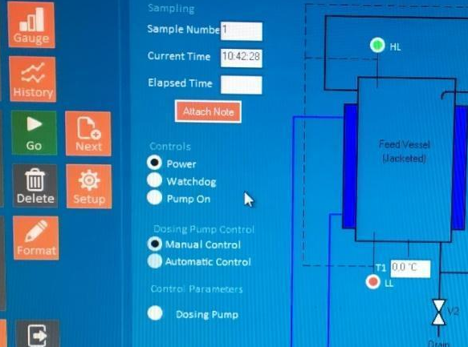
3.
- Fix (arrange) the filter (4) 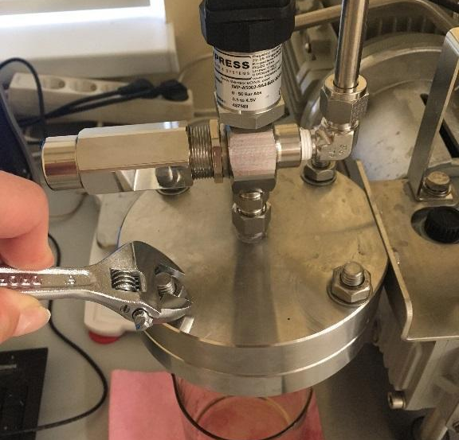
Cleaning
- For cleaning: fill the container with distilled water (until green signal, otherwise the program will stop).
- Pump for the cleaning process – 10
Turn Pump on (5) 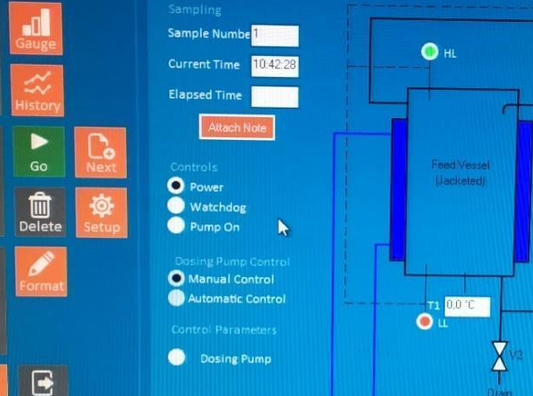
5.
- After cleaning: take the water out of the system by opening the switch in the vertical position
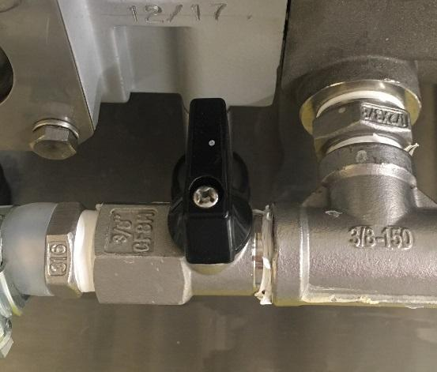

Ultrafiltration
- Open the filter and insert filter paper with the shiny side up and close it (picture 4). 1 filtration paper is valid for one filtration.
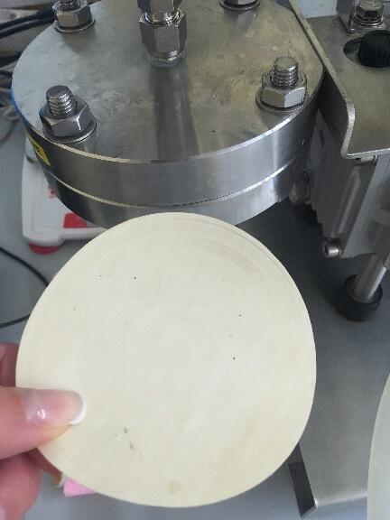

- Based on the Instruction manual for Industrial Food Technology Equipment FT17, pressure should be regulated on the left-hand side of the equipment, for MF 0,3-14 (6). On the computer you can see the regulation of the pressure.
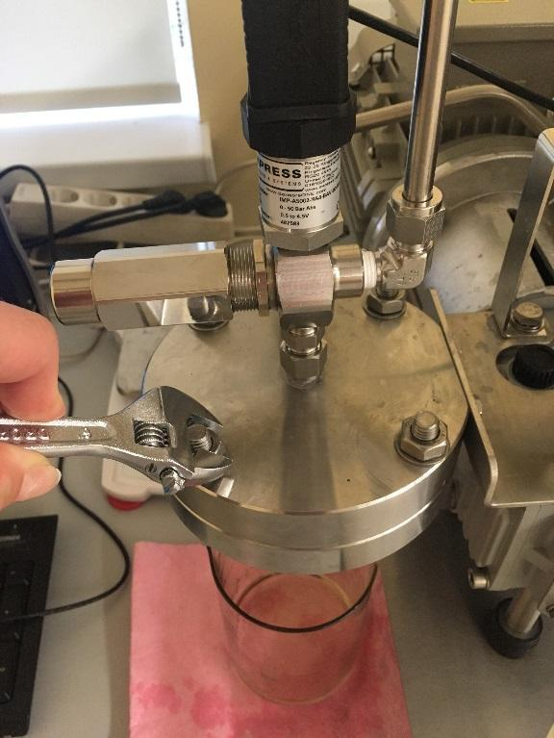
6.
- Turn on the pump – first 25 or less, optimum – 27, later you can use 40.
- Turn the pump on (picture 5).
- Stop the UF with the pump on (point out).
Cleaning
- After UF/MF, open the filter, take out the filtration paper, fix the filter (step 4).
- Cleaning in 3 steps:
- distilled water (15 minutes),
- 16% of NaOH (10 minutes),
- distilled water (15-20 minutes).
After each cleaning, take the water out of the system by opening the switch in the vertical position. After turning the switch to the “close” horizontal position.
- Switch off the equipment, cooler, programme, and the computer.
2. New type of product production from whey and butter milk
Students develop their one formulation and technology for new type of the product using by-products.

Conclusions

Approved by
(Name, surname, signature)
Date

Theme 8

HACCP in dairy processing companies
Theoretical materials
What is food safety?
Food safety is a scientific discipline describing handling, preparation, and storage of food in ways that prevent food borne illnesses. This includes a number of routines that should be followed to avoid potentially severe health hazards. In this way, food safety often overlaps with food defence to prevent harm to consumers.

As it is known since 1960s in EU each enterprise which works in Food segment must have a food safety system based on the 7 HACCP principles.
Seven basic principles are employed in the development of HACCP plans that meet the stated goal. These principles include hazard analysis, CCP identification, establishing critical limits, monitoring procedures, corrective actions, verification procedures, and record-keeping and documentation.
The Food Safety Plan - is not a stand-alone programme, but rather part of a larger food safety system. The foundational programmes that are part of the food safety system are frequently termed prerequisite programmes. The term was coined to indicate that they should be in place before HACCP based systems are implemented in order to effectively manage the risk of foodborne hazards. Good Manufacturing Practice (GMP) regulations address requirements for many prerequisite programmes. The conditions and practices that the regulated food industry must follow for processing safe food under sanitary conditions, including personnel, plant and grounds, sanitary operations, sanitary facilities and controls, equipment and utensils, processes and controls, warehousing and distribution, and action levels in case of potentially unsafe product.
The process flow of a food safety plan (HACCP or Preventive Controls) is the centre of a food product’s food safety story. It tells how a company makes its products and also what hazards and controls are associated with each step.
Monitoring records and logs must include the actual values or observation that document the actual implementation of a Food Safety Plan. For example, if a temperature is being measured, the actual temperature must be recorded rather than a check mark indicating that the temperature complied with the critical limit. To comply with regulations, information must be recorded at the time it is observed.
Here are suggested record and log types to use:
- Customer Complaints,
- Corrective Action Forms,
- Employee Training,
- Food Safety Quarterly Audit,
- Food Safety Checklist,
- Raw Materials/Receiving Log,
- Worker Illness Log,
- Refrigerator Log,
- Assembly Log,
- Shipping Temperature Log,
- Suggested Supply Chain.
Documents
The safety of your product depends on much more than just what you control within your own facility. The use of an ingredient that has a history of association with a specific hazard may require a supply chain programme as a control within your food safety program. Companies may have extensive supplier programmes that encompass much more than food safety elements to manage their supplier expectations and performance.
Here is a list of suggested documents to obtain from your supply chain:
- Food Safety HACCP or Preventive Controls Plan for each product,
- Food Defence/Business Continuity Plan,
- Validation of each product and/or process and Ready-To-Eat statements (if applicable),
- Certificates of Analysis (COA),
- Third Party Audit Certificate, Report & Corrective Actions,
- Product Specification,
- Allergen management,
- Country of Origin,
- Potential Hazards,
- Biological hazards,
Microbiological Contamination – During Processing at Source of Origin – Supplier Management and HACCP in place and verified to eliminate and reduce potential presence of Microbiological contamination.
Microbiological Contamination for instance, Microbiological growth due to breakdown of refrigeration units.
Chemical
Chemical Contamination by pesticides at source of origin – chemical/pesticide used at source is verified to be compliant with regulations.
Chemical Contamination from machine oils or lubricants, as well as cleaning chemicals.
Microbiological / Physical / Chemical Contamination from – cross contamination or taint of finished product due to poor hygiene.
Physical
Physical Contamination – external contamination from rain water, bird droppings, vermin/rodents, and flying insects during the unloading process.
Glass Contamination – glass contamination from internal light sources. – pests/rodents and or flying insects due to poor hygiene/debris build up - physical risks from straps/thermocouples/staples/foreign bodies found on pallets on intake.
Physical Contamination –foreign bodies found within product and/or packaging from source of origin or during transportation.
Physical Contamination – physical contamination from warehouse operative, pests/rodents, and/or flying insects due to poor hygiene/debris build up – physical contamination from personnel, foreign body/dust contamination from production environment.
What are the 5 basic everyday food safety principles?
The core messages of the five key principles to safer food are: (1) keep clean; (2) separate raw and cooked; (3) cook thoroughly; (4) keep food at safe temperatures; and (5) use safe water and raw materials.
Table 8.1.
Five key every day food safety principles
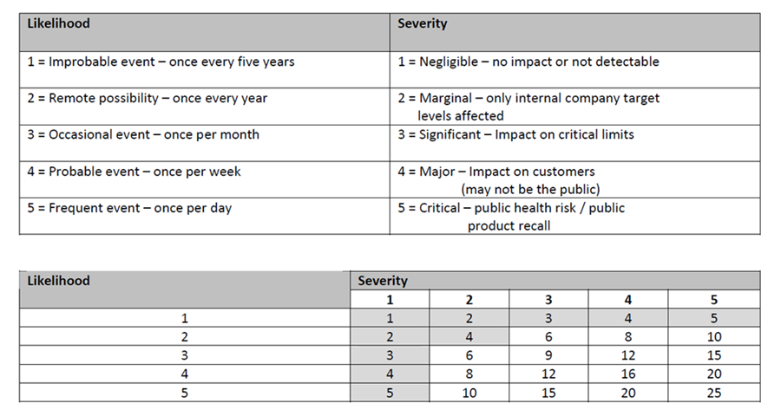
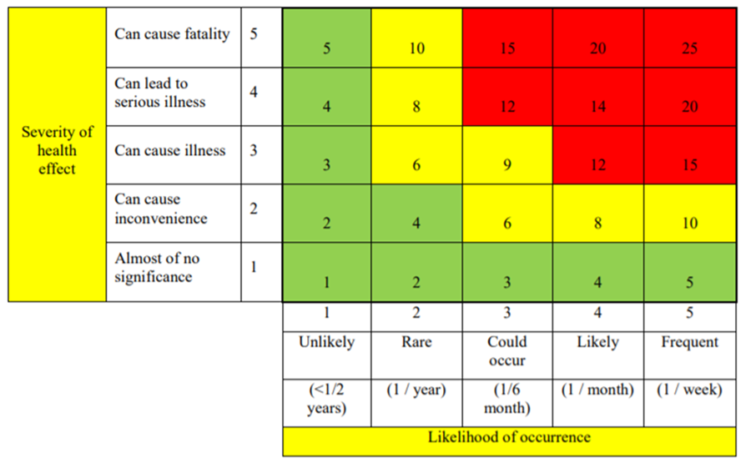
Example of a decision tree to identify critical control points (CCP)
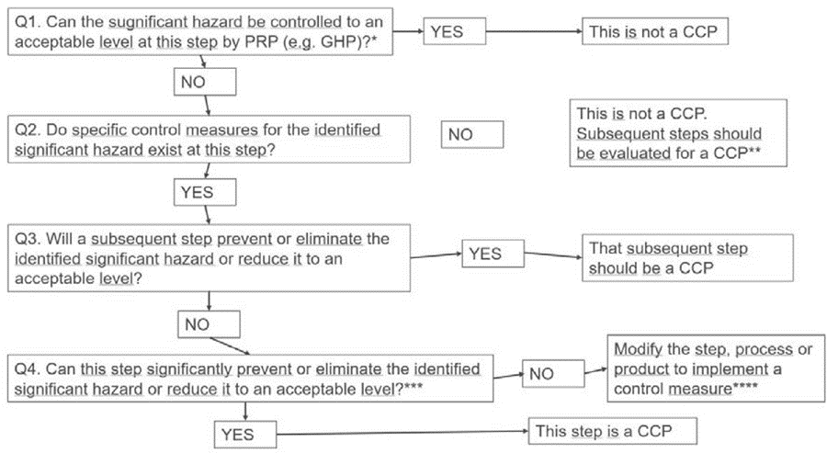

Practical work

Assessment of potential hazards in milk processing
1. For a selected milk processing product, develop a product description, develop and draw a diagram of the process steps (flow diagram).
2. Identify potential hazards:
biological:
* pathogenic microorganisms;
chemical:
* agricultural chemicals;
physical:
*foreign objects typical for the product.
3. Evaluate the danger of the identified hazards using a risk matrix. Record the information in the hazard assessment table.
4. Complete the CCP identification table and the HACCP plan.
5. Write conclusions on determining the CCP using a risk matrix and a decision scheme/tree.
Results
Table 8.2.
Risk assessment table
Process stage | The identified hazard | Hazard assessment |  |  |  |  | Means of control
Process stage | The identified hazard | Possibility | The severity of the consequences | Risk level | Assessment | CCP | Means of control

Table 8.3.
CCP identification table
Process stage | Process stage | Cause of risk | Description of the cause of the risk | Control actions | Answers to Decision Scheme questions |  |  |  | CCP yes/no
No. |  |  |  |  | 1 | 2 | 3 | 4

Table 8.4.
HACCP plan
In process | CCP/  CP | Risk | Measurable | Monitoring procedures |  |  |  | Order- | Corrections
stage |  | the cause | critical limits of parameters | What? | How to? | How often? | What? | In what way? | events

Conclusions

Approved by
(Name, surname, signature)
Date

The laboratory work was developed in collaboration with prof. I.Ciprovica
The laboratory work was developed in collaboration with prof. I.Ciprovica
The laboratory work was developed in collaboration with prof. I.Ciprovica
https://dairyprocessinghandbook.tetrapak.com/chapter/centrifugal-separators-and-milk-standardization
https://dairyprocessinghandbook.tetrapak.com/chapter/fermented-milk-products
Inga Ciproviča, lecture materials
https://www.frype.com/frozenyoggy/
https://reitingi.lv/lv/news/komerczinas/121941-par-godu-latvijas-simtgadei-izn-cis-pa-s-ekselence-sald-jums-latvijas-karoga-kr-s-s.html
https://pricer.lt/en/c/food/ice-cream-ice-cubes/tio-ice-cream
https://www.rimi.lv/e-veikals/lv/produkti/saldetie-edieni/saldejums-un-ledus/saldetas-sulas-saldejumi/sulas-saldejums-jungle-pop-kolas-70ml-70g/p/987983
https://cem.com/ice-cream-production-process
Metodiskie norādījumi “Piens, tā pārstrāde”, 2012 gads, Jelgava

