


Open Food Innovation University (OFINU)

Study Module
“MEAT PROCESSING TECHNOLOGIES”
WORKBOOK
for students

2024
Summary

The workbook is elaborated within the project “Open Food Innovation University" (OFINU), being in implementation with support of the European Union Erasmus+ Programme.
Overall objective of the project - to modernise food innovation and technology related higher education in Uzbekistan and Tajikistan, thereby increasing the quality and ensuring relevance of the higher education to the needs of the socio-economic growth of the countries concerned and especially of their regions.

Full partners:
- Lead partner: Latvia University of Life Sciences and Technologies
- Uzbekistan: Samarkand Agro-innovations and Research University, Andijan Institute of Agriculture and Agro-technologies
- Tajikistan: Technological University of Tajikistan, Kulob Institute of Technology and Innovation Management, Isfara Branch of the Technological University of Tajikistan
- Slovakia: Slovak University of Agriculture in Nitra

Associated partners in Uzbekistan:
- A group of companies "AGROMIR"
- "Navigul" MCHJ QK
- “Samarqand don mahsulotlari” JC (Samarkand grain products)

Associated partners in Tajikistan:
- CJSC “Combinati Shiri Dushanbe”
- LTD "Orion Rustam"
- Association of Entrepreneurs of Khatlon

The project implementation period: 01/02/2024 - 31/01/2027.

Funded by the European Union. Views and opinions expressed are however those of the authors only and do not necessarily reflect those of the European Union or the European Education and Culture Executive Agency. Neither the European Union nor the granting authority can be held responsible for them.

Partner universities and their academic staff, involved in the development of the study course:

P1 LBTU. Latvia University of Life Sciences and Technologies
Ilze Gramatina - meat processing technologies.
Sandra Muizniece-Brasava - packaging of meat and meat products.
Normunds Puzulis - meat processing equipment.
Evita Straumite - sensory evaluation of meat and meat products.
Egita Sproge - HACCAP.

P2 SAMARU. Samarkand Agroinnovations and Research University
Elnara Devletshaeva - technology of storage and processing of livestock products.
RahmatilloTashmanov - technology of storage and processing of agricultural products.

P3 AIAA. Andijan Institute of Agriculture and Agro-technologies
Rakhim Mirzaev - technology of storage and processing of agricultural products.
Kholdarov Shukhratjon - technology of storage and processing of agricultural products.

P5 KITIM. Kulob Institute of Technology and Innovation Management
Amrudin Rustamov - technology of meat and meat products.
Safar Odinaev - technology of meat and meat products.

P7 SUA. Slovak University of Agriculture in Nitra
Miroslava Kačániová - microbiologist.

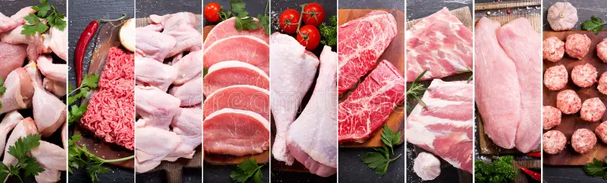https://www.dreamstime.com/food-collage-various-fresh-meat-chicken-top-view-image119436719

Contents
Course Schedule 8
Date, Time 8
Theme 2 27
Biochemical and microbiological developments in meat 27
Laboratory work Assessment of meat freshness using sensory, physic-chemical and microbiological quality analysis methods 38
Laboratory work 58
Evaluating the quality of food fat by analysing changes in sensory and physico-chemical quality parameters 58
Laboratory work 67
Microbiological testing of chilled meat 67
Theme 4 74
Meat preservation methods 74
Laboratory work 89
Sensory evaluation of meat 89
Practical work 91
Safety risk assessment of meat 91
Laboratory work 94
Microbiological testing of semi-finished meat products 94
Laboratory work 99
Mechanical equipment for meat processing 99
Seminar 101
Optimal packaging solutions for preserved meat products 101
Theme 5 105
Meat products 105
Laboratory work 119
Preparation of fresh, semi-dry or cooked sausages, determination and analysis of sensory, physico-chemical, and microbiological quality indicators 119
Laboratory work 126
Microbiological evaluation of processed meat products 126
Laboratory work 130
Sensory evaluation of meat products 130
Laboratory work 132
Preparation of semi-finished and liver pate or liver sausages. Determination and analysis of sensory, physico-chemical and microbiological quality indicators 132
Laboratory work 144
Microbiological evaluation of meat processing products 144
THEME 6 147
Canned meat products 147
Seminar 154
Package as added value of meat products 154
Practical work 155
Meat product safety risk assessment 155
Practical work 158
Thermal equipment for meat processing 158

Theme of the study course

The “Meat processing technologies” study module covers the following topics: technological process and equipment, packaging material and equipment, raw materials and product quality evaluation, including sensory evaluation and quality management assurance in the meat processing. A lecturer with knowledge in the specific field is involved in the implementation of each section in order to achieve the goal of the study module.

Learning methods

An innovative teaching method is used in the “Meat Processing Technologies” study module. The novelty for the Central Asian (CA) universities was: a) illustration of theory with practical examples; b) online classes, methods and tools used for their delivery; c) application of interactive methods, such as seminars; d) methods used for delivery of laboratory and practical work (individually, group work, discussions, retraining). All of the above helped to absorb new thematic knowledge.
The main pedagogical methods taught are as follows: learner centred approach, competence-based approach, experiential learning, cooperative learning, and interactive learning. The training includes practicing of methods, as well as an introduction to modern learning analytics, to be used to support the student engagement and responsibility, and to support assessment.
Highly appreciated are the knowledge and skills to produce and deliver classes and lectures in distance learning format, because the application of this method broadens availability of the experts and worldwide knowledge (inviting entrepreneurs, foreign academic staff etc. as lecturers), can be applied in the case of double diploma studies, provides an opportunity to study for persons having limited possibilities to take part in full time studies (young mothers, students with disabilities). Distance learning is very effective for specific courses when participation of lecturers from foreign partner universities is crucial and discussions with students with diverse experiences and visions are needed to explain and demonstrate possibilities and various solutions and options. The first feedback from the academic staff who has introduced the new methods has demonstrated positive impacts, such as:
1) transformation to teaching approaches in faculties;
2) the learner-centred approach has empowered students to take charge of their own learning, leading to increased engagement and motivation;
3) students have become more proactive in seeking knowledge and are more participative in class discussions;
4) the use of digital tools for interactive learning has made classes more dynamic and accessible - students can access learning materials from anywhere, leading to increased flexibility and convenience;
5) the collaborative nature of some of these methods has also led to increased interaction and rapport between faculty and students.
Open lectures discussions, involving internal and external stakeholders, is a new form of teaching and communication of higher education to the society, adopted at the participating UZ universities during the implementation of the project.

Course Schedule
Thematic Study Plan for module “Meat Processing Technologies”

Date, Time | Study form | Theme | Lecturer
Theme 1. Meat and its general characteristics, and quality
1st day | Lecture  (1h) | Introductory lecture in the study course.
1st day | Lecture  (3h) | Morphological structure of meat (Technology).
1st day | Lecture  (3h) | Meat quality, chemical composition and nutritional value (Technology).
1st day | Lecture  (1h) | The most suitable packaging materials for fresh meat (Packaging).
1st day | Lecture  (1h) | Meat safety and risk assessment (Quality).
2nd day | Laboratory work (8h) | 1st Laboratory work – evaluation of the chemical composition of meat using physico-chemical quality analysis methods (Technology).
Theme 2. Biochemical and microbiological processes in meat
3rd day | Lecture  (2h) | Biochemistry and microbiological developments in meat. Meat rigor-mortis, maturation and breaking down (Technology).
3rd day | Lectures  (2h) | Characteristics of main technological equipment (Equipment).
3rd day | Lecture  (3h) | Intensification of the maturation process. Meat maturation, PSE and DFD defective meat (Technology).
3rd day | Lecture  (1h) | Contamination, safety and risk assessment (Microbiology).
4th day | Laboratory work (8h) | 2nd Laboratory work – assessment of meat freshness using sensory, physic-chemical and microbiological quality analysis methods (Technology).
Theme 3. The slaughter process of animals and birds
5th day | Laboratory work (1h) | Microbiological testing of chilled meat (Microbiology).
5th day | Lecture  (3h) | Preparation of animals, birds for processing, and slaughtering. Animals and birds carcass division. (Technology).
5th day | Lecture  (1h) | By-products, use and processing (Technology).
5th day | Lecture  (1h) | Intestinal structure and treatment. (Technology).
6th day | Laboratory work (8h) | 3rd Laboratory work – evaluating the quality of food fat by analysing changes in the sensory and physico-chemical quality indices (Technology).
Theme 4. Meat preservation methods
7th day | Lecture  (2h) | Meat preservation methods. Chilling and storage of meat (Technology).
7th day | Lecture  (1h) | Quality indicators of meat (Sensory evaluation).
7th day | Seminar  (2h) | Sensory evaluation of meat (Sensory evaluation).
7th day | Lecture  (1h) | Chilled and frozen meat safety and risk assessment (Quality).
8th day | Lecture  (2h) | Meat freezing, changes in quality indicators during storage. (Technology).
8th day | Lecture  (2h) | Characteristics of equipment (Equipment).
8th day | Lecture  (1h) | Package selection for preserved meat (Packaging).
8th day | Practical work (3h) | Safety and risk assessment of meat (Quality).
9th day | Lecture  (2h) | Meat salting types, storage and characterisation of quality indicators (Technology).
9th day | Lecture  (1h) | Contamination risks of preserved meat (Microbiology).
9th day | Laboratory work  (2h) | Microbiological testing of semi-finished meat products (Microbiology).
9th day | Practical work  (2h) | Mechanical equipment for meat processing (Equipment).
10th day | Lecture  (2h) | Meat smoking, smoking methods, changes in quality indicators (Technology).
10th day | Lecture  (2h) | Meat product drying methods, quality indicators and their changes (Technology).
10th day | Lecture  (1h) | Optimal packaging solutions for preserved meat products (Packaging).
11th day | Lecture  (1h) | Security and risks of salted, smoked and dried products (Quality).
11th day | Seminar  (3h) | Optimal packaging solutions for preserved meat products (Packaging).
Theme 5. Meat products
12th day | Lecture  (2h) | Classification of semi-finished meat products (Technology).
12th day | Lecture  (3h) | The main raw materials for meat products production and their characterisation (Technology).
12th day | Lecture  (1h) | Sensory quality indicators of meat products and their changes during storage (Sensory evaluation).
13th day | Laboratory wok (8h) | 4th Laboratory work – preparation of semi-dry and cooked sausages, determination and analysis of sensory, physico-chemical, microbiological quality indicators (Technology).
14th day | Lecture  (2h) | Characteristics of the main equipment used in the processing of meat products (Equipment).
14th day | Laboratory work (2h) | Microbiological evaluation of processed meat products (Microbiology).
14th day | Lecture  (4h) | Meat cooking technologies (Technology).
15th day | Seminar  (3h) | Sensory evaluation of meat products (Sensory evaluation).
15th day | Lecture  (1h) | Microbiological quality indicators of meat products and their changes during storage (Microbiology).
15th day | Lecture  (1h) | Meat product safety and risks (Quality).
16th day | Laboratory works (8h) | 5th Laboratory work – preparation of semi-finished products and liver pate or liver sausages, determination and analysis of sensory, physico-chemical, and microbiological quality indicators (Technology).
17th day | Lecture  (3h) | Most important meat products sensory, physico-chemical, microbiological methods of analysis and equipment (Technology).
17th day | Seminar  (3h) | Sensory evaluation of meat products (Sensory evaluation).
17th day | Lecture  (1h) | Meat product safety and risk assessment (Quality).
17th day | Laboratory work (1h) | Microbiological evaluation of meat processing products (Microbiology).
Theme 6. Canned meat products
18th day | Lecture  (3h) | Canned meat technology. Changes during heat treatment, and quality indicators (Technology).
18th day | Lecture  (1h) | Meat products contamination risks (Microbiology).
18th day | Lecture  (1h) | Most value packaging types and materials for canned meat products (Packaging).
19th day | Seminar  (3h) | Package as added value of meat products (Package).
19th day | Practical work  (3h) | Meat product safety and risk assessment (Quality).
19th day | Practical work  (2h) | Thermal equipment for meat processing (Equipment).

Theme 1
Meat and its general characteristics and quality

Theoretical materials
Meat quality has become a more demanding issue due to consumer awareness of eating quality meat and its nutritional value. The sensory qualities of meat also have great importance in terms of consumer preference. At the purchasing stage, consumers generally evaluate the colour and oiliness of raw meat as quality criteria. The flavour of the meat consumed is linked to its softness, juiciness, aroma, and taste. Quality meat should be soft, high in moisture, contain more muscle fibres than connective tissue, pink in colour, and have an appropriate aroma.
Table 1.1.
Chemical composition of meat
Meat | Water | Proteins | Fats | Ash
Cattle | 58.5-74.0 | 15.6-21.1 | 3.8-22.9 | 0.8-1.1
Sheep | 48.0-72.2 | 13.3-20.9 | 8.9-35.1 | 0.7-1.0
Poultry | 58.4-68.3 | 18.5-21.5 | 9.3-22.5 | 0.9-1.1
Turkey | 55.5-73.5 | 20.6-22.5 | 4.8-22.9 | 1.0-1.1
Duck | 48.2-61.2 | 17.8-18.5 | 19.0-33.0 | 1.0-1.1
Goose | 38.0-53.4 | 15.9-16.5 | 29.0-45.6 | 0.8-1.1
Rabbit | 66.8-73.8 | 20.4-21.7 | 3.3-9.7 | 1.0-1.1

Moisture, protein, fat, and ash ratio constitute the chemical composition of meat. It is varied according to the species of animal, genotype, sex, age, body condition score, nutritional status, and muscle structure of the animal.
Water has the highest proportional value in the composition of meat. Muscle contains approximately 75 per cent water (ranging from 65 to 80%) by weight. Water is the principal constituent of the extracellular fluid and numerous chemical constituents are dissolved or suspended in it. Because of this, it serves as a medium for the transport of substances between the vascular bed and the muscle fibres. Water is an important thermoregulator and solvent, and plays an important role in cell and organ metabolism and the transport of metabolites and wastes. The water holding capacity of meat is an important factor affecting the appearance, colour, tenderness, taste, and aroma of the meat. The amount of water in the meat is an important factor affecting the profitability in terms of weight loss during the meat waiting processes (resting, packaging, freezing, transportation). At the same time, meat that does not lose its water as a result of the cooking methods and is able to keep its content is considered to be quality meat.
Meat proteins are superior to plant proteins because meat contains high biological value proteins in a concentrated form. Muscle proteins are broadly divided into following three categories: soluble in water or dilute salt solutions (the sarcoplasmic proteins), soluble in concentrated salt solutions (myofibrillar proteins), insoluble in salt solution at low temperature (proteins of connective tissue and other formed structures). Myoglobin, hemoglobin and various enzymes constitute sarcoplasmic protein, whereas, myofibrillar proteins are actin, myosin, tropomyosin, troponin, α, β and ɣ-actinin, C-proteins, M-proteins etc. Major connective tissue proteins are collagen, elastin and reticulin. Fat (%) We have already studied that proteins are made up of amino acid chains and 20 amino acids are very common. Animals can not synthesize amino groups which form amino acids. Therefore, proteins must be provided in the diet of animals so that they can synthesize their own amino acids. Meat proteins are a rich source of essential amino acids viz., phenylalanine, valine, tryptophan, threonine, methionine, leucine, isoleucine and lysine which are very much essential for humans. Generally, proteins are very much susceptible to denaturation at their isoelectric point (i.e., the point at which electrical charges on their amino and carboxyl groups exactly cancel one another), at relatively low temperature and on exposure to acid conditions. Denatured meat becomes insoluble in aqueous solution and this property affects the structure and characteristics of meat, its appearance and ability to hold or bind water. This is very important for comminuted meat products where meat is mixed with other components to form gels and emulsions.
Since proteins are the basic building blocks of the organism, they are key elements that should be included in diets. Proteins are essential nutrients that enable the development of muscles and organs in young people and direct the body in adults. An adult person needs about 70-80 g of protein per day. About half of this value should be of animal origin. Protein content in meat is under the influence of many factors such as species, genotype, age, gender, and ration composition. Animals with the same genotype may have different nutrient contents. In human nutrition, proteins of animal origin have an important place in terms of the essential amino acids and fatty acids they contain. It is generally desirable to have a higher protein content in meat products.
The fat content of meat varies greatly from species to species (ranging approximately 1.5 to 3 per cent). Fat is found in the meat as intracellular deposits or marbling, or intramuscularly in the adipose tissue deposits associated with the loose connective tissue septa between the bundles. Meat fats are generally simple triglycerides in nature, but beef and mutton have mixed triglycerides. The caloric value of fat depends on the fatty acid composition. Meat mainly contains saturated and monounsaturated fatty acids. Commonly occurring saturated fatty acids in meat are palmitic acid and stearic acid. Oleic, linoleic and linolenic acids are the major unsaturated fatty acids in meat.
Polyunsaturated fatty acids (PUFA) play a very important role in meat fat. Nowadays, people are very health conscious and think that meat fat is dangerous to health without knowing the scientific explanation behind this. In the case of PUFA, if the first double bond occurs three carbon atoms away from the methyl end of the molecule then it is called an omega-3 fatty acid and similarly, PUFA with that bond at six carbon atoms away from the methyl end, then it is called an omega-6 fatty acid. Linoleic acid is an omega-6 fatty acid and linolenic acid is an omega-3 fatty acid. For men, a dietary ratio of 4 or 5:1 for n-6; n-3 PUFA is desirable. The ratio of omega-3 fatty acids is important in relation to the incidence of cardiovascular disease. For example, omega-3 fatty acids reduce blood clotting and omega-6 fatty acids counteract this effect. Animals synthesise arachidonic acid from linoleic acid and use linolenic acid to synthesise eicosapentaenoic (EPA) and docosahexaenoic (DHA) acids. A diet rich in linoleic acid leads to deficiency of EPA and DHA. EPA and DHA can reduce the incidence of disease significantly. Scientists are trying to increase the proportion of polyunsaturated fatty acids to saturated fatty acids (P:S ratio) in meat considering their effects on human health. In non-ruminants such as pigs and poultry, the body fat closely reflects the characteristics of the dietary fat. Thus, it is not difficult to get the desirable P:S ratio in pork or chicken. But, this is not possible in beef or mutton, as a major part of unsaturated fat supplied through the diet of cattle and sheep (i.e. ruminants) is saturated through the process of hydrogenation by rumen microorganisms. Most animal fats are solid at room temperature because the triglycerides of animal fat 1 contain mainly saturated fatty acids. Pig fat is called lard which is soft in nature due to the higher ratio of unsaturated to saturated fatty acids. Beef fat is harder than pork fat because beef fat contains up to 25% stearic acid i.e. saturated fatty acid. The saturation of lamb or mutton fat may explain the 'greasy' mouthfeel associated with eating it as the melting point of this fat is often above the temperature of the mouth.
Fats are associated with tenderness, flavour, and aroma of meat products. In terms of human health, unsaturated fatty acids should be higher in the composition of the fatty acid profile of meat and saturated fatty acids should be lower. It is important for meat products to have a lower fat content in the diets of individuals with cardiovascular problems or obesity. The fat ratio in the meat composition differs depending on various factors. Since the muscle development is higher in male animals, the protein ratio is proportionally higher, and the fat content is lower. Carcass score is also one of the parameters to be taken into account as it affects fatness.
Although carbohydrate is a minor component of animal tissues in terms of the overall composition, it plays a very important role in conversion of muscle to meat. The main carbohydrate in meat is glycogen which is a polymer of glucose. It is found particularly in muscle and organ meat like liver. In well fed animals, the liver contains 50 mg glycogen per grammme of liver tissue. Generally 10-20 mg of glycogen is present in 1 grammme of muscle. In the fasting stage of an animal before the slaughter, the liver glycogen is converted into glucose in order to maintain blood glucose concentration at a constant level. In anaerobic conditions, muscle glycogen is used to produce energy for contraction and is then broken down into lactic acid. The post-mortem changes and the onset and completion of rigor mortis greatly depend on glycogen reserve in the muscle. We have studied this in the previous unit i.e. the conversion of muscle to meat. Other carbohydrates present in the meat are mucopolysaccharides associated with the connective tissue, glucose and intermediates of glycolytic metabolism such as lactic acid, acetoacetic acid etc.
Ash is the mineral substance of the meat and is very important for human health. It is generally stored in teeth and bones (calcium, phosphate, magnesium). Apart from this, there are also mineral substances stored in body fluids (iron, sodium, and potassium), enzymes (zinc), and nucleotides (phosphorus). Because mineral deficiencies cause significant discomfort in the body, it is very important to get them from food sources.
Generally lean meat is an excellent source of B-complex group of vitamins but is a poor source of fat soluble vitamins like vitamin A, D, E and K and water soluble vitamin C. Meat fats provide these fat soluble vitamins to some extent. Certain organ meats contain vitamin C in minor quantities. All of the B-complex vitamins are present in meat and in a concentrated form in the liver. Contents of the B-complex vitamins group vary among different types of meat. Pork is superior to beef, veal, lamb or poultry meat in terms of containing B-complex vitamins. Thiamin content in pork is 8 to 10 times higher than in other meats, but its vitamin B content is lower than in other meats. The liver of any animal is a good source of vitamin B, i.e. thiamin. During cooking, some of these water soluble vitamins are lost. Generally, 100 grammes of cooked meat supplies 25-60 per cent of the recommended (RDA) B-complex vitamins.
Table 1.2.
Chemical composition of typical adult mammalian muscle http://www.ifrj.upm.edu.my/18%20(03)%202011/4)IFRJ-2010-227.pdf
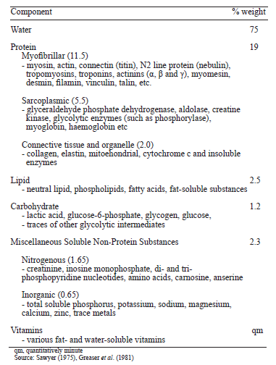

The most sustainable packaging materials for fresh meat
When packaging fresh meat, it is important to choose packaging materials and packaging technologies that not only contain the meat and meat products, but also extend the delivery time as much as possible.
Both single-layer and multi-layer packaging materials are used for packaging. If it is necessary to extend the shelf-life, then multilayer packaging materials with high gas barrier properties are used, which allows products to be packaged in vacuum (VP) and modified atmosphere packaging (MAP).
Table 1.3.
The most commonly used packaging shapes for packaging of fresh meat
Illustration | Package shape | Description
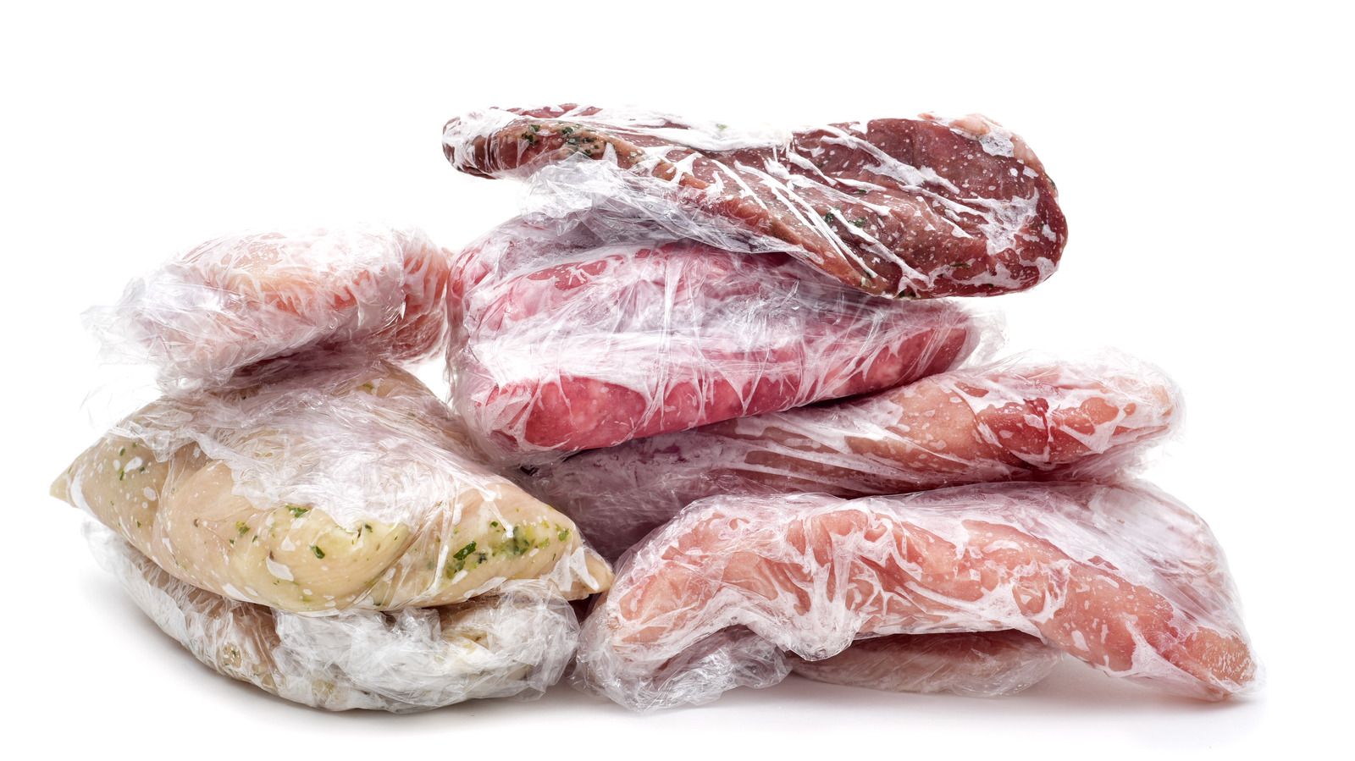 | Wrapped in cling film | Meat/meat products, which are expected to have a short period of sale, are usually wrapped in food film.
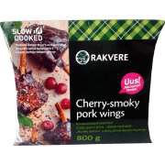 | Pillow pouches | Usually produced in-house in horizontal flow-pack equipment. Or purchased packaging in the form of ready-made packages with three fused seams.
 | Doypack | Usually produced in-house in horizontal flow-pack equipment. Or purchased packaging in the form of ready-made packages with three fused seams.
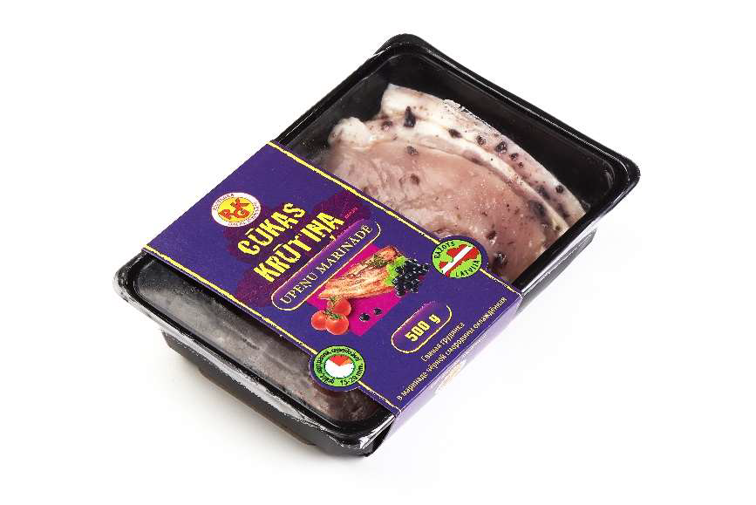 | Trays | Usually, companies already receive ready-made containers, which are hermetically sealed after placing the products.
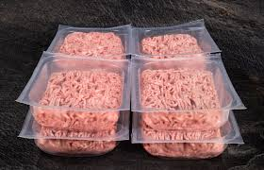 | Thermoformed packages | These packages are usually made in-house from a roll of packaging.
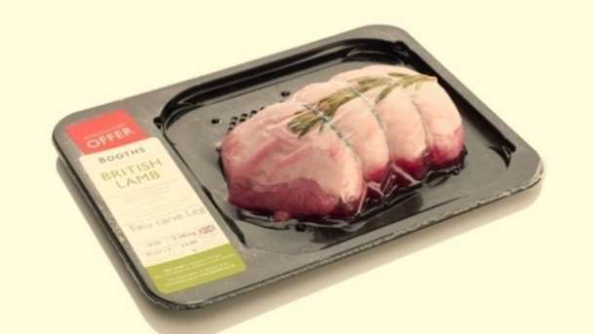 | SKIN package | As a rule, companies use a packaging tray on which, after placing the product on it, the upper film is fused to the base of the package

These three packaging technologies are mainly used for fresh meat packaging: air, vacuum and MAP packaging. When packaging products in an air environment, the packaging materials do not have specific characteristics. When packaging products in vacuum or MAP, it is important that the packaging materials have high gas barrier properties.
Multi-layer films. Practically all the other films used for meat packaging are designed to be strong oxygen and water vapour barriers. In order to fully achieve these requirements, films with good oxygen and water vapour barrier properties are combined.

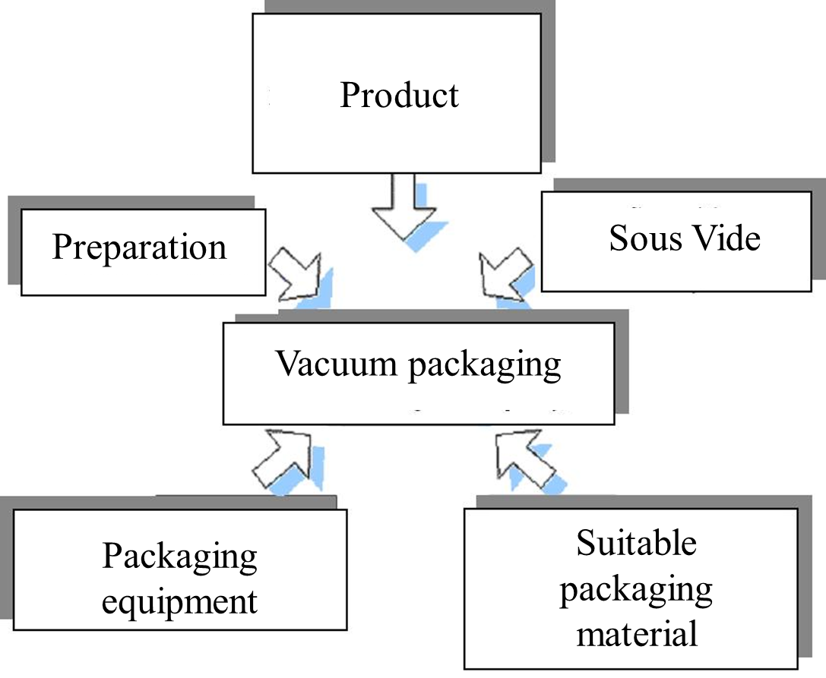
Figure 1.1. The vacuum packaging process was influenced by these aspects
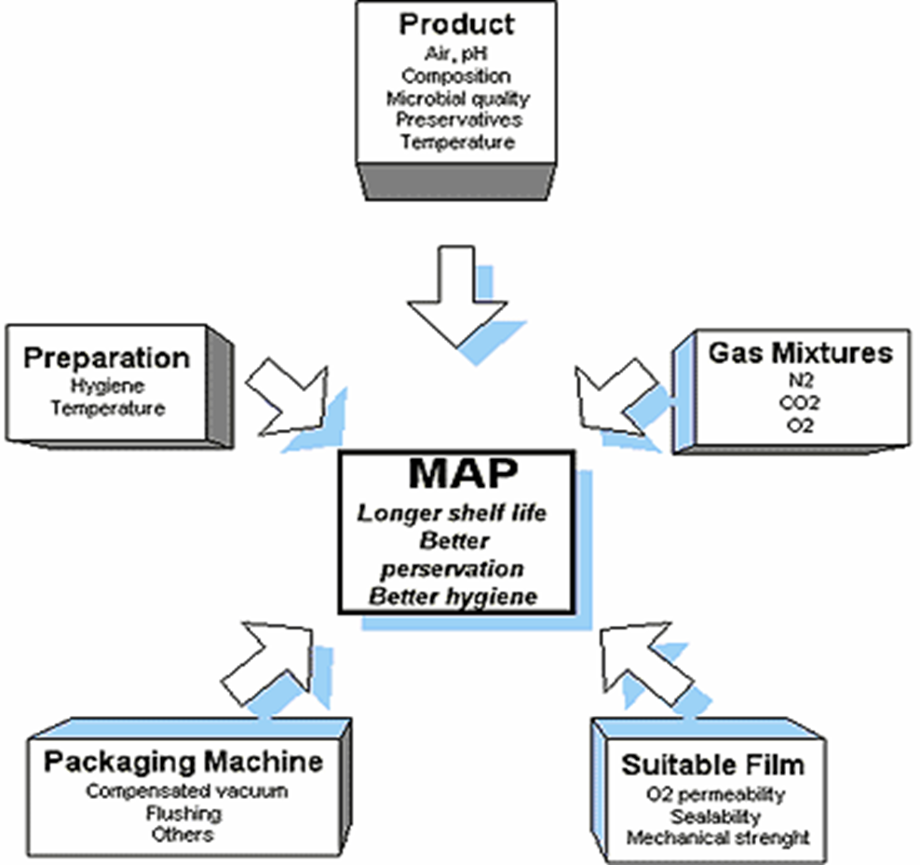
Figure 1.2. MAP process was influenced by these aspects
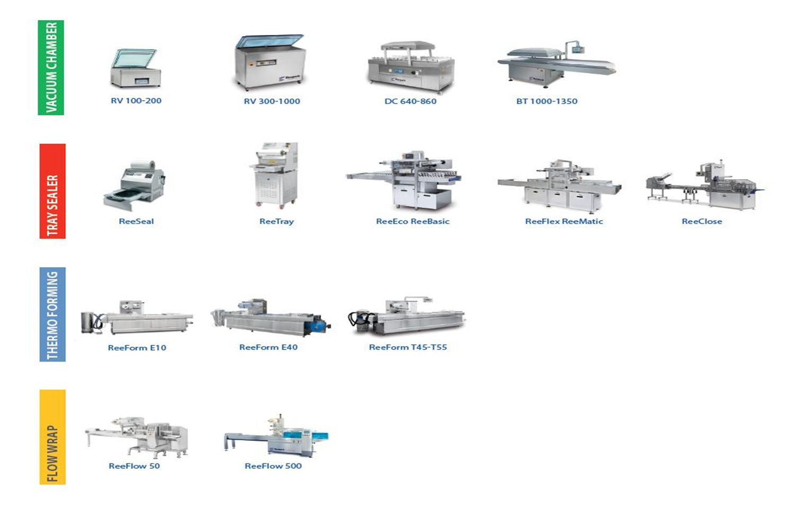
Figure 1.3. The most typical packaging equipment used for packaging meat / meat products
Chamber type machines and tray sealers are usually used by smaller production companies, while flow-wrap and flow-packs (horizontal and vertical) as well as thermoforming machines are usually used by larger capacity companies because of the high output of these machines.
All packaging equipment and technologies have their pros and cons, therefore, when choosing the equipment, some aspects should be evaluated.

Laboratory work

Evaluation of the chemical composition of meat using physico-chemical quality analysis methods

Materials
Different types of minced meat samples, an oven for drying at 150 ± 2 ºC temperature, scales with a precision of 0.01 gramme, prepared and preheated sands, metal crucible with lid and glass stick, porcelain bowl, H₂SO₄ of 1.5 density solution, butyrometer, sulfuric acid solution, water bath for heating samples at 70 to 75 °C temperature, centrifuge with 800 to 1 000 rpm, preheated porcelain crucibles, muffle for heating samples at 600 to 800 °C temperature, scales with a precision of 0.0001 gramme, Kjeldahl apparatus (mineralisation block and distillation unit), 250 mL mineralisation tubes, pipettes, cylinders, Kjeltabs tablets Cu/3.5 (3.5 g K₂SO₄, 0.4 g CuSO₄ per tablet), concentrated sulfuric acid solution, H₂O₂ (30 to 35% concentration) solution, distilled water, 4% boric acid solution, 40% NaOH solution, 0,1 n HCl solution.

Methods and Procedures
Task 1. Moisture content in meat
The moisture content of the meat determines its stability during storage (as the moisture content increases, oxidation processes intensify, and favourable conditions for the development of microorganisms are created). The moisture content of the meat and meat products is determined by drying in an oven at 150 ± 2 ºC;
Rationale for the method
To speed up the drying process, the meat sample is mixed with sand, which loosens the product, creates a larger evaporation surface, and prevents the formation of a drying layer. Before use, sift the sand through a sieve with holes 1-3 mm in diameter and wash, while stirring with water, to remove clay particles. When the water is no longer cloudy, drain it, add 1:1 diluted hydrochloric acid to the sand, mix and stand for one day. The sand is then rinsed in running water while stirring until neutral, then rinsed in distilled water. Dry and heat in a muffle oven. Store sand in a closed container. To determine the moisture, grind the meat sample twice in a meat mincer (meat grinder) with a sieve-hole diameter of 3 to 4 mm, mixing the resulting mass thoroughly each time. Determine the moisture content by drying the samples at 150 ± 2 ºC.
Procedure
Pour the heated sand into the metal crucible, which is 2-3 times the weight of the meat sample, put the lid on and weigh, for example 3 g of meat with 9 g of sand.
Weigh into a metal crucible about 3 g of the meat sample, weigh, mix thoroughly with sand using a glass stick and dry in an open oven at 150 ± 2 ºC for 1 hour, then place the lid on the metal crucibles, cool in a desiccator to room temperature and only then weigh it.
The moisture content in % is calculated according to the formula:
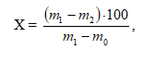
where: m₁ – mass of metal crucible with lid, sands, glass stick and sample before drying, g;
m₂ – mass of metal crucible with lid, sands, glass stick and sample after drying, g;
m₀ – mass of metal crucible with lid, sand and glass stick, g.

Task 2. Determination of fat content with a fat meter (butyrometer)

Background
The method for determining the fat content is based on treating the product with concentrated sulfuric acid solution, separating the fat with isoamyl alcohol, and further separating by centrifugation. Sulfuric acid breaks down proteins and separates fats easily. Further addition of isoamyl alcohol forms an isoamyl alcohol sulfuric acid ether, which reduces the surface tension of the fat globulesand promotes their adhesion. The formation of a fat layer is accelerated by heating and centrifuging the solution. During centrifugation, the fat, as the lightest component under the influence of centrifugal force, is concentrated closer to the centre on the scale of the fat gauge.
Procedure
Weigh 1 to 3 g (±0.01g as near as possible, you need to be extremely close) of the prepared sample, place in a porcelain bowl, add 5 mL of H₂SO₄ of 1.5 density, mix with a glass rod and heat (do not boil) for 5 to 10 minutes until a homogeneous mass is obtained. If the globules do not break, add another 2-3 mL of acid, reheat. Pour the resulting solution through a funnel into a butyrometer previously filled with 5 mL of sulfuric acid, rinsing the residue from the dish with small portions of sulfuric acid. Then pour 2-4 mL of isoamyl alcohol into the fat meter, close the fat meter with a rubber stopper and mix by inverting the butyrometer 2-3 times. The butyrometer is then placed with the stopper down in a water bath at 70 to 75 °C for 10 minutes and then centrifuged for 15 minutes at 800 to 1 000 rpm.
After centrifugation, place the butyrometer again in a water bath at 60 to 75 °C and after 5 minutes read the number of graduations taken up by the fat on the butyrometer scale.
The fat content in % is calculated according to the formula:
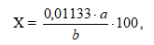
where: 0.01133 – the quantity of fat corresponding to one part by mass of the fat meter, g;
a – is the number of small sections of the fat-gauge occupied by the fat column;
b – product weight, g.

Task 3. Determination of ash content

Background
When organic compounds are heated, they decompose into carbon dioxide, water, ammonia and minerals, which remain ash. The amount and composition of ash in animal products depends on the chemical composition of the feed, the animal species, etc.. The physiological and technological value of the product can be judged by the composition and quantity of the ash.
During the ashing process, the mineral content of the product under investigation can be converted into volatile products, therefore ashing should be performed at a temperature of 550 ºC - 600 ºC. If the meat product contains a lot of moisture, the sample is first dried in an oven. To determine the ash content of meat with a high fat content, as well as the fat itself, the weight is first burned in a crucible containing ashless filter paper. Relationship between the glow colour and temperature: dark red onset - 525 ºC; dark red - 700 ºC; beginning of cherry colour - 800 ºC; cherry colour - 900 ºC; light cherry colour - 1000 ºC; dark orange - 1100 ºC; light orange - 1200 ºC; white - 1300 ºC; bright white - 1400 ºC; silvery white - above 1500 ºC.

Procedure.
Heat a clean porcelain crucible (approximately 1 hour) in a muffle furnace at 600 ºC, cool it in a desiccator and weigh, then heat, cool and weigh to constant weight. Repeat the weighing every 30 minutes. The mass is considered constant until the difference between the two weights is not more than 0.0002 g.
Weigh, to the nearest 0.0002 g, 2 to 5 g of the sample into the heated crucible. Initially, the incineration is carried out at a lower temperature (on an electric hob) to avoid weight loss. The combustion is carried out in a fume cupboard until the intense smoke is eliminated. Then place the crucible in a muffle furnace and continue incinerating at 600 to 800 °C for 1 to 2 hours.
If the residue is incomplete (dark ash with carbon particles), cool the crucible, moisten the ash with water, saturated ammonium nitrate or 30 drops of 30% hydrogen peroxide solution and continue to ash. This process is completed when the ash is white, yellowish or brownish. Ashing is carried out to a constant weight.
The ash content in % is calculated according to the formula:
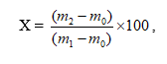
where: m₀ – empty crucible, g;
m₁ – crucible with the sample, g;
m₂ – crucible with the ash, g.

Task 4. Determination of protein content
The amount of protein in a product is judged by the amount of nitrogen in it. The total nitrogen content of the product can be determined by the Kjeldahl method

Background
A food is digested with a strong acid so that it releases nitrogen which can be determined by a suitable titration technique. The amount of protein present is then calculated from the nitrogen concentration in the food. The same basic approach is still used today, although several improvements have been made to speed up the process and to obtain more accurate measurements. It is usually considered to be the standard method of determining protein concentration. Because the Kjeldahl method does not measure the protein content directly, a conversion factor (F) is needed to convert the measured nitrogen concentration to a protein concentration. A conversion factor of 6.25 (equivalent to 0.16 g nitrogen per grammme of protein) is used for many applications, however, this is only an average value, and each protein has a different conversion factor depending on its amino-acid composition. The Kjeldahl method can conveniently be divided into three steps: digestion, neutralisation and titration.
Digestion. The food sample to be analysed is weighed into a digestion flask and then digested by heating it in the presence of sulfuric acid (an oxidizing agent which digests the food), anhydrous sodium sulphate (to speed up the reaction by raising the boiling point) and a catalyst, such as copper, selenium, titanium, or mercury (to speed up the reaction). Digestion converts any nitrogen in the food (other than that which is in the form of nitrates or nitrites) into ammonia, and other organic matter to CO₂ and H₂O. Ammonia gas is not freed in an acid solution because the ammonia is in the form of the ammonium ion (NH₄⁺) which binds to the sulphate ion (SO₄²⁻) and thus remains in solution:
N (food) → (NH₄)₂SO₄
Neutralisation. After the digestion has been completed the digestion flask is connected to a receiving flask by a tube. The solution in the digestion flask is then made alkaline by the addition of sodium hydroxide, which converts the ammonium sulphate into ammonia gas:
(NH₄)₂SO₄ + 2 NaOH → 2NH₃ + 2H₂O + Na₂SO₄
The ammonia gas that is formed is freed from the solution and moves out of the digestion flask and into the receiving flask – which contains an excess of boric acid. The low pH of the solution in the receiving flask, converts the ammonia gas into the ammonium ion, and simultaneously converts the boric acid to the borate ion:
NH₃ + H₃BO₃ (boric acid) → NH₄⁺ + H₂BO₃⁻ (borate ion)

Titration. The nitrogen content is then estimated by titration of the ammonium borate formed with standard sulfuric or hydrochloric acid, using a suitable indicator to determine the end point of the reaction.
H₂BO₃⁻ + H⁺ → H₃BO₃

The concentration of hydrogen ions (in moles) required to reach the end-point is equivalent to the concentration of nitrogen that was in the original food. The following equation can be used to determine the nitrogen concentration of a sample that weighs milligrams using a 0,1 M HCl acid solution for the titration.

Procedure
Use nitrogen-free weighing paper to facilitate weighing of the samples. Weigh, to the nearest ± 0,1 mg, 0.5 g of the sample into a 250 mL mineralisation tube. Add 2 Kjeltabs tablets Cu/3.5 (3.5 g K₂SO₄, 0.4 g CuSO₄ per tablet) to the mineralisation tube and, depending on the contents of the sample, add 12 to 15 mL of concentrated sulfuric acid. Shake it gently to soak the entire sample. When the paper used for weighing the sample has dissolved, add 5 mL of H₂O₂ (30 to 35% concentration). Place the tubes in a mineraliser heated to 420 ºC and place the hood on the tubes, and switch on the water aspirator.
Mineralise for 60 minutes until the contents of the tube are clear, greenish blue. Then remove the tubes from the mineraliser without removing the hood and cool the tubes in a fume hood for at least 15 minutes. Add 80 mL of distilled water to each chilled mineralisation tube and place in a distillation apparatus. Pour 25 to 30 mL of the receiving solution (boric acid solution) into a 250 mL conical flask which is placed in the distillation apparatus so that the end of the exhaust pipe is below the surface of the boric acid solution. Add 50 mL of 40% NaOH by distillation apparatus automatically. The distillation unit is operated according to the user manual. During the distillation process, the steam "transfers" the ammonia to the receiving flask. Distillation is continued for 5 minutes.
Titrate the trapped ammonia with 0,1 n HCl until the solution changes from green to pink, recording the acid consumption.
The protein content is calculated according to the formula:
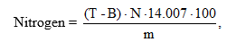
where: N – normality of the acid solution, 0.1;
B – the quantity in mL of 0.1 N HCl used to titrate the control sample;
T – the quantity in mL of 0.1 N HCl used to titrate the sample;
m – the weight of the sample, mg.
% Protein = Nitrogen content (%) × F
F = protein factor = 6.25 for meat and meat products.
The carbohydrate content in % can be calculated using the following formula:
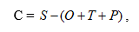
where: S – dry matter content, g;
O – protein content, g;
T – fat content, g;
P – ash content, g.

Results
Draw conclusions, and compare the obtained results with the information available in the literature and scientific publications.

Conclusion
1.
2.
3.

Approved by _____________________
Name, Surname, signature
Date ______________

Theme 2

Biochemical and microbiological developments in meat

Theoretical materials
Meat is defined as “the edible part of the skeletal muscle of an animal that was healthy at the time of slaughter”. Chemically, meat is composed of four major components including water, protein, lipid, carbohydrate and many other minor components such as vitamins, enzymes, pigments and flavour compounds. The relative proportions of all these constituents give meat its particular structure, texture, flavour, colour and nutritive value. However, because of its unique biological and chemical nature, meat undergoes progressive deterioration from the time of slaughter until consumption. Meat is a nutritious, protein-rich food which is highly perishable and has a short shelf-life unless preservation methods are used. Shelf life and maintenance of the meat quality are influenced by a number of interrelated factors, including holding temperature, which can result in detrimental changes to the quality attributes of meat.
Biochemical changes in meat during post mortem. In the living animal, aerobic metabolism is used to obtain energy. After slaughter, aerobic metabolism begins to fail due to the stored oxygen supply being depleted. After exsanguination, cessation of blood circulation shifts muscle metabolism from aerobic to anaerobic. It has been reported that when muscle contracts in an anaerobic environment, glycogen disappears and lactic acid becomes the principal end product of glycolysis; whereas under aerobic conditions, lactic acid does not accumulate as it is oxidised to CO₂ and water. One molecule of glucose will generate 3 moles of ATP via anaerobic glycolysis providing the high-energy phosphates necessary for post mortem (anaerobic) muscle contraction. Creatine phosphate is rapidly depleted as a result of post-mortem metabolism, yet ATP may be maintained for several hours from anaerobic glycolysis. Accumulation of lactic acid in post-mortem muscle reduces the localised pH and muscle is converted to meat. The conversion of glycogen to lactic acid will continue to lower the muscle pH until the glycogen (or ATP stores) are depleted or until the contractile proteins cease to function as a result of the low intramuscular pH. The sequence of chemical steps by which glycogen is converted to lactic acid is essentially the same post-mortem as in vivo when the oxygen supply may become temporarily inadequate for the provision of energy in the muscle; but it proceeds further. Except when inanition or exercise immediately pre-slaughter has appreciably diminished the reserves of glycogen in muscle, the conversion of glycogen to lactic acid will continue until a pH is reached when the enzymes affecting the breakdown become inactivated. In typical mammalian muscles this pH is about 5.4–5.5. An initial level of 600 mg glycogen/100 g muscle is required to attain this pH. Muscles that have an ultimate pH of 5.4–5.5 after post mortem glycolysis may still contain some residual glycogen, even though it is generally considered that there will be no residual glycogen if the pH fails to fall to 5.4–5.5 during post-mortem glycolysis. The final pH attained, whether through the lack of glycogen, inactivation of the glycolytic enzymes or because the glycogen is insensitive (or inaccessible) to attack, is referred to as the ultimate pH; this is generally about 5.5, which is the iso-electric point of many muscle proteins. Both the rate and the extent of the post-mortem pH fall are influenced by intrinsic factors such as species, muscle type and variability between animals; and by extrinsic factors such as the administration of drugs pre slaughter and the ambient temperature; pre slaughter exercise is also a known factor which produces dry firm dark (DFD) meat which has a pH of around 7.0 (http://www.ifrj.upm.edu.my/18%20(03)%202011/4)IFRJ-2010-227.pdf).
Meat is a complex of muscle, fatty, connective and bone tissue, the quality of which is determined by the quantitative proportions of its components. Morphological composition of meat depends on animal species, age, sex, fattening, technological processing. Meat quality is also influenced by transport, pre-slaughter holding, and slaughter method of animals. Meat quality mostly depends on its storing conditions.
External appearance. External appearance is characterised by the overall appearance of a product or carcass meat; attention is paid to presence of mould on the surface, extraneous inserts and drawing of a cut (of products), drying of carcass meat. Bruising, clots, residues of skin and the internal organs not only impairs commercial appearance of meat but also decreases its durability for storing.
Meat colour. It is one of the main quality characteristics evaluated by a consumer first: based on this characteristic, an opinion about the commercial appearance of meat is formed. Meat colour depends on various factors: firstly, on the muscle tissue pigments haemoglobin and myoglobin as well as the amount of their compounds; also on pH, quantitative proportion of fatty and connective tissue, mode of technological processing, storage conditions, etc.
Odour and flavour. These are also important quality characteristics which are determined by the chemical compounds characteristic to a product. Meat odour and flavour depends on the animal age, sex, the amount of fatty tissue and the nature of its distribution. Meat from a previously sick, scraggy animal will always taste worse. The flavour of fresh meat is specific, somewhat sweetish. Meat from goats does not have a strong taste or smell, whereas meat from cattle has a stronger specific smell and a less pleasant taste.
Consistence. It is one of the most important quality characteristics of meat and meat products which is evaluated quite strictly by a consumer. The concept of consistency is rather wide and difficult to define. When evaluating meat consistency, its softness, tenderness, juiciness, etc. is evaluated. Meat consistency is highly dependent on the condition of the myofibril proteins, the ratio of fatty and connective tissue, the pH of the muscle tissue, the level of hydration of the muscle proteins and other meat characteristics. The consistency of meat changes when stored in refrigerated conditions, when corned, and after thermal processing. When storing meat, its quality characteristics change; the intensity and character of the change depends on the storing conditions and mode, also on the composition and characteristics of the meat.
Putrefaction of meat. It is the main and most frequent type of meat deterioration. Putrefaction of meat is caused by proteolytic microorganisms, growth of which requires proteins or products of partial protein hydrolysis. This process can take place under both aerobic and anaerobic conditions, and its progress depends on the following factors:

1. Type of meat;
2. Initial microbial contamination and micro flora composition;
3. Meat pH;
4. Water content in the upper layers of meat or water activity;
5. Destructive properties of proteins;
6. External environmental factors (storing conditions).

Usually, putrefaction processes begin on the surface of meat when aerobic microorganisms from the environment start acting.
The first sign of aerobic putrefaction is the formation of mucus on the surface of the meat. At the initial stage of putrefaction, the previously red colour of meat gradually turns grey. At the deep stage of putrefaction, the colour of meat turns greenish. In the event of the aerobic decomposition, the meat pH is between 7.0 and 8.0, the meat has an unpleasant smell, however less strong than that of aerobic putrefaction.
Anaerobic putrefaction of meat begins in thick muscle layers, near bones, and joints. During this process, organic compounds are discharged which accumulate among muscle plates, the structure of the meat becomes porous, an unpleasant smell is present, the colour of the meat changes to blue-red or grey-green. Alkaline pH values (8.0 < pH > 9.0) are typical for such meat.
When carrying out sensory evaluation of raw material (meat), it must be ensured that: 1) The raw material was obtained from animals corresponding to the health requirements established in the EU legislative acts; 2) The raw material was obtained from enterprises following HACCP or the principles of good hygiene practices; 3) The raw material was transported using vehicles that meet the requirements applicable to such raw material; 4) The raw material has received a veterinary certificate with a health mark or other identification mark in accordance with the requirements provided for in the legislative acts; 5) The raw material is fresh.
When the compliance of documents received with raw material is assessed, the most important thing is to determine whether the raw material (meat) is fresh.

Contamination, safety and risk assessment of meat
Food safety is becoming a global problem, leading governments and public health organizations in many nations to search for more effective methods of production chain monitoring. As part of a comprehensive strategy for managing food hygiene, providing food hygiene training to all individuals who handle food could potentially lower the prevalence of food-borne illnesses. When food hygiene instruction is founded on an appropriate constellation of strategies created in accordance with successful health education theories and models, its efficacy could be significantly increased. These models could aid in the creation of strategies that take into account the social and environmental aspects that affect food safety in addition to the information that aims to change attitudes and behaviours. It is commonly known that the HACCP system is a management technique that can guarantee food safety. Food safety experts have understood the value of HACCP principles for reducing the risk factors that directly cause foodborne illness since the 1960s. However, according to European Union (EU) Directive 93/43/ EEC and Regulation 852/2004/EC, the application of HACCP principles is required at all stages of the food chain. Analysis of Hazards Crucial Control Point - the well-proven HACCP management system gives customers assurance about the safety of their food. The system is built on focused control at operation points, which could be essential to food safety. By promoting involvement in a system that guarantees the control of risk factors for foodborne illness, the principles of HACCP exemplify the idea of active managerial control. The fundamental idea behind the HACCP method is that dangerous or potentially harmful practices can be identified early in the food processing process. In the case of meat hygiene, the qualitative recognition of unseen microbiological and chemical contamination, rather than grossly-apparent abnormalities are now the most important sources of hazards to human health which has led to increasing demands for a more systematic regulatory approach to combat these hazards.

Food safety based on HACCP
Throughout the food supply chain, HACCP is a risk management method that finds, assesses, and controls hazards connected to food safety. It is commonly known that the hazard analysis and critical control point system is a management technique that can guarantee food safety. The system's main phrase is "prevention," which refers to identifying potential contaminants before they happen and defining control measures as maximising food safety at every stage of the procedure. Throughout the operation, the HACCP program can be used to manage chemical, biological, and physical risks. Customers and regulatory agencies can be assured by the plan that you are taking all necessary precautions to ensure food safety. It also aids in improving the design of new food products and lowering contamination linked to food losses. The ISO 9001 quality management system (QMS) and ISO 22000 food safety management systems (FSMS) are displayed in Fig. 2.1.
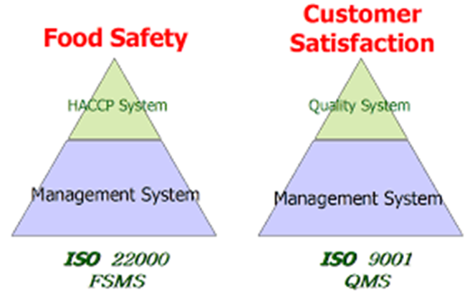
Figure 2.1. Food safety and customer satisfaction (Quality Resource Corporation)

ISO 22000:
According to Quality Resource Corporation, the ISO 22000 standards systematise and include the 12 phases and 7 HACCP principles. This is a requirement for Food Safety Management Systems (FSMS), which aims to provide security in all food chain industries. In order to guarantee food safety throughout the food chain up to the point of final consumption, ISO 22000 specifies the standards for an FSMS that incorporates the following widely acknowledged essential elements:
- Interactive communication,
- System management,
- Prerequisite programs,
- HACCP principles.
The organisation shall establish, document, implement and maintain an effective food safety management system and update it when necessary in accordance with the requirements of ISO22000 System.

ISO 9001:
Quality Resource Corporation (2009) defined ISO 9001 as the benchmark for customer satisfaction since it ensures the security of customers purchasing goods or receiving services by verifying and approving a business's Quality Management System. Building this system within your business also offers a significant benefit in terms of boosting constitutional improvement, consumer confidence, and other factors. In compliance with the ISO 9001 Standard, the business must create, record, implement, and maintain a quality management system and continuously enhance its efficacy. The company will:
a) Determine the processes needed for the quality management system and their application throughout the organization,
b) Determine the sequence and interaction of these processes,
c) Determine criteria and methods needed to ensure that both the operation and control of these processes are effective,
d) Ensure the availability of resources and information necessary to support the operation and monitoring of these processes,
e) Monitor, measure where applicable, and analyse these processes, and
f) Implement actions necessary to achieve planned results and continual improvement of these processes.

HACCP plan principles
Basic HACCP principles are as:
- Identification of food hazards and the necessary risk control measures,
- Identification of the food safety Critical Control Points (CCPs),
- Determination of the critical limits for each CCP,
- Establish monitoring procedures for CCPs,
- Plan and take corrective action when critical limits are exceeded,
- Establish verification procedures for the HACCP FSMS system,
- Establish documentation and record keeping for the HACCP FSMS system.

Requirements for the HACCP plan to be completed: To guarantee fundamental hygienic conditions in the processing plant, a few "prerequisite programs," such as good manufacturing practices and cleaning protocols, should be set up prior to the implementation of HACCP principles. Good manufacturing practices and sanitation standard operating procedures are the primary preparatory programs. The physical layout and upkeep of the facility, the water supply, the health and personal hygiene of the handlers, pest control, equipment sanitisation, instrument calibration, quality control of raw materials and ingredients, recall procedures, and consumer complaint handling are all included in these programs. The fundamental requirements for HACCP implementation in the food sector are depicted in Figure 2.2.
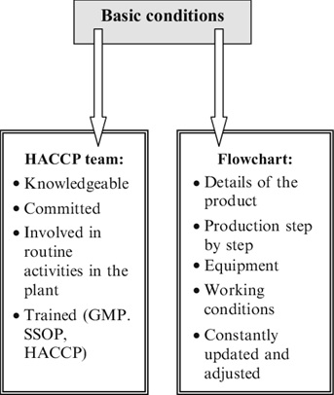
Figure 2.2. Basic conditions for HACCP implementation in the food industry

Impact of HACCP for Food Safety: The growing recognition of HACCP as the most economical approach to managing food-borne illnesses and the consequent spread of HACCP implementation have underscored the necessity of unambiguous directives regarding the training prerequisites essential for successful HACCP execution. Significant developments in food production over the past few decades, including improved manufacturing techniques, shorter time frames between production and consumption, longer product shelf lives, and a rise in the presence of some bacteria, have made the pursuit of safety more difficult.
HACCP is a crucial instrument for contemporary quality control in the food business, guaranteeing product integrity, avoiding FBDs, and safeguarding consumer health. Only until its principles are correctly and widely implemented at every stage of the food supply chain will HACCP become effective. The frequency of foodborne illness (FBD) outbreaks has increased recently, and some of the reasons for this could be attributed to low adoption rates of HACCP in developing nations—where the majority of FBD outbreaks occur—final consumer ignorance perpetuating inadequate food handling practices, and inadequate application or implementation of HACCP, particularly in small businesses.
HACCP application in the meat industry
All links in the food chain are covered under the Food Safety Act of 1990, which also makes it possible to enact laws like the Meat Products (Hygiene) Regulations of 1994. Since a significant amount of meat products are traded internationally, the meat sector places a high value on HACCP acceptance. The supplier of raw beef products will benefit from an HACCP program to monitor the microbiological condition of items entering the processing plant.
A person who works in the meat sector would be acquainted with the butchery and slaughterhouse procedures. In order to learn about the agricultural methods used from the time an animal is born until it arrives at the slaughterhouse, they should also get in touch with the farmers. Since the animal is a source of pathogenic and spoilage organisms, adopting HACCP should be used to manage every important control point at every stage of the animal's slaughter. Employees in the meat and poultry industries should also strive to protect themselves by donning a variety of safety gear and other items.
The organism has the potential to contaminate the carcass during the slaughter process. A 0.2% incidence of E. coli 0159:H7 was found on raw beef carcasses according to the USDA's statewide beef microbiological baseline collection program for steers and heifers (no E. coli 0157:H7 was observed on pork carcasses in the market hog study). Although there have been cases of cross-contamination from animal food to other foods, E. coli 0157:H7 contamination in foods is typically linked to animal goods, particularly ground beef. The pathogen E. coli 0157:h6 is resistant to freezing and refrigeration. If the bacteria is present, it can grow extremely slowly at 6 °C and could show up in a fermented product since it can endure for extended periods of time in an environment with a pH of 3.6 to 7.0, barring destruction by heat or other processes. The precise methods to be employed in order to destroy E. coli 0157:H7 frequently involve a mix of temperature, pH, Aw control, and microbiological controls in raw materials. Figure 3 illustrates how people usually wear a variety of safety and other equipment to help protect themselves from sickness and harm.
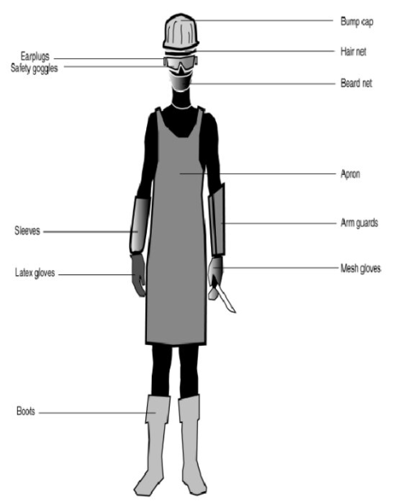
Figure 2.3. Safety and other equipment worn by meat and poultry production workers

Using HACCP in meat processing: To ensure the safety of the product generated by a processing system, both individual processors and processors working under the control system must establish a high degree of qualified potency. Generally speaking, the processing of meat involves implementing HACCP to prevent and decrease hazards to safe levels. The first step is to identify the many risks—such as microbiological, chemical, and physical risks that are connected to raw meat. Microbiological risks are the primary ones connected to raw meat, and they are managed both in farms and at abattoirs. Starter culture and the addition of curing salt are other essential control points. These components must be of the highest calibre to stop additional contamination and to work well to create the ideal environment for the development of beneficial bacteria utilised in fermented goods. Because the pH value drops quickly during the fermentation stage, most harmful microbes are inhibited from growing, making it another crucial CCP. The steps of heating and drying may cause a decrease in the number of organisms and growth inhibition. Raw fermented meat production is depicted in Fig. 4. Assemble the evolution of a HACCP plan for refrigerated beef ravioli in order to facilitate the HACCP discussion.
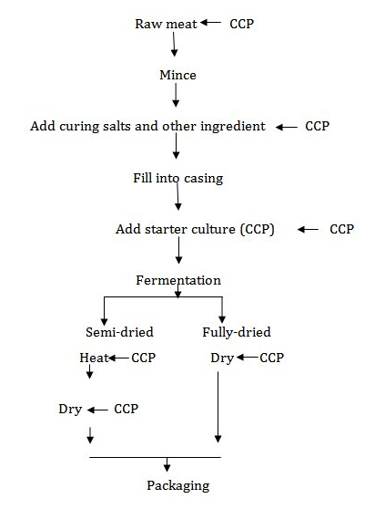
Figure 2.4. Flow diagram for the production of raw fermented meat

Control of meat and poultry products linked to microbiological hazards:
Because red meat and poultry are products of warm-blooded animals, their microbial flora is diverse and includes both mesophilic and psychrotropic bacteria. These bacteria include pathogenic species that come from the animal itself, environmental sources, and bacterial species that are added during raw product processing and slaughter. The pH range of 5-7 and aw>0.09 found in raw meat and poultry provide the ideal conditions for microbial development. When processing meat and poultry, a variety of control procedures are needed. Additives including sugars, nitrates, and salt are used in the cooking and smoking processes of cured meats and some sausage products. Bacterial biota may be limited to salt-tolerant species by salt. Numerous vegetative cells will be destroyed by cooking and smoking. It is important to take into account the possibility of introducing microorganisms, including pathogens, into packaged products due to factors such as product handling, processing environment, and packaging. Products made from meat and poultry have a long history of meeting requirements. Apart from the aforementioned requirements, specific combinations of pH, aw, and other variables can be employed to inhibit the growth of pathogens, which would otherwise escalate when meat products are stored at room temperature. Retail-processed goods, which are exempt from the HACCP regulation, should adhere to this recommendation and keep records regarding the management of risks.
Good manufacturing practices
Programs known as good manufacturing practices (GMPs) are made up of fundamental, universal actions and procedures that regulate working conditions in businesses and guarantee ideal circumstances for the production of safe food. The control factors known as GMPs are not process-specific; rather, they pertain to the entire operation. Programmes including pest control, recall protocols, building and maintenance, and cleanliness are examples of GMPs. To guarantee that GMPs are followed, there are detailed instructions that tell people what, how, and when to do the duties necessary to meet GMP requirements. The microbiological conditions of the product are given particular consideration in order to prioritise the safety and quality of processed goods.

Food safety hazard
The goals for food safety that regulatory bodies are currently adopting purport to take into account the idea that resources should be distributed in a way that minimises costs in order to identify and control the hazards that are most important to public health. Any biological, chemical, or physical substance, or food condition, that has the potential to hurt or negatively impact one's health when consumed, is considered a food safety hazard. Food safety risks are categorised as follows:
- Biological such as microorganisms,
- Chemical such as chemicals, pesticides, cleaning agents and allergens,
- Physical foreign objects that are not supposed to be in the food, such as timber, glass, packaging material and naturally occurring objects – bones, dust and grit.
Any business should aim to reduce the risk of these hazards in its food processing and service ensuring the food is safe to consume. A food safety programme outlines the systems in place to keep food safe and procedures which reduce the risk of the hazards which may occur in the food production and service business.

Physical hazards:
Physical hazards which can be found in food include:
- Objects naturally present in the food (animal hair, bone chips, leaves, etc.),
- Objects occurring in agriculture (dirt, manure, leaves, etc.),
- Objects added during processing (glass, plastic, hair, metal, etc.).

Reducing physical hazards is relatively simple in most hospitality businesses as they are physically visible in the food. They are normally controlled by procedures such as a visual inspection of food and good kitchen procedures such as no wood or glass policy, and keeping the food covered.

Chemical hazard:
Chemical hazards which can be found in food include:
- Naturally occurring poisonous chemicals (poisonous plants such as rhubarb leaves and mushrooms, poisonous animals such as puffer fish, algal blooms, mould toxins, etc.),
- Chemicals added via water, agricultural chemicals from soils, plants and animals (pesticides, antibiotics, dips, heavy metals, etc.),
- Chemicals added during food processing (additives, cleaners, etc.).

Some people have an allergic reaction to certain ingredients or parts of food. Common allergens include: soybeans and their products, seams, cereals containing gluten, milk and milk products, sulphites, egg and egg products, peanuts and their products, fish and fish products.
Chemical hazards in foods can be controlled by:
- Purchasing from an approved supplier,
- Covering food and protecting it from contamination,
- Having an allergen awareness, and strategies to prevent cross contamination from allergens,
- Separate chemical storage area, away from food,
- Use of food safe chemicals within the food preparation areas,
- Correct cleaning procedures.

Biological hazards:
Hazards that are present in foods and can come from multiple sources. These microorganisms (commonly called “germs”) are so small they can only be seen under a microscope. Not all microorganisms are harmful to humans. Pathogens are the microorganisms which cause harm to humans, when they reach a high level in food. Some examples are:
- Bacteria e.g., Salmonella, Staphylococcus aureus, Bacillus cereus,
- Viruses e.g., hepatitis A, influenza,
- Yeasts,
- Moulds,
- Protozoa e.g., Guardia.

Most food poisoning is the result of these microorganisms growing in food. When food is in moist and warm conditions, they multiply to an “infective dose” which makes a person ill. Most food poisoning occurs due to the continued growth to dangerous levels of microorganisms, particularly bacteria, in food. Food handlers should know about food poisoning bacteria and the conditions they require for growth, to ensure food borne illness is avoided. It is important to be aware of the different types of food safety hazards which may pose a significant risk to the safety of your customers. Situations when food safety hazards are likely to pose a significant risk are:
- Handling “potentially hazardous foods” which are susceptible to microorganism’s contamination and growth. These are low acid, high protein foods such as meat, eggs, poultry, seafood and dairy items,
- Handling raw food and fresh foods - handling food with your hands, rather than using equipment; cooking food - food needs to be cooked thoroughly to kill microorganisms,
- Chilling food - food needs to be chilled quickly to reduce the growth of microorganisms,
- Defrosting foods,
- Reheating foods,
- Displaying food on buffets or self-service.

Laboratory work Assessment of meat freshness using sensory, physic-chemical and microbiological quality analysis methods

Materials
Different types of meat samples, but for bouillon preparation the same minced meat samples, a knife, conical flasks from 100 to 250 mL capacity, distilled water, thermometer, scales with an accuracy of 0.01 grammes, scales with a accuracy of 0.0001 grammes, cylinders, pipettes, water bath for samples heating at 100 °C temperature, glass test tubes for chemical evaluation of meat freshness, 5% CuSO₄, Nessler reagent (double salt of mercury iodide and potassium iodide, melted in potassium hydroxide), 0.2% benzidine spirituous (96%) solution, 1% fresh H₂O₂ solution, 1% phenolphthalein spirituous solution, 0.1 n NaOH solution, 0.1 n KMnO₄ solution, 0.4 n H₂SO₄ solution, pH-meter, funnels, filter paper, 100 mL graduated flask, 10% aluminium alum [AlK(SO₄)₂·12H₂O] solution, saturated Ba(OH)₂ solution, formalin (titrated till neutral reaction with indicators No. 1), indicators No. 1. (equally mixed 0.1 % neutral red and methylene blue spirituous solutions), indicators No. 2. (1 part of 0.1 proc. thimolium blue mixed with 3 parts of 1 % phenolphtalein, dissolved at 50 % of spirit).

Methods and Procedures
Task 1. Sensory evaluation of raw meat
Evaluating freshness of raw material (meat)
When determining the freshness of meat by means of sensory method, the following characteristics are determined: external appearance, colour, structure, aroma of meat, condition of fat and tendons, broth transparency as well as condition of broth fats.
External appearance is evaluated by observing the surface and deeper layers. A dry surface of the meat indicates long term storage. Appearance and colour of muscles is viewed at the fresh cut of muscles. Moreover, when the appearance of meat is evaluated, the structure of the meat is evaluated by pressing the sample with your finger. The freshness of the meat is evaluated by placing filter paper on the meat sample. If the meat is fresh, no moisture is transferred onto the filter paper, i.e. no wet stain appears on it. Evaluation of meat color. The colour is determined by observing the whole carcass of meat upon taking a sample. When the colour of the meat is evaluated, attention is paid to the fact whether the colour is typical for that type of meat. The colour of meat depends on the changes of the pigments – haemoglobin and myoglobin. The colour of the meat surface (up to 3 cm deep) is determined by the pigment oxymyoglobin. The colour of deeper layers of meat depends on the purple-red myoglobin. As microorganisms develop, the colour of the meat gets darker (sometimes it turns green) as the pigments react with various compounds formed in meat. Therefore, various pigment derivatives are formed: metmyoglobin, methaemoglobin, sulphohaemoglobin.
Under the effect of hydrogen peroxide (which is formed due to microorganism activities), myoglobin can decompose to yellow or green pigments. The colour of meat can also change due to blue-green and pink pigments which are discharged by various types of microorganisms, for example, some mould can colour meat black, white or blue-green. The colour of the muscles of fresh meat has to correspond to the type of meat, i. e. pork – from pale pink to red; beef – from pale to dark red, etc.
Determining consistency. The consistency is determined at the fresh cut of meat by gently pressing it with a finger and observing the pit equilibrating: the cut of fresh meat is firm and elastic, the pit equilibrates quickly (up to 1 minute). When the meat deteriorates, its consistency becomes soft (as opposed to firm).
Determining odor. Firstly, the smell of the surface of the carcass or a sample taken from it is determined. Then, a cut is made with a clean knife and the smell of deeper layers is determined immediately. Special attention is paid to the smell of connective tissue which is around the bones. The smell has to be specific, typical for a particular type of meat. Changes of the smell of meat appear in great part due to aromatic and of sulfur-containing amino acids decomposition, when aromatic compounds of unpleasant smell are formed (anaerobic putrefaction). The sensory characteristics of meat freshness are shown in Table 2.1.
Table 2.1.
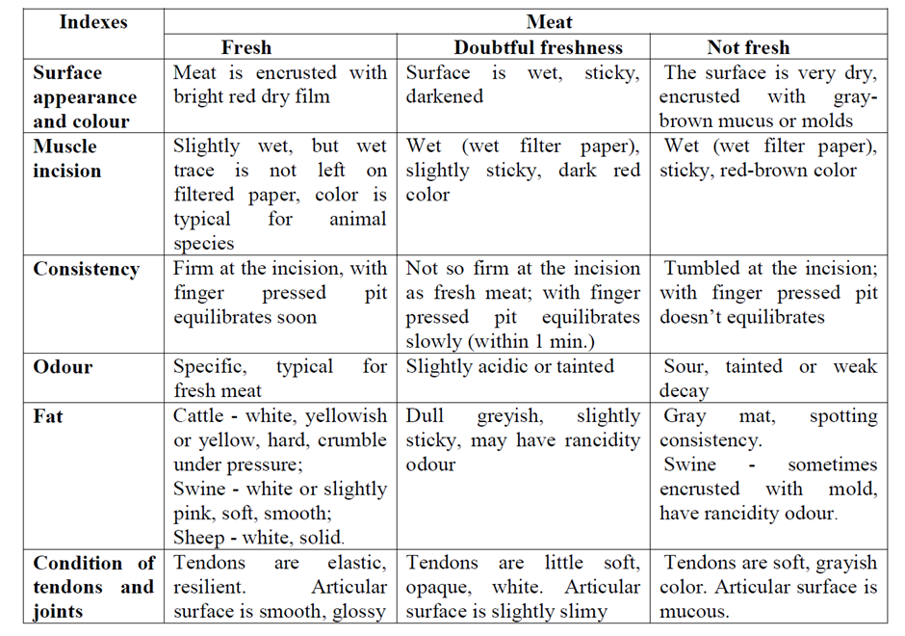
Sensory characteristics of meat freshness

Determining the transparency and aroma of bouillon. The bouillon has to be transparent and fragrant. Bouillon turbidity is caused by primary products of protein degradation dissolving in the hot water.
Meat boiling test. The meat sample is minced. Place 20 g of minced meat into 150-200 mL capacity flask, add 60 mL of distilled water, mix the content well and, after closing it with a clock glass, it is kept in boiling water for 10 minutes. When the meat sample heats to 80-85 °C, its odour is evaluated. The meat sample is filtered through a dense layer of cotton wool into a large tube and placed in cold water.
The quality of the meat bouillon obtained is determined by its aroma and colour. Pour into a cylinder (25 mL content and 20 mm diameter) 20 mL of meat bouillon and visually evaluate its lucidity (against white background).
Meat bouillon of healthy animals is lucid and aromatic. Bouillon of sick animals’ meat and of meat from animals slaughtered in agony, is muddy, with flakes, and can have an odour, which is unrepresentative of the meat.
Cold-processed meat is tested when defrosted. If there’s any doubt as to the freshness of the meat, chemical tests and tests for microbiological contamination are carried out. Meat has to be clean, without any visible additives, without extraneous smells, bruising, or blood residues.
The prepared bouillon is used to further determine the freshness of the meat by chemical methods!

Task 2. Chemical evaluation of meat freshness

2.1. Evaluation of primary protein degradation products in bouillon (copper sulphate reaction).

Background
The method is based on copper ion reaction with protein primary interaction products, forming insoluble compounds of copper sulphate.
Procedure
2 mL of meat bouillon is poured into the test-tube and 3 drops of 5% CuSO₄ solution are added. The tube is shaken 2 or 3 times and placed in the rack. After 5 minutes, analysis results are set.
Reaction with copper sulphate in bouillon:
- Fresh meat - bouillon is clear or slightly cloudy,
- Doubtful meat - bouillon with flakes,
- Not fresh meat - bouillon with bluish or greenish flakes and sediments.

2.2. Evaluation of ammonia and ammonium salts.
Background
Ammonia and ammonium salts reacting with the Nessler reagent (double salt of mercury iodide and potassium iodide, melted in potassium hydroxide) form mercuramony iodide – a substance of yellow-brown colour.
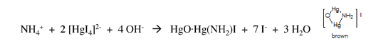
Procedure
In a test tube 1 mL of meat bouillon and 1-10 drops of Nessler reagent are added. The substance is mixed and the changes in colour and lucidity are observed.

Table 2.2.
Amount of NH₃ according to Nessler reagent drops
Drops of Nessler reagent | Colour of meat bouillon | Amount of NH₃ (mg %) | Evaluation of meat
10 | Without changes | Less than 16 | Fresh meat
10 | Transparent yellow colour or slight yellow opacity | 16-30 | The meat must be used immediately
6 | The yellow clouds are clearly visible | 31-45 | Only to be used after pre-treatment (cleaning, washing, etc.)
10 | A slight yellow precipitate which disappears after 30 min.) | 31-45 | Only use after pre-treatment
1-5 | Lots of yellow or orange precipitate | 46 and more | Meat is inedible
2.3. Peroxidase (benzidine) reaction.

Background
Activity of peroxidase enzyme depends on pH and oxidizing substances content in the extract of meat or meat bouillon. If the pH of the meat aqueous extract (1:4) or meat bouillon is less than 6.0, the peroxidase reaction is mostly positive, if the pH is 6.1-6.2 the reaction is suspicious, and if the pH is more than 6.2 it is negative. The reaction is based on the fact that, under the action of peroxidase, oxygen separates from hydrogen peroxide, which oxidises indicator benzidine and forms parachinon diamid, which, in responding to unoxidised benzinine, forms a coloured compound coloured extract blue-greenish, later changing to brown.
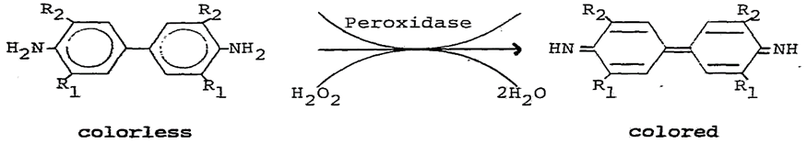
Procedure
2 mL of the tested meat bouillon are added to a test tube, later 5 drops of 0.2% benzidine spirituous (96%) solution are added and everything is mixed. Then 2 drops of 1% fresh hydrogen peroxide solution are dripped and the reaction is being observed. The filtrate of healthy animal meat within 1-2 minutes becomes blue greenish, then gets to brown (if peroxidase reaction is positive); meat filtrate of sick, weary during transport or slaughtered in agony animals turns blue green, soon changing to brown or very quickly becomes brown (negative reaction).
Peroxidase reaction can be carried out in an accelerated (express) method. On the fresh meat slices, 2 drops of 1% hydrogen peroxide solution and 5 drops of 0.2% benzidine are dropped. The reaction is considered positive if, in the place where the reagent has been applied, there appears a blue-green colour spot, which later becomes brown; if the reaction is negative, the blue-green colour spot does not form.

2.4. Evaluation of acidity-oxidation coefficient.
Background
Titratable acidity of healthy animals’ meat and its extract significantly increases because of accumulation of milk, and ortho-phosphoric and other acids. Titratable acidity of sick animals’ meat increases slightly. Meat’s oxidation depends on the amount of microorganisms and organic matter degradation products (reducing substances). Reducing matters or reducers are substances thatreduce oxidation (potassium permanganate). In turn, potassium permanganate oxidises reducers to colourless oxidation products, while reducing agents reduce potassium permanganate to colourless materials: manganese (II) sulphate, potassium sulphate and water. In meat of sick animals, titratable acidity increases slightly during the same period (24 h), while reducing material content is significantly higher than in healthy animals. Thus, there are less reducers in fresh meat of healthy animals. Characteristics of the meat titratable acidity and reducing material size vary in opposite directions. The acidity-oxidation coefficient of healthy animal's chilled meat is generally 2-3 times greater than that of the sick animals. When the meat starts to spoil, this ratio decreases.
Procedure
Evaluation of titratable acidity. 10 mL of a meat bouillon are poured into the flask No. 1 and it is diluted with 40 mL of distilled water, later 3 drops of phenolphthalein spirituous 1% solution are added and are titrated with 0.1 n of sodium hydroxide until a slightly pink colour appears and the amount of 0.1 n NaOH (mL) used for titrating is recorded.
Evaluation of reducing substances amount (oxydation). In an acidic environment, potassium permanganate oxidises organic substances which are in the tested meat extract to colourless oxidation products. Thus, the amount of potassium permanganate (oxydants) describes the amount of organic reducing substances in the meat extract. To the flask No. 2, add 50 mL of distilled water, 5 mL of 0.4n sulphuric acid solution and 1-2 drops of 0.1 n potassium permanganate solution until a slightly pink colour appears. The contents of the flask are heated to 40-50 °C (after heating if the colour disappears add an additional 1-2 drops of potassium permanganate solution). 2 mL of meat bouillon are poured into a warm flask and immediately filtered with 0.1n potassium permanganate solution till a slightly pink colour appears, not disappearing for 0.5 min. 0.1 n KMnO₄ solution (mL) consumed for flask No. 2 content titration is converted to 10 mL of extract, while 2 mL of meat extract were taken for analysis. Therefore, the amount of this solution, used for titrating of flask No. 2, is multiplied by 5.

Acidity-oxidation coefficient (AOC) is calculated using formula:
AOC = A/B
A – the amount of 0.1n NaOH solution (mL) consumed for flask No.1 content neutralisation (titration);
B – the amount of 0.1n KMnO4 solution (mL) consumed for titration of 10 mL of flask No.2 content.
Evaluation: AOC of fresh not chilled meat is 0.15-0.2. AOC of healthy animal mature meat is 0.4-0.6. AOC of sick animals’ meat and meat of doubtful freshness is 0.2-0.4. The AOC of spoiled meat is from 0.05 to 0.2.
Example of calculation. For titration of 10 mL of extract in the flask No.1, 3 mL of 0.1 n NaOH solution was used, and for titration of 5 mL of extract in the flask No.2 1.4 mL of 0.1 n KMnO4 solution was used. The amount of 0.1 n KMnO4 solution (mL) used for flask No 2 content titration is converted to 10 mL of extract. In this case, the amount of this solution used for the titration of flask No.2 is multiplied by 5:
1.4 mL of 0.1 n KMnO4 x5 = 7 mL 0.1 n KMnO4 solution; AOC = 3/7 = 0.43

2.5. Evaluation of meat pH.
Background
Partly matured meat is used for testing, which means that the time after slaughter of the animal is not less than 20-24 hours. Soon after the slaughter of the animal, the meat pH is neutral or slightly alkaline (pH 7.0-7.2). After some hours after the animal slaughter, because of glycolytic processes in the meat, lactic acid starts to concentrate and the meat becomes acidic (pH 6.2-6.4), after 24-48 hours the pH drops to 5.8-6.0. Such pH stays for a longer time. But if the animal was sick, thin or in agony before slaughter, there is little glycogen in the muscles and the activity of muscle enzymes is reduced. During the maturation of such animal meat, the amount of concentrated lactic acid is low and the meat does not become significantly acidic. The pH measures are made using colorimetric or potentiometric methods. The colorimetric method is based on indicators that change colour depending on the concentration of hydrogen ions. Most indicators are selective and change colour only in margins of particular pH intervals. Liquid indicators or indicatory papers are used. Depending on the indicator and pH, the colour of the meat extract changes. Different indicators can be used to measure the pH of meat and meat products (see in Table 2.3.).
Table 2.3.
Indicators for meat extract pH measuring
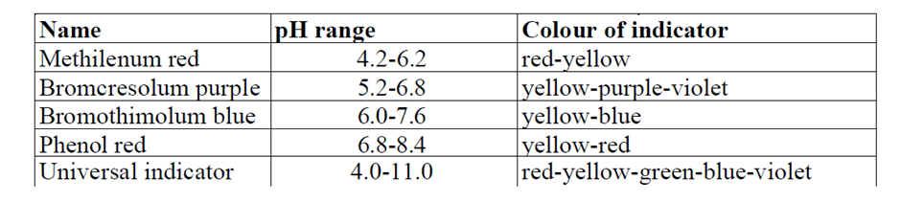
Procedure
For measuring the pH of meat and meat products, water extract 1:10 is prepared. The preparation of meat-water extract: 5 g of minced meat are weighed to an accuracy of 0.01 g and put into a conical flask of 100 mL capacity, where 50 mL of distilled water is poured. Periodically stirring, the content of the flask is stored for 30 min. Then it is filtered. The measuring of meat pH by potentiometric method and preparation of the pH-meter for work is done according to instructions.

2.6. Determination of amino-ammonium nitrogen content
Background
The method is based on the reaction of ammonia and amino groups with formalin. The total amount in the meat extract is equivalent to amount of 0,1 mol/l sodium hydroxide and is evaluated titrating.
The breakdown of meat proteins by the breakdown process breaks down the peptide bonds (-CO-NH-) of the protein molecules, resulting in an increase in the number of free amino and carboxyl groups.
Simultaneous deamination of amino acids is associated with the accumulation of ammonia compounds. Accordingly, the amount of nitrogen amino groups and nitrogen ammonium (amino-ammonium nitrogen) in meat increases, according to which the degree of the process of spoilage of meat can be judged.
The method for the determination of amino-nitrogen is based on the titration of the free carboxyl groups with alkali after blocking the amino groups with formalin, assuming that the number of carboxyl groups titrated is equal to the number of amino groups blocked and that the amount of alkali used is equivalent to the number of nitrogen amino groups. Amino group blocking is necessary to exclude the interaction of amino and carboxyl groups.
When titrating with alkali, ammonia is also blocked in the presence of formaldehyde, which is displaced by the alkali from the ammonia compounds, while the released acid values are titrated with alkali. This part of the alkali, which is equivalent to the amount of ammonia displaced, will correspond to the amount of ammonia in the nitrogen.
In this way, the total amount of alkali used for the titration will be equivalent to the total amount of nitrogen amino groups and ammonia.
Amino-ammonium nitrogen content: for fresh meat - up to 80 mg%; suspected of deterioration - from 80 to 130 mg%; for spoiled meat - more than 130 mg%.

Procedure
Preparation of meat extract
Weigh 25 g of minced meat into a 250 mL conical flask. Pour 100 mL of distilled water on top of the weighted sample. Using a glass rod, mix the sample with the water until slurry is obtained. Put the stopper on the conical flask and rinse for 3 minutes; allow it to stand for a further 2 minutes, then filter the contents of the conical flask through a triple gauze.

Preparation of meat filtrate
Weigh 40 mL of the meat extract obtained into a 100 mL graduated flask. To precipitation the protein, add to the meat extract accurately measured solutions of aluminium alum and barium hydroxide (Ba(OH)₂ in a total volume equal to or slightly greater than 40 mL).
To determine this ratio, pour 10 mL of 10% aluminium alum solution into a beaker, add 5 drops of 1% phenolphthalein solution and titrate with saturated ((Ba(OH)₂ solution) until the reaction is neutral. If 8 mL of saturated ((Ba(OH)₂) is used to neutralize 10 mL of 10% aluminium alum, take 25 mL of 10% aluminium alum and 20 mL of Ba(OH)₂.
Add to the graduated flask the calculated quantities of 10% aluminium alum and saturated Ba(OH)₂ (successively, aluminium alum solution first), top up to the mark with distilled water and allow to stand for 10 minutes, then filter the contents of the flask through a filter paper.
In parallel, top up to the mark with distilled water in the second flask, making up to volume with the calculated solutions of aluminium alum and Ba(OH)₂. Allow to stand for 10 minutes and filter through a filter paper. Determine the amount of amino-ammoniacal nitrogen in both filtrates.

Determination of amino - ammoniacal nitrogen
Weigh 20 mL of meat filtrate into a conical flask, add 0.3 mL of indicator No. 1 and titrate with 0.1 n NaOH until neutral, i.e. until the filtrate changes colour from purple to green.
Then add 10 mL of formalin, previously titrated to indicator No. 1, in the same flask, add 0.5 mL of indicator No. 2. The contents of the flask turn blue-purple. Titrate this solution with 0.1 n NaOH, which turns bright green at first and purple on further titration. Stop the titration when the colour changes from bright green to purple. Titrate analogously with 20 mL of control solution.

The amount of amino - ammonium nitrogen (mg%) is calculated using formula:
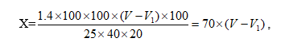
where: 1.4 – the amount of nitrogen in mg, equivalent to the amount of NaOH in 1 mL of 0.1n NaOH in 1 mL of 0.1 n NaOH solution,
100 – dilution of the meat sample with water, mL,
100 – dilution of the extract, mL,
V – amount of 0.1 n NaOH consumed for titration of the sample extract, mL,
V1 – amount of 0.1 n NaOH consumed for titration of the control test, mL,
100 – for conversion to 100 g of sample, g,
25 – sample weight, g,
40 – amount of extract taken to prepare the filtrate, mL,
20 – amount of filtrate taken for titration, mL.

Results
Draw conclusions and compare the obtained results with the information available in the literature and scientific publications.

Conclusion
1.
2.
3.

Approved by _____________________
Name, Surname, signature
Date ______________
Theme 3

The slaughter process of animals and birds

Theoretical materials
Veterinary and sanitary control is divided into pre-slaughter and post-slaughter.
Pre-slaughter control: only healthy animals are allowed to slaughter. It is also permitted to slaughter animals that are sick or suspected of having a disease if the meat, after appropriate processing, is suitable for human consumption. The slaughter of such animals is carried out on specially designated sanitary days either at the end of the working day or at a sanitary slaughterhouse. The slaughter of these animals is carried out in strict compliance with the rules in a sanitary slaughterhouse. Such conditionally suitable animals for slaughter include animals susceptible to tuberculosis, brucellosis, as well as foot-and-mouth disease, leukaemia, leptospirosis, colibacillosis, dysentery, and bronchopneumonia.
Animals that are in a state of agony (which can only be determined by a veterinarian or paramedic) cannot be killed for meat, regardless of the reasons that caused this state. In addition, animals vaccinated against anthrax and rabies within the first 14 days should not be killed. Animals younger than 14 days old and animals within 3 days if they have been treated with antibiotics are not allowed to be slaughtered.
Pre-slaughter control begins with measuring of the temperature of the entire population of cattle and horses, and selectively of pigs and sheep. Pre-slaughter holding of all horses, donkeys and mules in a meat processing plant must in all cases be at least 24 hours (until the results of malleinization). Animals that have a positive and questionable reaction to mallein are subject to destruction in accordance with the established procedure.
Preparing animals for slaughter. Preparation of animals for processing begins upon arrival at the stockyards and during the reception process, when they are sorted into homogeneous groups according to fatness, sex, age and health status. Usually the same groups of animals are sent for slaughter. The preparation for slaughter of livestock and poultry has a great influence on the quality of the resulting meat and facilitates primary processing. For this purpose, animals are sent to pens for pre-slaughter holding. Cattle and small cattle are kept for 24 hours, pigs - 12 hours, calves - 6 hours. During this time, the animals are not fed, but the supply of water is not limited, stopping it 2 hours before slaughter.
Pre-slaughter holding helps to clear the contents of the gastrointestinal tract and allows animals to rest. The quality of the meat largely depends on the condition in which the animals were sent to slaughter. Animals must not be beaten. Excitement, fear and pain cause increased blood flow to the muscles, trapping the blood in the vessels, so that the bleeding during slaughter is not complete. Poorly bled meat has a dark colour with a bluish tinge, is moist, of low quality, serves as a good breeding ground for various microflora, and therefore doesn’t store well. Blows inflicted on animals cause bruises and injuries, which also deteriorates the quality of the meat and its presentation. During veterinary examination, the tissue around bruises and wounds is carefully cleaned and removed, which leads to significant meat losses, and the quality of the hides is also reduced.
To move animals, it is recommended to use a firecracker or electric prod. The voltage in the electric drive should not be higher than 25 V.
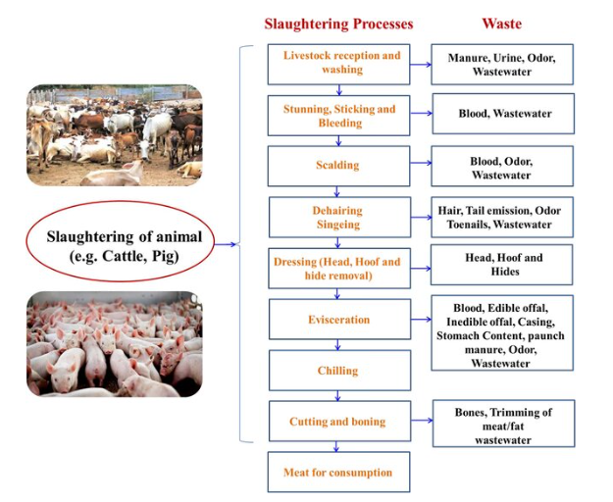Figure 3.1. Flow chart diagram of slaughtering process and the waste generation (https://www.researchgate.net/publication/358497457_Slaughterhouse_and_poultry_wastes_management_practices_feedstocks_for_renewable_energy_production_and_recovery_of_value_added_products/figures)

Cattle slaughter technology.
On the cattle slaughter conveyor line, the following operations are carried out sequentially.
Immobilisation of animals. Cattle are stunned before slaughter, firstly, due to humane considerations in relation to the animals, and secondly, to ensure the safety of the operators when applying fetlock chains to the hind legs of the animals when lifting them into the path of bleeding. A stunned animal loses the ability to move, the activity of its higher nerve centres stops, but the heart continues to work.
To immobilise cattle in a low-power enterprise, it is advisable to use devices in the form of pistols, stilettos and special mobile shooting devices. When stunning with a stylet, the blow is delivered to the medulla oblongata at a time when the animal's head is tilted down and fixed. When stunning, the blow is directed into the gap between the first occipital vertebrae and the occipital bone. With the help of pistols and shooting devices, a blow (cartridges, bullets, rods) is applied to the upper part of the frontal bone above eye level. The operation of stunning livestock should only be performed by qualified workers with extensive practical skills.
In addition to mechanical stunning methods, it is possible to use electrical stunning. A pointed electric glass is inserted into the occipital part of the head in the region of the medulla oblongata, piercing the skin to a shallow depth. Current voltage 127-220 V, duration of action 8-15 s. Electrical stunning can be carried out through the limbs with a three-phase current applied to the floor of the box. Voltage is applied until the animal stops moving (15-25 s). Electrical stunning is safe for operating personnel, but additional stunning is required, and the floors of the box are de-energised. The above method is widely used in meat processing plants of medium and high capacity.
To properly stun an animal, it must be in a certain position. For this purpose, it is introduced into a special chamber-box or tied to a ring embedded in the floor. The use of boxes ensures the safety of jammer workers.
Once stunned, the animal usually falls to the floor. Standing to the side of the stunned animal, a worker wraps a chain around the animal's hind legs. At one end of this chain there is a hook, the other is tightly attached to the roller on which the carcass will move along the suspended path. The chain is placed around the fetlock joint. Fetlock chains with lengths of 2, 1, 0.9, 0.6 m are used. Different lengths of chains make it possible to hang carcasses so that the head of each animal, regardless of its size, is approximately at the same height from the floor. This makes subsequent carcass processing operations easier. To lift carcasses onto the bleeding path, lifting mechanisms of various designs are used. The most widely used is the electric winch, which lifts the load and automatically installs the roller on the overhead track. It takes up little space and is reliable in operation; it is usually mounted above the box.
Stunning with electric current is carried out in a special chamber (box) to improve performance and better bleeding of the carcass. Stunning mode: current 1-1.5 A, voltage (depending on the age of the animal) 70-220 V when the stack comes into contact with the animal's body for 6-20 s. Electronarcosis ensures immobility of the animal for 5-10 minutes.
Slaughter and bleeding. In workshops equipped with overhead tracks, the slaughter and bleeding are usually carried out in a vertical position. In this position, blood flows out more completely and acceptable sanitary conditions are created for its collection. The complete bleeding of animals helps to obtain well-preserved meat.
Before bleeding, a ligature is placed on the esophagus to prevent the contents of the animal’s stomach from entering the bloodstream. To apply a ligature, it is necessary, holding a knife in your right hand with the blade up, to make a longitudinal incision in the skin of the neck along the midline, starting slightly above the middle of it and leading the incision to the junction of the neck with the body. The length of the incision is usually 30-50 cm. Having exposed the trachea, the esophagus is separated and tied with twine (or a spiral clamp is applied).
After applying a ligature to the esophagus, the worker proceeds to perform operations related to slaughter. Depending on the further use of the blood, the performance of these operations is not identical.
When collecting blood for technical purposes, the worker inserts a knife into the chest cavity of the animal at the junction of the neck with the body and by turning the knife transversely, he cuts the plexus of large blood vessels in the neck (carotid artery and jugular vein). For slaughter, a regular knife with a handle 15-20 cm long is used. The handle has a protrusion at the blade that protects the hand from cuts. For more complete bleeding, the worker, removing the knife from the wound, lengthens the cut, and the blood flows into the gutter. The duration of bleeding for cattle is 6-8 minutes.
Blood for food purposes is collected using a hollow knife. The blood flows through a hose into a vessel designed to collect blood.
A hollow knife is inserted into the animal’s neck from the right side of the trachea and guided from the bottom up until it enters the right atrium, where blood flows through the systemic circulation from the entire animal’s body. When the copious flow of blood stops, the hollow knife is removed from the carcass and the neck blood vessels are additionally cut to allow the remaining blood used for technical purposes to flow out.
When collecting edible blood, equipment, instruments and containers must always be clean. They must be washed after each use until all traces of blood are completely removed, and then disinfected with an antiseptic solution. After disinfection, equipment should be rinsed with hot water. It is recommended to use a solution of bleach or chloramine as an antiseptic.
During horizontal bleeding of a stunned animal laid on its right side, the worker uses a knife, holding it with the blade upward, to make a longitudinal incision in the skin on the neck along the midline, starting from the sternum up to the lower jaw. Through the incision, he inserts a knife into the junction of the neck and torso towards the chest cavity and cuts the neck veins and arteries. Blood flowing from the wound can be collected in basins. Bleeding lasts 8-10 minutes and is considered complete when the blood stops flowing out in streams. After bleeding, the head is separated from the carcass and the skin is removed from the head.
It is advisable to use the obtained blood (at low-power enterprises) in the future for the production of blood and culinary products. To prevent blood clotting, it is advisable to add a stabiliser solution to the vessels where the blood flows. As stabilisers, you can use pure table salt (3% of the blood weight), tripolyphosphate solution (15-20 mL per 1 litre of blood), 10% sodium pyrophosphate solution in the amount of 25 mL per 1 litre of blood.
Cutting the carcass. Cutting a carcass includes a number of technological operations that include removing the skin, removing internal organs, sawing, stripping the carcass, etc.
Skinning is carried out by combining manual techniques with a knife (whitening) with a mechanized operation for the final removal of the skin. First of all, the ears are removed and the skin is removed from the head; for this, a cut is made with a knife from one horn to the other, the skin is separated in the frontal, occipital, cheek, jaw parts and on the neck so that the skin of the head is integral with the skin of the body. The head is separated at the atlanto-occipital joint and hung on hooks for veterinary examination.
The pelvic and thoracic limbs are whitened after ring-shaped skin incisions at the level of the fetlock joints and cut along the inner surface of the pelvic limbs to the anus and further along the white line of the abdomen to the chest and neck. The skin is manually separated with a knife from the pelvic limbs, abdomen, chest and neck parts of the body, from approximately 35% of the surface of the carcass. The shooting is completed using mechanised units or skinning units.
The manual method of skinning. Cattle skins are removed on corrugated plates or special spreaders in three successive positions of the carcasses: horizontal, semi-vertical and vertical. After separating the head, the carcass is lowered to the floor by a winch, laid on its back towards the winch spreader and strengthened in a horizontal position with special support pads.
First, the worker skins the front and hind limbs, then breaks them at the carpal and fetlock joints; whitens the skin in the area of the udder or scrotum and groin, cuts along the white line of the abdomen (without damaging the abdominal muscles) and at the same time separates the left edge of the skin (from the left side) from the muscles to a width of 4-5 cm along the entire length of the cut. The worker then removes the skin from the sides until the longitudinal muscles (magpie meat) on the inside of the groin and thigh are completely exposed.
The worker removes the skin from the neck: inserts a knife under the skin in the forearm area and leads towards the shoulder, separates the skin from the forearm, then from the front of the chest and from the neck to its upper part at the withers.
Next, he incises the muscles along the midline of the sternum and cartilage and, following the incision made, starting from the crown, saws (or cuts) the sternum with a saw (or cleaver). The cutting line (cut) must pass exactly along the midline of the sternum, without violating the integrity of the internal organs.
Upon completion of whitening and sawing of the sternum, the carcass is winched to a semi-vertical position for subsequent operations.
Having pulled the skin away from the hock, the worker inserts the knife with the tip down and moves it from top to bottom towards the ridge, separating the skin from the upper part of the thigh, then from the thigh to the foot. It is necessary to ensure that the film from the thigh does not separate along with the skin. Next, he separates the skin from the side of the abdomen and the upper part of the back (sacrum). To do this, the worker pulls the skin upward, inserts the knife with the tip upward and leads it towards the root of the tail, separating the skin from the side of the abdomen and back to the spinal column. The skin from the sides up to half of the carcass (up to the lumbar vertebrae) begins to be removed from the foot the knife is inserted between the skin and the film and moved towards the shoulder blade.
When sealing the tail, the worker makes a longitudinal cut in the skin along the underside of the tail to its root, seals the skin around the root of the tail, and then with a sharp jerk pulls the tail out of the skin. Then he cuts the passage with a crown to a width of 4-5 cm from the walls of the pelvic bone, while cuts to the bladder and passage are not allowed.
The carcass is raised to its full height and the skin is torn off from the carcass, cutting off the fastening ligaments.
Workers engaged in whitening and skinning operations must sanitise tools, hands and clothing during work, for which workplaces must be equipped with hot and cold water devices.
Removing the entrails (gutting) requires preparatory operations (removing the genitals, udders in cows, ligating the rectum, cutting the pubic bones, sawing the sternum, etc.). The organs of the abdominal and thoracic cavities are removed almost simultaneously using special techniques through an incision in the abdominal wall along the white line of the abdomen, and the liver is removed through the hole formed after the incision of the sternum and the incision of the diaphragm.
Sawing up carcasses. Carcasses are sawn down the spine into two longitudinal halves. Sawing is necessary for rapid cooling of carcasses and the ease of transportation.
Before sawing along the spine, a deep incision is made into the muscles with a knife, capturing the muscles of the thoracic and cervical vertebrae. The spine is cut along the incision so that the vertebral bodies are divided in half; the cut should pass along the very edge of the spinal canal, without touching the brain, approximately 7 - 8 mm to the right from the midline of the spine. First, the sacrum is sawed, then the lumbar, thoracic and cervical vertebrae. The pressure on the saw blade should be moderate and uniform in order to prevent a zigzag cut.
Cleaning carcasses. To give the half-carcasses a marketable appearance, cleaning is carried out. When dry stripping, the following operations are performed: remove possible abscesses and bruises from half-carcasses; the meat and bone tail is separated; collect internal and kidney fat (together with the kidneys); the spinal cord is removed.
If necessary, the carcass is washed. After washing, the half-carcasses are placed in special chambers for drying at a temperature of 4 C.
Carcasses with trimmings and subcutaneous fat stripping of more than 15% of the entire surface are classified as non-standard, they cannot be sold, and they are processed in the workshops of the enterprise.
Branding of carcasses. After completing all the technological operations associated with the production of half-carcasses, the final stage is the commercial assessment of the resulting products. The commodity assessment involves branding the carcasses and weighing them. The carcass branding is carried out in accordance with the current regulations. After branding, the carcasses are weighed to determine pair weight. Next, a plumb invoice is printed, which is the main document in the relationship between the receiver and the livestock deliverer.
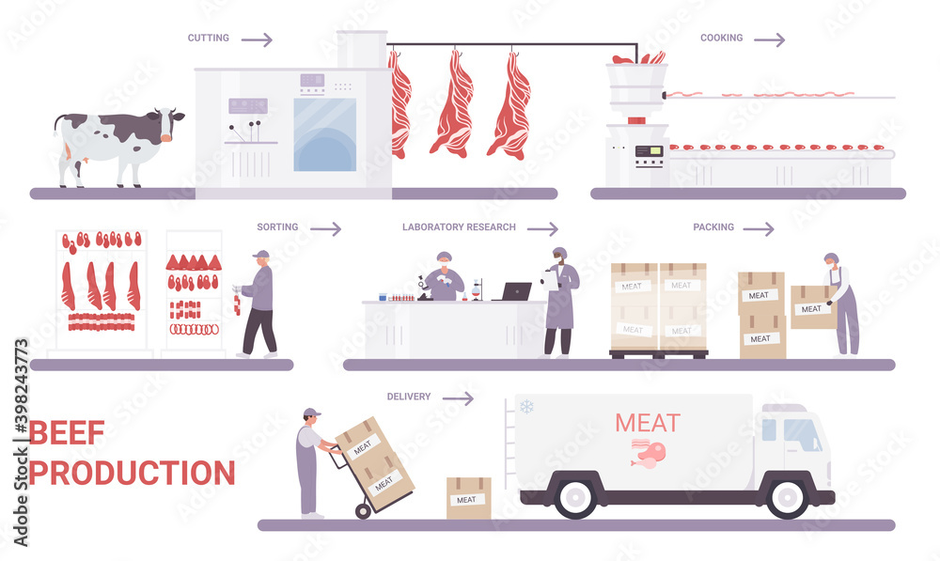
Figure 3.2. Beef meat production process stages https://www.alamy.com/beef-production-on-meat-factory-infographic-process-vector-illustration-cartoon-info-education-poster-with-automated-processing-line-from-cutting-sorting-packaging-farm-meat-products-technology-image389015426.html

Pig slaughter technology
Stunning pigs with electric shock. Pigs are stunned with high or industrial frequency electric current. Before stunning, they are fixed on special conveyors or using other devices. Boxes are also used.
Pigs are stunned with industrial frequency current using a single-horn stack, which is placed on the back of the head. The second contact is the floor. Electric current voltage is 65-100 V, frequency 50 Hz, duration of exposure 6-8 s.
In low-power meat processing plants, it is advisable to stun pigs using a special electric needle mounted together with a 24 V power source. The needle is inserted into the muscles behind the ear and is not removed until food blood has been completely collected. The duration of the process is 45 s. To prevent convulsive muscle contractions and, as a result, haemorrhages in the tissues, high-frequency current is used using the ФЭОС-У4 apparatus, voltage 200-250 V, frequency 2400 Hz, duration of exposure from 8 to 12 s.
At medium-power enterprises, electrical stunning of pigs is carried out in a carousel-type box. The pigs are driven with an electric drive into the compartment, which is located at an angle to the box, and then directly into the box, where they are picked up by the rotating floor and the inner wall and fed under the panels with electrodes. The electrodes have a free swing and are connected to the ФЭОС-У4 installation, which is mounted next to the drive on the ceiling of the box.
Stunning pigs with a gas mixture. The gas mixture consists of 65% carbon dioxide and 35% air. Stunning with a gas mixture is carried out in a sealed chamber for 45 s. Animals fall into deep sleep and remain motionless and relaxed for 1-3 minutes. During this time, they are lifted onto the overhead track, slaughtered and bled. Stunning with carbon dioxide prevents muscle and pulmonary haemorrhages and makes it easier to scald and remove hair from pig carcasses. The use of CO₂ for stunning pigs ensures a high degree of bleeding of carcasses. The blood yield during gas anaesthesia is 0.4% higher than during electrical stunning. Carbon dioxide consumption is 80 g per head.
Processing of pigs with skinning. Skinning pig carcasses is a more labour-intensive and complex operation than skinning other species.
A high-quality pork carcass is characterised by a relatively smooth surface, without fat snags formed when skinning. Snatches, which deteriorate the quality and presentation of carcasses, are formed in most cases on the loin and flank, less often in the lumbar region and ham. The area of the grabs is regulated by the standard.
The reason for the large number of fat snatches on carcasses of the fatty category is the low strength properties of fat. The subcutaneous tissue of pigs is of considerable thickness and filled with fatty deposits, so when harvesting, the skin must be separated directly from the subcutaneous fat. Fat cuts on the skin also remain because this is facilitated by the very structure of the inner layers of the dermis, which have many depressions filled with fat, which cannot be separated from the dermis.
The quality of skinning from pig carcasses is greatly influenced by the structure of subcutaneous fat, which depends on the breed of pigs, the nature of fattening and other characteristics of the animals.
The fat slits in the whitening area are usually 2-3 times larger than in the mechanical shooting area, so reducing the whitening area when removing skins from pork carcasses will help reduce fat loss in the form of slits and improve the marketable appearance of the carcasses. When removing skins, it is necessary to improve the quality of manual whitening, preventing fat from cutting into the skin.
Blowing carcasses with compressed air. Before skinning, carcasses are blown with compressed air. At the same time, the carcass swells, the skin stretches, and the folds straighten. This helps to reduce the loss of fat and meat from the carcass, damage to the skins, and facilitates the work of workers due to the weakening of the connection of the skin with the surface layer of the carcass.
Processing of pork carcasses with skin. Pork carcasses are lifted onto the bleeding path, washed, some of the side and back bristles are removed manually or using electric shearing machines and sent for scalding.
When scalding carcasses by immersion, the lungs fill with water, their volume increases, the colour changes, as a result of which their quality, as well as the quality of the carcasses, decreases. Microbial contamination of pork carcasses through scalding water can be significant. This is avoided by packing or ligating the windpipe. Ligation of the trachea of adult pigs is difficult due to the fact that the cartilaginous rings of the windpipe become rigid with age. A rubber stopper on an aluminium base is also used for tamponing. The stopper is inserted into the windpipe before the carcass is immersed in the scalding vat, which prevents water from entering the lungs. At the end of the scalding, the cork is removed and used again.
To prevent hot water from entering the lungs, the method of filling the chest cavity with compressed air before scalding is used. It is advisable to frequently (at least once per shift) replace the water in the steaming tank, or clean it.
The main importance for the quality of scalding and subsequent cleaning of pork carcasses on a scraping machine is compliance with scalding regimes - temperature and duration.
Pork carcasses are scalded at a water temperature of 63-65 °C for 3-5 minutes, depending on the pig breed, weight, type of fattening, age and other factors. When scalded, the top layer of the skin (epidermis) softens and the bristle bulb comes out of the hair follicle more easily.
Processing of pork carcasses using the cutting method.
Cropping is a combined method of processing pork carcasses, when the most valuable part of the skin (removed from the dorsal and side surface of the carcass) is used in tanning. The skin remains on the rest of the carcass; bristles, small hair, fluff and epidermis are removed from it.
Preparing pork carcasses for scalding. After washing, to prevent contamination of the lungs with water from the scalding vat, compressed air is blown into the chest cavity of the pork carcasses.
For pressurisation, compressed air with a pressure of 0.3-0.5 MPa is used from a centralised system or obtained at an individual installation and purified using oil filters.
Compressed air is pumped into the chest cavity immediately before lowering the carcasses into the scalding vat, for which the wall of the chest cavity is pierced with a needle between the 5th and 6th rib at the junction of them with the sternum, without violating the integrity of the internal organs. To prevent air from entering the muscle tissue, the shut-off valve is opened only after the needle is completely inserted into the chest cavity.
The blowing operation is performed with the carcasses in a vertical or horizontal position (depending on the organisation of workplaces). The carcasses are blown through for 5-7 s (until the feeling of the needle being pushed out appears). The air consumption for blowing 100 pork carcasses is 2.8-3.8 m³.
Pork carcasses prepared in this way are served along a suspended path to the table near the scalding vat and placed with the abdominal part into conveyor cradles immersed in water.
Scalding the belly of pork carcasses and removing bristles. Depending on the weight of the carcasses, the water level in the scalding tank is adjusted so that the abdominal part of the carcass is immersed in water to a depth of 15-20 cm from the nipple line. In this case, the croupon is not scalded. Heads are scalded under a shower mounted along the entire length of the vat. The scalding of carcasses and heads is carried out at a temperature of 63-65 °C for 3-5 minutes. The scalding process is considered complete when the bristles are easily pulled out by hand. The water in the steaming vat is changed as it gets dirty, at least once or twice a shift.
After scalding is completed, the carcasses are unloaded from the vat by conveyor into a scraper machine to clean the scalded areas from bristles. During the cleaning process in a scraper machine, the carcass is irrigated with water at a temperature of 30-45 °C. The duration of carcass processing is 25-30 s.
After unloading from the scraping machine, the carcasses are inspected. If necessary, they are additionally cleaned on the table manually with a knife. If scratches are found on the carcass, stop the scraping machine and eliminate the causes of their formation.
On the table before the scraper on the hind limbs of pork carcasses, a through puncture is made with a knife between the tibia bones and the common calcaneal (Achilles) tendon, the hooks of a spreader or trolley are inserted into the incision and the carcass is lifted by an elevator or winch onto a suspended track.
Shooting close-ups. Before shooting the croupon, it is isolated on the carcass by cutting the skin with a knife with a shortened blade (3-4 mm) along the following lines: on the sides of the carcass - along the boundaries between the scalded peritoneum and unscaled dorsal-side parts and across the carcass - at the base of the tail and at base of the head (at the junction of the occipital bone with 1 cervical vertebrae - the atlas and at the base of the ears).
After this, the neck part of the carcass is whitened so that the skin can be grabbed with a clamp or chain. Whitening of carcasses must be carried out without damaging the subcutaneous layer of adipose tissue and without causing cuts to the skins.
Removing internal organs from pig carcasses. After skinning the carcasses, or processing the carcasses in the skin, or removing the croup, the head is prepared for a veterinary examination, for which the head is semi-severed with an incision passing through the junction of the occipital bone with 1 cervical vertebra at the base of the ear and then along an oblique line at the level of the lower third jaws. The head is left with the carcass until a full veterinary examination of the carcass and all organs is carried out and is separated in such a way that the back part of the external masticatory muscles is exposed.
The parotid and submandibular lymph nodes of the carcass prepared for veterinary examination are examined and the carcass is sent for further cutting.
Before removing the internal organs, preparatory operations are performed: the breast bone is separated with an electric saw or knife; the genitals are separated from the carcasses of males (after cutting off the layer of fat covering them) and sent to the feed and technical products workshop; cut the abdominal muscles along the white line from the pubis to the sternum.
After the preparatory operations, the momentum is removed from the carcass, and then the intestines with the stomach and spleen are removed and placed on the evisceration conveyor or a special table. Then the liver is removed along with the tongue. The edges of the diaphragm are trimmed at the chest walls. Pulling the liver from the chest cavity, trim the muscles of the pharynx with a circular movement of the knife until the root of the tongue is completely separated from the adjacent tissues. The liver with tongue extracted from the carcasses is placed on a conveyor belt containing the gastrointestinal tract or hung on a hook. It is allowed to extract the liver without the tongue.
After removing the internal organs, pork carcasses are divided into half-carcasses, carcasses and half-carcasses are stripped, veterinary and sanitary examination, quality assessment, branding and weighting are carried out.
Sawing and cleaning pork carcasses. Longitudinal division of carcasses is carried out in the middle of the vertebrae without crushing them or adding whole vertebrae to one half-carcass.
For this purpose, the hind limbs of the carcass are pre-stretched to a distance of 600 mm using a special device or conveyor pushers. Carcasses are separated with a power saw or cleaver. When dividing the carcass into legs, 1 cervical vertebra is left whole and separated in the refrigerator.
After dry stripping, the half-carcasses are washed from the inside with warm (25-38 °C) or cold tap water using shower brushes or a hose to remove bruises and other contaminants. In case of surface contamination of the carcass, only the contaminated areas are washed, excess moisture is removed with the blunt side of a knife or by drying the surface of the carcass with a clean towel, blowing with air, etc. When washing carcasses with a hose, a stream of water is directed at an acute angle to the surface of the carcass to avoid damaging the integrity of the outer layer of muscle and adipose tissue.
After dry and wet stripping, pork half-carcasses should not have any remaining bristles, internal organs, blood clots, fringes of muscle and fatty tissue, dirt, and bruises.
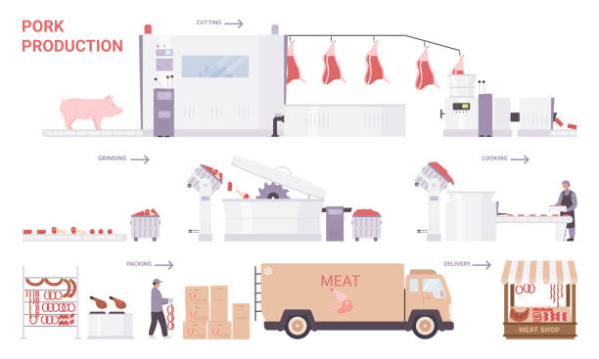
Figure 3.3. Pork meat production process stages https://stock.adobe.com/images/beef-production-on-meat-factory-infographic-process-vector-illustration-cartoon-info-education-poster-with-automated-processing-line-from-cutting-sorting-packaging-farm-meat-products-technology/398243773?asset_id=39978906

Laboratory work

Evaluating the quality of food fat by analysing changes in sensory and physico-chemical quality parameters

Materials
Different types of fat samples, glass test tubes, glass capillary, thermometers, scales with an accuracy of 0.01 gramme, scales with a accuracy of 0.0001 gramme, water bath for samples heating, prepared and preheated sand, metal crucible with lid and glass stick, porcelain bowl, 96% ethyl alcohol, conical flasks from 100 to 250 mL capacity, 0.2 n spirituous iodine solution, pipettes, distilled water, cylinders, 1% starch solution, 0.1 n Na₂S₂O₃ solution, neutral mix (1:2) of ethyl (96%) and ether solutions, 1% phenolphthalein spirituous solution, 0.1 n NaOH or KOH solutions, chloroform, icy acetic acid solution, fresh prepared saturated KJ solution, 0.01 n Na₂S₂O₃ solution, neutral red solution (fresh prepared aquatic 0.01 % solution of neutral red, 7,0 ≤ pH ≥ 7,2, is can be used for some hours).

Methods and Procedures
Task 1. Sensory evaluation of fat
Analysis is processed at a temperature of 15-20 °C.
Evaluation of colour. Melted fats are poured into a dry colourless glass test-tube. The test-tube is put in a glass with cold water for 1-2 hours. Fat colour and shades are evaluated in day light.
Evaluation of lucidity. Melted at a water bath, the fat is poured into dry colourless test-tube and its lucidity is evaluated in day light.
Evaluation of smell and flavor. A thin layer of melted fat is spread on objective glass and the smell is evaluated. For evaluation of flavour, a little piece of fat is tasted.

Table 3.1.
Sensory characteristics of fat
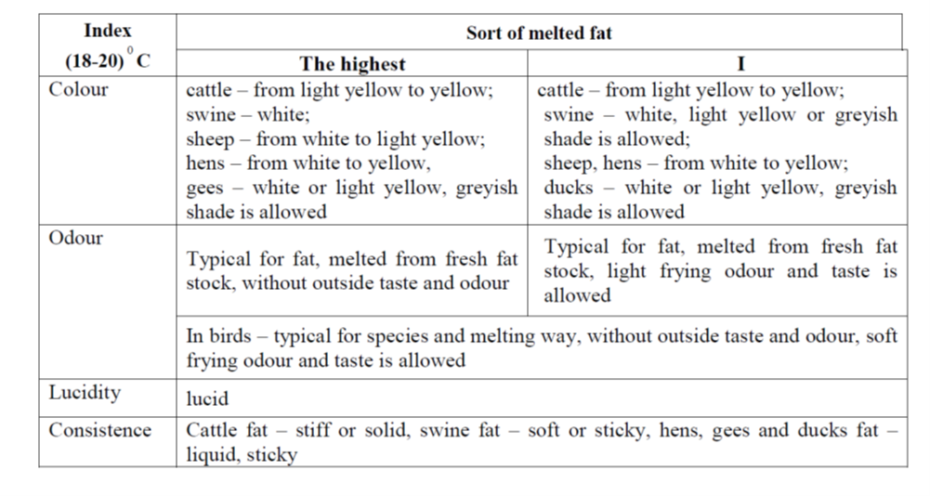

Task 2. Evaluation of fat physical and chemical characteristic
Fat consists of fatty acids mixed with different molecular mass, physical and chemical characteristics. Therefore, they melt and stiffen at certain temperature interval, while separate components of fatty acids mix, melt or stiffen.
2.1. Evaluation of fat melting temperature.
Background
A fat melting temperature is such temperature, at which the fat changes from a solid to a liquid and lucid state. Before analysis, the fat is melted and filtered through a dry paper filter to eliminate moisture which increases the melting temperature.
Procedure
The melted fat is drawn into the capillary at a height of 10 mm. Wipe the outside of the capillary with a moisture absorbent material and for 10 min. and leave it on ice surface (refrigerator freezer compartment) or leave it for 24 hours at room temperature. After the capillary is connected to the thermometer so that the fat bar should be in the one level with the thermometer mercury column. Then place the capillary thermometer in a glass with water at a depth of 3 to 4 cm so that no water flows into the open end of the capillary. The water onset temperature is 15-18 ° C. The glass with water is heated, stirring continuously.
The melting point of fat is considered to be the point at which the fat begins to move upward in the capillary. The melting point of the fat is determined twice by taking the average of the two measurements, which must not differ by more than 0.5 °C.
Melting temperature can be measured in capillary (see Figure 3.4.).
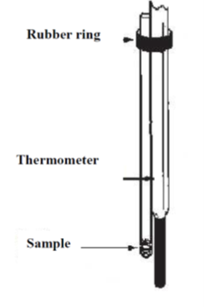
Figure 3.4Capillary tubes with thermometer for measuring fat melting temperature

Table 3.2.
Fat melting temperature of different animals and birds
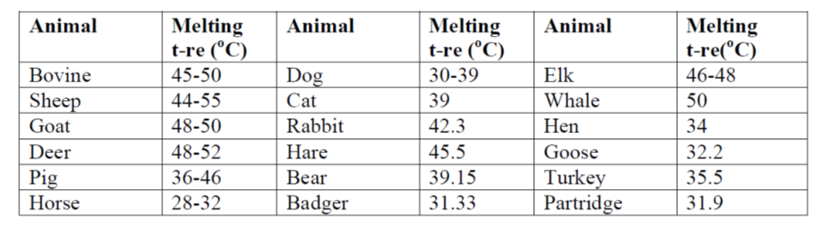

2.2. Evaluation of fat stiffening temperature
Background
According to the composition of the fatty acids and glycerides, different kinetic curves (which depend on crystallisation of different components) of fat stiffening can be seen. When cooling melted fats, at first a significant fall of temperature is seen, then, when the crystallisation begins, the temperature decreases more quickly or sometimes even increases because of the latent crystallization warmth. After crystallisation, the fat temperature decreases again.
At the stiffening temperature (Figure 3.5, a), solidification of fat takes place, but the temperature drop is delayed by the heat of crystallisation released. 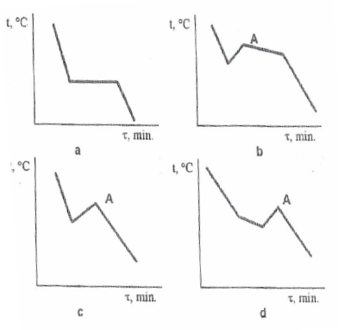
Figure 3.5. Curves of fat stiffening temperatures

Procedure
Put the fats in a porcelain bowl and then melt the sample in a water bath. When the temperature of the melted fat becomes about 15 °C higher than the expected fat stiffening temperature, they are poured into the dish, leaving 2 cm above. A thermometer is fixed in such a way that the end of the hydrargyrum column would be at the centre of the fat column. First, the liquid fat is mixed using a thermometer. Starting the thickening process, the fat stiffening temperature is checked. The thermometer is fixed every minute. According to the analysed data, the fat stiffening curve is drawn, at x axis marking time of the analysis (min), at y axis – showings temperature (in degrees).
2.3. Evaluation of fat moisture
Procedure
At an accuracy of 0.0002, 2-3 g of fat is weighed in a pre-heated metal crucible and dried in a drying fire (at 102-105 °C temperature) to fixed mass. First time, the sample is weighed after 1 val. Later weightings are repeated every 30 min. Before weightings, the dishes are cooled in a desiccator.
Amount of moisture (%) is calculated using formula:
where: m₀ – mass of metal crucible with lid, sand and glass stick, g;
m₁ – mass of metal crucible with lid, sand, glass stick and sample before drying, g;
m₂ – mass of metal crucible with lid, sand, glass stick and sample after drying, g.
The results are of accuracy of 0.1 %. The results of parallel analysis should differ no more than 0.05%. During drying, the fat oxidation can occur, which increases the sample mass, therefore the calculation is made according to the smaller dried sample mass.

2.4. Evaluation of fat iodine number
Background
The iodine number describes the amount of unsaturated fatty acids in fat. Unsaturated fatty acids, affected with halogens, easily attach themselves at the places of double joints. From the amount of attached halogens, it is decided about composition of fatty acids and nature of fat. According to the iodine number and other indices there is a possibility to decide about the clarity of the fat. The iodine number is its amount in grammes which 100 g of fat attach at the place of a double bond. A quicker method of the iodine amount evaluation is based on spirituous iodine reaction with joints of unsaturated fatty acids, participating sodium thiosulphate.
Procedure
0.3-0.4 g of fat is weighted into a cone flask at accuracy 0.0001 g and 30-40 mL of 96% ethyl alcohol is poured. The flask is covered with a plug which has a glass tube (30-50 cm of length) and is left at 40-50 °C temperature water bath, till the fat melts. The mixture is cooled to the ambient temperature, then 25 mL of 0.2 n spirituous iodine solution is dripped with a pipette and 50 mL of distilled water is poured. The flask is plugged again and the mix is shaken well. After 5 min. 0.5 mL 1% starch solution is poured and it is titrated with 0.1n Na₂S₂O₃, till a blue colour disappears. The parallel control analysis is made, using the same amount of water instead of fat.
Iodine number (%) is calculated using formula:
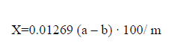
where: 0.01269 – amount of iodine, corresponded to 1 mL of 0,1 n Na₂S₂O₃ solution, g/mL;
a – amount of 0,1 n Na₂S₂O₃ solution (mL), used to titrate control sample;
b – amount of 0,1 n Na₂S₂O₃ solution (mL), used to titrate analysed sample;
m – fat amount, g

2.5. Evaluation of the number of fatty acids
Background
The acid number is one of the most important indicators of fat quality. In fat processing, this index describes the stickiness of hydrolytic fat spoilage, and analysing the quality of keeping fat shows oxidative spoilage (together with other more important indices). The method is based on titration of fatty acids, which are in a fat-spirituous-ether solution with an aquatic hydroxide solution. Ether is used as fat solvent and ethanol homogenizes fat and aquatic hydroxide systems, formed during titrating. If spirit isn’t used, the reaction takes place only at the surface of the phase connection, therefore the system must be homogenised by mixing ethanol with water and organic solvents.

Procedure
3-5 g of fat is weighed into a 250 mL conus flask at accuracy 0.01 g. The fat is melted in a water bath. 50 mL of neutral mix (1:2) of ethyl and ether, which is neutralised in advance with 0.1n of hydroxide solution to pink colour using phenolphthalein, is poured into the flask. The solution is mixed in the flask, 2-3 drops of 1% phenolphthalein are added and immediately titrated with 0.1n NaOH (KOH) till a pink colour appears. If the solution in the flask becomes muddy, 5-10 mL of ethyl alcohol and ether mix are added. If the feculence doesn‘t disappear, the flask is slightly warmed in the water bath and is titrated after cooling.
The number of fatty acids, described as KOH or NOH amount, used for neutralisation of free fatty acids in 1 g of fat.

Number of fatty acids (mg) is calculated using formula:
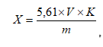
where: 5,61 – KOH (NaOH) amount (mg) which is in 1 mL of solution,
V – titrated amount (mL) of 0.1n KOH (NaOH) solution,
K – re-counting coefficient to straight 0.1n KOH (NaOH) solution,
m – fat amount, g.
Acid value in fresh fats is from 1.2 to 2.2 mg NaOH or KOH/g.

2.6. Evaluation of oxidative fat spoilage
One kind of fat spoilage is oxidation with air oxygen. Hydroperoxides are primary products of oxidation. Formed peroxides later take part in various chemical reactions, during which the secondary fat spoilage products form: aldehydes, ketones, little molecular mass acids, alcohols. Some of these products have an unpleasant odour and taste, and are toxic. The degree of oxidative spoilage is established using Table 3.3.

Table 3.3.
Indices, characterising oxidative fat spoilage
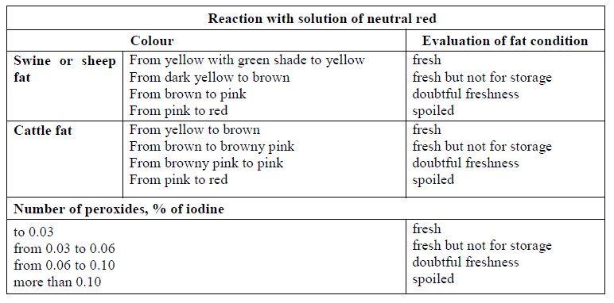
2.6.1. Evaluation of peroxides number
Background
During fat processing or storing unmelted fat stock for a long time, the influence of air oxygen, light, high temperature and other peroxides can form. The number of peroxides is related to sensory fat indices: worse fat taste and odour are typical for fats with high peroxides number (Table 3).
The number of peroxides, expressed as the amount of iodine (g), that the peroxides present in 100 g of fat will separate from potassium iodine in an acidic environment. The method is based on the interaction of the peroxides or hydroperoxide active oxygen with iodic acid (HJ) in the presence of acetic acid.
KJ + CH₃COOH → HJ + CH₃COOK
CH₃(CH₂)₆HOO-CH-CH=CH(CH₂)₇COOH + 2 HJ →
CH₃(CH₂)₆HO-CH-CH=CH(CH₂)₇COOH + H₂O + J₂
The liberated iodine is titrated with sodium thiosulphate.
J₂ + 2 Na₂S₂O₃ → 2 NaJ + Na₂S₄O₆
Procedure
1 g of fats are weighted with an accuracy of 0.002 g into cone flasks with a polished plug and are melted in a water bath. From the measuring cylinder along the flask wall, 10 mL of chloroform, 10 mL of icy acetic acid and 0.5 mL of fresh prepared saturated solution of KJ are poured, and the attached fat parts would be washed. The flask is plugged, and the solution is mixed accurately and left for 5 min. in a cool and dark place. Then, 100 mL of distilled water and 1 mL of 1 % starch are poured, mixed and separated iodine is titrated with 0.01n Na₂S₂O₃ solution till a blue colour disappears. The control analysis is made in parallel. Reagents are right for analysis if for titration of control samples no more than 0.07 mL of 0.01n Na₂S₂O₃ solution are used.
Number of peroxides (%) is calculated using formula:
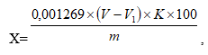
where: V – amount of 0,01n Na₂S₂O₃ solution (mL), used for titration of analysed sample,
V1 – amount of 0,01n Na₂S₂O₃ solution (mL), used for titration of control sample,
K – re-counting coefficient to straight 0,01n Na₂S₂O₃ solution,
m – amount of fat in extract, g.

2.6.2. Reaction with solution of neutral red
Procedure
0.5-1.0 g. of melted fat is put into a porcelain plate and a solution of neutral red is poured (a freshly prepared aquatic 0.01 % solution of neutral red, 7,0 ≤ pH ≥ 7,2, is used. The solution can be used for a few hours). Using a porcelain pistil, the fat and solution of neutral red are rubbed for 1 min.
Then the solution is poured out and fat colour is observed. The degree of oxidation spoilage is assessed using Table 3.

Results
Draw conclusions and compare the obtained results with the information available in the literature and scientific publications.

Conclusion
1.
2.
3.

Approved by _____________________
Name, Surname, signature
Date ______________

Laboratory work

Microbiological testing of chilled meat

Total Viable Count
Total Viable Counting is a laboratory technique used to count all the microorganisms in food. It is sometimes referred to as Standard Plate Counting (SPC) and Aerobic Plate Counting (APC). TVC, as the name suggests, is a quantitative analysis that provides the number of microorganisms that are viable and thrive on microbiological media for food and environment. The food industry has made extensive use of them to assess the efficacy of cleanliness programs, processing conditions, food quality, and food safety. The conditions under which food is processed have a big impact on the microorganism populations found in it. The microbiota is made up of a variety of microorganisms that are typically found in raw and uncooked foods. The majority of vegetative germs will die when exposed to heat, although certain heat-resistant spores will survive. The microorganisms may also develop spores or go into a viable but non-culturable (VBNC) condition as a result of additional non-thermal processing. A low TVC count does not always indicate that there are no pathogens in the meal; bacteria can still cause infection at low concentrations.
TVC has a number of limitations, including the inability to distinguish between different types of microorganisms and the inability to estimate microbial cells that do not develop on plates, such as anaerobic bacteria or bacteria that have formed spores. To ensure food safety, TVC is therefore more helpful in microbial food quality assessment than in food pathogen assessment.
Learning Outcomes. Learn microbiological skills such as pipetting, performing serial dilutions, preparing spread plates for a viable plate count, and performing a colony count.
Estimate the number of microbes in a sample using serial dilution techniques, including:
- correctly choosing and using pipettes and pipetting devices,
- correctly spreading diluted samples for counting,
- estimating appropriate dilutions,
- extrapolating plate counts to obtain the correct CFU in the starting sample.
Students work in a group; students receive raw meat obtained from the meat processing plant or market. Five grams of meat for 1 sample, for 1 student.

Materials
Prepare samples: 25 g of chilled meat sample + 225 mL 0.98 % physiological solution
Media: dilution tubes of sterile water
Supplies: nutrient agar plates, P-1000 Pipetman, sterile tips, sterile L-shaped blue cell spreaders ("hockey stick” or “spreader”)

Methods and Procedure
A. Sample dilution and spread plating
1. Label one a plate on the bottom for each of the following dilutions: 10⁻²-10⁻⁸. The dilution depends on the meat contamination.
2. Label the dilution tubes as follows: label the two tubes (navy blue caps) containing 9.9 mL sterile water as 10⁻² and 10⁻⁴; label the four tubes (green caps) containing 9.0 mL sterile water as 10⁻⁵, 10⁻⁶, 10⁻⁷, and 10⁻⁸.
3. Carefully and aseptically remove 0.1 mL (100 µL) of the sample and pipette it into the tube marked 10⁻². Mix the tube completely, being careful not to spill any of the contents. The vortex mixer will help you mix the contents of the tube.
• You have now prepared a 10⁻² (1/100) dilution. Why is it 10⁻²? Because 0.1 mL of undiluted culture was diluted into 9.9 mL of water, giving a total volume of 10.0 mL in the dilution tube. That makes this a 10⁻² dilution (0.1/0.1 + 9.9 = 0.1/10.0= 1/100=
10⁻²).
4. Change the pipette tip, and take 100µL (0.1 mL) from the 10⁻³ dilution and pipette it into the next 9.9 mL dilution tube marked 10⁻⁴. Mix well. You have now prepared a successive 1/100 dilution, resulting in 10⁻⁴ dilution of the original culture (1/100 multiplied by 1/100 = 1/10,000 = 10⁻⁴, which is the same as 10⁻² x 10⁻² = 10⁻⁴).
5. Change your pipette tip again.
• Why keep changing pipettes? Because any fluid left in the pipette tip from the previous dilution will contain many more cells per mL than any subsequent dilution and, if used, will grossly distort the final results by indicating a higher number of cells than were actually present in the original sample.
Now we will start doing a series of 1/10 dilutions. Set your Pipetman to 1,000µL and remove a 1,000 µL (1.0 mL) aliquot from the 10⁻⁴ dilution tube. Transfer it to the 9.0 mL dilution tube marked 10⁻⁵ and mix well. The original culture has now been diluted 1/100,000, or 10⁻⁵ (10⁻⁴ x 10⁻¹ = 10⁻⁵).
Continue your dilution series, as indicated in Figure 3.6., through to the 10⁻⁸ dilution tube.
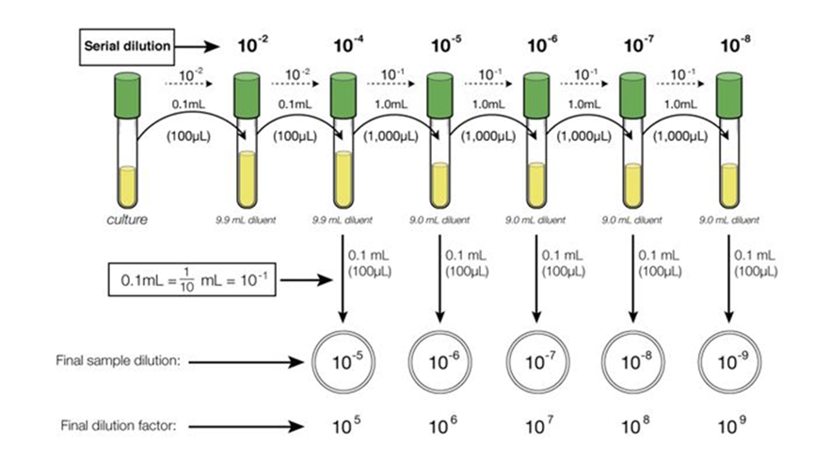
Figure 3.6. Serial dilution and plating
6. Using a new pipette tip, transfer 100 µL (0.1 mL) of the 10⁻⁸ dilution onto the centre of the agar surface of the plate marked 10^{-X}.
Consider why this is a 10^{-X} plate after you put 100uL (0.1 mL) of inoculum from the 10^{-X} dilution tube on it. Remember that you are trying to determine the number of viable cells in each 1.0 mL aliquot of the sample, and you only put 10% of 1.0 mL (0.1 mL) on the plate count agar (PCA).
Repeat with the rest of the dilutions, transferring 100µL (0.1 mL) from each dilution tube onto the appropriate agar surface, using a new pipette tip between each dilution tube.
7. Spread the plates: Using good aseptic technique, take one sterile blue L-shaped cell spreader out of the bag and reseal the bag. Starting with the plate marked 10^{-x}, using the spreader, gently push the liquid inoculum applied to the centre of the plate, two or three times clockwise around the dish, then several times anticlockwise, turning the plate on the turntable as needed to obtain complete coverage.
Continue with the rest of the spread plates using the same cell spreader. Make sure you are continuing to work backwards (from 10⁻² to 10^{-x} etc.) from the most dilute suspension to the most concentrated suspension to minimise the amount of carryover from plate to plate. Again, use good aseptic technique, work quickly, do not touch the cell spreader on surfaces other than the agar plate you are using. If you accidentally “contaminate” the spreader by touching a surface (table or other), then dispose of it and get a new spreader. We are trying to minimise the use of the spreaders to reduce waste, but if it gets compromised, then replace it with a new sterile spreader.
Dispose of the cell spreader in the small orange biohazard bin on your bench when you are done with your spread plates.
Remember that the plates should be labelled as a ten-fold higher dilution than the dilution tube of the 0.1 mL sample being plated. For example, 0.1 mL of the 10⁻² dilution tube should be plated on the agar plate marked 10⁻³.
It is generally desirable to make duplicate or triplicate plantings of each dilution and to average the resulting counts. However, since your lab sample comes from the same stock culture, the class average should give an accurate enumeration of the original stock culture.
8. After the spread plating, leave plates agar side down for at least 30 min in order for the inoculum to absorb onto the agar, then invert the plates and incubate at 30 °C.

B: Counting colonies on plates
1. Looking at the dilution plates you prepared last time, choose the plates that have from 30-300 colonies on them. As this might take some practice in plate counting, you might need to choose all plates with what looks like a reasonable number of colonies to count.
- those plates that have no microbial growth can be recorded as 0 or NG, No Growth.
- those plates on which colonies are not individually distinct (their edges run together) can be recorded as TNTC, Too Numerous To Count.
- those plates on which you cannot distinguish any individual colonies, the entire surface is covered with microbial growth, can be recorded as confluent.
2. Count each colony to give a total colony count for each plate chosen. You will avoid counting a colony twice by marking off the colonies on the bottom of the plate as you count them. This requires, of course, that the plate be upside down. Be sure to count any small colonies. Record your results on the report sheet.

C: Calculation of number viable cells/mL in the original sample
• Choose the plate containing between 30 and 300 colonies.
• Multiply the number of colonies on the plate by the final dilution factor. This gives the total viable cells/mL in the original sample.
• Calculate the colony-forming units, CFU, per mL for the sample.
Watch Video 1: Dilutions and Plating at NC State Microbiology labs. URL: https://youtu.be/IJcw4fRsYnU

Enumeration of Bacteria
Often one needs to determine the number of organisms in a sample of material, for example, in water, foods, or a bacterial culture. For example, bacterial pathogens can be introduced into foods at any stage: during growth/production at the farm, during processing, during handling and packaging, and when the food is prepared in the kitchen. In general, small numbers of pathogenic bacteria are not dangerous, but improper storage and/or cooking conditions can allow these bacteria to multiply to dangerous levels.
Faecal contamination of water is another one of the ways in which pathogens can be introduced. Coliform bacteria are Gram-negative non-spore forming bacteria that are capable of fermenting lactose to produce acid and gas. A subset of these bacteria are the faecal coliforms, which are found at high levels in human and animal intestines. Faecal coliform bacteria such as E. coli, are often used as indicator species, as they are not commonly found growing in nature in the absence of faecal contamination. The presence of E. coli suggests faeces are present, indicating that serious pathogens, such as Salmonella species and Campylobacter species, could also be present.
For the enumeration colony forming units for the meat samples we use violet red bile agar with lactose

Methods of Enumeration
Many approaches are commonly employed for enumerating bacteria, including measurements of the direct microscopic count, culture turbidity, dry weight of cells, etc. In a microbiology lab, we frequently determine the total viable count in a bacterial culture.
The most common method of measuring viable bacterial cell numbers is the standard or viable plate count or colony count. This is a viable count, NOT a total cell count. It reveals information related only to viable or live bacteria. Using this method, a small volume (0.1 - 1.0 mL) of liquid containing an unknown number of bacteria is spread over the surface of an agar plate, creating a "spread plate." The spread plates are incubated for 24-36 hours. During that time, each individual viable bacterial cell multiplies to form a readily visible colony. The number of colonies is then counted and this number should equal the number of viable bacterial cells in the original volume of sample, which was applied to the plate.
For accurate information, it is critical that each colony comes from only one cell, so chains and clumps of cells must be broken apart. However, many bacterial species grow in pairs, chains, or clusters or they may have sticky capsules or slime layers, which cause them to clump together. It is sometimes difficult to separate these into single cells, which in turn makes it difficult to obtain an accurate count of the original cell numbers. Therefore, the total number of viable cells obtained from this procedure is usually reported as the number of colony-forming units (CFUs).
A bacterial culture and many other samples usually contain too many cells to be counted directly. Thus, in order to obtain plates, which are not hopelessly overgrown with colonies, it is often necessary to dilute the sample and spread measured amounts of the diluted sample on plates. Dilutions are performed by careful aseptic pipetting of a known volume of sample into a known volume of a sterile buffer or sterile water. This is mixed well and can be used for plating and/or further dilution. If the number of cells in the original sample is unknown, then a wide range of dilutions are usually prepared and plated. The preparation of dilutions and the calculation and use of dilution factors to obtain the number of microorganisms present in a sample are important basic techniques in microbiology.

Method and Procedures
Aliquots from a stepwise or serial dilution of the original sample are spread on plates. Only a few of the plates following incubation will contain a suitable number of colonies to count; those plated from low dilutions may contain too many colonies to count easily while those plated from high dilutions may contain too few colonies or none at all. Ideally plates containing 30-300 colonies per plate should be counted. At this colony number, the number counted is high enough to have statistical accuracy, yet low enough to avoid mistakes due to overlapping colonies.
Figure 3.7. Serial dilution series and plating
A wide series of dilutions (e.g. 10⁻² to 10^{-x}) is normally performed on the sample culture and spread plates created from the dilutions. A number of spread plates are needed because the exact number of live bacteria in the sample is usually unknown. Greater accuracy can be achieved by plating duplicates or triplicates of each dilution.
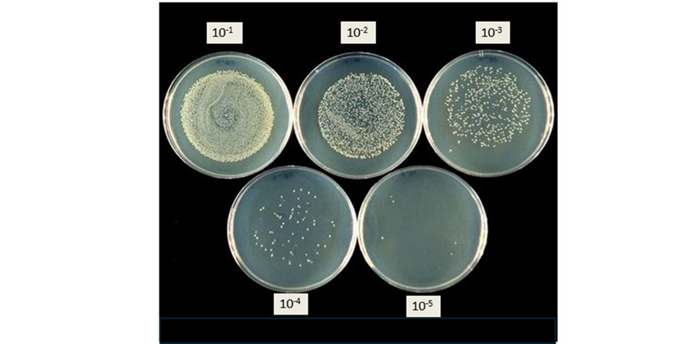
Figure 3.8. The series of dilutions

Results
Draw conclusions and compare the obtained results with the information available in the literature and scientific publications.

Conclusion
1.
2.
3.

Approved by _____________________
Name, Surname, signature
Date ______________

Theme 4

Meat preservation methods

Theoretical materials
Refrigeration as a method of preserving meat. Classification of meat by thermal condition.
Refrigeration processing of meat and meat products and their storage at appropriate low temperatures is one of the most modern methods of preventing or slowing down the spoilage of these products. During the refrigeration, the best preservation of the original native properties of meat and offal is achieved.
Cold storage ensures minimal changes in the nutritional value and taste of meat. Cold treatment suppresses the vital activity of microorganisms, and slows down the chemical and biochemical processes occurring in the product under the influence of its own enzymes, atmospheric oxygen, heat and light.
Depending on the expected shelf life, there are:
1. Storage at a temperature above the freezing point of tissue fluid, but close to it (0–4 °C); possible shelf life is 7–10 days, and under particularly favourable sanitary conditions – up to 3–4 weeks.
2. Storage at a temperature below the freezing point, but close to it, possible storage period up to 2–3 weeks.
3. Storage at temperatures well below freezing; Shelf life is 6–12 months, and under favourable conditions even longer.
Accordingly, the meat is cooled, i.e. its temperature is reduced close to the freezing point, or it is frozen, bringing its temperature to the one at which storage is proposed.
In technological practice, depending on the nature of refrigeration treatment, meat is classified as follows:
1. The meat is hot-steamed, that is, it has not lost animal heat with a temperature of at least 36–38 °C.
2. The meat has cooled down and has a temperature no higher than 12 °C.
3. Chilled meat, having a core temperature no higher than 4 °C after cooling under regulated conditions.
4. Frozen meat, having a temperature of –2-(–3) °C.
5. Meat frozen with a temperature not higher than –8 °C.
6. Frozen meat, the temperature of which, under certain conditions, is brought in thickness to 1 °C.
The original, natural properties of meat are most fully preserved in chilled meat, which is superior in quality to frozen meat.
Cooling meat to the freezing point of tissue fluid slows down the vital activity of microorganisms and also introduces a qualitative change in the composition of the microflora. The proportion of thermophiles and mesophiles decreases to 2–5% of the total. During freezing, the decrease in temperature and the removal of moisture as a result of crystal formation leads to the cessation of the vital activity of microorganisms. Psychrophilic bacteria lose their ability to reproduce at temperatures below –5 °C, psychrophilic yeast at –10 °C. At –18 °C and below, frozen meat cannot be spoiled as a result of the development of microorganisms.
Various spoilage agents, moulds, and yeasts cease their activity at temperatures below –10 °C. Moulds are the most resistant to low temperatures, including those that cause the formation of mucus on the surface of meat.
The high viability of microorganisms is due to the fact that the most important factor in their development is water, without which metabolism in microorganisms is impossible. When meat and offal are frozen, the water in the tissue fluid turns to ice. Complete freezing of tissue fluid occurs in meat at a temperature of –55 - (–65) °C. If the freezing temperature is not low enough, water remains in the meat, therefore, the most important conditions for the life of microorganisms remain. When food is frozen, along with the slowing down or cessation of the vital activity of microorganisms, their death also occurs. The death of microorganisms during freezing is caused by a significant metabolic disorder due to freezing of moisture and significant damage to the cell structure.
The maximum degree of damage to microbial cells is observed when meat is slowly frozen to a temperature of –6 - (–12) °C. When frozen very quickly, about 10% of the cells remain alive. This is explained by the formation of a large number of tiny ice crystals and, as a result, less damage to the cell structure. However, the processes of refrigeration processing of meat and offal should be carried out at an accelerated pace, since the faster the temperature of the product decreases, the faster the vital activity of microorganisms and the activity of enzymes are suppressed, and the slower the structural and chemical changes in the product occur.

Package selection for preserved meat
The choice of packaging for preserved meat has significantly expanded over the last few years – the possibilities for products in different types of packaging. As with fresh meat, processed meat is often packaged in a modified gas environment. Packaging solutions are very similar to fresh packaged meat. For hermetically sealed packages, it is essential that the packaging materials have high barrier properties
Table 4.1.
The most commonly used packages shapes for packing of fresh meat
Illustration | Package shape | Description
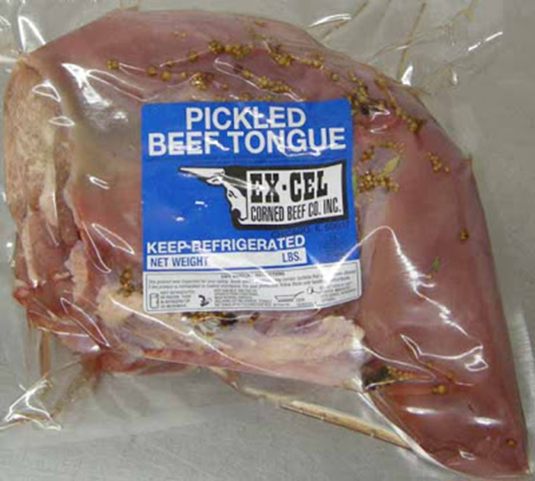 | Shrink package | More often, they are used for packaging various pickled baked goods.
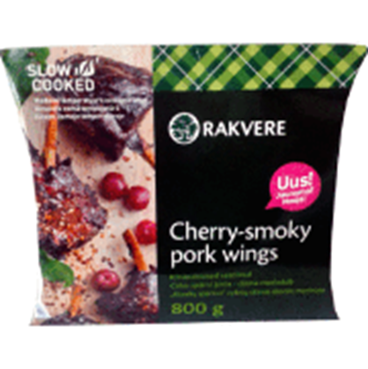 | Pillow pouch | Usually produced in-house in horizontal flow-pack equipment. Or purchased packaging in the form of ready-made packages with fused three seams. This type of packaging is also common for packaging different types of sausages, as well as for packaging frozen meat.
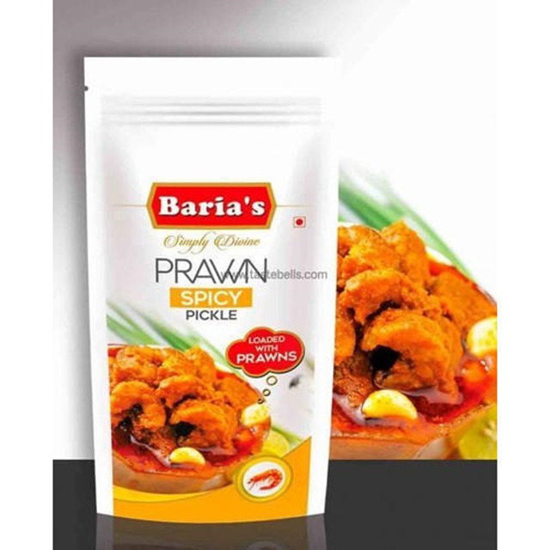 | Doypack | Usually produced in-company in horizontal flow-pack equipment. Or purchased packaging in the form of ready-made packages with fused three seams.
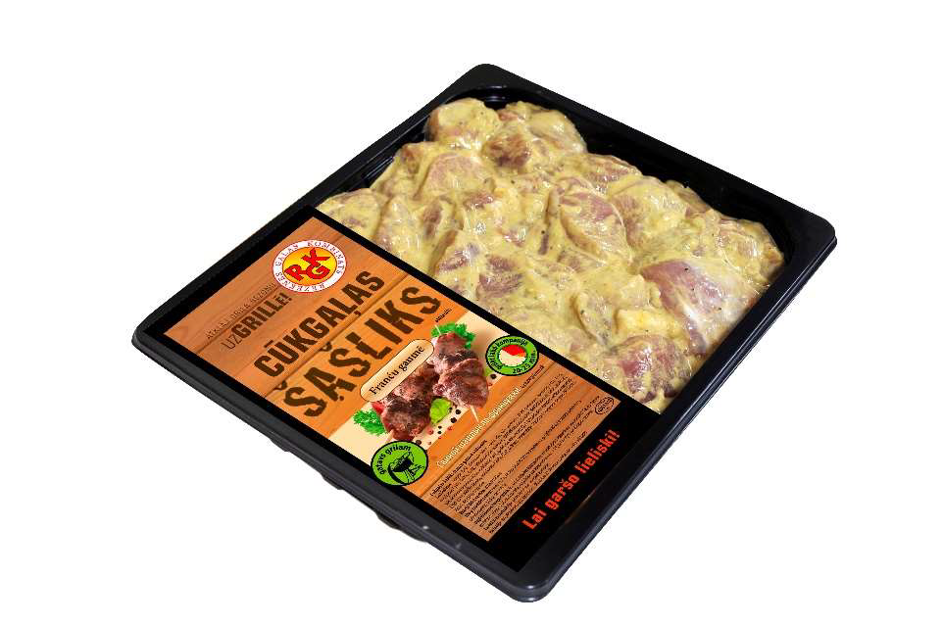 | Trays | Usually, companies already receive ready-made containers, which are hermetically sealed after placing the products.
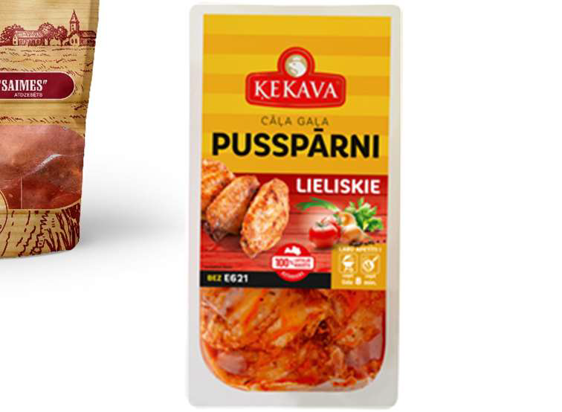 | Thermoformed packages | These packages are usually made in-house from a roll of packaging.
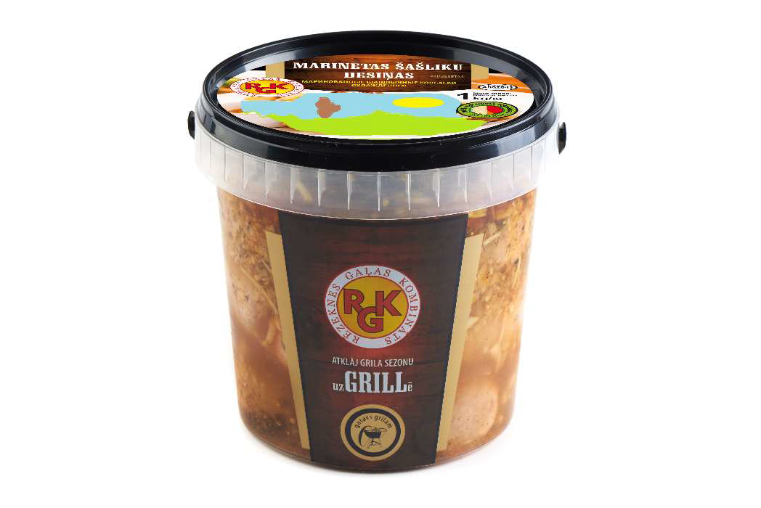 | Plastic buckets/containers | This type of packaging is often used for packaging marinated meat.
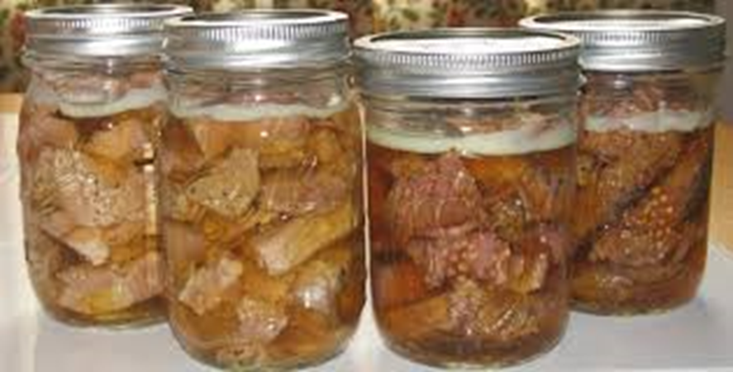 | Glass and/or plastic (PET) jars | Often used for packing pickled products.

For the packaging of this type of products, both air, vacuum and MAP technologies are used. The technological process is the same as for fresh meat.
However, it should be noted that when packing MAP it is important to know and observe the appropriate gas composition inside the package above the product. A mixture of CO₂ gas and N₂ gas is usually used as the shielding gas environment.
Gases. Oxygen helps to keep the fresh and natural colour of food products, prevents the growth of anaerobic bacteria (present in certain types of fish and vegetables) and allows fresh fruit and vegetables to breathe. In the case of fruit and vegetables, the absence of O₂ can lead to anaerobic respiration in the package which accelerates senescence and spoilage. Levels of O₂ that are too high do not retard respiration significantly and it is around 12% of O₂ where the respiration rate starts to decrease. So oxygen is used at low levels (3-5%) for positive effect.
When packaging meat and fish, for example, the high CO₂-levels are effective bacterial and fungal growth inhibitors. In the case of vegetables and fruits, CO₂ is not a major factor since CO₂-levels above 10% are needed to suppress fungal growth significantly. Unfortunately higher levels than 10% of CO₂ are working phytotoxic for fruit & vegetables.
Nitrogen, for example, is used as a filler gas since it neither encourages nor discourages bacterial growth and it prevents the oxidative rancidity caused by the presence of oxygen in packaged snacks and dried products.
In recent years, there has been a debate regarding the use of carbon monoxide (CO) in the packaging of red meat. While no risk was found in the use of low levels of CO, the fact that CO maintains the colour of the meat, and can hide visual evidence of spoilage, was raised.

When solving packaging issues, it is important to remember that meat and meat products are perishable products, therefore, not only the packaging, but the combination of the packaging material with the storage temperature is a very important factor.
It is also important that if the meat products are packed in different packages, it is possible to create a packaging system that combines all packaging processes in the company.
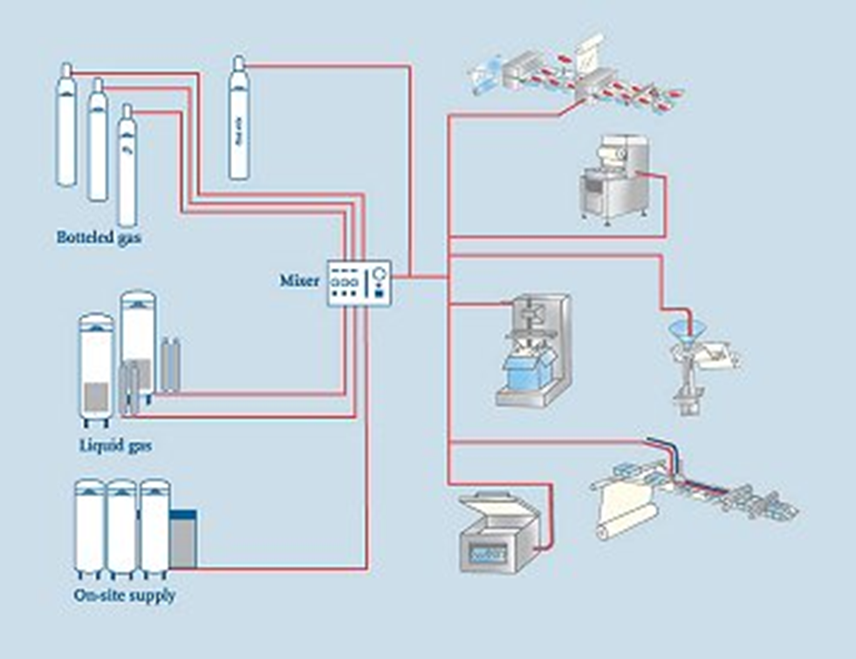
Figure 4.1. In protective uses of packaging systems

Contamination risks of preserved meat
Any meat that has been preserved through smoking, curing, salting, or the use of chemical preservatives is considered processed meat; examples of this type of meat include sausages, bacon, salami, hot dogs, processed deli meats, and luncheon meats. Meat products are the most consumed and highly appreciated food items globally. These meat products retain at least half of their original meat integrity after processing (i.e. the original meat qualities have reduced by half when a meat is processed into meat products). Food processing and supply businesses have been captivated by the prevalence of harmful microbes and spoilage, making safe food supply a global concern. The obstacles to the hygienic processing of meat have included the lack of centralised harvest facilities, the small amount of retail business (i.e. the retail enterprise is typically a small market), prohibitive capital expenses on mechanised, infrastructural, and recurring expenditures.
The main goal in trying to extend the shelf life of products is to reduce the initial bacterial load in meat. Meat products' shelf life is influenced by a number of variables, the most significant of which is their microbiological quality. Numerous research investigations have demonstrated a correlation between the consumption of meat and meat products and the occurrence of foodborne illness outbreaks. The primary causes of disease and mortality in developing nations are foodborne pathogens, which have a billion-dollar impact on societal and medical expenses. The failure or incapacity to control microorganisms at one or more stages of the food chain, from raw material consumption to end product consumption, leads to foodborne illness and microbial food spoilage. Events leading to outbreaks of food poisoning or food spoiling can have serious ramifications for food manufacturers, distributors, buyers, and government agencies.
One of the key elements influencing meat product quality during storage is microbial development, which can result in contamination, spoiling, and financial loss. Microbiological standards ought to consider any organisms that might be found in the beef product. When items are maintained properly, they should remain safe and wholesome until the end of their shelf life, even after allowing for the predicted growth of these organisms. This is because tolerance thresholds should be applied at the time of manufacture.
Animal-derived food safety for human consumption is now a crucial topic of discussion in public health discussions. Therefore, the environment, the type of meat and raw materials, the equipment, the handling procedures, the processing, the packaging, and the temperature of storage will all have a major impact on the microbial ecology of meat products.
Historically, microbiological testing of samples at different phases of manufacturing, including the finished product, has been used to demonstrate control of bacteria in food. The type of bacteria present and their capacity to proliferate to a point of concern under the storage circumstances used during the product shelf life determine the potential for growth and/or toxin production of residual microbial population in completed products.

Sources of Microbial Contaminants in Meat Products
During the manufacturing, packing, and marketing processes, meat handlers who are infected with harmful germs might contaminate meat products. The working habits of food handlers and disease-causing microorganisms on or in the food handler's body that are then transferred from the food handler to the food throughout the handling process are two of the main causes of food contamination hazards. Because humans are a primary source of contamination that can result in food poisoning from Staphylococcus aureus, personal cleanliness is crucial when handling food. Inadequate personal hygiene habits, such as failing to wash hands after using the restroom, can cause food workers to have up to 10⁷ CFU (colony-forming units) ml 1 pathogens under their fingernails.
Spices can harbour germs, moulds, or yeasts and play a significant role in meat products. Spice variety, processing technique, granule size, and moisture level all affect the microbiological load of the spice. When making sausages, minced meat and spice mixture have been found to be the main causes of contamination. The most likely cause of the increased microbial load in minced meat is the unclean nature of the raw flesh. The microbiological quality of raw meat and non-meat materials influences the finished product's quality. Another contributing source of contamination in processed beef products is the degree of sophistication and hygienic state of the harvesting and processing machinery. Research has indicated that as harvest facilities became more sophisticated, the amount of bacteria contaminating meat was reduced. Furthermore, different parts of the carcasses from which processed meat is extracted may have varying incidences of different foodborne pathogens; for example, research has indicated that, regardless of the processing conditions, thigh muscles were much more likely to become contaminated than breast muscles.

Some Microbial Contaminants of Processed Meat
In the right circumstances, a wide variety of bacteria may contribute to meat deterioration. Because of this, the microbial ecology of damaged meat products is extremely complicated, making it very challenging to stop the spoiling process. Numerous investigations have established the existence of foodborne pathogens, including Clostridium perfringens, Salmonella spp., Escherichia coli, S. aureus, and Listeria monocytogenes, in pork products.
Listeria monocytogenes is a facultative anaerobic gram-positive rod-type bacteria that does not form spores and is extremely mobile. It may thrive in a broad variety of pH and temperature ranges. The organism is widely distributed in the environment and is capable of withstanding nitrite and salt.
One of the most frequent culprits in bacterial food poisoning epidemics is Staphylococcus aureus, which is also a key pathogen responsible for the development of clinical or subclinical mastitis in dairy domestic ruminants. Milk and milk products, meat, poultry, and egg products have all been identified as common foods that can result in staphylococcal food poisoning. Because Staphylococcus aureus can create a wide variety of exotoxins and other virulence factors, it is one of the most common etiological agents of bacterial illnesses globally. Of them, the majority of common foodborne intoxications are caused by staphylococcal enterotoxins, which are produced by certain strains of S. aureus. Both staphylococcal food poisoning and toxin-1, which causes toxic shock syndrome, are the causes of staphylococcal scarlet fever.

Intervention against Microbial Contaminants of Processed Meat
Cooking can quickly deactivate the majority of microbial vegetative cells and hazardous products since they are susceptible to heat treatment. Consequently, the primary problem when packaging is post-cooking recontamination. Common strategies to manage microbiological contaminants in processed meat include post-package decontamination techniques such in-package thermal pasteurization and irradiation, as well as designing meat products with antimicrobial compounds. As a result, the producer has the advantage of taking action to lessen food contamination.

Irradiation
Exposure of items to radiant energy is the process that results in ionizing radiation. X-rays, electron beams, and gamma rays are examples of ionizing radiation. It has been observed that e-beam irradiation is superior to gamma-ray irradiation in terms of reducing Bacillus cereus and E. coli O157:H7, but not L. monocytogenes. Low-dose (0.75–0.90 kGy) radiation lowered L. monocytogenes by 42 log in cooked pork chops and hams infected with the pathogen. Compared to vacuum or modified environment packing settings, aerobic packaging resulted in significantly higher mortality rates from radiation treatments. The use of modified environment packaging in irradiated meat or poultry raises the possibility that pathogens will proliferate and/or develop poisons due to a lack of competing organisms. If spoiling is suppressed and does not give the typical warning signals, then this is even more of a concern. The impacts of temperature must be carefully taken into account because lower radiation temperatures generate fewer detrimental alterations to the sensory qualities of meat and poultry products. Nonetheless, higher radiation doses are needed in colder temperatures to render foodborne bacteria inactive. Another influence is the rate of radiation exposure since, at low doses, microbial enzymes may have more time to repair cell damage, leading to increased resistance. Because product compositions and irradiation circumstances might impact the effectiveness of irradiation, generalising about its effects can be deceptive.

Food Preservatives
Chemical antimicrobials: Due to its advantageous effects on meat quality when administered at the right concentrations, salt of lactate (SL) is widely utilised as an antimicrobial in meat products. There is a good chance that the shelf life of food products with a neutral pH can be extended by adding lactate. Under ideal growth circumstances (pH 6.5, 20 °C), Gram-positive bacteria were often more sensitive to lactate than Gram-negative bacteria. It has been shown that applying lactate and diacetate together has a synergistic inhibitory effect that inhibits the growth of harmful organisms in meat products. It has been demonstrated that a chemically produced short-chain peptide with six leucine and eight lysine residues is biocidal against a variety of foodborne pathogens, including L. monocytogenes suspended in phosphate buffer at doses ranging from five to fifty mg/ml. Meat exudate contained both aerobic and anaerobic microorganisms that were suppressed by peptide doses of 100 mg/ml. L. monocytogenes was successfully eradicated by the use of peroxyacetic acid, sodium hypochlorite, and quaternary ammonium compound as sanitizers in meat processing facilities.
Probiotic bacteria, bacteriocins, and lactobacilli: Using different lactic acid bacteria strains for biopreservation is a good substitute for chemical preservatives. Both naturally and artificially contaminated salami demonstrated the potent antibacterial activity of a bacteriocin-producing Lactobacillus plantarum MCS strain against L. monocytogenes. Therefore, adding Lactobacillus, Pediococcus, and enterococci to starter cultures could pose an extra barrier against pathogens in meat products that have undergone fermentation. It is also possible to employ lactic acid bacteria to stop bacterial contamination from growing in non-fermented foods. In the initial days following manufacturing, the addition of Lactobacillus sakei Lb 706 inhibited the growth of L. monocytogenes in pasteurised minced meat and comminuted cured raw pork. When a cocktail of three rifampicin-resistant mutant L. monocytogenes strains was added to cooked items at a concentration of 10⁵ - 10⁶ CFU/g right before slicing and vacuum packaging, the growth of those strains was reduced at both 8 °C and 4 °C. Bacteriocins are polypeptides that bacteria create through ribosome synthesis that have the power to either kill or stop the growth of related bacterial strains. Because of its comparatively lengthy history of safe usage, nisin is the most significant bacteriocin in terms of commerce. Approximately fifty nations currently recognize it as a safe food preservative.
Plant extracts: Plant extracts have a wide range of antibacterial action against numerous genera of bacteria and fungi because of their antioxidant and antimicrobial properties. Pine bark extract and eugenol (clove extract) have been shown to strongly suppress the growth of L. monocytogenes and Aeromonas hydrophila inoculated in cooked beef slices. After nine days of refrigeration, the treated raw ground beef with 1 % pine bark extract as an antibiotic showed a decrease in the quantity of E. coli O157:H7, L. monocytogenes, and S. typhimurium. These findings imply that using natural plant extracts in conjunction with other preservation techniques may help lower the pathogen content of processed beef.

In-Package Thermal Pasteurisation
When exposed to an 85 °C water bath for 10 seconds (a 46-log reduction), all of the L. monocytogenes cells were destroyed; however, viable cells were still detectable after up to 10 minutes of heating at 61 °C (a 0.6-log reduction). These findings were related to the effects of surface pasteurisation temperatures on the survival of L. monocytogenes in low-fat turkey bologna. The size of the packaging and the roughness of the product surface affected how well in-package pasteurisation inactivated pathogenic germs. The efficiency of heat pasteurisation is also influenced by the strains of bacteria. Prior to heat treatment, cells grown at 42.8 °C showed greater thermo-tolerance than those grown at 37 °C. L. monocytogenes thermo-tolerance was raised by heating at gradually rising temperatures (0.7 °C/min), and the organism's heat resistance in broth was increased by starving it in phosphate-buffered saline pH 7 for six hours at 30 °C.

High-Pressure Processing
Food is processed using a revolutionary non-thermal technique called high-pressure processing (HPP), in which it is heated to high pressures either with or without the input of heat. Microorganisms can be rendered inactive by HPP without causing noticeable alterations to the food's nutritional content, texture, or colour. HPP is a potent instrument for managing pathogenic organisms, but it also works well against viruses and spores. In addition, a number of other variables, including pressure, temperature of treatment, duration of exposure, pH, water activity, and food composition, affect how effective HPP is at decontaminating. Numerous investigations have demonstrated that HPP was somewhat less efficient at ambient temperature than it was when chilled. Moreover, the presence of oil decreased the efficiency of high pressure in eliminating L. monocytogenes, and the shape of the cell also affected HPP, with bacilli being more pressurised-sensitive than cocci. Because HPP causes sublethal damage to living cells, the death rate increases when mixed with antimicrobials such as bacteriocins.

Combination Therapy Technology
Combination treatment technology is based on the application of many preservative elements to ensure food stability and microbiological safety. Temperature, water activity, acidity, redox potential, antimicrobials, and competitive microbes are the most significant barriers utilised in food preservation. If obstacles strike at different times and disrupt the equilibrium of the microbes found in food, a synergistic effect can result. The most often used barriers for beef products include nitrite, vacuum packing, thermal processing, and chilled storage. These obstacles, however, don't seem to be enough for L. monocytogenes because of its widespread distribution, capacity to grow in anaerobic environments and at cold temperatures, and resistance to nitrite and salt.

Microbial Contamination Intervention and Processed Meat Quality
Interventions produce free radicals that can lead to lipid peroxidation and other chemical changes that affect the quality of processed meat, even if they are particularly successful at controlling food-borne pathogens in meat. Meat items exposed to radiation may take on a distinct smell that has been called "bloody sweet" or "barbecued corn-like." According to sensory analysis, the irradiation dose rose with the sulfur odour. Irradiation significantly boosted other volatiles in the beef products in addition to sulfur compounds. Depending on the radiation dose, animal species, muscle type, pH, meat reduction potential, and packaging style, radiation can cause a wide range of colour changes. The formation of carbon monoxide during irradiation is linked to the colour change caused by radiation and is correlated with the enhanced redness of irradiated meat. Carbon monoxide-myoglobin (CO-Mb) is the pigment that gives irradiated turkey flesh its pink colour.
It has also been observed that radiation causes substantial yields of side-chain hydroperoxides, which are linked to the oxidation of lipids and proteins, which in turn causes the oxidation of amino acids. When cooked and vacuum-packed beef top rounds were injected with SL, the cooked beef produced larger cooking yields and a deeper, redder colour with less grey surface area. The addition of SL improved the flavour notes associated with fresh beef and reduced flavour deterioration during storage. In Chinese-style sausage, the addition of 3 % SL resulted in better quality regarding physicochemical characteristics. Research reports have shown that SL added to fresh pork sausage did not affect the internal lean colour but resulted in more rapid surface discoloration, and that 2 % potassium lactate had no effect on quality and sensory properties of low-fat pork sausage or lean colour during refrigerated aerobic storage. Adding 2 % SL to turkey breast rolls resulted in lower colour values, but increased hardness, springiness, cohesiveness, chewiness, and resilience of turkey breast rolls. Including 3.3 % commercial SL in frankfurter formulation did not affect the textural profile of sausage. The texture of products was unaffected by the addition of up to 0.1% potassium sorbate or up to 0.1% sodium benzoate in the product composition. These findings imply that the degree of SL and the kinds of items influence how SL affects product quality. The flavour of ham products is adversely affected by excessive sodium diacetate (SDA) concentrations. Nevertheless, SDA has no effect on the quality of meat products at lower concentrations (0.1%). Benzene level in the volatiles of irradiated RTE turkey ham and breast rolls significantly increased with the addition of potassium benzoate, indicating that benzoate salt is not a suitable antibacterial to be utilised in goods for irradiation. Nonetheless, there is no denying that HPP alters the quality of meat. While certain modifications, like colour and lipid oxidation, are undesirable, other changes, like pressure tenderisation and pressure-assisted gelation, are advantageous.

Conclusion
At several points during the meat processing process, microbial contamination can happen and can be minimised. The most significant indicator species that are frequently employed to guarantee food safety are coliform bacteria, faecal coliform bacteria, Escherichia coli, total Enterococcus spp., and aerobic plate count, as demonstrated by experiments. Counting yeast on samples taken during processing in small firms to confirm appropriate manufacturing methods is beneficial in certain cases. It was discovered that this monitoring-based verification was a more appealing option than having the final items examined. Before entering the processing facility, raw meat and additives must be examined to guarantee the microbiological quality of the finished goods. It is necessary to choose certified vendors. For suppliers of raw meat, strict standards for hygienic quality must be established. The materials and uncooked meat must be kept in the right storage conditions until used. Processing plant cleaning and sanitation procedures need to be done well. Employees should adhere to basic hygiene protocols, and their health should be routinely monitored. Lastly, the right time and temperature settings for processing meat should be chosen.

HACCP (Hazard analysis and critical control points)
Food safety is a scientific discipline describing handling, preparation, and storage of food in ways that prevent food borne spoiling. This includes a number of routines that should be followed to avoid potentially severe health hazards. In this way food safety often overlaps with food defence to prevent harm to consumers.
As it is known since the 1960s in the EU each enterprise that works in the Food segment must have a food safety system that is based on 7 HACCP principles. Seven basic principles are employed in the development of HACCP plans that meet the stated goal. These principles include hazard analysis, CCP identification, establishing critical limits, monitoring procedures, corrective actions, verification procedures, and record-keeping and documentation.
The Food Safety Plan - is not a stand-alone programme, but rather part of a larger food safety system. The foundational programmes that are part of the food safety system are frequently termed prerequisite programmes. The term was coined to indicate that they should be in place before HACCP based systems are implemented in order to effectively manage risk from foodborne hazards. Good Manufacturing Practice (GMP) regulations address requirements for many prerequisite programs. The conditions and practices the regulated food industry must follow for processing safe food under sanitary conditions, including personnel, plant and grounds, sanitary operations, sanitary facilities and controls, equipment and utensils, processes and controls, warehousing and distribution, and action levels in case with potentially unsafe product.
The process flow of a food safety plan (HACCP or Preventive Controls) is the centre of the food safety story of a food product. It tells how a company makes its products and also what hazards and controls are associated with each step.
Monitoring records and logs must include the actual values or observations that document the actual implementation of a Food Safety Plan. For example, if a temperature is being measured, the actual temperature must be recorded rather than a check mark indicating that the temperature complied with the critical limit. To comply with regulations, the information must be recorded at the time it is observed.
Here are suggested record and log types to use:
- Customer complaints,
- Corrective action forms,
- Employee training,
- Food safety quarterly audit,
- Food safety checklist,
- Raw materials/receiving log,
- Worker illness og,
- Refrigerator .og,
- Assembly log,
- Shipping Temperature og,
- Suggested supply chain.

Documents. The safety of your product depends on much more than just what you control within your own facility. Using an ingredient that has a history of association with a specific hazard may require a supply chain programme as a control within your food safety programme. Companies may have extensive supplier programmes that encompass much more than food safety elements to manage their supplier expectations and performance.
Here is a list of suggested documents to obtain from your supply chain:
- Food safety HACCP or preventive controls plan for each product,
- Food defence/ business continuity plan,
- Validation of each product and/or process and Ready-to-Eat statements (if applicable),
- Certificates of Analysis (COA),
- Third party audit certificate, report & corrective actions,
- Product specification,
- Allergen management,
- Country of origin,
- Potential hazards.
Biological hazards. Microbiological contamination – during processing at source of origin – supplier management and HACCP are in place and verified to eliminate and reduce the potential presence of microbiological contamination.
Microbiological contamination, for instance microbiological growth due to breakdown of refrigeration units.
Chemical hazards. Chemical contamination by pesticides at source of origin – chemical/pesticide used at source is verified to be compliant with regulations.
Chemical contamination from machine oils or lubricants, as well as cleaning chemicals.
Microbiological/ physical/ chemical contamination from – cross contamination or taint of finished product due to poor hygiene.
Physical hazards. Physical contamination – external contamination from rainwater, bird droppings, vermin/ rodents, and flying insects during the unloading process.
Glass contamination from internal light sources – pests/rodents and/or flying insects due to poor hygiene/debris build up - physical risks from straps/thermocouples/staples/foreign bodies found on pallets on intake.
Physical contamination from: 1) company quality inspectors – foreign bodies found within product and/or packaging from source of origin or during transportation; 2) warehouse operatives, pests/rodents, and/or flying insects due to poor hygiene/debris build up; 3) personnel foreign body/dust contamination from production environment.
The core messages of the Five Keys to Safer Food are: (1) keep clean; (2) separate raw and cooked; (3) cook thoroughly; (4) keep food at safe temperatures; and (5) use safe water and raw materials.
Recall plan. According to the Food Safety Modernisations Acts, Preventive Controls for Human food regulation requires the development of a written recall plan when a hazard analysis identifies a hazard requiring preventive control. Recalls are actions taken by an establishment to remove an adulterated, misbranded or violative product from the market. In other words, a product for which FDA or a state could take legal action against the company would be subject to recall.
Verification is an important component of supply chain, sanitation, allergen and critical controls. It confirms that the Food Safety Plan is operating as intended. Validation confirms the effectiveness of the Food Safety Plan in controlling food safety hazards. The purpose of verification is to provide a level of confidence that the Food Safety Plan is: 1) based on solid scientific principles that are adequate to control the hazards associated with the products and process, and 2) that the plan is being followed correctly every day of operation.

Risk assessment Matrix:
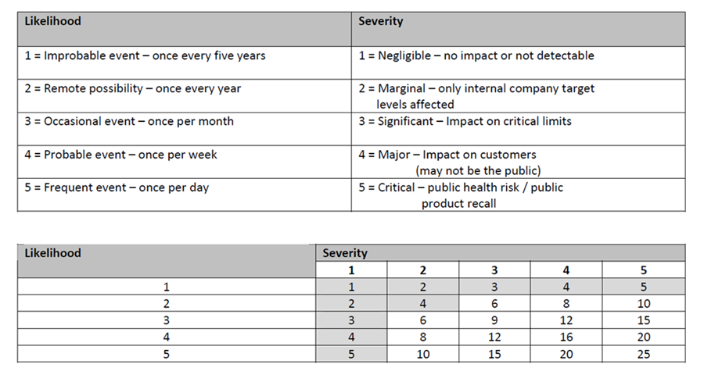
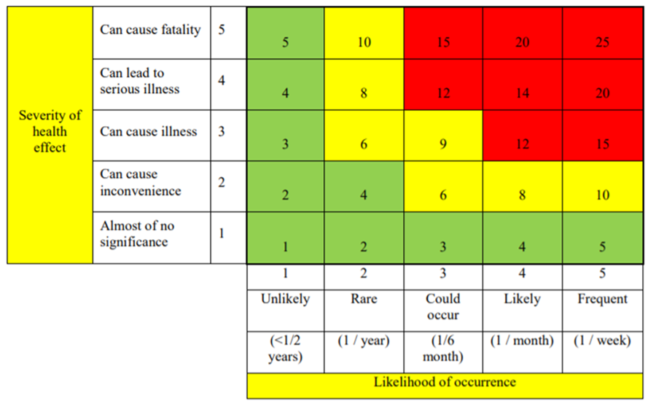
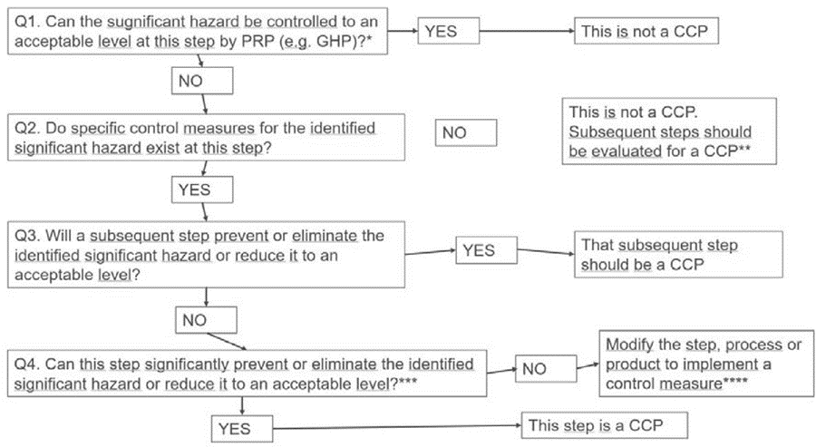
Figure 4.2. Example of a decision tree to identify critical control points (CCP)

Laboratory work

Sensory evaluation of meat

Materials
Different types of fresh meat samples (max. 7) for each panellist.

Methods and Procedures
Fresh meat samples need to be evaluated for appearance, structure and aroma. Mark the characteristics of each meat sample in the Table 4.2.
Table 4.2.
Sensory evaluation of meat
Sensory property | SAMPLE CODE
Appearance

Structure

Aroma

Results
After samples sensory evaluation and completing the table, students compare the results and draw the main conclusions.

Conclusion
1.
2.
3.

Approved by _____________________
Name, Surname, signature
Date ______________

Practical work

Safety risk assessment of meat

Materials
Theoretical materials
Methods and Procedures:
The following tasks must be completed in the practical part of the work:
1. For a selected meat, develop a product description, and draw a diagram of the process steps.
2. Identify potential hazards:
- biological – pathogenic microorganisms,
- chemical – agricultural chemicals,
- physical – foreign objects atypical for the product.
3. Evaluate the danger of the identified hazards using a risk matrix.
- Record the information in the hazard assessment table.
- Complete the CCP identification table and the HACCP plan.
- Write conclusions on determining CCP using a risk matrix and a decision scheme.

Results
Table 4.3.
Risk assessment table
Process stage | The identified hazard | Hazard assessment |  |  |  |  | Means of control
Process stage | The identified hazard | Possibility | The severity of the consequences | Risk level | Assessment | CCP | Means of control
Table 4.4.
CCP identification table
Process stage | Process stage | Cause of risk | Description of the cause of the risk | Control actions | Answers to Decision Scheme questions |  |  |  | CCP yes/no
No. |  |  |  |  | 1 | 2 | 3 | 4

Table 4.5.
HACCP plan
In process | CCP/  CP | Risk | Measurable | Monitoring procedures |  |  |  | Order- | Corrections
stage |  | the cause | critical limits of parameters | What? | How to? | How often? | What? |  | events

Conclusion
1.
2.
3.

Approved by _____________________
Name, Surname, signature
Date ______________

Laboratory work

Microbiological testing of semi-finished meat products

Total Viable Count
Total Viable Counting is a laboratory technique used to count all the microorganisms in food. It is sometimes referred to as Standard Plate Counting (SPC) and Aerobic Plate Counting (APC). TVC, as its name suggests, is a quantitative analysis that provides the number of microorganisms that are viable and thrive on microbiological media for food and environment. The food industry has made extensive use of them to assess the efficacy of cleanliness programs, processing conditions, food quality, and food safety. The conditions under which food is processed have a big impact on the microorganism populations found in it. The microbiota is made up of a variety of microorganisms that are typically found in raw and uncooked foods. The majority of vegetative germs will die when exposed to heat, although certain heat-resistant spores will survive. The microbe may also develop spores or go into a viable but non-culturable (VBNC) condition as a result of additional non-thermal processing. A low TVC count does not always indicate that there are no pathogens in the meal; bacteria can still cause infection at low concentrations.
TVC has a number of limitations, including the inability to distinguish between different types of microorganisms and the inability to estimate microbial cells that do not develop on plates, such as anaerobic bacteria or bacteria that have formed spores. To ensure food safety, TVC is therefore more helpful in microbial food quality assessment than in food pathogen assessment.
Learning Outcomes. Learn microbiological skills such as pipetting, performing serial dilutions, preparing spread plates for a viable plate count, and performing a colony count. Estimate the number of microbes in a sample using serial dilution techniques, including:
- correctly choosing and using pipettes and pipetting devices,
- correctly spreading diluted samples for counting,
- estimating appropriate dilutions,
- extrapolating plate counts to obtain the correct CFU in the starting sample.
Materials
Cultures: stationary phase broth culture of Serratia marcescens
Media: dilution tubes of sterile water
Supplies: nutrient agar plates, P-1000 Pipetman, sterile tips, Sterile L-shaped blue cell spreaders ("hockey stick” or spreader”)
Methods and Procedures
A. Sample dilution and spread plating
1. Label one plate on the bottom for each of the following dilutions: 10⁻⁵,10⁻⁶, 10⁻⁷, 10⁻⁸, and 10⁻⁹. See Figure 4.3.
2. Label the dilution tubes as follows: label the two tubes (navy blue caps) containing 9.9 mL sterile water as 10⁻² and 10⁻⁴; label the four tubes (green caps) containing 9.0 mL sterile water as 10⁻⁵, 10⁻⁶, 10⁻⁷, and 10⁻⁸.
3. Carefully and aseptically remove 0.1 mL (100 µL) of the Serratia marcescens culture and pipette it into the tube marked 10⁻². Mix the tube completely, being careful not to spill any of the contents. The vortex mixer will help you mix the contents of the tube.
• You have now prepared a 10⁻² (1/100) dilution. Why is it 10⁻²? Because 0.1 mL of undiluted culture was diluted into 9.9 mL of water, giving a total volume of 10.0 mL in the dilution tube. That makes this a 10⁻² dilution (0.1/0.1+9.9=0.1/10.0=1/100=10⁻²).
4. Change the pipette tip, and take 100µL (0.1 mL) from the 10⁻² dilution and pipette it into the next 9.9 mL dilution tube marked 10⁻⁴. Mix well. You have now prepared a successive 1/100 dilution, resulting in 10⁻⁴ dilution of the original culture (1/100 multiplied by 1/100 = 1/10,000 = 10⁻⁴, which is the same as 10⁻² x 10⁻²=10⁻⁴).
5. Change your pipette tip again.
• Why keep changing pipettes? Because any fluid left in the pipette tip from the previous dilution will contain many more cells per mL than any subsequent dilution and, if used, will grossly distort the final results by indicating a higher number of cells than were actually present in the original sample.
Now we will start doing a series of 1/10 dilutions. Set your Pipetman to 1,000 µL and remove a 1,000 µL (1.0 mL) aliquot from the 10-4 dilution tube. Transfer it to the 9.0 mL dilution tube marked 10⁻⁵ and mix well. The original culture has now been diluted 1/100,000, or 10⁻⁵ (10⁻⁴ x 10⁻¹ = 10⁻⁵),
You have just prepared a 10⁻¹ (1/10) dilution of the previously diluted culture. Why is it 10⁻¹? Because 1.0 mL of diluted culture was further diluted into 9.0 mL of water, giving a total volume of 10.0 mL in the dilution tube. (1.0/1.0 + 9.0 = 1.0/10.0 = 1/10 = 10⁻¹). Now you know why these series of dilutions are referred to as serial dilutions.
Continue your dilution series, as indicated in Figure 4.3., through to the 10⁻⁸ dilution tube.
Figure 4.3. Serial dilution and plating
6. Using a new pipette tip, transfer 100 µL (0.1 mL) of the 10⁻⁸ dilution onto the centre of the agar surface of the plate marked 10⁻⁹. Consider why this is a 10⁻⁹ plate after you put 100 µL (0.1 mL) of inoculum from the 10⁻⁸ dilution tube on it. Remember that you are trying to determine the number of viable cells in each 1.0 mL aliquot of the original Serratia marcescens sample, and you only put 10% of 1.0 mL (0.1 mL) on the nutrient agar plate.
Repeat with the rest of the dilutions, transferring 100 µL (0.1 mL) of each dilution tube onto the appropriate agar surface, using a new pipette tip between each dilution tube.
7. Spread plates: using good aseptic technique, take one sterile blue L-shaped cell spreader out of the bag and reseal the bag. Starting with the plate marked 10⁻⁹, using the spreader, gently push the liquid inoculum applied to the centre of the plate, two or three times clockwise around the dish, then several times anticlockwise, turning the plate on the turntable as needed to obtain complete coverage.
Continue with the rest of the spread plates using the same cell spreader. Make sure you are continuing to work backwards (from 10⁻ ⁹, then 10⁻⁸, then 10⁻⁷ then 10⁻⁶ etc.) from the most dilute suspension to the most concentrated suspension to minimise the amount of carryover from plate to plate. Again, use good aseptic technique, work quickly, do not touch the cell spreader on surfaces other than the agar plate you are using. If you accidentally “contaminate” the spreader by touching a surface (table or other), then dispose of it and get a new spreader. We are trying to minimise the use of the spreaders to reduce waste, but if it gets compromised, then replace it with a new sterile spreader.
Dispose of the cell spreader in the small orange biohazard bin on your bench when you are done with your spread plates.
Remember that the plates should be labelled as a ten-fold higher dilution than the dilution tube of the 0.1 mL sample being plated. For example, 0.1 mL of the 10⁻⁶ dilution tube should be plated on the agar plate marked 10⁻⁷. Again, if you need help visualising this, see Figure 4.3.
It is generally desirable to make duplicate or triplicate plantings of each dilution and to average the resulting counts. However, since your lab sample comes from the same stock culture, the class average should give an accurate enumeration of the original stock culture.
8. After the spread plating, leave plates agar side down for at least 30 min in order for the inoculum to absorb onto the agar, then invert the plates and incubate at 30 °C.

B. Counting colonies on plates
1. Looking at your dilution plates prepared last period, choose the plates that have from 30-300 colonies on them. As this might take some practice in plate counting, you might need to choose all plates with what looks like a reasonable number of colonies to count.
a. Those plates that have no microbial growth can be recorded as 0 or NG, No Growth.
b. Those plates on which colonies are not individually distinct (their edges run together) can be recorded as TNTC, Too Numerous To Count.
c. Those plates on which you cannot distinguish any individual colonies, the entire surface is covered with microbial growth, can be recorded as confluent.
2. Count each colony to give a total colony count for each plate chosen. You will avoid counting a colony twice by marking off the colonies on the bottom of the plate as you count them. This requires, of course, that the plate be upside down. Be sure to count any small colonies. Record your results on the report sheet.

Results
Draw conclusions and compare the obtained results with the information available in the literature and scientific publications.
C. Calculation of number viable cells/mL in the original sample
• Choose the plate containing between 30 and 300 colonies.
• Multiply the number of colonies on the plate by the final dilution factor. This gives the total viable cells/mL in the original sample.
• Calculate the colony-forming units, CFU, per mL for the Serratia marcescens culture. Watch Video 1: Dilutions and Plating at NC State Microbiology labs. URL: https://youtu.be/IJcw4fRsYnU

Conclusion
1.
2.
3.

Approved by _____________________
Name, Surname, signature
Date ______________

Laboratory work

Mechanical equipment for meat processing

Materials
Different types of meat samples ground with different mesh sizes of grinder.

Methods and Procedures
According to the flow chart (see below in Figure 4.4.), students prepare hamburgers. In the meat grinding process use different mesh sizes of grinder.
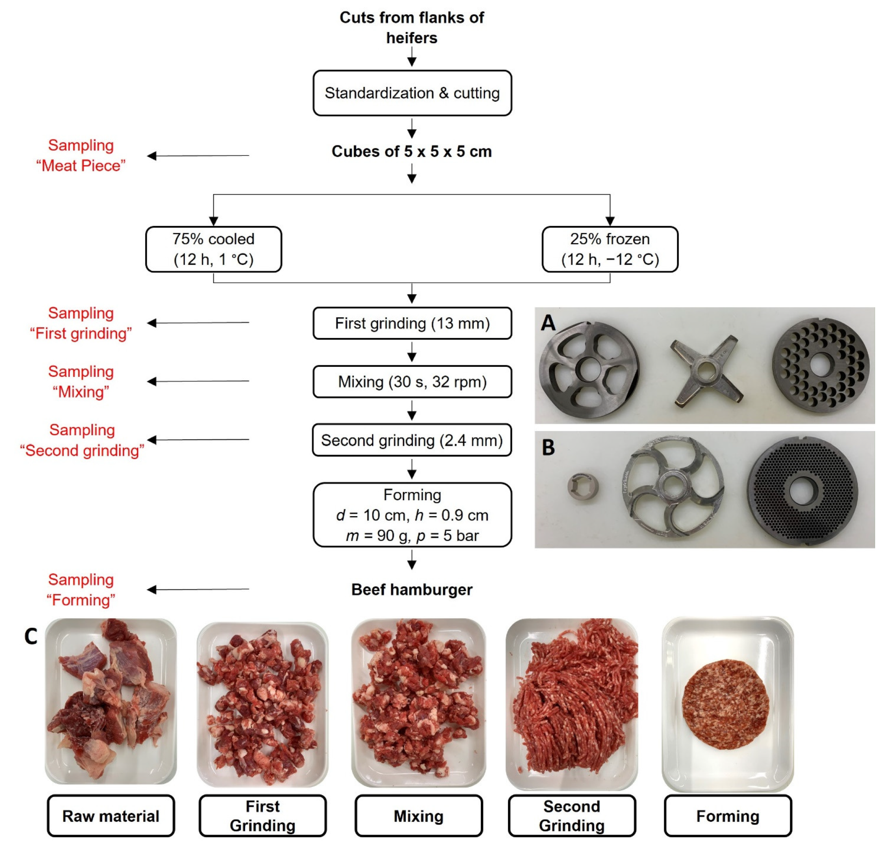
Figure 4.4. Flow chart of the hamburger manufacturing with different points of sampling, cutting set composition of (A) first grinding step (3-part cutting system: pre-cutter, 4-bladed knife, 13 mm inclined perforated disc) and (B) second grinding step (3-part cutting set: spacer, 5-bladed sickle knife, 2.4 mm inclined perforated disc) and photographs of the samples (C) (https://www.mdpi.com/2076-3417/12/15/7377#)

RESULTS
Draw conclusions and compare the obtained results with the information available in the literature and scientific publications.

Conclusion
1.
2.
3.

Approved by _____________________
Name, Surname, signature
Date ______________

Seminar

Optimal packaging solutions for preserved meat products

The optimal packaging solution includes the correct selection of packaging materials, packaging gas environment, packaging equipment and technological processes.
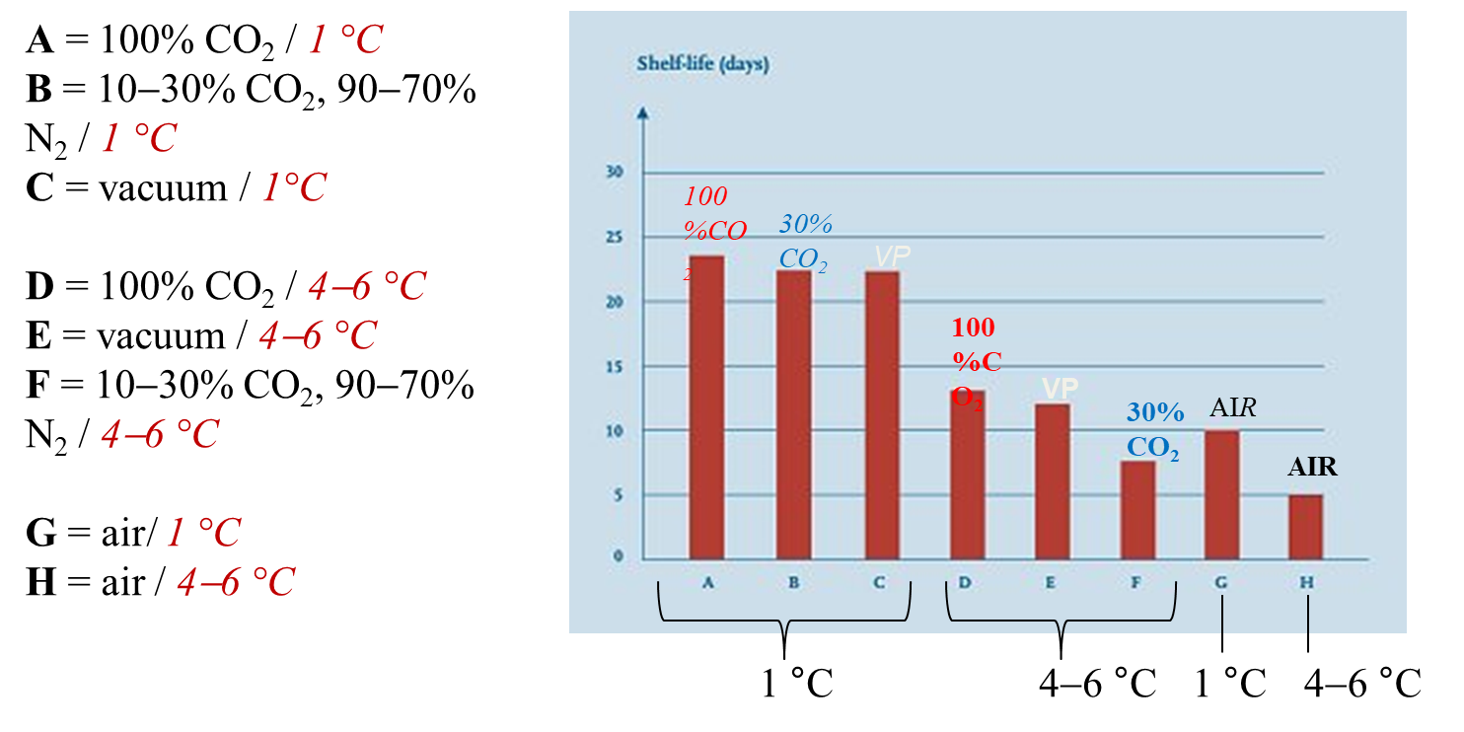
Figure 4.5. Gas composition and temperature influence on meat storage time

VIDEO: packaging process: (11.4 min): https://www.youtube.com/watch?v=nqcwpa7aAV0&nohtml5=False
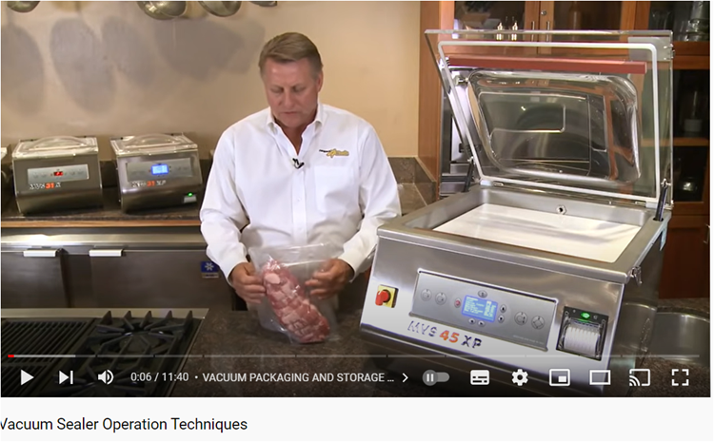
When packaging products in a gas environment, it is essential to choose the most appropriate composition of gasses, which can extend the time of shelf life.
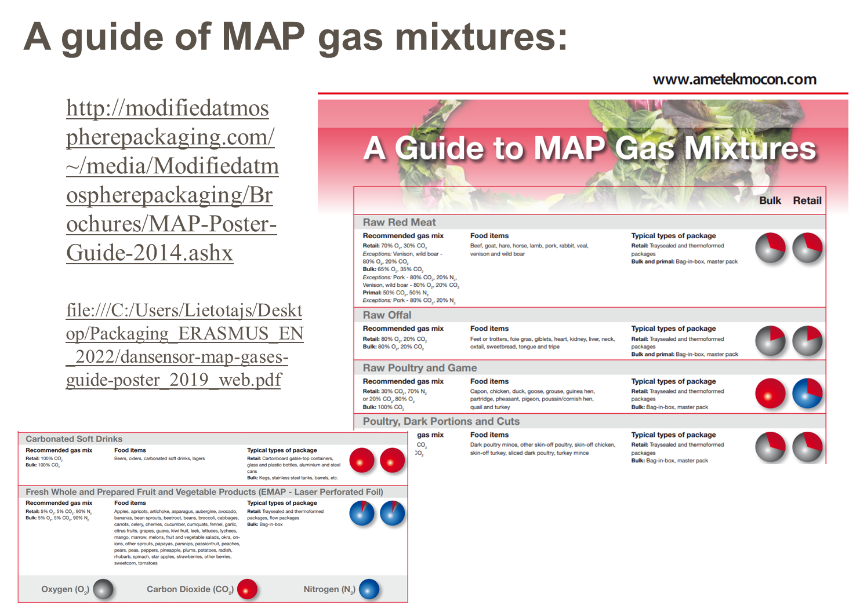
The issue of not only packaging products in such a way that they have a longer shelf life, but also how to optimise the packaging in the direction of sustainability is becoming more and more urgent.
The aim of the seminar is to gain knowledge and acquire skills in the packaging of preserved meat products using different packaging equipment, and different packaging materials. The group of students is divided into teams and each team analyses products packaged using different packaging solutions.

Materials
Different prototypes of packaged products, or photos found on the Internet of different packaged products.

Methods and Procedures
Each group of students analyses three different packages. And the characteristics are given in Table 4.6.

Results
The results obtained should be reflected in Table 4.6.
After completing the table, different groups of students compare the results. If possible, each group presents and justifies its performance.
During the exercise, the students acquire skills in characterising packages and analysing situations, as well as experience in working in groups.

Table 4.6.
Packages characterisation
Characteristic parameters | Samples
Characteristic parameters | Product No. 1 | Product No. 2 | Product No. 3
Packaging material
Packaging shape
Is gas environment used in the package, if yes, what is its composition?
What equipment can be used for this packaging process?
What information is printed on the package?
Does the packaging contain information about the recyclability of the packaging?

Conclusion
1.
2.
3.

Approved by _____________________
Name, Surname, signature
Date ______________

Theme 5

Meat products

Theoretical materials
Sausage classification
Sausage type:
- fresh sausages,
- cooked and smoked sausages,
- uncooked, smoked sausages,
- dry or fermented sausages,
- fermented sausages,
- semi-dry sausages,
- mould-ripened sausages.

Fresh sausage:
- fresh sausage is made from coarse or finely ground meat,
- it is mixed with seasonings and can be stuffed into casings, wrapped as a bulk package, or pressed into patty form,
- this type must be refrigerated and thoroughly cooked before eating,
- fresh sausage is typically prepared from one or more kinds of meats, but not from meat by-products (heart, kidney, or liver, for example),
- it may contain water (not exceeding 3 percent of the total ingredients in the product), binders and extenders (for example, wheat flour and non-fat dry milk),
- examples include fresh pork breakfast sausage, Italian sausage, bulk pork sausage, and most bratwurst.
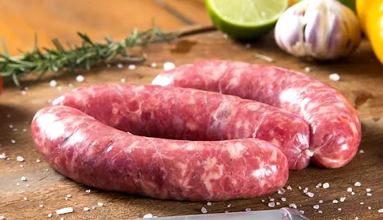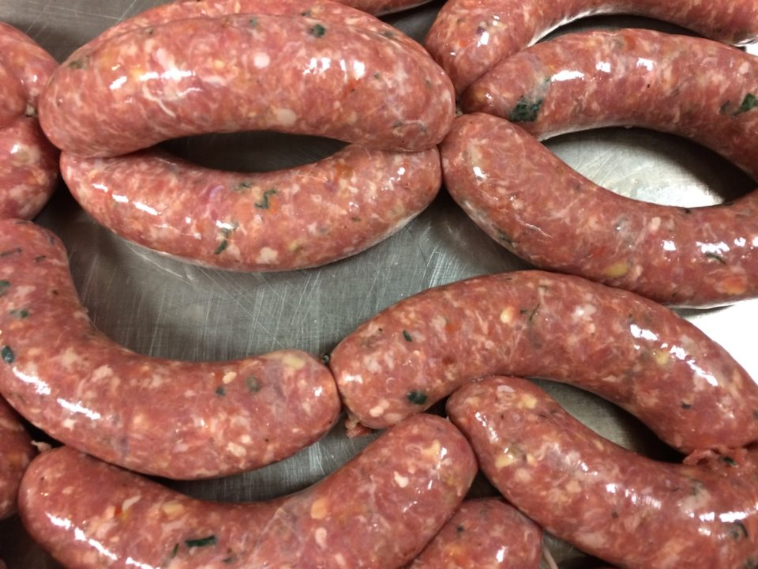
Figure 5.1. Fresh sausages - examples
https://www.stoysichonline.com/product-page/fresh-sausage
https://www.5280.com/stuff-it-try-western-daughters-sausage-101-class/

Cooked and smoked sausages:
- cooked and smoked sausages are made from meats that are ground, seasoned, stuffed into casings, and fully cooked (to a min. internal temperature of 72 °C) and smoked during processing,
- cooked sausages, like frankfurters or bologna, are made from fresh or frozen meats that are cured during processing, fully cooked and/or smoked, then packaged as ready-to eat products,
- cooked sausages are perishable and will last approximately seven to 14 days under refrigerated conditions,
- these sausages must be refrigerated all the time, up until time of consumption,
- since most processors prefer to vacuum-pack these sausages, consumers should pay attention to storage-life and reheating conditions,
- cooked and smoked sausages develop some additional flavours through the addition of nitrates and during the cooking and smoking processes,
- examples of cooked and smoked sausages are wieners, bologna, Berliner, cotto salami, frankfurters, and red hots.
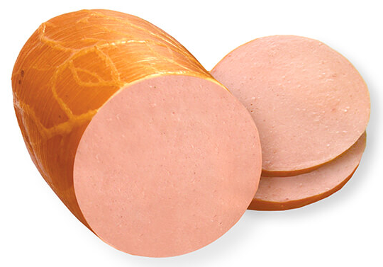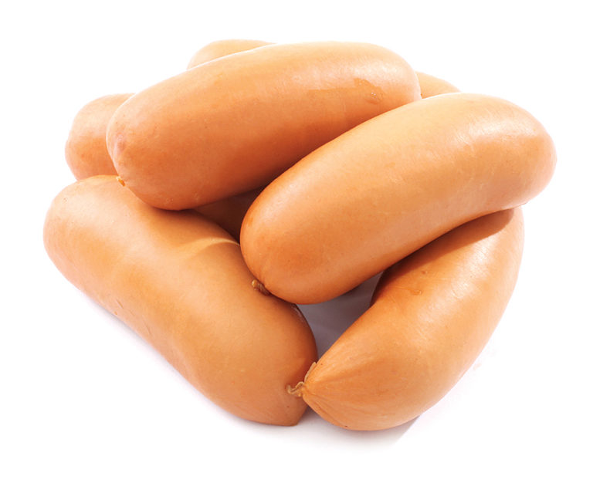
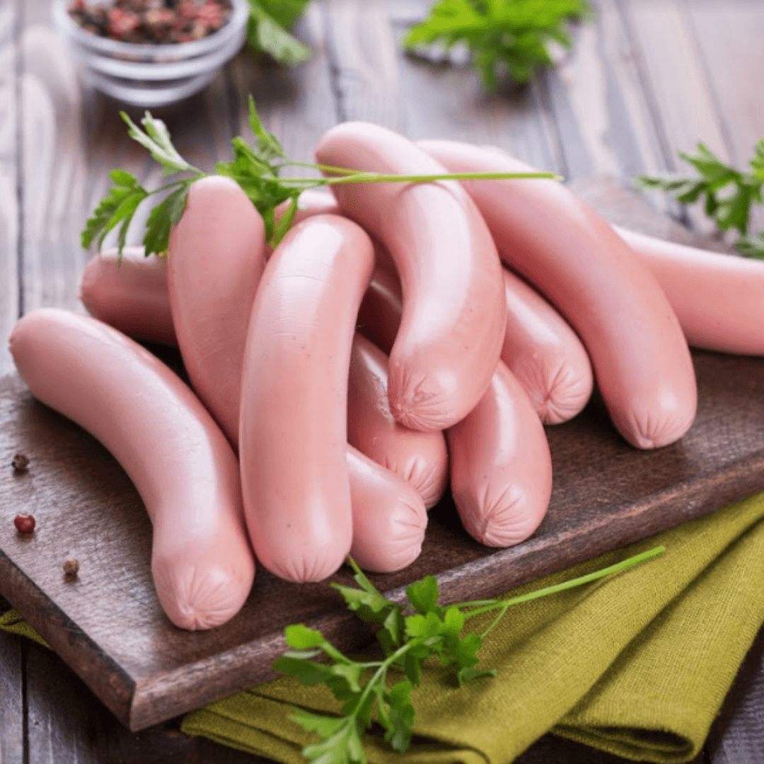
Figure 5.2. Cooked sausages - examples
https://www.rgk.lv/b/raznas-doktordesa-1
https://gpu.lv/produkti/cisini-un-sardeles/sardeles-premium/
https://www.prasuma.com/product/chicken-frankfurters

Uncooked, smoked sausages:
- uncooked, smoked sausages are manufactured from ground meat, seasoned, stuffed in casings, and smoked,
- these sausages are smoked for flavour development; they MUST be fully cooked before eating,
- uncooked, smoked sausages must be stored under refrigerated conditions or can be frozen for longer storage,
- uncooked, smoked sausages are NOT ready to eat. “Uncooked”, “Ready-to-cook”, “Cook-before eating”, “Cook and serve”, or “Needs to be fully-cooked” should be stated on the label,
- the product should display cooking directions that are sufficient for the intended user to prepare it properly.

Dry or fermented sausages:
- the lactic acid is produced by microbial fermentation of the sugars, and the addition of salt often provides a distinctive and enticing aroma, flavour, and a characteristic “bite”,
- sausages are dried for varying lengths of time during processing and smoking, depending on the sausage type,
- fermentation and drying are the oldest way of preserving meat and meat products. The drying is accomplished by adding salt to meat to prevent spoilage,
- they are also referred to as “summer sausages” and eaten cold,
- some examples are summer sausage, Italian salami, German salami, Lebanon bologna, Genoa salami, thuringer, cervelat, and pepperoni,
- fermented sausages are prepared from chopped or ground meat products that, as a result of microbial fermentation of a sugar, reach a pH range of 4.6–5.3 (pH of 4.6– 5.0 is more typical) and have undergone a drying or aging process to remove 15–25 per cent of the moisture,
- these products are typically cured, but not necessarily cooked or smoked,
- dry- and semi-dry sausages are considered shelf stable due to low water activity (aw), and may be sold and consumed without further cooking or heat treatment,
- sausage products must have an aw below 0.85 and a pH under 5.3 to be shelf stable,
- examples are pepperoni and salami(s).

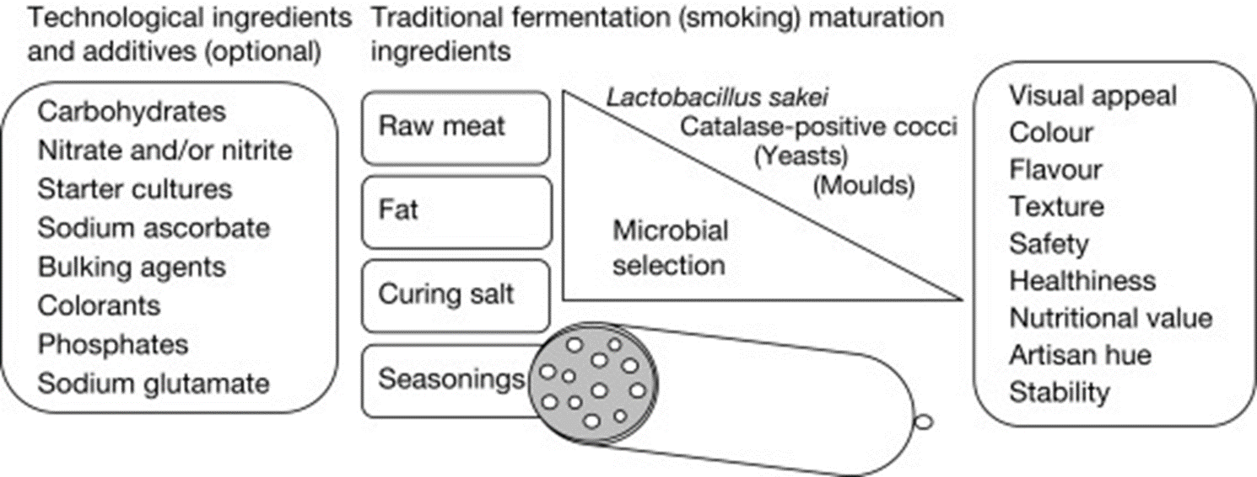
Figure 5.3. The main ingredients of fermented sausages
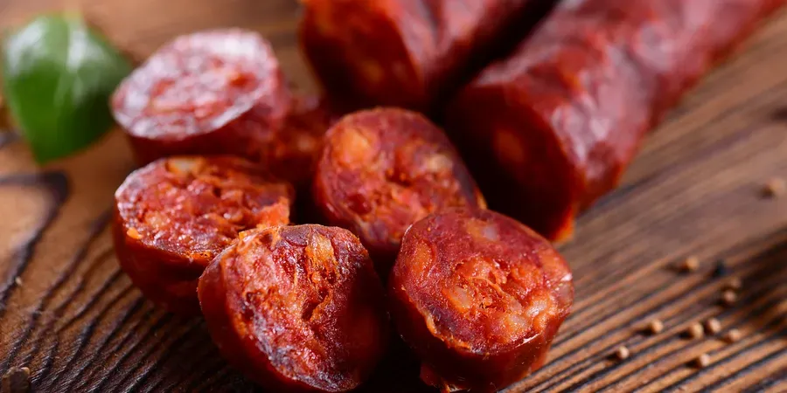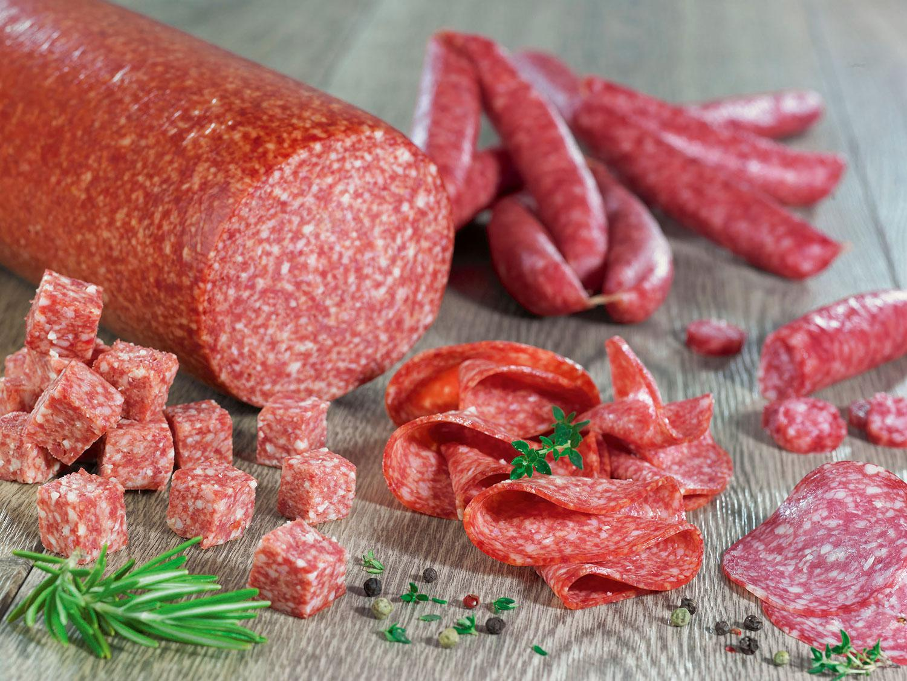
Figure 5.4. Fermented sausages - examples
https://www.labmanager.com/how-microbes-in-starter-cultures-make-fermented-sausage-tasty-23481
https://www.dekeysermeatproducts.com/products/salami-and-fermented-meat-products

Semi-dry sausages:
- semi-dry sausages differ greatly from dry sausages due to their pronounced tangy flavour,
- these products are generally stuffed in medium- to large-diameter natural casings, and the length of fermentation, drying, and/or smoking depends on their type,
- the final pH of semi-dry sausages varies from 4.7 to 5.4, but their moisture content is typically 35 percent or higher,
- semi-dry sausages may be smoked and slightly cooked in the smokehouse and after smoking, or these sausages may be air dried for a relatively short time,
- compared with dry sausages, semi-dry products have higher water activity (aw) values (greater than 0.90 up to 0.91),
- the main difference with semi-dry fermented sausages is the long maturing and drying process.
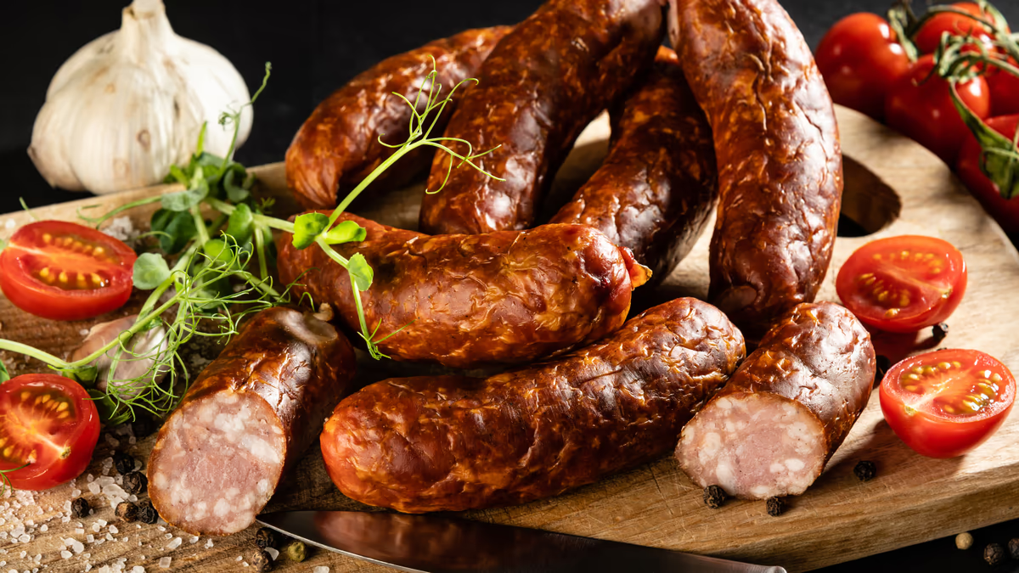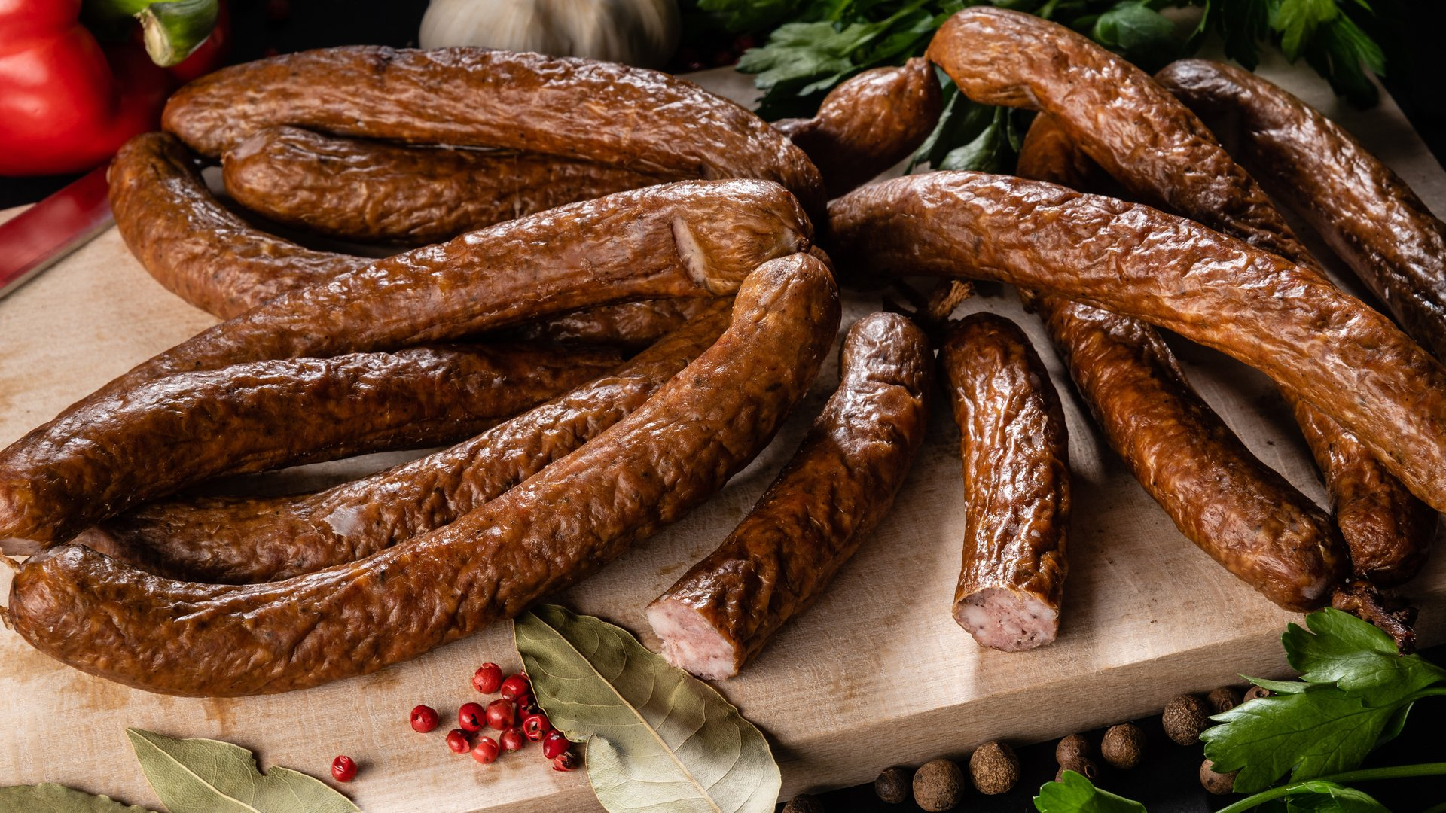
Figure 5.5. Semi dry sausages - examples
https://wolt.com/en/lva/cesis/venue/ama/items/puszavetas-desas-8
https://wolt.com/en/lva/cesis/venue/ama/mednieku-desinas-itemid-65d34bda8c8ca5597d264df6

Mould-ripened sausages:
- mould-ripened sausages are raw, fermented products usually with a longer ripening and drying time,
- mould-ripened sausages can be classified as very similar to fermented sausages,
- mould growth requires time and a supporting environment with adequate temperature and relative humidity,
- the starter culture can be the mould present either as native flora or added as an artificial inoculum,
- mould growth and changes in ripening conditions are the basic differences between sausages with and without mould.
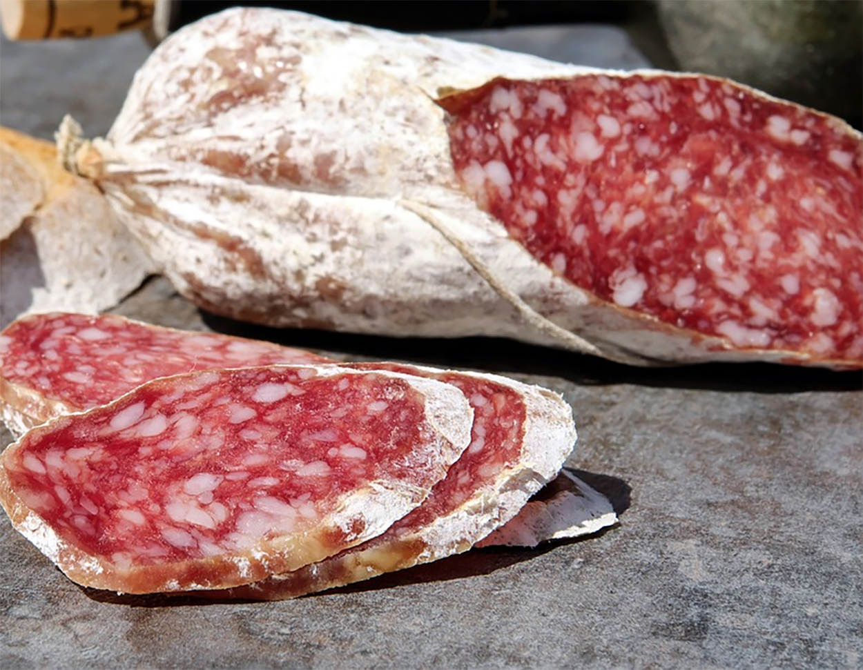
Figure 5.6. Mould-ripened sausages examples
https://startercultures.eu/product/sausages-and-charcuterie/starter-cultures-for-sausage-making/molds/bactorferm-600/

Meat products and contamination risks
Ham
To a certain degree, microorganisms can enhance the quality of meat products. They have the ability to increase the nutritious content of meat products in addition to accelerating the breakdown of fat and protein and enhancing the creation of flavouring compounds. In addition, they can lessen the amount of salt used in meat products, enhance their flavour, lower the amount of nitrite and BAs, stop the growth and reproduction of dangerous bacteria, and increase the safety of meat products.
Fresh (frozen) pig hind legs are the main raw material used to make ham, which is a non-ready-to-eat pork product that is further enhanced by other ingredients after curing, washing, desalting, air-drying, fermenting, and other procedures. The staphylococci and the aldehyde compounds that are generated as hexanal, nonanal, benzaldehyde, and phenylacetaldehyde have a close link that suggests their roles in the development of distinctive flavour compounds in Jinhua dry-cured ham. Moulds and yeasts were mostly found on the outside of the ham, whereas cocci and yeasts were mostly found on the inside. The amount of microorganisms within the Jinhua ham reduced to 2.0 × 10³ CFU/g throughout the maturation stage, from 1.39 × 10⁶ CFU/g during the dehydration of the ham. The two main types of bacteria found in Jinhua ham are lactic acid bacteria and staphylococci. Primarily, Pediococcus urinaeequi (P. urinaeequi), Pediococcus pentosaceus, and Lactiplantibacillus pentosus have been identified as the lactic acid bacteria. Staphylococcus xylosus, Staphylococcus equus, and Staphylococcus gallinarum are the three main species of staphylococci.
Moulds, staphylococci, and micrococci were the most common microorganisms in ham; their counts above 10² CFU/g internally and over 10⁶ CFU/g on the surface. The ham was found to contain 27 fungi according to PCR-DGGE analysis. The main species were Candida glucosophila, Yamadazyma triangularis, Aspergillus pseudoglaucus, Phialosimplex caninus, and Aspergillus penicillioides. Aspergillus pseudoglaucus was the most common species. Ham has a higher diversity and abundance of bacteria than fungi. At the phylum level, ten bacterial phyla were identified, with Firmicutes and Proteobacteria being the most prevalent. At the genus level, 154 different bacterial genera were found, with Psychrobacter, Acinetobacter, Ochrobactrum, Staphylococcus, and Micrococcus being the most prevalent genera. At the phylum level, four fungal phyla were identified, with Ascomycota being the most prevalent fungi. At the genus level, 51 fungal genera were identified, with Debaryomyces, Aspergillus, Yamadazyma, Candida, and Penicillium emerging as the most prevalent fungi. Ten strains in all were obtained after the dominant microorganisms in ham were isolated and purified. These strains included four strains of S. equinosus, two strains of S. xylosus, two strains of Lactococcus lactis, one strain of Candida metapsilosis, one strain of Candida parapsilosis, and two strains of S. equinosus.
Sausage
A variety of non-ready-to-eat meat products, such as sausage, are created by cutting (or mincing), stirring, curing, filling (or shaping), baking (or air-drying in the shade), smoking (or not smoking), and other procedures from fresh (frozen) livestock and poultry meat and other auxiliary materials. Sausage was shown to include Bacteroidetes, Proteobacteria, Firmicutes, and Actinobacteria at the phylum level. The two most common phyla were Firmicutes (85.65-93.96%) and Proteobacteria (5.59-13.95%). At the genus level, Lactobacillus, Weissella, Brochothrix, Pediococcus, and Staphylococcus were found. The two most common genera among them were Lactobacillus (63.14%) and Weissella (26.74%). Ninety percent of sausages contained unclassified fungi; only Ascomycota and Bangiales accounted for more than 0.1% of the total fungi. At the genus level, Porphyra accounted for 10.75%, whereas Debaryomyces and Saccharomyces contributed less than 1 percent.
Sausages were used to isolate 12 strains of lactic acid bacteria and 19 strains of staphylococci. S. epidermidis, Staphylococcus cohnii, Lactococcus garvieae, and Bacillus spp. were the secondary dominant bacteria, according to PCR-DGGE identification. The primary dominant bacteria were Staphylococcus saprophyticus (S. saprophyticus), S. xylosus, and Lactobacillus. Sausages were found to include the following phyla: Firmicutes (57.01%), Proteobacteria (30.43%), Cyanobacteria (7.67%), Bacteroidetes (2.63%), and Actinobacteria (2.01%), with Firmicutes and Proteobacteria being the two most prevalent phyla. Among the genera that were discovered, Brochothrix accounted for 38.34 percent, followed by Staphylococcus (9.79%), Psychrobacter (7.55%), Photobacterium (5.90%), Pseudomonas (4.82%), Lactobacillus (2.80%), Leuconostoc (2.29%), and Acinetobacter (2.19%).
In most sausages, the main phylum is Firmicutes. Furthermore, the most common genera were Pseudomonas, Tetragenococcus, Psychrobacter, Lactobacillus, and Micrococcus. The Ascomycota was the most common phylum of fungi. Research has indicated that in five different varieties of sausage, Lactobacillus, Staphylococcus, Leuconostoc, Lactococcus, and Weissella are the predominant genera, and Firmicutes and Proteobacteria are the major phyla. S. xylosus, Leuconostoc citreum, Lactococcus raffinolactis, W. hellenica, L. sakei, and L. plantarum are the dominant species.

Preserved meat
A variety of non-ready-to-eat meat products, such as preserved meat, are created using fresh (frozen) cattle meat as the main ingredient and other ingredients through curing, baking, smoking, air-drying in the shade, or drying by other methods. The main flavouring agents in preserved meat were hexanal, 3-methyl butyraldehyde, 3-methyl valeraldehyde, (E)-2-octenal, octanal, linalool, nonanal, hexanoic acid, ethyl hexanoate, anisole, and acetone.
Traditional preserved meat contains microorganisms belonging to the phylum Firmicutes, Proteobacteria, Actinobacteria, Cyanobacteria, and Bacteroidetes, with Firmicutes being the most prevalent phylum. Staphylococcus was the most common genus among the bacteria, with Micrococcus, Acinetobacter, Psychrobacter, Pseudomonas, Brochothrix, Cupriavidus, Citrobacter, and Enterobacter being the other genus.
Traditional preserved meat contains Ascomycota, Basidiomycota, Glomeromycota, and Rozellomycota among other fungi, with Ascomycota being the most prevalent phylum. At the genus level, the dominating fungi were Aspergillus, followed by Debaryomyces, Candida, Wallemia, Penicillium, Malassezia, and Didymella. Staphylococcus and Micrococcus were the most common microbes during the preserved meat's shelf life, followed by Lactobacillus. Firmicutes (54.05%) and Proteobacteria (44.28%) were the two most common phylum-level microorganisms found in preserved meat. Pseudoalteromonas (9.37%), Brochothrix (8.53%), Cobetia (4.71%), and Acinetobacter (2.31%) were the most common genus-level microorganisms. 2.6 × 10⁷ CFU/g of yeasts and moulds were found in the conserved beef. Staphylococci and micrococci were counted at 3.7 × 10⁶ CFU/g. Lactic acid bacteria were detected at 2.4 × 10⁶ CFU/g, while heat-resistant microorganisms were found at 3.5 × 10³ CFU/g.
According to a study on the microbial diversity in preserved meats, there were about 20 different phyla present, with Firmicutes, Proteobacteria, Cyanobacteria, and Actinobacteria being the most common. Furthermore, over ten different bacteria taxa were identified, with the most prevalent ones being Staphylococcus, Sphingomonas, Pseudomonas, Enterobacter, and Leuconostoc. Lactobacillus curvatus (L. curvatus), Latilactobacillus sakei, Companilactobacillus alimentarius (C. alimentarius), P. pentosaceus, and Leuconostoc mesenteroides (L. mesenteroides) were among the lactic acid bacteria found in preserved meat. Among these, L. plantarum exhibited a robust acid production capacity and demonstrated a high degree of tolerance towards sodium chloride and sodium nitrite.
In preserved beef, the total quantity of microorganisms was 2.863 × 10⁷ CFU/g. Prior to air drying, the most common microbes at the genus level were Halospirulina, Acinetobacter, and Bacillus. Following a week of air drying, Pseudomonas, Acinetobacter, Psychrobacter, and Halospirulina were the most prevalent microbes. Following two weeks of air drying, Erwinia, Halospirulina, Enterobacter, and Acinetobacter were the most prevalent microbes. Following three weeks of air drying, Bacillus, Halospirulina, Enterobacter, and Erwinia were the most prevalent microbes. Following four weeks of air drying, Halospirulina, Acinetobacter, Enterobacter, and Microbacteriaceae were the most prevalent microbes.

Pressed salted duck
Duck is used as the raw material for pressed salted duck, a non-ready-to-eat meat product that is prepared through the following steps: slaughter, hair removal, evisceration, cleaning and curing, shape, and air drying. A specialty of the southwest is pressed salted duck, which is one of their most well-known goods. The main flavouring ingredients in pressed salted duck are benzoaldehyde and - 2.4-nonadienal. The main substances influencing the flavuor variations in crushed salted ducks from various places were hexanal, nonanal, naphthalene, (Z)-2-heptenal, (E)-2-octenal, (E)-2-kunienal, 1-octene-3-ol, 2-n-pentylfuran, and linalool. In air-dried ducks, there were 4.692 x 10³ CFU/g of microbial colonies overall, with Neisseria, Micrococcus, and Staphylococcus being the three main dominating species.
Yeasts, moulds, micrococci, lactic acid bacteria, and staphylococci are the main helpful microorganisms found in pressed salted duck. S. carnosus, S. simulans, and S. xylosus are among the staphylococci. Lactobacillus: Lactobacillus plantarum, L. sakei, Lactobacillus acidophilus, Lactobacillus lactis, Lacticaseibacillus casei, L. curvatus, Limosilactobacillus fermentum, Loigolactobacillus bifermentans, Levilactobacillus brevis, Lentilactobacillus buchneri subsp. buchneri, Lactobacillus helveticus, and Lactobacillus delbrueckii subsp. bulgaricus are among the lactic acid bacteria, and Pediococcus: Pediococcus cerevisiae, and Pediococcus acidilactici. Macrococcus auterisiae, Micrococcus candidus, Micrococcus varians, Micrococcus roseus, Micrococcus epidermidis, and Micrococcus luteus are among the micrococci. At the end of the duck's shelf life, Brochothrix thermosphacta and lactic acid bacteria were the main spoilage bacteria in water-cooked salted duck; enterobacteriaceae, micrococci, yeasts, and moulds were the minor components.

Air-dried meat
Meat that has been air dried is kept at low temperatures. To create a product that can be eaten right away, the meat is chopped into thin strips, spiced, pickled, hung in the shade, and allowed to naturally air dry for about three months. Acids, aldehydes, ketones, alcohols, alkenes, sulfur-containing compounds, and heterocyclic compounds are among the volatile taste compounds found in air-dried meat. The main contributors include heptanal, 1-octene-3-ol, cyclopentanol, 3-hydroxy-2-heptanone, and 6-methyl-5-heptene-2-ketone. During the air-drying phase of the beef, micrococci, staphylococci, and lactic acid bacteria were the most common microbes.
The total number of microorganisms was 8.0 × 10⁸ CFU/g, 1.48 × 10⁷ CFU/g of lactic acid bacteria, 4.40 × 10⁸ CFU/g of staphylococci and micrococci, approximately 10² CFU/g of Enterobacteria, less than 10⁵ CFU/g of enterococci, and approximately 1.50 × 10⁴ CFU/g of yeasts and moulds. The air-dried beef included 36% Enterobacteria, 33% yeasts, 16% pseudomonades, 10% cocci, and 5% lactic acid bacteria. Twenty-one microbial phyla and two hundred and forty species were found in naturally fermented air-dried beef; the three most common phyla were Firmicutes (39%), Proteobacteria (40%), and Bacteroidetes (14%).

Conclusion
The study of meat products mostly focuses on their microbial variety, the ways in which particular bacteria affect the product's quality, its distinctive flavour, and its manufacturing process. Numerous studies have demonstrated that microbes can enhance the flavour of meat products and prevent the production of nitrosamines, biogenic amines, and other hazardous compounds in fermented meat products; however, the precise mechanisms underlying these effects have not been thoroughly documented.

Microbiological quality indicators of meat products and its change during storage
Spoilage microbial diversity
Major types of spoilage microorganisms in livestock meat
Specific spoilage organisms (SSOs) are a limited initial group of microorganisms found in meat that are responsible for food spoiling; not all bacteria produce this. SSO metabolises available substrates in meat products during preservation, changing the flavour and quality of the meat.
According to a study, Klebsiella (46.05%) and Escherichia (39.96%) were the most common bacteria in the meatballs of the blown pack spoilage (BPS) group packed with 71.85% CO₂. Because it could pack edema, Klebsiella pneumoniae was the primary strain responsible for BPS in meatballs. Both culture-dependent and non-culture-dependent techniques identified Proteobacteria, Firmicutes, Pseudomonas spp., Acinetobacter spp., Pantoea spp., Brochothrix spp., and Raoultella spp. as the primary pathogenic and spoilage bacteria in chilled pork. Pork preserved between −2 °C and 4 °C exhibited a highly comparable microbial composition, with the predominant species being Pseudomonas and Brochothrix. The indicators of damaged pork meat kept at 25°C were Acinetobacter spp., Myroides spp., and Kurthia spp. The current research findings indicate that while the primary putrefactive microorganisms of different types of ham vary, the aberrant growth of lactic acid bacteria, Micrococcaceae, Enterobacteriaceae, yeast, and mould plays a major role in the formation of dry cured ham odour problems. Aspergillus (84.27%) was the most common fungus genus in ham, whereas Clostridium_sensu_stricto_2 (92.01%) was the most common bacterial genus.
In comparison to normal ham, the amount of Enterobacteriaceae and Enterococcus in the degraded ham was much higher. The aberrant growth of Enterobacteriaceae and Enterococcus in degraded ham is caused by high water content and low salt content. The three predominant ham spoiling bacteria were B. cereus ATCC 14579, E. faecalis ATCC 19433, and C. farmei CDC 2991–81. The most prevalent Clostridium species found in vacuum-packed beef and other raw meats linked to BPS was found to be C. sestertheticum. Meat surfaces that were dry-aged for 19 days showed higher levels of Lactobacillus (3.20 log CFU/cm²) and total viable bacteria (8.75 log CFU/cm²).
Pseudomonas and Enterobacteriaceae, which are thought to be the main spoilers in dry-aged beef, are present in the microbial communities of all the samples examined in dry-aged beef. In a different study, the most common type of Clostridium was discovered to be psychrophilic Clostridium spp. after samples of beef and lamb from Europe, North and South America, and Oceania were examined.

Major types of spoilage microorganisms in poultry meat
Poultry meat demand and consumption have been rising steadily on a global scale. Processed chicken meat accounts for over 75% of all poultry meat consumed, with turkey and duck meat following closely behind with roughly 25% each of the total. Salmonella and Campylobacter are among the pathogenic organisms found in poultry flesh. In cold meat and poultry packed under aerobic conditions, Pseudomonas spp., Bacillus spp., Crude Typhimurium spp., Schwartzella spp., and Aeromonas spp. are typically considered the dominant communities when defining the dominant spoilage bacteria in the meat product spoilage process based on the number of bacteria. Meat from poultry degrades easily, even when refrigerated.
Clostridium perfringens was shown to have significantly increased with time in nearly all poultry samples that were kept aerobically under various chilling conditions. Poultry flesh kept at 8 °C for four days deteriorates due to Pseudomonas fluorescens, Aeromonas salmonicida, and Serratia liquefaciens. In poultry products, a number of novel enterococci or lactic acid bacteria have also been discovered, including Heterofermentative lactic acid bacteria, Seigonensis enterococcus, and Viikkiensis enterococcus. With the advancement of MS investigations, evaluating the spoiling capacity of bacterial isolates cultured in situ is a more suitable method for identifying the predominant spoiling organism.
Pseudomonas fragilis, Pseudomonas lundengensis, and Pseudomonas fluorescens are the most prevalent pseudomonas in chicken flesh. During storage, Pseudomonas aeruginosa, Pseudomonas fragilis, and Pseudomonas fluorescens generated slime on meat and its by-products. Pseudomonas aeruginosa secretes extracellular enzymes that exhibit potent protease activity directed against myogenic fibronectin and myxomatosis protein. This facilitates the entry of microorganisms into the meat to find fresh nutrition sources, which increases mucus production and softens the flesh. In addition, during microbial spoilage (MS), the generation and softening of slime were linked to Serratia spp., Micrococcus spp., Serratia spp., and Brucella spp.

Common control approaches
Packaging methods
Both intrinsic (natural and added components, pH, redox potential, and water activity) and extrinsic (storage temperature and packing techniques) factors can influence the proliferation of microbes in meat.
A study on modified atmospheric packaging (MAP) found that it could prolong the frozen meat's shelf life. Research has shown that when fresh turkey sausage was combined with MAP (50% CO₂ -50% N₂), a 2% (w/w) lactic acid formulation greatly decreased acidification, off-flavours, and prevented the sausage from turning brown or dark grey. MAP (70% O2-30% CO2) modestly lessens the sense of off-flavour in pig sausages. Meat quality decreases during storage due to bacterial metabolism activity as well as bacterial population density. The free amino acids that proteases generate can be further processed by bacteria, giving rise to the mucus and bad flavours linked to spoiling.
Frozen chicken can have its shelf life increased by using a gas mixture of 30% CO2 and 70% N2 for MAP, according to earlier research. Compared to storage in the air, meat under this MAP has fewer Pseudomonas species and is less likely to deteriorate. Thus, MAP might have an impact on both bacterial growth and metabolism. Microorganism development and carp shelf life are impacted by various packaging circumstances.
At4 °C, the air-packed (AP) and vacuum-packed (VP) filets had respective shelf lives of 8 and 12 days. The AP sample contains the greatest concentration of Pseudomonas aeruginosa, while the VP sample has a comparatively high concentration of lactic acid bacteria (LAB). VP delays the increase in biogenic amine content compared to AP.
The growth of common meat spoilage and dangerous bacteria was examined in relation to innovative antimicrobial packaging materials that contained poly-[2-(tertbutylamino) methylstyrene] (poly-TBAMS). The findings demonstrated that the antibacterial activity increased with a rise in the amount of poly (TBAMS) in the base polymer and that Gram-positive bacteria were more vulnerable to poly (TBAMS) foil than Gram-negative bacteria. A novel hybrid packing pad with antibacterial properties was created using biodegradable polyurethane. It was discovered that this kind of packing material exhibited strong antibacterial activity against Salmonella typhimurium and Staphylococcus aureus.
TiO2 nanocomposites and 3kGy radiation were found to prolong the shelf life of fish filets in cold storage by maintaining their chemical, microbiological, and sensory qualities for longer periods of time. Research shown that TiO2 nanoparticle-containing antibacterial polyvinyl alcohol coatings inhibited Pseudomonas putida, Aeromonas hydrophila, and Shewanella spp. in addition to extending the shelf life of macroscopic rotenone by one to two days.

Addition of antibacterial substances
Recently, there has been a hunt for new natural product alternatives due to the negative impacts of synthetic preservatives. Commercially available polyphenols minimise the destruction of salt-soluble myogenic fibrin and sulfhydryl groups, inhibit lipoxygenase activity, increase meat colour stability, and slow down the growth of germs. They also lower levels of primary and secondary lipid peroxidation. The plant families Asteraceae, Lamiaceae, Lauraceae, Myrtaceae, Rutaceae, Umbelliferae, and Zingiberaceae are among those from which essential oils (EOs) are derived, which are a complex blend of volatile, low molecular weight substances. The bark, flowers, fruits, leaves, roots, and stem of the plant are among the sections that might yield these useful chemicals.
Staphylococcus aureus, Pseudomonas aeruginosa, and Bacillus cereus are all inhibited by thymol and carvacrol. On the other hand, it has been noted that Gram-negative bacteria are strongly inhibited by the free terpenes that are frequently present in essential oils. In meat products utilised as fresh pig sausages, sage essential oil (EO) was shown to have the ability to reduce aerobic thermophilic bacterial counts (4.8–7.3%) at the end of the storage period. Satureja montana L. EO's antibacterial ability in fresh pork sausage was assessed. When Satureja montana L. EO is added to sausage, it can decrease the overall amount of Enterobacteriaceae (7.1-19.6%) and thermophilic aerobic bacteria (4.9-10.9%) compared to the control group. The growth of cryophilic, Enterobacteriaceae, and thermophilic bacteria, as well as Staphylococcus aureus and Escherichia coli O157:H7, was found to be significantly impacted by both lactobacillus peptides and essential oils in raw beef patties. The samples treated with 0.2% essential oil + 500 IU/g lactobacillus peptide showed the fastest reduction in the number of tested microorganisms.
MAP conditions encourage the growth of anaerobic bacteria, which can create toxins, in fish meat. Consequently, to increase the potency of natural preservatives, they are frequently used in conjunction with other modalities (MAP, edible coatings and films, non-thermal sterilisation, etc.). Black spot shrimp treated with chitosan coating in conjunction with pomegranate peel extract (PPE) showed reduced total volatile alkaline nitrogen and total aerobic colony values than shrimp treated with chitosan coating or PPE alone, suggesting a synergistic effect between the two treatments.
It was discovered that using vacuum packaging with natural antioxidants including rosemary, sage, thyme, and clove essential oils might increase the shelf life of smoked rainbow trout by 6-7 weeks. A prior study examined the impact of commercial oil-based (sunflower, canola, corn, olive, soybean, and hazelnut oils)- nanoemulsions on the fatty acid contents of farmed sea bass kept at 2 ± 2 °C. According to the findings, at the end of the storage period, the hazelnut group had the greatest polyunsaturated fatty acid concentration, followed by canola and soybean. These oils may be suggested for use in fish nanoemulsions as a preservative.

Sterilization with plasma
Different microbicidal mechanisms are used by reactive oxygen species (ROS) in atmospheric pressure cold plasma (APCP) to affect both Gram-positive and Gram-negative bacteria. Prolonged exposure to APCP raises intracellular ROS levels in Listeria monocytogenes and Staphylococcus aureus without significantly harming their cell walls. Staphylococcus aureus and Listeria monocytogenes shrink when exposed to APCP, although the cell wall is not significantly harmed. In addition, it has been demonstrated that the duration of APCP exposure raises the intracellular ROS levels of Staphylococcus aureus and Listeria monocytogenes. The plasma from dielectric barrier discharge (DBD) sources produces reactive oxygen species (ROS) that can pierce cell membranes, and induce death by damaging intracellular DNA. According to earlier research, DBD treatment decreased the amount of Listeria monocytogenes in inoculated meat and meat products by 0.59–6.52 Log CFU/g.
Sterilization of bacteriophages
Phages are thought to be a promising new class of bioretention agents due to their ability to lyse specific and efficient targets of bacteria. Three phage cocktails considerably raised the pH, total volatile basic nitrogen, and organoleptic value indices of catfish filets while also substantially suppressing the growth of Shiva in the filets.
Low-level radiotherapy
Low-level radiation is thought to be a typical method for preserving the freshness of fish meat. Sous-vide filets can withstand up to eight weeks of refrigeration by being irradiated (5.0 kGy) without compromising their organoleptic and physicochemical qualities.

Conclusion
Meat microbial contamination, which accounts for about 21% of all food losses, is the primary cause of losses during manufacturing, storage, and distribution. We discuss steps to avoid MS and evaluate recent developments in studies on the microbial variety causing deterioration of animal, poultry, and fish meat. However, more thorough and accurate data on the make-up of microbial communities and the dynamic processes of their metabolism must be obtained in order to achieve more precise and successful control of spoilage microorganisms in meat. Through the identification of distinct interplays among diverse spoilage phenotypes during MS, we could attain manageable product quality throughout the meat production, transportation, marketing, and storage processes.

Laboratory work

Preparation of fresh, semi-dry or cooked sausages, determination and analysis of sensory, physico-chemical, and microbiological quality indicators

Materials
Different types of meat, spices or spice mixtures and other ingredients according to recipes. Students can find in literature or internet sources and choose their favourite fresh, semi-dry or cooked sausages recipe.

Methods and Procedures
Fresh sausages - these products are meat mixtures composed of comminuted muscle meat, with varying quantities of animal fat. These products are only salted, and curing is not practiced.
Non-meat ingredients are added in smaller quantities to improve the flavour and aid binding; in low-cost versions larger quantities are added for volume extension. All meat and non-meat ingredients are added fresh (raw). Heat treatment (frying or cooking) is applied immediately prior to consumption to make the products palatable.
Ingredients: (https://www.simplyrecipes.com/recipes/how_to_make_homemade_sausage/):
- 1.8 kg shoulder of beef or sheep meat
- 450 g beef or sheep fat
- 40 g salt
- 35 g sugar
- 20 g toasted fennel seeds
- 6 g cracked black pepper
- 4 g ground nutmeg
- 1 cup chopped fresh parsley
- 1 bulb of garlic, peeled and chopped
- 178 g dry sherry
- 59 g sherry vinegar

Additional steps for making sausage mass:
1. Start with very cold ingredients and equipment: make sure your ingredients are laid out, and the meat and fat are very cold (fat can be completely frozen), before you begin (put the meat and fat in a freezer for 2 hours). Put bowls and grinder in the freezer or refrigerator for an hour before using them.
2. Cut the fat and meat into chunks and keep cold in a bowl over ice: prepare a large bowl of ice and put a medium metal bowl on top of it. Slice your meat and fat into chunks between an inch and two inches across. Cut your fat a little smaller than your meat. To keep your ingredients cold, put your cut meat and fat into the bowl set into a larger bowl filled with ice.
- 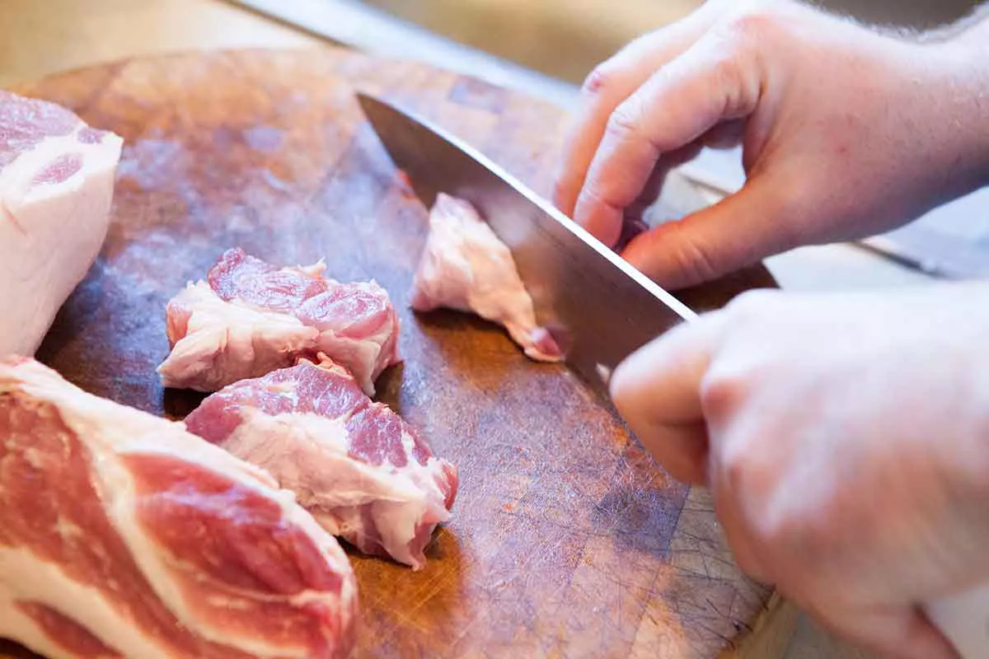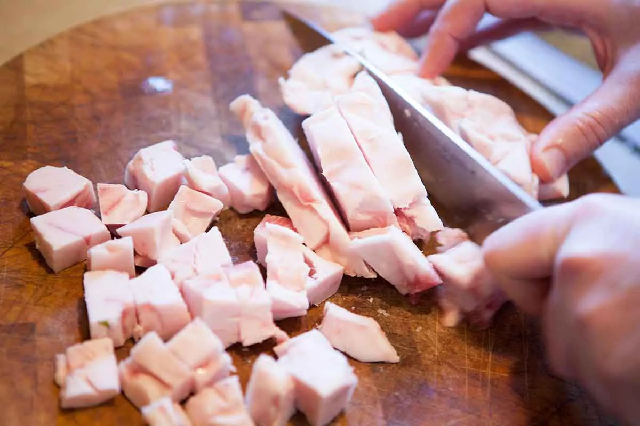
- Figure 5.7. Cutting the fat and meat into chunks
- https://www.simplyrecipes.com/recipes/how_to_make_homemade_sausage/

3. Mix the meat and fat, add most of the spices and chill: When the meat and fat are cut, mix them quickly. Add in most of your spices; I leave out a tablespoon or two of fennel seeds and a tablespoon of black pepper for later. Mix quickly. Add the salt and sugar and mix one more time.
- 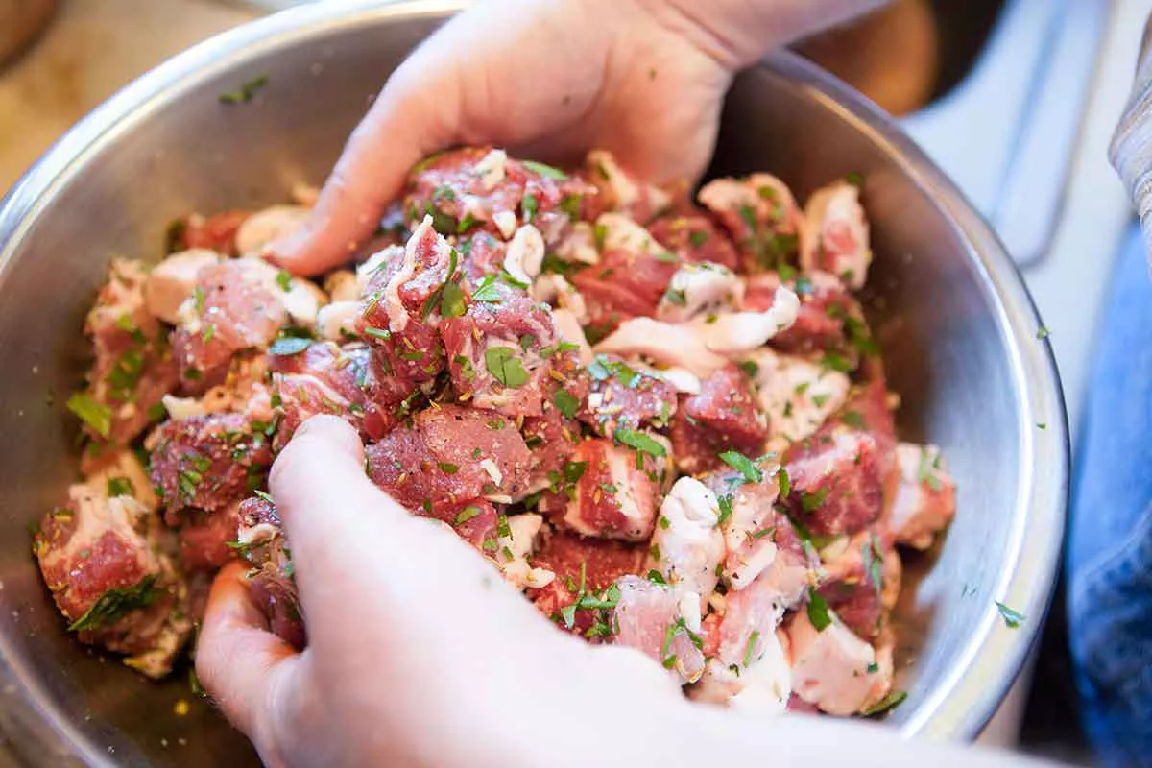
Figure 5.8. Meat and fat mixing

Place into a covered container or top the bowl with plastic wrap and put the sausage mixture into the freezer for at least 30 minutes but not more than an hour. Now you can call back whoever might have bothered you when you started this process.
4. Mix the sherry vinegar and the dry sherry and chill: I know that sherry is not traditional in Italian sausage. You can use white wine and white wine vinegar if like (I save red wine and red wine vinegar for the hot sausages).
5. Immerse the casings in warm water: if you plan on stuffing your sausage, take out some of the casings and immerse them in warm water. (If you are not planning on stuffing the sausage, you can skip this step.)
- 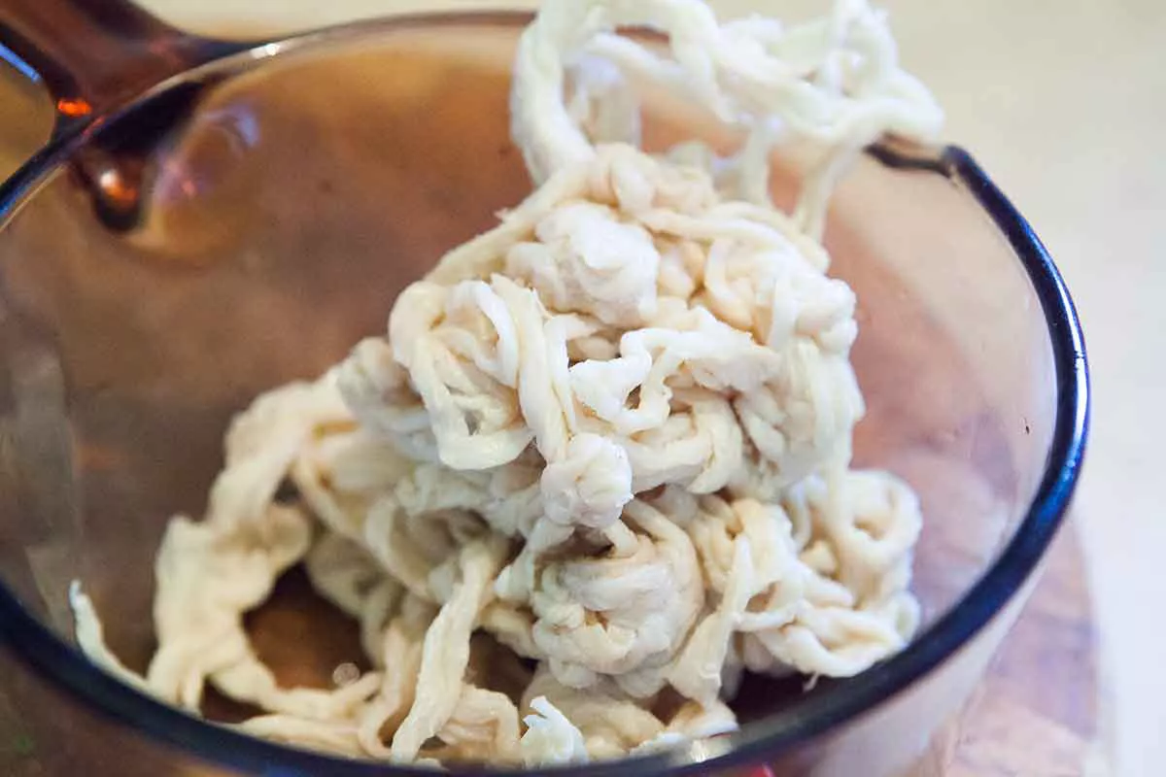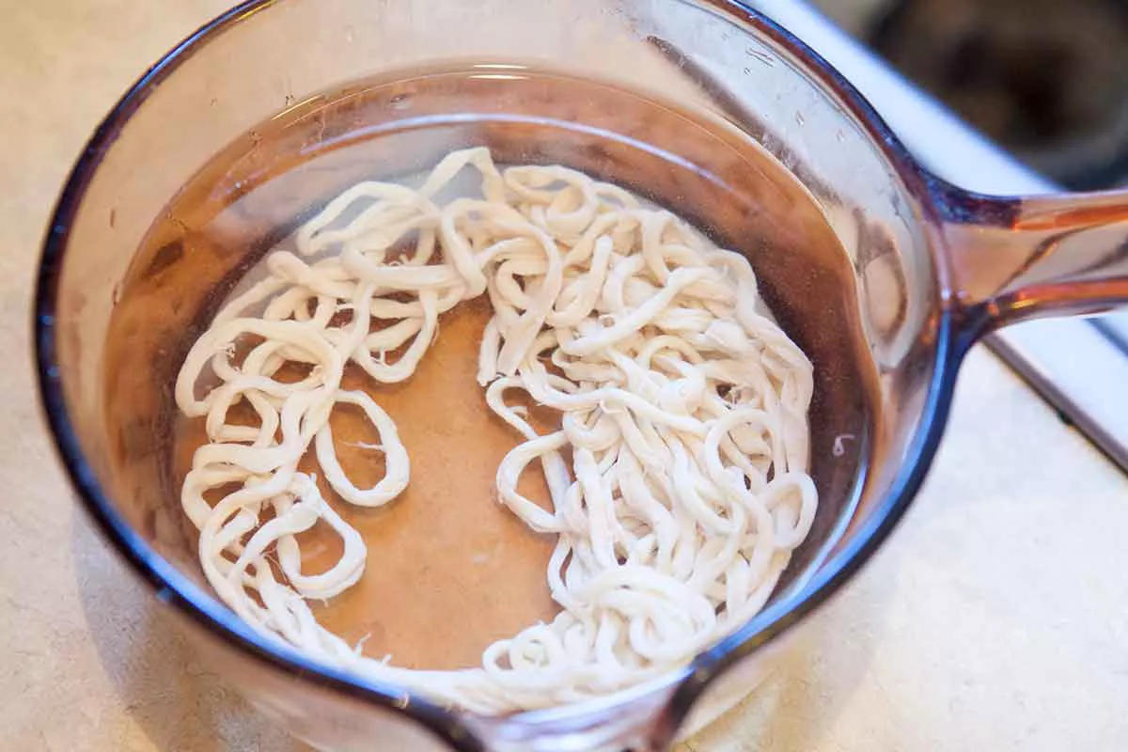
- Figure 5.9. Casings preparation

6. Set up the grinder: after your sausage mixture has chilled, remove your grinder from the freezer and set it up. I use the coarse die for Italian sausage, but you could use either. Do not use a very fine die, because to do this properly you typically need to grind the meat coarse first, then re-chill it, then grind it again with the fine die. Besides, an Italian sausage is supposed to be rustic.
7. Push the mixture through grinder and chill: push the sausage mixture through the grinder, working quickly. If you use the KitchenAid attachment, use it on level 4. Make sure the ground meat falls into a cold bowl. When all the meat is ground, put it back in the freezer and clean up the grinder and the work area.
8. Add the remaining spices and sherry mixture: when you’ve cleaned up, take the mixture back out and add the remaining spices and the sherry-sherry vinegar mixture. Using the paddle attachment to a stand mixer (or a stout wooden spoon, or your very clean hands), mix the sausage well. With a stand mixer set on level 1, let this go for 90 seconds. It might take a little longer with the spoon or hands. You want the mixture to get a little sticky and begin to bind to itself — it is a lot like what happens when you knead bread.
When this is done, you have sausage. You are done if you are not making links. To cook, take a scoop and form into a ball with your hands. Flatten out a bit. Cook on medium low heat in a skillet for 5 to 10 minutes each side until browned and cooked through.
- 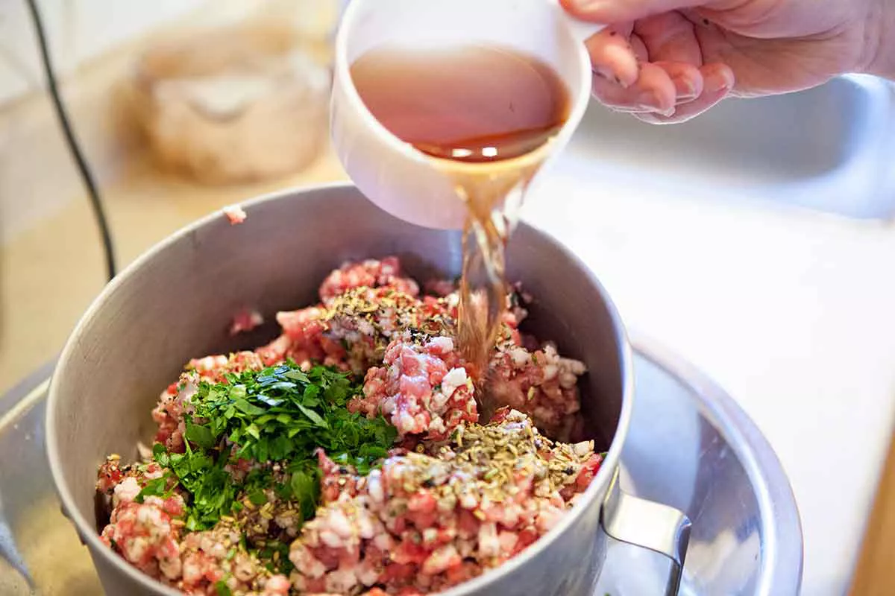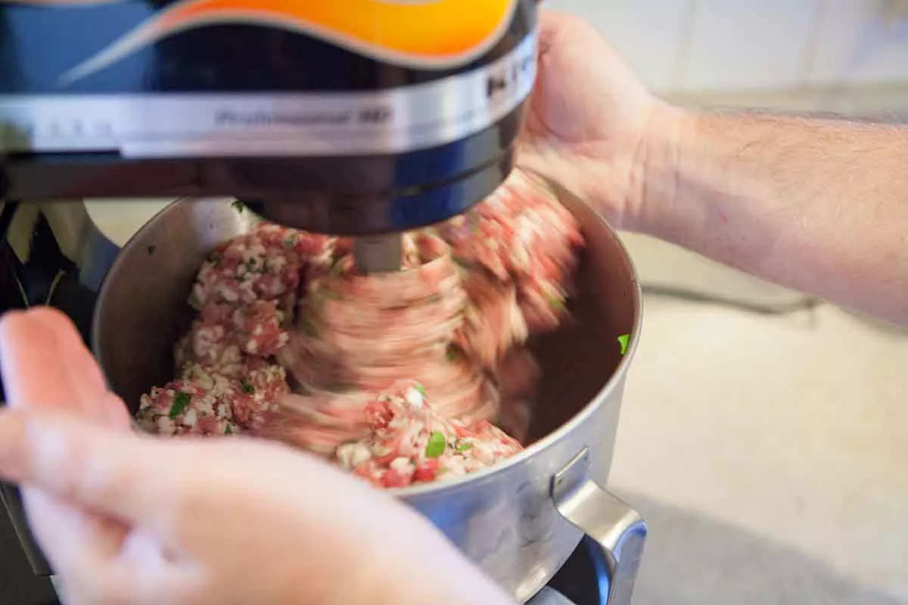
- Figure 5.10. Meat mass mixing

Additional steps for making sausages:

1. Chill the sausage mixture: put the mixture back in the freezer so it's chilled for stuffing in the casings.
2. Run warm water through the casings and set up sausage stuffer: bring out your sausage stuffer, which should have been in the freezer or refrigerator. Run warm water through your sausage casings. This makes them easier to put on the stuffer tube and lets you know if there are any holes in the casings. Be sure to lay one edge of the flushed casings over the edge of the bowl of warm water they were in; this helps you grab them easily when you need them.
3. Slip a casing onto the stuffing tube: Leave a “tail” of at least 6 inches off the end of the tube: You need this to tie off later.
- 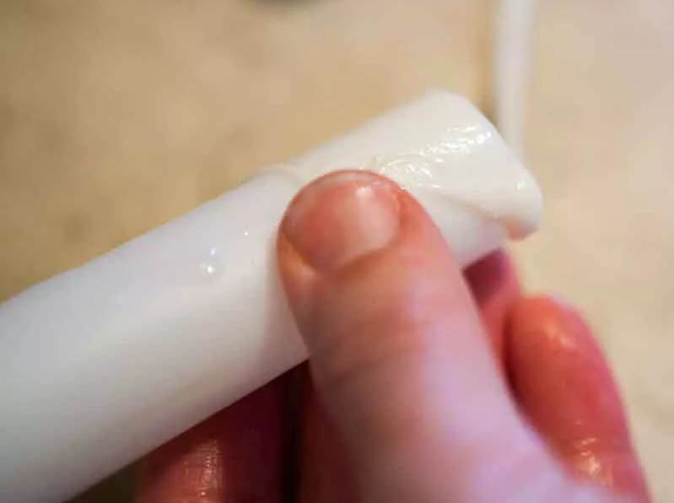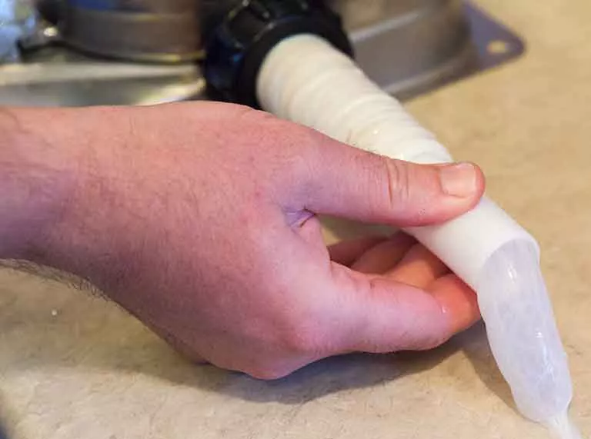
- Figure 5.11. Casing slipping onto the stuffing tube

4. Add the meat to the stuffer and start cranking the stuffer: take the meat from the freezer one last time and stuff it into the stuffer. If all the meat will not fit, keep it in a bowl over another bowl filled with ice, or in the fridge while you stuff in batches. Start cranking the stuffer down. Air should be the first thing that emerges — this is why you do not tie off the casing right off the bat.
5. Let the sausage come out in one long coil and then tie-off: when the meat starts to come out, use one hand to regulate how fast the casing slips off the tube; it’s a little tricky at first, but you will get the hang of it. Let the sausage come out in one long coil; you will make links later. Remember to leave 6 to 10 inches of “tail” at the other end of the casing. Sometimes one really long hog casing is all you need for a 5-pound batch. When the sausage is all in the casings, tie off the one end in a double knot. You could also use fine butcher’s twine.
- 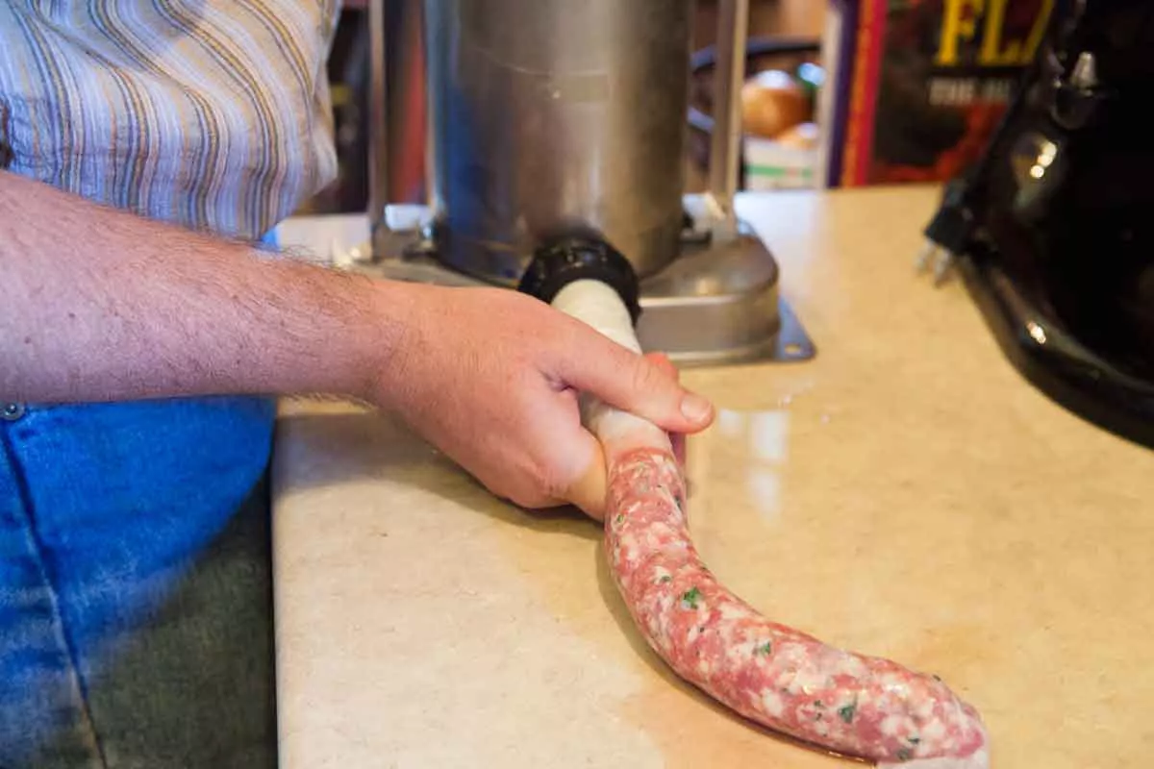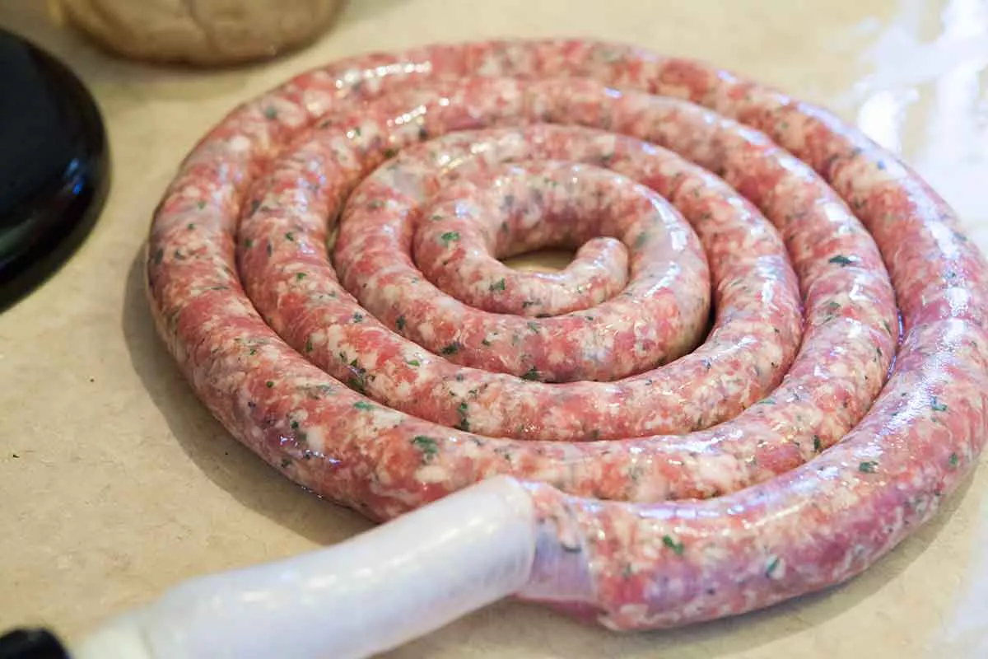
- Figure 5.12. Meat stuffing into casings

6. Pinch and spin the links: With two hands, pinch off what will become two links. Work the links so they are pretty tight: You want any air bubbles to force their way to the edge of the sausage. Then spin the link you have between your fingers away from you several times. Repeat this process down the coil, only on this next link, spin it towards you several times. Continue this way, alternating, until you get to the end of the coil. Tie off the other end.
- 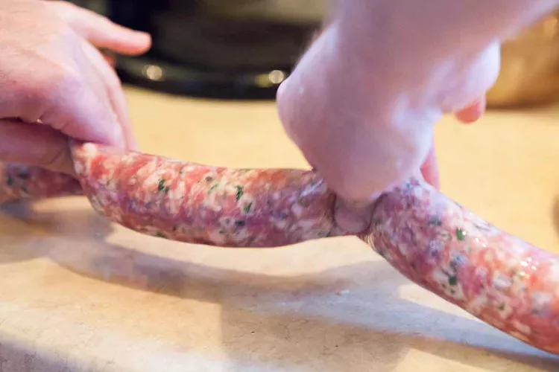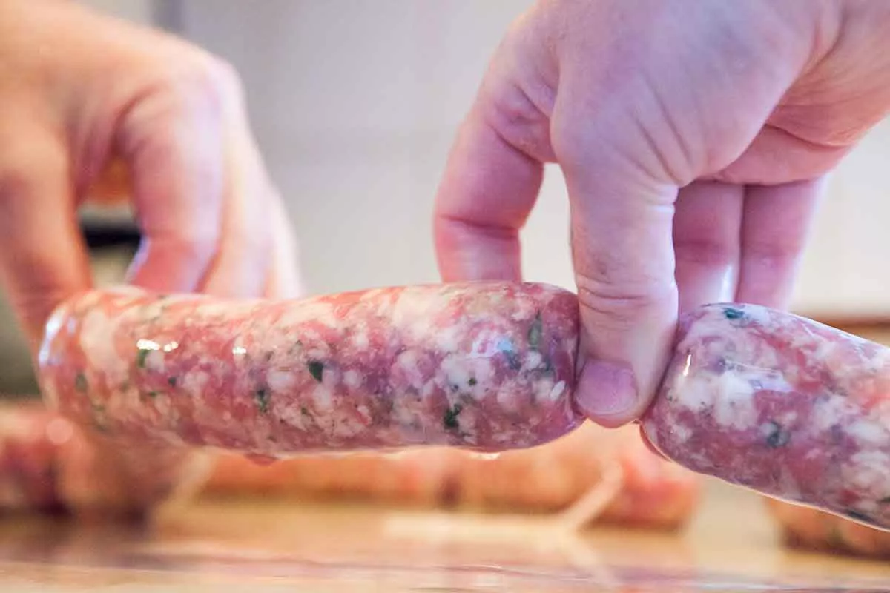
- Figure 5.13. Sausages formation

7. Hang the sausages and prick air bubbles with sterilised needle: almost done. Time to hang your sausages. Hang them on the rack so they don’t touch (too much), and find yourself a needle. Sterilise it by putting into a gas flame or some such, then look for air bubbles in the links. Prick them with the needle, and in most cases the casing will flatten itself against the link.
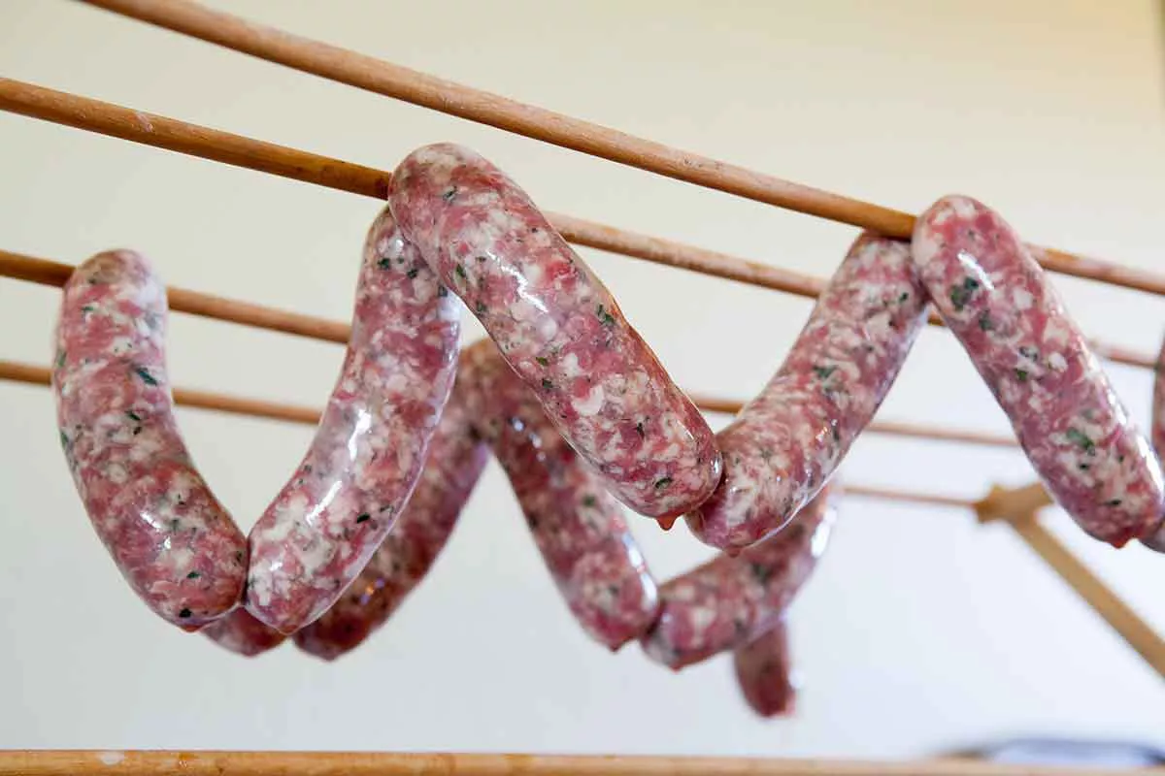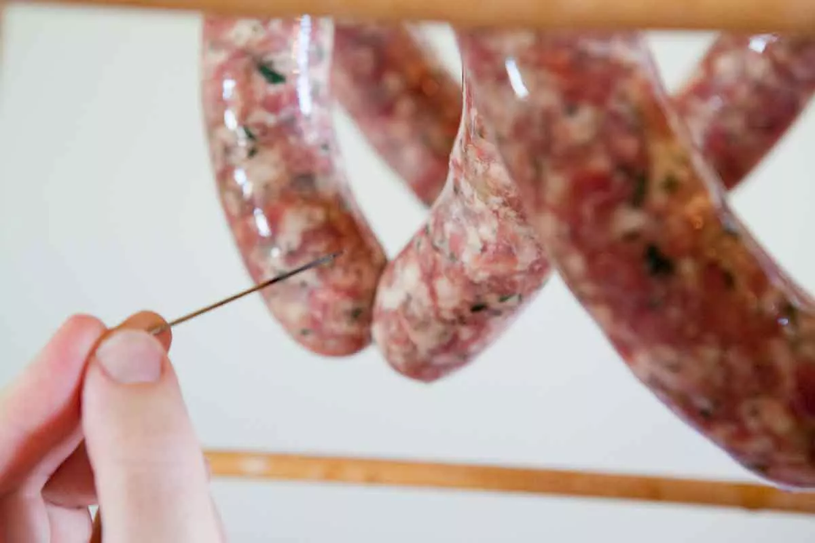
Figure 5.14. Sausages hanging
8. Let dry for an hour or two and then chill: let these dry for an hour or two, then put them in a large container in the fridge overnight, with paper towels underneath. Package them up or eat them the next day. They will keep for a week, but freeze those that will not be used by then.

Results
Sensory evaluation of all prepared fresh, semi-dry and cooked sausages. Compare the samples and choose the best one. Analysis of the physico-chemical, microbiological quality indicators as described above.

Conclusion
1.
2.
3.

Approved by _____________________
Name, Surname, signature
Date ______________

Laboratory work

Microbiological evaluation of processed meat products

Enumeration of Bacteria
Often one needs to determine the number of organisms in a sample of material, for example, in water, foods, or a bacterial culture. For example, bacterial pathogens can be introduced into foods at any stage: during growth/production at the farm, during processing, during handling and packaging, and when the food is prepared in the kitchen. In general, small numbers of pathogenic bacteria are not dangerous, but improper storage and/or cooking conditions can allow these bacteria to multiply to dangerous levels. Faecal contamination of water is another one of the ways in which pathogens can be introduced (1). Coliform bacteria are Gram-negative non-spore forming bacteria that are capable of fermenting lactose to produce acid and gas. A subset of these bacteria are the faecal coliforms, which are found at high levels in human and animal intestines. Faecal coliform bacteria such as Esherichia coli, are often used as indicator species, as they are not commonly found growing in nature in the absence of faecal contamination. The presence of Eschericia coli suggests faeces are present, indicating that serious pathogens, such as Salmonella species and Campylobacter species, could also be present.
Methods of Enumeration
Many approaches are commonly employed for enumerating bacteria, including measurements of the direct microscopic count, culture turbidity, dry weight of cells, etc. In a microbiology lab, we frequently determine the total viable count in a bacterial culture. The most common method of measuring viable bacterial cell numbers is the standard or viable plate count or colony count. This is a viable count, NOT a total cell count. It reveals information related only to viable or live bacteria. Using this method, a small volume (0.1-1.0 mL) of liquid containing an unknown number of bacteria is spread over the surface of an agar plate, creating a "spread plate." The spread plates are incubated for 24-36 hours. During that time, each individual viable bacterial cell multiplies to form a readily visible colony. The number of colonies is then counted and this number should equal the number of viable bacterial cells in the original volume of sample, which was applied to the plate.
For accurate information, it is critical that each colony comes from only one cell, so chains and clumps of cells must be broken apart. However, many bacterial species grow in pairs, chains, or clusters or they may have sticky capsules or slime layers, which cause them to clump together. It is sometimes difficult to separate these into single cells, which in turn makes it difficult to obtain an accurate count of the original cell numbers. Therefore, the total number of viable cells obtained from this procedure is usually reported as the number of colony-forming units (CFUs).
A bacterial culture and many other samples usually contain too many cells to be counted directly. Thus, in order to obtain plates, which are not hopelessly overgrown with colonies, it is often necessary to dilute the sample and spread measured amounts of the diluted sample on plates. Dilutions are performed by careful aseptic pipetting of a known volume of sample into a known volume of a sterile buffer or sterile water. This is mixed well and can be used for plating and/or further dilution. If the number of cells in the original sample is unknown, then a wide range of dilutions are usually prepared and plated. The preparation of dilutions and the calculation and use of dilution factors to obtain the number of microorganisms present in a sample are important basic techniques in microbiology.
Materials
Cultures: stationary phase broth culture of Serratia marcescens
Media: dilution tubes of sterile water
Supplies: nutrient agar plates, P-1000 Pipetman, sterile tips, Sterile L-shaped blue cell spreaders ("hockey stick” or spreader”)
Methods and Procedures
Aliquots from a stepwise or serial dilution of the original sample are spread on plates. Only a few of the plates following incubation will contain a suitable number of colonies to count; those plated from low dilutions may contain too many colonies to count easily while those plated from high dilutions may contain too few colonies or none at all. Ideally plates containing 30-300 colonies per plate should be counted. At this colony number, the number counted is high enough to have statistical accuracy, yet low enough to avoid mistakes due to overlapping colonies.
Figure 5.15. Serial dilution series and plating
A wide series of dilutions (e.g. 10⁻² to 10⁻⁸) is normally performed on the sample culture and spread plates created from the dilutions. A number of spread plates are needed because the exact number of live bacteria in the sample is usually unknown. Greater accuracy can be achieved by plating duplicates or triplicates of each dilution.
Figure 5.16. The series of dilutions

B. Counting colonies on plates
1. Looking at your dilution plates prepared last period, choose the plates that have from 30-300 colonies on them. As this might take some practice in plate counting, you might need to choose all plates with what looks like a reasonable number of colonies to count.
a. Those plates that have no microbial growth can be recorded as 0 or NG, No Growth.
b. Those plates on which colonies are not individually distinct (their edges run together) can be recorded as TNTC, Too Numerous To Count.
c. Those plates on which you cannot distinguish any individual colonies, the entire surface is covered with microbial growth, can be recorded as confluent.
2. Count each colony to give a total colony count for each plate chosen. You will avoid counting a colony twice by marking off the colonies on the bottom of the plate as you count them. This requires, of course, that the plate be upside down. Be sure to count any small colonies. Record your results on the report sheet.

Results
C. Calculation of number viable cells/mL in the original sample
• Choose the plate containing between 30 and 300 colonies.
• Multiply the number of colonies on the plate by the final dilution factor. This gives the total viable cells/mL in the original sample.
• Calculate the colony-forming units, CFU, per mL for the Serratia marcescens culture. Watch Video 1: Dilutions and Plating at NC State Microbiology labs. URL: https://youtu.be/IJcw4fRsYnU
Draw conclusions and compare the obtained results with the information available in the literature and scientific publications.

Conclusion
1.
2.
3.

Approved by _____________________
Name, Surname, signature
Date ______________

Laboratory work

Sensory evaluation of meat products

Materials
A total of five sausage samples are used for the sensory evaluation – four from previously prepared samples and one from the store, already available in the market. The sausage samples are served in containers coded with three randomised numbers. Sample size – approximately 25-30 g to each panellist.
To clean your mouth between samples - warm black tea and / or Maca bread.
Methods and Procedures
Task – to evaluate the intensity of sensory properties (colour, aroma, chewability, salty taste and aftertaste) for sausage samples.

12 cm Line scale
TRAY NO. _____________________________________

Please mark the intensities of the presented product samples on the Line scale and write the sample number below the marking.

Results
After samples sensory evaluation and completing the line scales, students compare the results and draw the main conclusions.

Conclusion
1.
2.
3.

Approved by _____________________
Name, Surname, signature
Date ______________

Laboratory work

Preparation of semi-finished and liver pate or liver sausages. Determination and analysis of sensory, physico-chemical and microbiological quality indicators

Materials
Fresh chicken meat, beef livers and other ingredients according to recipes. Students can find in literature or internet sources and choose their favourite pâté recipe.

Methods and Procedures
Chicken liver pate I
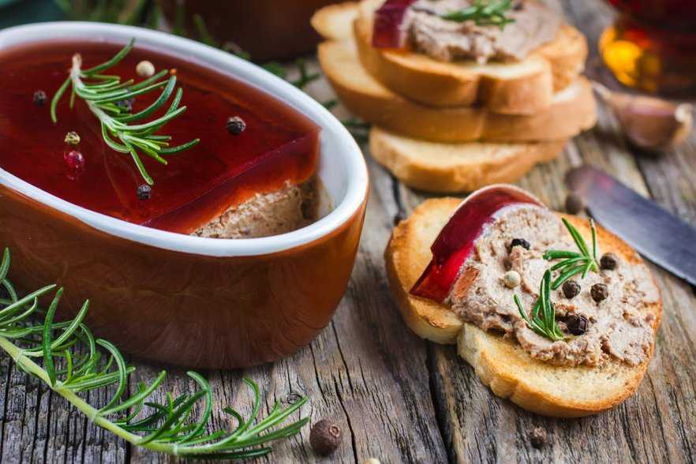
Figure 5.17. Chicken liver pate I
https://www.delfi.lv/tasty/45833919/recepsu-kolekcijas/51875043/majas-gatavota-aknu-pastete-17-receptes-un-specialistu-padomi
https://www.santa.lv/raksts/ievasreceptes_/receptes/pamatsastavdalas/vistas-galas-edieni/vistu-aknu-pastete-ar-brendija-piedevu-11191/
Ingredients:
- 1 kg of chicken liver
- 2 carrots
- 1 celery stalk
- 2 onions
- 2 cloves of garlic
- Thyme
- 1 bay leaf
- 300 g of whipping cream (35% fat)
- 150 g melted butter
- Frying oil
- Salt, pepper
- Nutmeg
1. Chicken livers are washed, dried, cleaned of films, tendons, blood vessels and cut into small pieces.
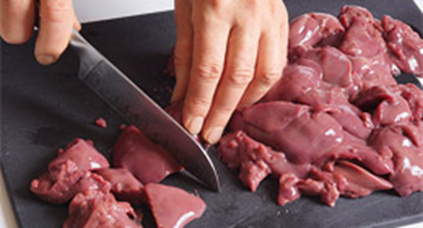
Figure 5.18 Chicken livers cutting

2. Chop carrot, celery stalk, onions and garlic into small pieces. Heat 25 g of butter in a pan, add a little oil and fry the liver quickly. Add sliced vegetables, thyme and bay leaf. Allow it to fry a little.
3. Add whipping cream, salt and pepper, boil and simmer for 5-6 minutes, remove from heat and cool slightly.
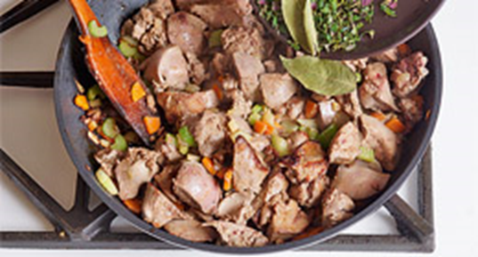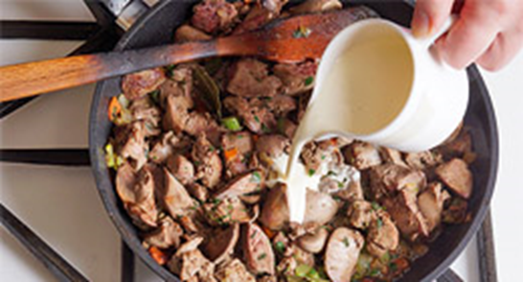
Figure 5.19. Chicken liver frying with vegetables, spices and whipping cream

4. The thyme twigs and bay leaf are removed, the liver and vegetables are finely blended or ground several times in a meat grinder.
5. Mix the rest of the butter, add nutmeg, add salt and pepper to taste, reheat and whisk well.
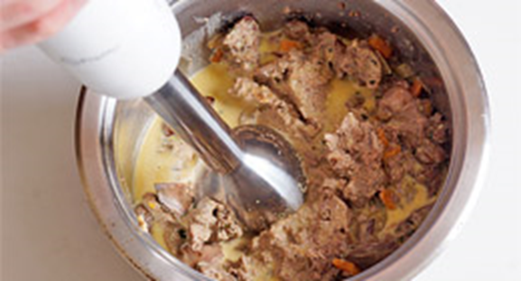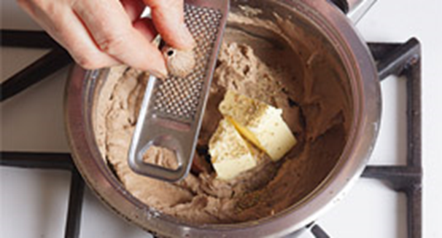
Figure 5.20. Chicken liver pate mixing

6. Finished pate is filled into dishes, decorated and cooled.
Chicken liver pate II

Figure 5.21. Chicken liver pate II
https://www.delfi.lv/tasty/45833919/recepsu-kolekcijas/51875043/majas-gatavota-aknu-pastete-17-receptes-un-specialistu-padomi
https://www.piegalda.lv/receptes/garda-aknu-pastete/
Ingredients:
- 1 kg of fresh chicken liver
- 2 small onions
- 3-4 cloves of garlic
- 1 carrot
- 100 g of melted butter
- 4 tablespoons oil
- 2 hard boiled eggs
- 2 large sweet and sour apples
- 300 g of whipping cream
- Glass of milk
- Freshly ground black pepper
- Salt

1. The liver is washed under running water and cleaned of films with a knife. Then put the liver in a bowl, pour cold milk and leave to soak for approx. 2 hours. Milk removes liver acuity. If you need to hurry, the liver can also be cooked unabsorbed.
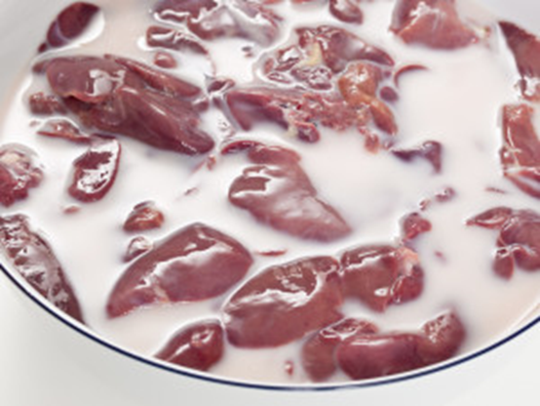
Figure 5.22. Chicken liver soaking in cold milk

2. The eggs are peeled and chopped, the apples are peeled and cut into slices. Onions and garlic are cleaned and finely chopped, peeled carrots are finely cut or grated on a coarse grater. Heat 1 tablespoon of oil and 50 g of butter in a pan. Lightly brown the onions, garlic and carrots.
3. The liver is removed from the milk. Heat the remaining oil and butter in a pan and fry the liver on both sides. The liver should not be overcooked – it should be slightly pink inside. When the liver is browned on both sides, add the already fried onions and carrots, as well as the sliced apples and add half a glass of water. Put the lid on the pan and cook for 10-15 minutes.
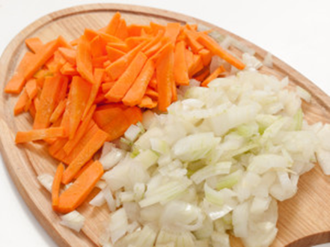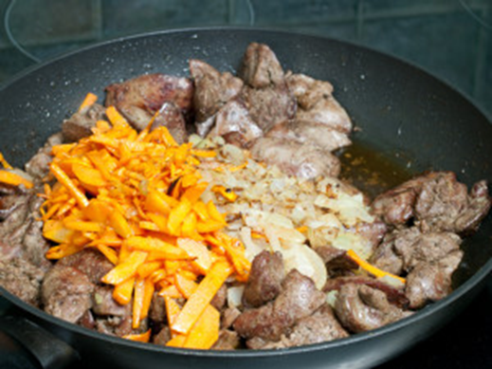
Figure 5.23. Prepared vegetables and chicken liver frying with vegetables and spices

4. Transfer the liver to a large bowl, add the chopped eggs, add whipping cream and grind into a homogeneous, slightly airy mass. Finely chopped sage leaves can also be added to enrich the taste. Add salt and freshly ground black pepper and mix.
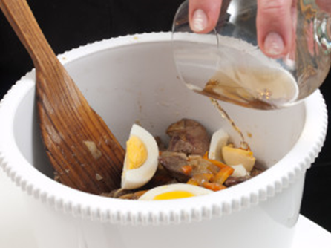
Figure 5.24. Chicken liver pate preparation
5. Put the pate in bowls, melted butter can be poured on top so that the pate does not dry out. When the pate has cooled, it is left to stand in the refrigerator until it is completely cold.

Beef liver pate
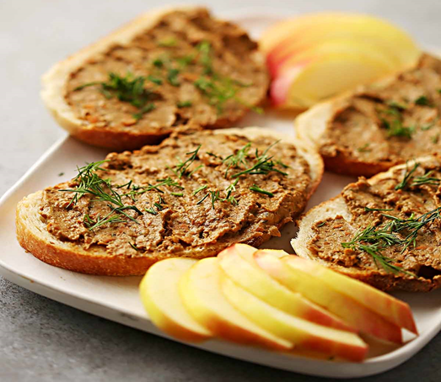
Figure 5.25. Beef liver pate
https://flavorfulhome.com/recipes/beef-liver-pate-recipe/

Ingredients:
- 1 kg of fresh beef liver
- 2 small onions
- 6 cloves of garlic
- 1/2 cup olive oil (+ 2 tablespoons for frying)
- 1 1/2 tablespoons salt
- 1/2 tablespoon black pepper
- 1 tablespoon vinegar (or lemon juice for candida diet + AIP)
- 4 sprigs fresh thyme
- 2 sprigs fresh rosemary

1. Start by slicing up your onions and garlic and set them aside in a small bowl.
2. Remove the stems from your fresh herbs and set aside in a small bowl.
3. Next, cut your beef liver into thin slices. Optionally, you can transfer your liver slices over to a plate lined with paper towels to soak up the excess blood.
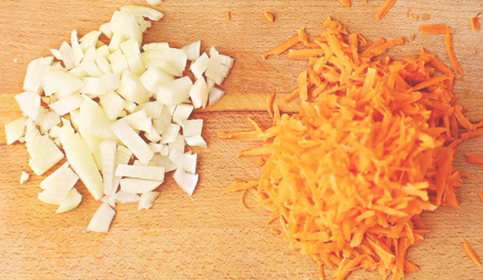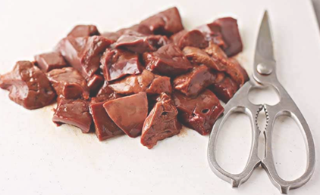
Figure 5.26. Cutting of vegetables and beef livers

4. Heat your frying pan to medium heat, and then add your 2 tablespoons of olive oil, sliced onions and garlic.
5. Sauté your onions and garlic until they start to brown, and then add your liver pieces and your fresh herbs.
6. Fry everything until your liver has cooked through completely.
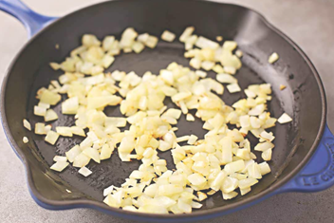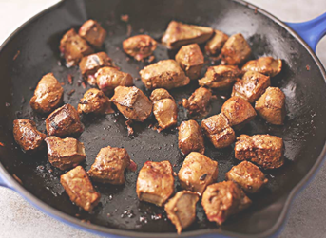
Figure 5.27. Beef liver and onions frying

7. Turn your stove off and let your cooked liver mixture cool completely.
8. Once it has cooled, transfer the mixture over into your food processor and then add all the remaining ingredients including the 1/2 cup oil, 1 tablespoon vinegar, salt and pepper.
9. Blend in a food processor on high until your pate is smooth and has no remaining clumps.
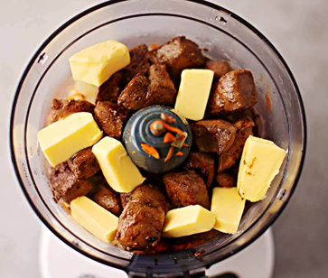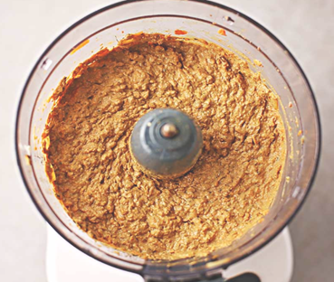
Figure 5.28. Beef liver pate mixing

10. Serve your pate in small ramekins surrounded by your favourite bread and/or crackers. If you are making it ahead of time, make sure to store it in a sealed container in the fridge (or covered in plastic wrap) until you are ready to serve it.
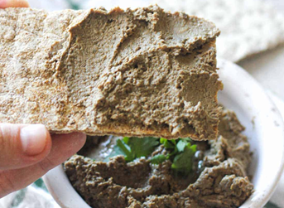
Figure 5.29. Ready pate product

Results
Carry out sensory evaluation of all prepared liver pate product; compare the samples and chooses the best one. Perform analysis of the physico-chemical, microbiological quality indicators as described above.

Conclusion
1.
2.
3.

Approved by _____________________
Name, Surname, signature
Date ______________
Laboratory work Sensory evaluation of meat products

Materials
A total of five liver pate samples are used for the sensory evaluation – three from previously prepared samples and two from the store, already available in the market. The liver pate samples are served in containers coded with three randomised numbers. Sample size - approximately 20 g to each panellist.
To clean your mouth between samples - warm black tea and / or Maca bread.
Methods and Procedures
Task: to evaluate the liking of liver pate sensory properties - aroma, structure and taste, using a 5-point Hedonic scale.

5-point Hedonic scale
TRAY NO. _____________________________________
Please evaluate the liking of the liver pate samples sensory properties. Indicate how much you like or dislike each sample by checking (V or X) the appropriate phrase.
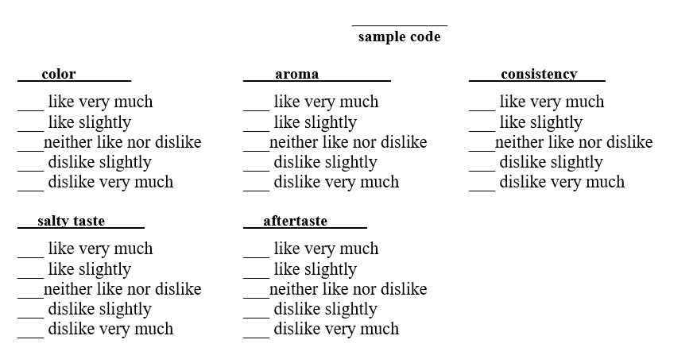

Results
After the liver pate sensory evaluation and completing the 5 point Hedonic scales, the students compare the results and draw the main conclusions.

Conclusion
1.
2.
3.
4.

Approved by _____________________
Name, Surname, signature
Date ______________

Laboratory work

Microbiological evaluation of meat processing products

Materials
Cultures: stationary phase broth culture of Serratia marcescens
Media: dilution tubes of sterile water
Supplies: nutrient agar plates, P-1000 Pipetman, sterile tips, Sterile L-shaped blue cell spreaders ("hockey stick” or “spreader”)

Methods and Procedures
Aliquots from a stepwise or serial dilution of the original sample are spread on plates. Only a few of the plates following incubation will contain a suitable number of colonies to count; those plated from low dilutions may contain too many colonies to count easily while those plated from high dilutions may contain too few colonies or none at all. Ideally plates containing 30-300 colonies per plate should be counted. At this colony number, the number counted is high enough to have statistical accuracy, yet low enough to avoid mistakes due to overlapping colonies.
Figure 5.30. Serial dilution series and plating
A wide series of dilutions (e.g. 10⁻² to 10⁻⁸) is normally performed on the sample culture and spread plates created from the dilutions. A number of spread plates are needed because the exact number of live bacteria in the sample is usually unknown. Greater accuracy can be achieved by plating duplicates or triplicates of each dilution.
Figure 5.31. The series of dilutions

B. Counting colonies on plates
1. Looking at your dilution plates prepared last time, choose the plates that have from 30-300 colonies on them. As this might take some practice in plate counting, you might need to choose all plates with what looks like a reasonable number of colonies to count.
a. Those plates that have no microbial growth can be recorded as 0 or NG, No Growth.
b. Those plates on which colonies are not individually distinct (their edges run together) can be recorded as TNTC, Too Numerous To Count.
c. Those plates on which you cannot distinguish any individual colonies, the entire surface is covered with microbial growth, can be recorded as confluent.
2. Count each colony to give a total colony count for each plate chosen. You will avoid counting a colony twice by marking off the colonies on the bottom of the plate as you count them. This requires, of course, that the plate be upside down. Be sure to count any small colonies. Record your results on the report sheet.

Results
C. Calculation of number viable cells/mL in the original sample
• Choose the plate containing between 30 and 300 colonies.
• Multiply the number of colonies on the plate by the final dilution factor. This gives the total viable cells/mL in the original sample.
• Calculate the colony-forming units, CFU, per mL for the Serratia marcescens culture. Watch Video 1: Dilutions and Plating at NC State Microbiology labs. URL: https://youtu.be/IJcw4fRsYnU
Draw conclusions and compare the obtained results with the information available in the literature and scientific publications.

Conclusion
1.
2.
3.

Approved by _____________________
Name, Surname, signature
Date ______________

THEME 6

Canned meat products

Theoretical materials
Heating is probably the cheapest and most efficient method of preserving meat; its main objective is to ensure the destruction of most pathogens and spoilage microorganisms and to inactivate enzymes, in such a way as to prevent spoilage reactions and proliferation of undesirable microflora. Depending on the expected shelf life, a specific food is subjected to a set of conditions, of varying intensity. If food is cooked, only partial elimination of spoilage microorganisms and enzymes takes place, but additional preservation methods are necessary; conversely, canning allows the destruction of virtually all microorganisms and their spores, able to proliferate and/or produce toxins, specially Clostridium botulinum, as well as spoilage microorganisms. The result of some thermal-processing methods, such as canning, is the production of self-stable foods, with a considerably long shelf life, without the need of applying and other special storage conditions. However, thermal processing usually alters sensory and physical characteristics; in some cases, changes in physical structure are highly desirable, and are even part of the process itself, as is the case of luncheon meat where an emulsion system changes to a gel as a result of thermal processing.
Therefore, a compromise must be reached between food safety and the desirable, or minimum, sensory and physical properties alteration. When a thermal process is applied for the first time, it is calculated taking as the basis the destruction of the most harmful or the most abundant microorganism present, or the enzyme or enzymes that need to be inactivated to prevent spoilage for a reasonably long time. Usually, C. botulinum destruction is taken as a calculation basis, although other bacteria can be considered for meat processing, such as Staphylococcus aureus or Streptococcus thermophilus, depending if an uncooked or processed meat is processed.
Microorganisms in meat. Microbial populations in foods are not static; as these are heterogeneous substrates, a given microbial population is established depending on nutrient availability. This is even more noticeable when a food material is processed and its chemical and physical characteristics change. In cured meats, considerable microbial reduction is obtained due to the action of nitrites and salt on aw and pH. However, these products require further processing or refrigeration to extend their shelf life. Microbial contamination can occur during meat fabrication; the populations present can be Enterobacteria, Clostridium spp., some psychorphiles such as Lactobacillus viridescens and Leuconostoc.
There is a specific association in refrigerated meats of nonfermentative Gram-negatives belonging to genera Pseudomonas, Alcaligens, Flavobacterium, Shewella, and Moraxella. The addition of salt, nitrates, and nitrites and phosphates during curing completely changes the microbial association to Gram positives, such as Micrococcus, Lactobacillus, Carnobacterium, and Brochothrix.
Although the striated muscle of a healthy animal is considered sterile, meat microbial contamination starts from a number of sources: water, skin, viscera, and workers’ clothing and handling. It is mainly composed by yeasts, bacilli, and bacteria such as Moraxella, Acinetobacter, Flavobacteria, Enterobacteriaceae, Escherichia coli, Salmonella spp., Shewanella putrefaciens, and Listeria spp. After prolonged refrigerated storage, psychrophiles are the main responsible of meat spoilage, mainly by Brochothrix thermosphacta, Carnobacterium spp., Lactobacillus spp., Leuconostoc spp., Weissella spp., Pseudomonas spp., Acinetobacter, and Psychrobacter inmobilis. In poorly refrigerated meats, Clostridium perfringens and Enterobacteriaceae are present.
In general, no signs of deterioration become evident in meats contaminated with pathogens. There are few exceptions, such as contamination with proteoytic strains of Clostridium botulinum, causing off-odours although not intense enough to be taken as a pathogen indicator. Some of the most important microorganisms causing food poisoning, involving meat and meat products are Salmonella spp., Escherichia coli O157:H7, Yersinia enterocolítica, Campylobacter jejuni, Staphylococcus aureus, Listeria monocytogenes, Clostridium perfringes, Clostridium botulinum, Bacillus cereus, and Staphylococcus aureus.
The thermal destruction of microorganisms is calculated from the point of view of sanitation as well as extending food shelf life. Vegetative cells are destroyed at temperatures slightly higher than their maximum temperature to grow, whereas spores can survive much higher temperatures. Two principles must be taken into consideration:
1. All microbial cells and spores, able to grow and/or to produce toxins, must be eliminated.
2. Spoilage microorganisms must be reduced to a safe lowest limit.

From the commercial point of view, a food is commercially sterile if it is free from Bacillus stearothermophilus or Clostridium perfringens. Sporulated thermophiles are important only if food is to be stored at high temperatures. Thermal processes that eliminate Clostridium botulinum and Clostridium sporogenes produce a thermostable food of long shelf life, without the need of other preservation methods.
Heat transfer mechanisms. Process calculations consider vegetative cell destruction following the ratio:
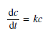
That is, cell concentration (dc) decreases with time (dt) in a direct proportion to viable cell concentration (c). This is a logarithmic destruction, decreasing one long cycle (for instance, 10³–10²) as time linearly increases. This calculation has the advantage of allowing death rate comparison among microbial populations, as all microorganisms follow a log destruction pattern.
In all heat transfer operations, it is necessary to know the amount of heat to be transferred. This allows calculating the transport parameters in the system. As this is a dynamic process, heat flow is proportional to the driving force and inverse to the resistance to flow. The heat transfer mechanisms are conduction, convection, and radiation.
Thermal technologies. Heat transfer is a phenomenon directed by energy interchange; as a material is heated, molecules move faster; the kinetic energy increases the absorbed caloric energy. Heat capacity (Cp, p means that it occurs at constant pressure) defines the amount of caloric energy necessary to increase the temperature to a given mass unit. As mentioned before, the application of a given thermal treatment intensity depends on the required shelf life. It can be as mild as cooking where only few vegetative cells and enzymes are inactivated, to sterilisation where practically all the microorganisms are destroyed. Canning, a treatment at intermediate severity, can range from semi-preserves to tropical preserves with shelf life from 6 months at < 5 °C up to 1 year at 40 °C, respectively. Mild heat treatments, however, need an extra preservation method, such as refrigeration for cooked meats to prevent proliferation of spoilage microorganisms and pathogens as well as toxin production, in some cases. Even Though, heat transfer principles are the same for all thermal technologies, each one has a different aim. Depending on the treatment severity, they can be divided into scalding, cooking, pasteurisation, and sterilisation.
Sterilisation. In a sterile product, no viable microorganism is present. However, the term “sterile” is not suitable for food processing, as the sterility criterion for food is the growth inhibition of vegetative cells and spores in normal storage conditions. Therefore, in foods, the term used is “commercial sterility,” “bacteriologically inactive,” or “partially sterile.” These foods have a considerably extended shelf life without any other preservation method. Usually Clostridium botulinum and Clostridium sporogenes are used as indicators for meats, and process calculations are based on the destruction of these bacteria.
Process calculations. In order to establish the thermal process severity, calculations require two types of basic information: 1) heat resistance of a given microorganism taken as process indicator, usually Clostridium botulinum or Clostridium perfringens; 2) previous handling of the products: for meats, post-mortem handling, sanitation, etc. It is also necessary to define the expected shelf life of the product and thermal sensitivity of the product (possible alterations in colour, flavour, odour, texture, etc.). Several inactivation parameters are usually calculated:
D-value: it is the time interval, at a given temperature, necessary to destroy 90% of a given microbial population. This value varies among microorganisms, and allows comparing thermal destruction among populations. For instance:
- At 110 °C, 90% Clostridium sporogenes population (10⁵–10⁴) is reduced if heating is kept for 10 min (D_{110 °C} = 10 min),
- At 115 °C, the necessary time for the same reduction is 3 min (D_{115 °C} = 3 min),
- At 120 °C, only 1 min is necessary (D_{120 °C} = 1 min).
On the other hand, at different heating times, the destroyed population increases with time of the exposure.
Z-values: it is the temperature necessary for reducing D values in 1/10. For example: if Z = 10 °C; D-value at 100 °C is 50 min; at 110 °C is 5 min; at 120 °C is 0.5 min.
F-values: it is a calculation of the overall process efficiency. Total F-value of a given process is the sum of lethality efficiency of every part of the process (heating, holding, and cooling). F-values are used to compare severity of different thermal treatments, according to microbial resistance to process conditions. F and D values are related by the following equation:
where: a - initial cell load
b - final cell load
Process lethality is calculated by the equation: log (t/F) = (250 − T)/Z. In fact, total process lethality is the sum of the lethality calculated for every minute of the entire process, resulting in a process curve; the area under the curve represents total lethality. Low acidity foods, such as meats, are heated at temperature that ensure reduction of Clostridium botulinum spores in 12 log cycles, or 12D, with a final contamination of one Clostridium botulinum spore per g, an extremely low probability of finding a spore, or 1/10¹². In order to reach this reduction, heating must be 12 times more severe than D₁₂₁ = 0.2 min, therefore, the meat must be processed for 2.52 min at 120 °C. The process lethality is F = 2.5, known as botulinum cooking.
https://www.researchgate.net/profile/Abdelkader-Bouaziz/post/Can-we-increase-the-oxidative-stability-of-meat-and-meat-products-and-if-possible-how-is-it-done/attachment/5eb934f8f155db0001faf18d/AS%3A889966779457543%401589196023464/download/Handbook+of+Meat+and+Meat+Processing+(2nd+Est).pdf
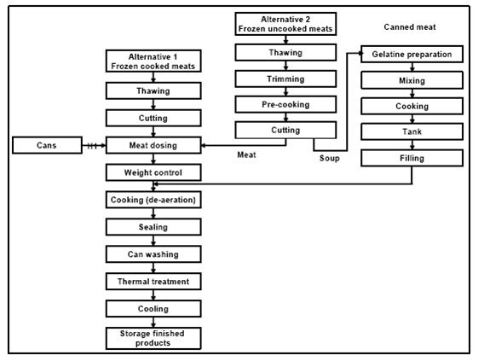
Figure 6.1. Production flowchart for canned meat products
http://wiki.zero-emissions.at/index.php?title=File:Flowsheet_of_canned_meat_production,_figure1.jpg

Highest value packaging types and materials for canned meat products
Canned products are distinguished by a combination of processing and packaging technologies that allow products to be stored at room temperature for a long time. Therefore, the choice of packaging is important. Most often, after the product is packed in a package, the product is thermally treated together with the package. This means that, in addition to the previously mentioned properties, such as barrier properties, the package must have heat resistance properties.
Table 6.1.
The most commonly used packages shapes for packing of canned meat products
Illustration | Package shape | Description
 | Pillow pouch | Usually produced in-house in horizontal flow-pack equipment. Or purchased packaging in the form of ready-made packages with fused three seams. This type of packaging is also common for packaging different types of sausages, as well as for packaging frozen meat.
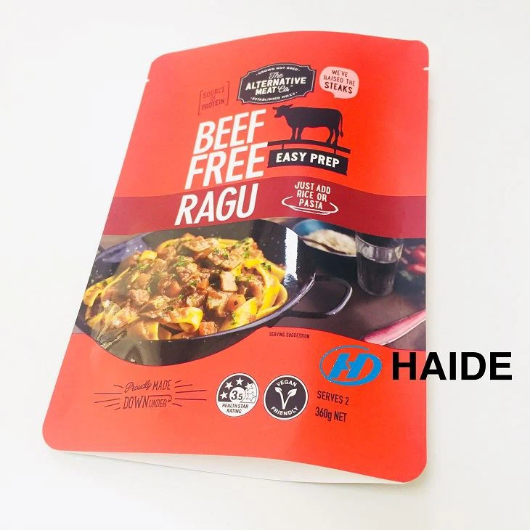 | Doypack | Usually produced in-house in horizontal flow-pack equipment. Or purchased packaging in the form of ready-made packages with fused three seams.
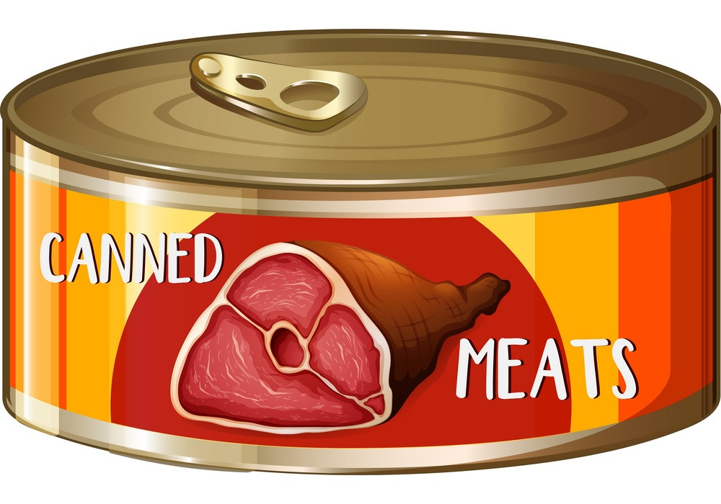 | Metal cans | Generally, raw product is packaged, both in high-volume machines and in low-volume machines. Boxes tend to have different shapes.
 | Glass jars | Often used for meat packing pickled products.

For this type of products, it is important to choose the appropriate packaging with high barrier properties, as well as correctly calculate the time and temperature of heat treatment, as this can significantly affect the expiration date.

Seminar

Package as added value of meat products

The aim of the workshop is to analyse the packaging as attached value for the product, because the packaging often plays an important role in choosing a product. The group of students is divided into teams, and each team analyses products packaged using different packaging solutions, paying significant attention to packaging design.
Materials
In the seminar uses either different prototypes of packaged products or photos found on Internet resources with different packaged products.
Methods and Procedures
Each group of students analyses three different packages. And the characteristics are given in Table 6.2.

Results
The results obtained should be reflected in Table 6.2. After completing the table, different groups of students compare the results. If possible, each group presents and justifies its performance.
During operation, students acquire skills in characterizing packages and analysing situations, as well as experience working in groups.
Table 6.2.
Characteristic parameters | Samples
Characteristic parameters | Product No. 1 | Product No. 2 | Product No. 3
Packaging material
Packaging shape
What information is printed on the package?
Does the packaging contain information about the recyclability of the packaging?
What should be done to make the packaging more attractive?
Are there any flaws or gaps in the information printed on the package? If so, which ones?
Conclusion
1.
2.
3.
Approved by _____________________
Name, Surname, signature
Date ______________

Practical work

Meat product safety risk assessment

Materials
Theoretical materials

Methods and Procedures
The following tasks must be completed in the practical part of the work:
1. For a selected meat processing product, develop a product description, develop and draw a diagram of the process steps.
2. Identify potential hazards:
- biological - pathogenic microorganisms,
- chemical - agricultural chemicals,
- physical - foreign objects atypical for the product.
3. Evaluate the danger of the identified hazards using a risk matrix.
1. Record the information in the hazard assessment table.
2. Complete the CCP identification table and the HACCP plan.
3. Write conclusions on determining CCP using a risk matrix and a decision scheme.

Results
Table 6.3.
Risk assessment table
Process stage | The identified hazard | Hazard assessment |  |  |  |  | Means of control
Process stage | The identified hazard | Possibility | The severity of the consequences | Risk level | Assessment | CCP | Means of control

Table 6.4.
CCP identification table
Process stage | Process stage | Cause of risk | Description of the cause of the risk | Control actions | Answers to Decision Scheme questions |  |  |  | CCP yes/no
No. |  |  |  |  | 1 | 2 | 3 | 4

Table 6.5.
HACCP plan
In process | CCP/  CP | Risk | Measurable | Monitoring procedures |  |  |  | Order- | Corrections
stage |  | the cause | critical limits of parameters | What? | How to? | How often? | What? |  | events

Conclusion
1.
2.
3.

Approved by _____________________
Name, Surname, signature
Date ______________

Practical work

Thermal equipment for meat processing
Materials
Technological schemes of different meat product production, and internet network.

Methods and Procedures
According to interest and wishes, students choose one technological scheme of meat product production, for example, cooking boiled sausages, semi-dried sausages.
In the future, using the Internet resources and educational literature, according to the technological scheme of product production, technological equipment is selected. The selected circuits are arranged according to the technological process and a scheme is created. For each of the selected equipment, its necessity, justification and principle of operation must be explained.
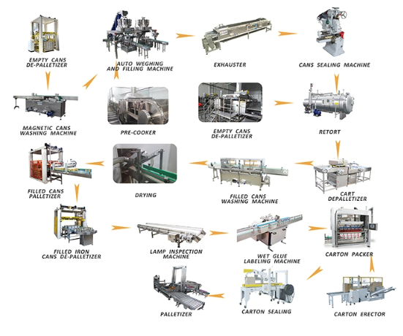
Figure 6.2. Canned meat production line
https://shleadworld.en.made-in-china.com/product/edRGuZYcCVWt/China-Leadworld-Canned-Corned-Beef-Machine-Canned-Meat-Production-Line.html
Results
Students collect the information obtained. Students choose one of the pieces of equipment that can ensure constant quality of the finished product, or provides CCP (critical control point).
Conclusion
1.
2.
Approved by _____________________
Name, Surname, signature
Date ______________
Literature sources

1. Heinz, G., Hautzinger, P. Meat processing technology. Bangkok: FAO. 2007. – 368 p.
2. Toldra, F. Handbook of meat processing. USA: Publishing by Wiley-Blackwell. 2010. – 566 p.
3. Винникова, Л. Г. (2006). Технология мяса и мясных продуктов. Киев: ИНКОС. 600 стр.
4. Зонин, В.Г. Современное производство колбасных и солено-копченых изделий. Санкт-Петербург: Издательство «Профессия». 2007. – 221 ст.
5. Васюкова А., Куликов., Славянский А. (2019). Оборудование пищевых предприятий. Краснодар: Кнорус. 286 стр.
6. Рогов, И.А., Жаринов, А.И.,Текутъева, Л.А., Шепелъ, Т.А. Биотехнология мяса и мясопродуктов. Москва: ДеЛи принт. 2009. – 296 ст.
7. Лисицын, А.Б., Липатов, Н.Н., Кудряшов, Л.С., Алексахина, В.А., Чернуха, И.М. Технология и практика переработки мяса. Москва: Эдиториал сервис. 2008. – 305 ст.
8. Meat science. The Official Journal of the American Meat Science Association.
9. Алимардонова М. Биохимия мяса и мясных продуктов: Учебное пособие.-Астана: Фолнат, 2009-184.
10. Normahmatov Ro’ziboy Oziq- ovqat tavarlari sifat ekspertizasi. R. Normahmato. Oliy
o’quv yurtlari talabalari uchun darslik. T.: Tafakkur, 2013.515 bet
11. Бахромов А.Б Товаршунослик асослари Тошкент ТХХИ 1996.
12. Yaranoglu, B., Zengin, M., Gokce, M., Varol Avcilar, O., Berhun Postaci, B., Erdogan, C., Odabas, E. (2023). Chemical composition of meat from different species of animals. International Journal of Agriculture, Environment and Food Sciences, 7 (3), 581-587 (https://dergipark.org.tr/en/download/article-file/3287716).

