


Open Food Innovation University (OFINU)

Study module
“Fruit and Vegetable Processing Technologies”
WORKBOOK
for students

2024
Summary

The workbook is elaborated within the project “Open Food Innovation University" (OFINU), being in implementation with support of the European Union Erasmus+ Programme.
Overall objective of the project - to modernise food innovation and technology related higher education in Uzbekistan and Tajikistan, thereby increasing the quality and ensuring relevance of the higher education to the needs of the socio-economic growth of the countries concerned and especially of their regions.

Full partners:
- Lead partner: Latvia University of Life Sciences and Technologies
- Uzbekistan: Samarkand Agro-innovations and Research University, Andijan Institute of Agriculture and Agro-technologies
- Tajikistan: Technological University of Tajikistan, Kulob Institute of Technology and Innovation Management, Isfara Branch of the Technological University of Tajikistan
- Slovakia: Slovak University of Agriculture in Nitra

Associated partners in Uzbekistan:
- A group of companies "AGROMIR"
- "Navigul" MCHJ QK
- “Samarqand don mahsulotlari” JC (Samarkand grain products)

Associated partners in Tajikistan:
- CJSC “Combinati Shiri Dushanbe”
- LTD "Orion Rustam"
- Association of Entrepreneurs of Khatlon

The project implementation period: 01/02/2024 - 31/01/2027.

Funded by the European Union. Views and opinions expressed are however those of the authors only and do not necessarily reflect those of the European Union or the European Education and Culture Executive Agency. Neither the European Union nor the granting authority can be held responsible for them.

Partner universities and their academic staff, involved in the development of the study course:

P1 LBTU. Latvia University of Life Sciences and Technologies
Assistant professor, Ph.D. Liene Ozola - fruit and vegetable processing technology; microbiological evaluation.
Professor, Dr.sc.ing. Tatjana Ķince: fruit and vegetable processing equipment.
Associate professor, Dr.sc.ing. Evita Straumīte - sensory evaluation of fruit, vegetables and their processing products.
Professor, Dr.sc.ing. Sandra Muižniece-Brasava - product packaging materials and technology.
Quality manager, Mg TQM Egita Sproģe - food safety QM systems.
P2 SAMARU. Samarkand Agroinnovations and Research University
Assistant teacher, MSc Elnara Devletshaeva - technology of storage and processing of agricultural products.
Ph.D. Haitmurod Tilavov - technology of storage and processing of agricultural products.
P3 AIAA. Andijan Institute of Agriculture and Agro-technologies
Associate Professor, Ph.D Oybek Egamberdiev - technology of storage and processing of agricultural products.
Assistant teacher MSc, Dekhkonova Shakhnozaxon - technology of storage and processing of agricultural products.
P4 TUT. Technological University of Tajikistan
Assistant Professor, Ph.D. in Tech. Sc. Gulmahmad Mirzozoda- technological equipment for canning production; technology and equipment of vegetable oil production.
Assistant Professor, Ph.D. in Tech. Sc. Maksudakhon Abdullaeva - fruit and vegetable processing technologies; new food product development.
P5 KITIM. Kulob Institute of Technology and Innovation Management
Assistant Professor, Ph.D. in Tech. Sc. Ziyodullo Obidov - physico: chemical and biochemical foundations of food production; physico-chemical analysis of food products.
Senior lecturer, Saidislom Jangov - fruit and vegetable processing technologies; new food product development.
P6 BTUTI. Branch of the Technological University of Tajikistan in the city of Isfara
Senior lecturer, Sirojiddin Boboev - fruit and vegetable processing technology; microbiological evaluation; food safety QM systems.
Senior lecturer, Sunatullo Qodirov - fruit and vegetable processing equipment.
Senior lecturer, Turanboy Turanboev - sensory evaluation of fruit, vegetables and their processing products; product packaging materials and technology.
P7 SUA. Slovak University of Agriculture in Nitra
doc. Ing.Ph.D Ivana Mezeyová - vegetable technology.
doc. Ing.Ph.D Miroslav Šlosár - vegetable technology.
doc. Ing.Ph.D Oleg Paulen - fruit technology.
doc. Ing.Ph.D Ján Mezey - fruit technology.

CONTENT
Theme of the study course 8
Learning methods 9
Course Schedule 11
Theme 1 17
Chemical composition and physical properties of fruit, vegetables, and mushrooms. Fruit and vegetable classification. 17
Theoretical materials 17
Laboratory work 22
Chemical composition of fruit, berries and vegetables 22
Laboratory work 27
Natural pigments and their detection, quality changes in fruit, berries and vegetables 27
Laboratory work 31
Chemical composition and quality parameters of potato tubers 31
Theme 2 37
Fruit and vegetable preservation 37
Theoretical materials 37
Knowledge questions 41
Theme 3 42
Fresh, minimally processed fruit and vegetables 42
Theoretical materials 42
Laboratory work 48
Preparation of fresh, cut and packaged vegetables 48
Laboratory work 52
Quality evaluation of fresh, cut and packaged vegetables 52
Laboratory work 56
Microbiological assessment of fresh, cut and packaged vegetables 56
Theme 4 60
Packaging equipment and special packaging materials and methods used in fruit and vegetable product production 60
Knowledge questions 60
Theme 5 62
Technological equipment for fruit and vegetable processing 62
Knowledge questions 62
Theme 6 64
Fermented fruit and vegetable production 64
Theoretical materials 64
Laboratory work 70
Preparation of sauerkraut 70
Laboratory work 74
Packaging and storage of sauerkraut. Product treatment in sous-vide. 74
Laboratory work 76
Microbiological evaluation of prepared sauerkraut 76
Laboratory work 80
Sensory evaluation of sauerkraut 80
Laboratory work “Quality evaluation of prepared sauerkraut” 83
Theme 7 88
Assessment of the Safety and Risks of fruit and vegetable products (HACCP) 88
Theoretical materials 88
Laboratory work 94
Assessment of potential hazards in fruit and vegetable processing 94
Control actions 95
Theme 8 100
Microbiological aspects of fruit and vegetable processing 100
Theoretical materials 100
Knowledge questions 103
Theme 9 105
Production technology of frozen fruits and vegetables 105
Theoretical materials 105
Laboratory work 107
Freezing of fruits and vegetables 107
Laboratory work 110
Quality analysis of frozen fruits and vegetables 110
Theme 10 116
Sensory aspects of processed fruit and vegetable products 116
Knowledge questions 116
Theme 11 117
Thermally processed vegetable preserves 117
Processed potato products 117
Theoretical materials 117
Laboratory work 122
Preparation and analysis of potato processing products using different technologies - French fries 122
Laboratory work 130
Preparation and analysis of potato processing products using different technologies - chips 130
Laboratory work 134
“Sensory evaluation of potato chips” 134
Tomato processing products 137
Theoretical materials 137
Laboratory work 140
Preparation of tomato concentrates and sauces using different technologies 140
Laboratory work 144
Quality assessment of prepared tomato products 144
Laboratory work 148
Sensory evaluation of prepared tomato products 148
Theme 12 151
Thermally processed fruit and berry preserves 151
Fruit and berry compotes, jams and purees 151
Theoretical materials 151
Laboratory work 152
Apple compote preparation 152
Laboratory work 154
Quality evaluation of apple compotes 154
Fruit and berry marmalades 158
Theoretical materials 158
Laboratory work 163
Preparation of fruit and berry marmalades using different gelling agents 163
Laboratory work 165
Quality analysis of fruit and berry marmalades 165
Laboratory work 168
Sensory analysis of fruit and berry marmalades 168
Fruit, berry and vegetable juices 172
Theoretical materials 172
Laboratory work 175
Principles of production of fruit and vegetable juices, evaluation of prepared juices 175
Theme 13 180
Vegetable oils 180
Theoretical materials 180
Laboratory work 185
Vegetable oil analysis 185
Theme 14 187
Fruit berry and vegetable drying 187
Theoretical materials 187
Laboratory work 189
Apple drying using different technologies 189
Laboratory work 190
Quality evaluation of dried apples 190
Literature sources 193

Theme of the study course
The study module “Fruit and Vegetable Processing Technologies” includes the following topics: technological processes and equipment, packaging materials and equipment, raw materials and product quality evaluation, including sensory evaluation. Quality management assurances in fruit and vegetable processing. A lecturer with knowledge in the specific field is involved in the implementation of each section in order to achieve the goal of the study module.

Learning methods
Creating an effective study module for students involves incorporating a variety of learning methods to cater to different learning styles and enhance comprehension and retention.
The main pedagogical methods taught are as follows: learner centred approach, competence-based approach, experiential learning, cooperative learning, and interactive learning.
The training includes practice methods, as well as an introduction to modern learning analytics, which are used to support the engagement and responsibility of a student, and to support assessment.
Highly appreciated are the knowledge and skills to produce and deliver classes and lectures in the form of distance learning, because the application of this method broadens the availability of experts and worldwide knowledge (inviting, entrepreneurs, foreign academic staff etc. as lecturers), can be applied in the case of double diploma studies, provide an opportunity to study for persons with limited opportunities to take part in full-time studies (young mothers, students with disabilities). Distance learning is very effective for specific courses where participation of lecturers from foreign partner universities is crucial and discussions with students with diverse experiences and visions are needed to explain and demonstrate possibilities and different solutions and options.
In order to improve and promote the learning in the study module, it is possible to use different teaching methods in the study course, for example:
- Lecture-based learning - Traditional method where an instructor delivers content through spoken presentations, often supplemented by visual aids such as slides.
- Interactive learning – Actively engages students through discussions, Q&A sessions, and interactive activities. This enhances understanding and retention by involving students in the learning process. Techniques include think-pair-share, debates, and group discussions.
- Collaborative learning - Students work together in small groups to solve problems, complete tasks, or create projects. The method helps to develop teamwork skills, fosters peer learning, and encourages diverse perspectives. Examples include group projects, peer reviews, and study groups.
- Problem-based learning - Students learn through the experience of solving open-ended problems. Promotes critical thinking, application of knowledge, and self-directed learning. Typically involves real-world scenarios that require research and collaborative problem-solving.
- Case-based learning - Uses detailed scenarios (cases) to stimulate analysis and application of concepts. Helps students apply theoretical knowledge to practical situations, improving analytical and decision-making skills. Commonly used in business, law, and medical education.
- Flipped classroom - Students review lecture material at home (e.g., video lectures) and engage in interactive activities in class. It maximises classroom time for active learning through discussions, problem-solving, and hands-on activities.
- Self-directed learning - Students take responsibility for their learning, setting goals, finding resources, and assessing their progress. The method encourages lifelong learning skills, autonomy, and self-motivation. Methods include reading assignments, online courses, and independent projects.
- Experiential learning - Learning through reflection on doing, which includes hands-on experience and practical application of skills. Provides real-world context and practical skills. Examples include lab work, internships, simulations, and field trips.
- Technology-enhanced learning - Incorporates digital tools and online resources to support learning. It offers flexibility and access to a wide range of resources. Includes e-learning platforms, educational apps, virtual labs, and online discussion forums.
- Socratic method - Teaching through questioning to stimulate critical thinking and illuminate ideas. This encourages deep thinking, dialogue, and exploration of complex concepts. Often used in philosophy, law, and humanities.
- Assessment and feedback - Regular assessments (formative and summative) and feedback to guide learning and improvement. This ensures understanding, tracks progress, and provides actionable feedback. Includes quizzes, peer assessments, and instructor feedback.
Implementation tips:
- Diverse methods - incorporate a mix of methods to address different learning styles (visual, auditory, practical).
- Clear objectives - define clear learning objectives for each method and activity.
- Engagement - design activities that actively engage students and encourage participation.
- Flexibility - be adaptable to student and study theme needs and feedback, adjusting methods as necessary.
- Resources - provide adequate resources and support for each learning method, including technology and materials.
Masterclasses, open lectures, and discussions, involving internal and external stakeholders, is a new form of teaching and communication of higher education to the society, which has been adopted at the involved UZ universities during the implementation of the project.

Course Schedule
Thematic Study Plan for module “Fruit and Vegetable Processing Technologies”

Date, Time | Study form | Theme | Lecturer
Theme 1. Chemical composition and physical properties of fruit, vegetables, and mushrooms. Fruit and vegetable classification
Day 1 | Lecture  (2h) | Introduction lecture about the study course.  Chemical composition and physical properties of fruit and vegetables.
Day 1 | Laboratory work (3h) | Chemical composition of fruit, berries and vegetables.
Day 1 | Lecture  (1h) | Fruit and vegetable classification.
Day 1 | Lecture  (1h) | Mushrooms - structure and chemical composition.
Day 2 | Lecture  (4h) | Chemical composition and quality aspects of herbs, wild and domesticated fruit and berries.  Nuts, their chemical composition and quality characteristics.  Citrus fruits, their chemical composition.
Day 2 | Laboratory work (3h) | Natural pigments and their detection, quality changes in fruit, berries and vegetables.
Day 3 | Lecture  (1h) | Structure and chemical composition of potato tubers.
Day 3 | Laboratory work (2h) | Chemical composition and quality parameters of potato tubers.
Theme 2. Classification of fruit and vegetable processing products
Day 3 | Lecture  (1h) | Introduction to the fruit, berry and vegetable processing industry in “Your Country”.
Day 3 | Lecture  (2h) | Fruit and vegetable storage conditions. Methods of preserving fruits, berries and vegetables.
Theme 3. Fresh, minimally processed fruit and vegetables
Day 4 | Lecture  (1h) | Production of fresh, minimally processed fruits and vegetables.
Theme 4. Packaging equipment and special packaging materials and methods used in fruit and vegetable product production
Day 4 | Lecture  (4h) | Packaging equipment and special packaging materials and methods used in fruit and vegetable product production.
Day 4 | Laboratory work (3h) | Connected and a continuation of Theme 3  Preparation of fresh, cut and packaged vegetables (1st part).
Theme 5. Technological equipment for fruit and vegetable processing
Day 5 | Lecture  (4h) | Overview of technological equipment for fruit and vegetable processing.
Theme 6. Fermented fruit and vegetable production
Day 5 | Lecture  (1h) | Fermented vegetables - technological aspects of preparation and product quality with focus on sauerkraut production).
Day 5 | Laboratory work (2h) | Preparation of sauerkraut (1st part).
Theme 7. Assessment of the Safety and Risks of fruit and vegetable products (HACCP)
Day 8 | Lecture  (2h) | Assessment of Safety and Risks of fruit and vegetable products (HACCP).
Day 8 | Practical work / Seminar  (4h) | Assessment of Safety and Risks of fruit and vegetable products (HACCP).
Day 9 | Excursion | Excursion to a local fruit and vegetable processing company.
Theme 8. Microbiological aspects of fruit and vegetable processing
Day 10 | Lecture  (2h) | Microbiological aspect in fruit and vegetable processing.
Continuation of laboratory work from Day 4 and in the context of Themes 3, 4 and 8
Day 10 | Laboratory work  (2h) | Microbiological evaluation of fresh, cut and packaged vegetables (2nd part).
Day 10 | Laboratory work (4h) | Quality evaluation of fresh, cut and packaged vegetables (3rd part).
Theme 9. Production technology of frozen fruits and vegetables
Day 11 | Lecture  (2h) | Production of frozen fruit and vegetables
Day 11 | Laboratory work  (1h) | Freezing of fruit and vegetables (1st part)
Theme 10. Sensory aspects of fruit and vegetable processing products
Day 11 | Lecture  (2h) | Fruit, berry and vegetable and their product sensory evaluation.
Continuation of Themes 6
Day 12 | Laboratory works  (2h) | Microbiological evaluation of prepared sauerkraut (2nd part).
Day 12 | Laboratory work (2h) | Packaging and storage of sauerkraut. Product treatment in sous-vide. (3rd part)
Continuation of Day 10 and conclusion of Theme 3
Day 15 | Laboratory work  (1h) | Data collection of microbiological assessment of fresh, cut and packaged vegetables.
Day 15 | Seminar  (1h) | Conclusion of Theme 3.  Seminar on obtained data and evaluation of laboratory works.
Continuation of Day 12 and conclusion of Theme 6
Day 15 | Laboratory work  (1h) | Data collection of microbiological assessment of prepared sauerkraut.
Day 15 | Laboratory work  (2h) | Sensory evaluation of sauerkraut.
Day 15 | Laboratory work  (2h) | Quality evaluation of prepared sauerkraut.
Day 15 | Seminar  (1h) | Conclusion of Theme 6. Seminar on obtained data and evaluation of laboratory works.
Theme 11. Thermally processed vegetable preserves
Day 16 | Lecture  (2h) | Natural preserves. Testing of canned food sterility.
Day 16 | Lecture  (4h) | Processing of tomatoes. Production of acidified vegetable preserves.
Day 17 | Laboratory work  (6h) | Preparation of tomato concentrates and sauces using different technologies.
Day 18 | Laboratory work  (2h) | Quality assessment of prepared tomato products.
Day 18 | Laboratory work  (2h) | Sensory evaluation of prepared tomato products.
Day 18 | Lecture  (2h) | Potato processing products and technologies, needed equipment, and their characteristics.
Day 19 | Laboratory work  (4h) | Preparation and analysis of potato processing using different technologies - French fries.
Day 19 | Laboratory work  (2h) | Preparation and analysis of potato processing using different technologies – chips -Preparation stage.
Day 22 | Laboratory work  (2h) | Preparation and analysis of potato processing using different technologies - chips- Analysis stage.
Day 22 | Laboratory work  (1h) | Sensory evaluation of potato chips.
Day 22 | Seminar  (1h) | Conclusion of Theme 11. Seminar on obtained data and evaluation of laboratory works.
Continuation of Day 12 and conclusion of Theme 9
Day 22 | Laboratory work  (3h) | Quality analysis of frozen fruit, berries and vegetables (2nd part).  Conclusion of Theme 9. Seminar on obtained data and evaluation of laboratory works.
Theme 12. Thermally processed fruit and berry preserves
Day 23 | Lecture  (2h) | Classification of fruit and berry processing products. The technology and equipment of preparation of compotes and jams, purees.
Day 23 | Laboratory work  (2h) | Apple compote preparation (1st part).
Day 23 | Lecture  (2h) | The technology of fruit and berry marmalade production.
Day 23 | Laboratory work  (1h) | Preparation of fruit and berry marmalades using different gelling agents.
Day 24 | Laboratory work  (2h) | Quality evaluation of apple compotes.
Day 24 | Laboratory work  (1h) | Sensory analysis of fruit and berry marmalades.
Day 24 | Laboratory work  (2h) | Quality analysis of fruit and berry marmalades
Day 24 | Lecture  (2h) | Fruit, berry and vegetable juices, their division and juice production technologies, and equipment.
Day 25 | Laboratory work  (5h) | Fruit, berry and vegetable juice production (preparation of samples) and quality evaluation.
Day 25 | Seminar  (1h) | Conclusion of Theme 12.  Seminar on obtained data and evaluation of laboratory work.
Theme 13. Vegetable oils
Day 26 | Lecture  (3h) | Oils, their division and extraction methods.
Day 26 | Laboratory work  (2h) | Quality analysis of vegetable oils.  Conclusion of Theme 13.  Seminar on obtained data and evaluation of laboratory work.
Theme 14. Dried fruit and vegetable products
Day 29 | Lecture  (1h) | Drying of fruits, berries and vegetables.
Day 29 | Laboratory work  (5h) | Apple drying using different technologies.
Day 30 | Laboratory work  (2h) | Quality evaluation of dried apples.  Conclusion of Theme 13. Seminar on obtained data and evaluation of laboratory works.
Day 30 | Excursion | Excursion to a local fruit and vegetable processing company.

Theme 1

Chemical composition and physical properties of fruit, vegetables, and mushrooms. Fruit and vegetable classification.

Theoretical materials
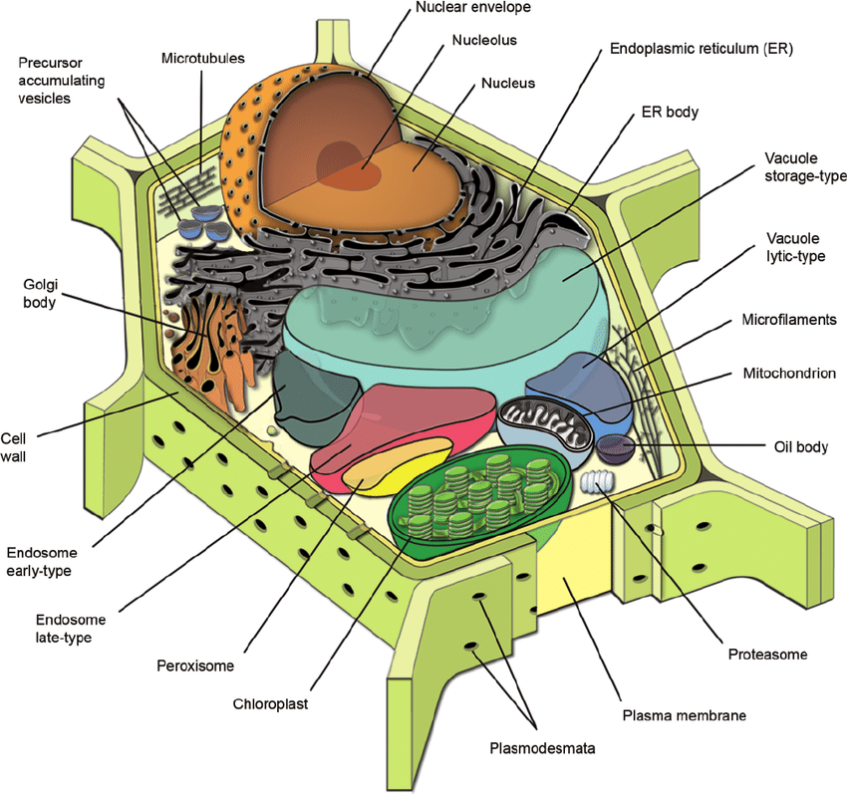
Fig.1.1 Plant cell structure (https://www.researchgate.net/publication/237155186_Illuminating_subcellular_structures_and_dynamics_in_plants_A_fluorescent_protein_toolbox/figures?lo=1)
Fruit, berries and vegetables are composed of both simple and complex cells.
Simple tissue includes:
  - Dermal tissue
  - Parenchyma tissue
Complex tissue:
  - Vascular tissue
  - Collenchyma tissue
  - Sclerenchyma supporting tissue

Water (~70-90%)

Carbohydrates:
Simple (sugar – glycose, fructose etc.)
Complex (fibres - starch, cellulose, hemicellulose, pectic substances) etc.

Protein (< 2%)

Fat (< 5%)

Mineral compounds

Vitamins

Bioactive compounds
Phenolic compounds
Pigments ( chlorophyll – green; carotenoids – yellow, red, orange; anthocyanin – red, blue, purple; anthoxanthin – white) etc.

Flavour compounds
Sulphur containing (allium, brassica)
Organic acids (citric acid, malic acid, tartaric acid, oxalic acid etc.)

Enzymes
Fig. 1.2. Overall chemical composition of fruit and vegetables

Soluble solids
The content of soluble solids characterises the chemical composition of fruit and berries, as it is made up of organic acids, sugars, pectin substances, tannins, etc. The soluble solids in fruit and berries are highest during their maturity. As the fruit overripe, the content of soluble solids gradually decreases and continues to decrease during fruit storage.
Cherries (16.3%) and blackcurrants (14.4%) have the highest content of soluble solids. The soluble solids content of apples varieties grown in Latvia ranges from 9.7-16.0%.

Titratable acid
The most common acids in fruit are malic acid and citric acid. Apples and pears mostly contain malic acid, while citrus fruits contain citric acid.
The most common acids in berries are citric and malic. For example, raspberries contain 97% citric acid and 3% malic acid, while strawberries contain 90% citric acid and 10% malic acid.
In addition to these common acids, fruits and berries also contain other acids in smaller amounts, such as succinic acid (in blackcurrants, sweet cherries), benzoic acid (in cranberries, lingonberries), salicylic acid (in raspberries), etc.
Some of the acids occur in free form and some - in the form associated with minerals (in the form of salts).
The total amount of acids is characterised by titratable acid or total acid. Average titratable acid content:
- in apples 0.85%
- in pears 0.18%
- currants 2.7%
- raspberries 1.0%
- strawberries 0.8%
- in apple juice 0.8%
- in lemon juice 4.8%
- in mandarin juice 0.5%
- in grape juice 0.4%
- in orange juice 1.2%
Titratable acids in ripe fruits and berries are lower than in unripe ones, and as the fruit overripe, the amount of acid gradually decreases, as it is used in the respiration process.

Tannins
Tannins are polyphenolic compounds widely distributed in the plant kingdom. Tannins give fruit and berries (aronia, rowan, etc.) an astringent, harsh, bitter taste, as well as protect them against various microorganisms. When tannins oxidise, dark-coloured compounds - phlobaphenes - are formed. This explains the dark colouring of the flesh of a cut or mechanically compressed fruit.

Ascorbic acid (vitamin C)
Vitamin C is the most important vitamin that we get almost exclusively from fruit and vegetables. However, it oxidises rapidly both in the presence of oxygen and also at high temperatures, so it is important to evaluate the best way of processing method with the least reduction of vitamin C. Potatoes are not very rich in vitamin C, but due to their high consumption, they can be an important source of daily vitamin C.

Total phenols
The term 'phenols' includes approximately 8,000 compounds of natural origin, all of which are characterised by a common structural element – the phenol ring (i.e. the aromatic ring containing at least one hydroxyl group substituent). The current classification, based on the number of phenolic subunits, divides phenols into polyphenols and simple phenols. Polyphenols that have at least two phenolic rings in their structure belong to the flavonoid subgroup, while compounds with three or more phenolic rings are called tannins. Phenolic compounds have strong antioxidant activity and are able to bind reactive oxygen, nitrogen. They can also bind to metal ions, up to thereby reducing pro-oxidant activity.

Anthocyanins
Anthocyanins (plant glycosides) are water-soluble pigments that colour many fruit, berries and vegetables from red to dark blue. For example, the pigment of this group is found in grapes, quercitin, in cherries - keracyanin, in strawberries - fragarin, in beets - betanin, etc. The colour of anthocyanins depends on various conditions, it is affected by increased temperature, environmental reaction, light, ions of several metals.
Anthocyanins are thermolabile compounds, so when fruit, berries and vegetables are heated, they decompose and change colour (for example, sterilised strawberries, cherries, etc.). Betanin found in beetroot is also sensitive to heat. The persistence of the colour depends on its concentration, for example, beetroot cooked with the skin is dark red, but chopped, cooked beetroot is yellow-pink, because the colour has diffused into the solution and broken down due to the low concentration.
The colour of anthocyanins changes depending on the reaction of the environment: they are red in an acidic environment, and blue or even green in an alkaline environment.
The colour of anthocyanins also changes under the influence of light during storage (when canned berries are stored, they seem to fade). The colour change during storage depends on temperature. At lower temperatures, it changes more slowly.
The colour of anthocyanins changes when they combine with ions of various metals (Zn, Al, Fe, Sn, etc.). For example, when cranberry anthocyanins come into contact with Al or Fe, a blue-violet colour is formed. Anthocyanins of cherries, strawberries, blueberries do not react with aluminium, but brown compounds are formed with iron.

Chlorophyll
Chlorophyll – the green pigment that colours the green leaves of plants, various fruits, berries and vegetables. Chlorophyll is found in the chloroplasts of plant cells in compounds with proteins, and it is not soluble in water.
In a living cell, chlorophyll is stable as long as it is bound to proteins. But when heated, living cells die, proteins denature and chlorophyll is easily oxidised when it comes into contact with cell juice acids. As a result, pheophytin (olive-green or brown-green in colour) is formed. This chlorophyll decomposition reaction occurs only in the presence of acid. In order to preserve the beautiful green colour of green peas, cucumbers, spinach, cabbage, etc. during thermal processes, it has been tried to add various substances that inhibit the decomposition of chlorophyll. Adding sodium hydrogen carbonate (soda) to vegetables creates a slightly alkaline environment, which reduces the breakdown of chlorophyll and ensures the preservation of the green colour. But the addition of sodium bicarbonate adversely affects the nutritional value of vegetables (reduces the amount of vitamins C and B1), so this technique is not used in practice.
Unscrupulous manufacturers have tried to add copper salts to canned vegetables. In this case, copper ions exchange places with magnesium ions in the chlorophyll molecules and form a stable green compound. However, the use of copper salts is prohibited, as copper ions not only contribute to the oxidation of ascorbic acid, but can also cause severe poisoning.

Total carotenoids
Carotenoids give fruits and vegetables their yellow and orange colour. They are effective antioxidants with important health-promoting functions, such as provitamin A activity, improving the immune system and reducing cardiovascular disease, as well as helping to prevent atherosclerosis and cancer. The carotenoid group includes: carotenes, which are hydrocarbons, and xanthophylls, which contain oxygen in the form of hydroxyl, methyl, carboxyl, keto, or epoxy groups.
The amount of carotenoids in fruit does not exceed 0.1% of dry matter and the most common are α-carotene, β-carotene, lycopene and xanthophyll, which is in an esterified form.

Laboratory work

Chemical composition of fruit, berries and vegetables

Materials
Various fruit and vegetable juices. Laboratory work is suitable for commercial sample and fresh sample comparison.

Methods
- Determination of soluble solids
Determination of soluble solids with a handheld refractometer
Open the closing cap of the prism and add 1-2 drops of the juice to be analysed on its dry and clean surface, then close the prism cap and check whether the surface of the prism is wet. Turn the refractometer towards the light (towards a window or artificial lighting) and look through the eyepiece. The field of vision shows a scale, as well as a dark and light area. The dividing line between the light and dark area indicates the dry matter content (%) of the solution as read on the scale.
After determining the dry content, the lid of the prism is opened, and the juice is dried with a paper towel. Readings are performed in triplicate. After that, a few drops of distilled water are added to the prism so that it moistens the surface of the prism, the cap is closed, opened and the water is dried. At the end of the work, the prism must be clean and dry.
Determination of soluble solids with a digital refractometer
Turn on the digital refractometer with its power button. First, the instrument is calibrated with distilled water: put 3-4 drops of distilled water on the prism and press and hold the "Cal" calibration button. When the result appears, press the "OK" button, wipe the prism with a paper towel, and the device is ready for work. Add 3 drops of the juice to be analysed to the clean dry prism and the "OK" button of the device is pressed. When the result appears, write it down, press the "OK" button of the device again until the inscription "READY" appears, wipe the prism with a paper towel and pour the juice again (3 repetitions in total). After the last repetition, the prism is additionally rinsed with distilled water and then wiped. At the end of the work, the prism must be clean and dry.
- Determination of titratable acid
For titration, measure 10 mL of juice in a 100 - 150 mL beaker with a pipette. Heat the juice in a flask to 90 ℃, add 3 - 5 drops of 0.1% phenolphthalein and titrate with 0.1n NaOH until a pink colour appears.

The amount of acid to be titrated is calculated:

x - amount of acid to be titrated,%
n - titrated 0.1n NaOH solution, mL
f - acid factor
Expressing the acid to be titrated :
with malic acid f = 0.067 g;
as citric acid f = 0.064;
as tartaric acid f = 0.075 g
10 - the amount of juice taken for analysis, mL
- Determination of pH
To determine the pH of the environment, the sample to be analysed is poured into a beaker, in which the electrode of the pH meter is dipped and the pH of the product is determined . The pH of the environment is determined according to the instructions for use of the pH meter.
- Determination of tannins
From the sample given for analysis, measure 50 mL of juice in a 100 mL measuring flask with a pipette and fill up to the mark with distilled water. Using a pipette, pour 10 mL of the prepared analysis into a 500 mL volumetric flask, add 20 mL of 0.6% indigo carmine solution, 10 mL of 24% H ₂ SO ₄ , 200 mL of water and titrate with 0.1n KMnO ₄ from a burette, stirring constantly. The titration is stopped when the colour of the solution changes from blue, dark green, light green or blue-yellow to yellow.
To calculate the oxidisable substances of the juice for tanning agents and dyes, pour 10 mL of the analysis into a porcelain bowl, add 1 g of animal charcoal, mix well and heat in a water bath, stirring the solution constantly. After that, the liquid is filtered in a 500 mL flask, and the carbon and the filter are thoroughly rinsed several times with distilled water. The filtrate should be colourless. After that, add 20 mL of 0.6% indigo carmine, 10 mL of 24% H ₂ SO ₄, 200 mL of water to the flask and, while stirring constantly, titrate with 0.1n KMnO ₄ until a yellow colour is obtained.
The amount of tannins and pigments (%) is calculated (expressed as tannin):
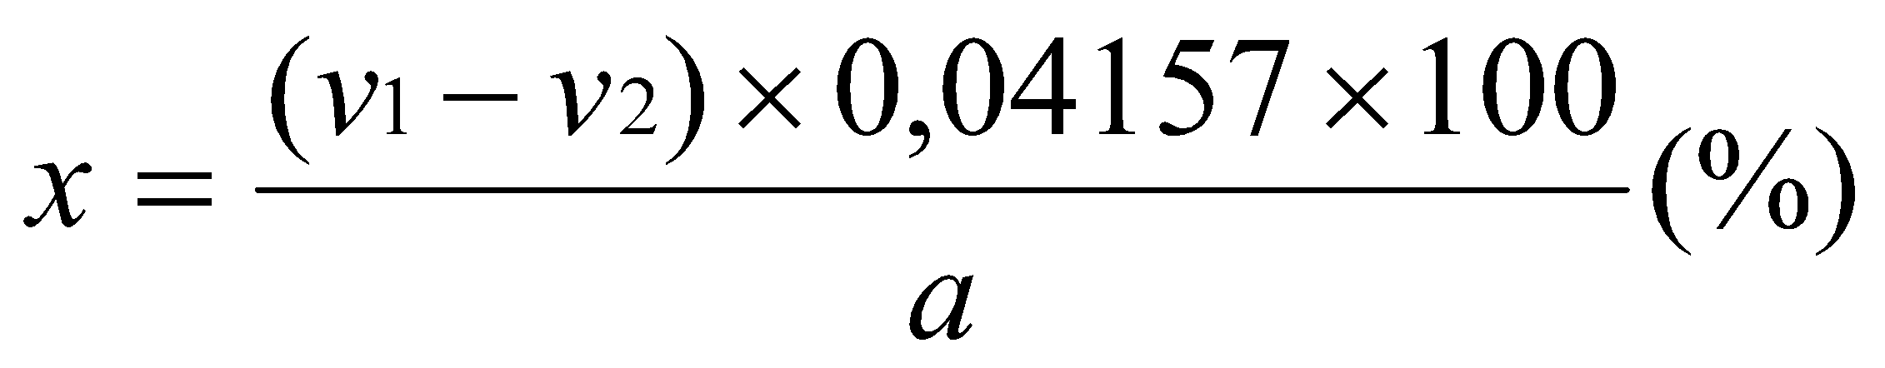
V ₁ - amount of 0.1n KMnO ₄ in mL, required for titration of all oxidisable substances in the juice, mL;
V ₂ - the amount of 0.1n KMnO ₄ in mL, which is required for the titration of the other oxidisable substances of the juice (which are not tannins and pigments);
a - 10 mL of 0.1n KMnO ₄ used for oxidation of 0.1n oxalic acid quantity, mL;
0.04157 - the amount of tannin g that oxidises 1 mL of 0.1n KMnO ₄
The titer of potassium permanganate is determined with a 0.1n oxalic acid solution. Fill 10 mL of 0.1n oxalic acid solution with a pipette into a 100 ml beaker, add 2 mL of sulfuric acid solution (1:4), heat to 70 °C and titrate with KMnO ₄ to a faint pink colour.
- Determination of ascorbic acid
Vitamin C is rapidly oxidised both in the presence of oxygen and also at high temperatures, so it is important to evaluate the best way of processing and extracting juices, with the least reduction of vitamin C.
Determine the content of L-ascorbic acid (reduced form) in the given samples by the iodine method.
Methodology:
- prepare a standard solution of ascorbic acid: 20 mg of ascorbic acid per 100 mL of 6% oxalic acid solution;
- Add 2 mL of 1% starch solution to 25 mL of ascorbic acid standard solution and titrate with 0.05 M iodine solution while stirring. Observe the colour change. Write down the amount of iodine used;
- Weigh 25 g of berry juice into a 250 mL beaker;
- 100 mL of 6% H ₂ C ₂ O ₄ solution is poured over the prepared weight and for 60 s, mix very well;
- Filter through a cotton filter;
- Add 2 mL of 1% starch solution to 10 mL of filtrate and titrate with 0.05M iodine solution while stirring. Observe the colour change which does not disappear within 30 seconds and write down the amount.
Calculation of ascorbic acid:
$$C vit. \left(\frac{mg}{100g}\right)=5000* \frac{ V_{J sample}}{{m* V}_{J standard}}$$
5000 - coefficient
V _{J sample} - the amount of iodine solution used for the titration of 10 mL of the sample
V _{J stndard} - the amount of iodine solution used for the titration of 25 mL standard solution
m – sample mass.
- Determination of total phenols
Measure approximately 2 ± 0.001 g of the juice sample to be analysed in a 100 mL beaker, add 20 mL of ethyl alcohol-water mixture (80:20), place the beaker on a magnetic stirrer, put a magnet in it and leave it to stir for 2 hours. When mixing is complete, filter the sample into another conical flask with a funnel through a paper filter until the sample is completely filtered. 0.5 mL of the extract to be analysed is measured with a pipette in three separate dishes, 2.5 mL of "Folin-Ciocalteus" phenolic reagent diluted tenfold with distilled water is added to the extract, after 5 min add 2 mL of 7.5% Na ₂ CO ₃, mix and leave for 30 minutes. The result is read on a spectrophotometer at a wavelength of 765 nm.
The gallic acid equivalent used to quantify total polyphenol content. A gallic acid calibration curve is created and, using the absorbances read, the total polyphenol content in the analysed samples is expressed as milligrams of gallic acid equivalent per 100 grams of sample mass (GAE mg 100 g ⁻¹ ).
The total amount of phenols is calculated according to the formula:
$$X=\frac{L}{C}*A$$
Where: X – amount of total phenols (mg 100g ⁻¹ );
C – coefficient of the calibration curve (for example 0.1029);
L – absorption coefficient read from the spectrophotometer;
A – sample dilution.

Results
Make calculations for the detected parameters and summarise the obtained results in table 1
Table 1
Results of the obtained data
Sample (name)
Parameters | The result | The result
Soluble solids content
Titratable acids
pH
Content of tannins
Ascorbic acid content
Total phenolic content

Conclusion
- Write conclusions on assessment of at least two of the analysed samples.
- Give answers to the following questions:
- What is the soluble solids content?
- What is characterised by the content of titratable acids in products and what is characterised by pH of products? Are the obtained readings comparable? Explain your answer.
- What is ascorbic acid and what impacts its changes in products?
- What are phenols and what is the total phenolic content of products?
- What method is used to determine the total phenol content in a product and what is the method based on?

Approved by ______________________________________
Name, surname, signature

Date ______________________________________

Laboratory work

Natural pigments and their detection, quality changes in fruit, berries and vegetables

Materials
Various fruit and vegetables that could be considered as representative source of the analysed parameter. Substitutions of juice material can be provided depending on availability of materials. Laboratory work is suitable for commercial sample and fresh sample comparison.

Methods
- Beetroot anthocyanins and their colour changes
Pour diluted (1:4) beetroot juice in the following amounts into five test tubes: 1, 2, 3, 4 and 5 mL. Then add enough water to each of the five test tubes to make a total volume of 10 mL in each test tube.
All test tubes are placed in a boiling water bath and left there for 15 minutes. The tubes are then removed and cooled. Describe and explain the changes that have occurred. The obtained results are summarised in table 1.2.
- Fruit and berry anthocyanins
- Properties of anthocyanins depending on environmental pH.
Pour 5 mL of the given juice into a 300 mL measuring cup and add 100 ml of distilled water. Measure the initial pH and characterise the colour. Carefully add 0.1n NaOH solution drop by drop to the contents of the beaker until the natural colour changes. Periodically measure the pH of the medium. Describe the gradual colour change in the measuring cup depending on the pH of the environment. Compare the results obtained and explain the colour change. The obtained results are summarised in table 1.3.
- Determination of total anthocyanin content in berries
20 g of berries are weighed on the electronic scale. Add 40 mL of previously prepared ethyl alcohol + 1.5M HCl solution to the weight. Chop with a mixer for 1 min. Filter through a cotton filter, rinsing the precipitate 3x with 3x10 mL of ethyl alcohol and HCl solution (total 30 mL). The obtained extract is further analysed spectrophotometrically at a wavelength of 535 nm. The sample is diluted with an alcohol-hydrochloric acid solution until its absorption coefficient falls within the range of 0.6 ÷ 0.8. The anthocyanin content in the sample is calculated according to the formula:
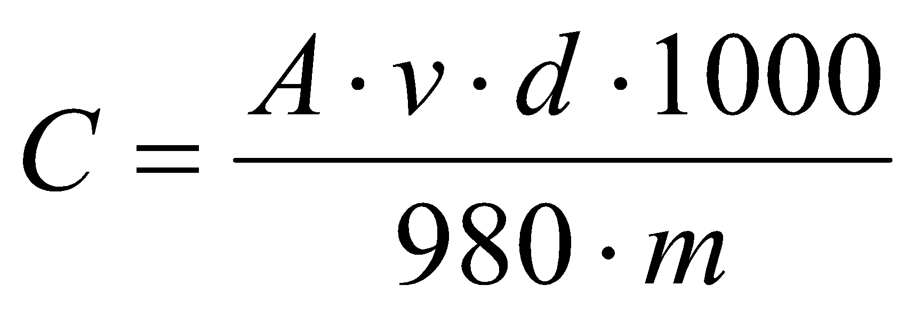;

Which A– absorption coefficient;
v – total volume of the extract;
d – dilution;
m – sample mass g.
- Changes in chlorophyll under the influence of environment changes
Boil the given vegetable samples:
- in distilled water;
- 0.1N NaOH;
- in 0.1N oxalic acid solution;
- in 1% copper sulphate solution.
Explain the colour change of the cooked vegetable samples. The obtained results are summarised in Table 1.4.
- Total carotenoids in fruits and vegetables.
The analysed sample is well crushed (homogenised). Weigh 1-2 g (accurate to 3 decimal places) and place in a 100 mL beaker. 20 mL of 96% ethyl alcohol is added to the weight and a magnet is placed, the sample is then stirred for 15 minutes, then 25 mL of petroleum ether is added and it is stirred on a magnetic stirrer for 1 hour. Allow the sample to stand until complete separation of the two layers has occurred, then carefully pour the top - yellow petroleum ether layer into the glass cuvette. The absorption is measured at a wavelength of 440 nm. If the absorption is very high (high carotenoid content), then reduce the weight to 0.3-0.5 g and repeat the procedure. Using the calibration graph taken with potassium dichromate, the carotene equivalent (KE), i.e. the amount of potassium dichromate corresponding to the measured absorbance, is found. Carotenoid content (mg 100g ⁻¹) is calculated according to the formula:
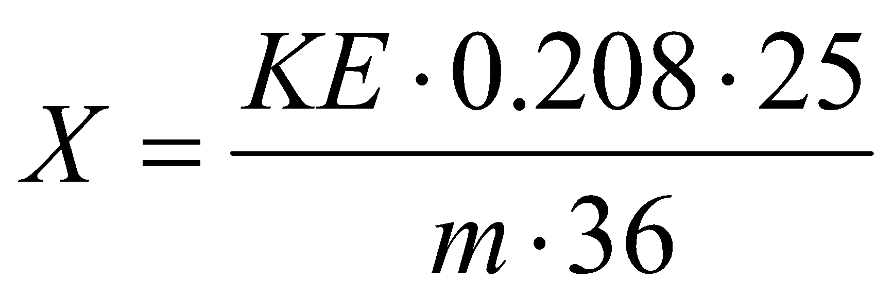
Where: 0.208 and 36 – the coefficients presented in the literature, which describe the relationship between the amount of K ₂ Cr ₂ O ₇;
KE – carotene equivalent found according to the graduation schedule;
KE= (Abs.)/0.0194;
Abs. – absorbance read from the spectrophotometer for the given sample;
M - weight of the researched material, g.

Results
Table 1.2
Changes in beetroot juice of different concentrations after heating
 | Beet juice concentrations
 | 1 mL | 2 mL | 3 mL | 4 mL | 5 mL
Colour at the beginning
Colour after 15 min. of heating

Table 1.3
Effect of addition of different concentrations of NaOH on juice colour
 | Concentrations of added NaOH
 | 0 mL | mL | mL | mL | mL | mL
Sample colour
The pH of the sample

Table 1.4
Environmental effects on vegetable colour
Sample | In distilled water | 0.1N NaOH | in 0.1N oxalic acid solution | in 1% copper sulphate solution
Colour at the beginning
Colour after 15 min of cooking

Conclusion
Provide answers to the following questions:
- Table beet anthocyanins and their colour changes.
- Fruit and berry anthocyanins.
- Explain changes in chlorophyll under the influence of environmental changes.
- Carotenoids in fruit and vegetables.

Approved by ______________________________________
Name, surname, signature
Date ______________________________________

Laboratory work

Chemical composition and quality parameters of potato tubers

Materials
Fresh and raw potatoes of different varieties and quality, depending on the number of student groups and availability.

Methods
- Determining the amount of dirt
Only whole, uncompressed, dry, healthy, un-sprouted potatoes without straw, husks and other impurities are accepted for processing. The amount of soil adhering to tubers is allowed at 1.5% in alcohol and starch factories, and 1% for table potatoes.
Progress of work
Weigh 1 kg of potatoes, then wash them thoroughly and put them on a sieve to drain excess water for 2-3 minutes. Weigh the washed potatoes. Deduct 1% (adherent water) from the amount of washed potatoes. The amount of dirt (%) is calculated:

X - amount of dirt %
a - quantity of dirty potatoes, kg
b - quantity of washed potatoes, kg
1% - amount of stuck water, kg
- Blackening of potatoes
In certain cases, the natural colour changes of vegetables and fruit are undesirable. When exposed to air, cleaned, cut potatoes turn dark - black. The tyrosine in potatoes oxidises, resulting in a black pigment - melanin. The enzyme polyphenol oxidase takes part in the oxidation reaction. Different varieties of potatoes blacken at different rates. The rate of blackening is related to the activity of polyphenol oxidase, as it is higher, the faster the blackening of peeled and cut potatoes. Blackening can be prevented by completely destroying or inactivating the enzyme.
Progress of work
Clean the potato and cut it into 3 slices of the same size and thickness (3-5 mm thick). One of them is scalded in boiling water (duration of scalding – 3-5 minutes), the other is held for 3 min in 1% HCl solution and rinsed in water, but the 3rd slice is left untreated for control. All three slices are placed on a plate and left exposed to air. ATTENTION! First you need to boil the water, prepare the necessary dishes for work and only then clean the potato. Otherwise, the blackening reaction will start prematurely in the cleaned potato and the final results will not be reliable.
Every 0.5 hour a colour change in the potato slices is observed. The results are summarised in a table 1.5 and explain what and why happened to the colour of the observed potato samples.
- Determination of sensory quality indicators
Sensory indicators of potato quality are the size of their tubers and the amount of damaged tubers, shape, colour, taste, and smell.
Progress of work
To determine the size of potato tubers, weigh 1 kg of potatoes, measure the largest cross-sectional diameter of all tubers (with an accuracy of + 1 mm) and divide into the following fractions:
- potato tubers, the dimensions of which correspond to the specified dimensions (see table 1.6),
- potato tubers that meet the permissible dimensions (see table 1.6),
- potato tubers that do not meet the specified and permissible dimensions.
The potato tubers of each fraction are weighed and their percentage in the analysed sample is determined (with an accuracy of 0.1%).
After that, the potato tubers, which in terms of size meet the specified and permissible standard requirements, are inspected and divided as follows:
- tubers without any damage or signs of disease,
- tubers with damage and signs of disease.
The fraction with damaged potatoes is weighed and its percentage in the analysed sample is determined. Compare the results with the data in table 1.7.
Sensory evaluation of cooked potatoes of different varieties.
First, boil 2 peeled potatoes of each variety. For boiled potatoes of different varieties, evaluate the given sensory properties in a 5-point system and write your findings in table 1.8
- Determination of starch grain form
Different crops have different shapes and sizes of starch grains. By knowing the shape of the starch grains of different plants, it is possible to determine the fake flour, for example, wheat flour mixed with pea flour.
Progress of work
Examine and draw the given starch samples under a microscope, and also, using photographs of starch grains of different plants, determine which plants the given samples correspond to.
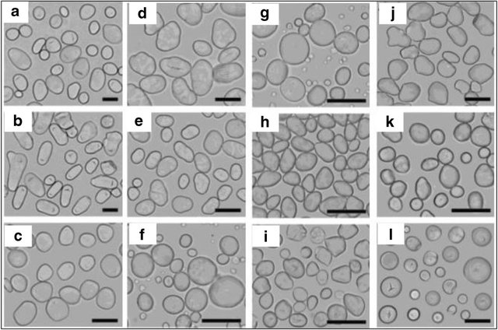
Fig.1.3 Morphology of starch granules under normal light microscope: A) Potato. B) Lotus rhizome. C) Yam. D) Pea. E) Bean. F) Barley. G) Wheat. H) Lotus seeds. I) Water chestnut. J) Water caltrop. K) Ginkgo. L) Sweet potato. DOI: 10.1007/s12551-020-00614-7
To prepare microscope slides, weigh 0.1 - 0.5 g of starch, mix with a small amount of water. A drop of the prepared suspension is placed on a glass slide with a glass rod, covered with a coverslip. The preparation is examined in two magnifications (8x7 and 40x7).
- Content of vitamin C.
From the given sample of potatoes, choose two medium potatoes, wash and peel one and leave the other with the skin on. Determine the amount of vitamin C in fresh peeled and fresh unpeeled potatoes.
Determine the content of L-ascorbic acid (reduced form) in the given samples by the iodine method.
Progress of work
- Prepare a standard solution of ascorbic acid: 20 mg of ascorbic acid per 100 mL of 6% oxalic acid solution.
- Add 2 mL of 1% starch solution to 25 mL of ascorbic acid standard solution and titrate with 0.05 M iodine solution while stirring. Observe the colour change. Write down the amount of iodine used.
- Weigh 25 g of chopped potato sample into a 500 mL beaker.
- 100 mL of 6% H ₂ C ₂ O ₄ solution is poured over the prepared weight and for 60 s. Grind with a mixer.
- Filter through a cotton filter.
- Add 2 mL of 1% starch solution to 10 mL of filtrate and titrate with 0.05M iodine solution while stirring. Observe the colour change that does not disappear within 30 seconds and write down the amount.
$$C vit. \left(\frac{mg}{100g}\right)=5000* \frac{ V_{J sample}}{{m* V}_{J standard}}$$
5000 - coefficient
V _{Jin the sample} - the amount of iodine solution used for the titration of 10 mL of the sample
V _{Jst. no.} - the amount of iodine solution used for the titration of 25 mL standard solution
m – sample mass

Results
Table 1.5
Blackening of potatoes
Samples | Colour change
Samples | after 0.5h | After 1h | after 1.5 hours | After 2h
Raw control
Treated with 1% HCl
Treated with boiling water

Table 1.6
Characteristics of potato tubers
Indicator name | Characteristics and norm | In the given sample
1. External appearance | Tubers are healthy, dry, clean, not green, not overgrown, without growths, cracks, not twisted, similar in shape and skin colour.  For late potatoes – large with a dense skin.
2. Form | Rounded– oval, elongated.
3. The colour of a peeled potato | From white to yellow
Indicator name | Characteristics and norm
4. Smell | Characteristic of potatoes, without side smells.
5. The smallest potato tuber diameter, mm, not less than:  - for late potatoes  - for early potatoes | 50.0 mm  30.0 mm
6. The number of potato tubers, the size of which is 5 mm smaller than shown in point 5, mass %, no more than | 10.0%

Table 1.7
Characteristics of potato tubers
Indicator name | Characteristics and norm | In the given sample
1. The number of potatoes damaged by diseases, % of mass, no more | 5.0
2. The number of mechanically damaged potatoes during harvesting, % of mass, no more | 2.0
3. Amount of soil stuck to potatoes, % of mass, no more than | 1.0

Table 1.8
Sensory characteristics of potato tubers
Sensory characteristics | Potato variety
Appearance
Colour
Aroma
Taste
Consistency
Flouriness

Conclusion
Write an overview and your own conclusions on the analysed potato tuber samples. Describe your preferences and overall sample compliance with the quality requirements.

Approved by ______________________________________
Name, surname, signature
Date ______________________________________

Theme 2

Fruit and vegetable preservation

Theoretical materials
Proper storage conditions for fruit and vegetables are essential to maintain their freshness, nutritional value, and overall quality.

General storage principles
Temperature - different produce items have optimal temperature ranges. Some require refrigeration, while others are best kept at room temperature.
Humidity - high humidity levels can prevent dehydration of fruits and vegetables, but too much moisture can promote mould and decay.
Ventilation - good airflow can help prevent the build-up of ethylene gas, which accelerates ripening and spoilage.
Ethylene sensitivity - some fruits produce ethylene gas, which can hasten ripening in other produce items. It’s important to store ethylene-producing and ethylene-sensitive items separately.
Cleanliness - ensure storage areas and containers are clean to prevent mould and bacteria growth.
Container choice - use breathable bags or containers for items that need high humidity, and sealed containers for items that should stay dry.
Regular checks - regularly inspect stored produce for signs of spoilage or decay and remove affected items promptly to prevent spread.
Table 2.1
Overview of fruit and vegetable storage conditions
Storage Method | Temperature | Humidity | Suitable Produce | Notes | Storage Method
Refrigeration | 0 °C to 4 °C | High | Leafy greens (lettuce, spinach, kale), root vegetables (carrots, radishes, beets), cruciferous vegetables (broccoli, cauliflower, Brussels sprouts), berries (strawberries, blueberries, raspberries), apples, pears, bell peppers, cucumbers. | Separate ethylene-producing items (apples, pears) from other produce; use crisper drawers and perforated bags. | Refrigeration
Room temperature | 16 °C to 21 °C | Moderate | Tomatoes, bananas, citrus fruits (oranges, lemons, limes, grapefruits), stone fruits (peaches, plums, nectarines), melons (watermelons, cantaloupes, honeydews). | Let stone fruits and tomatoes ripen before refrigeration; bananas should not be refrigerated due to skin darkening. | Room temperature
Cool, dry and dark place | 10 °C to 16 °C | Low | Onions, garlic, potatoes, winter squash (butternut, acorn, spaghetti squash). | Avoid storing onions near potatoes; ensure good ventilation to prevent sprouting and moisture build-up. | Cool, dry and dark place
High-Humidity Storage | Cool | High | Root vegetables (for extended storage, such as carrots and parsnips), tubers (sweet potatoes). | Use damp sand or sawdust for long-term storage of root vegetables; cure sweet potatoes before long-term storage. | High-humidity storage
Ethylene producers and sensitive produce | Varies | Varies | Ethylene producers: apples, bananas, pears, tomatoes, avocados, melons. Ethylene sensitive: leafy greens, carrots, broccoli, cucumbers, berries. | Store ethylene producers separately from sensitive items to prevent premature ripening and spoilage. | Ethylene producers and sensitive produce

Preserving fruit and vegetables is essential for extending their shelf life, maintaining nutritional value, and reducing food waste. Various preservation methods can be employed, each with its own set of principles and techniques.

Refrigeration
- Slows down the enzymatic and microbial activities that cause spoilage.
- Suitable for short-term preservation. Most fruits and vegetables can be stored in the refrigerator to keep them fresh for a few days to a couple of weeks.

Freezing
- Stops microbial growth and slows down enzyme activity by lowering the temperature below freezing point.
- Suitable for long-term preservation. Vegetables are often blanched before freezing to preserve colour, flavour, and nutritional value. Fruit can be frozen whole, sliced, or pureed.

Canning
- Involves placing fruits and vegetables in jars or cans and heating them to a temperature that destroys microorganisms and inactivates enzymes.
- Provides long-term shelf stability. There are two main methods: water bath canning for high-acid foods (like fruit and pickles) and pressure canning for low-acid foods (like vegetables).

Drying
- Removes moisture from fruit and vegetables, inhibiting the growth of microorganisms and enzymes.
- Can be done using sun drying, air drying, or using a food dehydrator. Dried fruits and vegetables are lightweight and can be stored for extended periods.

Fermentation
- Uses beneficial bacteria or yeasts to convert sugars in fruit and vegetables into acids or alcohol, which act as preservatives.
- Commonly used for vegetables like cabbage (sauerkraut) and cucumbers (pickles), as well as for fruit in the production of chutneys and relishes. Fermented foods often have a distinct tangy flavour.

Pickling
- Preserves fruits and vegetables in an acidic solution (usually vinegar) with added salt, sugar, and spices.
- Suitable for a wide variety of vegetables (e.g. cucumbers, carrots, onions) and some fruit (e.g. mangoes, peaches). Pickled products are stored in airtight containers.

Jam and jelly making
- Involves cooking fruit with sugar and pectin to create a gel-like consistency.
- Extends the shelf life of fruit by reducing water activity and creating a high-sugar environment that inhibits microbial growth. Jams and jellies are stored in sterilised jars.

Vacuum sealing
- Removes air from the packaging to reduce oxidation and microbial growth.
- Used in combination with refrigeration or freezing to extend the shelf life of fruit and vegetables. Vacuum-sealed produce retains freshness and nutritional value longer.

Pasteurisation
- Involves heating fruits and vegetables to a specific temperature to kill harmful microorganisms without significantly affecting the nutritional value or taste.
- Common in the preservation of fruit juices and some vegetable products. Pasteurised items are then sealed in sterile containers.

Chemical preservation
- Uses chemicals like sodium benzoate, sulphur dioxide, or ascorbic acid to inhibit microbial growth and oxidation.
- Commonly used in commercial preservation. Examples include sulphite -treated dried fruits and chemically preserved juices.

Considerations:
- Nutritional impact - Some methods (like freezing and drying) retain more nutrients than others (like canning, which can result in some nutrient loss).
- Flavour and texture - The preservation method can affect the flavour and texture of the fruits and vegetables. For instance, freezing can maintain texture better than drying.
- Safety - Proper techniques and hygiene are crucial to prevent foodborne illnesses, especially with methods like canning and fermentation.
- Storage conditions - Different methods require different storage conditions. For example, canned goods should be kept in a cool, dark place, while frozen items need to remain at sub-zero temperatures.

Knowledge questions
After familiarising yourself with the lecture materials, provide answers to the following questions.
- What are the main goals of preserving fruit and vegetables?
- Why is it important to choose the right preservation method for different types of fruit and vegetables?
- How does refrigeration help in preserving fruit and vegetables?
- What are some common fruit and vegetables that should be refrigerated to extend their shelf life?
- What is the ideal temperature range for storing most fruit and vegetables in a refrigerator?
- What are the key elements for successful fresh fruit and vegetable storage?

Approved by ______________________________________
Name, surname, signature
Date ______________________________________

Theme 3

Fresh, minimally processed fruit and vegetables

Theoretical materials
Along with the chemical composition of fruit and vegetables, their quality indicators are of great importance. The most important of these are external appearance, size, colour, texture, degree of ripeness, taste, smell, as well as mechanical damage caused by diseases and pests.
External appearance is an important quality criterion by which the consumer evaluates fresh fruits and vegetables. The appearance is determined by various physical factors: size, shape, integrity, defects (spots, bruises, pest damage etc.), gloss and consistency. Size and shape can be affected by variety, level of ripeness, growing conditions and environment.
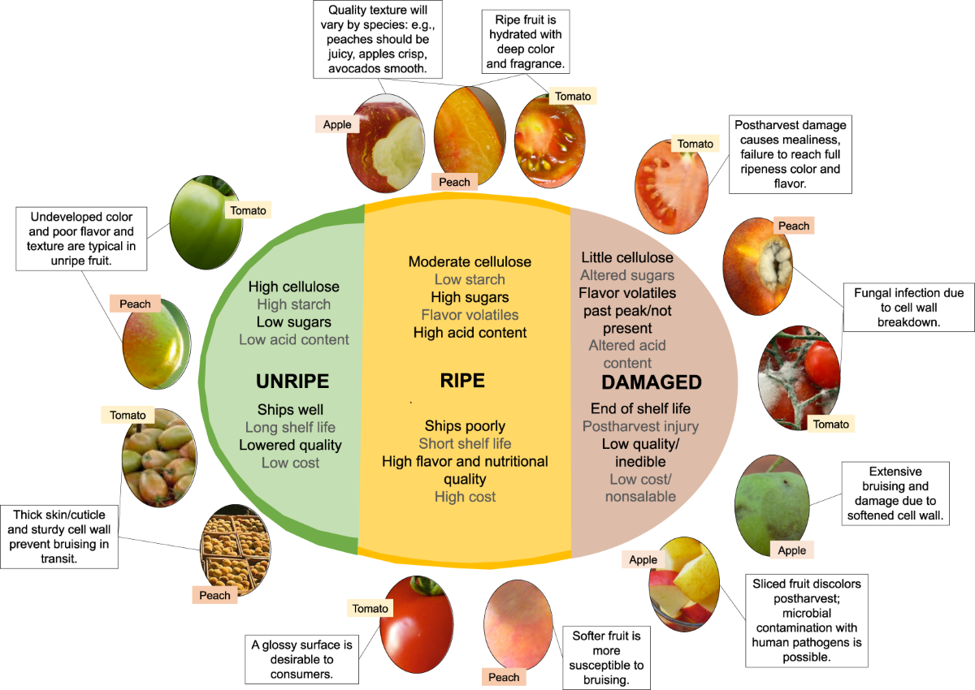
Fig. 3.1. Fruit and vegetable quality and Physico-biological characteristics. https://www.nature.com/articles/s41438-020-00428-4/figures/3
The colour of fruit and vegetables is determined by the natural pigments that are released during their ripening and other external ones continues to change under the influence of factors such as light, temperature, and air oxygen.
When peeling, cutting and chopping fruit and vegetables, brown, grey and black pigments can be observed forming, as a result the colour of fruit and vegetables changes significantly.
The texture of fruit and vegetables is a property that can be felt by touch or mechanical action. The structure of fruit and vegetables is determined by the degree of ripeness, the specifics of the cell structure and other factors. The composition and content of substances (mostly water) in the skins and pulp of fruit and vegetables affect the formation of structures. The structure of fruit and vegetables can be determined by touch when the product is picked up in the hand or by eating it. Unlike taste, this property is easy to measure using a penetrometer, structures analyser or similar devices.
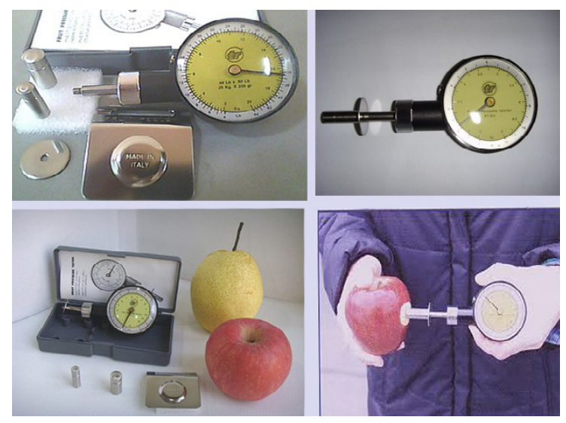
Fig. 3.2 Penetrometer measuring the density of fruit https://www.pamalyne.com/articlegroup.asp?gid=1462
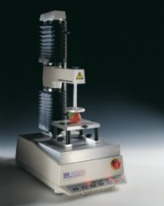
Fig. 3.3 Structure analyser https://www.stablemicrosystems.com/TAXTplus.html
Fresh and minimally processed fruits and vegetables are key components of a healthy diet. They retain most of their natural nutrients, flavours, and textures, providing essential vitamins, minerals, fibre, and antioxidants. Here's a breakdown of each category:

Fresh fruit and vegetables
- Fresh fruit: These are picked and sold with minimal delay. Examples include apples, bananas, oranges, berries, grapes, and melons. They should be stored properly to maintain freshness.
- Fresh vegetables: These are harvested and sold in their natural state. Examples include leafy greens (spinach, kale), root vegetables (carrots, beets), and cruciferous vegetables (broccoli, cauliflower).

Minimally processed fruits and vegetables
Minimally processed foods have undergone slight alterations to make them more convenient without significantly changing their nutritional content. This processing can include cleaning, cutting, peeling, or packaging.
- Pre-cut and pre-washed: These fruit and vegetables are cleaned and cut for convenience, such as bagged salad greens, carrot sticks, and fruit salads.
- Frozen: Freezing preserves most nutrients and can be a convenient alternative to fresh produce. Examples include frozen berries, peas, and spinach.

Benefits of fresh and minimally processed produce
- Nutritional value: These foods are rich in essential nutrients, including vitamins C and A, folate, potassium, and fibre.
- Antioxidants: They contain antioxidants that help protect the body from oxidative stress and may reduce the risk of chronic diseases.
- Low in additives: Fresh and minimally processed produce typically contain fewer preservatives, sodium, and sugar compared to more heavily processed options.
- Flavour and texture: They offer better flavour and texture, enhancing the overall eating experience.

Tips for selecting and storing
- Selection: Choose fruit and vegetables that are firm, vibrant in colour, and free from blemishes or signs of spoilage.
- Storage: Store produce properly to extend shelf life. Refrigerate most fruit and vegetables, except those that ripen on the counter (e.g. tomatoes, avocados, bananas).
Importance of packaging
Packaging in a modified environment (vacuum, inert gas environment) is the most suitable technology that can be offered to processors who want to prepare fresh vegetables for commercial needs and meet the modern demands of the public.
It is known that by changing the composition of the environment around the product in the package, it is possible to inhibit or delay the natural deterioration processes and extend the storage time. Therefore, in order to evaluate the importance of storage technologies on product quality, samples must be prepared initially.
If you choose a packaging material with selective properties, it is possible to significantly extend product shelf life.
For fruit, berries and vegetables, the optimal environment is the EMAP environment, where the gas composition inside the package is as follows: O₂ = 2-10% and CO₂ = 5-15%.

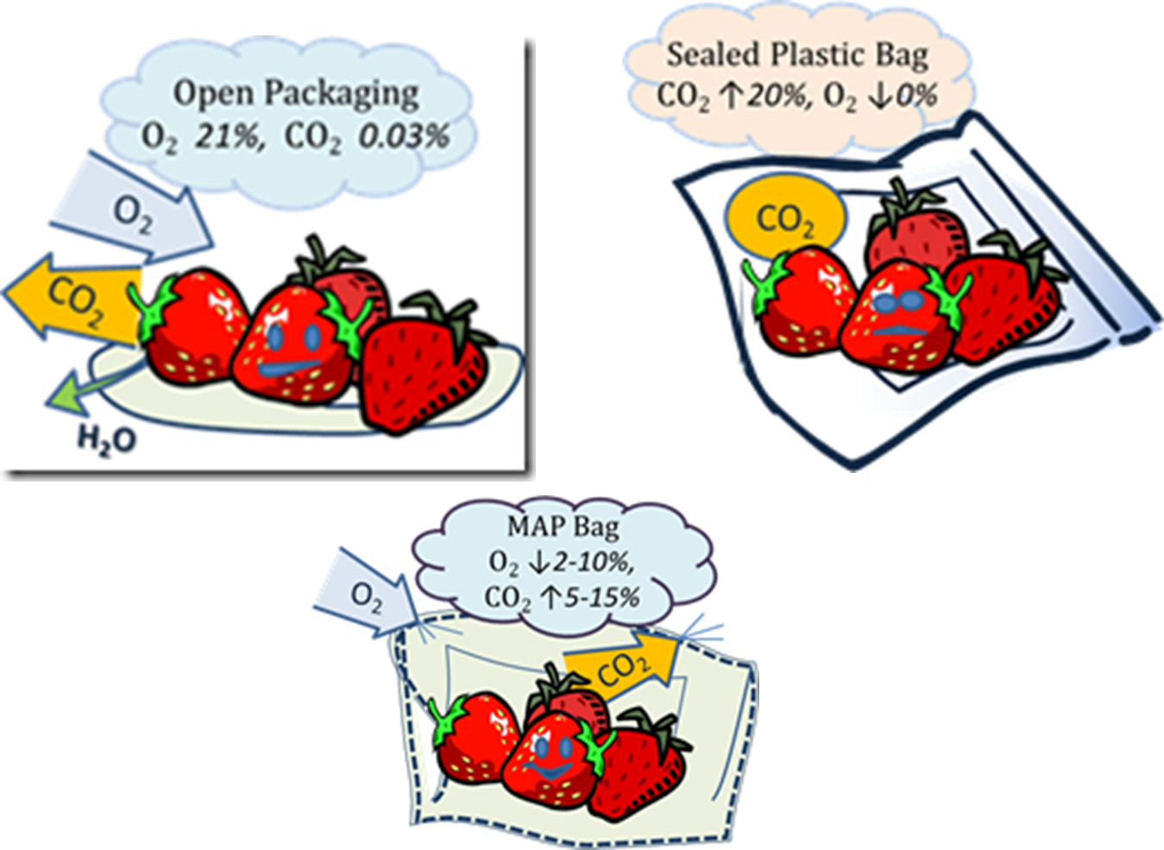
Fig. 3.4 Illustration on the effect of barrier properties of the packaging materials on the product during storage.
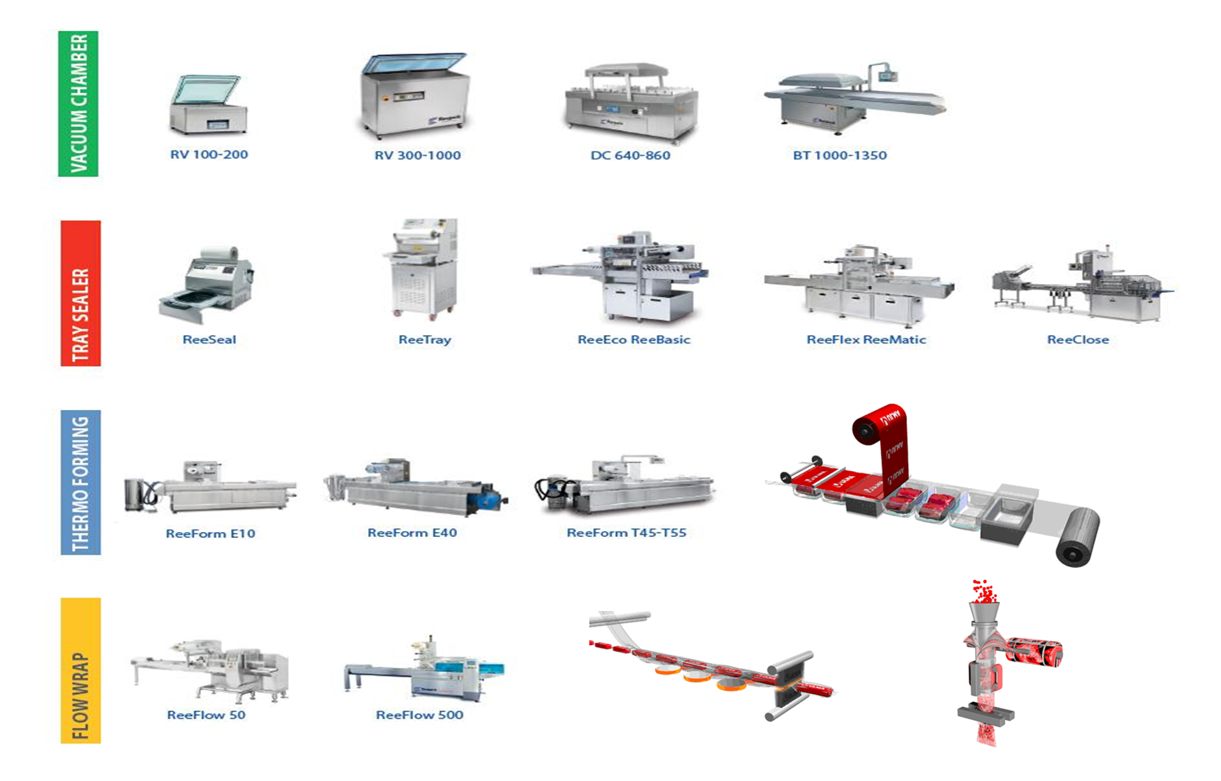
Fig. 3.5 Summary of possible packaging equipment https://gpnuy.com/project/tffs-spapor-bassa/
The choice of packaging equipment depends on the volume of product packaging required by the company.
Microbiological aspects of fresh, cut and minimally processed fruit and vegetables
The microbiological aspects of fresh, cut, and minimally processed fruit and vegetables are critical to ensuring food safety and quality. These products are susceptible to microbial contamination at various stages of production, handling, and storage. Below are key points addressing the microbiological concerns:
Fresh produce:
- Sources of contamination:
  - Soil and water: Pathogens such as Escherichia coli, Salmonella, and Listeria monocytogenes can be present in soil and irrigation water.
  - Animals and insects: Wildlife, livestock, and insects can introduce pathogens to crops.
  - Human handling: Contamination can occur through improper handling by farm workers.
- Types of microorganisms:
  - Pathogenic bacteria: E. coli, Salmonella, Listeria monocytogenes, Shigella, and Campylobacter.
  - Spoilage organisms: Pseudomonads, lactic acid bacteria, and moulds that cause visible spoilage.
Cut and minimally processed produce:
- Increased risk of contamination:
  - Cutting and peeling can release nutrients and water, creating an ideal environment for microbial growth.
  - Damaged tissues are more susceptible to contamination and spoilage.
- Handling and processing:
  - Sanitation: Equipment and surfaces used in cutting and processing must be properly sanitised to prevent cross-contamination.
  - Temperature control: Maintaining appropriate refrigeration temperatures (typically below 5°C) is crucial to slowing microbial growth.
- Modified atmosphere packaging (MAP):
  - MAP involves altering the atmosphere inside the packaging to reduce oxygen levels and increase carbon dioxide, inhibiting the growth of aerobic spoilage organisms and pathogens.
  - However, MAP can sometimes promote the growth of anaerobic pathogens if not managed properly.

Control measures and safety practices
- Good agricultural practices (GAP):
  - Ensuring the use of clean water for irrigation and washing.
  - Implementing measures to keep animals away from growing areas.
  - Training farm workers in hygiene and sanitation practices.
- Good manufacturing practices (GMP):
  - Properly cleaning and sanitising equipment and facilities.
  - Implementing Hazard Analysis and Critical Control Points (HACCP) systems to identify and manage potential contamination risks.
- Consumer practices:
  - Washing fresh produce thoroughly under running water.
  - Storing cut fruits and vegetables at appropriate refrigeration temperatures.
  - Avoiding cross-contamination by using separate cutting boards and utensils for raw produce and other foods like raw meat.
Common microbial concerns in specific produce
- Leafy greens: High risk due to their large surface area and frequent consumption without cooking.
- Melons: The rough rind can harbour pathogens, which can be transferred to the flesh when cut.
- Berries: Susceptible to contamination due to their delicate nature and frequent consumption without washing.

Emerging concerns
- Antimicrobial resistance: The use of antibiotics in agriculture can lead to the development of resistant strains of bacteria.
- Novel pathogens: New pathogens can emerge, posing unexpected risks to food safety.
Maintaining the microbiological safety of fresh, cut, and minimally processed fruit and vegetables requires a comprehensive approach encompassing good agricultural and manufacturing practices, effective sanitation, temperature control, and consumer education. Continuous monitoring and adaptation to emerging threats are also essential to ensure the safety and quality of these perishable products.

Laboratory work

Preparation of fresh, cut and packaged vegetables

Materials
Various vegetables. Different packaging materials:
- Material with high gas barrier properties;
- A second material with low gas barrier properties, and
- A third packaging material with selective barrier properties.
Depending on the application, the finished pillow-shaped packages or products are placed in ready-made trays and sealed in different packaging machines.

Methods
Sample 1 – Potatoes
To observe changes in potato quality during storage, prepare the following variations:
Fresh, unpeeled potato 1-2 pieces.
Fresh, peeled potatoes, cut into 1 cm wide sticks, rinsed, dried and packed in 3 different conditions. One package contains an average of 300 g of potatoes.
Samples need to be prepared for storage under normal conditions and for refrigerated storage.
The prepared samples are documented according to the information required in table 3.1 and evaluated before storage and every 2 days thereafter, making appropriate notes in table 3.1.
Sample 2 – Beetroot
To observe changes in the quality of beets during storage, prepare the following variations:
Fresh, unpeeled beets 1 piece.
Fresh, peeled beets, cut into 1 cm wide sticks, rinsed, dried and packed in 3 different conditions. One package contains an average of 300 g of beets.
Samples need to be prepared for storage under normal conditions and for refrigerated storage.
The prepared samples are documented according to the information required in table 3.1 and evaluated before storage and every 2 days thereafter, making appropriate notes in table 3.1.
Sample 3 – Carrots
To observe changes in the quality of carrots during storage, prepare the following variations:
Fresh, unpeeled carrots 1-2 pieces.
A fresh, peeled carrot, cut into 1 cm wide discs, rinsed, dried and packed in 3 different conditions. One package contains an average of 300 g of carrots.
Samples need to be prepared for storage under normal conditions and for refrigerated storage.
The prepared samples are documented according to the information required in table 3.1 and evaluated before storage and every 2 days thereafter, making appropriate notes in table 3.1.

Results
Table 3.1
Description of samples
Analysed sample:
Storage conditions | Storage time | Description of the visual appearance of the product | Image  (if possible)

Conclusion
Provide an overview on the obtained results. Write possible explanations on the detected quality changes.

Approved by _____________________________________
Name, surname, signature
Date ______________________________________

Laboratory work

Quality evaluation of fresh, cut and packaged vegetables

Materials
In previous laboratory work prepared samples.
Laboratory equipment: gas composition detector; colour analyser; structure analyser.

Methods
- Visual evaluation of packaged vegetables
Visually evaluate and compare packaged vegetables to see if there are any quality differences or deviations. Briefly describe and summarise the observations in table 3.1.
- Gas composition analysis
Place an unopened packet of packaged vegetables near the gas analyser, carefully poke the needle through the layer of the packaging material so that the tip of the needle is in the inner environment of the package (without piercing the vegetables), then read the obtained result by pressing the reading button of the device. The results are summarized in table 3.2.
- Colour (in the L*a*b* system) analysis
To determine the colour of the vegetable in the coordinate system, the unpeeled vegetable is first peeled and cut in the same way as the peeled samples. Following it, 3 pieces of vegetables are taken from each sample, placed on the table on white paper and analysed with a colour analyser in the L*a*b* system. The L*a*b* system uses three perpendicular axes, on which a negative a* value represents the intensity of the green color, a positive a* value represents the intensity of the red color, a negative b* value means an increase in the blue colour intensity, a positive b* value represents the yellow colour intensity, while L* is a representative of white-black or light-dark intensity (Figure 3.6).
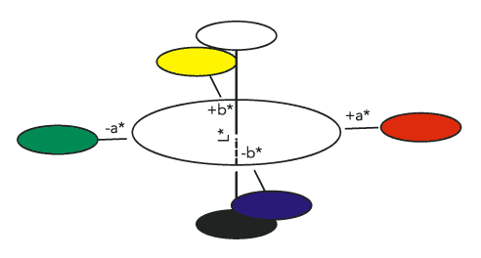
Fig. 3.6 CIE L*a*b* colour system https://www.ulprospector.com/knowledge/16423/pc-the-cielab-system-the-method-to-specify-colors-of-coatings/
- Hardness, elasticity analysis with structure analyser
The vegetable pieces to be analysed are placed on the texture analyser tray (figure 3.7). Measurements are made by pressing the sample with force and measuring the force (N) with which the vegetable can be cut at a pressing speed of 10 mm s ⁻¹.
Fig. 3.7 Structure analyser https://www.stablemicrosystems.com/TAXTplus.html
The result is the maximum force (N) needed to cut the respective vegetable.
The fresher the vegetables are, the easier they are to cut and less force is required, but as vegetables age, losing moisture, they become more flexible and harder to cut. Measurements are made by taking three pieces from each vegetable sample.
- Determination of pH
To determine product pH changes in vegetable samples, they are first peeled, cut and ground in a blender. From the obtained vegetable mass, juice is squeezed through cheesecloth and poured into a beaker in which the electrode of the pH meter is dipped and the pH of the product is determined.

Results
Table 3.2
Description of samples
Sample | Composition of gases | Colour L*a*b* | Average firmness, N | pH

Conclusion
Provide an overview of the obtained results. Write possible explanations on the detected quality changes.

Approved by _____________________________________
Name, surname, signature
Date ______________________________________

Laboratory work

Microbiological assessment of fresh, cut and packaged vegetables

Materials
Samples prepared in previous laboratory work or commercial samples.
Laboratory equipment: thermostats (for microorganism incubation at 27 °C, 30 °C and 37 °C); bag mixer (homogeniser); scales, colony counter (optional).

Methods
- Visually evaluate the samples ready for microbiological evaluation. Based on your findings decide on the levels of dilution you should prepare to detect TPC (total plate count), E.coli, yeasts and moulds, and lactic acid bacteria (if needed).
- Prepare agars needed to detect TPC (total plate count), E.coli, yeasts and moulds, and lactic acid bacteria (if needed).
- Sample preparation:
- Clean and prepare a sterile working space to prepare the product for microbiological evaluation.
- For homogenous samples, blend or homogenise 10 g of sample in a sterile blender with 90 mL of diluent like buffered peptone water.
- Prepare serial dilutions (e.g. 1:10, 1:100, etc.) by transferring 1 mL of the homogenate into 9 mL of sterile diluent.
- Microbial enumeration:
- Media preparation - prepare plate count agar (PCA) or another suitable growth medium.
- Plating - using a pipette, transfer 1 mL of each dilution onto separate Petri dishes.
- Spreading - pour molten agar (cooled to around 40 °C) over the sample and swirl to mix evenly.
- Incubation - incubate plates according to table 3.3
- Counting - count the colonies on plates and calculate CFU/mL or CFU/g using the dilution factor.
- Perform tests in duplicate or triplicate to ensure accuracy and reproducibility.

Table 3.3
Microorganism media and incubation parameters
Microorganism | Agar | Incubation temperature | Incubation time | Characteristics
TPC | Plate Count Agar (PCA) | 30 °C | 48-72 hours | General growth of bacteria, colony count
E.coli and coliform bacteria | Endo agar (ENDO) | 37 °C | 24-48 hours | Metallic green sheen colonies
E.coli and coliform bacteria | Chromogenic Agar | 37 °C | 24-48 hours | Blue/purple colonies
Yeasts and moulds | Potato Dextrose Agar (PDA) | 25-30 °C | 5-7 days | Yeasts: creamy colonies, moulds: fuzzy colonies
Yeasts and moulds | Sabouraud Dextrose Agar (SDA) | 25-30 °C | 5-7 days | Yeasts: creamy colonies, moulds: fuzzy colonies
Yeasts and moulds | Malt extract agar (NMA) | 25-30 °C | 5-7 days | Yeasts: creamy colonies, moulds: fuzzy colonies
Lactic acid bacteria | De Man, Rogosa and Sharpe (MRS) Agar | 30 °C | 48-72 hours | Small, round, and creamy colonies
- Data recording and analysis:
- Colony counting - count colonies on all relevant plates and calculate CFU based on dilution factors.
- Data logging - record all results meticulously, including colony counts, media used, incubation conditions, and any confirmations performed.
- Statistical analysis - analyse the data to determine the microbial load, presence of pathogens, and any trends or patterns.

Results
Write down and summarise all of the findings according to work description. Write down and summarise sample description, the methods, results, and interpretations for sample testing.

Conclusion
- Ensure and compare the report complies with relevant regulatory and safety standards.
- Based on the findings, provide recommendations for handling, processing, or further testing if contamination is detected.

Approved by ______________________________________
Name, surname, signature
Date ______________________________________

Theme 4

Packaging equipment and special packaging materials and methods used in fruit and vegetable product production

Knowledge questions
After familiarising yourself with the lecture materials, provide answers to the following questions:
- How do packaging materials affect the delivery time of fruit, vegetables and berries?
- How do packaging technologies affect the delivery time of fruit, vegetables and berries?
- Packaging as an element of added value.
- How does a vacuum packaging machine work, and what are its benefits for preserving fruit and vegetables?
- What are the characteristics of polyethylene (PE) and how is it used in packaging fruit and vegetables?
- Explain the benefits and applications of polypropylene (PP) in packaging.
- How does the use of biodegradable packaging materials benefit the environment?
- What are the properties of modified atmosphere packaging (MAP) films, and how do they help in preserving produce?
- Describe the role of ethylene absorbers in fruit packaging.

Approved by ______________________________________
Name, surname, signature
Date ______________________________________

Theme 5

Technological equipment for fruit and vegetable processing

Knowledge questions
After familiarising yourself with the lecture materials, provide answers to the following questions:
- How does automation improve the efficiency and consistency of fruit and vegetable processing?
- Describe the working principle of a fruit and vegetable washing machine.
- What are the advantages of using automated sorting machines in processing plants?
- How do optical sorters differentiate between good and bad produce?
- How does a dicing machine maintain uniformity in processed vegetable products?
- What are the main types of juicers used in fruit processing, and how do they differ?
- Explain the sterilisation process in canning and its importance.
- Explain the pasteurisation process in canning and its importance.

Approved by ______________________________________
Name, surname, signature
Date ______________________________________

Theme 6

Fermented fruit and vegetable production

Theoretical materials
Fermenting vegetables is a traditional method of preserving food and enhancing its nutritional value and flavour. The process involves the action of beneficial bacteria, primarily lactic acid bacteria, which convert sugars in the vegetables into lactic acid. This acid acts as a preservative, creating an environment that inhibits the growth of harmful bacteria.
Fermentation is the oldest form of preservation. Modern nutritional science recognises that of all the methods of processing vegetables, only acidification using lactic acid bacteria does not reduce, but even improves the nutritional value of the product - it increases the content of vitamins, free amino acids and other physiologically active substances.
The accumulation of lactic acid does not allow the development of rotting and butyric acid bacteria, therefore, in order for the products to be fermented and not to spoil, conditions must be created that promote the development of lactic acid bacteria.

Steps for fermenting vegetables
- Selection of vegetables - Choose fresh, high-quality vegetables. Common choices include cabbage (for sauerkraut and kimchi), cucumbers (for pickles), carrots, radishes, beets, and peppers.
- Preparation - Wash the vegetables thoroughly. Depending on the type of vegetable and the desired end product, they can be shredded, chopped, sliced, or left whole.
- Salting - Salt is essential for fermentation. It draws out water from the vegetables, creates brine, and inhibits the growth of undesirable bacteria. The salt concentration typically ranges from 1-3% of the vegetable weight.
- Adding starter culture (optional) - While natural fermentation relies on the bacteria present on the vegetables and in the environment, adding a starter culture (such as whey or a previous batch of fermented vegetables) can kick-start the fermentation process.
- Packing - Pack the vegetables tightly into a fermentation vessel (such as a jar or crock), ensuring that they are submerged under the brine. Use a weight to keep the vegetables submerged.
- Fermentation - Cover the vessel with a lid or cloth to keep out dust and insects, but to allow gases produced during fermentation to escape. Place the vessel at room temperature, typically between 18-22 °C.
- Monitoring - Check the vegetables daily to ensure they remain submerged under the brine. Skim off any mould or scum that forms on the surface.
- Tasting and storage - Fermentation time can vary from a few days to several weeks, depending on the vegetable, temperature, and desired flavour. Taste the vegetables periodically and move them to cold storage (refrigerator or cellar) once they reach the desired level of fermentation.

Important factors for successful fermentation
- Cleanliness - Ensure all equipment and work surfaces are clean to prevent contamination.
- Temperature control - Fermentation proceeds faster at higher temperatures, but may result in softer vegetables. Cooler temperatures slow the process, but produce crisper vegetables.
- Salt quality - Use non-iodised salt, such as sea salt or kosher salt, as iodine can inhibit the fermentation process.
- Brine levels - Keeping vegetables submerged in brine prevents exposure to air, reducing the risk of spoilage.

Some health benefits of fermented products
Fermented vegetables are rich in probiotics, which are beneficial for gut health. They can improve digestion, boost the immune system, and increase the bioavailability of nutrients. Additionally, the fermentation process can reduce anti-nutrients and increase levels of certain vitamins, such as B vitamins and vitamin K₂.

Quality defects
- Slimy vegetables - Caused by too low a salt concentration or too high a temperature. Adjust the salt and temperature.
- Mould - White mould is usually harmless and can be skimmed off. Black, red, or pink mould indicates spoilage, and the batch should be discarded.
- Off-smells - While fermentation produces strong smells, a rotten or putrid odour suggests spoilage.

For fermentation of sauerkraut:
- Raw materials must not be contaminated with soil, containers intended for pickling must be perfectly clean.
- Fermentation must take place at a temperature higher than 1 5°C (optimal 18-22 °C).
- It is necessary to ensure that the sugars diffuse quickly and as completely as possible from the raw materials into the juice that surrounds them during fermentation.
During the preparation stage for making sauerkraut, you should not add too much salt to pickling cabbage, as this will reduce the effectiveness of the lactic acid bacteria and vitamin C is not well preserved. The desired amount of salt in sauerkraut is 1.3 - 1.8%. Cabbage with 1.3% of added salt has the best taste and keeps well. In Latvia, the favourite seasoning for sauerkraut is caraway seeds. They contain a lot of essential oils, which give the cabbage a pleasant smell and taste. No more than 0.2% of cumin seeds are added. Carrots are often used as an additive at 2-3% of the total mass. Carrots give sauerkraut a pleasant taste and colour.

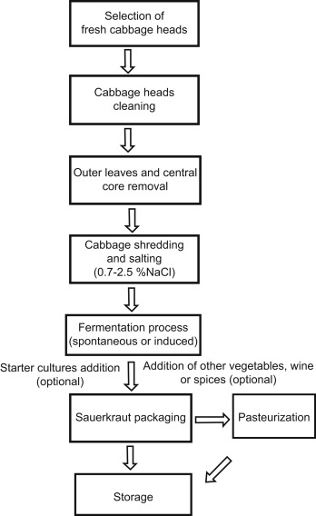
Fig 6.1 Sauerkraut production (https://doi.org/10.1016/B978-0-12-802309-9.00024-8)
Key microbiological aspects of fermented vegetable products
Fermented vegetable products rely on the activity of beneficial microorganisms to preserve the vegetables and enhance their flavour and nutritional value. Understanding the microbiological aspects is crucial for producing safe and high-quality fermented foods. Here’s an overview of the key microbiological aspects involved in the fermentation of vegetables:

Key microorganisms in vegetable fermentation
- Lactic acid bacteria (LAB):
  - Primary role - The main drivers of vegetable fermentation, LAB convert sugars into lactic acid, lowering the pH and creating an acidic environment that inhibits the growth of spoilage and pathogenic organisms.

  - Common LAB Species:
    - Lactobacillus: Lactobacillus plantarum, Lactobacillus brevis, Lactobacillus acidophilus.
    - Leuconostoc: Leuconostoc mesenteroides.
    - Pediococcus: Pediococcus pentosaceus, Pediococcus acidilactici.
- Yeasts:
  - Role: Some yeasts can contribute to the flavour profile and secondary fermentation processes. They may also produce alcohol and carbon dioxide.
  - Common yeast species: Saccharomyces cerevisiae, Candida spp.
- Other Bacteria:
  - Acetic acid bacteria: Can be involved in surface fermentation, producing acetic acid.
  - Enterobacteriaceae: Often present in the initial stages, but usually decline as acidity increases.

Fermentation Process
- Initial phase (heterofermentative LAB):
Leuconostoc mesenteroides typically dominate, producing lactic acid, carbon dioxide, and some acetic acid and ethanol. This phase lowers the pH and creates anaerobic conditions.
- Primary fermentation phase (homofermentative LAB):
Lactobacillus plantarum and Pediococcus spp. take over, producing primarily lactic acid, which further decreases the pH to around 3.5-4.0, preserving the vegetables.
- Final stabilisation phase:
Further reduction in pH and inhibition of spoilage organisms ensure the longevity and safety of the fermented product.

Factors influencing microbial activity
- Salt concentration:
Optimal salt concentrations (typically 2-3% for many vegetables) help select for LAB while inhibiting undesirable microorganisms. Too little salt can allow spoilage bacteria to thrive, while too much can inhibit LAB activity.
- Temperature:
Optimal fermentation temperatures range from 18-22 °C (64-72 °F). Higher temperatures can speed up fermentation, but may lead to softer textures and increased risk of spoilage, while lower temperatures slow down the process.
- Oxygen levels:
Anaerobic conditions are essential for proper fermentation. Exposure to air can lead to spoilage and growth of aerobic organisms like moulds.
- pH Levels:
A rapid drop in pH to below 4.6 is critical to inhibit the growth of pathogenic bacteria such as Clostridium botulinum.

Safety and quality control
- Pathogen inhibition:
The low pH and high lactic acid concentration in fermented vegetables inhibit the growth of most pathogens. Proper salt concentration and anaerobic conditions are key to preventing the growth of harmful bacteria such as Listeria monocytogenes and Clostridium botulinum.
- Hygiene and sanitation:
Clean equipment and sanitary practices help prevent contamination by spoilage organisms and pathogens.
- Starter cultures:
While traditional fermentation relies on naturally occurring microorganisms, using starter cultures can provide more consistent results and reduce the risk of undesirable microbial activity.

Common issues
- Mould growth:
Typically occurs due to exposure to air. Ensure vegetables are fully submerged in the brine, and use fermentation weights and airlock systems to maintain anaerobic conditions.
- Off-flavours:
Can result from contamination, inadequate salt concentration or improper fermentation temperatures. Adjusting these factors can help maintain desirable flavours.
- Soft texture:
Often due to high temperatures or insufficient salt. Lower fermentation temperatures and correct salt levels can help retain crispness.

Sensory parameters of sauerkraut
Sensory evaluation of sauerkraut means - to assessing and describing its sensory properties (appearance, aroma, flavour, texture, and overall liking). In sensory evaluation, these properties are often assessed by both trained panellists and consumers to ensure that the sauerkraut meets quality standards (company or ISO or GOST or others determined by different countries) and consumer preferences.
The colour of sauerkraut - from pale yellow to light green. The colour should be uniform without dark spots or discolouration, brightness, uniformity, and presence of any discolouration or defects in the sauerkraut.
The aroma of sauerkraut - fresh, without any off-odours; a characteristic tangy, sour smell indicative of the lactic acid fermentation process; may include notes of spices or other ingredients if added during fermentation.
The taste of sauerkraut - balanced sour, resulting from lactic acid produced during fermentation; if spices, herbs, or other vegetables are added, these should complement the primary taste.
The texture of sauerkraut - the cabbage should retain some crunch, indicating it hasn't become overly soft or mushy; pieces of cabbage should have a firm bite, not too hard or too limp.
A Line scale can be used to determine the influence of different sauerkraut preparation technologies and the raw materials used on the intensity of the product’s sensory properties (colour, aroma, crispness, sour taste, salty taste). With the Line scale, you can determine the intensity of each sensory property and it is possible to create a profile of the sensory properties of each sample.

Laboratory work

Preparation of sauerkraut

Materials
Fresh white cabbage, salt, cumin and other additives as available and/or preferred.

Methods
Tasks:
- Calculate the mass loss of cabbage during the pickling process.
- Ferment cabbage with various additives.
Preparation of sauerkraut using various additives

Sample 1
Cabbage is cleaned, cored and chopped. Place it in a container and add 1.3% table salt (coarse), 0.2% cumin and 0.5% sugar as additives. The mass is mixed, kneaded until the juice is released, covered with cabbage leaves, weight is placed on top, and left at room temperature. After about 3 days, when the cabbage has soured, add another 1.5% of cranberries.
Sample 2
Cabbage is cleaned, cored and chopped. Place it in a container and add 1.3% table salt (coarse), 0.2% cumin as additives. The mass is mixed, kneaded until the juice is released, covered with cabbage leaves, put on a load, and left at room temperature.
Sample 3
Cabbage is cleaned, cored and chopped. Place it in a container and add 1.4% table salt (coarse salt), 0.2% cumin and 1.5% carrots as additives. The mass is mixed, kneaded until the juice is released, covered with cabbage leaves, put on a load, and left at room temperature.
Sample 4
Cabbage is cleaned, cored and chopped. Place it in a container and add 1.5% table salt (coarse salt), 0.3% sugar and 0.3% cranberries as additives. The mass is mixed, kneaded until the juice is released, covered with cabbage leaves, weight is placed on top, and left at room temperature.
Sample 5
Cabbage is cleaned, cored and chopped. Place it in a container and add 1.5% table salt (coarse salt), 0.3% sugar and 0.6% cranberries as additives. The mass is mixed, kneaded until the juice is released, covered with cabbage leaves, weight is placed on top, and left at room temperature.

Sample 6
Cabbage is cleaned, cored and chopped. Place it in a container and add 1.5% table salt (coarse salt) and 2.5% apple as additives. The mass is mixed, kneaded until the juice is released, covered with cabbage leaves, weight is placed on top, and left at room temperature.
Sample 7
Cabbage is cleaned, cored and chopped. Place it in a container and add 1.4% table salt (coarse salt) and 2.5% carrots as additives. The mass is mixed, kneaded until the juice is released, covered with cabbage leaves, weight is placed on top, and left at room temperature.
Sample 8
Cabbage is cleaned, cored and chopped. Place in a container and add 1.6% table salt (coarse salt), 1% sugar and 3% carrots as additives. The mass is mixed, kneaded until the juice is released, covered with cabbage leaves, weight is placed on top, and left at room temperature.
Sample 9
Cabbage is cleaned, cored and chopped. Place it in a container and add 1.4% table salt (coarse salt) and 2.5% carrots as additives. The mass is mixed, kneaded until the juice is released, covered with cabbage leaves, weight is placed on top, and left at room temperature.
Sample 10
Cabbage is cleaned, cored and chopped. Place it in a container and add 1.5% table salt (coarse salt) and 4% apple as additives. The mass is mixed, kneaded until the juice is released, covered with cabbage leaves, weight is placed on top, and left at room temperature. After about 3-5 days, when the cabbage has soured, add another 3% of cranberries.

Approved by ______________________________________
Name, surname, signature
Date ______________________________________

Laboratory work

Packaging and storage of sauerkraut. Product treatment in sous-vide.
The aim of the laboratory work is to acquire skills in sous-vide packaging technology, using packaging materials with high gas barrier properties and using a chamber-type melting device. An experiment was carried out where the heat treatment time is changed.
The group of students is divided into teams and each team performs experiments.

Materials
Products prepared in previous experiments or commercially available products/materials purchased.

Methods
Take part of the previously prepared sauerkraut or commercially available sauerkraut. The product is placed in packaging bags (pouches) and then hermetically sealed, and then hot water is added in a bath where the temperature and pasteurisation time are controlled. Each group packs at least 6 packs so that different heating/pasteurisation times can be experimented with.
The rest of the prepared sauerkraut is placed in airtight containers and stored refrigerated until further testing - (4±2°C).
During the practical work, students learned the skills of working with packaging equipment and packaging technologies. Students learn to work in groups.

Results
Depict the obtained results in table 6.1.
Table 6.1
Obtained results
Sample | Product No. 1 | Product No. 2 | Product No. 3
Sample without heat treatment
Heat treatment - 5 min
Heat treatment - 10 min
Heat treatment - 20 min
Heat treatment - 30 min

Conclusion
After the products have been packaged, different groups of students compare the results. Write an overview of your findings and give explanations to differences noted between the samples.

Approved by _____________________________________
Name, surname, signature
Date ______________________________________

Laboratory work

Microbiological evaluation of prepared sauerkraut

Materials
Product samples prepared in previous laboratory work or commercially available product samples.
Laboratory equipment: thermostats (for microorganism incubation at 27 °C, 30 °C and 37 °C); bag mixer (homogeniser); scales, colony counter (optional).
- Visually evaluate the samples ready for microbiological evaluation. Based on your findings, decide on the levels of dilution you should prepare to detect TPC (total plate count), E.coli, yeasts and moulds, and lactic acid bacteria (if needed).
- Prepare agars needed to detect TPC (total plate count), E.coli, yeasts and moulds, and lactic acid bacteria (if needed).
- Sample preparation:
- Clean and prepare a sterile working space to prepare the product for microbiological evaluation.
- For homogenous samples, blend or homogenise 10 g of sample in a sterile blender with 90 mL of diluent such as buffered peptone water.
- Prepare serial dilutions (e.g. 1:10, 1:100, etc.) by transferring 1 mL of the homogenate into 9 mL of sterile diluent.
- Microbial enumeration:
- Media preparation - prepare plate count agar (PCA) or another suitable growth medium.
- Plating - using a pipette, transfer 1 mL of each dilution onto separate Petri dishes.
- Spreading - pour molten agar (cooled to around 40 °C) over the sample and swirl to mix evenly.
- Incubation - incubate plates according to table 6.2
- Counting - count the colonies on plates and calculate CFU/mL or CFU/g using the dilution factor.
- Perform tests in duplicate or triplicate to ensure accuracy and reproducibility.

Table 6.2
Microorganism media and incubation parameters
Microorganism | Agar | Incubation temperature | Incubation time | Characteristics
TPC | Plate Count Agar (PCA) | 30 °C | 48-72 hours | General growth of bacteria, colony count
E.coli and coliform bacteria | Endo agar (ENDO) | 37 °C | 24-48 hours | Metallic green sheen colonies
E.coli and coliform bacteria | Chromogenic Agar | 37 °C | 24-48 hours | Blue/purple colonies
Yeasts and moulds | Potato Dextrose Agar (PDA) | 25-30 °C | 5-7 days | Yeasts: creamy colonies, moulds: fuzzy colonies
Yeasts and moulds | Sabouraud Dextrose Agar (SDA) | 25-30 °C | 5-7 days | Yeasts: creamy colonies, oulds: fuzzy colonies
Yeasts and moulds | Malt extract agar (NMA) | 25-30 °C | 5-7 days | Yeasts: creamy colonies, moulds: fuzzy colonies
Lactic acid bacteria | De Man, Rogosa and Sharpe (MRS) Agar | 30 °C | 48-72 hours | Small, round, and creamy colonies
- Data recording and analysis:
- Colony counting - count colonies on all relevant plates and calculate CFU based on dilution factors.
- Data logging - record all results meticulously, including colony counts, media used, incubation conditions, and any confirmations performed.
- Statistical analysis - analyse the data to determine the microbial load, presence of pathogens, and any trends or patterns.

Results
Write down and summarise all of the findings according to work description. Write down and summarise sample description, the methods, results, and interpretations for sample testing.

Conclusion
- Ensure and compare the report complies with relevant regulatory and safety standards.
- Based on findings, provide recommendations for handling, processing, or further testing if contamination is detected.

Approved by ______________________________________
Name, surname, signature
Date ______________________________________

Laboratory work

Sensory evaluation of sauerkraut

Materials
A total of six samples are used for the sensory evaluation - five from previously prepared samples and one from the store, already available in the market.
For mouth cleaning between samples - water.

Methods
Task - to evaluate the intensity of sensory properties (colour, aroma, crispness, sour taste and salty taste) for sauerkraut samples.
12 cm Line scale
TRAY NO. _____________________________________
Please mark the intensities of the presented product samples on the Line scale and write the sample number below the marking.
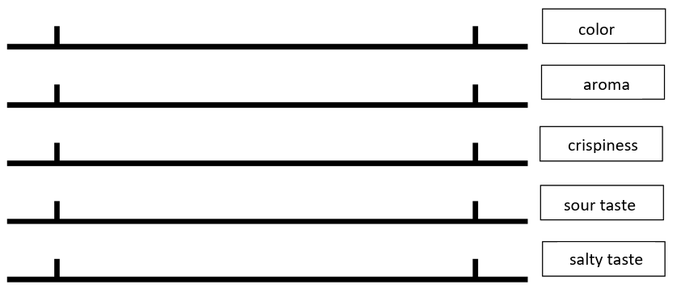

Results
Taste the samples, evaluate them using the Line scale and prepare sensory properties profile of the analysed sauerkraut samples.
EXAMPLE:
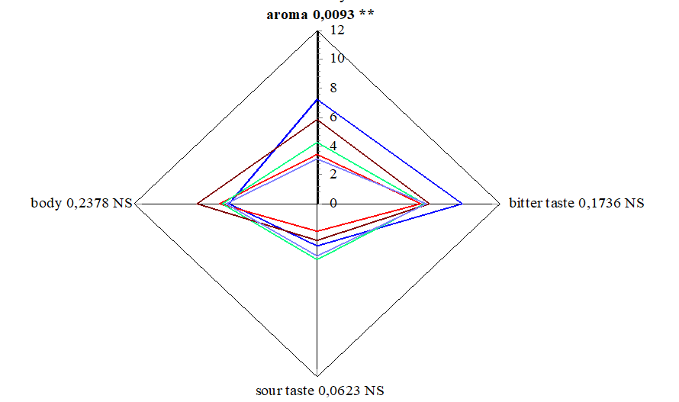

Conclusion
Provide an overview on the obtained results. Write possible explanations on the detected sensory differences.

Approved by ______________________________________
Name, surname, signature
Date ______________________________________

Laboratory work “Quality evaluation of prepared sauerkraut”

Materials
Sauerkraut prepared in previous laboratory work and commercially available product.

Methods
- Determining the relationship between cabbage and juice.
Weigh the dish together with the cabbage, weigh the enamelled bowl (record the mass in the protocol), put a strainer or colander in it and shake the sample to be analysed, leave it for 15 minutes, so that the juice flows freely. Then weigh the container with the sample to be analysed and the container with the drained juice.
After the difference in mass, the ratio of cabbage and juice is calculated in %. The result is recorded in the protocol and compared with the standard requirements.
The calculation can be made according to formulas 1 and 2:
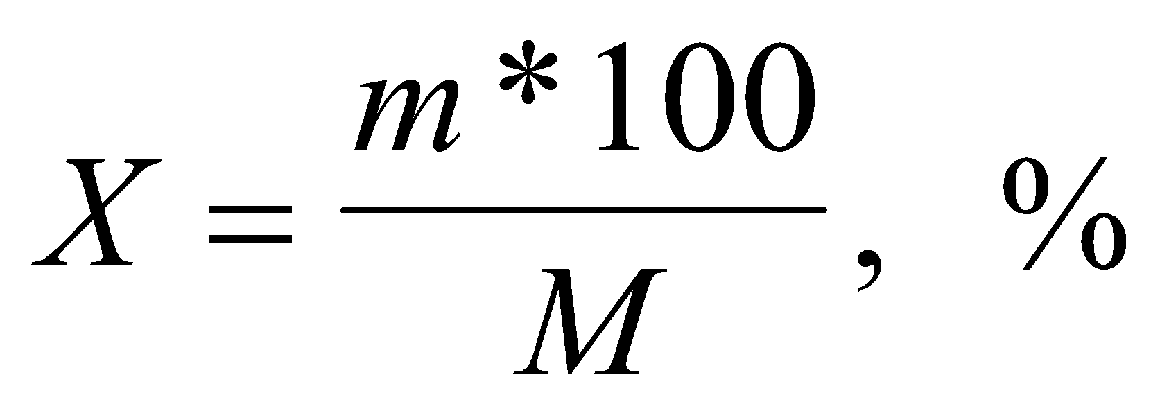Formula 1
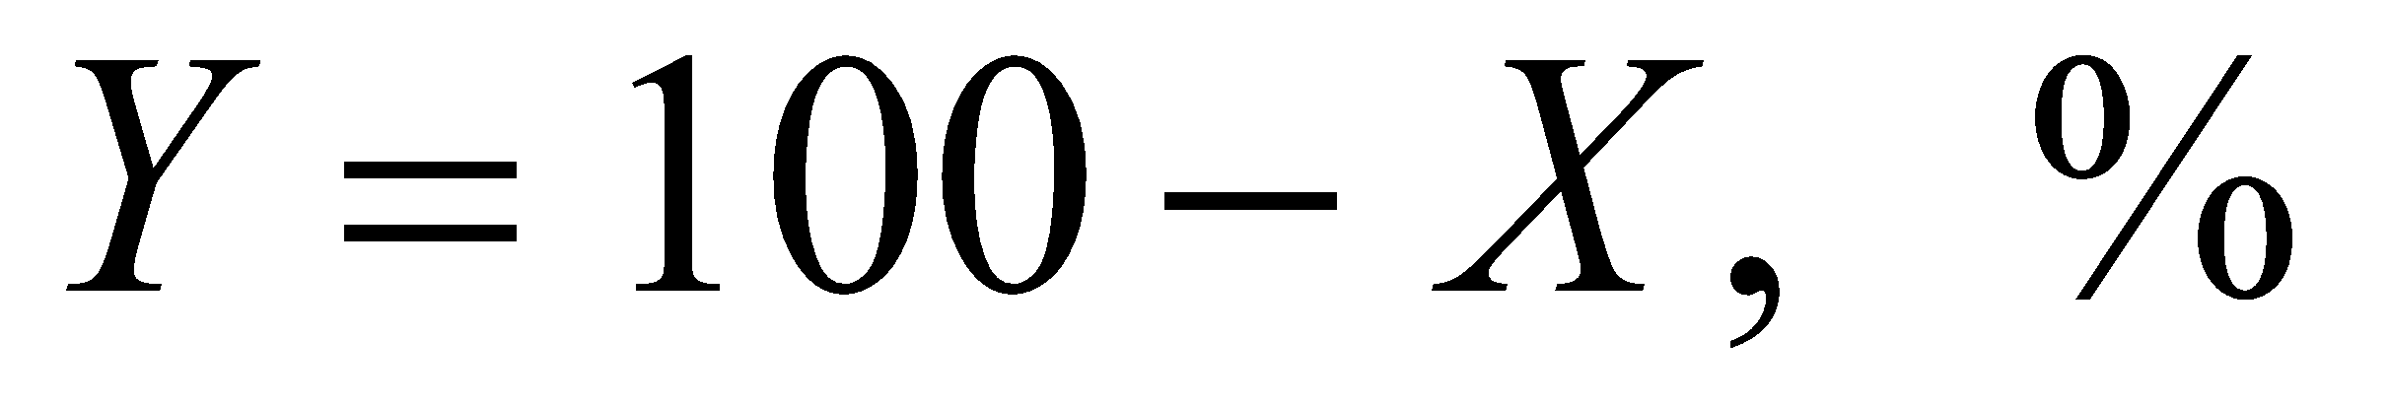Formula 2
where: X - content of pickled vegetables, %
M - total mass of the sample, kg
m - mass of sauerkraut after draining the juice, kg
Y - juice content, %.
- Determining the percentage of cooking salt
The amount of cooking salt can be determined either by the chemical method or by the density of sauerkraut juice, the first method is more accurate, but the second one is faster.
- Determining the amount of cooking salt by the density of cabbage juice
The filtered sauerkraut juice is poured into a dry measuring cylinder, the temperature is measured (and recorded) and the aerometer is immersed in the juice, when it stops oscillating, the density is read. The amount of cooking salt can be found from table 6.3.

Table 6.3
The dependence of the amount of salt on the density of the juice
Density | NaCl, % | Density | NaCl,%
1.0053 | 1 | 1.0268 | 4
1.0125 | 2 | 1.0340 | 5
1.0196 | 3 | 1.0413 | 6
 |  | 1.0490 | 7
A recalculation is made, i.e. the correction 0.00045 is multiplied by the number of degrees by which the actual juice temperature differs from 20°C (n=20°C- actual temperature). The obtained value is added to the density (measured) if the temperature of the juice is lower than 20 °C and is subtracted at elevated temperatures.
The introduction of the correction is necessary because density and temperature are inversely related, but the aerometer scale is intended for measuring the densities of solutions at 20 °C.
By calculating the actual density, the amount of table salt can be determined. If the actual density does not match the data in the table, a recalculation is made.
Example: Density of the juice to be determined - 1.0150 g/cm3.
We make the proportion according to the closest data from table 6.3:
1.0196 - 3%
1.0125 - 2%,
0.0071 - 1%
1.0150 - 1.0125=0.0025
0.0071 - 1%
0.0025 - x
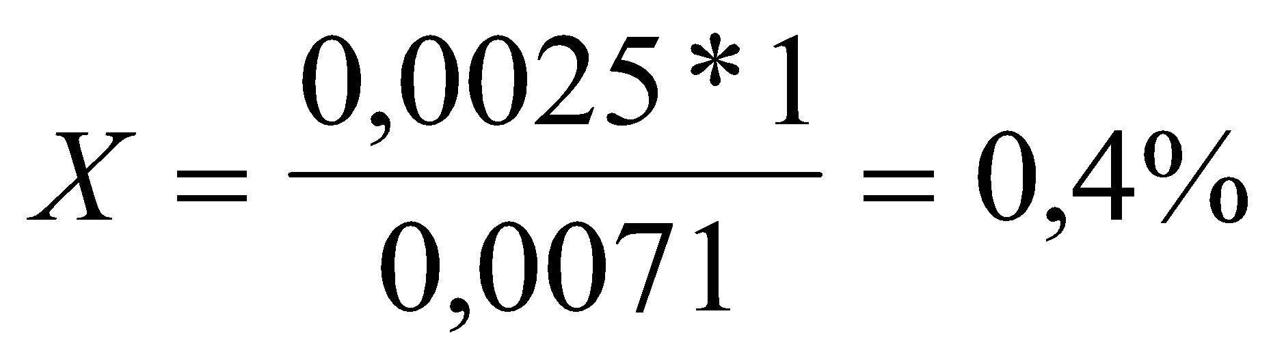Formula 3
2+0.4=2.4% - the content of table salt corresponding to the density of 1.0150 g/cm3.
The results are summarized in table 6.4.
- Determination of table salt content by chemical method
Cabbage juice is filtered through cheesecloth. Pour 5 mL of the filtrate into a 100 mL beaker, add 3-4 drops of saturated potassium chromate solution (indicator) and titrate from a burette with a 0.1 N silver nitrate solution. The reaction takes place according to the following scheme:
NaCl + AgNO3 = AgCl + NaNO3
AgCl precipitates as a white deposit. As the chloride ion precipitates, the silver nitrate begins to react with the potassium chromate:
2 AgNO3 + K2CrO4 + 2 KNO3.
Ag2CrO4 turns the solution orange-brown, indicating that the titration should be stopped. The amount of table salt is calculated according to the following formula:
Formula 4
where x - table salt content, %
a - AgNO3 0.1 n solution consumed for titration (ml).
b - the amount of filtrate taken for titration (ml).
0.00585 - amount of NaCl (g) corresponding to 1 ml of 0.1 n AgNO
- Determination of titratable acid
Pour 10 mL of cabbage juice into a 100 mL beaker with a pipette, add 10 mL of distilled water, add 3 drops of phenolphthalein, mix thoroughly and titrate with 0.1 n NaOH until a faint pink colour appears. The amount of acid is calculated according to the formula
Formula 5
where x - amount of acid to be titrated, %
a - consumed 0.1 n NaOH solution, mL
b - amount of juice taken for titration, mL
0.009 - the amount of lactic acid in g, which corresponds to 1 ml of 0.1n NaOH.
Table 6.5
Physico-chemical indicators of sauerkraut
Indicator name | Norms of indicators
The ratio between cabbage and juice, % | 88 - 90
Table salt content, % | 1.2 - 1.8
Total acidity, % | 0.7 - 1.3
Adjacent impurities | are not allowed
- Ascorbic acid content in sauerkraut juice
Methodology:
- Prepare a standard solution of ascorbic acid: 40 mg of ascorbic acid per 100 mL of 6% oxalic acid solution.
- Add 2 mL of 1% starch solution to 25 mL of ascorbic acid standard solution and titrate with 0.05 M iodine solution while stirring. Observe the colour change. Write down the amount of iodine used.
- weigh 50 g of cabbage juice into a 250 Ll beaker.
- 100 mL of 6% H ₂ C ₂ O ₄ solution is poured over the prepared weight and mixed.
- Filter through a cotton filter.
- Add 2 mL of 1% starch solution to 10 mL of filtrate and titrate with 0.05M iodine solution while stirring. Observe the colour change that does not disappear within 30 seconds and write down the amount.
$$C vit. \left(\frac{mg}{100g}\right)=5000* \frac{ V_{J sample}}{{m* V}_{J standard}}$$
5000 - coefficient
V _{Jin the sample} - the amount of iodine solution used for the titration of 10 mL of the sample
V _{Jst. no.} - the amount of iodine solution used for the titration of 25 mL standard solution
m – sample mass.

Results
Table 6.4
Determination of salt content in acidified products
Measured density | Temperature °C | Amount of % | Temperature difference (n) | Correction n*0.00045 | The actual density

Create a table to combine the obtained data on the analysed samples.

Conclusion
- Provide an overview on the obtained results. Write possible explanations of the detected differences. Is the obtained data comparable to legislative guidelines?
- Provide answers to the following questions:
- What causes cabbage to go sour?
- What is the best temperature for pickling?
- Why should cabbage be pounded and strained before pickling?
- What does adding salt to cabbage do?
- What additives are usually added when making sauerkraut?
- What should be observed during the storage of sauerkraut?
- Why it is not recommended to add apples and cranberries to cabbage during pickling?
- Why are the results obtained in determining the salt content different? Which method is more suitable for determining the salt content in this type of product?

Approved by ______________________________________
Name, surname, signature
Date ______________________________________

Theme 7

Assessment of the Safety and Risks of fruit and vegetable products (HACCP)

Theoretical materials

What is food safety?
Food safety is a scientific discipline describing handling, preparation, and storage of food in ways that prevent food borne illnesses. This includes a number of routines that should be followed to avoid potentially severe health hazards. In this way, food safety often overlaps with food defence to prevent harm to consumers.
As it has been known in the EU since 1960, each enterprise that works in the food segment must have a food safety system that is based on 7 HACCP principles.
Seven basic principles are used in the development of HACCP plans that meet the stated goal. These principles include hazard analysis, CCP identification, establishing critical limits, monitoring procedures, corrective actions, verification procedures, and record-keeping and documentation.
The Food Safety Plan - is not a stand-alone programme, but rather part of a larger food safety system. The foundational programmes that are part of the food safety system are frequently termed prerequisite programs. The term was coined to indicate that they should be in place before HACCP based systems are implemented in order to effectively manage risk from foodborne hazards. Good Manufacturing Practice (GMP) regulations address requirements for many prerequisite programmes. The conditions and practices the regulated food industry must follow for processing safe food under sanitary conditions, including personnel, plant and grounds, sanitary operations, sanitary facilities and controls, equipment and utensils, processes and controls, warehousing and distribution, and action levels in case with potentially unsafe product.
The process flow of a food safety plan (HACCP or Preventive Controls) is the centre of a food product’s food safety story. It tells how a company makes its products and also what hazards and controls are associated with each step
Monitoring records and logs must include the actual values or observations that document the actual implementation of a Food Safety Plan. For example, if a temperature is being measured, the actual temperature must be recorded rather than a check mark indicating that the temperature complied with the critical limit. To comply with regulations, information must be recorded at the time it is observed.

Suggested record and log types to use:
- Customer complaints,
- Corrective action forms,
- Employee training,
- Food safety quarterly audit,
- Food safety checklist,
- Raw materials/receiving log,
- Worker illness log,
- Refrigerator log,
- Assembly log,
- Shipping temperature log,
- Suggested supply chain documents.
The safety of your product depends on much more than just what you control within your own facility. The use of an ingredient that has a history of association with a specific hazard may require a supply chain programme as a control within your food safety programme. Companies may have extensive supplier programmes that encompass much more than food safety elements to manage their supplier expectations and performance.
Suggested documents to obtain from your supply chain:
- Food safety HACCP or preventive controls plan for each product,
- Food defence/business continuity plan,
- Validation of each product and/or process and ready-to-eat statements (if applicable),
- Certificates of analysis (COA),
- Third party audit certificate, report & corrective actions,
- Product specification,
- Allergen management,
- Country of origin.

Potential Hazards
Biological hazards
Microbiological Contamination – during processing at source of origin – supplier management and HACCP in place and verified to eliminate and reduce potential presence of microbiological contamination.
Microbiological contamination for instance microbiological growth due to breakdown of refrigeration units.
Chemical hazards
Chemical contamination by pesticides at source of origin – chemical/pesticide used at source is verified to be in conjunction with regulations.
Chemical contamination from machine oils or lubricants, as well as cleaning chemicals.
Microbiological / physical / chemical contamination from cross contamination or taint of finished product due to poor hygiene.
Physical hazards
Physical contamination – external contamination from rainwater, bird droppings, vermin/rodents, and flying insects during unloading process.
Glass contamination – glass contamination from internal light sources. Pests/rodents and or flying insects due to poor hygiene/debris build up. Physical risks from straps/thermocouples/staples/foreign bodies found on pallets on intake.
Physical contamination – foreign Bodies found within product and/or packaging from source of origin or during transportation.
Physical contamination – physical contamination from warehouse operative, pests/rodents, and/or flying insects due to poor hygiene/debris build up. Physical contamination from personnel foreign body/dust contamination from production environment.

What are the 5 basic food safety requirements?
- keep clean;
- Separate raw and cooked;
- Cook thoroughly;
- Keep food at safe temperatures;
- Use safe water and raw materials.

Recall Plan
According to the Food Safety Modernization Act, the Preventive Controls for Human Food regulation requires the development of a written Recall Plan when a hazard analysis identifies a hazard requiring preventive control. Recalls are actions taken by an establishment to remove an adulterated, misbranded or violative product from the market. In other words, a product for which the FDA or a state could take legal action against the company would be subject to a recall.

Verification
Verification is an important component of supply chain, sanitation, allergen and critical controls. It confirms that the Food Safety Plan is operating as intended. Validation confirms the effectiveness of the Food Safety Plan in controlling food safety hazards. The purpose of verification is to provide a level of confidence that the Food Safety Plan:
- Based on solid scientific principles that are adequate to control the hazards associated with the product and process.
- That the plan is being followed correctly every day of operation.

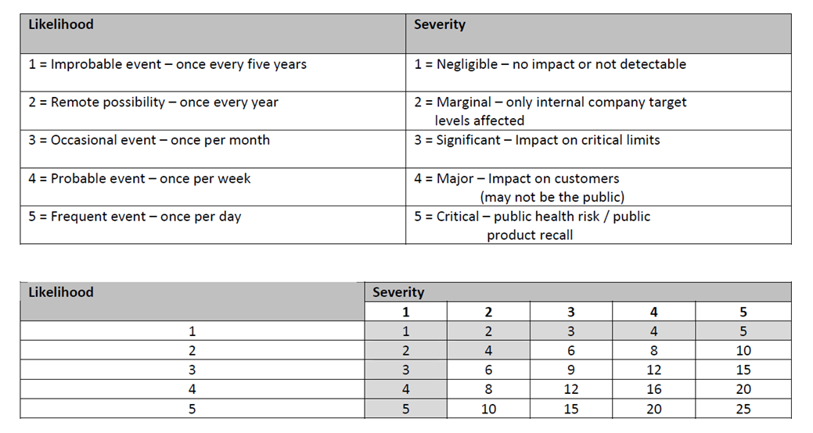
Fig. 7.1 Risk assessment matrix 1
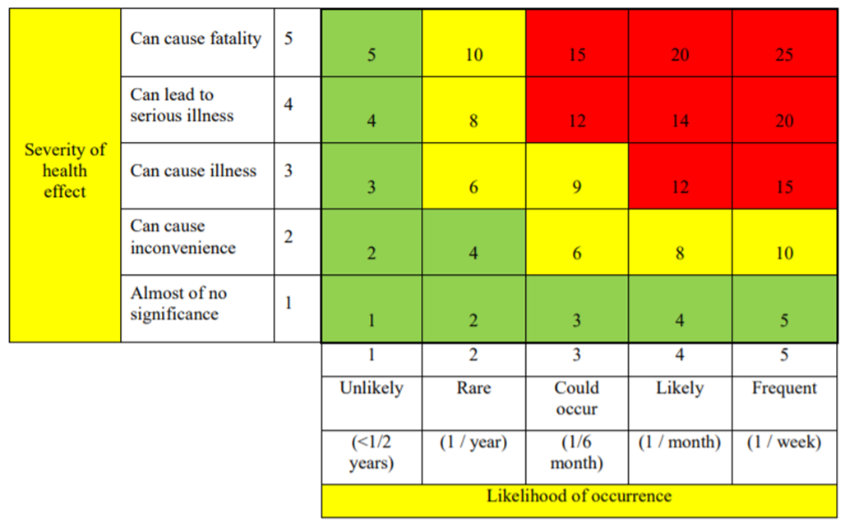
Fig. 7.1 Risk assessment matrix 2

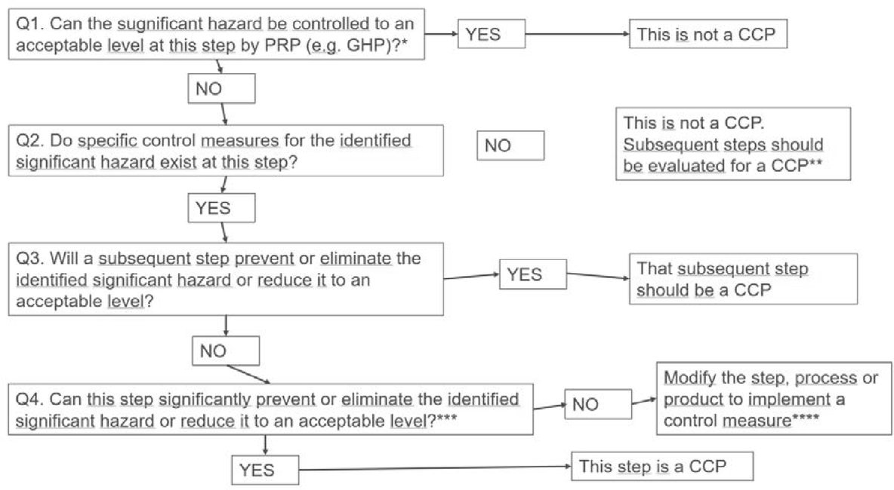
Fig. 7.3 Example of a decision tree to identify critical control points (CCP)
https://eur-lex.europa.eu/legal-content/EN/TXT/?uri=CELEX%3A52022XC0916%2801%29

Laboratory work

Assessment of potential hazards in fruit and vegetable processing

Methods
Tasks:
- For a selected fruit and vegetable processing product, develop a product description, and draw a diagram of the process steps.
- Identify potential hazards:
  - biological: pathogenic microorganisms;
  - chemical: agricultural chemicals;
  - physical: foreign objects atypical for the product.
- Evaluate the danger of the identified hazards using risk matrix 1 or 2. Record the information in the hazard assessment Table 7.1.
- Complete the CCP identification Table 7.2 and the HACCP plan table 7.3.
- Write conclusions on determining CCP using a risk matrix and a decision scheme.

Results
Table 7.1
CCP identification table
Process stage No. | Process stage | Cause of risk | Description of the cause of the risk | Control actions | Answers to Decision Scheme questions |  |  |  | CCP yes/no
 |  |  |  |  | 1 | 2 | 3 | 4 | CCP yes/no

Table 7.2
Risk assessment table
Process stage | The identified hazard | Hazard assessment |  |  |  |  | Means of control
Process stage | The identified hazard | Possibility | The severity of the consequences | Risk level | Assessment | CCP | Means of control

Table 7.3
HACCP plan
In process stage | CCP/CP | Risk the cause | Measurable critical limits of parameters | Monitoring procedures |  |  |  | Ordered by | Corrections events
 |  |  |  | What? | How to? | How often? | What? | Ordered by | Corrections events

Conclusion
Write conclusions on determining the CCP using a risk matrix and a decision scheme

Approved by ______________________________________
Name, surname, signature
Date ______________________________________

Theme 8

Microbiological aspects of fruit and vegetable processing

Theoretical materials
Microbiological safety and quality are critical aspects of fruit and vegetable processing. These products can harbour a variety of microorganisms, including bacteria, yeasts, moulds, and viruses. Ensuring their control throughout the supply chain—from harvest to consumption—is essential for public health and product quality.

Sources of microbial contamination
- Soil and water: Fruit and vegetables can be contaminated with soil-borne and water-borne pathogens. Irrigation water, in particular, can be a significant source of contamination.
- Handling and processing: Human handling, equipment surfaces, and processing environments can introduce or spread microorganisms.
- Post-harvest practices: Storage, transportation, and packaging conditions can influence microbial growth.
Table 8.1
Most common microbiological spoilage of fruit, vegetables and their products
Spoilage organism | Type | Conditions favouring growth | Characteristics of spoilage | Visual description
Fruit
Saccharomyces spp. | Yeast | High sugar content, low pH | Fermentation, off-flavours, gas production | Bubbles, frothy appearance, cloudy liquid
Candida spp. | Yeast | High sugar content, low pH | Slimy texture, off-flavours | Slimy film on surface, white colonies
Aspergillus spp. | Mould | Warm, humid conditions | Visible mould, off-flavours, mycotoxins | Black or green powdery mould
Penicillium spp. | Mould | Cold, moist conditions | Visible mould, soft rot | Blue or green fuzzy mould
Botrytis cinerea | Mould | High humidity | Grey mould, soft rot | Grey, fuzzy mould covering surface
Rhizopus spp. | Mould | Warm, humid conditions | Black mould, soft rot | Black, fuzzy mould with white edges
Lactobacillus spp. | Bacteria | Low pH, anaerobic conditions | Sour taste, off-flavours | Cloudy liquid, off-odour
Vegetables
Pseudomonas spp. | Bacteria | Moist conditions, refrigeration | Soft rot, sliminess | Water-soaked, mushy areas with a foul odour
Erwinia spp. | Bacteria | Warm, moist conditions | Soft rot, watery decay | Water-soaked, slimy, foul-smelling
Xanthomonas spp. | Bacteria | Warm, humid conditions | Leaf spots, blights | Yellow or brown spots on leaves
Clostridium spp. | Bacteria | Anaerobic conditions | Gas production, off-odours | Swollen packaging, foul odour
Bacillus spp. | Bacteria | High temperatures | Off-flavours, sliminess | Cloudy liquid, off-odour
Penicillium spp. | Mould | Cold, moist conditions | Visible mould, soft rot | Blue or green fuzzy mould
Alternaria spp. | Mould | Warm, humid conditions | Black spots, mould growth | Black spots, fuzzy grey or dark mould
Geotrichum candidum | Mould | High humidity | Sour rot, yeast-like growth | White, yeast-like growth
Fruit Juices and Purees
Zygosaccharomyces spp. | Yeast | High sugar content, low pH | Fermentation, gas production | Bubbles, frothy appearance, cloudy liquid
Lactobacillus spp. | Bacteria | Low pH, anaerobic conditions | Sour taste, off-flavours | Cloudy liquid, off-odour
Leuconostoc spp. | Bacteria | Low pH, anaerobic conditions | Gas production, sour taste | Swollen packaging, off-odour
Alicyclobacillus acidoterrestris | Bacteria | Acidic conditions, heat resistant | Off-flavours, spoilage after pasteurisation | Off-odour, flat sour taste
Penicillium spp. | Mould | Cold, moist conditions | Visible mould, off-flavours | Blue or green fuzzy mould
Canned Vegetables
Clostridium botulinum | Bacteria | Anaerobic conditions, inadequate processing | Toxin production, botulism | Swollen cans, off-odour, discoloured contents
Geobacillus stearothermophilus | Bacteria | Thermophilic conditions | Flat sour spoilage, off-flavours | Cloudy liquid, off-odour, no gas production
Bacillus coagulans | Bacteria | Acidic conditions | Flat sour spoilage, off-flavours | Cloudy liquid, off-odour, no gas production

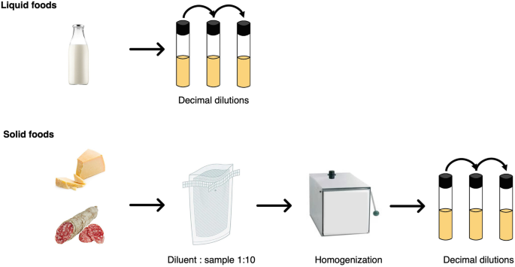
Fig. 8.1 Sample preparation for microbiological analysis https://link.springer.com/chapter/10.1007/978-1-0716-3413-4_2
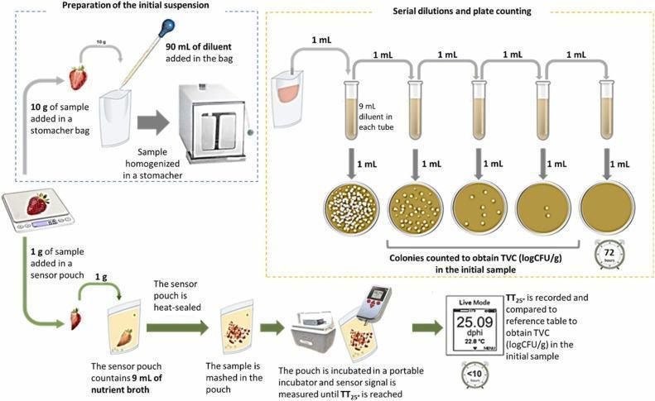
Fig. 8.2 Sample preparation for microbiological analysis https://www.sciencedirect.com/science/article/pii/S0925400523007311

Knowledge questions
After familiarising yourself with the lecture materials, provide answers to the following questions:
- What are the common types of microorganisms found on fruits and vegetables?
- What conditions promote the growth of spoilage microorganisms on fresh produce?
- What are the primary sources of microbial contamination in fruit and vegetable processing?
- How can soil and water contribute to the microbial load on fruits and vegetables?
- What role do handling and transportation play in the contamination of fresh produce?
- Describe the importance of good agricultural practices (GAP) in reducing microbial contamination.
- What are some key sanitation practices that should be implemented in processing facilities?
- What is the role of pH and water activity (aw) in controlling microbial spoilage?
- What are some common beneficial microorganisms used in the fermentation of vegetables?

Approved by ______________________________________
Name, surname, signature
Date ______________________________________

Theme 9

Production technology of frozen fruits and vegetables

Theoretical materials
The quality of frozen fruit and vegetables is affected by the quality of the raw material, the type of pre-treatment, the freezing technology (selected equipment, freezing speed, temperature), the storage modes and temperature, as well as its stability.
The variety determines the quality of the raw material, the freezing rate of the product, the specifics of ice crystal formation and other factors. Cultivation and weather conditions affect the water content of fruit and vegetables. For this reason, if one wants to have tight control over the freezing process, one must choose a certain tried and true variety, seed and even fertiliser. One of the most important factors affecting the quality of frozen products is the duration of storage of raw materials before freezing.

Pre-treatment methods used for frozen produce production
- Blanching is used to protect products from spoilage caused by enzymes. Blanching affects the permeability of cell membranes. Vegetables must be cooled immediately after blanching, because the amount of vitamins quickly decreases at high temperatures, and the taste and natural colour are lost.
- Addition of sugar and other substances. Fruit and berries are frozen with sugar, in sugar syrup or without it. The addition of sugar and its syrup protects the fruit from the effects of ice crystals, inhibits enzymatic reactions, and reduces the amount of oxygen in frozen fruit and berries. Fruit and berries are poured with cooled sugar syrup with a concentration of 20-60% and kept at 0 °C for 8-10 hours.
- Citric acid is used to optimise the stability of frozen products and reduce discoloration. Ascorbic acid and sodium ascorbate are widely used as antioxidants and colour stabilisers.
- Adding pectin to the sugar syrup used to infuse the berries reduces the release of colourants from the berries during the tempering process and makes the berries firmer.
Industrial fruit and berry freezers are essential for preserving the freshness, texture, and nutritional value of produce on a large scale. These freezers come in various types, each designed to meet specific freezing requirements. Here’s an overview of the key types of industrial freezers, notable brands, and important considerations for selecting the right equipment.

Types of industrial freezers
- Blast / flash freezers
  - Utilise extremely cold air (-30 °C to -40 °C) circulated at high speed to rapidly freeze products.
  - Ideal for quick freezing of fruit and berries to preserve texture and quality.
  - Rapid freezing time, prevents large ice crystal formation, and maintains product integrity.
- Tunnel freezers
  - Products are placed on a conveyor belt and passed through a tunnel where they are exposed to very cold air or nitrogen gas.
  - Suitable for continuous freezing of large quantities of produce.
  - Continuous operation, customisable speed and temperature settings, efficient for high-volume processing.
- IQF (Individually Quick Freezing) freezers
  - Use cold air or liquid nitrogen to freeze individual pieces of fruit or berries quickly.
  - Ideal for fruit and berries that need to be frozen separately to prevent clumping.
  - Maintains individual pieces, preserves quality and nutritional value, suitable for bulk packaging.
- Plate freezers
  - Produce is placed between metal plates that are cooled to very low temperatures.
  - Commonly used for block freezing, suitable for packed or boxed produce.
  - Efficient for packed goods, uniform freezing, compact design.
- Cryogenic freezers
  - Use cryogenic gasses like liquid nitrogen or carbon dioxide to achieve rapid freezing.
  - High-value, delicate fruits and berries that require minimal cellular damage.
  - Ultra-rapid freezing, minimal dehydration, preserve texture and flavour.

Laboratory work

Freezing of fruits and vegetables

Materials
A variety of fresh fruit, berries and vegetables available.
Laboratory equipment: deep freezer; flash freezer; contact type (plate) freezer.

Methods
- Pre-treatment before freezing
- Carrots – washed, cleaned, cut into slices and divided into 2 parts:
- Place in containers and cool to +4 - +6;
- Heat water and hold at 90 °C for 7 minutes, cool, dry, put in containers and cool at +4-+6 °C .
- Potatoes - washed, cleaned, cut into straws and divided into 2 parts:
- Place in containers and cool to +4 - +6 °C;
- Heat water and hold at 75 °C for 5 minutes, cool, dry, put in containers and cool at +4 - +6 °C .
- Potatoes - washed, cleaned, cut into straws and divided into 2 parts:
- Heat water and hold at 85 °C for 7 min, cool, dry, put in containers and cool at +4 - +6 °C;
- Prepare 1 g of citric acid and 200 mg of ascorbic acid per 100 g of water, soak the cut potato straws in it and leave for 20 minutes, then dry, put in containers and cool at +4 - +6 °C.
- Beets - washed, cleaned, cut into 7x7 mm cubes and divided into 2 parts:
- Place in containers and cool to +4 - +6 °C;
- Heat water and hold at 95 °C for 7 min, cool, dry, put in containers and cool at +4 - +6 °C.
- Apples - wash, peel, remove the seed, cut into slices and divide into 2 parts:
- Place in containers and cool to +4 - +6 °C ;
- Heat water, add sugar (20 g of sugar and 80 g of water) and prepare a sugar syrup in which apples are heated at 85 °C for 5 minutes, cooled, dried, put in containers and cooled to +4 - +6 °C;
- Apples - wash, peel, remove the seed, cut into slices and divide into 2 parts:
- Prepare 1 g of citric acid and 200 mg of ascorbic acid per 100 g of water, soak the sliced apples in it and leave for 20 minutes, then dry, put in containers and cool at +4 - +6 °C
- Put the apple slices in the dishes and pour over the prepared, cooled sugar syrup (20 g sugar and 80 g water) and cool it to +4 - +6 °C;
Freezing
- Freezing is carried out in a standard freezer (deep freezer) at -20±2 °C.
- In a contact type (plate) freezer: half of the carrots of variant 2, potatoes of variant c) of variant 1, beets of variant 2), apples of variant f) of variant 1).
- Flash freezer (-40 °C): half of the carrots of variant 2, potatoes of variant c) of variant 1, beets of variant 2), apples of variant f) of variant 1).
NOTE – plan the number of sample sizes according to freezing methods

Results
Package the prepared samples and provide them with the sample name. Leave them in the freezer until further quality analysis.

Approved by ______________________________________
Name, surname, signature
Date ______________________________________

Laboratory work

Quality analysis of frozen fruits and vegetables

Materials
Previously prepared samples. For quality analysis of frozen produce shop bought samples can be added for quality comparison and evaluation.

Methods
Task 1 Assess the quality of frozen berries:
- Loss of juice after defrosting
Weigh the frozen berry sample and leave it to cool at room temperature. Half an hour after the berries are completely released, weigh the berries without the released juice a second time. Determine the mass difference and calculate the juice loss in %.
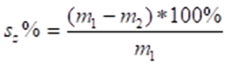
Where: m ₁ – mass at the beginning, g;
m ₂ – mass after annealing, g;
s _{z} % - juice losses, %.
Then express the juice loss % in points:
s _{z} 1% - 5 points
1% - 5%: 4 points
5% - 10%: 3 points
10% - 20%: 2 points
s _{z} 21% - 1: point
- Ascorbic acid content in berries
One of the indicators of the quality of frozen berries is the content of ascorbic acid.
Determine the content of L-ascorbic acid (reduced form) in the given samples by the iodine method.
Methodology:
1. Prepare a standard solution of ascorbic acid: 40 mg of ascorbic acid per 100 mL of 6% oxalic acid solution.
2. Add 2 mL of 1% starch solution to 25 mL of ascorbic acid standard solution and titrate with 0.05 M iodine solution while stirring. Observe the colour change. Write down the amount of iodine used.
3. Weigh 25 g of berries into a 250 mL beaker.
4. 100 mL of 6% H ₂ C ₂ O ₄ solution is poured over the prepared weight and blend for 60 seconds in a mixer.
5. Filter through a cotton filter.
6. Add 2 mL of 1% starch solution to 10 mL of filtrate and titrate with 0.05M iodine solution while stirring. Observe the colour change that does not disappear within 30 seconds and write down the amount.
Calculation of ascorbic acid:
$$C vit. \left(\frac{mg}{100g}\right)=5000* \frac{ V_{J sample}}{{m* V}_{J standard}}$$
5000 - coefficient
V _{Jin the sample} - the amount of iodine solution used for the titration of 10 mL of the sample
V _{Jst. no.} - the amount of iodine solution used for the titration of 25 mL standard solution
m – sample mass.
- Sensory evaluation of chilled berries
When the berries have ripened, each representative of the group should evaluate their appearance, colour, taste and aroma in points according to the descriptions given in table 8.2.
Table 8.2
Sensory characteristics of frozen and thawed berries
Parameter | 5 points | 4 points | 3 points | 2 points | 1 point
Appearance, structure | Beautiful, firm, completely matching the appearance of fresh berries | Good appearance, firm, little change in shape or structure | Slightly crushed or torn, soft, oozing | The structure is strongly changed, the berries are disintegrated or curled | Berries have completely lost their shape and natural structure and appearance
Colour | Bright, completely matching the colour of fresh berries | The berries are in their natural colour, however, there are slight colour changes in some places | All berries show slight colour changes (browning, etc.) | Most berries show strong colour changes | The berries have completely changed their natural colour
Taste | Perfectly suited to the taste of fresh berries | Basically corresponding to the taste of fresh berries, however, some other uncharacteristic aftertaste is slightly noticeable | Unexpressed, a little bland, an uncharacteristic aftertaste can be felt | Strongly pronounced other uncharacteristic flavours (bitterness, bitterness, etc.) | Completely changed, with a distinct unpleasant aftertaste
Aroma | Strong aroma of fresh berries | A slightly weaker, yet well-perceived aroma of fresh berries | Very weak, almost imperceptible aroma of fresh berries | There is no aroma or a foreign, uncharacteristic aroma is felt | Strong unpleasant smell
Calculate the average points for the appearance, colour, taste, aroma of berries.
- Assessment of berry quality.
Summing up the obtained results (adding together all the points obtained both after determining juice loss and organoleptic evaluation and extracting the average) and determining the quality of the berries:
4.5 – 5 points – very good quality berries;
4.0 – 4.4 points – good quality berries;
3.5 – 3.9 points – berries of average good quality;
3.0 – 3.4 points – average quality berries;
2.5 – 2.9 points – poor quality berries;
2.4 points – berries of inadequate quality (defective).
Task 2
- Comparison of cooking time for fresh and frozen vegetables
Take fresh and frozen carrots, potatoes and beets and boil them separately. Determine the cooking time of all samples.
- Colour (in the L*a*b* system) analysis
To compare fresh and frozen fruits and vegetables in the colour coordinate system, the sample is placed on a napkin (if the sample is very soft, it is placed in a Petri dish). The sample is then analysed with a colour analyser in the L*a*b* system. The L*a*b* system uses three perpendicular axes, on which a negative a* value represents the intensity of the green colour, a positive a* value represents the intensity of the red colour, a negative b* value means an increase in the blue colour intensity, a positive b* value represents the yellow colour intensity, while L* is a representative of white-black or light-dark intensity.
- Structure analysis with Structure Analyser
Measurements are made on fresh, frozen and cooked samples. Choose 3 pieces of fruit, vegetables, which are placed on the tray of the structure analyser. Measurements are made by pressing the sample with a knife and measuring the force (N) with which the sample can be cut at a pressing speed of 1 mm s ⁻¹.
The result is the maximum force (N) required to cut the product in question.
The softer the fruit or vegetable, the less cutting force is required.
The obtained data are compared with the data of other frozen samples and relevant conclusions are made about the effects of processing and freezing.

Results
Compare physical analysis indicators with fresh and frozen fruits and vegetables. Summarise the results in the given tables 8.3 ant table 8.4.
Table 8.3
Compilation of quality indicators of fresh and frozen fruit and vegetables
Option | Colour L* | Colour a* | Colour b* | Boiling time, min. | Hardness, N
Fresh
v. 1
v. 2
v. 3
v. 4

Table 8.4
Sensory evaluation of frozen apples and vegetables
Parameters | The fresh ones | Frozen ones
Parameters | The fresh ones | v. 1 | v. 2 | v. 3 | v. 4
Colour
Structure
Taste
Aroma
Boiling time
If the quality to be evaluated does not differ between the fresh and frozen samples, then both are evaluated with a rating of "1", if they differ, then the one with the weaker quality is evaluated with "0", the best with "1". The notes indicate how pronounced and what the difference is.

Conclusion
Provide an overview on the obtained results. Write possible explanations for the detected differences.

Approved by ______________________________________
Name, surname, signature
Date ______________________________________

Theme 10

Sensory aspects of processed fruit and vegetable products

Knowledge questions
After familiarising yourself with the lecture materials provide answers to the following questions.
- What sensory properties should be evaluated for processed fruit and vegetable products?
- What sensory methods can be used to evaluate processed fruit and vegetable products?
- How to present and analyse the results obtained in a sensory evaluation?
- How can sensory evaluation be integrated into the quality control process for processed fruit and vegetables?
- What are the common sensory defects encountered in processed fruit and vegetables and how are they addressed?

Approved by ______________________________________
Name, surname, signature
Date ______________________________________

Theme 11

Thermally processed vegetable preserves

Processed potato products

Theoretical materials
Potatoes are used for the production of alcohol, starch extraction, and the production of various food products. The breakdown of processed potato products is summarised in the Figure 11.1.
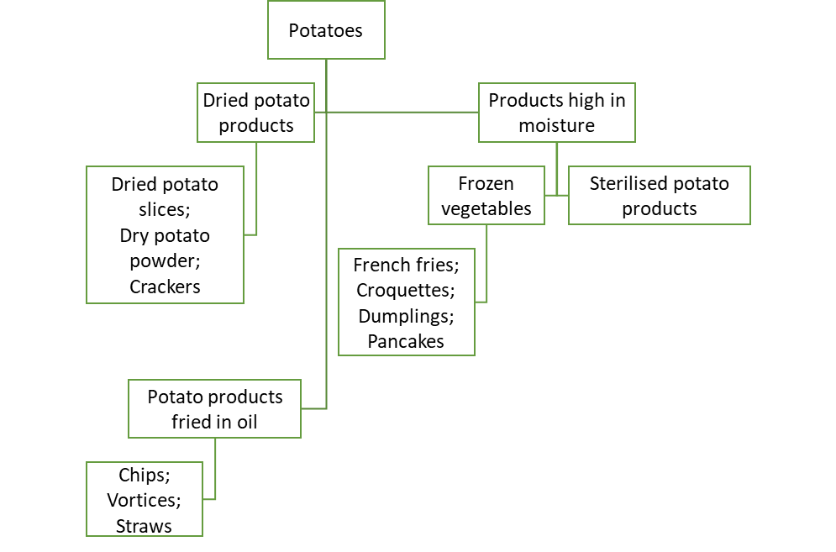
Fig 11.1 Processed potato products

Potato processing involves transforming raw potatoes into various products, each with its own specific processing methods, quality parameters, and production requirements. Here are some common processed potato products, their quality parameters, and an overview of their production processes.

1. Potato chips
Quality parameters:
- Colour - uniform golden-brown,
- Texture - crisp and crunchy,
- Flavour - free from off-flavours, not too oily or burnt,
- Oil content - controlled to avoid greasiness,
- Absence of defects - no brown spots, blisters, or uneven slices.
Production process:
- Selection and cleaning: Choose high-quality potatoes with low sugar content. Wash to remove dirt and debris.
- Peeling: Mechanically or chemically peeled to remove skins.
- Slicing: Potatoes are sliced uniformly using a slicer.
- Blanching: Optional step to remove excess starch and improve texture.
- Frying: Slices are fried in hot oil (typically 175 – 185 °C) until crispy.
- Seasoning: Chips are seasoned with salt and other flavourings.
- Packaging: Cooled chips are packed in moisture-proof packaging.
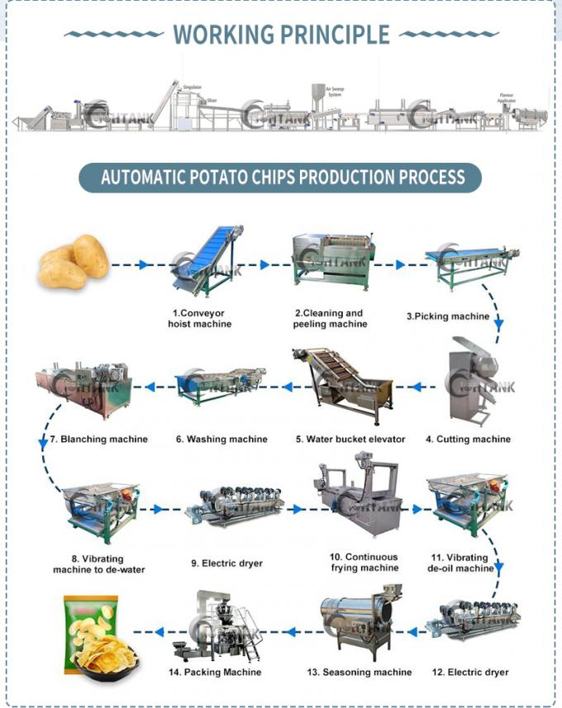
Fig. 11.2 Potato chip production line https://www.potatoproductionline.com/sale-14146204-500kg-h-potato-chips-production-line-potato-chips-making-machine-for-small-business.html

2. French fries
Quality parameters:
- Colour - Light to golden brown,
- Texture - crispy exterior, fluffy interior,
- Length - uniform length preferred,
- Flavour - no off-flavours, consistent seasoning,
- Oil content - not excessively oily.
Production Process:
- Selection and cleaning: Use potatoes with high solids content. Clean thoroughly.
- Peeling: Mechanically or steam-peeled.
- Cutting: Potatoes are cut into strips or wedges.
- Blanching: Blanched in hot water or steam to remove excess starch.
- Drying: Surface moisture is removed to improve frying efficiency.
- Par-frying: Partially fried to set the structure.
- Freezing: Rapidly frozen to preserve quality.
- Final frying: Fully fried at the point of sale or by the consumer.

3. Dehydrated potato products
Quality parameters:
- Colour - light cream to yellow,
- Texture - rehydrates to a smooth, non-gritty texture,
- Flavour - clean potato flavour,
- Moisture content - low to ensure long shelf life.
Production process:
- Selection and cleaning: Choose high-quality potatoes. Clean thoroughly.
- Peeling: Mechanically or steam-peeled.
- Cutting and cooking: Potatoes are cut into desired shapes and cooked.
- Mashing: Cooked potatoes are mashed into a uniform consistency.
- Dehydrating: Water is removed using drum dryers or other dehydration methods.
- Packaging: Dehydrated products are packed in moisture-proof packaging.

4. Potato starch
Quality parameters:
- Purity - high starch content with minimal impurities,
- Colour - white, free from discoloration,
- Granule size - consistent granule size
- Moisture content - controlled for storage stability.

Production process:
- Selection and cleaning: Use high-starch potatoes. Clean thoroughly.
- Grinding: Potatoes are ground to release starch granules.
- Separation: Starch is separated from the potato pulp using water and centrifugal force.
- Drying: Starch is dried to reduce moisture content.
- Packaging: Dried starch is packed in moisture-proof packaging.

Production considerations
- Quality control:
  - Regular inspection of raw materials and finished products.
  - Monitoring of processing conditions (temperature, time, etc.).
  - Sensory evaluation (taste, texture, appearance).
  - Microbiological testing to ensure safety.
- Hygiene and sanitation:
  - Maintaining clean equipment and facilities.
  - Adhering to good manufacturing practices (GMP) and HACCP protocols.
- Storage and distribution:
  - Proper storage conditions to maintain product quality.
  - Effective packaging to protect against moisture, light, and contamination.
  - Efficient distribution channels to ensure timely delivery to markets.

Laboratory work

Preparation and analysis of potato processing products using different technologies - French fries

Materials
Good quality potatoes, vegetable oil, salt and or other seasonings based on preferences or availability.
Laboratory equipment: deep fryer; dehydrator (convective dryer); electric grader (optional); freeze-dryer; plate-type freezer or flash freezer.

Methods
Task 1
Prepare "French fries" using different processing technologies
- Potatoes are peeled, rinsed, cut into straws, put in water to which salt and spices are added. After 10 minutes, take the potatoes out of the water, dry them and fry them in hot oil at 180 °C until they acquire a golden brown crust.
- Potatoes are peeled, rinsed, cut into straws, put in water to which salt and spices are added. The potatoes are then blanched in water at 85 °C for 7-8 minutes. After blanching, they are removed from the water, dried and fried in hot oil at 180 °C until they acquire a golden brown crust.
- Potatoes are peeled, rinsed, cut into straws, put in water to which salt and spices are added. They are then blanched in water at 85 °C for 7-8 minutes. After blanching, they are removed from the water and dried in a convective dryer at 100 °C for 10 minutes. Fry the dried potatoes in hot oil at 180 °C until they acquire a golden brown crust.
- Potatoes are peeled, rinsed, cut into straws, put in water to which salt and spices are added. The potatoes are then blanched in water at 85 °C for 7-8 minutes. After blanching, the potatoes are removed from the water and dried in a convective dryer at 100 °C for 15 minutes, cooled and frozen in a plate-type freezer. Fry the frozen potatoes in hot oil at 180 °C until they acquire a golden brown crust.
- Potatoes are peeled, rinsed, cut into straws, put in water to which salt and spices are added. They are then blanched in water at 85 °C for 7-8 minutes. After blanching, they are removed from the water and dried in a convective dryer at 100 °C for 20 minutes. Fry the dried potatoes in hot oil at 180 °C until they acquire a golden brown crust.

Task 2
- Analysis of “French fries”
- Detection of “French fries” fragility using structure analyser.
The samples to be analysed are placed on the structure analyser tray (figure 11.3). Measurements are performed by pressing the surface of a special tip on the sample and measuring the force (N) with which the sample can be broken at a pressing speed of 1 mm s ⁻¹
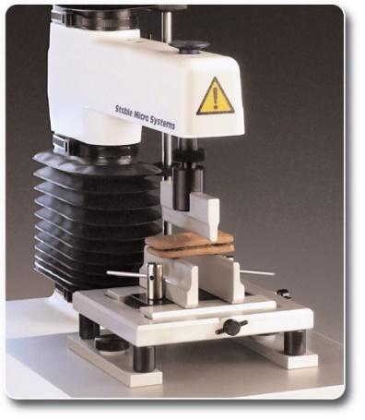
Fig. 11.3 Structure analyser https://www.stablemicrosystems.com/TAXTplus.html
The result is the maximum force (N) required to break the sample in question. The more fragile the products, the less force will be required to break the product, while hard, unbreakable potato straws will require more force.
- Detection of moisture content in “French fries”
Drying the sample to constant weight is the most commonly used method for moisture determination in various products.
Chop the potato straws into small pieces with a knife. A heated weighing glass (a metal dish with a lid) is weighed on the balance and approximately 2 g of the sample is weighed (to the nearest 3 decimal places). The weighing cups with the samples are placed in an oven at 105 °C for 3 hours, with the cap placed under the weighing cup. After drying, the measuring cups are removed from the drying oven with tongs, put on a cap and placed in a desiccator to cool. Weigh the cooled, closed measuring cups. Calculate the moisture content of the sample according to the formula:
$$\frac{\left(M-x\right)-(m-x)}{(M-x)}×100=\frac{M-m}{M-x}×100$$
where M – initial mass of the sample + weighing glass ;
x – mass of weighing glass;
m – final mass of yeast + container
- Colour analysis (in the L*a*b* system).
Colour is one of the most important criteria for the external appearance of the product. If the product oxidises very quickly, the colour may be unattractive, brownish or greyish, so it is important to evaluate and compare the colour.
To determine the colour of the products in the CIE L*a*b* coordinate system, several potato straws are put together, placed on a table on white paper and analysed with a colour analyser. The L*a*b* system uses three perpendicular axes, on which a negative a* value represents the intensity of the green colour, a positive a* value represents the intensity of the red colour, a negative b* value means an increase in the blue colour intensity, a positive b* value represents the intensity of the yellow colour, but L* is a characteristic of white (L=100) – black (L=0) or light-dark intensity (figure 11.4).
Fig. 11.4 CIE L*a*b* colour system https://www.ulprospector.com/knowledge/16423/pc-the-cielab-system-the-method-to-specify-colors-of-coatings/
- Please describe sensory properties of prepared French Fries before and after frying

SAMPLE 1_____________________________

Appearance (colour, shape size):
Before frying_________________________________________________________________

After frying __________________________________________________________________

Aroma:
Before frying_________________________________________________________________

After frying __________________________________________________________________

Oiliness (oil content):
Before frying_________________________________________________________________

After frying __________________________________________________________________

Taste:
Before frying_________________________________________________________________

After frying __________________________________________________________________

SAMPLE 2__________________________________

Appearance (colour, shape size):
Before frying_________________________________________________________________

After frying __________________________________________________________________

Aroma:
Before frying_________________________________________________________________

After frying __________________________________________________________________

Oiliness (oil content):
Before frying_________________________________________________________________

After frying __________________________________________________________________

Taste:
Before frying__________________________________________________________________

After frying __________________________________________________________________

SAMPLE 3__________________________________

Appearance (colour, shape size):
Before frying_________________________________________________________________

After frying __________________________________________________________________

Aroma:
Before frying_________________________________________________________________

After frying __________________________________________________________________

Oiliness (oil content):
Before frying_________________________________________________________________

After frying __________________________________________________________________

Taste:
Before frying_________________________________________________________________

After frying __________________________________________________________________
SAMPLE 4__________________________________

Appearance (colour, shape size):
Before frying_________________________________________________________________

After frying __________________________________________________________________

Aroma:
Before frying_________________________________________________________________

After frying __________________________________________________________________

Oiliness (oil content):
Before frying_________________________________________________________________

After frying __________________________________________________________________

Taste:
Before frying_________________________________________________________________

After frying __________________________________________________________________

SAMPLE 5__________________________________

Appearance (colour, shape size):
Before frying_________________________________________________________________

After frying __________________________________________________________________

Aroma:
Before frying_________________________________________________________________

After frying __________________________________________________________________

Oiliness (oil content):
Before frying_________________________________________________________________

After frying __________________________________________________________________

Taste:
Before frying_________________________________________________________________

After frying __________________________________________________________________

Results
Create a table to combine the obtained data on the analysed samples and fill it out.

Conclusion
Provide an overview on the obtained results. Write possible explanations of the detected differences.

Approved by ______________________________________
Name, surname, signature
Date ______________________________________

Laboratory work

Preparation and analysis of potato processing products using different technologies - chips

Materials
Good quality potatoes, vegetable oil, salt and or other seasonings based on preferences or availability.
Laboratory equipment: deep fryer; dehydrator (convective dryer); electric grader (optional); freeze-dryer.

Methods
Task 1
Preparation of potato chips with different processing technologies.
- Peel the potatoes, rinse them, chop them into thin slices with an electric grater, put them in water to which salt and spices are added. After 10 minutes, take the potatoes out of the water, dry them and fry them in hot oil at 180 °C until they acquire a golden brown crust and are crispy.
- Peel the potatoes, rinse them, cut them into thin slices with an electric grater, put them in water to which salt and spices are added. The potatoes are then blanched in water at 85 °C for 7-8 minutes. After blanching, they are removed from the water and dried in a convective dryer 100 °C 10 minutes. Fry the dried potatoes in hot oil at 180 °C until they acquire a golden brown crust.
- Peel the potatoes, rinse them, cut them into thin slices with an electric grater, put them in water to which salt and spices are added. Then the potatoes are blanched in oil at 180 °C for 45 seconds, and then in water at 85 °C for 5 minutes. The potato slices are removed from the water, drained and dried in a convective dryer at 110 °C until completely dry and crispy.
- Peel the potatoes, rinse them, cut them into thin slices with an electric grater, put them in water to which salt and spices are added. After that, the potatoes are blanched in oil at 180 °C for 45 seconds, and then in water at 85 °C for 5 minutes. The potato slices are removed from the water, drained, and dried in a freeze-dryer until they are completely dry and crispy.
- Peel the potatoes, rinse them, cut them into thin slices with an electric grater, put them in water. After that, the potatoes are blanched in water at 85 °C for 5 minutes, dried and fried in oil at 180 °C for 45 seconds. The potato slices are removed from the oil, drained, and dried in a freeze-dryer until they are completely dry and crispy.

Task 2
Analysis of prepared potato chips
- Determining the brittleness of potato chips with a structure analyser.
The samples to be analysed are placed on the structure analyser tray. Measurements are performed by pressing the surface of a special tip on the sample and measuring the force (N) with which the sample can be broken at a pressing speed of 1 mm s ⁻¹.
The result is the maximum force (N) required to break the sample in question. The more brittle the products, the less force will be required to break the product, while hard, unbreakable potato chips will require more force.
- Determination of moisture content of potato chips
Drying the sample to constant weight is the most commonly used method for moisture determination in various products.
Mash the potatoes into small pieces. A heated weighing glass (a metal dish with a lid) is weighed on the balance and approximately 2 g of the sample is weighed (to the nearest 3 decimal places). The weighing cups with the samples are placed in an oven at 105 °C for 3 hours, with the cap placed under the weighing cup. After drying, the measuring cups are removed from the drying oven with tongs, put on a cap and placed in a desiccator to cool. Weigh the cooled, closed measuring cups. Calculate the moisture content of the sample according to the formula:
$$\frac{\left(M-x\right)-(m-x)}{(M-x)}×100=\frac{M-m}{M-x}×100$$
where M – initial mass of the sample + weighing glass;
x – mass of weighing glass;
m – final mass of yeast + container.
- Colour (in the L*a*b* system) analysis.
Colour is one of the most important criteria for the external appearance of the product. If the product oxidises very quickly, the colour may be unattractive, brownish or greyish, so it is important to evaluate and compare the colour.
To determine the colour of the products in the CIE L*a*b* coordinate system, 5 identical chips are selected by colour, the potato chips are placed on the table on white paper and analysed with a colour analyser. The L*a*b* system uses three perpendicular axes, on which a negative a* value represents the intensity of the green colour, a positive a* value represents the intensity of the red colour, a negative b* value means an increase in the blue colour intensity, a positive b* value represents the intensity of the yellow colour, but L* is a characteristic of white (L=100) – black (L=0) or light-dark intensity.

Results
Create a table to combine the obtained data on the analysed samples and fill it out.

Conclusion
Provide an overview on the obtained results. Write possible explanations of the detected differences.

Approved by ______________________________________
Name, surname, signature
Date ______________________________________

Laboratory work

“Sensory evaluation of potato chips”
The aim of this laboratory work is to evaluate how different preparation methods can affect sensory properties (colour, aroma, crunchiness, salty taste and aftertaste) of potato chips.

Materials
Each panellist receives 4-5 prepared potato samples. The potato chips are served in containers coded with three randomised numbers. At least 3 chips are served to each panellist. Warm black tea is used to neutralise the taste between samples.

Methods
Just about Right (JAR) test - helps in product optimisation by identifying attributes that need adjustment to meet consumer expectation.
JAR (Just about Right) test
TRAY NO. _____________________________________
Select and write on the right-hand side of the scale the sensory properties that are specific to potato chips.
Please, evaluate the sensory properties (colour, aroma, crunchiness, salty taste and aftertaste) of potato chips samples using the JAR (Just About Right) test.
Please, indicate your opinion about potato chips sensory properties, marking the squared box that matches your preference and liking.
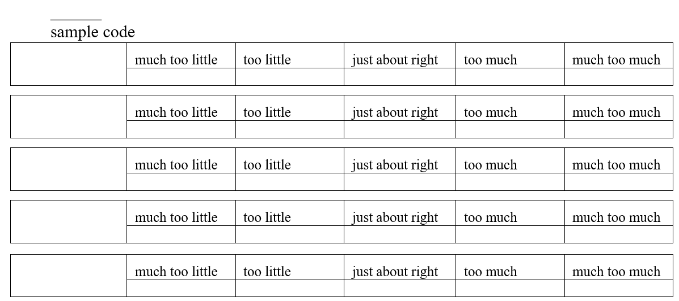

Conclusion
Provide an overview on the obtained results. Write possible explanations of the detected differences.

Approved by ______________________________________
Name, surname, signature
Date ______________________________________

Tomato processing products

Theoretical materials
Producing tomato products involves a variety of processes to transform fresh tomatoes into items like tomato paste, tomato sauce, canned tomatoes, and tomato juice. Each product requires specific steps to ensure quality, safety, and flavour.
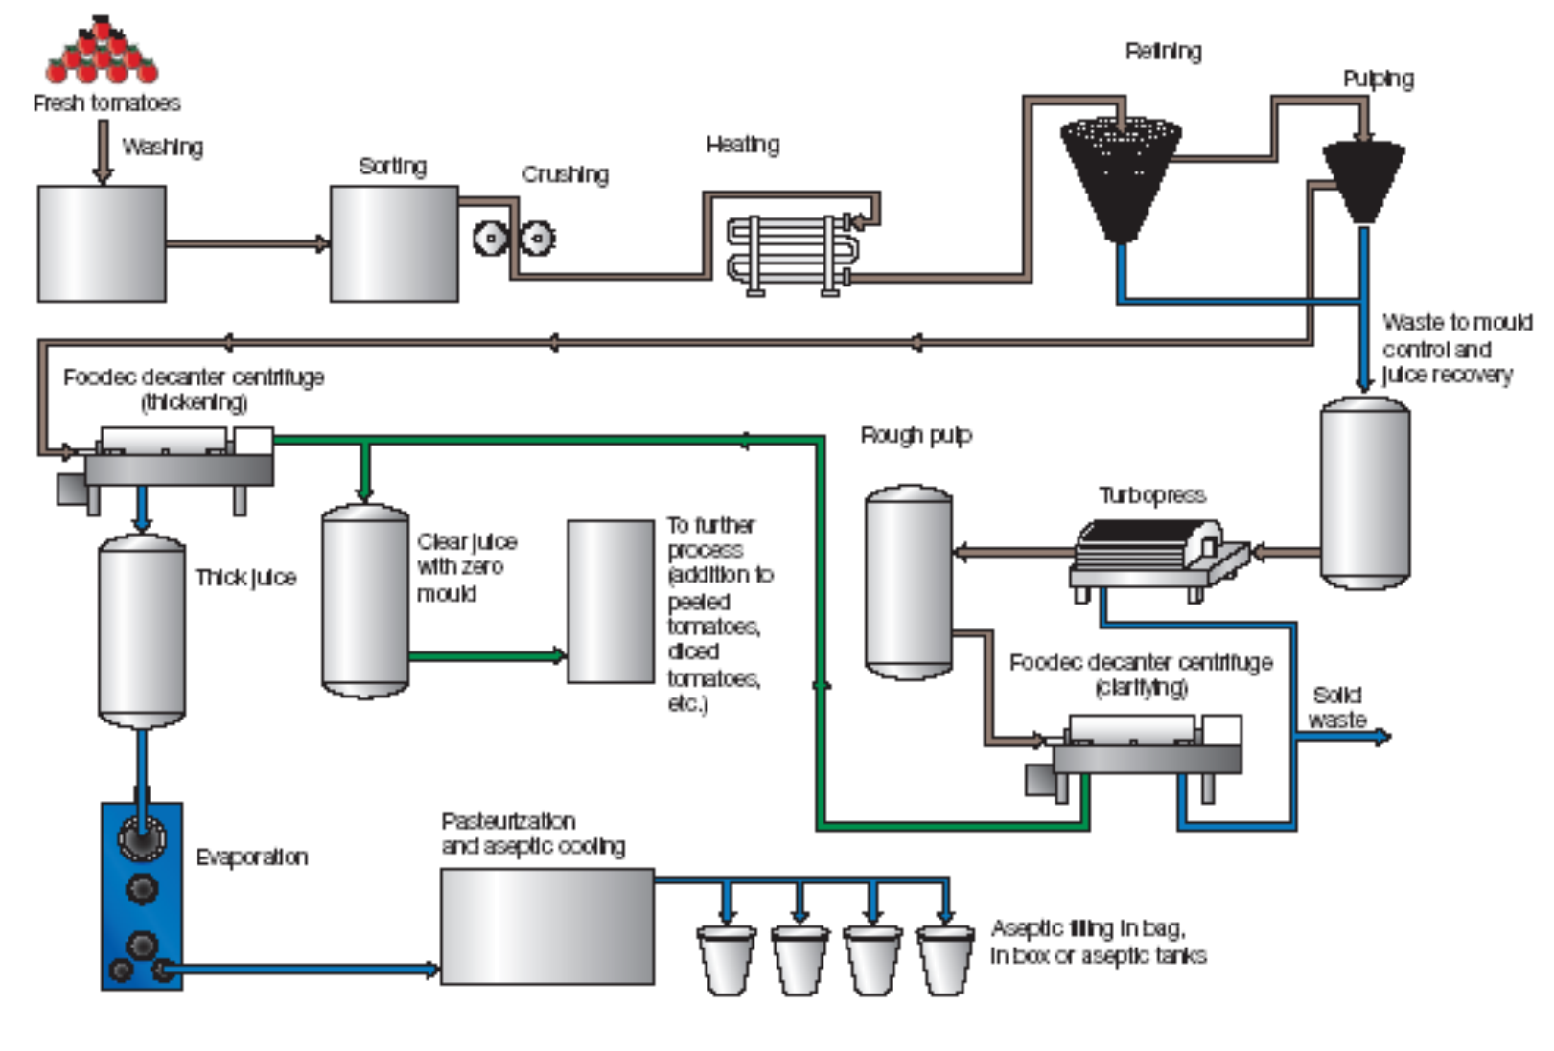
Fig. 11.5 Production of tomato paste https://mazmach.tripod.com/id4.html
Tomato paste, tomato juice, ketchup, hot sauce, and tomato sauce are all tomato-based products, but they differ significantly in their ingredients, consistency, preparation methods, and culinary uses.
Tomato sauce is a product made from concentrated tomato products (paste, puree) or fresh tomatoes with various spices and herbs, packed in hermetically sealed containers. Tomato sauces may be pasteurised or preserved with a preservative.

Table 11. 1
Overview of tomato product characteristics
Product | Ingredients | Consistency | Preparation | Uses
Tomato paste | Tomatoes | Very thick | Long cooking and reduction, strained | Base or thickener for soups, stews, sauces
Tomato juice | Tomatoes, sometimes salt/seasoning | Smooth, liquid | Crushed and heated tomatoes, strained | Beverage, cocktail base, soup base
Ketchup | Tomatoes, vinegar, sugar, salt, spices | Smooth, thick | Cooked tomatoes with vinegar, sugar, spices, pureed | Condiment for fries, burgers, hot dogs, sauces, marinades
Hot sauce | Tomatoes, vinegar, chilli peppers, salt, spices | Thin to moderately thick | Blended tomatoes with chilli peppers and other ingredients, cooked | A condiment to add heat to dishes
Tomato sauce | Tomatoes, onions, garlic, herbs, sometimes meat/vegetables | Thick, smooth to chunky | Cooked tomatoes with other ingredients, blended if desired | Base for pasta, pizza, casseroles, savoury recipes

Tomato sauce and ketchup in Latvia
In Latvia, most companies traditionally produce tomato sauces according to company standards, assuming that no food additives should be added to tomato sauces, except for the preservative - sorbic acid.
At the moment, in Latvia, there is no definition of the difference between tomato sauce and ketchup. In the dictionary, ketchup is translated as "hot tomato sauce" whereas, according to cookbooks, "ketchup" can be any hot sauce, and ketchup was originally a fish sauce.
Since there is no regulation in Latvia of what "ketchup" is, manufacturers freely interpret it, taking into account that ketchup is based on tomatoes, adding many permitted food additives (flavouring agents, thickeners).
The quality of tomato sauce is indicated by organoleptic and physicochemical quality indicators.

Table 11.2
Physico-chemical indicators of tomato sauce
No. | Indicators | The norm | Standard
1. | Dry matter content,% | 18-25 | VST 8756.2
2. | Salt content, % | 2.2-2.5 | VST 26186
3. | Titratable acidity, converted to acetic acid, % | 1.0-1.3 | VST2555.3
4. | Environmental pH | 3.8-4.4 | VST 26188
5. | Mineral impurities | are not allowed | VST 25555.5
6. | Mass fraction of fat, % | 2 | -

Laboratory work

Preparation of tomato concentrates and sauces using different technologies

Materials
Tomatoes and other ingredients for tomato product preparation.
Laboratory equipment: digital refractometer, pH meter; colour analyser; rotary juicer; rotary-type vacuum evaporator; vacuum cooker.

Methods
Task 1
Weigh the tomatoes intended for juicing. Obtain tomato juice with a mechanical slow rotation press. If the tomato pulp is very wet when pressed the first time, it can be pressed again. Weigh the resulting juice and calculate the juice yield.
Task 2
Determine the following quality indicators for the finished juice sample.
- Soluble solids (using refractometer)
To compare the degree of sweetness of the juice, the content of soluble solids is determined by using digital refractometer, by placing 3 drops of the liquid part of the product on the prism of the refractometer and taking a reading. Measurements are performed in three replicates and the arithmetic mean is calculated.
- Product pH
To determine the product pH in a juice sample, it is poured into a beaker in which the electrode of the pH meter is dipped and the pH of the product is determined. Measurements are performed in triplicate and averaged.
- Colour (in the L*a*b* system) analysis
Colour is one of the most important criteria for the external appearance of juices. If the juice oxidises very quickly, the colour may be unattractive, brownish or greyish, so it is important to evaluate and compare the colour.
To determine the colour of juices in the CIE L*a*b* coordinate system, the product is poured into a prepared Petri dish so that the cap fits tightly to the product without an air gap, placed on a table on white paper and analysed with a colour analyser. The L*a*b* system uses three perpendicular axes on which a negative a* value reflects the intensity of the green colour, a positive a* value reflects the intensity of the red colour, a negative b* value - an increase in the blue colour intensity, a positive b* value - the intensity of the yellow colour, while L* represents the intensity of the light-dark colour. L=0 corresponds to black, L=100 to white.
Task 3
Concentrate the resulting juice with the following methods.
- Atmospheric pressure, boiling on the stove in an open pot at 100 °C to a soluble solids content of 24 Brix %. Note the cooking time.
- In a rotary-type vacuum evaporator at a temperature of 60 °C to a soluble solids content of 24 Brix %. Fix the cooking time.
- Stephen in a vacuum cooker at 70 °C to a soluble solids content of 20 Brix %. Fix the cooking time.
pH and colour after concentration. All the obtained results are summarised in table 11.3.
Task 4
Using the raw materials available, create your own tomato sauce or ketchup recipe for 500 g of the total product. Prepare the respective product and fill it into 2 jars.
Examples of recipes.
- Example: tomato sauce
INGREDIENTS: 300 g of onion, 1 tablespoon (tbsp) of oil, 1 kg of tomatoes, salt (to taste), 1 tbsp of vinegar, 4 cups of water, 3 tbsp of sugar, 1 chili, 1 cinnamon stick, ground white pepper (to taste), 3 cloves of garlic.
PREPARATION: Peel the onions, cut them into small pieces. Heat the oil in the pot in which to fry the onions. At the end, add garlic and fry for another half a minute.
Spices, sugar, salt, vinegar and chili are added to the tomato puree. Boil.
Fill in jars and cover.
- Example: thick ketchup with starch
The sauce comes out moderately spicy, with aromatic spices that can be added according to your taste and liking.
INGREDIENTS: 1.2 kg of tomatoes, 2 sweet peppers, 5-6 cloves of garlic, 1 tablespoon of starch, 2 teaspoons of salt, 50 g of sugar, 20 mL of 9% vinegar, spices according to taste and preferences – paprika, cumin, black pepper, cloves, bay leaves.
PREPARATION :
Put the tomato puree, paste or other concentrate in the pot. Cleaned and finely chopped sweet pepper is also added there.
Stew for 0.5 hour, stirring occasionally. Allow the mass to cool and blend or strain through a sieve. Pour back into the pot. Clean the garlic, take a piece of clean cheesecloth, put garlic and spices (except salt and sugar) in it. Put this bag in the pot. Stew for 20 minutes. Five minutes before the end, add salt and sugar, add vinegar and stir.
Remove the spice bag with a slotted spoon. Dissolve the starch in the cooled juice, which is poured before, and pour it into the hot ketchup. Leave to simmer over a low heat for another 5 minutes.
The hot sauce is poured into jars and closed.

Results
Table 11.3
Quality indicators of tomato juice concentrates obtained in different ways
Type of sample | Cooking time, min. | Soluble solids | pH | Colour |  |  | Consistency (N)
 |  |  |  | L* | a* | b* | Consistency (N)
Fresh juice
At atmospheric pressure 100 ℃
Vacuum- infusion
Vacuum cooking

Conclusion
Provide an overview on the obtained results. Write possible explanations of the detected differences.

Approved by ______________________________________
Name, surname, signature
Date ______________________________________

Laboratory work

Quality assessment of prepared tomato products

Materials
In previous laboratory work prepared tomato products.

Methods
Make a comparison of the physical and chemical parameters of your prepared sample of tomato sauce and two more coded samples. Based on the obtained indicators, evaluate their differences and whether the coded samples correspond to tomato sauce or ketchup.
- Determination of soluble solids with a refractometer
From the average sample, weigh 10 g of tomato sauce into a measuring cup, put it in a double-folded cheesecloth and press 2 drops of the sauce onto the lower prism of the refractometer. The drops are squeezed between the prisms and viewed in the eyepiece. The % of soluble solids is read on the scale on the right-hand side of the field of vision and compared to the standard requirements. Measurements are made in three replicates, and the dry matter content is determined as the arithmetic mean of the 3 replicates.
- Determination of table salt content by chemical method
Place 5 ml of tomato sauce or ketchup in a 100 ml beaker, add 3-4 drops of saturated potassium chromate solution (indicator) and titrate from a burette with 0.1 n silver nitrate solution. The reaction takes place according to the following scheme:
NaCl + AgNO ₃ = AgCl + NaNO ₃
AgCl precipitates as a white precipitate. As the chloride ion precipitates, the silver nitrate begins to react with the potassium chromate:
2 AgNO ₃ + K ₂ CrO ₄ + 2 KNO ₃ .
Ag ₂ CrO ₄ turns the solution orange-brown, indicating that the titration should be stopped. The amount of table salt is calculated according to the following formula:
Where: x - table salt content, %
a - AgNO3 0.1 n solution consumed for titration (ml).
b - the amount of filtrate taken for titration (ml).
0.00585 - amount of NaCl (g) corresponding to 1 ml of 0.1 n AgNO _{3.}

- Determination of titratable acid
Weigh 4 g of tomato sauce or ketchup into a 250 mL conical flask, add 100 mL of distilled water, add 3 drops of phenolphthalein, mix thoroughly and titrate with 0.1 n NaOH until a faint pink colour appears.
The amount of acid is calculated according to the formula:
$$S= \frac{v×n×k}{10×m}$$
Where: S - acid content (mg/g)
v - titrated volume of 0.1 n NaOH (ml)
n - NaOH normality (0.1).
k - acid coefficient, which is 64.047 when converted to citric acid.
m - mass of weight taken for titration (g)
- Determination of product pH
To determine the pH of the environment in the samples of tomato sauce, it is poured into a beaker in which the pH meter electrode is dipped and the pH of the product is determined.
- Structure analysis with structure analyser
The samples to be analysed, trying not to destroy their structure, are placed in a structure analyser dish in a 1.5 cm thick layer (Figure 2). Measurements are made by placing the dish with the sample on the base of the structure analyser (figure 2), pressing the sample with a wheel and measuring the compressive force (N) at a deformation rate of 1 mm s ⁻¹.
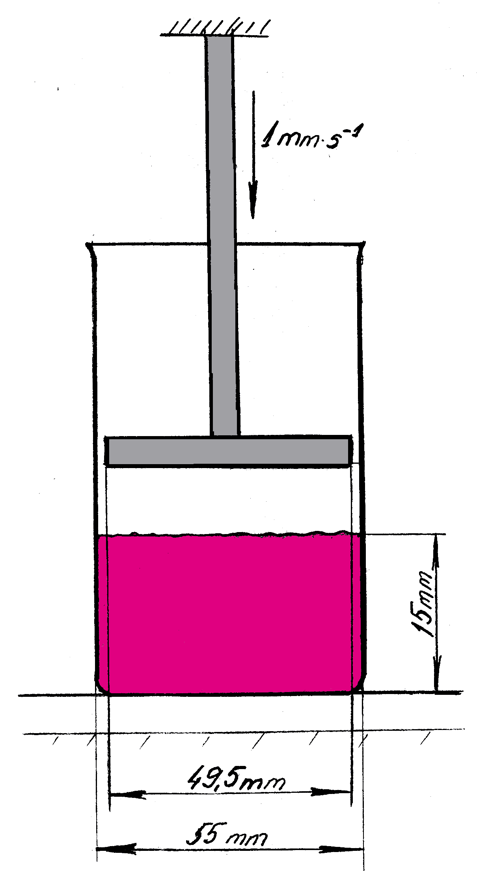
Fig.11.6 Structure analysis of sample
The result is the maximum force (N) required to push the puck through the sample layer.

- Colour (in the L*a*b* system) analysis
To determine the colour of tomato sauce and ketchup in the coordinate system, the sample is first placed in a clean Petri dish and a second glass cover is placed so that no air bubbles remain between the sample and the glass. The sample is then analysed with a colour analyser in the L*a*b* system. The L*a*b* system uses three perpendicular axes, on which a negative a* value represents the intensity of the green colour, a positive a* value represents the intensity of the red colour, a negative b* value means an increase in the blue colour intensity, a positive b* value represents the yellow colour intensity, while L* is a representative of white-black or light-dark intensity.

Results
Create a table to combine the obtained data on the analysed samples and fill it out.

Conclusion
Provide an overview on the obtained results. Write possible explanations for the detected differences. Provide the data comparison with the parameters regulated in your country for tomato products.

Approved by ______________________________________
Name, surname, signature
Date ______________________________________

Laboratory work

Sensory evaluation of prepared tomato products

Materials
Each panellist receives 5 samples, which are evaluated according to the recommendation given in table 11.4. Each sample is given to the panellist in a 30 mL glass jar with a screw-on lid. Warm black tea or Maca bread is used to neutralise the taste between the samples.

Methods
Table 11.4
Recommendation of sensory analysis of tomato products
Sensory quality parameters | Evaluation in points
1. Appearance
Characteristic colour, characteristic of the type of product, homogeneous colour and consistency, shiny | 5
Characteristic with small deviations in the product colour, glossy | 4
A little matte, a little uncharacteristic colour (light red or brown colour), grainy | 3
Uneven, serum separation (solid phase and serum phase), dull | 2
Uncharacteristic of the type, lumpy, uneven pieces, beginning to deteriorate | 1
2. Consistency
Characteristic, homogeneous, slow flowing, creamy | 5
Characteristic with minor deviations | 4
A little too liquid, uneven, floury | 3
Watery, a bit lumpy, too thick | 2
Lumps / mismatched pieces, flaky, very flowy or very thick | 1
3. Aroma
Adequate, balanced, pleasant, balanced additive aroma | 5
Balanced with minor deviations | 4
Neutral, weakly expressed, slight unbalanced | 3
Vinegar, unbalanced, pungent, empty smell | 2
Very sour, very sharp, sour, uncharacteristic / foreign, mouldy | 1
4. Taste, aftertaste
Adequate, balanced, pleasant, pronounced taste and aftertaste of tomatoes and additives | 5
Appropriate with minor deviations | 4
Characteristic of the product, but weak or too pronounced, unstable, slight unbalance | 3
Vinegar, empty, watery, bare, dominated by one of the flavours, uncharacteristic, foreign | 2
Bitter, uncharacteristic, sour, unpleasant, very salty, very sour, very bitter, very sweet, pungent vinegar, musty | 1

The total score of sensory properties and their transcript:
18-20 very good quality
15-17 good quality
12-14 average quality
11 and under inadequate quality

Results
Evaluate the given tomato product samples according to evaluation recommendations given in table 11.5. For the appropriate evaluation, mark each characteristic with a mark and if any deviations are found, justify them.
Table 11.5
Sensory property | Points and characteristics
Sensory property | S1 | S2 | S3 | S4 | S5
Appearance
Consistency
Aroma
Taste and aftertaste
TOTAL

Conclusion
Provide an overview on the obtained results. Write possible explanations of the detected differences.

Approved by ______________________________________
Name, surname, signature
Date ______________________________________

Theme 12

Thermally processed fruit and berry preserves

Fruit and berry compotes, jams and purees

Theoretical materials
Heat-treated fruit and berry preserves include compotes, juices and similar products (such as syrups, drinks, nectars, etc.), as well as preserves with a high sugar content (jams, jellies, marmalades, etc.).
Compotes are fruit and berries from which the inedible parts have been removed, the raw materials are whole or cut into pieces, covered with sugar syrup and pasteurised or sterilised.
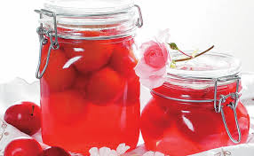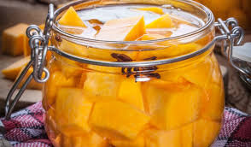
Fig 12.1 Plum https://www.santa.lv/raksts/ievasreceptes_/receptes/edienu-veidi/konservejumi/plumju-kompots-10512/ and pumpkin compote https://receptes.tvnet.lv/recepte/4339-kirbja-kompots
Canned foods with high sugar content
Jam is a mixture prepared to a jelly-like consistency, consisting of one or more types of fruit pulp or puree, or a mixture of both raw materials, as well as sugar and water.
Fruit jam is a fruit mixture heated and prepared to a flowing consistency, consisting of one or more types of whole or chopped fruit, their pulp or puree, as well as sugar and water, with a soluble solids content of 47-59% according to refractometer readings.
Jelly is a jelly-like consistency product consisting of one or more types of fruit juice or aqueous extracts, or a mixture of both raw materials and sugar.
Marmalade is a mixture prepared to a jelly-like consistency, consisting of water, sugar and one or more fruit raw materials - pulp, puree and juice, aqueous extracts and peel.

Laboratory work

Apple compote preparation

Materials
Apples, sugar, water, different types of additives (cinnamon bark; cranberry berries; rowan fruit; blueberries; sea buckthorn) and other spices based on preference.

Methods
Tasks
- weigh the apples, wash them, peel them and calculate the losses;
- prepare sugar syrup with a sugar concentration of your own choosing;
- prepare apple compote according to all three given processing methods, choosing the same type of additives and the same concentration of sugar for all types.
Winter and autumn apple varieties are the most suitable for making apple compote. Apples should be picked with patience. Apples of the same variety must be selected in one container for making compotes. To make good-looking compotes, choose apples with dense flesh, without bruises, because each bruise causes brown spots during heating.
After washing, peel the apples. Peeling is recommended with a stainless steel knife. Then core the apples and cut them into slices. Cut fruit should not be kept in the air, because they turn dark, and oxidise. Therefore, the cut slices are immediately placed in cold water, to which 2 teaspoons of vinegar or ½ teaspoon of citric acid have been added per litre of water. After preparing the apples, remove them from the water, drain the excess water on a sieve and pour over boiling sugar syrup. The amount of sugar depends on the variety of apples, degree of ripeness and the consumer taste preference.
Preparation of syrup
Dissolve 200-400 g of sugar in one litre of water and boil for 5-6 minutes, ½ litre of syrup is enough to pour over a litre jar.
Technique 1
Remove the prepared apples from cold water, drain, put in a bowl and pour over the prepared boiling sugar syrup, let it cool. During this time, the sugar syrup partially squeezes the air out of the apples (apples sometimes contain up to 25% air), the apple slices become elastic and light. The apples no longer turn dark because the enzymes in them have died.
Remove the apples from the syrup with a slotted spoon and pour them into heated jars. The remaining syrup is strained through a double cheesecloth to separate the remains of the apples, boiled and poured over the fruit.
To make it look prettier, you can add some other colourful berries or fruit.
Place a boiled metal lid on the prepared jar, cover and pasteurise at 85 °C: 0.5 l jar for 15 minutes, 1 l jar for 20 minutes. After that, the jars are covered andkept upside down for ½ hour and then cooled in the surrounding air.
Technique 2
Remove the prepared apples from cold water, drain, put in a bowl and pour over the prepared boiling sugar syrup, let it cool. During this time, the sugar syrup partially expels the air from the apples (apples sometimes contain up to 25% air), the apple slices become elastic and light. The apples no longer turn dark because the enzymes in them have died.
Remove the apples from the syrup with a slotted spoon and pour them into heated jars. The remaining syrup is strained through a double cheesecloth to separate the remains of the apples, boiled and poured over the fruit.
To make it look prettier, you can add some other colourful berries or fruit.
Place a boiled metal lid on the prepared jar, seal and sterilize °at 105 °C: 0.5 l jar for 3 minutes, 1 l jar for 5 minutes. The jars are then cooled.
Technique 3 - hot infusion
Prepared, sliced apples are placed in a pot, poured with previously prepared sugar syrup so that the apples are completely covered, slowly heated to a temperature of 90 °C. Then let it cool for half an hour. After that, the sugar syrup is drained from the apples and the apples are placed in jars, and the syrup is boiled and the boiling water is poured over it. After 10-15 minutes pour out the syrup and boil it for the third time. If the syrup is not clear, before the third boil, strain it through cheesecloth and pour it hot over the apples. Boiled metal lids are put on the jars and closed. The jars are kept upside down for half an hour and then cooled in the surrounding air.
This technique is better for large containers - 2-3 litre jars.
If the apples are not sour, 1-3 g of citric acid can be added to the sugar syrup per litre of syrup.

Approved by ______________________________________
Name, surname, signature
Date ______________________________________

Laboratory work

Quality evaluation of apple compotes
Materials
Previously prepared apple compote samples.
Methods
Analyse the quality parameters of previously prepared apple compotes.
- Colour (in the L*a*b* system) analysis
Colour is one of the most important criteria for the external appearance of compotes. If the apples have not been properly prepared, they can also be brown or grey in the compote, so it is important to evaluate and compare the colour.
To determine the colour of apple slices in the coordinate system, 5 apple slices of characteristic colour are selected, placed on the table on white paper and analysed with a colour analyser in the L*a*b* system. The L*a*b* system uses three perpendicular axes, on which a negative a* value represents the intensity of the green colour, a positive a* value represents the intensity of the red colour, a negative b* value means an increase in the blue colour intensity, a positive b* value represents the yellow colour intensity, while L* is a representative of white-black or light-dark intensity.
- Hardness, flexibility analysis with structure analyser
Another important indicator of quality in the finished compote is the firmness and consistency of apples and other additives. The fruit must not be disintegrated or too hard, tough.
Choose 3 apple slices of the same size, and place them on the tray of the structure analyser. Measurements are made by pressing the sample with a knife and measuring the force (N) with which the fruit can be cut at a pressing speed of 10 mm s ⁻¹.
The result is the maximum force (N) required to cut the product in question.
The softer the apple slices, the less cutting force is required.
Task Measure the maximum compressive force of the apple slices of your prepared compote and then compare it with the maximum compressive forces of other samples as well as the sensory consistency indicators.
- Soluble solids (refractometrically)
In order to compare the degree of sweetness of the prepared compotes, the content of soluble solids is determined refractometrically by dropping 3 drops of compote syrup on the prism of the refractometer and taking a reading. The measurements are performed in triplicate. The dry matter content is determined as the arithmetic mean of 3 replicates.
Task Measure the soluble solids content of your sample and compare the obtained data with the results of other samples, as well as with the obtained sensory evaluations of the degree of sweetness. Draw conclusions.
- Sensory evaluation using Quantitative descriptive method
The sensory evaluation of compotes is carried out according to the given table 12.1, which reflects the sensory indicators of a good compote.
Table 12.1
Quantitative descriptive method for compotes
Sensory parameters | Characterisation
Appearance | Apple slices cut the same, evenly arranged throughout the volume of the jar. The poured syrup is clear, evenly covering the fruit in the entire volume of the jar. For plums, the peel must not be cracked and peeling.
Structure | Apple slices are juicy, firm, easy to digest (they should not be hard or mushy).
Aroma | The aroma is pleasant, characteristic of apples, the aroma of added additives can also be smelled. No other side smells are allowed.
Taste | Balanced sweet and sour, pleasant, without bitterness or any other uncharacteristic aftertastes.
Colour | Light yellow or white (if no colouring additives are added), apple slices must not have brownish or other spots. The syrup should be golden clear with no signs of cloudiness. If colouring additives are added, the colouring should be uniform throughout the container.
A total of four compotes samples are used for the sensory evaluation - three from previously prepared samples and one from the store, already available in the market.
Use water to clean your mouth between samples.
Task - to evaluate the intensity of sensory properties (colour, aroma, crispness of apples, sour taste and sweet taste) for apple compotes samples.

12 cm Line scale
TRAY NO. _____________________________________
Please mark the intensities of the presented product samples on the Line scale and write the sample number below the marking.
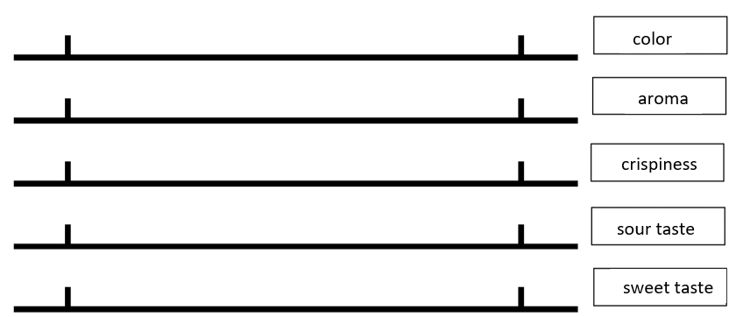

Results
- Create a table to combine the obtained data on the analysed samples and fill it out.
- Prepare sensory properties profile of analysed compotes samples in a spider graph!

Conclusion
Provide an overview on the obtained results. Write possible explanations for the detected differences.

Approved by ______________________________________
Name, surname, signature
Date ______________________________________

Fruit and berry marmalades

Theoretical materials
Thickeners and thickeners used in the production of jams, jellies and marmalades
Thickeners and thickeners are substances that increase the viscosity of the product without significantly changing its other properties.
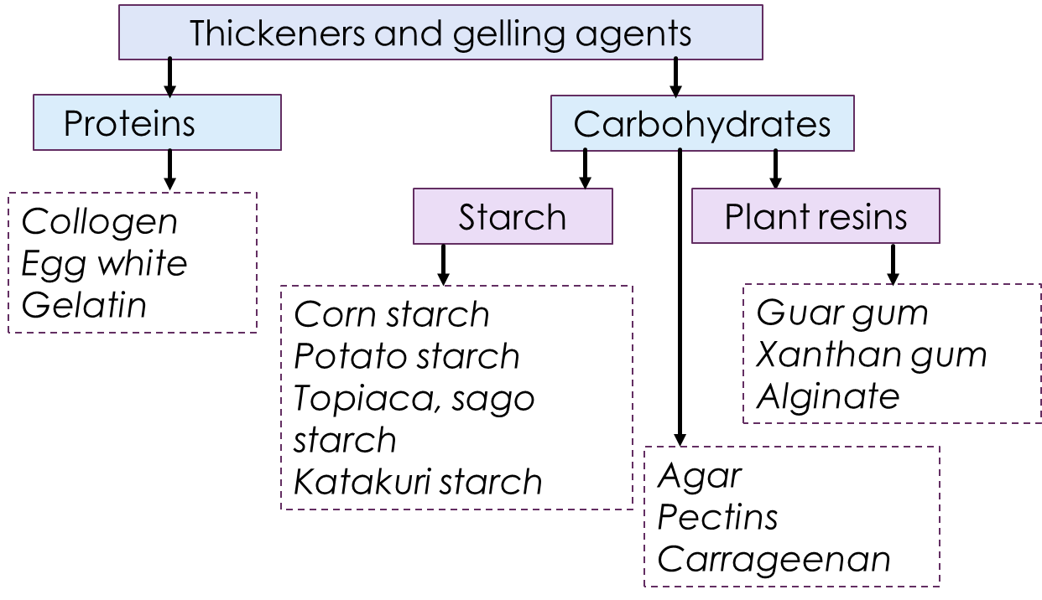
Fig. 12.2 Overview of thickeners and gelling agents used in production of fruit and vegetable products
Table 12.2
Comparison of some of the thickeners and gelling agents
Gelling Agent | Source | Properties | Advantages | Limitations | Applications
Pectin | Fruits (apples, citrus) | Requires sugar and acid, clear gel | Natural, common, firm gel | Needs precise conditions, sensitive to overcooking | Jams, jellies, marmalades
Gelatine | Animal collagen | Sets when cooled, melts upon reheating | Simple to use, versatile | Not vegetarian/vegan, heat sensitive | Fruit desserts, gelatine salads
Agar-Agar | Red algae | Sets at room temp, melts at 85 °C | Vegetarian/vegan, heat stable | Firm, less elastic texture, requires boiling | Fruit jellies, aspics
Carrageenan | Red seaweed | Various textures | Vegetarian/vegan, versatile | Requires careful measurement, potential allergen | Dairy and non-dairy desserts
Agarose | Red algae | Clear, strong gels | High clarity, firm gels | Expensive, specialised use | High-clarity fruit gels, lab uses
Starch | Corn, potato, tapioca | Thickens with heat, smooth texture | Widely available, inexpensive | Not a true gel, can become cloudy | Pie fillings, sauces, preserves
Pectin is a versatile and natural gelling agent derived from fruit, predominantly used in the food industry to create gels, stabilise products, and improve texture. It comes in two main types—high-methoxyl (HM) and low-methoxyl (LM)—each suitable for different applications based on their gelling requirements. Its wide range of uses includes jams, jellies, dairy products, confectionery, and beverages, making it an essential ingredient in fruit and berry production. Proper handling and precise usage are key to leveraging its full potential.
- Source: Pectin is a naturally occurring polysaccharide found in the cell walls of fruits and vegetables. It is particularly abundant in citrus fruits (like oranges and lemons) and apples.
- Structure: Pectin is a complex carbohydrate composed primarily of galacturonic acid units. These units are linked together to form a chain, with varying degrees of methylation and amidation influencing its gelling properties.
Types of Pectin:
- High-methoxyl (HM) pectin:
  - Degree of methylation: More than 50% of the galacturonic acid units are esterified with methanol.
  - Gelling conditions: Requires a high sugar concentration (typically 55-65%) and an acidic environment (pH 2.8-3.6) to gel.
  - Uses: Commonly used in making traditional jams, jellies, and marmalades.
- Low-methoxyl (LM) pectin:
  - Degree of methylation: Less than 50% of the galacturonic acid units are esterified.
  - Gelling conditions: Can gel with low or no sugar presence but requires the addition of calcium ions. Works well in a broader pH range (3.2-4.0).
  - Uses: Suitable for low-sugar or sugar-free jams, jellies, and dairy products like yogurt.
Functional properties:
- Gelling agent: Pectin forms a gel matrix by bonding with sugar and acid (HM pectin) or calcium ions (LM pectin), providing structure and texture to jams, jellies, and preserves.
- Stabiliser: Helps stabilize acidic protein systems, preventing curdling in products like yogurt and certain beverages.
- Thickener: Increases viscosity in fruit fillings, sauces, and syrups, contributing to the desired mouthfeel and consistency.
- Emulsifier: Assists in emulsifying and stabilizing emulsions, particularly in fruit-based products and beverages.
Preparation and usage:
- Dissolution: Pectin must be properly dissolved in water. For HM pectin, it is typically dissolved in boiling water with sugar and acid. For LM pectin, calcium ions are introduced to facilitate gelling.
- Concentration: The typical usage concentration ranges from 0.5% to 2.0%, depending on the desired gel strength and the type of pectin.
- Cooking: Overcooking can break down pectin, reducing its gelling ability. It’s important to follow precise cooking times and temperatures.
Quality control:
- Purity: High-quality pectin should have a high degree of purity, free from impurities that can affect gelling properties.
- Consistency: Consistent performance across batches is crucial for maintaining product quality.
- Storage: Pectin should be stored in a cool, dry place to prevent degradation and loss of gelling ability.
Gelatine is a highly versatile gelling agent derived from animal collagen. It forms a thermo-reversible gel and is used widely in the food industry for gummy candies, marshmallows, and jellied desserts, as well as in pharmaceuticals for capsules, and in cosmetics for its protein content. Its key properties include its ability to gel, thicken, foam, and emulsify. While it offers many benefits, such as versatility and safety, its animal origin and sensitivity to heat limit its use in certain applications. Proper handling, including hydration and temperature control, is essential for optimal performance.
- Source: Gelatine is derived from the collagen found in animal connective tissues, such as skin, bones, and cartilage. Common sources include bovine (cows) and porcine (pigs).
- Composition: Gelatine is a protein made up of amino acids, predominantly glycine, proline, and hydroxyproline. It forms when collagen is partially hydrolysed.
Physical and chemical properties:
- Appearance: Gelatine is typically available as a colourless or slightly yellow powder, granules, or sheets.
- Solubility: It dissolves in warm water, forming a viscous solution that gels upon cooling.
- Gel formation: Gelatine forms a thermo-reversible gel, meaning it sets when cooled and melts when heated. The gelling and melting points depend on the concentration and the type of gelatine.
Types of gelatine:
- Type A gelatine:
  - Source: Derived from acid-treated collagen (often from pork skins).
  - pH range: Typically has a pH between 4.8 and 5.5.
  - Uses: Commonly used in food products like gummy candies, marshmallows, and certain desserts.
- Type B gelatine:
  - Source: Derived from alkaline-treated collagen (often from bovine hides and bones).
  - pH range: Typically has a pH between 5.0 and 7.0.
  - Uses: Often used in pharmaceutical applications, capsules, and some food products.
Functional properties:
- Gelling agent: Gelatine can form gels of various strengths and textures, from soft and elastic to firm.
- Thickening agent: Increases the viscosity of liquids, providing a rich, smooth texture.
- Foaming agent: Stabilises foams in products like marshmallows and whipped desserts.
- Emulsifying agent: Helps in stabilising emulsions, improving texture and consistency.
Preparation and usage:
- Hydration: Gelatine must first be hydrated in cold water (blooming) before being dissolved in warm water.
- Concentration: Typical usage ranges from 0.6% to 3.0%, depending on the desired gel strength.
- Temperature control: Proper temperature control is crucial. Gelatine solutions should not be boiled as it can degrade the protein and reduce gelling ability.
Quality control:
- Bloom strength: Measures the firmness of the gelatine gel and is an indicator of gel strength. Higher bloom values indicate firmer gels.
- Clarity and colour: High-quality gelatine should be clear and free from colour, as this affects the appearance of the final product.
- Purity: Should be free from impurities that can affect performance and safety.
Advantages:
- Versatility: Can be used in a wide range of applications, both in food and non-food industries.
- Edible and safe: Generally recognized as safe (GRAS) by regulatory authorities.
- Thermo-reversibility: Can be repeatedly melted and re-gelled, useful for various culinary applications.

Limitations:
- Not vegetarian/vegan: Derived from animal sources, unsuitable for vegetarians and vegans.
- Heat sensitivity: Gelatine can break down if exposed to high temperatures for extended periods.
- Texture variability: The texture can be affected by the presence of other ingredients like acids or salts.

Laboratory work

Preparation of fruit and berry marmalades using different gelling agents

Methods
Make marmalade candies from the given raw materials: juices, purees and chopped berries. Convert marmalade recipes to 300g of product.
The gelling agents offered for making marmalades:
  - Pectins
    - HM pectin
    - LM 130 AS
    - LM 102 AS
  - Gelatine
  - Agar
Recipes:
- Marmalade candies with HM pectin (per 150 g total mass)
Recipe 1: Sugar 65 g; water 20 g; apple juice 40 g; cranberry puree 12 g; glucose syrup 10 g; HM pectin 2 g; citric acid 0.7 g; trisodium citrate 0.3 g.
Preparation : Weigh the liquid and dry ingredients separately. Pectin, citric acid, trisodium citrate are mixed together with sugar and added to the still cool product mass. Then, stirring the product over low heat, it starts to boil. Glucose syrup is added while continuing to stir while boiling. The mass continues to boil for at least 7-10 minutes (until the mass becomes already thick, viscous). The finished mass is quickly poured into previously prepared dishes.
- Marmalade candies with LM pectin (per 200 g total mass)
Recipe 2.1: Water 28.2 g; cranberry puree 20 g; apple juice 80 g; sugar 60 g; LM pectin 102 10 g; citric acid 1.6 g; ca citrate 0.2 g.
Recipe 2.2: Water 28.2 g; cranberry puree 20 g; apple juice 80 g; sugar 60 g; LM pectin 130 10 g; citric acid 1.6 g; ca citrate 0.2 g.
Preparation: Weigh the liquid and dry ingredients separately. Pectin, citric acid Ca citrate is mixed together with sugar and added to the still cool product mass. When everything is well mixed together, let the pectin swell for 5 minutes. After that, while stirring, the mass starts to heat up to the boiling point on a slow fire and continues to boil for about another 5 minutes. The finished mass is quickly poured into previously prepared dishes.

- Marmalade candies with gelatine (per 200 g total mass)
Recipe 3: Apple juice 80 g; cranberry juice 21 g; water 26 g; sugar 60 g; gelatine 12 g; citric acid 1 g.
Preparation: Water is mixed with juices and puree, sugar, gelatie, and citric acid. Allow the gelatine mass to swell for 5-10 minutes. When the gelatine swells, the mass is heated to 100 °C while stirring. The finished liquid mass is filled into dishes.
- Marmalade candies with agar (per 200 g total mass)
Recipe 4: Cranberry juice 30 g; apple juice 86 g; water 20 g; Sugar 60 g; Agar 4 g.
Preparation: Weigh all the ingredients, weigh the dry ingredients separately and mix together. Then they are mixed into the total mass. Boil the mass at 100 °C for about 5 minutes and then pour it into moulds.

Approved by ______________________________________
Name, surname, signature
Date ______________________________________

Laboratory work

Quality analysis of fruit and berry marmalades

Materials
Previously prepared fruit marmalades.

Methods
The quality of marmalades is determined by various chemical and physical indicators. In addition, the main indicators by which the quality of marmalades can be judged are directly physical: firmness, colour fastness.
Task 1 To determine the chemical quality indicators of marmalades:
- Soluble solids (refractometrically)
Weigh 5 g of marmalade from the sample into a measuring cup, add 5 g of hot distilled water, mix thoroughly, and put 2 drops of the obtained sample on the prism of the refractometer with a chopstick. The measurements are performed in triplicate. The dry matter content is determined as the arithmetic mean of 3 replicates and the dilution factor is included in the calculations.
$$S=a×k$$
where S – content of soluble solids in the product;
a – amount of dry matter measured with a refractometer, %;
k – dilution factor, k=2
- Titratable acids
Weigh 4 g of marmalade into a 250 mL conical flask, add 100 mL of hot distilled water, mix thoroughly. Then, add 3 drops of phenolphthalein, mix thoroughly and titrate with 0.1 N NaOH until a faint pink colour appears. The amount of acid is calculated according to the formula:
$$S= \frac{v×n×k}{10×m}$$
where: S - acid content (mg/g)
v - titrated volume of 0.1 n NaOH (mL)
n - NaOH normality (0.1).
k - acid coefficient, which is 64.047 when converted to citric acid.
m - mass of weight taken for titration (g)
Task 2 Get to know the physical quality indicators of marmalades.
- Colour (in the L*a*b* system) analysis
To determine the colour of marmalade in the coordinate system, the sample is placed on a napkin (if the sample is very soft, it is placed in a Petri dish). The sample is then analysed with a colour analyser in the L*a*b* system. The L*a*b* system uses three perpendicular axes, on which a negative a* value represents the intensity of the green colour, a positive a* value represents the intensity of the red u, a negative b* value means an increase in the blue colour intensity, a positive b* value represents the yellow colour intensity, while L* is a representative of white-black or light-dark intensity.
- Structure analysis with structure analyser
Measure your prepared sample. Choose 3 pieces of marmalade and place them on the structure analyser tray. The measurements are made by pressing the sample with a knife and measuring the force (N) with which the sample can be cut at a pressing speed of 1 mm s ⁻¹.
The result is the maximum force (N) required to cut the product in question.
The softer the marmalade, the lower the cutting force required.
The obtained data are compared with the data of other marmalade samples and relevant conclusions are made about the influence of the selected softeners on the hardness of the samples.
Results
Compare the chemical and physical parameters of the marmalade candies with other marmalade candies prepared by other groups or commercially available. Summarise the results in the given table.
Table 12.2
Compilation of marmalade quality indicators
Sample name | Colour L* | Colour a* | Colour b* | Hardness, N | Soluble solids, % | Titratable acids, %

Conclusion
Provide an overview on the obtained results. Write possible explanations for the detected differences.

Approved by ______________________________________
Name, surname, signature
Date ______________________________________

Laboratory work

Sensory analysis of fruit and berry marmalades
The hedonic scale is a common tool used in sensory evaluation of food products to measure the degree of liking or disliking by consumers. It typically consists of a series of points (often 9 or 7) ranging from extreme dislike to extreme like. A typical 9-point hedonic scale includes the following points:
- Dislike Extremely
- Dislike Very Much
- Dislike Moderately
- Dislike Slightly
- Neither Like Nor Dislike
- Like Slightly
- Like Moderately
- Like Very Much
- Like Extremely
Using the hedonic scale in a sensory evaluation provides valuable insights into consumer preferences, guiding food product development and ensuring products meet consumer expectations.

Materials
Each panellist receives 4 prepared marmalade samples. The marmalades are served in containers coded with three randomised numbers. 1 piece (approximately 20 g) of marmalade is served to each panellist. Water is used to neutralise the taste between samples.

Methods
Evaluate the liking of marmalade sensory properties - aroma, structure and taste, using 5-point hedonic scale.

5-point hedonic scale
TRAY NO. _____________________________________
Please evaluate the overall liking of marmalade samples sensory properties. Indicate how much you like or dislike each sample by checking (V or X) the appropriate phrase.
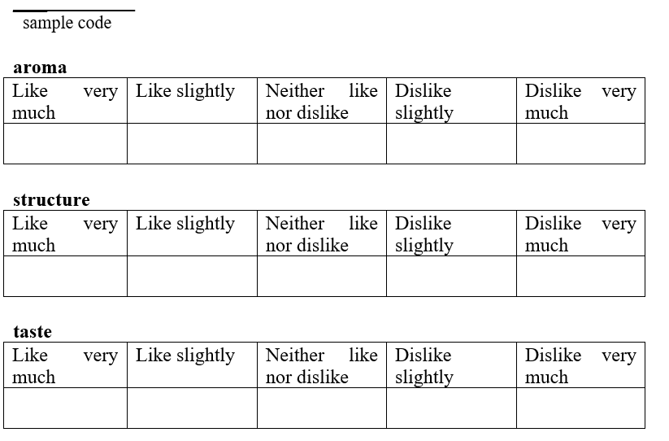

Conclusion
Provide an overview on the obtained results. Write possible explanations for the detected differences.

Approved by ______________________________________
Name, surname, signature
Date ______________________________________

Fruit, berry and vegetable juices

Theoretical materials
When it comes to industrial juicers for extracting fruit and vegetable juice, there are several key factors to consider, including the type of produce being processed, the desired juice quality, the production capacity, and the specific features required for your operation. Here are some of the main types of industrial juicers and notable brands on the market:

Types of industrial juicers
- Centrifugal juicers:
  - Advantages: High speed, efficient for hard and fibrous produce, relatively low cost.
  - Disadvantages: Not as effective for leafy greens, can produce heat that affects juice quality.
  - Applications: Best for large quantities of apples, carrots, beets, and similar produce.
- Masticating (cold press) juicers:
  - Advantages: Retains more nutrients due to low heat, effective for a wide range of produce including leafy greens.
  - Disadvantages: Slower process, generally more expensive.
  - Applications: Ideal for high-quality juice production where nutrient retention is important.
- Twin gear (triturating) juicers:
  - Advantages: Highest juice yield, excellent nutrient retention, handles a variety of produce well.
  - Disadvantages: Expensive, complex to clean and maintain, slower operation.
  - Applications: Premium juice products, diverse product processing.
- Hydraulic press juicers:
  - Advantages: Exceptional juice quality, high yield, excellent for commercial use.
  - Disadvantages: Very high cost, requires more space, slower compared to centrifugal juicers.
  - Applications: High-end juice production, large-scale operations.
The technology for obtaining fruit and vegetable juice involves several processes and types of equipment designed to extract juice efficiently while maintaining the nutritional quality and flavour of the produce. Here’s an overview of the key technologies and processes used in the juice extraction industry:

Key technologies in juice extraction
- Washing and sorting
  - Before juicing, fruits and vegetables are washed to remove dirt, pesticides, and other contaminants. Sorting is also done to remove any damaged or unripe produce.
  - Washing machines, sorting conveyors, and grading machines.
- Crushing and grinding
  - Produce is crushed or ground into smaller pieces to facilitate juice extraction.
  - Crushers, grinders, and shredders.
- Juice extraction
  - Centrifugal extraction:
    - Uses a high-speed spinning mechanism to separate juice from pulp through centrifugal force.
    - Suitable for hard and fibrous produce like carrots, apples, and beets.
    - Centrifugal juicers.
  - Cold press (masticating) extraction:
    - Slowly crushes and presses produce juice, minimising heat generation and preserving nutrients.
    - Ideal for leafy greens, soft fruits, and producing high-nutrient juice.
    - Masticating juicers, twin gear juicers.
  - Hydraulic press extraction:
    - Uses hydraulic pressure to extract juice from produce wrapped in a cloth or mesh bag.
    - High-end juice production with excellent nutrient retention and juice yield.
    - Hydraulic press juicers.
  - Steam extraction:
    - Uses steam to heat the produce, causing cells to burst and release juice.
    - Commonly used for making juice from berries and grapes.
    - Steam juicers.
- Filtration and clarification
  - Removes pulp, seeds, and other solids from the juice to improve clarity and texture.
  - Filters, decanters, centrifuges, and clarifiers.
- Pasteurisation
  - Heat treatment used to kill harmful microorganisms and extend the shelf life of the juice.
  - Pasteurisers.
- Homogenisation
  - Breaks down large particles and disperses them evenly throughout the juice to improve texture and stability.
  - Homogenisers.
- Packaging
  - Filling machines, bottling lines, aseptic packaging systems.

Advanced technologies
- Ultrafiltration
  - Uses semi-permeable membranes to remove suspended solids and microorganisms.
  - Produces clear, high-quality juice without the need for pasteurisation.
  - Ultrafiltration systems/membranes.
- High Pressure Processing (HPP)
  - Uses high pressure instead of heat to pasteurise juice, preserving more nutrients and flavour.
  - Extends shelf life while maintaining fresh juice characteristics.
  - HPP units.
- Enzyme Treatment
  - Enzymes like pectinase are added to break down cell walls, increasing juice yield and clarity.
  - Particularly useful for producing clear apple and grape juices.
  - Enzyme dosing systems.

Laboratory work

Principles of production of fruit and vegetable juices, evaluation of prepared juices

Materials
Any available fruit, berries and/or vegetables that can be used for juice production and have the basic processing ingredient quality parameters.
- Mechanical screw press;
- Mechanical slow rotation press;
- Evaporation of juice in a diffusion pot.

Methods
Task 1: Obtain fruit or vegetable juice by one of the proposed methods:
- Mechanical screw press;
- Mechanical slow rotation press;
- Evaporation of juice in a diffusion pot.
Fruit and vegetables intended for the juice, their juice extraction options and comparison:
- Apples:
  - grind and press screws in a press;
  - heat up to 75 °C, stand for 3-5 minutes, chop and press in a screw press;
  - Pour the juice into the steaming pot of sliced apples, evaporate.
- Beets:
  - grind and press screws in a press;
  - heat up to 95 °C, stand for 5 minutes, chop and press in a screw press
- Carrots:
  - obtain the juice mechanically in a slow rotation press.
  - grind and press the screws in a press
- Gooseberries:
  - place whole gooseberries into a steaming pot for juice, evaporate;
  - obtain the juice mechanically in a slow rotation press.
- Sea buckthorn:
  - pour whole berries into a steaming pot for juice, evaporate;
  - Obtain the juice mechanically in a slow rotation press.

Task 2: Determine the following quality indicators for the finished juice samples
- Calculation of juice yield %
To calculate the juice yield, the fruit, vegetables and berries are first weighed before juicing, then the resulting juice is weighed and its percentage of the total product is calculated.
- Soluble solids (refractometrically)
In order to compare the degree of sweetness of the prepared juices, the content of soluble solids is determined refractometrically by placing 3 drops of the liquid part of the product on the prism of the refractometer and taking a reading. The measurements are performed in triplicate. The dry matter content is determined as the arithmetic mean of 3 replicates.
- Colour (in the L*a*b* system) analysis
Colour is one of the most important criteria for the external appearance of juices. If the ingredients are not compatible or if they oxidise very quickly, the colour can be unattractive, brownish or greyish, so it is important to evaluate and compare the colour.
To determine the colour of the juice in the coordinate system, the product is poured into a prepared Petri dish so that the cap fits tightly to the product without an air gap, placed on a table on white paper and analysed with a colour analyser in the L*a*b* system. The L*a*b* system uses three perpendicular axes, on which a negative a* value represents the intensity of the green colour, a positive a* value represents the intensity of the red colour, a negative b* value means an increase in the blue colour intensity, a positive b* value represents the yellow colour intensity, while L* is a representative of white-black or light-dark intensity.
- Determination of product pH
To determine the pH of the environment in the juice samples, they are poured into a beaker in which the electrode of the pH meter is dipped and the pH of the product is determined. Measurements are performed in triplicate and averaged.
- Titratable acids
Weigh 4 g of juice in a 250 mL conical flask, add 100 mL of hot distilled water, mix thoroughly, and leave for 5 minutes. Then, add 3 drops of phenolphthalein, mix thoroughly and titrate with 0.1 N NaOH until a faint pink colour appears. The amount of acid is calculated according to the formula
$$S= \frac{v×n×k}{10×m}$$
where: S - acid content (mg/g)
v - titrated volume of 0.1 n NaOH (mL)
n - NaOH normality (0.1)
k - acid coefficient, which is 64.047 when converted to citric acid, 67.00 when converted to malic acid
m - mass of weight taken for titration (g)

- Ascorbic acid content in juice
Vitamin C is rapidly oxidised both in the presence of oxygen and also at high temperatures, so it is important to evaluate the best way of processing and extracting juices, with the least reduction of vitamin C.
Determine the content of L-ascorbic acid (reduced form) in the given samples by the iodine method.
Methodology:
- Prepare a standard solution of ascorbic acid: 20 mg of ascorbic acid per 100 mL of 6% oxalic acid solution.
- Add 2 mL of 1% starch solution to 25 mL of ascorbic acid standard solution and titrate with 0.05 M iodine solution while stirring. Observe the colour change. Write down the amount of iodine used.
- Weigh 25 g of juice sample into a 250 mL beaker.
- 100 mL of 6% H ₂ C ₂ O ₄ solution is poured over the prepared weight and mixed it well for 60 seconds.
- Filter through a cotton filter.
- Add 2 mL of 1% starch solution to 10 mL of filtrate and titrate with 0.05M iodine solution while stirring. Observe the colour change that does not disappear within 30 seconds and write down the amount.
$$C vit. \left(\frac{mg}{100g}\right)=5000* \frac{ V_{J sample}}{{m* V}_{J standard}}$$
5000 - coefficient
V _{Jin the sample} - the amount of iodine solution used for the titration of 10 mL of the sample
V _{Jst. no.} - the amount of iodine solution used for the titration of 25 mL standard solution
m – sample mass

- Sensory evaluation of samples
Compare the obtained finished juice samples and record the sensory evaluations in table 2.

Results
Create an additional table to combine the obtained data on the analysed samples and fill it out.
Table 12.3
Sensory evaluation of fruit and vegetable juices
Sensory properties | Sample 1 | Sample 2 | Sample 3 | Notes
Appearance (cloudiness and clearness, colour)
Consistency
Aroma
Taste balance
Sweet taste
Sour taste
Aftertaste

Conclusion
Provide an overview on the obtained results. Write possible explanations for the detected differences.

Approved by ______________________________________
Name, surname, signature
Date ______________________________________

Theme 13

Vegetable oils

Theoretical materials

Sunflower seed processing
The first stage – processing of sunflower seeds – is extremely important in production. From the quality of the seeds supplied for processing, ultimately depends on the quality of the final product – vegetable oil. In addition to this indicator, the cleaning of raw materials, the conditions of storage are also taken into account, such as temperature and light conditions. When determining the quality of sunflower seeds, the main thing to take into account is their qualitative indicators - mass and humidity. Different varieties of sunflower have different levels of oil content. At the same time, the yield of vegetable oil depends directly on the level of oil content of seeds. Other indicators - humidity and timing maturation are no less important when choosing raw materials for the production of a quality product. During the processing, the seeds are thoroughly cleaned from husks and defects, pass through the stages of additional cleaning, drying, and separating the seed shells from the kernels. The peeled seeds undergo a grinding process, eventually turning into a pulp. Grinding the seeds is the initial stage of direct oil production. The production technology itself is divided into cold and hot pressing, extraction, and refining.

Cold and hot press
Cold press technology allows the preservation of vegetable oil with a maximum amount of nutrients, as well as its originally organoleptic qualities. During the pressing, the oil production process consists of many stages. First, the prepared crushed raw materials (pulp) are heated to a certain temperature, usually up to 110 ºС. At the same time, the components of the raw materials are carefully mixed on specialised equipment, which results in the maximum volume of progress of the finished quality product (oil). At the next stage, the mixture isolated from the raw material passes through the squeezing process in screw presses. During hot pressing, the crushed raw materials are heated at higher temperatures. The result is a product with a richer, more intense aroma, taste and colour, but with this technology the amount of nutrients in the product is reduced. Hot press is one of the most common technologies that does not require knowledge or significant costs for oil production. Waste raw materials obtained during the production of vegetable oil are further processed and used in feed additives for feeding research of farm animals.
Extraction is a method of producing plant oil, which consists of mixing prepared new raw materials with organic solvents. In turn, the fat emulsion also passes through additional processing - filtration and clearing of impurities. As a result, such a multi-level technological process produces a purified concentrated product – unrefined vegetable oil.

Refining
According to the latter, the nutritional value of refined oil is reduced because the level of useful nutrients in this product is significantly reduced as a result of technological processing. This oil contains only trace amounts of essential fatty acids, including linolenic and linoleic, as well as some other vitamins. Therefore, among all types of refined oils it is considered the least beneficial for health. During the refining process, sunflower oil goes through many processing stages. At the initial stage, the prepared raw materials are carefully cleaned from impurities present in it, then it gradually undergoes the processes of settling, filtration and centrifugation. Next comes the stage of hydration, or processing of the resulting fat emulsion with hot water at about 70 °C. This processing method allows eliminating waste that contributes to product spoilage. The next stage of oil refining is neutralisation which removes free fatty acids from a mixture, pesticides and heavy metals that oxidise the product and lead to rapid spoilage. One of the disadvantages of refined oil is its low phospholipids. Bleaching is the purification of a mixture with organic adsorbents from colouring pigments, in particular carotenoids and brightening the product.
At the next stage, the oil undergoes a process of deodorisation – removal of all aromatics from the composition substances under the influence of hot steam at a high temperature mode – 220 °C. The removal of impurities, white carbonic and aromatic substances, allows to significantly increase the shelf life of the finished product.
The final technological stage is oil freezing - it consists of removing waxy acids from its composition. Freezing completely cleanses fat - a mixture of waxes and makes it colourless.
Thus, the use of different production technologies in the production of vegetable sunflower oil allows for the production of products with different organoleptic characteristics. However, despite some differences, each type of vegetable oil, produced in accordance with technological requirements, represents a high-quality food product.

Advanced technologies

Enzymatic extraction
- Description: Uses enzymes to break down cell walls and release oil.
- Advantages: Environmentally friendly, can improve oil yield and quality.
- Applications: Emerging technology, still under development for commercial use.

Supercritical fluid extraction
- Description: Uses supercritical CO2 as a solvent to extract oil.
- Advantages: Solvent-free, retains more nutrients, produces high-purity oil.
- Applications: High-value oils, pharmaceuticals, and cosmetics.

Membrane technology
- Description: Uses membrane filtration to refine oil.
- Advantages: Energy-efficient, reduces chemical usage.
- Applications: Suitable for degumming, de-acidification, and removal of impurities.
Vegetable oil production technology involves a combination of traditional methods and advanced technologies to extract and refine oil efficiently. The choice of technology depends on factors such as the type of oilseed, the desired oil quality, the scale of production, and environmental considerations. By leveraging appropriate technologies, producers can optimise their processes, improve oil yield and quality, and meet market demands effectively.
Producing vegetable oil involves several stages, each requiring specific types of equipment. Here is a comprehensive list of the equipment needed for the various stages of vegetable oil production:

Seed cleaning and preparation
- Seed Cleaner: Removes impurities such as dust, leaves, and stones.
- Dehuller: Removes the hull or shell from seeds.
- Crusher: Crushes seeds to facilitate oil extraction.

Oil Extraction

Mechanical extraction (Pressing)
- Oil Expeller/Press: Uses mechanical pressure to extract oil from seeds.
- Screw Press: A type of expeller that uses a screw to press oil from the seeds.
- Hydraulic Press: Uses hydraulic pressure to extract oil, suitable for smaller operations.

Solvent extraction
- Solvent Extractor: Uses a solvent (usually hexane) to dissolve the oil from the seeds.
- Desolventizer-Toaster: Removes the solvent from the extracted oil.
- Solvent Recovery System: Recovers and reuses the solvent for further extraction.

Oil refining

Degumming
- Degumming tank: Removes gums and other impurities from the crude oil.
- Centrifuge: Separates the gums from the oil.

Neutralisation
- Neutralisation tank: Adds alkaline to the oil to neutralise free fatty acids.
- Centrifuge: Separates the soap stock from the neutralised oil.

Bleaching
- Bleacher: Mixes the oil with bleaching clay to remove colour pigments.
- Filter press: Filters out the spent bleaching clay.

Deodorization
- Deodorizer: Uses steam distillation to remove odour-causing compounds.

Winterisation (Optional)
- Winterising tank: Cools the oil to precipitate out waxes.
- Filter press: Filters out the precipitated waxes.

Packaging
- Filling machine: Fills the refined oil into bottles or containers.
- Capping machine: Seals the containers.
- Labelling machine: Labels the containers with product information.

Key considerations
- Capacity: Choose equipment based on the production scale (small, medium, or large).
- Seed type: Equipment specifications might vary depending on the type of seeds (soybean, sunflower, canola, etc.).
- Quality requirements: Higher-quality oil might require more refined processing stages.
- Energy efficiency: Consider energy-efficient equipment to reduce operational costs.
- Regulatory compliance: Ensure equipment meets local safety and food production standards.
By selecting the right combination of equipment tailored to your production needs, you can efficiently produce high-quality vegetable oil.

Peroxide number
Peroxide number is the amount of active oxygen equivalents in 1kg of sample, given in mmol/kg units.
In oxidation processes, hydrogen peroxides are mainly produced as the initial oxidation products, and in parallel with them, small amounts of other peroxides. The peroxide value indicates the degree of oxidation of the sample and therefore, with some limitations, the extent to which the fat has been damaged. It should be noted that as the oxidation processes progress, the division of peroxides increases, and thus the peroxide value decreases. Quality fats and oils have a peroxide value of less than 6 mmol/kg (usually between 0 and 3 mmol/kg).
The maximum permissible peroxide value in edible oils is defined in the Codex Alimentarius section named vegetable oils:
- Refined oils up to 10 mEq of active oxygen/kg of oil
- Cold-pressed and virgin oils up to 15 mEq of active oxygen/kg of oil
Fat stability tests
Active oxygen method (AOM) - the fat is heated and filtered air is supplied until the peroxide rises to a certain value, which indicates the onset of rancidity. The peroxide number at which rancidity begins to form is different for each type of fat and is determined organoleptically. For example, for pig fat - 20 mEq/ kg, for vegetable oils - 100 mEq/kg.

Acid number
The acid number is the mass mg of potassium hydroxide required to neutralise the free fatty acids in 1 gram of fat (or fatty acids). It describes the amount of free acids in fats and fatty acids.
Vegetable oils always contain free fatty acids. Their quantity depends on the quality of the seeds, the type of oil extraction and the conditions of seed storage. Oils obtained from unripe, poorly dried seeds have a high acid number.
The Codex Alimentarius specifies the following acid numbers for edible oils:
Refined oil 0.6mg KOH/g oil
Cold pressed and virgin oils 4.0 mg KOH/g oil
The acid number of raw, unrefined fats can reach 10, while it is usually <0.2 for refined fats.

Laboratory work

Vegetable oil analysis

Materials
Vegetable oils of different quality, type and/or age.

Methods
- Determination of the peroxide number
Weigh 3 g of oil into a 200 mL flask, dissolve in 30 mL of solvent (chloroform:acetic acid = 3:2), add 0.5 mL of saturated potassium iodide solution, close the flask and shake for 1 minute. Then add 30 mL of distilled water, 0.5 mL of starch solution, titrate with 0.01 M sodium thiosulfate solution (Na₂S₂O₃).
P_{S}=(V×C×/m_{p})×1000
V – volume of sodium thiosulfate, mL
C - sodium thiosulfate concentration, mol/l
m_{p} - sample weight, g
2. Determination of the acid number
Weigh 5 g of oil into a 200 mL flask, dissolve in 50 mL of solvent (diethyl ether:ethanol = 1:1), add a few drops of 1% phenolphthalein and titrate with KOH until a stable red colouration.
S_{S}=VKOH×CKOH×56.1/mp
V_{KOH} - volume of KOH, mL
C_{KOH} - KOH concentration, mol/l
56.1 – KOH molar mass
mp – sample weight, g

Results
Create a table to combine the obtained data on the analysed samples and fill it out.

Conclusion
Provide an overview on the obtained results. Write possible explanations for the detected differences.

Approved by ______________________________________
Name, surname, signature
Date ______________________________________

Theme 14

Fruit berry and vegetable drying

Theoretical materials
Drying is one of the oldest ways of preserving products - it is the amount of water reduction in the product to the extent that the activity of microorganisms ceases. Dried fruit and vegetables are used both as food additives and as ingredients in preparation of various dessert products. The main advantages of dried products are:
- reduced product mass, less consumption of packaging materials, containers and warehouses area, transportation costs;
- very simple storage conditions are required.

Production technology of dried fruit and vegetables
The production of dried fruit and vegetables begins with washing the raw materials.
Inspection, grading and calibration. Inspection of production, selection of unusable raw materials, also cutting out damaged parts. During the inspection, sorting and calibration by quality is also carried out, degrees of ripeness, colour, shape, size, as well as varieties.
The skin of fruit and rhizomes is separated using mechanical, thermal or chemical treatments techniques.
To prevent fruit and vegetables from turning brown after cleaning, sulphitation is performed by immersing them in sulphur dioxide. A 0.1-0.4% sodium bisulfite solution is used in the sulfation of vegetables and potatoes. Most sulphur dioxide evaporates during drying.
Repeat cleaning. After sulphitation, repeated cleaning of the raw materials is carried out, during which the imperfections (dark spots and other unpleasant looking damages) are cut out, or those pieces are removed.
Cutting. To increase the surface area for evaporation, and speed up blanching and drying, vegetables and fruit are cut into cubes, straws, circles or rings 3-7 mm thick.
Blanching. Blanching inactivates enzymes, stabilises the colour of the product, and makes the product tissues softer. Raw materials are blanched with hot water or steam.
Drying off. Drying off is done in order to get rid of the excess amount of water resulting from blanching.
Drying. Drying modes depend on both the type of fruit or vegetable to be dried and the drying method selected.

Fruit and vegetable drying technologies
Today, drying in the sun, solar drying, osmotic-air drying, convection drying (in ovens of tunnel type, shelf type, etc.), microwave drying, vacuum drying, infrared technology, drying in a high-frequency current field and freeze-drying are used.
Table 14.1
Summary of drying methods used for fruit and vegetable drying
Drying Method | Advantages | Limitations | Applications | Required Conditions
Drying in the sun | Low cost, simple | Weather-dependent, risk of contamination | Fruit, vegetables, grains | Hot, dry, sunny weather; clean drying surfaces
Solar drying | More controlled, efficient | Higher initial setup cost, sunlight dependent | Fruit, vegetables, fish | Sunny weather; solar dryer with transparent covers and good ventilation
Osmotic-air drying | Preserves quality, reduces drying time | Additional processing step, solution disposal | Fruit, vegetables | Osmotic solution (sugar/salt); controlled temperature and humidity for air drying
Convection drying (tunnel/shelf) | Uniform drying, controlled environment | High energy consumption, equipment cost | Fruit, vegetables, meats, fish | Controlled temperature (50-90 °C); air circulation
Microwave drying | Rapid drying, preserves nutrients | High cost, risk of uneven drying | Fruit, vegetables, herbs | Microwave oven; precise control of time and power settings
Vacuum drying | Low temperature, fast drying | Expensive, complex operation | Pharmaceuticals, high-value fruit, vegetables | Vacuum chamber; controlled low temperature (20-50 °C) and pressure
Infrared drying | Efficient, short drying times | Surface heating issues | Fruit, vegetables, meat | Infrared heaters; controlled distance and exposure time
High-frequency current field drying | Rapid, uniform, quality preservation | High cost, complex technology | High-value, sensitive products | High-frequency electromagnetic field equipment; controlled field intensity and exposure time
Freeze-drying | Best preserves quality, long shelf life | Very high cost, energy-intensive | Coffee, high-value fruits, vegetables, pharmaceuticals | Freeze at -40 °C or below; vacuum chamber for sublimation; controlled slow heating

Laboratory work

Apple drying using different technologies

Materials
Apples.
Laboratory equipment: convective dryer; microwave-vacuum dryer; freeze dryer.

Methods
Task 1 Different ways of processing apples before drying
- Wash, peel, cut into slices, soak in 1% citric acid solution. Then drain, and dry.
- Wash, peel, cut into slices, soak in 1% citric acid solution, and blanch in water at 80-85 °C for 3-5 minutes. Then drain, and dry.
- Wash, peel, cut into slices, soak in 1% citric acid solution, and blanch in 40% sugar syrup at 80-85 °C for 3-5 minutes. Then drain, and dry.
- Wash, peel, cut into slices, dip in quince or plum syrup (with soluble solids content of at least 65% Brix), heat to 69 °C, leave for 15 minutes and let the fruit cool in the syrup.
Task 2 Drying apples in different dryers
- Drain the apple slices carefully in a sieve and place them on trays lined with paper towels.
- Everything is divided into 5 parts.
- Dry:
- in a convective dryer at 40 °C ;
- in a convective dryer at 60 °C ;
- in a convective dryer at 80 °C ;
- microwave-vacuum dryer;
- freeze dryer.

Approved by ______________________________________
Name, surname, signature
Date ______________________________________

Laboratory work

Quality evaluation of dried apples

Materials
Previously dried apples.

Methods
- Fragility analysis of dried fruits with a structure analyser
The samples to be analysed are placed on the structure analyser tray (figure 1). The measurements are performed by pressing the surface of a special tip on the sample and measuring the force (N) with which the sample can be broken at a pressing speed of 1 mm s ⁻¹.
The result is the maximum force (N) required to break the sample in question.
The more fragile the dried products, the lower the measurement results will be, while hard, unbreakable vegetables will have the highest results.
- Determination of moisture content of dried products
Drying the sample to constant weight is the most commonly used method for moisture determination in dried products. The determination of moisture in dried fruits is carried out at a temperature of 105 °C for 3 hours.
Chop the dried fruit into small pieces with a knife. Weigh the weighing cup on the balance and weigh approximately 2 g (to the nearest 3 decimal places) of the sample into it. The weighing cups with the samples are placed in an oven at 105 °C for 3 hours. After drying, the measuring cups are removed from the drying oven with tongs, put on a cap and placed in a desiccator to cool. Weigh the cooled, closed measuring cups. Calculate the moisture content of the sample according to the formula:
$$\frac{\left(M-x\right)-(m-x)}{(M-x)}×100=\frac{M-m}{M-x}×100$$
where M – mass of the initial sample + container;
x- mass of the vial;
- Colour analysis (in the L*a*b* system) of dried fruits
Colour is one of the most important criteria for the external appearance of the product. If the product oxidises very quickly, the colour may be unattractive, brownish or greyish, so it is important to evaluate and compare the colour.
To determine the colour of the product in the coordinate system, solid products are placed on a table on white paper and analysed with a colour analyser in the L*a*b* system. The L*a*b* system uses three perpendicular axes, on which a negative a* value represents the intensity of the green colour, a positive a* value represents the intensity of the red colour, a negative b* value means an increase in the blue colour intensity, a positive b* value represents the intensity of the yellow colour, but L* is a characteristic of white (L=100) – black (L=0) or light-dark intensity.
- Product rehydration ability
All dried apples (20 g) are soaked in a glass of water (100 mL), left for 30 minutes, the excess water is drained on a sieve, weighed and calculated how much water each product absorbed.

Results
Please arrange the obtained data in table 14.2
Table 14.2
Product | Colour L* | Colour a* | Colour b* | Fragility, N | Moisture, % | Rehydration ability
K 40
K 60
K 80
MV
FD

Conclusion
Provide an overview on the obtained results. Write possible explanations for the detected differences.

Approved by _____________________________________
Name, surname, signature
Date ______________________________________

Literature sources
Methods and standards used in laboratory works:
- Singleton, V. L., Orthofer, R., Lamuela-Raventós, R. M. (1999). Analysis of total phenols and other oxidation substrates and antioxidants by means of folin-ciocalteu reagent. Method Enzymol., 299, 152–178.
- ISO 1442:1973 - Meat and meat products -- Determination of moisture content. (n.d.).
- ISO 15214:1998 - Microbiology of food and animal feeding stuffs -- Horizontal method for the enumeration of mesophilic lactic acid bacteria -- Colony-count technique at 30 degrees C. (n.d.).
- ISO 21527-1:2008 - Microbiology of food and animal feeding stuffs -- Horizontal method for the enumeration of yeasts and moulds -- Part 1: Colony count technique in products with water activity greater than 0,95. (n.d.).
- ISO 2173:2003 - Fruit and vegetable products -- Determination of soluble solids -- Refractometric method. (n.d.).
- ISO 2917:1999 - Meat and meat products -- Measurement of pH -- Reference method. (n.d.).
- ISO 4833-1:2013 - Microbiology of the food chain -- Horizontal method for the enumeration of microorganisms -- Part 1: Colony count at 30 degrees C by the pour plate technique. (n.d.).
- ISO 6496:1999 - Animal feeding stuffs -- Determination of moisture and other volatile matter content. (n.d.).
- ISO 6887-4:2003 - Microbiology of food and animal feeding stuffs -- Preparation of test samples, initial suspension and decimal dilutions for microbiological examination -- Part 4: Specific rules for the preparation of products other than milk and milk products, meat and meat products, and fish and fishery products. (n.d.).
- ISO 7251:2005 - Microbiology of food and animal feeding stuffs -- Horizontal method for the detection and enumeration of presumptive Escherichia coli -- Most probable number technique. (n.d.).
- ISO 750:1998 - Fruit and vegetable products -- Determination of titratable acidity. (n.d.).
- Полюдек-Фабини, Р., Бейрих, Т. (1981). Органический анализ, Химия.
Additional literature:
- Ahvenainen, R. (Ed.). (2003). Novel food packaging techniques. Woodhead Publishing. ISBN: 978-1-85573-675-5
- Ashurst, P. R. (Ed.). (2016). Chemistry and technology of soft drinks and fruit juices (3rd ed.). Wiley-Blackwell.
- Bahrami, A., Moosavi-Nasab, M., Ghanbarzadeh, B., & Khodaiyan, F. (2020). Application of edible films and coatings in fresh fruits and vegetables. Food Science & Nutrition, 8(12), 5240-5254. doi: 10.1002/fsn3.1877
- Baird-Parker, T. C., Gould, G. W., & Lund, B. M. (Eds.). (2000). Microbiological safety and quality of food (Vol. 1). Springer.
- Barbosa-Cánovas, G. V., & Gould, G. W. (Eds.). (2000). Innovative food processing technologies. CRC Press.
- Barrett, D. M., Somogyi, L. P., & Ramaswamy, H. S. (Eds.). (2004). Processing fruits: Science and technology (2nd ed.). CRC Press. ISBN: 978-1-56676-931-3
- Brennan, J. G. (Ed.). (2006). Food processing handbook. Wiley-VCH. ISBN: 978-3-527-31379-3
- Carol A.Wallace, William H. Sperber, Sara E.Mortimore. Food Safety for the 21st Century: Managing HACCP and Food Safety Throughout the Global Supply Chain. 2nd ed. ISBN 9781119053583. –New York, Wiley 2018. – 494 p
- Codex Alimentarius. Available from: http://www.fao.org/fao-who-codexalimentarius/en/
- EU COMMISSION NOTICE on the implementation of food safety management systems covering Good Hygiene Practices and procedures based on the HACCP principles, including the facilitation/flexibility of the implementation in certain food businesses (2022/C 355/01) https://eur-lex.europa.eu/legal-content/EN/TXT/?uri=CELEX%3A52022XC0916%2801%29
- Fellows, P. (2009). Food processing technology: Principles and practice (3rd ed.). Woodhead Publishing.
- Fellows, P. J. (2017). Food processing technology: Principles and practice (4th ed.). Woodhead Publishing. ISBN: 978-0-08-101907-8
- Food Packaging: Advanced Materials, Technologies, and Innovations Hardcover. Sanjay Mavinkere Rangappa, Parameswaranpillai Jyotishkumar, Senthil Muthu Kumar Thiagamani, Senthilkumar Krishnasamy, Suchart Siengchin. 2020. CRC Press; 1st edition (2020); ‎ 394 pages; ISBN-10 ‏ : ‎ 0367335387; ISBN-13 : ‎ 978-0367335380
- Food Science Source. (n.d.). Retrieved from https://www.ebsco.com/products/research-databases/food-science-source
- Global standard for food safety issue 9 - https://www.brcgs.com/our-standards/food-safety/issue-9-revision/
- Gould, G. W. (Ed.). (2012). New methods of food preservation. Springer Science & Business Media.
- Gunstone, F. D. (Ed.). (2011). Vegetable oils in food technology: Composition, properties, and uses (2nd ed.). Wiley-Blackwell.
- Hamm, W., Hamilton, R. J., & Calliauw, G. (Eds.). (2013). Edible oil processing (2nd ed.). Wiley-Blackwell.
- https://www.fruitrop.com/en/Articles-by-subject/Quality-defects
- Hui, Y. H. (Ed.). (2010). Handbook of fruit and vegetable flavors. Wiley. ISBN: 978-0-470-22721-3
- Jaiswal, A. K. (Ed.). (2020). Nutritional composition and antioxidant properties of fruits and vegetables. Academic Press. ISBN: 978-0-12-812780-4
- Jongen, W. (Ed.). (2002). Fruit and vegetable processing: Improving quality. Woodhead Publishing. ISBN: 978-1-85573-564-2
- Lim, T. K. (2012). Edible medicinal and non-medicinal plants: Volume 1, fruits. Springer. ISBN: 978-94-007-1763-3
- Lozano, J. E. (Ed.). (2006). Fruit manufacturing: Scientific basis, engineering properties, and deterioration behavior. Springer. ISBN: 978-0-387-26014-8
- Marco, M. L., Heeney, D., Binda, S., Cifelli, C. J., Cotter, P. D., Foligné, B., Gänzle, M., Kort, R., Pasin, G., Pihlanto, A., Smid, E. J., Hutkins, R., & Ventura, M. (2017). Health benefits of fermented foods: Microbiota and beyond. Current Opinion in Biotechnology, 44, 94-102. doi:10.1016/j.copbio.2016.11.010
- Martin-Belloso, O., & Soliva-Fortuny, R. (Eds.). (2010). Advances in fresh-cut fruits and vegetables processing. CRC Press. ISBN: 978-1-4398-0988-9
- Mérillon, J.-M., & Ramawat, K. G. (Eds.). (2018). Bioactive molecules in food. Springer. ISBN: 978-3-319-54528-8
- Mujumdar, A. S. (Ed.). (2014). Handbook of industrial drying (4th ed.). CRC Press
- OCED International Standards for Fruit and Vegetables (https://www.oecd-ilibrary.org/agriculture-and-food/international-standards-for-fruit-and-vegetables_19935668?page=1)
- Packaging & Distribution of Fresh Fruits & Vegetables. by Ph.D. Chonhenchob, Vanee, Ph.D. Singh, Paul, Ph.D. Singh, Jay. 2016. ISBN-13; 978-1605953274; Publisher Destech Pubns Inc
- Packaging and Storage of Fruits and Vegetables Emerging Trends. Edited By Tanweer Alam, 2022. 1. st Edition. ISBN 9781774638422. 326 Pages 46 B/W Illustrations. Apple Academic Press.
- PubMed. (n.d.). Retrieved from https://pubmed.ncbi.nlm.nih.gov/
- Ramaswamy, H. S., & Marcotte, M. (2006). Food processing: Principles and applications. CRC Press.
- Regulation (EU) 2023/988 of the European Parliament and of the Council of 10 May 2023 on general product safety, amending Regulation (EU) No 1025/2012 of the European Parliament and of the Council and Directive (EU) 2020/1828 of the European Parliament and the Council, and repealing Directive 2001/95/EC of the European Parliament and of the Council and Council Directive 87/357/EEC (Text with EEA relevance)
- Regulation (EU) No 1169/2011 of the European Parliament and of the Council of 25 October 2011 on the provision of food information to consumers, amending Regulations (EC) No 1924/2006 and (EC) No 1925/2006 of the European Parliament and of the Council, and repealing Commission Directive 87/250/EEC, Council Directive 90/496/EEC, Commission Directive 1999/10/EC, Directive 2000/13/EC of the European Parliament and of the Council, Commission Directives 2002/67/EC and 2008/5/EC and Commission Regulation (EC) No 608/2004 Text with EEA relevance
- Samelis, J. (Ed.). (2014). Foodborne pathogens: Hazards, risk analysis and control (2nd ed.). Woodhead Publishing. ISBN: 978-0-85709-421-5
- Saravacos, G. D., & Kostaropoulos, A. E. (2016). Handbook of food processing equipment (2nd ed.). Springer. ISBN: 978-1-4939-3115-3
- Shahidi, F. (Ed.). (2005). Bailey’s industrial oil and fat products (6th ed., Vols. 1-6). Wiley-Interscience.
- Silva, C. L. M., & Oliveira, F. A. R. (Eds.). (2008). Thermal food processing: New technologies and quality issues. CRC Press.
- Sinha, N. K., Hui, Y. H., Evranuz, E. Ö., Cano, M. P., Barta, J., & Siddiqi, J. I. (Eds.). (2012). Handbook of fruits and fruit processing. Wiley-Blackwell. ISBN: 978-0-8138-0261-6
- Sinha, N. K., Sidhu, J. S., Barta, J., Wu, J. S. B., & Cano, M. P. (Eds.). (2012). Handbook of fruits and fruit processing (2nd ed.). Wiley-Blackwell.
- Speranza, B., Bevilacqua, A., Corbo, M. R., Sinigaglia, M., & Campaniello, D. (2018). Microbial dynamics during fermentation of an Italian fermented vegetable product as revealed by metagenomic analysis. LWT - Food Science and Technology, 92, 541-547. doi:10.1016/j.lwt.2018.03.019
- Sun, D.-W. (Ed.). (2005). Emerging technologies for food processing. Elsevier Academic Press.
- Tamang, J. P., & Kailasapathy, K. (Eds.). (2010). Fermented foods and beverages of the world. CRC Press. ISBN: 978-1-4200-9234-8
- Tamang, J. P., Shin, D. H., Jung, S. J., & Chae, S. W. (2016). Functional properties of microorganisms in fermented foods. Frontiers in Microbiology, 7, 578. doi:10.3389/fmicb.2016.00578
- Tressler, D. K., Joslyn, M. A., & Marsh, G. L. (1968). The chemistry and technology of fruit and vegetable juice production. AVI Publishing Company.
- Yahia, E. M. (Ed.). (2019). Postharvest physiology and biochemistry of fruits and vegetables. Woodhead Publishing. ISBN: 978-0-12-813278-4
- А.Расулов. Сабзавот, картошка ва полиз ма\сулотларини саклаш. Т., «Мехнат», 1995.
- Р.О.Орипов ва бошкалар. Кишлок хужалиги махсулотларини саклаш ва кайта ишлаш технологияси. Т., «Мехнат», 1991.
- С.П.Широков. Технология хранения и переработки плодов и овощей. М., «Колос», 1978.
- Х-Буриев, Р.Ризаев. Мева, узум махсулотлари биокимёси ва технологияси. Т., «Мехнат», 1996.

