


Open Food Innovation University (OFINU)

Study module
“Cereal technology”
WORKBOOK
for students

2024
Summary

The workbook is elaborated within the project “Open Food Innovation University" (OFINU), being in implementation with support of the European Union Erasmus+ Programme.
Overall objective of the project - to modernise food innovation and technology related higher education in Uzbekistan and Tajikistan, thereby increasing the quality and ensuring relevance of the higher education to the needs of the socio-economic growth of the countries concerned and especially of their regions.

Full partners:
- Lead partner: Latvia University of Life Sciences and Technologies
- Uzbekistan: Samarkand Agro-innovations and Research University, Andijan Institute of Agriculture and Agro-technologies
- Tajikistan: Technological University of Tajikistan, Kulob Institute of Technology and Innovation Management, Isfara Branch of the Technological University of Tajikistan
- Slovakia: Slovak University of Agriculture in Nitra

Associated partners in Uzbekistan:
- A group of companies "AGROMIR"
- "Navigul" MCHJ QK
- “Samarqand don mahsulotlari” JC (Samarkand grain products)

Associated partners in Tajikistan:
- CJSC “Combinati Shiri Dushanbe”
- LTD "Orion Rustam"
- Association of Entrepreneurs of Khatlon

The project implementation period: 01/02/2024 - 31/01/2027.

Funded by the European Union. Views and opinions expressed are however those of the authors only and do not necessarily reflect those of the European Union or the European Education and Culture Executive Agency. Neither the European Union nor the granting authority can be held responsible for them.

Partner universities and their academic staff, involved in the development of the study course:
P1 LBTU. Latvia University of Life Sciences and Technologies
Dace Klava - cereal processing technology.
Tatjana Ķince - cereal processing equipment.
Evita Straumite - sensory evaluation of cereal products.
Sandra Muizniece-Brasava - packaging of cereal products.
Egita Sproge - HACCAP.
P2 SAMARU. Samarkand Agroinnovations and Research University
RahmatilloTashmanov - cereal processing technology.
Temurbek Mikhliev - cereal processing technology.
Yigitali Tashpulatov - cereal processing equipment.
Babur Eshonkulov - cereal processing technology.
Kamoliddin Bozorov - quality management of cereal products.
P3 AIAA. Andijan Institute of Agriculture and Agro-technologies
Murodjon Atajanov - cereal processing technology.
Muhammad Zahiriddin Zaynobiddinov - cereal processing equipment.
Oybek Egamberdiev - quality management of cereal products.
P4 TUT. Technological University of Tajikistan
Mavzuna SHARIPOVA - cereal processing technology.
P5 KITIM. Kulob Institute of Technology and Innovation Management
Iskandar HAKIMOV - cereal processing technology.
P6 BTUTI. Branch of the Technological University of Tajikistan in the city of Isfara
Zokirkhoja Soliev - cereal processing technology.
P7 SUA. Slovak University of Agriculture in Nitra
Eva Ivanišová - cereal processing technology.

Contents
Course Schedule 8
Date, Time 8
Theme 1 14
Cereals, their characteristics and quality Error! Bookmark not defined.
Laboratory work 17
Analysis of grain mechanical and physical properties 17
Laboratory work 24
Determination of grain quality parameters 25
Practical Work 27
Equipment for receiving and pre-treatment of grain 27
Practical work 29
Quality management in the grain processing industry 29
Seminar Grains and Quality 37
Theme 2 38
Grain processing - flour, groats and flakes Error! Bookmark not defined.
Theoretical materials 38
Laboratory work 41
Flour and breakfast flakes quality assessment 41
Practical work 44
Packaging of flour and flakes and evaluation of the quality 44
Laboratory work 46
Flour quality Analysis 46
Laboratory work 58
Sensory evaluation of breakfast cereals, granola and muesli 58
Seminar flour production and quality 62
Theme 3 63
Pasta production and quality evaluation Error! Bookmark not defined.
Theoretical materials 63
Laboratory work 65
Pasta production in laboratory condition 65
Evaluation of pasta quality 65
Practical works 68
Packaging of pasta 68
Laboratory works 72
Sensory evaluation of laboratory-prepared pasta 72
Seminar 73
Pasta in the world 73
Theme 4 74
The basics of bread making Error! Bookmark not defined.
Theoretical materials 74
Laboratory work 76
Quality evaluation of raw materials 76
Laboratory work 80
Microbiology analyses of raw materials 80
Laboratory work Sourdough preparation 84
Laboratory work 88
Microbiology analyses of Sourdough 89
THEME 5 Wheat bread technology 93
Theoretical materials 93
Laboratory work 95
Baking test of wheat bread with sourdough 95
Laboratory work 99
Wheat bread with yeast baking test and freezing processes 99
Practical work 103
Wheat bread packaging 103
Laboratory work 105
Sensory evaluation of different types of bread 105
Laboratory work 109
Evaluation of wheat bread quality 109
Laboratory work 113
Evaluation of wheat bread microbiology quality 113
SEMINAR 115
Nutrition aspects of bread 115
THEME 6 116
Wholegrain and traditional bread technology Error! Bookmark not defined.
Theoretical materials 116
Laboratory work 118
Baking test of wholegrain bread with sourdough and scald 118
Practical work 124
Packaging and pasteurisation of rye (wholegrain) bread 124
Laboratory work 127
Sensory evaluation of bread (quality evaluation of bread as experts) 127
Laboratory work 131
Evaluation of rye bread microbiology quality 131
Practical work 133
Quality management in a bread bakery 133
SEMINAR 137
Bread around the world 137
THEME 7 138
Flour confectionery and traditional confectionary Error! Bookmark not defined.
Theoretical materials 138
Laboratory work 140
Creating new ideas for traditional desserts/cakes in new versions. Prepare innovative desserts/cakes 140
Literature Sources 148

Theme of the study course
The study module “Cereal technology” includes the following topics: technological process and equipment, packaging material and equipment, raw materials and product quality evaluation, including sensory evaluation. Quality management assurance in grain processing. A lecturer with knowledge in the specific field is involved in the implementation of each section in order to achieve the goal of the study module.

Learning methods
In the implementation of the module, the teachers use the learner-centred approach. It empowers students to take charge of their own learning, leading to increased engagement and motivation. The use of digital tools for interactive learning has made classes more dynamic and accessible - students can access learning materials from anywhere, leading to increased flexibility and convenience. Interactive methods, such as seminars, methods for providing laboratory and practical work (individually, group work, discussions, re –training).

Course Schedule
Thematic Study Plan for module “Cereal Technology”
Date, Time | Study form | Theme | Lecturer
Theme 1 - Cereals, their characteristics, and quality
1st day | Lecture  (1h) | Introduction lecture about the study course.
1st day | Lecture  (3h) | Grains and their characteristics.
1st day | Lecture  (3h) | Types of grains, chemical composition - carbohydrates, proteins, lipids, their properties, vitamins, minerals, pigments, water.  Physical properties of grains. Developmental processes in grains.
1st day | Laboratory work (4h) | Analysis of grain mechanical and physical properties (thousand grain weight, bulk density, first class proportion, moisture content, hardness, trial milling).
2nd day | Lecture  (2h) | Equipment for receiving and pre-treatment grain.
2nd day | Laboratory work (4h) | Determination of grain quality parameters (0rganoleptic, TTA, pH, ash content, moisture).
2nd day | Practical work (2h) | Equipment for receiving and pre-treatment grain.
3rd day | Lecture  (3h) | Quality management in the grain processing industry.
3rd day | Practical works (2h) | Quality management in the grain processing industry.
4th day | Excursion | Visit grain processing factory or grain production farm.
Theme 2 - Grain processing: flour, groats, flakes
5th day | Seminar  (1h) | Grains and quality
5th day | Lecture  (2h) | Flour production.  Production of semolina, couscous, semolina and flakes.
5th day | Lecture  (1h) | Equipment and lines for the production of flour, semolina, and flakes.
6th day | Laboratory works (3h) | Flour and breakfast flake quality assessment.
6th day | Practical works (2h) | Packaging of flour and flakes and evaluation of the quality of flakes and muesli.
7th day | Laboratory works (3h) | Flour quality analysis (determination of ash, protein, Zeleny index, acidity, falling number, quantity and quality of gluten, rheological properties).
7th day | Lecture  (2h) | Sensory evaluation of flour and flakes.
7th day | Laboratory works (2h) | Sensory evaluation of breakfast cereals, granola and muesli.
Theme 3 Pasta production and quality evaluation
8th day | Seminar  (1h) | Seminar - flour production and quality
8th day | Lecture  (2h) | Characteristics of pasta.  Technological process of pasta production.
8th day | Lecture  (1h) | Pasta production equipment.
9th day | Laboratory works (4h) | Pasta production in laboratory condition. Evaluation of pasta quality (cooking ability, water absorption, volume).
9th day | Practical work (2h) | Packaging of pasta.
10th day | Laboratory work  (4h) | Sensory evaluation of pasta.
11th day | Excursion | Visit to a pasta processing factory or mill.
Theme 4 - The basics of bread making
12th day | Seminar  (1h) | Pasta in the word.
12th day | Lecture  (3h) | Characteristics of the bread industry and tendencies.  Characteristics and quality requirements of raw materials used in bread baking.  Sourdough role in bread preparation.
12th day | Lecture  (2h) | Equipment for wheat bread making.
12th day | Lecture  (2h) | Sensory evaluation of bread.
13th day | Laboratory work (2h) | Quality evaluation of raw materials.
13th day | Laboratory work (1h) | Microbiology analyses of raw materials.
13th day | Laboratory l work (2h) | Sourdough preparation (I stage) of sourdough and quality evaluation.
13th day | Laboratory work (1h) | Microbiology analyses of sourdough (I stage).
14th day | Laboratory work (2h) | Sourdough preparation (II stage) of sourdough and quality evaluation  Microbiology analyses of sourdough (II stage).
14th day | Laboratory l work (2h) | Sourdough preparation (III stage) of sourdough and quality evaluation  Microbiology analyses of sourdough (III stage).
Theme 5 - Wheat bread technology
15th day | Lecture  (2h) | Wheat dough processing (dividing, rounding, pre-fermentation, shaping, baking).
15th day | Lecture  (2h) | Equipment for wheat bread making.
15th day | Laboratory work (2h) | Microbiology analyses of raw materials – results.  Microbiology analyses of sourdough I stage, microbiota identification of sourdough.
15th day | Laboratory work (2h) | Baking test of wheat bread with sourdough (kneading dough and fermentation time not less than 8 h).
16th day | Laboratory work (2h) | Baking test of wheat bread with sourdough.
16th day | Lecture  (2h) | Freeze technologies in wheat bread making.
16th day | Laboratory work (2h) | Microbiology analyses of sourdough II and III stage, microbiota identification of sourdough I stage results.
17th day | Laboratory work (5h) | Wheat bread with yeast baking test and freezing processes.
17th day | Laboratory work (1h) | Microbiota identification of sourdough I stage results.
17th day | Practical work (2h) | Wheat bread packaging.
18th day | Lecture  (2h) | Sensory evaluation of different types of bread.
18th day | Laboratory work  (2h) | Sensory evaluation of different types of bread.
18th day | Laboratory work  (2h) | Evaluation of wheat bread quality.
18th day | Laboratory work  (2h) | Evaluation of wheat bread microbiology quality.
19th day | Excursion | Visit a bread bakery.
Theme 6 - Wholegrain and traditional bread technology
20th day | Seminar  (1h) | Seminar - nutrition aspects of wheat bread.
20th day | Lecture  (3h) | Ways of preparing rye (wholegrain) dough. Dividing, shaping, and fermentation of rye (wholegrain) dough. Baking rye (wholegrain) bread.
20th day | Lecture  (3h) | Quality management in a bread bakery.
21th day | Laboratory work  (8h) | Baking test of wholegrain bread with sourdough
22th day | Practical work (2h) | Packaging and pasteurisation of rye (wholegrain) bread.
22th day | Laboratory work  (2h) | Sensory evaluation of bread
22th day | Practical work (2h) | Presentation of analysis of bread faults and their reasons.
22th day | Laboratory work  (2h) | Evaluation of rye bread microbiology quality.
 | Practical work (2h) | Quality management in a bread bakery.
Theme 7 - Flour confectionery and traditional confectionary
23th day | Seminar  (1h) | Seminar bread around the word
23th day | Lecture  (4h) | Characteristics of raw materials used in flour confectionery.  Types and differences of dough  Fillings and their variety using in confectionery
23th day | Laboratory work  (4h) | Creating new ideas for traditional desserts/cakes - new versions. Prepare innovative desserts/cakes.

Theme 1

Cereals, their characteristics and quality
Theoretical materials
Cereals are one of the most commonly used plants in food production. Maize, rice and wheat are the world's top three food grains. Their nutritional value is determined by agrotechnical conditions, grain structure, processing technological processes. Figure 1.1. shows a general description of the structure and chemical composition of wheat grains, while table 1.1. shows the chemical composition of different cereals.
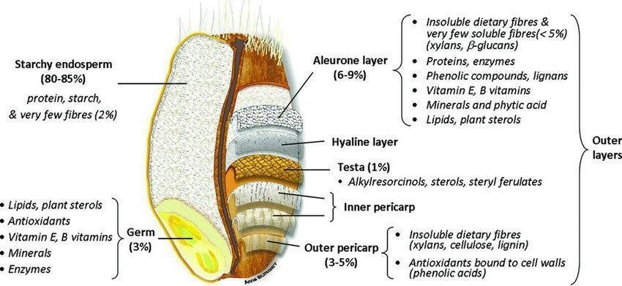

Fig. 1.1. Wheat grain structure. Adapted from Surget & Barron (2005) and Brouns et al. (2012) with permission.
Table 1.1.
Chemical composition of different grains, g/100g
Parameters | Wheat | Barley | Rye | Rice | Corn | Oat
Moisture | 12.6 | 12.1 | 13.6 | 13.0 | 11.3 | 13.1
Carbohydrate | 71 | 76 | 65 | 74 | 65 | 66
Protein | 12 | 11 | 9 | 7.7 | 8.8 | 10.8
Lipids | 1.8 | 1.2 | 1.7 | 2.2 | 3.8 | 7.2
Dietary fibre | 12 | 15 | 13 | 2.2 | 9.8 | 12
Ash | 1.7 | 1.2 | 1.9 | 1.2 | 1.3 | 2.9

Technological quality - the degree of raw material suitability for the utilisation (processing) purpose. Technological qualitative parameters of raw materials that are based on standards: ISO, ICC (each country has the same parameters, but different values). ISO - International Organisation for Standardisation. ICC – International Association for Cereal Science and Technology (publishers of international standard methods).
Technological (processing) quality includes the following quality parameters:
Sensory parameters:
Colour – uniform colour, according to type of grain used to obtain the flour. Smell – smell after heated sample in hand, must be typically pleasant, straw, no side smell (e.g. mould, chemical, etc.). etc.
The moisture content of a product is defined as the loss in weight under the conditions specified in the Standard, expressed as a percentage of the weight of the original sample. Standard value is max. 14%.
Hygienic condition of grain – good condition without pests, impurities (organic, inorganic) – max 2%.
Milling parameters characterise the structural and mechanical structure of the grain and its chemical composition. Evaluated parameters:
One thousand grain weight – weight of 1000 grains. The bigger and heavier grains give more endosperm= more flour.
First class proportion – is the weight of grains proportion retained by a sieve with a slot size of 2.5 mm. The amount of full, round grains.
Bulk density – is the weight of 1 litre (l) of grains in grams (g).
Vitreosity – depends on the arrangement of starch in the cells. More proteins in the cells give harder grains.
Hardness – hard endosperm, use more for semolina flour.
Trial milling – it is characterises flour extraction, colour of flour, ash matters in flour, power consumption and more.
Technological equipment for grain preparation - grain drying, grain cleaning, hydrothermal treatment and grain precipitation, grain cleaning, secondary hydrothermal treatment, weighing and magnetic control, grinding / storage.
The process of reducing the grain's moisture content can take place using various methods, such as hot air drying or ventilation. Grain can only be stored safely if the moisture content is 14% or less. The moisture content of harvested grain in Latvia is approximately 18-20%, so drying and cleaning should be done as soon as possible. If wet or insoluble grains are stored, a self-heating process can occur, resulting in a decrease in grain quality and nutritional value, as well as an increase in the activity of microscopic fungi.
The grain dryer is intended for drying pre-cleaned materials: seeds or grains, cereals, legumes and oilseeds with an initial moisture content of up to 35%. The grain dryers can be installed separately or as part of a grain cleaning and drying complex in grain farms, flour mills, grain receiving companies, alcohol plants, poultry plants and feed mills.
Main types of dryers - shaft type (grain drying is carried out in vertical shafts on boxes, with the heat carrier flowing through), tower type (the grain is pushed between two metallic plates through which hot air is blown), cylinder type (rotary) (the grains are mixed and transported with the help of special paddles), carousel type (the grain is treated with warm air), conveyor type (grain is heated and moved on conveyor belts), modular type (the grains are distributed in a vertical column between metal plates through which the heat carrier is directed), mobile grain dryers.
Grain treatment - separation of impurities, grain surface washing, grain conditioning, preparation of batches of grain for grinding.
Grain separators - intended for cleaning grain from various impurities.
Stone separation plant - in the flour industry, vibro-pneumatic stone separation equipment is more often used. The main operating mechanism of the equipment is a vibrating air-permeable threshing box, where, thanks to the inclination of the equipment and the air flow, the flow of the grain is ensured, as well as the fractionation of the grain by mass.
Magnetic separator - a magnetic separator is used for additional grain purification. Metal impurities are separated from the grain with a static magnet or, less often, with the help of an electromagnet.
Dehusking plant - dehusking equipment is designed to separate the husks from the grain. According to the design, they can have a steel surface (the effect on the grain is very gentle), with an abrasive surface (intensive grain cleaning) and equipment with a metal mesh (medium effect on the grain).
Grain storage equipment - grain warehouses, grain elevators (procurement, mill, ports, reserves), assembly of silos. A ventilation system in silos is necessary during long-term grain storage to ensure grain drying, cooling and heating.

Laboratory work

Analysis of grain mechanical and physical properties
The aim of the laboratory work is to strengthen the theoretical knowledge of the methods of determining grain quality parameters and the importance of quality indicators in the storage and processing process. During the laboratory work, the basic parameters of grain quality will be analysed - moisture, thousand grain weight, bulk density, first class proportion, moisture content, hardness).
Materials and procedures
Wheat, rye, barley, oat varieties, laboratory scales, hygroscope, hectolitre scale, round sieves, calculator of seeds, beakers, watch glass.
1. Moisture content determination
The moisture content of the grains is determined by drying. Determination of grain moisture can be done using the express method or the standard method. The moisture content is calculated from the difference in weight before and after drying. Grains are classified according to their moisture content (Table 1.2.).
Table 1.2.
Moisture content, %
Dry grains | Moderately dry  grains | Wet grains | Very wet grains
< 14 | 14.0 - 15.5 | 15.5 – 17 | > 17
Express method. Pour wheat grains into the hygroscope until you reach the line. A hygroscope will measure the% of actual grain moisture (GM). Using the value and formula to calculate dry matter content (DM).
DM i(%) = 100 – GM (%)
Standard method (AACC 44-19). Weigh 20 g of grain, grind in a grinder. Wheat, rye, rice, buckwheat grind for 30 s, but barley and oats - 60 s.
Dry 2 aluminium dishes of about 55mm, not more than 40mm deep, in an oven at 105 °C for 1 hour, then cool in a desiccator for 10 to 15 minutes and extract to the nearest 0,01 g. Weigh 2 ± 0,05 g of the ground grain into the heated and weighed aluminium dishes. With lids removed. Place the dishes and lids in the oven as quickly as possible and dry the samples for 2 hours at 135 °C. Place lids on dishes and transfer to the desiccator to cool.
Weigh and calculate the loss in weight as moisture.
Grain moisture is calculated:
$$X moisture content, \%=\frac{Loss of moisture, g × 100 }{Weight of sample,g}$$
Summarise the obtained results in Table 1.4.

2. Bulk density determination
Bulk density is the mass of 1 litre of grain, g/l (Table 1.3.). It is determined using special scales - slings. The method of determination is based on the assumption that dry, well-ripened grains with a high endosperm content and a thin skin have a high bulk density and thus a higher flour yield. The results of bulk density measurements are influenced by moisture, grain chemical composition, shape, impurities. Light impurities (leaves, weed seeds, etc.) reduce the bulk density of grains, while impurities of mineral nature (sand, stones, etc.) increase the bulk density. For cereals, the bulk density is determined to calculate the storage capacity, or the number of vehicles required.
Table 1.3.
Bulk density of grain, g/l
Culture | Bulk density |  |  | Culture | Bulk density
Culture | min | common | max | Culture | min | common | max
Wheat | 700 | 730-785 | 810 | Barley | 530 | 570-650 | 680
Rye | 650 | 680-715 | 735 | Oats | 440 | 460-550 | 590

Procedure. Place wheat grains into hectoliter scales and measure the bulk density and summarise in Table 1.4. Please see video https://youtu.be/PWLS5IO5WJs?si=iGmIXKA-BRTGV12f.
3. Proportion of I. class of grains
The quality of grain is characterised by its purity. When determining purity, various impurities are distinguished from the grain. A distinction is made between granular and gritty, granular or other grains or damage grains and pests impurities.
The group of cereal impurities includes the green, immature grains of the main crop and damaged grains, provided that at least 50% of the endosperm is preserved.
This group of impurities also includes grains of other crops specified in the standards, for example, oats, wheat, and rye grains may be mixed with barley.
Grainy impurities can be live (pests, weed seeds, microorganisms, as well as seeds of other crops that are not included in the standards as grain impurities). Dead debris can be mineral (sand, stones, soil particles, etc.) or organic (stalks, weeds, leaf parts, etc.). Debris-like impurities can also be poisonous (poisonous weed seeds, mould-damaged grains, etc.). Gritty impurities make it difficult to store grain, as they are usually wetter, spoil faster and also cause grain damage.
Procedure
Sift 50 grams of grain through a sieve with movements of 110 to 120 sieves per minute for 3 minutes. A sieve with 1.0x1.0 mm mesh is used for rye and wheat, and 1.5x1.5 mm mesh for oats and barley. After sifting, the grain is spread on a glass plate and divided into 3 fractions with tweezers - greasy impurities, main crops and other cereals. The fractions are weighed and expressed as a percentage (separately for each fraction).
The amount of impurities is calculated:
X = m₀ – m₁
X – amount of impurities, %
m₁ – mass of impurities, g
m₀ – mass of the test sample, g
4. Thousand grain weight determination (TGW)
The absolute mass of the grain is the mass of 1000 grains in dry matter. The absolute mass of the grain is an indicator of quality and a physical property. Grains with a higher absolute weight contain more endosperm. More flour and groats are obtained from grains with a higher absolute weight. For the production of malt, it is recommended to use beer barley with a weight of more than 44 grams per 1000 grains. The absolute weight of the grain depends on the grain size, chemical composition, moisture and other conditions.
Procedure
Enter proportion of grains of I. class into the calculator. Start the procedure and the calculator will automatically count 1000 grains. Weigh the grains and calculate.
If you do not have the equipment you can count by hand.
50 g of clean grains (without impurities) are spread in a square layer of equal thickness, which is divided into four parts in diagonals - triangles. From each two opposite triangles deduct (without sampling) 500 grains (250 grains each). Both deductions (2x500) are weighed separately. Weigh to the nearest 0.01 g on an analytical scale. The difference between the two weights must not exceed 5% of the average weight. If the difference is greater, the weighing must be repeated. Convert 1000 g mass to absolute mass using the formula:
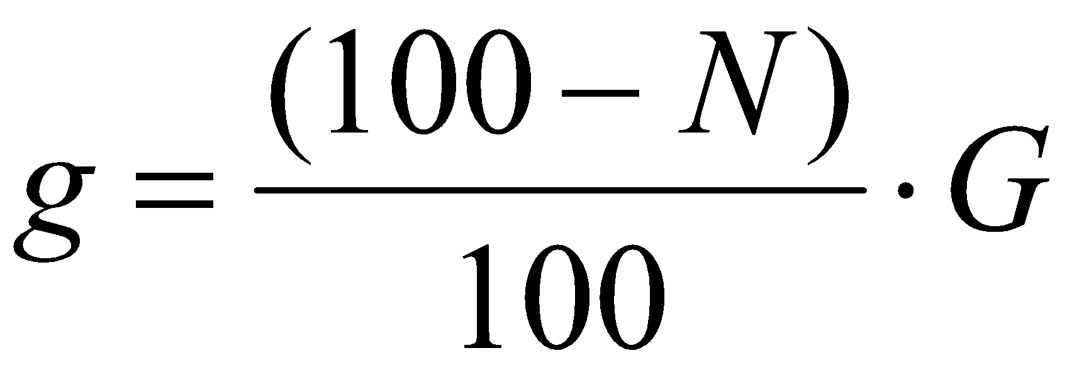
where,
g - absolute mass of grains, g
G - mass of 1000 grains with actual moisture, g
N - grain moisture, %
Obtained results summarize in Table 1.4.
5. Trial milling
Procedure
100 g of wheat grains milling by using a laboratory mill M3 (Figure 1.2.). This mill gives four milling fractions:
I. fraction (flour I – endosperm, size of fragment <155 µm);
II. fraction (flour II. – endosperm, size of fragment <195 µm),
III. fraction (fine bran, size of fragment 195 – 265 µm),
IV. fraction (coarse bran, size of fragment > 530 µm).
Yield of milling products, calculated using formulas:
Y, % = I. fraction (g) + II. fraction (g) + III. fraction (g) + IV. fraction (g)
Yield of eating milling products, % = I. fraction (g) + II. fraction (g) + III. fraction (g)
Evaluate of eating milling products:
> 73% very good,
73 – 69% good,
69 – 66% above average,
66 – 63% average,
63 – 60% below average,
< 60% low.

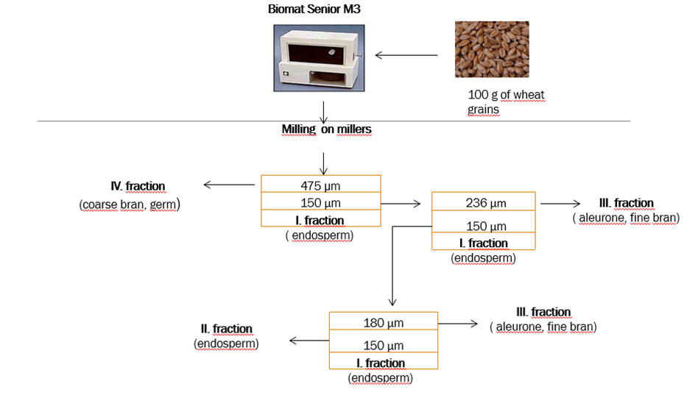
Fig. 1.2. Laboratory Mill M3 and flour fractions.
6. Determination of grain glassiness
The endosperm of the grain may be vitreous and floury. In vitreous grains, proteins stick together the grains of starch and form a mass that is partially textured. If microscopic air spaces remain between the starch grains, light diffusion occurs (light does not pass through) and the grain is floury.
Procedure
The vitreous aspect of the grains is determined with a grainscope (Figure 1.3.). Place the wheat grains in the metal grid of the grainscope/diaphanoscope to fill all the cavities. First examine the first row of grains through the eyepiece of the grainscope /diaphanoscope, counting the vitreous, semi-vitreous and floury grains. Count the grains in the other rows in the same way. The results are summarised in Table 1.5.
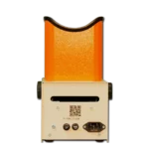
Fig. 1.3. Laboratory grainscope OLISLAB 5100 .
https://olis.com.ua/en/osnashenie/visual-optic-en/diaphanoscope-dsz-3/

Please find video https://youtu.be/qBHHTLRslDk on how to perform the analysis.
7. Sprouting and germination of cereals
Sprouting and germination are the course of grain life. Sprouting is the number of grains sprouted in 3 days (%). Germination is the number of germinated grains in 5 days (%).
A high sprouting rate (close to 100%) indicates that the grains have been prepared correctly for processing. Such grains germinate quickly and evenly.
Sprouting is an indicator of quality in malt production. The sprouting capacity of beer barley must not be less than 95%. It may be reduced if barley drying and storage regimes are not followed. Non-sprouting grains reduce the quality of green malt as well as finished malt.
Procedure
Subtract 2 x 100 grains from the sample and place (each grain must be separately) in specially prepared filter paper containers. Place a filter paper on the Petri dish on which the grains will be arranged. Apply water to the filter paper, preferably so that the entire filter paper is moist but not soaking wet. The filter paper absorbs water, but the grains placed on it slowly swell and begin to sprout. Sprouting takes place at 16-17 °C. After 3 days, the sprouted grains are counted and sprouting is calculated, and the germination is calculated after 5 days. Obtained data summarised in Table 1.3.

Results
Table 1.3.
Results of grain quality parameters
Variety | MC [ %] | BD [g/L] | TGW [ %]
Standard | Max. 14% | Min. 780 g/L | Min. 30%

Table 1.4.
Results of glassiness
Method of determination | Glassiness  group | Number of grains, pcs. | Number of grains, % | Total glassiness, %
With  grainscope /diaphanoscope | glassy
With  grainscope /diaphanoscope | semi - glassy
With  grainscope /diaphanoscope | flour
The total glass content (%) is calculated by:
S - number of vitreous grains, pcs
Ps - number of semi-vitreous grains, pcs

Table 1.5.
Results of Germination
Variety | Germination test | Repetitions  1 and 2 |  | Avg., %
 | Amount of grains sprouted in 3 days
 | Sprouting
 | Amount of germinated grains after 5 days
 | Germination
Calculate the addition or deduction of grain mass and summaries previous results in Grain quality Protocol (Table 1.6.).
The reference mass is calculated, taking into account the grain moisture and the compliance of the amount of impurities with the norms set by the condition.
If these indicators differ from the norms, the paid physical, accounting mass of the grain is increased or decreased.
For each percentage of moisture and impurities, that is lower than the specified condition, 1% is added to the mass of the invoice. For each percentage, that is higher than the specified condition, it is deducted from the mass.
If the quality of the grain, assessed by volume, amount of gluten, grain impurities, the presence of pests, is higher or lower, the grain payment is increased or decreased accordingly:
- for every 10 g of volumetric weight above the norms set for base conditions, 0.1% surcharge;
- for every 10 g of volumetric weight under base conditions, 0.1% is deducted;
- for every 1% of granular impurity above the indicators set in the norms, 0.1% is deducted;
- if there are mites in the grain, 0.5% is deducted.
Table 1.6.
Grain quality protocol
Indicators | Wheat |  | Barley
Indicators | Base conditions | Actual quality | Base conditions | Actual quality
Physical mass of accepted grains, kg | 160 000 |  | 110 000
Moisture, % | 14 |  | 14
Granular impurities, % | 1 |  | 2
Deviations from the base norms, %
Natural addition (+) or deduction (-)
Reference weight, kg
Bulk Density, g/l  bases  actual | 750  782 |  | 590  640
Granular impurities, %  Bases actual | 2  3.6 |  | 2  2.2
Pest infestation | ticks |  | ticks
Purchase price, EUR/t | 80.00 |  | 65.00
The amount for the registration weight, EUR
Actual payment, EUR

Conclusions

Approved by _________________________________________
Name, surname, signature

Date _________________________________________

Laboratory work

Determination of grain quality parameters
Grain quality indicators such as acidity, pH, and ash content are important factors in the processing process. They can change under the influence of agrotechnical conditions, during storage, as well as under the influence of storage conditions. The aim of the laboratory work is to strengthen the theoretical knowledge of the methods of determining grain quality parameters and the importance of quality indicators in the storage and processing process.
Materials and Procedures
1. Evaluation of sensory properties of grain sample
Prepare an average sample of grains and evaluate their smell, colour, grain size and uniformity. Summarise the results in Table 1.7.
2. Titratable acidity (standard method AACC 02-31)
Dissolve and disperse 10 g of samples in 100 mL of water and mix thoroughly. Let stand for approximately 1hour. Stir gently and then pipette 17.6 mL into a porcelain casserole dish. Rinse out the same pipette with 17.6 mL of water and add this to the sample in the casserole dish.
Add 0.5 mL phenolphthalein indicator and titrate with standardized 0,1N NaOH until faint pink colour persists for 30 seconds.
X = 2 × a
where, X - Titratable Acidity of grain, ml NaOH
a – amount of NaOH, ml
The results are summarised in Table 1.7.
3. pH acidity of grain
Dissolve and disperse 10 g of samples in 100 mL water and mix thoroughly. Use a pH indicator or pH meter and fix results in Table 1.7.
Results
Table 1.7.
Sensory properties and acidity of grain
Type of grains | Aroma | Colour | Size, shape of grains | Titratable acidity | pH
Conclusions

Approved by _________________________________________
Name, surname, signature

Date _________________________________________

Practical Work

Equipment for receiving and pre-treatment of grain

The aim of the practical work is to get opportunities for the development of cereal processing.

Materials and procedures
1. Using the lecture materials and available internet resources, please provide information on the following questions:

- What are the main grain quality parameters that should be taken into account for the preparation of flour, bread, pasta, flakes and confectionery?
- What equipment should be used to prepare grades for grinding?
- Which equipment for grain processing is mandatory and which can be dispensed with?
- Which grain chisel would you choose? Justify your answer.
- What latest technological solutions for grain processing are you aware of?
- What would you recommend for promoting the development of the segment of grain processing products?

2. Make a batch (calculate) of grain for grinding so that the glassiness of the grain is 60%. Batch preparation will use grains with a glassiness of 86% (a) (Group I) and 43% (b) (Group II). The weight of the grain lot must be 1000t (A). Summarise the results in Table 1.8.
Table 1.8.

Parameter | Mixture components |  | The required mixture
Parameter | Grain group I | Grain group II | The required mixture
Vitreous, %
Vitreous displacement from assigned creators, %
Calculated ratio of components in the batch | (B) | (C) | (D)
Calculation of the mass of the first component | 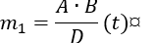
Calculation of the mass of the second component | 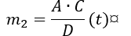
Checking the correctness of the calculation | 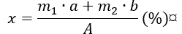

Conclusions

Approved by _________________________________________
Name, surname, signature

Date _________________________________________

Practical work

Quality management in the grain processing industry
What is food safety?
Food safety is a scientific discipline describing handling, preparation, and storage of food in ways that prevent food borne illnesses. This includes a number of routines that should be followed to avoid potentially severe health hazards. In this way, food safety often overlaps with food defence to prevent harm to consumers.
As it is known since the 1960s in the EU, each enterprise that works in the food segment must have a food safety system that is based on 7 HACCP principles.
Seven basic principles are used in the development of HACCP plans that meet the stated goal. These principles include hazard analysis, CCP identification, establishing critical limits, monitoring procedures, corrective actions, verification procedures, and record-keeping and documentation.
The Food Safety Plan - is not a stand-alone programme, but rather part of a larger food safety system. The foundational programmes that are part of the food safety system are frequently termed prerequisite programmes. The term was coined to indicate that they should be in place before HACCP based systems are implemented in order to effectively manage risk from foodborne hazards. Good Manufacturing Practice (GMP) regulations address requirements for many prerequisite programs. The conditions and practices the regulated food industry must follow for processing safe food under sanitary conditions, including personnel, plant and grounds, sanitary operations, sanitary facilities and controls, equipment and utensils, processes and controls, warehousing and distribution, and action levels in case of potentially unsafe products.
The process flow of a food safety plan (HACCP or Preventive Controls) is the centre of a food product’s food safety story. It tells how a company makes its products and also what hazards and controls are associated with each step.
Monitoring records and logs must include the actual values or observations that document the actual implementation of a Food Safety Plan. For example, if a temperature is being measured, the actual temperature must be recorded rather than a check mark indicating that the temperature complied with the critical limit. To comply with regulations, information must be recorded at the time it is observed. Here are suggested record and log types to use:
Customer complaints, corrective action forms, employee training, food safety quarterly audit, food safety checklist, raw materials/receiving log, worker illness log, refrigerator log, assembly log, shipping temperature log.
Suggested Supply Chain Documents
The safety of your product depends on much more than just what you control within your own facility. The use of an ingredient that has a history of association with a specific hazard may require a supply chain programme as a control within your food safety programme. Companies may have extensive supplier programmes that encompass much more than food safety elements to manage their supplier expectations and performance.
Here is a list of suggested documents to obtain from your supply chain:
Food safety HACCP or preventive controls plan for each product, food Defence/business continuity plan, validation of each product and/or process and ready-to-eat statements (if applicable), certificates of analysis (COA), third party audit certificate, report & corrective actions, product specification, allergen management, country of origin, potential hazards.
Biological hazards:
Microbiological contamination – during processing at source of origin – supplier management and HACCP in place and verified to eliminate and reduce potential presence of microbiological contamination.
Microbiological contamination for instance microbiological growth due to breakdown of refrigeration units.
Chemical hazards:
Chemical contamination by pesticides at source of origin – chemical/pesticide used at source is verified to be in conjunction with regulations.
Chemical contamination from machine oils or lubricants, as well as cleaning chemicals.
Microbiological / physical / chemical contamination from – cross contamination or taint of finished product due to poor hygiene.
Physical hazards
Physical contamination – external contamination from rainwater, bird droppings, vermin/rodents, and flying insects during unloading process.
Glass contamination – glass contamination from internal light sources. Pests/rodents and or flying insects due to poor hygiene/debris build up. Physical risks from straps/thermocouples/staples/foreign bodies found on pallets on intake.
Physical contamination – physical contamination from foreign bodies found within product and/or packaging from source of origin or during transportation.
Physical contamination – physical contamination from warehouse staff, pests/rodents, and/or flying insects due to poor hygiene/debris build up. Physical Contamination from personnel foreign body/dust contamination from production environment.
What are the 5 basic food safety requirements?
The core messages of the Five Keys to Safer Food are: (1) keep clean; (2) separate raw and cooked; (3) cook thoroughly; (4) keep food at safe temperatures; and (5) use safe water and raw materials.

Recall Plan
According to the Food Safety Modernisation Act, Preventive Controls for Human Food regulation requires the development of a written Recall Plan when a hazard analysis identifies a hazard requiring preventive control. Recalls are actions taken by an establishment to remove an adulterated, misbranded or violative product from the market. In other words, a product for which FDA or a state could take legal action against the company would be subject to recall.
Verification
Verification is an important component of supply chain, sanitation, allergen and critical controls. It confirms that the Food Safety Plan is operating as intended. Validation confirms the effectiveness of the Food Safety Plan in controlling food safety hazards. The purpose of verification is to provide a level of confidence that the Food Safety Plan is: 1) based on solid scientific principles that are adequate to control the hazards associated with the product and process, and 2) that the plan is being followed correctly every day of operation.
Table 1.9.
Risk assessment matrix
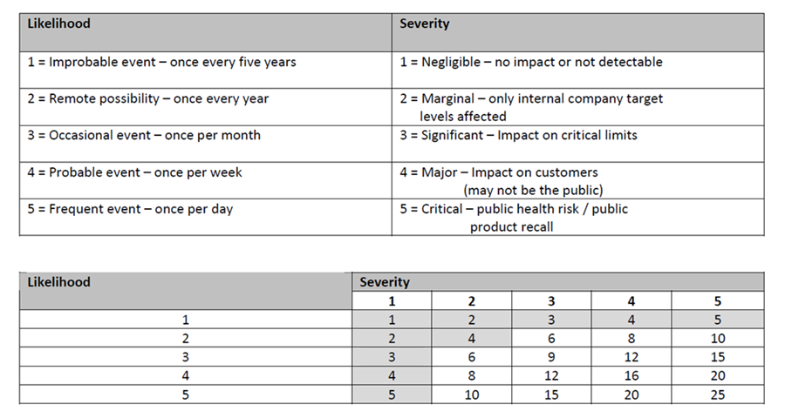
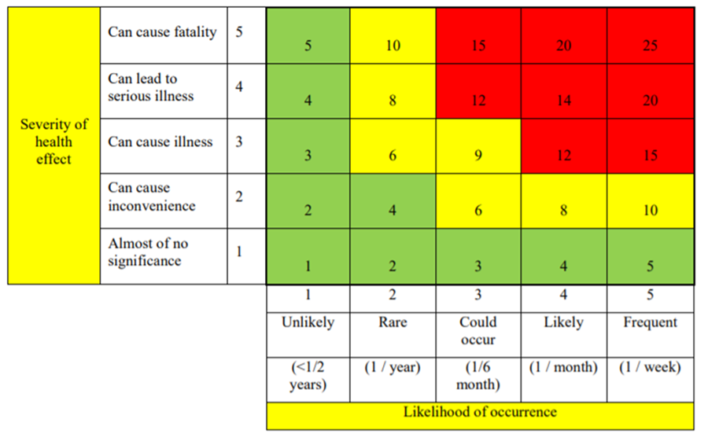
Fig. 1.4. Risk assessment matrix.
Example of a decision tree to identify critical control points (CCP)
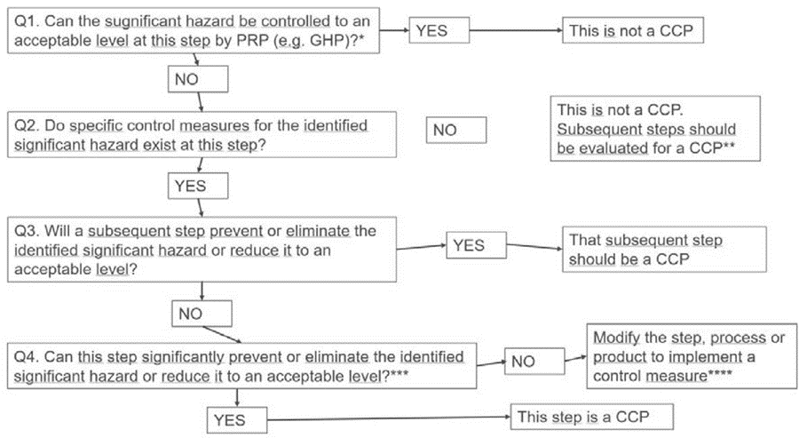
Fig. 1.5. Decision tree to identify CCP.
Materials and Procedures
Method - assessment of potential hazards in grain processing

1. For a selected processed grain product, develop a product description, develop and draw a diagram of the process steps.
2. Identify potential hazards:
- Biological:
  - pathogenic microorganisms;
- Chemical :
  - agricultural chemicals;
- Physical :
  - foreign objects atypical for the product.
3. Evaluate the danger of the identified hazards using a risk matrix 1 or 2 (Table 1.9 or Figure 1.4). Record the information in the hazard assessment Table 1.10.
4. Complete the CCP identification Table 1.11 and the HACCP plan (Table 1.12).
5. Write conclusions on determining CCP using a risk matrix (Table 1.9 or Figure 1.4) and a decision scheme.

Remember: Monitoring activities at a CCP. Some types of monitoring activities at a CCP may include:
- physical measurements:
  - time
  - weight
  - temperature
  - belt speed
- chemical measurements:
  - pH
  - water activity
  - % salt
- microbiological testing:
  - microbiological analysis of critical raw materials before their use in processing (for example, analytical results in dried milk used in chocolate products, or in starch used in canned foods)
  - microbiological analysis of critical finished products before their release to highly sensitive consumers (for example, infant formulas)
Note: You need to consider the time required to obtain results when deciding what monitoring activity should be used at a CCP. Rapid tests are preferable for monitoring procedures taking place on dynamic processing lines.

Results
Table 1.10.
Hazard assessment
Process stage | The identified  hazard | Hazard assessment |  |  |  |  | Means of control
Process stage | The identified  hazard | Possibility | The severity of  the consequences | Risk  level | Assessment | CCP | Means of control

Table 1.11
CCP identification table
Process stage | Process stage | Cause of risk | Description of the cause of the risk | Control actions | Answers to Decision Scheme questions |  |  |  | CCP yes/no
No. |  |  |  |  | 1 | 2 | 3 | 4

Table 1.12
HACCP plan
In process | CCP/  CP | Risk | Measurable | Monitoring procedures |  |  |  | Records /document | Corrections
stage |  | the cause | critical limits of parameters | What? | How to? | How often? | What? |  | events

Conclusions

Approved by _________________________________________
Name, surname, signature

Date _________________________________________

Seminar Grains and Quality
Student teams research information and develop presentations for discussion on the following issues:
1. Which cereals and why will you use for gluten-free product development?
2. Which cereals are grown, processed and exported the most in the EU, Central Asia, USA or other regions or countries?
3. Are quinoa and amaranth grown in your country? What is valuable in these pseudo-cereals?
4. Describe what cereals and pseudo-cereals are grown in your country and what is their application in food processing.
5. What are the quality requirements of wheat grain?
6. How is the volumetric weight of grains and the absolute (1000) grain weight determined and what does it characterise?
7. What are the quality requirements of rye grain?
8. How is the amount of gluten and the quality of gluten determined and what does it characterise?
9. How is the fall number determined and what is it characterised by?
10. Protein extraction from legumes.
11. Resistant starch, its types and production.
12. Types of extrusion and characteristics of the obtained products.
13. Types of flour used in the production of extruded products.

Theme 2

Grain processing - flour, groats and flakes

Theoretical materials

Processing parameters - characterise colloid complex of grain: starch and proteins and activity of enzymes
Crude protein content – is the amount of all nitrogen substances multiplied by a factor of 5.7 (for wheat) and 6.62 (for barley).
Ash content –refers to the minerals and inorganic substances left after heating to 600 °C temperatures to remove moisture, volatiles, and all organic materials.
Gluten content – gluten is a plastic-elastic protein substance made of gliadin and glutenin (proteins) insoluble in water.
Gluten tensibility – ability to keep consistency by pulling.
Gluten swelling – ability to expand its volume in low acid medium.
Zeleny index – ability of all proteins of wheat flour to swell in a lactic acid solution during standard time.
Falling number – is defined as the time in seconds required to measure starch liquefaction (gel) due to alpha-amylase activity (enzymes) in flour.
Rheological (physical) properties of dough – physical properties measured by specialised equipment.
Flour acidity (titratable acidity) – number of acidic substances, which are determined by titration with sodium hydroxide solution.
Rheological properties of dough
Rheology
- a branch of physics that studies the deformation and flow of matter in response to applied stress or strain,
- the term rheology was coined by professor Eugene C. Bingham in 1920 - inspired by the aphorism of Greek philosophers, panta rhei, ”everything flows”.
- in cereal, an important rheology part – the dough,
- dough – the most unique system from the point of material science,
- it is viscoelastic system which exhibits shear-thinning and thixotropic behaviour (viscosity decrease with time),
- this behaviour is the consequence of dough complex structure in which starch granules (75 – 80 %) are surrounded by three-dimensional protein (20 – 25%) network,
Wheat proteins – consisted of gluten proteins (80 – 85% of total wheat proteins) which comprise of prolamins (in wheat - gliadins) and glutelins (in wheat - glutenins) and non-gluten proteins (15-20% of the total wheat proteins) such as albumins and globulins,
Gluten complex – viscoelastic protein responsible for dough structure formation,
Gliadin – protein fraction soluble in alcohol solution, single bonds, provides extensibility of dough - responsible for allergenicity.
Glutenin – protein fraction soluble in alkali solution (KOH, NaOH), more chains, molecules are linked by disulphide bonds, provides flexibility to dough.

Farinograph
- the most popular and accepted device for measuring dough physical properties is Brabender Farinograph,
- measures and records the mechanical resistance of the dough during mixing and kneading,
- physical properties of the dough are measured by placing a defined mass of flour in a tempered (30°C) mixing bowl equipped with two Z-type kneaders,
- depending on the available quantity of flour, tests can be performed in 300 g, 50 g and 10 g mixing bowls,
- In order to obtain the dough, the rheological properties of which are actually measured, water is added to the flour in amount to ensure the dough consistency of 500 FU (farinograph units).
Extensograph
- Brabender Extensograph is an internationally accepted standard method that is in compliance with ISO 5530-2, ICC 114/1, AACC 54-10,
- it is applicable for the measurement of physical properties of dough subjected to mechanical handling and resting,
- provides information about the resistance of dough to stretching and extensibility by measuring the force to pull a hook through a cylindrically shaped piece of dough,
- during the measurement, the resistance of dough to stretching and the distance the dough stretches before breaking is recorded in the form of a diagram extensograph.
Amylograph
The baking properties of flour depended on the gelatinisation of the starch and on the enzyme activity (α-amylase) in the flour. The Amylograph measures wheat, rye, maize, and rice flour and enables:
- assessment of the flour quality,
- suitability of the flour for various applications,
- measurement of the baking characteristics of flour,
- control of enzyme addition.
The Amylograph test measures the flour starch properties and enzyme activity, which results from sprout damage (alpha amylase enzyme activity).
Sprouting in wheat, as indicated by high enzyme activity, produces sticky dough that can cause problems during processing and results in products with poor colour and weak texture.
For Asian noodle products, flour of medium to high peak viscosity is preferred because it gives noodles better texture characteristics.
Preparation of grain for grinding - modern wheat, rye and c. mills can be both industrial, 5-6 floors high, and modular complexes. The modular mill comes complete with a frame and platforms. Takes up little space and is not that expensive.
Construction of a grain mill includes - preparation of grain for grinding, grain grinding, fractionation of the ground product into fractions (by particle size), breakdown of the ground product by quality, separation of metallic impurities, air purification and transportation of the ground product, filling of the ground product into tanks, etc.
Mill types - roller (used for grinding rye, wheat, barley, beans, rapeseed, corn - the resulting product is homogeneous), hammer type, disc type mill, pneumatic hammer mill.
Technological equipment for the production of groats - technological lines.
The main technological equipment for the production of flakes - technological lines, aspiration column, grit separation plant, steamer, roller.

Laboratory work

Flour and breakfast flakes quality assessment
The aim of the work is to acquire skills in developing of flour and determining its quality, however to determine the quality parameters of commercially available breakfast cereals. The group of students is divided into teams and each team prepares different products.
Materials and Procedures
Wheat, Rye, Barley and Oat grains for processing. Commercial breakfast cereals.

1. Obtaining flour and quality assessment

1) Using the scales in the laboratory, ______________________ weigh the ____________ grains.
2) Grind ______________ grains using the ____________________ mill in the laboratory.
3) Determine flour yield as well as milling losses.
4) Determine the moisture content of the obtained flour using a moisture scale.
5) Using the water activity determination equipment in the laboratory, ______________________ should determine the water activity of the obtained flour.
6) Using the colour analyser in the laboratory ____________________ should determine the colour intensity of the obtained flour.
7) Using the flour sifter in the laboratory _______________________ the flour should be sifted and the percentage distribution of the existing fractions should be determined.
8) Calculate the amount of residual products that occur during flour sifting.
The results obtained in the experiments should be reflected in Table 2.1.
Table 2.1.
Quality of flour
The parameter to be analysed | Type of flour
Grain mass, g
Flour yield, %
Flour milling losses, %
Flour moisture, %
Water activity of flour, units
Flour colour, units
L*
a*
b*
Distribution of flour by fractions, g
160 µ
250 µ
315 µ
450 µ
Residual products obtained during flour sifting, %
2. Flakes quality assessment
1. Determination of water activity using the _________________________________ water activity determination device.
2. Determination of moisture content using ________________________________________ moisture scales.
3. Determination of hardness and crispness using ________________________________________ structure analyser.
4. Determining the volumetric mass using the volumetric mass determination device ________________________.
The results obtained in the experiments should be reflected in Table 2.2.
Table 2.2.
Quality of flakes
No. | Parameter | Sample
No. | Parameter | 1 | 2 | 3
1 | Water activity, units
2 | Moisture, %
3 | Hardness, N
4 | Crispness, units
5 | Volumetric mass, g L

Conclusions

Approved by _________________________________________
Name, surname, signature

Date _________________________________________

Practical work

Packaging of flour and flakes and evaluation of the quality
The aim of the work is to acquire skills in packaging of flour and flakes with different packaging equipment using various packaging materials. The group of students is divided into teams and each team packs products using different solutions.
Materials and Procedures
Products prepared in previous experiments or raw materials purchased at the discretion of the teacher.
The vertical flow-pack packaging equipment and the pulsed simple hermetically sealed equipment. Single-layer film packaging material on a roll with high moisture barrier properties and multi-layer packaging. Ready-made stand-up packages made of material with high moisture barrier properties and multi-layer packaging.
The results obtained in the experiments should be reflected in Table 2.3.
Table 2.3.
Summaries of experiments
Characteristic parameters | Samples
Characteristic parameters | Product No. 1 | Product No. 2 | Product No. 3
Packaging material
Packaging shape
How well the sealing went
What is the sealing temperature of the package?
What is the sealing time (sec.) of the package?

Conclusions
After packaging the products, different groups of students compare the results. If possible, each group packs 5 packages of each type, and then observes and determines the quality of the products during storage over the course of the study.
During the practical sessions, the students learnt the skills of working with packaging equipment.

Approved by _________________________________________
Name, surname, signature

Date _________________________________________

Laboratory work

Flour quality Analysis
Aim of laboratory work – analyse organoleptic properties of flour, crude protein content, ash content, Zeleny index, acidity, falling number, quantity and quality of gluten, rheological properties.
Materials and Procedures
1. Organoleptic evaluation of flour
Organoleptic properties is quality indicators that are determined for each type of flour.
The smell of fresh flour should be characteristic of flour. Since flour is hygroscopic, it easily attracts moisture and foreign smells. If the flour is stored in inappropriate conditions, for example at elevated temperature and room humidity, near odorous substances, the smell and also the taste can change. It can be rancid, bitter, sour, wormwood or with some other smell.
The taste of fresh flour is characteristic of flour and is designated as "normal". If a bitter, sweet, sour, mouldy, rancid or other aftertaste is felt, it indicates that the quality of the flour does not meet the requirements. Flour that is characterised by a foreign taste cannot be used in the preparation of dough, as it may remain during baking. When checking the taste of the flour, it is also determined whether there are any mineral impurities in the flour, which can be felt as a crunch between the teeth. In certain cases, control cakes can be baked and mineral impurities can be determined organoleptically in bread samples.
Procedure. Warm a small amount of flour (approx. 20 g) in your hands with warm breath and smell it. Pour 10-15 grams of flour into a clean beaker, pour hot - about 60 °C water over it, cover the beaker with a lid and leave for 2-3 minutes. After that, the water is drained and the smell of the flour is determined again. In the protocol, it is noted whether in this case the smell of flour is more pronounced, easier to feel and describe in Table 2.6.
The taste of flour and the presence of mineral impurities are determined by tasting it once or twice in 1 g. Obtained results should be described in Table 2.6.
2. Crude protein content
Flour samples from last Laboratory works, pipettes, 0.1 M solution of NaOH, lactic acid, bromophenol blue reagent, Zeleny cylinder, Zeleny mixer, thermostat, 2% solution of NaCl, beakers, Kjeldahl apparatus, muffle oven, watch glass, viscometer, farinograph, extensograph, amylograph, laboratory scales.
Mineralization
1. 1 g of sample with pure acid H₂SO₄ and catalyst, organic nitrogen converted to NH₃ and with acid H₂SO₄ forms (NH₄)₂SO₄.
2. Distillation – displacement of NH₃ from (NH₄)₂SO₄ by means of NaOH, and the displaced NH₃ is bound in a sample with a known amount of boric acid.
3. Titration – it is determined how much NH₃ reacted in the sample with boric acid, sample is titrated with 0.05 M H₂SO₄ with Tashir indicator from green to purple colour.
4. Calculation
Step 1
$$Crude protein, \%= \frac{1. 4007 × 0.05×(a-b)×2}{w}$$

where,
a – amount of H₂SO₄ in mL for sample titration
b – amount of H₂SO₄ in mL for blank titration
w – weight of sample, g
Step 2
$$Crude protein, \%= result from step 1 ×5.7$$

5.7 (factor for wheat)
Step 3
$$Crude protein. \%= \frac{Result from step 2 × 100}{DM}$$
Where, DM – dry matter
5. Results are recorded in Table 2.6.
3. Ash content
Weigh 3 g of the sample into a special porcelain cup.
The door of the muffle oven is opened until the material starts to burn, then it is closed until it is completely decomposed, cooled to a room temperature and immediately weighed to the nearest 0.001 g.
Calculation.
$$Ash, \%= \frac{W1 x 100}{W0} ×\frac{100}{100-MC}$$

where, W0 – weight of the sample in g,
W1 – weight of the residue in g,
MC – moisture content, % of the flour sample.
Results should be recorded in Table 2.6.
4. Zeleny index
Ability of all proteins in wheat flour to swell in lactic acid solution during standard time. Higher gluten content of wheat and better gluten quality give rise to higher sedimentation test values. Zeleny sedimentation test assessing the quality of wheat as a means of predicting the baking strength of the flour, which can be made from it.
Procedure
weigh 3.2 g of flour onto cellophane paper and pour into the Zeleny cylinder. Add 50 mL of solution bromophenol blue and leave for 5 minutes. Then shake and add 25 mL of lactic acid solution and leave for 5 minutes and then shake. At the end, it is left for 5 minutes. The sediment and the height of the formed sediment are read. Obtained results should be summarised in Table 2.6.
5. Flour titratable acidity
Titratable acidity amount of solution NaOH (mmol) necessary to neutralise the acidic substances in 1 kg of flour. Titratable acidity depends on the type of cereal and milling process, in wheat flours 4 to 8 ml NaOH, in rye flours at 5 to 9 mL NaOH.
Procedure
10 g of flour is mixed with 100 cm³ of distilled water and left at a laboratory temperature for 30 minutes. After this time, add 2-3 drops of phenolphthalein and titrate with 0.1 M sodium hydroxide until a clear pink colour appears.
X = 2 × a
X - Titratable Acidity of grain, ml NaOH
a – amount of NaOH, ml
The results should be summarised in Table 2.6.
6. Falling number
Falling number is defined as the time, in seconds, required to measure starch gelatinisation (gel) due to α - amylase activity (enzymes). Starch gelatinisation - during baking enzymes α - amylase degrade starch (complex sugar) to simple sugars (glucose, fructose). Simple sugars become nutrition for yeast during bread baking.
Low FN (< 200s): α-amylase activity is high and the time of starch liquefaction is short and it causes high porosity of wheat bread in terms of technological quality.
High FN (>300s): α-amylase activity is low and the time of starch liquefaction is long and it causes that shape and volume of bread are not optimal in terms of technological quality. Wheat bread does not have porosity and it has small volume.
Standard 220 - 300 s for wheat flour and 180 – 220 s for rye flour.
Procedure
Weigh 6 g of flour, add 25 mL of distilled water and put on a slide and place in a visco bath (Figure 2.1). Use the video for information on how to evaluate falling number of flour https://youtu.be/-XmsT080DNM?si=lDHRMXJcb4PLCBdE. All results should be summarised in Table 2.6.

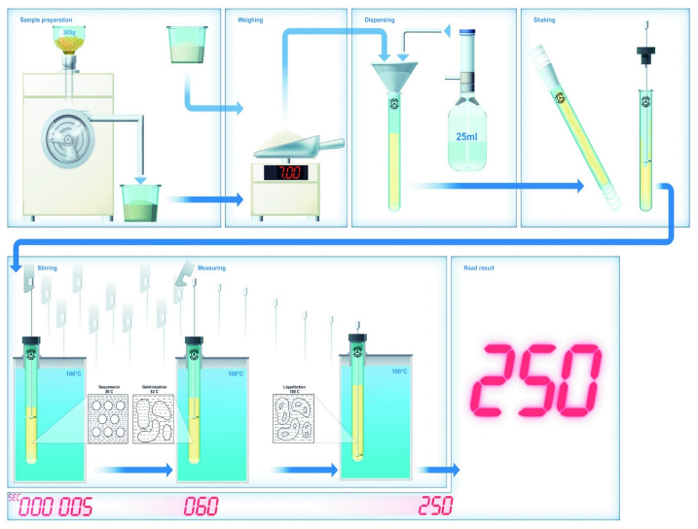
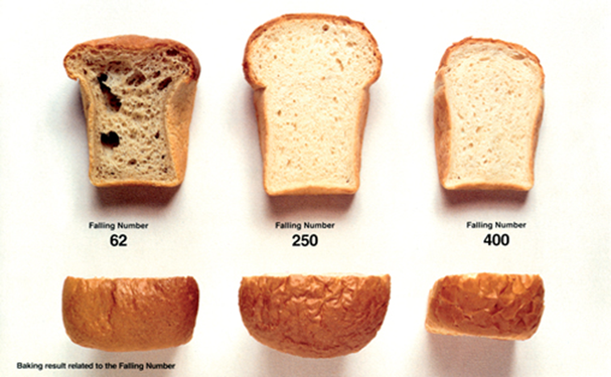
Fig. 2.1. Procedure of falling number evaluation and quality of bread.
6. Gluten content
Gluten is a plastic-elastic substance made of gliadin and glutenin (proteins) insoluble in water. Gluten content in wheat flour is min. 26 %. Gluten tensibility is 5 – 14 cm. Gluten swelling:
low-quality gluten, ≤8
medium quality gluten, 9 – 10
good gluten, 11 – 12
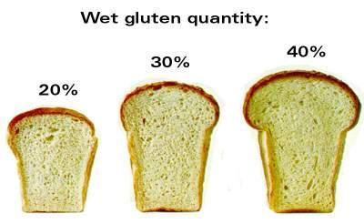
very good gluten, 12≤

Fig. 2.2. Gluten and influence of wheat bread quality.
(https://www.perkinelmer.com/product/perten-glutomatic-pergm)
Procedure
Weigh 10 g of wheat flour and add 5 mL of 2 % NaCl solution and make a ball of dough. Wash it immediately under running cold water over a sieve until clear water flows (this stops the leaching of starch and water-soluble proteins). Washed gluten has a gummy texture. After washing the gluten, weigh and recalculate to dry matter. For washing use Perten Glutomatic® 2000 System (Figure 2.3.)
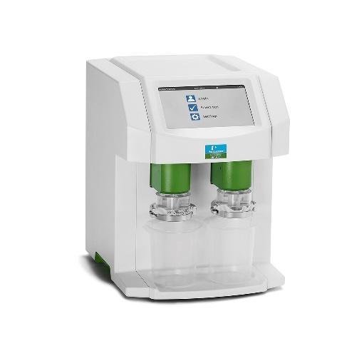
Fig. 2.3. Glutomatic 2000 system.
(https://www.calibrecontrol.com/main-product-list/perten-glutomatic).
Calculation.
$$Gluten, \%= \frac{a ×100}{DM} ×w$$
a – weight of gummy gluten, g
DM – dry matter content
w – weight of sample (flour), g

Gluten tensibility
Form a cylinder (diameter 6 – 7 mm) from the wet gluten, which is then stretched over a ruler until it breaks. Repeat 3 times and calculate the average results and write it in Table 2.6.
Gluten swelling
Procedure. Pour 80 mL of lactic acid into the Berliner flask, cut 1 g of gluten into 30 approximately equal pieces, put in the flask and let it swell in the thermostat for 90 minutes at 32 °C and read the volume of the swollen gluten in mL.
All results summarize in table 2.6.
6. Rheological properties - Farinograph
Water absorption – the amount of water required to centre the farinograph curve on the 500 farinographg unit (FU) line. This relates to the amount of water needed for flour to be optimally processed into finished products. Absorption is expressed as a percentage.
Development time – time when the top of the curve leaves the 500-FU line. This indicates the time when the dough is beginning to break down and is an indication of dough consistency during processing. Development time is expressed in minutes.
Stability – is the difference in time between the time when the curve first touches the 500 FU line and the time when the curve leaves the 500 FU line. It is generally accepted that the longer the stability of flour, the greater the tolerance to mixing.
Degree of softening (12 minutes after start) – the difference in FU value at the top of the curve at the peak time and the value at the top of the curve 12 minutes after the peak. This indicates the degree of softening during mixing. It is expressed in farinographic units (FU).
Farinograph quality number (FQN) – the distance from the start of the measurement to the point where the consistency (middle curve) fell by 30 FU from 500 FU.

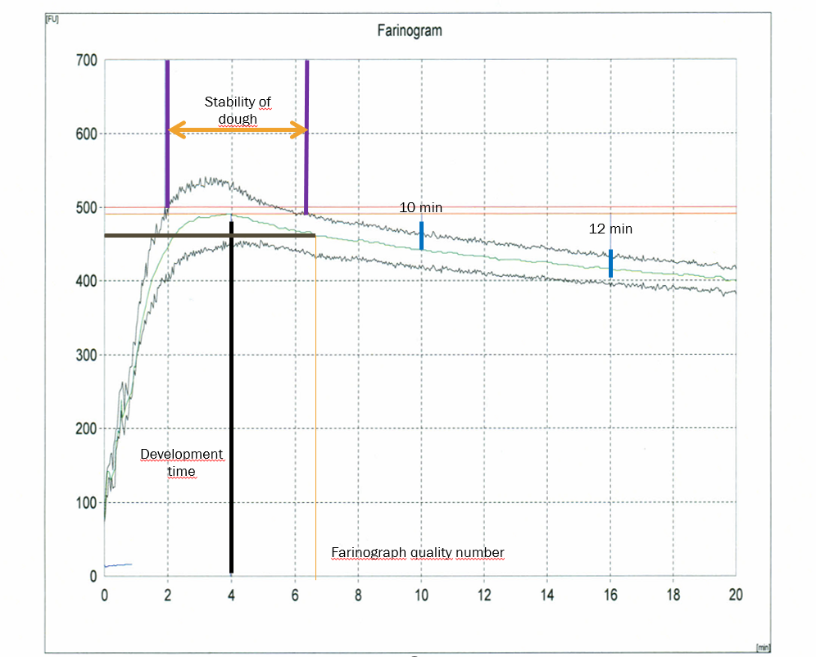
Fig.2.4. Curve of Farinogram.

For evaluation of wheat flour quality use data from Table 2.4.

Table 2.4.
Quality parameters from Farinograph.
Flour | Weak | Middle strong | Strong
Water absorption, % | <50 | 52 - 56 | 57 - 60
Development time, min | <1 | 1 - 2 | >2
Stability, min | <1 | 1 - 3 | >4
Degree of softening, FU | >90 | 40 - 90 | <40
FQN | <40 | 40 – 99 | >100

Procedure
Please use the video to learn about the analysis method https://youtu.be/6ZhfQYz_Cko?si=E9AH2zj_P0DT2GB8.
Connect the Farinograph device (Figure 2.5.) to the power supply and turn on water circulation.
Turn on the computer and open the Farinograph computer program
Preparing the equipment for work:
- water circulation is performed to heat the water and avoid air bubbles by pressing the green icon with a droplet "Flush...",
- it is necessary to calibrate the equipment before working,
- press the yellow icon "Calibrate..." and follow the instructions,
- press the "start" button on the device, the paddles start working,
- water circulation begins,
- weigh glass for water measurements,
- insert the tube into the glass and perform the first water weight calibration,
- record the actual weight in the computer program,
- weigh the glass with water and leave the tube in the glass to calibrate the next amount of water and record the actual weight in the computer program.
Taking measurements:
- open a new page in the computer program,
- enter the necessary information (sample humidity, predicted water binding capacity),
- start measurements by pressing the "start" key,
- follow the instructions - pour in 300 g of flour, implement water circulation and only then insert the blue tube into the mixer.
If the maximum resistance (in Brabender units) is 500, the measurement was performed correctly, otherwise the analysis should be repeated, taking into account the recommended corrections in the program.
According to the schedule, the water absorption capacity of the flour, the time of mixing the dough and the stability of the dough is read.
Analyse the obtained data and summarise it in Table 2.6.
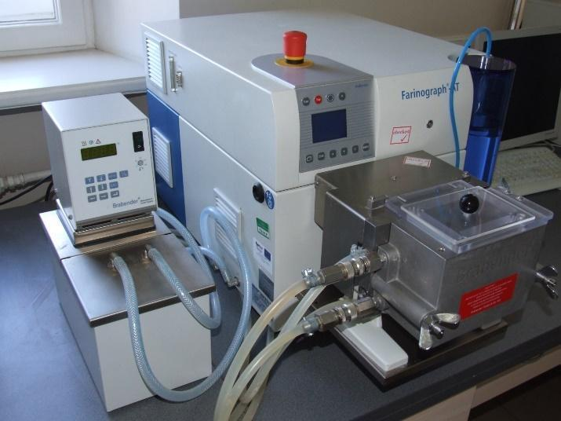

Fig. 2.5. Brabender Farinograph
(https://scientificservices.eu/id/item/5369/farinograph-R--at-version-12.html)
7. Dough resistance Extensiograph
For dough resistance properties use Extensiograph (Figure 2.6.).
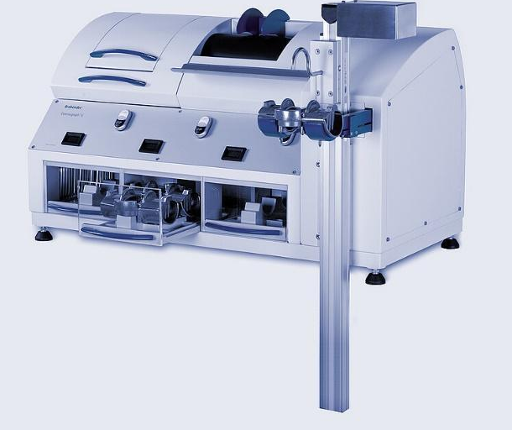

Fig. 2.6. Brabender Extensiograph.
(https://www.anton-paar.com/corp-en/products/details/extensograph/ )
The curve of the obtained results (Figure 2.7.) shows us the following parameters:
The maximum resistance (Rmax), or the resistance at constant deformation usually corresponds to the height of the curve at 50 mm from the beginning of stretching (R50). The latter is preferably expressed within the cereal testing laboratories since it represents the resistance at a fixed extension for all tested doughs. This parameter is expressed in Extensograph units.
The dough extensibility (E) expressed in mm, which represents the distance of stretching before rupture.
The ratio of resistance to extensibility – high ratio indicates the short gluten properties resulting in low volume of baked products.
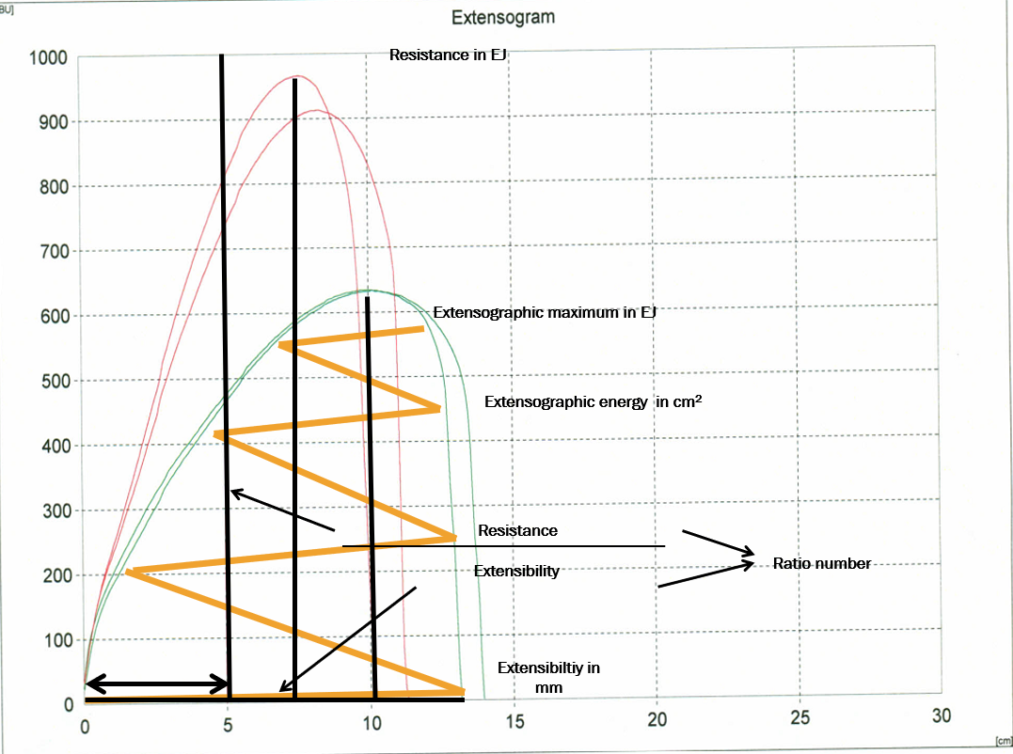
The area under the curve, which is proportional to the energy required to stretch the test piece to its rupture point. This parameter, expressed in cm², is a convenient single figure for characterising flour strength. The stronger the flour, the more energy is required to stretch the dough.
Fig.2.7. Extensiograph Curve.
For evaluation of wheat flour quality, use data from Table 2.5.
Table 2.5.
Quality parameters from Extensiograph.
Technology quality | Extensiographic parameters |  |  | Ratio number
Technology quality | Resistance (EU) | Extensibility (mm) | Energy (cm²) | Ratio number
Weak | 150 | 180 | 37 | 0.8
Middle strong | 350 | 160 | 90 | 2.2
Strong | 550 | 155 | 150 | 3.5
Procedure
- Preparation of dough (with 2% salt based on flour weight) in the Brabender Farinograph mixer, usually at 2% less than its optimum absorption to compensate the salt addition,
- Moulding of dough pieces on the Extensograph into a cylindrically shaped dough piece.
- Resting of the dough pieces for a fixed period of time (15, 30, 45, 90, 135 min),
- Stretching the dough pieces until they rupture and recording the extensibility of the dough and its resistance to stretching.
Obtained data should be summarised in Table 2.6.
8. Wheat flour viscosity Amylograph
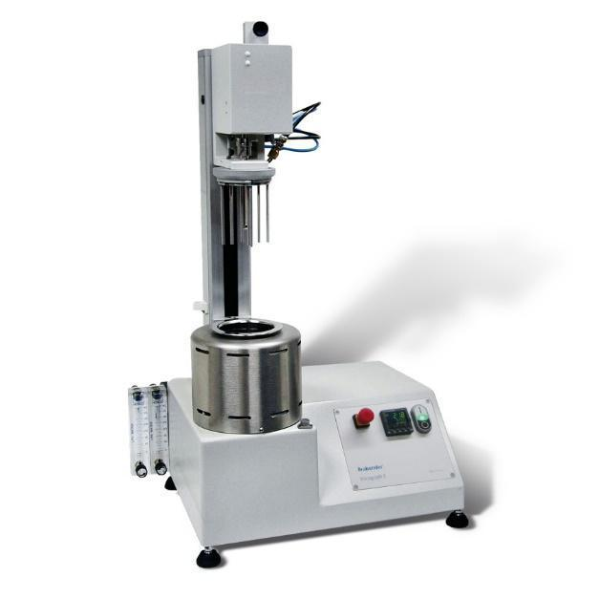
The Brabender Viscograph E (Figure 2.8.) provides you with a complete picture of the gelatinisation behaviour of starches and all modified starches. To ensure compliance with Viscograph-E, use a standard starch viscometer that measures the gelatinisation properties of starch according to ICC 169 and AACCI Method No. 61-01.01.
Fig. 2.8. Brabender Viscograph E.
(https://www.calibrecontrol.com/main-product-list/brabender-viscograph-e )
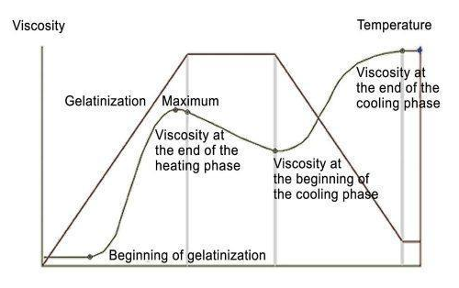
The curve of the Viscograph (Figure 2.9.) shows starch gelatinisation max temperature and the viscosity of starch. Peak viscosity is the maximum resistance of a heated flour and water slurry to mixing with pins. It is expressed in Bradbender units (BU) or Amilograph units (AU). Flours with different starch viscosities can be used to produce different qualities of bread (Figure 2.10.).
Fig. 2.9. Viscograph E curve.
(https://www.nexus-analytics.com.sg/product/viscograph-e/)

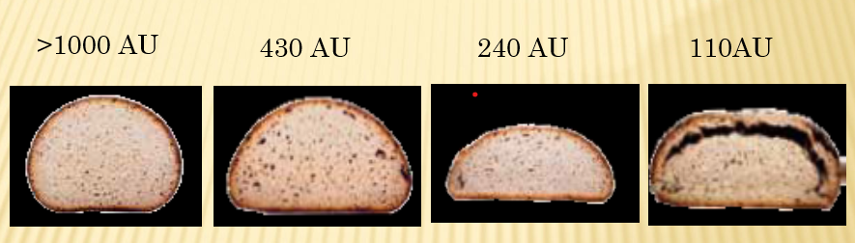
Fig. 2.10. Bread quality samples.
Procedure
A sample of 80 grams of flour is combined with 450 mL of distilled water and mixed to make slurry.
The slurry is stirred while being heated in the amylograph, beginning at 30 degrees Celsius and increasing at a constant rate of 1.5 degrees Celsius per minute until the slurry reaches 95 degrees Celsius.
The Viscograph E records the resistance to stirring as a viscosity curve on graph paper.
The viscograph analyses the viscosity by measuring the resistance of a flour-and-water slurry to the stirring action of pins or paddles.
When the slurry is heated, the starch granules swell and the slurry becomes paste.
A thicker slurry has more resistance to the pins during stirring and has a higher peak viscosity. Generally, a thicker slurry indicates less enzyme activity and makes better products.
Obtained results are summarised in Table 2.6.

Results
Table 2.6
Flour quality
Quality indicators | Score and rating
Organoleptic evaluation of flour | Colour:  Smell:  Taste:
Flour moisture
Flour titratable acidity
Amount of ash
Amount of gluten
Gluten quality
Farinograph
Dough kneading time
Dough persistence
Water absorption capacity
Extensiograph
Resistance, EU
Extensibility, mm
Energy, cm²
Viscograph:
Starch gelatinization, °C;
Max gelatinization temperature, °C;
Max Viscosity, BU
Conclusion

Approved by _________________________________________
Name, surname, signature

Date _________________________________________

Laboratory work

Sensory evaluation of breakfast cereals, granola and muesli
Sensory evaluation of breakfast cereals involves assessing and measuring various sensory attributes such as appearance, aroma, flavour, texture, and overall acceptability. This evaluation can be conducted using both trained sensory panels and consumer panels. In the sensory evaluation of breakfast cereals, granola and muesli, a method will be used, which assumes that the product is evaluated in a group and a common opinion is adopted for the entire group of experts.
Materials and Procedures
In each evaluation group - 4-5 experts; for each group - 5-7 samples of breakfast cereals or granola or muesli. About 30 g of the product is prepared for each group and placed in transparent zip bags. Each sample is coded with three randomised numbers.
To clean the mouth between samples, use water or warm black tea.
Use the recommendations given in Table 2.7 for sensory evaluation of products.
Table 2.7.
Recommendation for breakfast cereals sensory evaluation
 | Appearance* | Consistency | Aroma | Taste, aftertaste
5 | Even, not stuck together, not broken flakes | The flakes are evenly swollen, soft | Pronounced, characteristic smell of grain | Pleasant, balanced and typical for product
4 | Minor deviations | Some flakes unevenly swollen | Pleasant cereal | Typical for cereals, but not pronounced
3 | Some of the flakes are broken, crumbled, visible stuck together flakes or ingredients | Flakes unevenly swollen | A faint, straw smell | Unbalanced, too sweet
2 | Unsightly, uneven colours, crumbled | Hard unswollen flakes, difficult to chew or dissolved flakes | Uncharacteristic, off-odour | Bitter taste and aftertaste
1 | Unattractive appearance | Flakes too soft or hard, flakes completely dissolved | Inappropriate | Inappropriate, unpleasant taste and aftertaste
*Appearance is evaluated for dry samples. For evaluation of external appearance the flake sample is weighed into 15 g beakers and visually assessed.
For evaluation of consistency, smell and taste - pour over a sample of flakes (15 g) over 50 mL milk, mix and evaluate after 5 minutes.
The total score of sensory properties and their transcript:
20-19 very good quality
16-18 good quality
15–12 average quality
12 and less inadequate quality
Results
1. Evaluate breakfast cereal samples and fill each expert group, results write in table 2.8.
Table 2.8.
Breakfast cereals sensory evaluation sheet
Sample code | Appearance* | Consistency | Aroma | Taste, aftertaste | TOTAL

Conclusions

Approved by _________________________________________
Name, surname, signature

Date _________________________________________

Seminar flour production and quality
Using the available internet and bibliographic resources, teams of students prepare an infographic on one of the issues and develop a discussion during the seminar between the teams using the Bingo method (preparing questions to which other students must find answers).

- What cereals are used in the production of flour?
- Classification of flour according to the amount of grain sheaths.
- What are the by-products of flour production?
- What kind of products is barley used in?
- What products are oats used in production?
- What is the market demand for breakfast cereals in the EU and Central Asia?
- Protein extraction from legumes.
- Resistant starch, its types and production.
- Types of extrusion and characteristics of the obtained products.
- Types of flour used in the production of extruded products.

Theme 3

Pasta production and quality evaluation

Theoretical materials
Pasta is a ready to eat, extruded product having higher nutritional properties. It is really suited for a daily balanced diet because of the higher concentration of unsaturated fatty acid. Mixing, extrusion, drying, cooling and packaging are the major steps used in the production of pasta. Pasta can be produced from different cereals like sorghum, maize, wheat, rice, oats and the addition of these cereals can change the textural, functional, physicochemical properties and microstructure of pasta.
Pasta is an ancient ready to eat product made from durum wheat, water by using a high-capacity cold extruder with different types of dyes to ensure different shapes of product. It contains carbohydrates, proteins, vitamin-B Complex, iron whether it is low in sodium, amino acids and total fat. Semolina pasta contains about 74 % of carbohydrates, 11-12% of protein, 2% of fat and 12% of water. The Uncooked pasta contains about 68.2 g of starch, 11 g of protein, 4.3 g of soluble sugars, 2.8 g of fibre and 1.4 g of fat which provides 353 kcal.
Mixing, extrusion, cooling, packing are the major steps in the production of pasta. Cold extrusion method is commonly used here. After the drying process, the product retains 10% of moisture in it. The major things that should be taken care of for high quality pasta are proper selection of raw materials, other additives and ingredients, processing line and packaging requirements.
Storage of pasta
- Dried pasta should be tightly wrapped and stored in a cool, dry place.
- Fresh pasta should be kept in the refrigerator until the “use by” date.
- Cooked pasta will keep for two to three days in the refrigerator.
Evaluation pasta quality
Sensory evaluation:
- before cooking (shape, colour), by touch considered properties of surfaces – smooth, semi-smooth, rough.
- after cooking with 1 % of NaCl: evaluating taste, smell and adhesiveness.
- cooking ability – indicate the time in minutes for perfect cooking of pasta.
- pasta water absorption – amount of water in %, which pasta absorbed during cooking.
- pasta volume index – volume of pasta before and after cooking, expressed as multiple of original volume.
Technological solutions for the production of extruded products - breakfast cereals, flakes (grit sifting, washing, boiling groats in a sugar-salt solution, cereal drying, grit flattening, heat treatment ("expansion"), airy products (whole grains or prepared pellets, the raw materials are placed in a high-pressure chamber, hermetically sealed and heated, when the moisture in the product heats up, overpressure is formed, hermeticity is broken, pressure drops, product increases in volume (expansion); extruded products (gluten-free cereals with high starch content are used as raw materials, bran, sprouts, malt can be added, various spices are added: sugar, salt, chopped nuts, etc., the extrusion process includes: cold forming, heat treatment and low pressure forming, or heat treatment and high pressure forming). Production possibilities of extruded products with filling. Dry component mixer. Glazing equipment.
Extrusion characteristics. Equipment for the extrusion process - Extrusion. Types of extrusion. Extrusion cooking. Classification of extruders. Construction of the extruder. Twin screw extruder. Single-screw and double-screw barrel. Variations of extruder screws and matrix.

Laboratory work

Pasta production in laboratory condition

Evaluation of pasta quality
Pasta production in laboratory conditions. Evaluation of pasta quality – evaluation of cooking ability, water absorption and pasta volume.
Materials and procedures
Semolina, eggs, salt, water, extruder for pasta preparing, cooker, pots, plates, fork, sieve, cylinder, laboratory scales.
1. Prepare pasta dough
Ingredients: Semolina 1kg; 2 eggs; Water 300 mL; Salt 5g.
Mix all the ingredients for 15 minutes in a pasta extruder into a dough, after preparation of the dough, form various shapes (spaghetti and node) using matrix and cutter.
After packing the pasta, the following quality indicators are determined:
2. Evaluate quality parameters of pasta and compare with industrial pasta samples
Pasta cooking ability
Procedure: Bring 1 l of water with 10 g NaCl heat to boil and add 100 g of pasta, mix and simmer. Good pasta preparation (cooking) is determined by taste; pasta’s starch must be gelling, i.e. the starch changes its structure and swells. The pasta doesn’t have must have gelatine on the whole surface, a hard core. The result is the time in minutes.
Pasta water absorption
Procedure: after cooking, leave pasta for 2 minutes in a sieve (remove water) and after that determine the weight.
Calculation: the weight of cooked pasta – the mass of uncooked pasta = water absorption in g/%.
Pasta volume
Procedure: place 100 g of fresh uncooked pasta into a glass cylinder 1000 cm3, which is filled with water to 500 cm³mark slowly mixing (to run-off air) and passing the volume. Repeat the same procedure with cooked pasta.
Calculation: the volume of cooked pasta (cm³): the volume of uncooked pasta (cm³) = multiple (dimensionless number).
Results
Summarise the results obtained in the laboratory work in table 3.1.
Table 3.1.
Results of pasta quality evaluation
Sample | Sensory characteristics | Pasta cooking ability | Pasta water absorption | Pasta volume

Conclusions

Approved by _________________________________________
Name, surname, signature

Date _________________________________________

Practical works

Packaging of pasta
The aim of the work is to acquire skills in packaging of pasta with different packaging equipment using various packaging materials. The group of students is divided into teams and each team packs products using different solutions.
Materials
Products prepared in previous experiments or raw materials purchased at the discretion of the teacher.
The vertical flow-pack packaging equipment and the pulsed simple hermetically sealed equipment. Single-layer film packaging material in a roll with high moisture barrier properties. Ready-made pillow packages made of material with high moisture barrier properties.
Procedures and results
The results obtained in the experiments should be reflected in Table 3.2.
Table 3.2.
Parameters | Sample packed in flow-pack shape | Sample packed in pillow shape packages
Characteristics of the packaging material.
Which packaging machine is more suitable for packaging of pasta? Describe why?
How well the sealing went (excellent, good, bad)?
What is the sealing temperature of the package?
What is the sealing time (sec.) of the package?

Results

Conclusion
After packaging the products, different groups of students compare the results. If possible, each group packs 5 packages of each type, and then observes and determines the quality of the products during storage during the study course.
During the practical work, the students learnt the skills of working with packaging equipment.

Approved by _________________________________________
Name, surname, signature

Date _________________________________________

Laboratory works

Sensory evaluation of laboratory-prepared pasta
Pasta from the laboratory work and industrial samples are used for the sensory evaluation.
Materials and Procedures
Evaluate the sensory properties of pasta using Table 3.3. and summarise results in table 3.4.
Table 3.3
Sensory evaluation of Pasta
Colour  (intensity  1 - 5) | Aroma  (intensity) | Aroma  (pleasantness) | Taste | Structure
1 | very weak | pleasant | excellent | soft
2 | weak | very pleasant | very good | little soft
3 | middle weak | middle pleasant | middle good | thicker
4 | strong | weak pleasant | good | little thick
5 | very strong | unpleasant | bad | thick
Results
Table 3.4.
Results of sensory properties of pasta
Sample | Colour | Aroma (intensity) | Aroma (pleasant) | Taste | Structure
Conclusion

Approved by _________________________________________
Name, surname, signature

Date _________________________________________

Seminar

Pasta in the world
Using the available internet and bibliographic resources, student teams prepare an infographic on one of the issues and develop a discussion during the seminar between the teams using the Bingo method (prepare questions to which other students must find answers).
Themes:
- What types of flour can be used in the production of gluten-free pasta?
- What are the quality requirements for gluten-free pasta?
- Analysis of the demand for gluten-free pasta in the EU and Central Asian countries.
- Latest trends in pasta production.
- Volumes of production and consumption of pasta in the EU, Central Asia and other regions and countries.
- Types of flour used in the production of pasta and their characteristics.
- The latest trends in the production of pasta in the world.
- Types of pasta, their classification and characteristics.
- Compare the quality requirements of pasta production in the EU and Central Asia.

Theme 4

The basics of bread making

Theoretical materials
Bread and its products are food products made from flour, water, yeast and with/without lactic acid bacteria, salt, with/without additional ingredients, by kneading the dough, fermentation, dividing it, shaping it, post-fermentation and heat treatment.
Wheat bread is bread made with at least 90% wheat flour.
Rye bread is bread made with at least 90% rye flour.
No less than 51% of wheat flour is used in the preparation of wheat-rye bread.
No less than 51% of rye flour is used in the preparation of rye-wheat bread.
Whole grain bread - rye or wheat whole grain flour must be at least 95% from all flour.
The baking properties of flour are a complex concept. A set of several properties that ensure the production of high-quality bread.
Important for wheat flour: gas formation capacity, gluten quantity and quality - flour strength - dough properties, flour colour and its changes during baking.
Gluten is a complex of the water-insoluble proteins gliadin and glutenin, which may contain other proteins and minerals.
Important for rye flour: starch and enzyme complex; falling number (a B amylase activity); a complex of proteins and their enzymes that break down proteins; proteins do not form gluten, starch gels more easily and at a lower temperature than wheat starch, starch is more easily exposed to amylolytic enzymes, always active α-amylase breaks down starch into dextrins and maltose, rye flour contains 6-8% pentosans, which swell very strongly, bind water well, proteins peptize and become viscous.
Baker's yeast (Saccharomyces cerevisiae) is a thermophilic yeast, as the optimal temperature for its activity is around 30-35 °C.
Salt improves the structural and mechanical properties of the dough, regulates enzyme activity, affects the organoleptic indicators of bread, especially the taste.
A small amount of sugar promotes fermentation processes, an increased amount of sugar (20%) inhibits the fermentation process, and doughs with a large amount of sugar must be prepared with caution.
Fat improves the structure and porosity of the bread crumb, taste characteristics, extends the shelf life of products.
Light (unfermented) malt - contains active enzymes - diastatic power. Added to dough to speed up the rate of starch breakdown.
Sourdough - a dough made from flour, water and yeast, in which, as a result of the action of microorganisms, mostly lactic acid bacteria and yeast, a continuous increase in acidity and the formation of carbonic acid gas have been achieved.
Starter culture – specially selected lactic acid bacteria (with or without yeasts), without pathogenic microorganisms, in order to ensure the start of lactic acid fermentation in the shortest possible time when preparing the yeast.
The total colony units of lactic acid bacteria 10⁸ – 10¹⁰ cfu/g.
The number of yeast cells is 10⁵ – 10⁷ cfu/g.
Titratable acidity - shows the amount of acids and determines the taste of bread. In sourdough on average: 12 - 17 degrees.
pH of the environment - shows the strength of acids and determines the properties of the pulp (stickiness, elasticity, porosity) - average in sourdough: pH 3.6 - 4.0.

Laboratory work

Quality evaluation of raw materials
Quality control of bread production raw materials is carried out to determine the total count of yeast cells live cells and gas production of yeast. Quality yeast should have no less than 10⁶ CFU/g, 70% of which should be live. Gas production time should be up to 5 minutes.
Materials and procedures
1. Determination of the total count of yeast cells
The Gorjaev chamber is used to determine the number of microorganisms in a pure culture suspension. Gorjaev's chamber is a thick object glass, in the middle part of which four grooves are hollowed out transversely, between which there are plates. The middle plate, which is divided in half by the special cavity, is 0.1 mm lower than the outer ones. Therefore, when covering the chamber with a cover glass, a microspace is created, the depth of which is 0.1 mm. On the surfaces of both sides of the middle plate, a grid is engraved in the glass (Figure 4.1). The grid consists of 225 (15×15) squares. Every third square is divided into 16 small squares. There are 25 such squares in the grid. The edge of the small square is 1/20 mm, its volume is 1/4000 mm3.
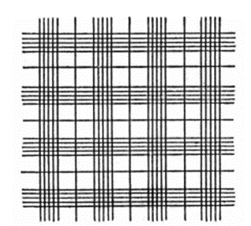
Fig. 4.1. Goryaev's camera.
Procedure
The procedure for determining the number of microorganisms with the Gorjaev’s chamber:
1. From the starting material (bread yeast S. cerevisiae) a dilution suspension of 1:100 is prepared, that is, 1 g of yeast is placed in 99 mL of sterile physiological solution and stirred for 2 minutes.
2. The suspension prepared with a sterile droplet is applied to both sectors of the Gorjaev’s chamber and fixed with the cover glass.
3. Position the microscope so that the camera is clearly visible.
4. Yeast cells are counted in 5 squares, which are divided into small squares (80 small ones) along the diagonal of the camera grid. For this purpose, find the large divided square in the upper left corner of the visual field and count the cells visible in it. After that, moving the camera diagonally down and finding the next divided square, count again, repeating this 5 times. In order not to count the same cells twice, the following rule should be followed: count the cells that are in the small squares, but if the cells are on the edge of the square, then count only on two edges, for example, the cells on the left and upper edge, if at least half cells are in a square,
5. The number of cells in 1 mL of suspension is calculated according to the formula:
$X= \frac{a ×1000}{S ×h ×n}$,
where,
X – the number of cells in 1 mL of suspension;
a – average arithmetic number of cells in 5 large or 16 small squares;
1000 – conversion factor;
S – chamber area, mm² (large – 1/25 mm², small – 1/400 mm²);
h – chamber depth, mm (0.1 mm);
n – number of squares.
6. Summarise the obtained results in a table.
2. Determination of living and non-living cells
Vital staining is an express method that can be successfully used to determine the activity of pure cultures of microorganisms by identifying and determining the amount of living and non-living cells in the respective culture medium or in the pure culture suspension of the prepared physiological solution. Living cells of microorganisms did not stain with methylene blue dye, but dead cells, whose cell envelopes have become permeable, stained blue.
Procedure.
1. The slide and coverslip are sterilised;
2. Place a drop of the suspension or culture medium in which the microorganisms are cultured on a sterile slide with a sterile pipette or loop and fix it with a coverslip;
3. Place a small drop of methylene blue dye next to the coverslip. When filter paper is applied to the other side of the coverslip, the deposited material is stained as a result of the flow of the solution;
4. The prepared sample is put under a microscope and the living and non-living cells are counted (preparation with methylene blue).
5. Obtained results summarised in Table 4.1.
3. Yeast Activity, Gas Production
To determine the yeast's ability to produce gas, knead the dough from 50 g of flour with 1 g of yeast and 25 mL of water. Make a ball of dough and place it in a beaker with 200 mL of water (t-30 °C). Take time and observe the fermentation process. Mark after how many minutes the ball of dough rises to the top of the beaker.
Summarise the obtained results in Table 4.1.

Results
All results should be summarised in Table 4.1.
Table 4.1.
Evaluation of yeast quality
Quality indicator | Sample 1 | Sample 2 | Sample 3
Yeast cell count
Number of live cells
The number of dead cells
Yeast activity count
Yeast activity (min)

Conclusions

Approved by _________________________________________
Name, surname, signature

Date _________________________________________

Laboratory work

Microbiology analyses of raw materials

Total Viable Counting (TVC) is a laboratory technique used to count all the microorganisms in food. It is sometimes referred to as Standard Plate Counting (SPC) and Aerobic Plate Counting (APC). The TVC, as its name suggests, is a quantitative analysis that provides the number of microorganisms that are viable and thrive on microbiological media for food. The food industry has made extensive use of it to assess the efficacy of cleanliness programmes, processing conditions, food quality, and food safety. The conditions under which food is processed have a big impact on the microorganism populations found in it. The microbiota is made up of a variety of microorganisms that are typically found in raw and uncooked foods. The majority of vegetative germs will die when exposed to heat, although certain heat-resistant spores will survive. The microbe may also develop spores or go into a viable but non-culturable (VBNC) condition as a result of additional non-thermal processing.
The TVC has a number of limitations, including the inability to distinguish between different types of microorganisms and the inability to estimate microbial cells that do not develop on plates, such as anaerobic bacteria or bacteria that have formed spores. To ensure food safety, the TVC is therefore more helpful in microbial food quality assessment than in food pathogen assessment.
Materials and procedures
Task 1. Preparation of samples and inoculation preparation for yeasts, moulds, mesophilic aerobic and facultative anaerobic microorganisms (MAFAm) in raw materials
Procedure
Dilutions are prepared for determining the amount of microorganisms for all food products, and the degree of dilution should be chosen so that the number of colonies in the Petri plate is between 50-200 - the maximum permissible limit is 300 KVV. Raw materials are weighed, placed in a bag with a filter and homogenised with physiological solution in a homogeniser. The time and speed of homogenisation is chosen depending on the consistency of the product, a harder and thicker sample requires a longer time and a higher speed.
As a result, a homogeneous suspension should be obtained from which inoculations can be made. If necessary, prepare a dilution of the analysed product (see dilution preparation scheme in Figure 4.2.);
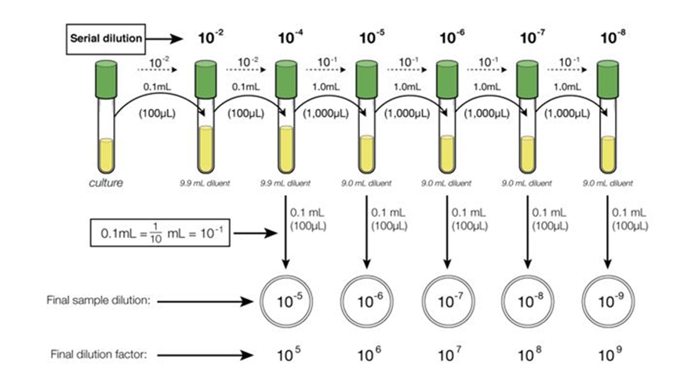
Fig. 4.2. Serial dilution and plating.
Spread Petri plates. Thaw previously prepared sterile agarised media and prepare Petri plates.
Apply 1 mL of the product or its dilution to 2 Petri dishes with a sterile pipette in the Laminar box in sterile conditions. Gently push the liquid inoculum applied to the centre of the plate, two or three times clockwise around the dish, then several times anticlockwise, turning the plate on the turntable as needed to obtain complete coverage. Remember that the plates should be labelled. After the spread plating, leave plates agar side down for at least 30 min in order for the inoculum to adhere onto the agar, then invert the plates and incubate at 30 °C, 37 °C or 27 °C according to microorganisms.
2. Counting colonies on plates
Looking at your dilution plates you prepared last time, choose the plates that have from 30-300 colonies on them. As this might take some practice in plate counting, you might need to choose all plates with what looks like a reasonable number of colonies to count.
  - Those plates that have no microbial growth can be recorded as 0 or NG, No Growth.
  - Those plates on which colonies are not individually distinct (their edges run together) can be recorded as TNTC, Too Numerous To Count.
  - Those plates on which you cannot distinguish any individual colonies, the entire surface is covered with microbial growth, can be recorded as confluent.
2. Count each colony to give a total colony count for each plate chosen. You will avoid counting a colony twice by marking off the colonies on the bottom of the plate as you count them. This requires, of course, that the plate be upside down. Be sure to count any small colonies.
3. Record your results in Table 4.3.
Results
Table 4.2.
Count of microorganisms, CFU/g
Raw materials | Microorganisms | Count of colony forming units | Method | Notes

Conclusions

Approved by _________________________________________
Name, surname, signature

Date _________________________________________

Laboratory work Sourdough preparation
The laboratory work is designed to learn the process of making spontaneous sourdough and to understand the processes taking place during fermentation. Here you will find the technological parameters of sourdough preparation.
Materials and procedures
Task 1. Using the parameters indicated in table 4.3. on the protocol, prepare the sourdough.
In the protocol, describe the observations (appearance, colour, smell, acidity to the taste) at each stage of sourdough preparation. Add a picture and explain the ongoing fermentation processes.
Note: Instead of rye flour, you can also choose whole grain flour from other cereals.
Results
Table 4.3.
Sourdough preparation and quality evaluation
No.​ | Parameters | Sample 1 | Sample 2 | Sample 3 | Notes
Day 1
1 | Flour | 100 | 100 | 100
2. | Water | 200 | 200 | 200
3. | Sourdough temperature
4. | Fermentation camera temperature
5. | Fermentation time
6. | Sourdough consistency
7. | The smell of sourdough
8. | Sourdough taste
 | Image
No.​ | Parameters | Sample 1 | Sample 2 | Sample 3 | Notes
Day 2
1 | Flour | 100 | 100 | 100
2. | Water | 100 | 100 | 100
3. | Sourdough | 100 | 100 | 100
4. | Sourdough temperature
5. | Fermentation camera temperature
6. | Fermentation time
7. | Sourdough consistency
8. | The smell of Sourdough
9. | Sourdough taste
10. | Image
No.​ | Parameters | Sample 1 | Sample 2 | Sample 3 | Notes
Day 3
1 | Flour | 100 | 100 | 100
2. | Water | 100 | 100 | 100
3. | Sourdough | 100 | 100 | 100
4. | Sourdough temperature
5. | Fermentation camera temperature
6. | Fermentation time
7. | Sourdough consistency
8. | The smell of sourdough
9. | Sourdough taste
10. | Image
No.​ | Parameters | Sample 1 | Sample 2 | Sample 3 | Notes
Day 4
1 | Flour | 100 | 100 | 100
2. | Water | 100 | 100 | 100
3. | Sourdough | 100 | 100 | 100
4. | Sourdough temperature
5. | Fermentation camera temperature
6. | Fermentation time
7. | Sourdough consistency
8. | The smell of sourdough
9. | Sourdough taste
10. | Image
Conclusion

Approved by _________________________________________
Name, surname, signature

Date _________________________________________

Laboratory work

Microbiology analyses of Sourdough
When preparing spontaneous sourdough, it is important to monitor the development of microorganisms in order to obtain sourdough with appropriate quality parameters. The sourdough used in bread production must have:
The total colony units of lactic acid bacteria 10⁸ – 10¹⁰ cfu/g.
The number of yeast cells is 10⁵ – 10⁷ cfu/g.
Titratable acidity - 12 - 17 NaOH ml.
Acidity pH 3.6 - 4.0.
When performing the laboratory work of spontaneous sourdough preparation, the microbiological parameters of sourdough and changes in acidity are additionally analysed.
Materials and procedures
Procedure
Dilutions are prepared for determining the amount of microorganisms for all stage sourdough, and the degree of dilution should be chosen so that the number of colonies in the Petri plate is between 50-200 - the maximum permissible limit is 300 KVV. Sourdough first stage and after each fermentation stage are weighed, placed in a bag with a filter and homogenised with physiological solution in a homogeniser. The time and speed of homogenisation is chosen depending on the consistency of the product, a harder and thicker sample requires a longer time and a higher speed.
As a result, a homogeneous suspension should be obtained from which inoculations can be made. If necessary, prepare a dilution of the analysed product (see dilution preparation scheme in figure 4.2.).
Spread Petri plates. Thaw previously prepared sterile agarised media and prepare Petri plates.
Apply 1 mL of the product or its dilution to 2 Petri dishes with a sterile pipette in the Laminar box, with sterile conditions. Gently push the liquid inoculum applied to the centre of the plate, two or three times clockwise around the dish, then several times anticlockwise, turning the plate on the turntable as needed to obtain complete coverage. Remember that the plates should be labelled. After the spread plating, leave plates agar side down for at least 30 minutes in order for the inoculum to adhere onto the agar, then invert the plates and incubate at 30 °C, 37 °C or 27 °C according to microorganisms.
2. Counting colonies on plates
Looking at your dilution plates you prepared last time, choose the plates that have from 30-300 colonies on them. As this might take some practice in plate counting, you might need to choose all plates with what looks like a reasonable number of colonies to count.
  - Those plates that have no microbial growth can be recorded as 0 or NG, No Growth.
  - Those plates on which colonies are not individually distinct (their edges run together) can be recorded as TNTC, Too Numerous To Count.
  - Those plates on which you cannot distinguish any individual colonies, the entire surface is covered with microbial growth, can be recorded as confluent.
2. Count each colony to give a total colony count for each plate chosen. You will avoid counting a colony twice by marking off the colonies on the bottom of the plate as you count them. This requires, of course, that the plate be upside down. Be sure to count any small colonies.
3. Record your results in Table 4.4.
3. Identification of lactic acid bacteria and yeasts in spontaneous sourdough
After the final fermentation of the sourdough, the identification of microorganisms is carried out.
Sample inoculations are prepared using the procedure described above. After isolation of pure cultures on agar medium, lactic acid bacteria or yeasts are identified using API tests.
Procedure.
1. On the agarised medium, the material is removed from the grown colony-forming units and, using dilution the relevant microorganism is isolated in the form of a pure culture.
2. Prepare a suspension of microorganism cells in the API enteric inoculation liquid according to the method instructions. The Densimat device measures the concentration of cells introduced into the suspension.
3. The suspension is poured into the wells of the API matrix strip (Figure 4.3.). The inoculation rehydrates the substrate and the metabolism of microorganisms begins.
4. The matrix is closed, placed in a thermostat and incubated under optimal conditions for the growth of the microorganism.
5. After the specified incubation time, observe changes in colour or turbidity that occur as a result of metabolites released by microorganisms.
6. From the results of biochemical reactions– changes in the well of each strip – a numerical code (Figure 4.4.) is formed, which is used as a basis for identification.
7. The digital code is entered into a computer that has an electronic code book of the API ID system.
8. The name of the identified microorganism, its biotype, as well as the reliability coefficient of the obtained results appear on the screen.
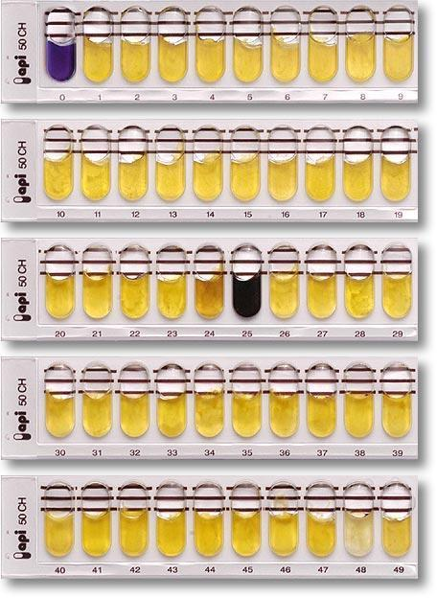
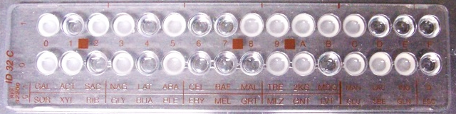
Fig. 4.3. API 50 CH and API ID 32 C matrix strip.
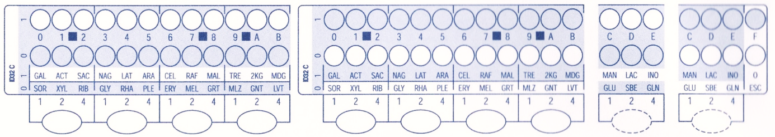
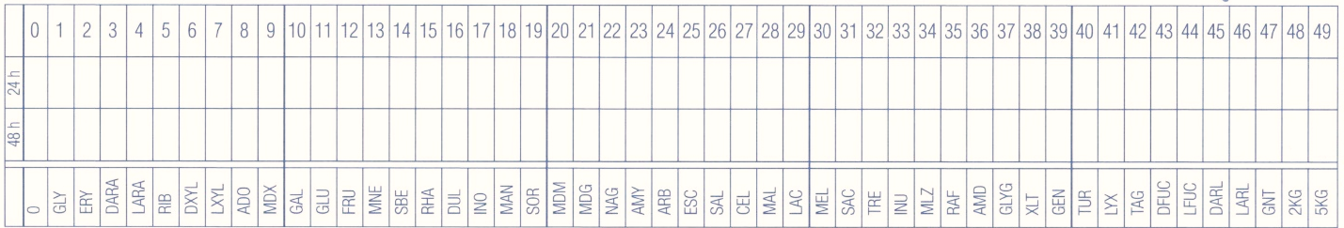
Fig. 4.4. API 50 CH and API ID 32 C microorganism identification results sheet.

More information and instruction on how to use tests can be found onhttps://www.biomerieux-usa.com/clinical/api.

Conclusions
Describe (optimal conditions for development, released metabolites) the identified microorganisms and their influence on the quality of sourdough and bread.

Approved by _________________________________________
Name, surname, signature

Date _________________________________________

THEME 5 Wheat bread technology

Theoretical materials
Wheat bread is known in many countries of the world, however, the traditions of its preparation tend to be different. In this topic, we will learn more about and understand the basic principles of wheat bread making and explain the processes involved.
The basic principle of the wheat bread recipe
Wheat flour - 100%
Yeast - 0.5 - 5%
Salt - 1 - 2%
Water - 50 - 60%
Sugar - 2 - 5%
Fatty substances margarine/oil- 2 - 5%
Bread improver - 0.5 - 2%
Malt products - 2 - 5%
Other additives - 5 – 20%

There are three ways of making bread:
1. Direct.
2. With leaven. Leaven is a dough with flour, yeast and water. Leaven preparation types are divided into short, medium and long. The fermentation time, temperature and the amount of flour and yeast used differ for each.
3. With sourdough. Sourdough is a dough made with active lactic bacteria, yeast, flour and water.
The mixing time of wheat dough is on average 8-10 minutes. For doughs with a large amount of fibre, it increases to 20 minutes and more.
Stages of the kneading process:
- mixing of raw materials (approx. 1 minute),
- formation of dough structure (2-3 minutes for wheat dough),
- stabilisation of the dough structure (3-5 minutes for wheat dough).
Fermentation for wheat dough takes an average of 60-90 minutes.
Processes taking place in the dough: the swelling of the dough ingredients continues; the activity of yeast and enzymes that break down the components of the flour continues; the amount of gas increases; pore size increases, pore walls remain thinner; the amount of flavouring increases.
During baking (as the temperature in the dough gradually rises to 90 °C), proteins denature under the influence of temperature (60-80 °C), acids or bases, losing the fourth, third, second structure; as a result of denaturation, they stick together, compact, coagulate; they release water, which is attracted to the starch. Starch gelatinisation – changes in the structure of starch grains – swelling by attracting water; the starch properties of different grains are different.
As the temperature increases in the bread crust, the formation of light and dark dextrins and the caramelisation of sugar occur.
At the beginning of the wheat bread baking process, steam must be provided so that condensation forms on the dough preparation - the surface of the dough is elastic, the products increase in volume, do not crack; dextrins are formed - a shiny crust.

Some recommendations for the use of steam during baking:
- A lot of steam - the products are not risen, a hot oven, for small products with strong gluten,
- Little steam - products are well risen, cool oven,
- Keep the steam for a long time - for doughs with strong gluten, slightly risen and in a hot oven,
- Keep steam for a short time - for doughs with weak gluten, well-leavened, cool ovens,

Loss of mass of bread:
- Technological losses 1-2%,
- During baking (losses of moisture and volatile compounds) - 10-12%,
- During cooling of bread 1-2%.

Laboratory work

Baking test of wheat bread with sourdough
The purpose of the work is to acquire knowledge and practical skills in preparing rye and wheat bread using sourdough from previous laboratory work.
Materials and procedures
Tasks:
1. Prepare sourdough, dough and bake products using the recipe in table 5.1.
2. To justify the importance of raw materials in ensuring product quality.
3. Present the obtained product and evaluate the quality.
4. Justify and explain the obtained results.
Table 5.1.
Recipe
Ingredients | Amount, % | Amount, g
Whole wheat flour | 50 | 250
Wheat flour 550 types | 50 | 250
Sourdough | 30 | 150
Salt | 1.5 | 7
Sugar | 10 | 50
Seed mixture (of your choice) | 20 | 100
Water | 50 - 55 | 250 - 300
Procedure
1. Making the dough. The pre-prepared sourdough, or for those who have kept the activated sourdough in the refrigerator, and the other raw materials are slowly kneaded to form dough of medium firm consistency, the amount of water may therefore vary.
Sourdough activation – flour and water are added to the stored sourdough in a ratio of 1:1:1 (you can also use a teaspoon of sugar), mix, the consistency should be like thick yoghurt. Put in a fermentation camera (27-30 °C) until the fermentation processes are felt (pores appear and the yeast increases in volume), it can take up to 6-12 hours.
2. Dough making and fermentation. Here are two options, choose which one seems easier for you:
A. We monitor the dough completely (T= ~2 – 3h); the temperature of the fermentation room is 32±5 °C) and then carefully (without pressing or sticking too much) we make a dough, press the patterns and leave the marks to bake.
B. We knead the dough a little (T-45 min), make a ball and put it in a shape, then leave it for ~1.5h at a temperature of 32±5 °C, providing moisture and let it bake. If we bake the bread in a form (cake forms can be used), then we make the dough softer - add more water.
3. Baking bread. We heat the oven to a temperature of 220 °C. Place the dough blanks in the hot oven and bake for ~ 1 hour. It depends on the weight of the bun. Readiness is determined by tapping the bottom of the bun or by measuring the temperature in the middle of the bun, it should be 98 °C.
4. Cooling the bread. The bread must cool down and ripen, so you will be able to feast only after 4-6 hours.
5. Evaluate the bread sensory parameters according to Table 5.2.
6. Summarise all parameters and results in table 5.2.
Results
Table 5.2.
Baking report
Name of sample | Amount, g  / parameters | Notes
Ingredients
Whole wheat flour
Wheat flour 550 types
Sourdough
Salt
Sugar
Seed mixture (of your choice)
Water
Technological parameters
Dough mixing time, min
Mass of dough, g
Dough temperature, °C
Mass of semi – finished product, g
Dough properties | Soft / Normal / Hard
Fermentation time, min | 60
Fermentation temperature, °C | 36–40
Baking time, min | 60
Baking temperature, °C | 220–230
Mass of hot bread, g
Value of baking loss, % | 6 – 10
Mass of cooled bread, g
Value of dry off, % | 3 - 4
Sensory parameters
Bread form / crust
Colour of bread crust
Properties of bread soft part
Regularity of pores | Regular / non-regular,  big / small
Properties of bread soft part | Springy / non - springy  Regular colour, aroma and taste
Aroma
Taste
Value of bread baking loss (%) is decreases of dough mass during baking process.

$$X= \frac{Ms-Mkm}{Ms} ×100$$
where,
X – baking loss, %
M_{s} – mass of dough, g
M_{km} – mass of ready hot bread, g
Value of bread dry off (%) is decrease of bread mass during cooling.

$$X= \frac{Mkm-Mam}{Mkm} ×100$$
where,
X – value of bread dry off, %
M_{km} – mass of hot bread, g
M_{am} – mass of cooled bread, g

Conclusions

Approved by _________________________________________
Name Surname, signature

Date _________________________________________

Laboratory work

Wheat bread with yeast baking test and freezing processes
The aim of the work is to acquire knowledge and practical skills in preparing wheat bread with yeast and about the bread freezing process.
Methods and procedures
1. Prepare wheat dough with yeast and bake bread using the recipe in table 5.3.
Table 5.3.
Recipe of wheat bread with yeast.
Ingredients | Amount, % | Amount, g
Wheat flour 405 type | 100 | 1000
Salt | 1.5 | 15
Yeast | 3 | 30
Rapeseed oil | 3 | 30
Sugar | 3 | 30
Water | 50 - 55 | 500 - 550
Procedure
1. Dough making. Mix wheat flour, salt, sugar, yeast, sourdough and red beet puree for 15 seconds and gradually add water and slowly knead for 2 minutes until the dough forms has medium firm consistency, then mix intensively for 6 minutes until you obtain an elastic, firm dough.
2. Loaf of bread making and proofing. Proof the dough T-15min, t – 21 °C, divide dough by 75g, make a loaf as a ball and proof in a proof camera at a temperature of 32±5 °C, approx. 45 minutes, ensuring moisture.
3. Bread baking.
For ready to use bread, heat the oven to the temperature of 180 – 200 ℃. Baking takes ~ 17 minutes. Readiness is determined by measuring the temperature in the middle of the loaf, it should be 98 °C. But the crust of bread is light. Continuing the baking process after defrosting will fry it golden brown.
For frozen bread, heat the oven to the temperature of 160 – 180 ℃. Baking takes ~ 15minutes. The crust must be light yellow. Golden brown colour bread is obtained after the second baking process in the customer’s home.
5. Cooling both types of bread. Wheat bread must cool down to 25 °C.
6. Evaluate bread sensory parameters according to Table 5.3.
7. Summarise all parameters and results in Table 5.3.
2. Partially baked bread is cooled after baking and frozen using the shock freezing method t -40 °C freeze to -18 °C inside of loaf. Packed and stored in a freezer (-18 °C) for quality assessment.
Procedure.
1. After baking, the bread samples are placed in a shock freezer (-40 °C) and frozen for 30-40 minutes.
2. The Frozen breads are placed in the refrigerator (-18 °C) for storage.
3. The frozen products defrost in the fermentation chamber - temperature +35 °C, chamber humidity at 75 %, defrosting time 20-30 minutes.
4. The bread samples bake for 10 minutes, in a temperature of 180-220 °C with steam until the loaf acquires a golden-brown colour.
5. Cooling both types of bread. Wheat bread must cool down to 25 °C.
6. Evaluate bread sensory parameters according to Table 5.4.
7. Summarise all parameters and results in Table 5.4.
Results
Summarise all results in baking report.
Table 5.4.
Baking report
Name of sample | Amount, g  / parameters | Notes
Ingredients
Wheat flour 405 type
Salt
Yeast
Rapeseed oil
Sugar
Water
Technological parameters
Dough mixing time, min
Mass of dough, g
Dough temperature, °C
Mass of semi – finished product, g
Dough properties | Soft / Normal / Hard
Fermentation time, min | 60
Fermentation temperature, °C | 36–40
Baking time, min | 60
Baking temperature, °C | 220–230
Mass of hot bread, g
Value of baking loss, % | 6 – 10
Mass of cooled bread, g
Value of dry off, % | 3 - 4
Sensory parameters
Bread form / crust
Colour of bread crust
Properties of bread soft part
Regularity of pores | Regular / non-regular,  big / small
Properties of bread soft part | Springy / non - springy  Regular colour, aroma and taste
Aroma
Taste
Value of bread baking loss (%) is decreases of dough mass during baking process.

$$X= \frac{Ms-Mkm}{Ms} ×100$$
X – baking loss, %
M_{s} – mass of dough, g
M_{km} – mass of ready hot bread, g
Value of bread dry off (%) is decrease of bread mass during cooling.

$$X= \frac{Mkm-Mam}{Mkm} ×100$$
X – value of bread dry off, %
M_{km} – mass of hot bread, g
M_{am} – mass of cooled bread, g

Conclusions

Approved by _________________________________________
Name, Surname, signature

Date _________________________________________

Practical work

Wheat bread packaging
The aim of the work is to learn skills in wheat bread packaging using different packaging technologies (packing in air, vacuum, modified gas composition (MAP)) with different packaging technologies using various packaging equipment (simple sealer and chamber-type vacuum packaging equipment). Experiments with different vacuum depths were carried out during vacuum packing. The group of students is divided into teams and each team packs products using different solutions.
Materials and procedures
Products prepared in previous experiments or raw materials purchased at the discretion of the teacher.
Pulsed simple hermetically sealing equipment. Ready-made pillow packages made of mono material with high moisture barrier properties and multi-layer packaging material with high weather barrier properties.
Results
The results obtained in the experiments should be reflected in Table 25.
Table 5.6.
Summary of experiments results
Parameters | Packaging in AIR | Packaging in Vacuum | Packaging in MAP
Characteristics of the mono packaging material
Characteristics of the multi-layer packaging material
Which packaging solution is more suitable for packaging of wheat bread? Describe why?
How well the sealing went (excellent, good, bad)
What is the sealing temperature of the package?
What is the sealing time (sec.) of the package?
Is it possible to close the package non-hermetically? Will it affect the expiration date?
How eco-friendly is the chosen packaging? How sustainable is the chosen packaging?

Conclusions
After packaging the products, different groups of students compare the results. If possible, each group packs 5 packages of each type, and then observes and determines the quality of the products during storage during the course of the study.
During practical work, the students learned the skills of working with packaging equipment and packaging technologies.

Approved by _________________________________________
Name, surname, signature

Date _________________________________________

Laboratory work

Sensory evaluation of different types of bread
A 10-point line scale can be used to determine the intensity of the sensory properties (colour, aroma, porosity, sweet taste and sour taste) of bread samples. With the line scale, you can determine the intensity of each sensory property and it is possible to create a profile of the sensory properties of each sample.
The hedonic scale is a common tool used in the sensory evaluation of food products to measure the degree of liking or disliking by consumers. It typically consists of a series of points (often 9 or 7) ranging from extreme dislike to extreme like. A typical 9-point hedonic scale includes the following points:
- Dislike Extremely
- Dislike Very Much
- Dislike Moderately
- Dislike Slightly
- Neither Like nor Dislike
- Like Slightly
- Like Moderately
- Like Very Much
- Like Extremely
Using the hedonic scale in sensory evaluation provides valuable insights into consumer preferences, guiding food product development and ensuring that products meet consumer expectations.
Materials and procedures
For each panellist - 5-7 different types of bread (wheat, rye, wheat-rye, rye-wheat, baguette, ciabatta etc.) samples. The bread samples are served in portions of approximately 20 g or half a slices. The bread samples are served on coded plates.
For taste neutralisation between samples - water or black tee.
1. To evaluate the intensity of the sensory properties (colour, aroma, porosity, sweet taste and sour taste) for bread samples (worksheet 5.1.)

Worksheet 5.1.
10-point Line scale
TRAY NO. _____________________________________
Please mark the intensity of the sensory property for the presented bread samples on the Line scale and write the sample number below the marking.
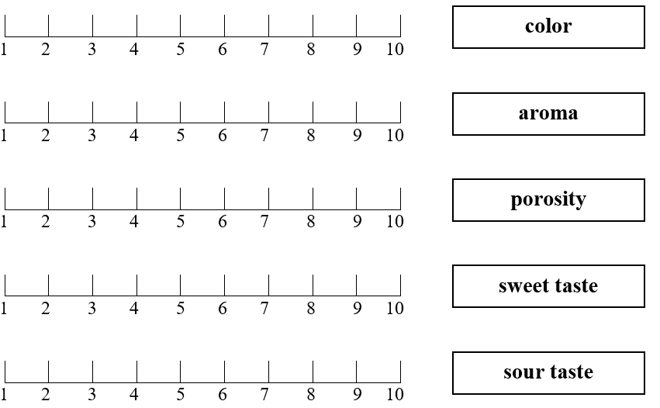

2. To evaluate the overall liking of bread samples, using 7-point Hedonic scale (work sheet 5.2.).

Worksheet 5.2.
7-point Hedonic scale
TRAY NO. _____________________________________
Please evaluate the overall liking of the bread samples. Indicate how much you like or dislike each sample by checking (V or X) the appropriate phrase.
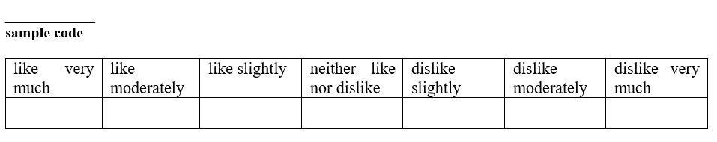
Conclusion

Approved by _________________________________________
Name, surname, signature

Date _________________________________________

Laboratory work

Evaluation of wheat bread quality
The purpose of bread evaluation is to determine the quality of bread products and deviations from it. The properties of each product are evaluated with a certain number of points, and if deviations are detected, the number of points is reduced. In the sensory evaluation of bread, the following product properties are evaluated: moisture, titratable acidity, pH, porosity, specific volume of bread and comparison with an industrial wheat bread sample.
Materials and procedures
Wheat bread (from the last laboratory work) after defrosting and final baking. Industrial wheat bread as control.
1. Evaluate wheat bread moisture
Bread moisture is one of the most important indicators of bread quality. Increased bread moisture lowers the nutritional value of bread, changes the structural properties of bread, and also contributes to bread mould. Optimum amount of bread moisture:
For wheat bread 41-43%
For rye bread 44-45%
Determination of bread moisture by express method
Procedure
The bread moisture content is determined using a moisture scale 9 (express method). Cut out and weigh 5 g of bread pulp from a loaf of bread. Place the prepared sample on a foil plate and press the "T" (tare) key; weigh the product - about 5 g, spreading evenly on the plate, without scraping the product past the plate; selects a program, presses the "start/stop" button; when the humidity of the product no longer changes, the lamp of the device turns off; record the result; carefully open the lid of the device; clean the foil plate, put it back in the machine;
Determination of bread moisture by standard method.
Procedure
Two weighing cups with lids are weighed on the electronic scale with an accuracy of up to 0.01 g, each weighing 5 g of the flour to be analysed. The weighing cups with the sample are placed in a drying cabinet with a temperature of 130 °C and heated for 40 minutes. The lids are placed next to each other. Weighing glasses with crucible rods are taken out of the cabinet, covered and placed in a desiccator for 15-20 minutes, cooled and weighed.
Flour moisture is calculated:
$$X= \frac{\left(a-b\right)}{a} ×100$$

where,
X - flour moisture, %
a - mass of flour before drying, g
b - flour mass after drying, g
Summarise the results in Table 5.7.
2. Determination of bread acidity
The acidity of bread is the amount of NaOH consumed, which is necessary to neutralise the acid in 100g of the product.
Optimum acidity for bread:
For wheat bread 2.5 – 6 mL NaoH
For wheat-rye bread 6 – 8 mL NaoH
For rye - wheat bread 7 - 9 mL NaoH
For rye bread 10-12 mL NaoH
Procedure
Weigh 25 g of chopped bread crumbs and place it in a 500 mL flask. About 50 mL of distilled water is poured on the bread and mixed with a glass chopstick until a homogeneous mass is obtained. Then add all the remaining water up to the mark of the flask. Close the flask with a cork and shake vigorously for 2 minutes. After the solution has settled, pour 50 mL of the solution into a volumetric flask, add phenolphthalein and titrate with 0.1N NaOH solution until the suspension turns a uniform pink colour.
Bread acidity is calculated:
$$X=2 ×a$$

where,
X – sourness of bread, ml NaoH
a – amount of NaOH consumed, ml
Summarise the results in Table 5.7.
3. Determination of porosity of bread
Porosity is the total volume of pores in the bread pulp, expressed as a percentage of the total volume of the bread.
Optimum porosity of bread:
Wheat bread 58-73%
Rye bread 45-55%
Procedure
With Zhuravlyov's apparatus, 3 pieces of bread crumbs of a certain size are cut out of the bread sample to be analysed. To cut out the pieces with a twisting motion, the entire cylinder is introduced into the bread pulp, when it is pulled out of the loaf of bread, it is filled with bread. The cylinder is placed on a board and with a wooden roller, a small piece of bread is pushed out of it to the mark, and a 3.8 cm long piece is cut with a knife. The cut pieces of bread are weighed to an accuracy of 0.01g and the results are calculated using formula.

$$X=\frac{(V-\frac{G}{V1})}{V}×100$$

where,
X - bread porosity %;
V - volume of the cylinder of cut bread pulp - 27 cm²
V1 - density of non-porous bread pulp, which is assumed to be 1.31;
G - average mass of one cut out cylinder of bread pulp, g
Summarise the results summarize in Table 5.7.
4. Determining the specific volume of a loaf
Loaf volume shows the total volume of bread. It is influenced by raw materials, fermentation conditions, baking process, as well as weight. Different devices can be used to determine the loaf volume (Figure 5.1.).
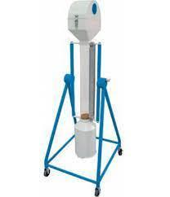
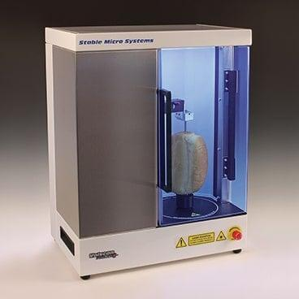
Fig. 5.1. Devices for measuring loaf volume.
https://store.ttech.vn/bread-volume-meter-13300-bastak-p44173
Procedure
The cylinder is filled with rapeseed and the edges are filled. The cylinder is placed in the box. The loaf of bread is placed in a cylinder with rapeseed so that it is not visible and the surface is smoothed. Pour the spilled seeds into the cylinder and measure the volume. Summarise the results in Table 5.7.
Results
Table 5.7.
Wheat bread quality parameters
Sample | Moisture,  % | Titratable acidity,  ml NaOH | pH | Bread Porosity,  % | Specific Volume of loaf, mL
Conclusions

Approved by _________________________________________
Name, Surname, signature

Date _________________________________________

Laboratory work

Evaluation of wheat bread microbiology quality
Purpose of the laboratory work: to get acquainted with the bacteriological research methods of wheat bread and, based on the obtained results, to give an assessment of its quality. Moulds and yeasts, the total number of MAFAm colony-forming units and the presence of Bacillus subtilis will be practically evaluated.
Materials and procedures
Task 1. Preparation of samples and inoculation preparation for yeasts, moulds, mesophilic aerobic and facultative anaerobic microorganisms (MAFAm) in wheat bread
Dilutions are prepared to determine the amount of microorganisms for all food products, and the degree of dilution should be chosen so that the number of colonies in the Petri plate is between 50 and 200 - the maximum permissible limit is 300 KVV. Wheat bread is weighed 10 g, placed in a bag with a filter and homogenised with physiological solution in a homogeniser. The time and speed of homogenisation is chosen depending on the consistency of the product, a harder and thicker sample requires a longer time and a higher speed.
As a result, a homogeneous suspension should be obtained from which inoculations can be made. If necessary, prepare a dilution of the analysed product (see dilution preparation scheme in figure 4.2.).
Spread Petri plates. Thaw previously prepared sterile agarised media and prepare Petri plates;
Apply 1 mL of the product or its dilution to 2 Petri dishes with a sterile pipette in the Laminar box, which is in sterile condition. Gently push the liquid inoculum applied to the centre of the plate, two or three times clockwise around the dish, then several times anticlockwise, turning the plate on the turntable as needed to obtain complete coverage. Remember that the plates should be labelled. After the spread plating, leave the plates agar side down for at least 30 minutes in order for the inoculum to adhere onto the agar, then invert the plates and incubate at 30 °C, 37 °C or 27 °C depending on the microorganisms.
Task 2. Counting colonies on plates
1. Looking at your dilution plates you prepared last time, choose the plates that have from 30-300 colonies on them. As this might take some practice in plate counting, you might need to choose all the plates with what looks like a reasonable number of colonies to count.
  - Those plates that have no microbial growth can be recorded as 0 or NG, No Growth.
  - Those plates on which colonies are not individually distinct (their edges run together) can be recorded as TNTC, Too Numerous To Count.
  - Those plates on which you cannot distinguish any individual colonies, the entire surface is covered with microbial growth, can be recorded as confluent.
2. Count each colony to give a total colony count for each chosen plate. You will avoid counting a colony twice by marking off the colonies on the bottom of the plate as you count them. This requires, of course, that the plate be upside down. Be sure to count any small colonies.
3. Record your results in Table 5.8.

Results
Table 5.8.
Count of microorganisms, CFU/g
Samples | Microorganisms | Count of colony forming units | Method | Notes

Conclusions

Approved by _________________________________________
Name, surname, signature

Date _________________________________________

SEMINAR

Nutrition aspects of bread
1. The seminar is organised as work in groups, where students learn about different topics and introduce fellow students. Themes of the seminar:
- Nutritional characteristics of wheat bread.
- Describing the technological methods of increasing the nutritional value of wheat bread.
- Describing the possibilities of increasing the nutritional value of wheat bread by using different plant and animal raw materials.
- The latest trends in wheat bread production.
- Raw materials used in the production of gluten-free bread, their differences compared to whole wheat flour.
- Differences between the gluten-free bread production process and the traditional wheat bread production technology.
2. Each group of students is given one package of bread with information about the ingredients in the bread, nutritional value and other mandatory requirements are indicated. The task of the students is to evaluate the compliance of the label with the requirements established by the legislation and give a solution. Evaluate the amount of nutrients and explain their importance from the nutritional point of view. Find a solution for increasing or decreasing the amount of fibre, protein, carbohydrates or fat and present a proposal based on calculations to your fellow students.

THEME 6

Wholegrain and traditional bread technology

Theoretical materials
Rye bread has a special place in the culture of the Baltic States. It is produced in large factories, artisan bakeries and at home using various recipes based on rye sourdough. The whole process of rye bread preparation includes rye sourdough fermentation, leavening, and baking. Frequently, scalding is also applied. Although the Baltic States, Estonia, Latvia and Lithuania, are neighbour countries, there are some differences in the making of rye bread.
Sourdough rye bread (Rudzu rupjmaize) is a naturally fermented bread, baked in Latvia from rye flour, with scalded rye flour and sourdough being used in the fermentation process. This type of sourdough bread is baked in a hearth oven and the loaf weighs about one or more kilograms, with a smooth and glossy crust, to which starch paste or water is applied after baking.
The external appearance and shape of this traditional Latvian sourdough rye bread may be described as an elongated loaf with rounded ends, at least twice as long as it is wide. Moreover, a mark may be made on the top of the crust, and imprints may be made on the sides.
Traditionally, the scalded rye flour or scald is prepared in wooden tubs made from planks of deciduous wood from aspen or lime trees, with a volume of approximately 30 l. The scald is mixed with a wooden spatula. After the dough preparation process the tub is not washed but is carefully scraped out and kept in a dry place. Therefore the microbiota being present in the wood pores of the tub from previously fermented dough stimulates fermentation. Each baker has his own special rye bread recipe, some are sweeter other are more sour. The main ingredients used for “Salinātā rye bread” recipe is summarised in APPLICATION FOR REGISTRATION OF A TSG COUNCIL REGULATION (EC) No 509/2006 on agricultural products and foodstuffs as traditional specialities guaranteed (2) ‘SALINĀTĀ RUDZU RUPJMAIZE’ EC No: LV-TSG-0007-01043-11.10.12. Available at: https://eur-lex.europa.eu/LexUriServ/LexUriServ.do?uri=OJ:C:2013:177:0012:0017:EN:PDF.
Rye flour does not contain gluten, so the dough is not elastic, and the starch gels more easily and at a lower temperature than wheat starch, so it breaks down into sticky dextrins.
The enzyme α amylase is much more active than in wheat flour and breaks down starch into dextrins and maltose.
Rye flour contains 6-8% pentosans, which swell very strongly, bind water well, but the dough is sticky.
Scald is the dough phase in which the flour is poured over with hot water (above 90 °C), with or without additives (malt), to intensively breakdown starch into maltose and dextrins. The purpose of scald is to intensively break down starch into maltose, which is an excellent environment for the development of lactic acid bacteria and yeast.
The effects of scalding on bread quality are: the bread has a strongly aromatic, sweet and sour taste; the physical properties of the dough improve; the crumb of the bread is more elastic and with more homogeneous structure and it keeps fresh for longer.
Rye bread baking implement in a falling temperature mode, in two stages:
1. Roasting stage - for a short time (1 to 3 minutes) at a high temperature (300 400 °C). In this stage, a thin crust is formed, it does not crack, it produces the largest volume of loaf, it has more pronounced aroma and taste.
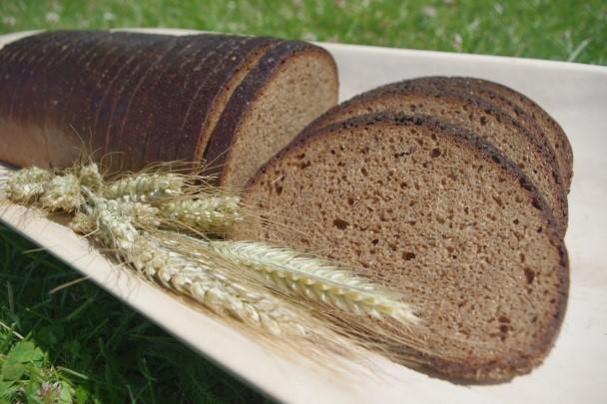
2. Baking stage - the loaf is carefully transferred to an oven at a temperature of about 260-240 °C, where the temperature decreases to 180 - 200 °C during the baking process.
Fig. 6.1. Traditional sourdough rye bread (Photo G. Duka).

Laboratory work

Baking test of wholegrain bread with sourdough and scald
The aim of the work is to acquire knowledge and practical skills in preparing rye wholegrain bread with scald and sourdough.
1. Prepare Wholegrain rye dough with scald and sourdough and bake bread using the recipe from Table 6.1.
Table 6.1.
Recipe of rye bread with sourdough and scald.
Ingredients | Amount, % | Mass, g
Scald
Rye flour | 30 | 250
Malt | 2.5 | 20
Cumin | 1.5 | 12
Water |  | ~750
Sourdough |  | 250
Dough
Rye flour | 50 | 400
Wheat flour | 25 | 200
Salt | 1.5 | 12
Sugar | 4 | 30
Procedure
1. Scald preparation.
Flour, malt and cumin are poured over with boiling water (92 - 100 °C). If there is no malt, then only flour and cumin are used. It is then mixed and beaten quickly to form a mass similar to the consistency of cream. The scald is left to cool (~4-6h) to 37 °C, stirring occasionally. During this time, sugaring takes place - the scald becomes sweet because of the enzymes a β amylases break down starch into reducing sugars. Adding malt promotes this process, if there is no malt, then the process will be slower and the malt will not be as sweet. Add all the results in Table 6.2.
2. Adding active sourdough prepared in previous laboratory work.
The sourdough is added to the scalding (scalding temperature 37 °C – so that the hand, fingers in the middle of the screed do not burn) and left for at least 6 hours. If there was no malt in the preparation of the wort, then at this point add the specified amount of sugar. The scald is slowly stirred 1-2 times during fermentation. It is better to ferment in a camera with temperature 32±5 °C, if it is not possible, leave it in the warmest possible place. Ready-made fermented scald should have an intense sweet-sour taste.
3. Making the dough.
The rest of the ingredients are added to the fermented scald, the dough is slowly kneaded and left to ferment in the heat (conditions similar to when fermenting the scald).
4. Dough making and proofing.
Here are two options, choose which one seems easier for you:
a. Monitor the dough completely (T= ~1.5 – 2h; the temperature of the fermentation room is 32±5 °C) and then carefully (without pressing or sticking too much) make a loaf, press the patterns and leave the marks to bake.
b. Knead the dough (T-15min), make a loaf, press a shape and then ferment it at a temperature of 32±5 °C, providing moisture and let it bake.
5. Baking bread. Heat the oven to the maximum temperature - 250 - 300 °C. Place the dough loaf in the hot oven and after 3-4 minutes, when a light crust has formed, reduce the temperature to 180 – 200 °C. The oven will gradually cool down and the dough will turn into bread. Baking takes ~ 1-1.5 hours depending on the weight of the loaf. Readiness is determined by tapping the bottom of the bread or by measuring the temperature in the middle of the bread - it should be 98 °C.
6. Cooling the bread. Rye bread must cool down and ripen, so you will be able to feast only after 4-6 hours.
7. All results should be summarised in the baking protocol for evaluation (Table 6.3.).
Results
Table 6.2.
The protocol for preparation and quality assessment of scald
No. | Raw materials / parameters | Sample 1 | Sample 2 | Notes
1. | Flour
2. | Water
3. | Rye malt
4. | Cumin
5. | Flour temperature
6. | Water temperature
7. | Organoleptic assessment of scald
8. | Scald temperature
9. | Scald pH
10. | Scald titratable acidity
11. | The time of over-sugaring of the scalding
12. | Organoleptic assessment of scald after sugaring
13. | Scald temperature after 1h
14. | Scald temperature after 2h
15. | Scald temperature after 3h
16. | Images of scald

Table 6.3.
Baking Report
Ingredients | Amount, g / parameters | Notes
Scald
Sourdough
Dough
Rye flour
Wheat flour
Salt
Sugar
Technology parameters
Dough mixing time, min
Mass of dough, g
Dough temperature, °C
Mass of semi – finished product, g
Dough properties | Soft / Normal / Hard
Fermentation time, min | 60
Fermentation temperature, °C | 36–40
Baking time, min | 60
Baking temperature, °C | 220–230
Mass of hot bread, g
Value of baking loss, % | 6 – 10
Mass of cooled bread, g
Value of dry off, % | 3 - 4
Bread form / crust
Colour of bread crust
Properties of bread soft part
Regularity of pores | Regular / non-regular,  big / small
Properties of bread soft part | Springy / non - springy  Regular colour, aroma and taste
Aroma
Taste
Value of bread baking loss (%) is decreases of dough mass during baking process.

$$X= \frac{Ms-Mkm}{Ms} ×100$$
where,
X – baking loss, %
M_{s} – mass of dough, g
M_{km} – mass of ready hot bread, g
Value of bread dry off (%) is decrease of bread mass during cooling.

$$X= \frac{Mkm-Mam}{Mkm} ×100$$
where,
X – value of bread dry off, %
M_{km} – mass of hot bread, g
M_{am} – mass of cooled bread, g
Conclusions

Approved by _________________________________________
Name, surname, signature

Date _________________________________________

Practical work

Packaging and pasteurisation of rye (wholegrain) bread
The aim of the work is to learn skills in rye (wholegrain) bread packaging using different packaging technologies (packing in air and vacuum) and simple sealer and chamber-type vacuum packaging equipment. Pasteurisation/sterilisation of packaged bread was carried out. The group of students is divided into teams and each team packs products using different solutions.
Materials and procedures
Wheat or Rye bread prepared in previous experiments or purchased at the discretion of the teacher.
Pulsed simple hermetically sealing equipment. Ready-made pillow packages made of mono material with high moisture barrier properties and multi-layer packaging material with high weather barrier properties. Pasteurisation equipment.
Results
The results obtained in the experiments should be reflected in Table 6.4.
Table 6.4.
Results of experiments
Parameters | Packaging in AIR | Packaging in Vacuum | Vacuum packed bread and pasteurised together with the package
Characteristics of the mono packaging material
Characteristics of the multi-layer packaging material
Which packaging solution is more suitable for packaging of rye bread? Describe why?
How well the sealing went (excellent, good, bad)
What is the sealing temperature of the package?
What is the sealing time (sec.) of the package?
Is it possible to close the package non-hermetically? Will it affect the expiration date?
How eco-friendly is the chosen packaging? How sustainable is the chosen packaging?
Conclusions
After packaging the products, different groups of students compare the results. If possible, each group packs 5 packages of each type, and then observes and determines the quality of the products during storage during the study course.
During practical operation, students learned the skills of working with packaging equipment and packaging technologies.

Approved by _________________________________________
Name, surname, signature

Date _________________________________________

Laboratory work

Sensory evaluation of bread (quality evaluation of bread as experts)
Materials and Procedures
In each evaluation group - 4-5 experts; for each group - 5-7 different types of bread samples (wheat, rye, wheat-rye, rye-wheat, baguette, ciabatta etc.). The bread samples are removed from their original packaging and placed in transparent zip bags. Each sample is coded with three randomised numbers.
To clean the mouth between samples - water or warm black tea.
Table 6.5.
Recommendation for evaluation of bread defects
Sensory quality characteristics | Points
1. Shape of bread, appearance
Characteristic volume, even, symmetrical | 5
Small deviations – uneven shape, flat, round shape, too small volume, narrower middle part of the loaf, different thickness of slices, different size of slices | 4
Unsightly loaf, sticky sides, sticky ends, unevenly strewn, too much sprinkled, dirty loaf bottom | 3
Pronounced deviations mentioned above and cracked bread connection site, concave surface | 2
Serious defects in shape and appearance | 1
2. Bread surface, crust
Even crust colour of bread, not cracked, crispy crust, crust thickness uniform throughout the loaf | 5
Uneven brown bread crust, uneven crust thickness, slightly wrinkled crust, too light, too dark crust colour, cracked crust, no shine, too thin, too thick crust | 4
Side and surface cracks larger than 1.5 mm, burnt crust | 3
Pronounced above deviations for the surface and crust of the bread | 2
Serious defects in the crust and surface of the bread | 1
3. Porosity, bread crumb
Uniform, void-free, characteristic porosity | 5
Uneven porosity, insufficient porosity, large pores, small cracks in bread crumb, small voids, slightly bounced crust | 4
Inadequate porosity, pronounced voids, water ring, water band, bounced crust, inappropriate crumb colour, uneven crumb colour, insufficiently swollen grains, cracks in the bread crumb | 3
The aforementioned porosity deviations are pronounced | 2
Serious defects in the bread porosity and crumb | 1
4. Structure, elasticity of crumb
Well-baked, elastic, non-crumbling, dry-to-the-touch bread crumb | 5
Bread crumb too dry, bread crumb too hard, sticky crumb, uneven colour of crumb, insufficient elasticity | 4
Crumbles when cut, spongy crumb, lumps of flour in crumb, crumbly crumb, slice does not hold together, slices stick together | 3
Pronounced defects of the aforementioned bread crumb | 2
Serious defects in bread structure and crumb elasticity | 1
5. The taste and aroma of bread
Pronounced, pleasant, characteristic taste and smell of the respective type of bread | 5
Less aromatic, but pleasant, without aftertaste and smell | 4
Not enough aroma, yeasty, doughy taste, sour, bitter, salty and sweet taste, too much spice, one sided sour | 3
More pronounced characteristics of the aforementioned bread taste and smell, as well as the taste and smell of thin, over-leavened dough, foreign smell and taste | 2
Bad taste and smell, rancid | 1
The total number of points for the sensory properties of bread and their transcription:
25 - 20 very good quality
15-19 good quality
10 -14 average quality
5 – 9 inadequate quality

The task is to evaluate given bread samples and fill each expert group Table 6.6.
Table 6.6.
Bread sensory evaluation sheet
Sample code | Shape of bread, appearance | Bread surface, crust | Porosity, bread crumb | Structure, elasticity of crumb | Taste, aroma | TOTAL
Conclusion

Approved by _________________________________________
Name, surname, signature

Date _________________________________________
Practical work
Presentation of analysis of bread faults and their reasons.

1. Collect photos, descriptions and look for explanations for bread defects!

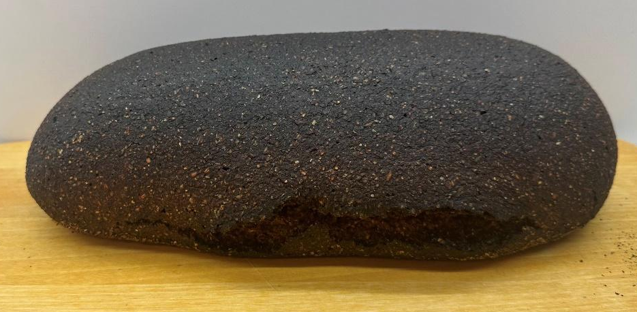
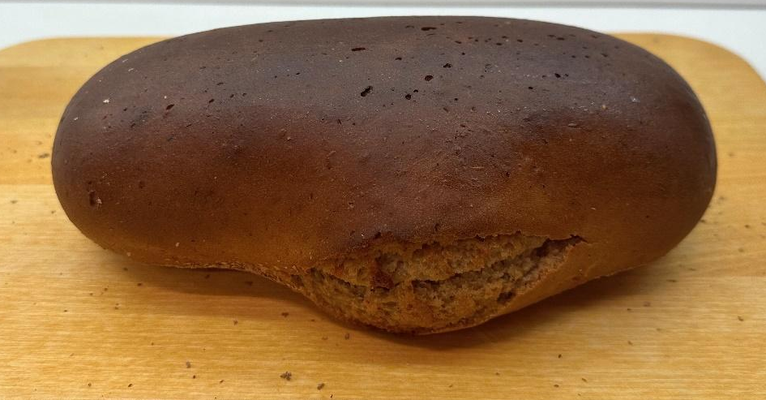
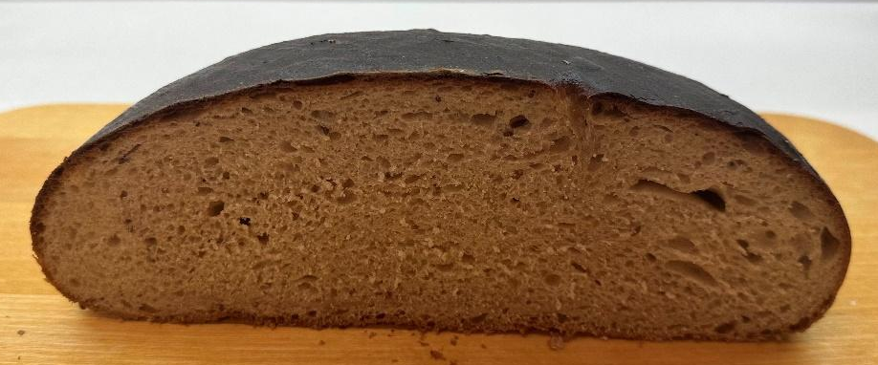

Laboratory work

Evaluation of rye bread microbiology quality
Rye bread is characterised by high acidity and moisture content. Purpose of the laboratory work: to get acquainted with the bacteriological research methods of rye bread and, based on the obtained results, to give an assessment of its quality. Moulds and yeasts and the total number of MAFAm colony-forming units are evaluated practically.
Materials and procedures
1. Preparation of samples and inoculation preparation for yeasts, moulds, mesophilic aerobic and facultative anaerobic microorganisms (MAFAm) in rye bread.
Dilutions are prepared to determine the amount of microorganisms for all food products, and the degree of dilution should be chosen so that the number of colonies in the Petri plate is between 50-200 - the maximum permissible limit is 300 KVV. Wheat bread is weighed,10 g, and placed in a bag with a filter and homogenised with physiological solution in a homogeniser. The time and speed of homogenisation is chosen depending on the consistency of the product, a harder and thicker sample requires a longer time and a higher speed.
As a result, a homogeneous suspension should be obtained from which inoculations can be made. If necessary, prepare a dilution of the analysed product (see dilution preparation scheme in Figure 4.2.).
Spread Petri plates. Thaw previously prepared sterile agarised media and prepare Petri plates;
Apply 1 mL of the product or its dilution to 2 Petri dishes with a sterile pipette in the Laminar box, which is in sterile condition. Gently push the liquid inoculum applied to the centre of the plate, two or three times clockwise around the dish, then several times anticlockwise, turning the plate on the turntable as needed to obtain complete coverage. Remember that the plates should be labelled. After the spread plating, leave plates agar side down for at least 30 minutes in order for the inoculum to adhere onto the agar, then invert the plates and incubate at 30 °C or 27 °C depending on the microorganisms.
2. Counting colonies on plates.
Looking at your dilution plates prepared last time, choose the plates that have from 30-300 colonies on them. As this might take some practice in plate counting, you might need to choose all plates with what looks like a reasonable number of colonies to count.
  - Those plates that have no microbial growth can be recorded as 0 or NG, No Growth.
  - Those plates on which colonies are not individually distinct (their edges run together) can be recorded as TNTC, Too Numerous To Count.
  - Those plates on which you cannot distinguish any individual colonies, the entire surface is covered with microbial growth, can be recorded as confluent.
2. Count each colony to give a total colony count for each plate chosen. You will avoid counting a colony twice by marking off the colonies on the bottom of the plate as you count them. This requires, of course, that the plate be upside down. Be sure to count any small colonies.
3. Record your results in Table 6.7.

Results
Table 6.7.
Count of microorganisms, CFU/g
Samples | Microorganisms | Count of colony forming units | Method | Notes

Conclusions

Approved by _________________________________________
Name, surname, signature

Date _________________________________________

Practical work

Quality management in a bread bakery
Materials and procedures
Method - Assessment of potential hazards in bread baking process.
1. For a selected bread baking process product, develop a product description, develop and draw a flow chart of the technological process.
2. Identify potential hazards:
- Biological:
  - pathogenic microorganisms;
- Chemical:
  - agricultural chemicals;
- Physical:
  - foreign objects atypical for the product.
3. Evaluate the danger of the identified hazards using a risk matrix 1 or 2 (Table 1.9 or Figure 1.4). Record the information in the hazard assessment Table 6.8.
4. Complete the CCP identification Table 6.8. and the HACCP plan (Table 6.9.).
5. Write conclusions on determining CCP using a risk matrix (table 1.9 or figure 1.4) and a decision scheme.
Remember: Monitoring activities at a CCP. Some types of monitoring activities at a CCP may include:
- physical measurements:
  - time
  - weight
  - temperature
  - belt speed
- chemical measurements:
  - pH
  - water activity
  - % salt
- microbiological testing:
  - microbiological analysis of critical raw materials before their use in processing (for example, analytical results in dried milk used in chocolate products, or in starch used in canned foods)
  - microbiological analysis of critical finished products before their release to highly sensitive consumers (for example, infant formulas)
Note: You need to consider the time required to obtain results when deciding what monitoring activity should be used at a CCP. Rapid tests are preferable for monitoring procedures taking place on dynamic processing lines.

Results
Table 6.8.
Hazard assessment
Process stage | The identified  hazard | Hazard assessment |  |  |  |  | Means of control
Process stage | The identified  hazard | Possibility | The severity of  the consequences | Risk  level | Assessment | CCP | Means of control

Table 6.9.
CCP identification table
Process stage | Process stage | Cause of risk | Description of the cause of the risk | Control actions | Answers to Decision Scheme questions |  |  |  | CCP yes/no
No. |  |  |  |  | 1 | 2 | 3 | 4

Table 6.10
HACCP plan
In process | CCP/  CP | Risk | Measurable | Monitoring procedures |  |  |  | Records /document | Corrections
Stage |  | The cause | Critical limits of parameters | What? | How to? | How often? | What? |  | Events

Conclusions

Approved by _________________________________________
Name, surname, signature

Date _________________________________________

SEMINAR

Bread around the world
The value of every country and culture is bread. Traditions related to the preparation and use of bread are inherited from generation to generation. Therefore, the seminar will introduce the types of bread from different countries and cultures, their differences and diversity.
Student teams will choose one of the bread varieties - see below. Add all the results from the discussion in Table 6.11. Prepare a presentation on bread types from the EU and Central Asia.

Rye Bread - traditional bread in Baltic state.
Knackerbrod -thin, unleavened dried rye bread.
Ciabatta -´Italian bread, large pores a bit of sour taste.
Pizza - Italian bread (loaf).
Baguette - French bread. A long, thin loaf of bread with a crispy crust.
Brioche - Light, hearty French bread (flour-butter ratio is 2:1).
Croissant - Small French pastry. A cone of puff pastry.
Tortilla - Round unleavened Mexican cornbread.
Table 6.11.
Common and different for different types of bread

Parameters | Common | Different
Shape
Recipe
Technology process
Taste
Aroma

THEME 7

Flour confectionery and traditional confectionary

Theoretical materials
Flour confectionery means any cooked food which is ready for consumption without further preparation (other than reheating), of which a characterising ingredient is cereal, including shortbread, sponges, crumpets, muffins, macaroons, ratafias, pastry and pastry cases, and also includes meringues, petits fours and uncooked pastry and pastry cases.
Confectionery does not include bread, pizzas, biscuits, crispbread, extruded flat bread or any food containing a filling which has as an ingredient such as cheese, meat, offal, fish, shellfish, vegetable protein material or microbial protein material.
The most important ingredients for confectionery are flour; sugar and other sweeteners; eggs; dairy products; fats, oils and emulsions; chocolate and products containing cocoa; nut masses; for leavening - baking powder, yeast; stabilisers; flavourings, colouring; spices.
Wheat flour is more often used in pastry. An important quality indicator is the amount of starch. Flour with a higher amount of starch is used in the preparation of confectionery products. Sometimes rice, corn, potato flour is also used to increase the proportion of starch.
Sugar and sweeteners are used not only for taste, but also to ensure technological processes. Sugar is more often used for making dough. In yeast dough, it ensures fermentation processes. Sugar also provides colour to the finished product. In biscuits, cream masses, fillings, glazes, it affects the foaming properties. Sucrose is used more often, but today it is also possible to use glucose or fructose syrup, stevia and other sweeteners. Their characteristics are different from sucrose, so it is always necessary to check how they affect the technological properties of confectionery products.
Eggs are an indispensable raw material in the preparation of confectionery. In European countries, mostly chicken eggs or egg masses are used. Duck and goose eggs have a higher microbiological safety risk, so they are used less often. Eggs have a high foaming ability, they act as emulsifiers in yeast doughs, and they also affect the colour of the product's crust.
Dairy products improve the taste, affect the properties of the dough, and the products stay fresh longer. Milk, cottage cheese, cheese, butter are used more often in flour confectionary.
Fats, oils and emulsions are used not only in the preparation of dough, but also in the preparation of creams. Butter or special margarines are more often used in the preparation of creams. On the other hand, more oil, animal fat or butter is used in the preparation of dough. A special margarine is used in the preparation of puff pastry, which helps ensure the formation of layers during baking.
Chocolate and products containing cocoa are indispensable confectionary ingredients, they are used in decorating and making glazes. Chocolate is offered as couverture, cocoa powder, and cocoa mass. Its quality is determined by the amount of cocoa butter and cocoa content.
Leavening agents in confectionery are divided into three groups - physical, chemical (baking powder, potash), and biological (yeast, sourdough). They improve the structure of the products, increase the volume, affect the flavour characteristics, soften the consistency of the product. Chemically modified starch, hydrocolloid system, agar - agar, alginates, carrageenates, pectin, gelatine are more often used as stabilisers. They increase the viscosity of the products, bind free water and form gel structures, thereby stabilising the structural properties.
Flavourings, colouring, and spices give products nuanced taste characteristics and appearance.
In confectionery, the following doughs are more often used - yeast dough, puff pastry, choux dough, and egg mass products. Yeast dough can be used in pastry for both sweet and savoury products. Sweet dough is characterised by a high sugar and fat content (more than 10%). As a leavening agent - yeast is more often used to ensure the fermentation process, and the technique of making yeast is often used. There are different types of puff pastry. Yeast puff pastry is made with yeast and has a softer, more elastic structure and requires supervision before baking. Puff pastry without yeast is drier with crispier layers. Puff pastry with butter and butter puff pastry differ in the way the fat and dough are placed, the folding and layering process. Dutch puff pastry is made by mixing all the ingredients into one dough. A characteristic indicator of layered dough is the type of laminating and the number of layers and the number of dough rounds obtained, which can reach 109 layers.
Choux dough uses boiling water, fats, flour and eggs. Its difference is the technological process of puffing and the binding of a large amount of water in the dough, as a result of which a large volume, moist pores near the crust and an empty centre are formed when the water evaporates during baking.
Egg mass products are biscuits, egg white masses, muffins. They are characterised by a large proportion of eggs and good foamability, which is provided by the proteins contained in the eggs.
Creams and glazes. Creams are made from raw materials with a high fat content. It should be well foamed (the volume should not be less than 2-3 times that of the original), melt easily and gently in the mouth with a pleasant, nuanced aroma and taste. Creams are divided into lightly whipped creams, boiled creams, butter creams, and whipped cream.. Glazes are a coating of a homogeneous mass of melted sugar, which is used to make pastries more beautiful. White sugar and chocolate glazes are often used.

Laboratory work

Creating new ideas for traditional desserts/cakes in new versions. Prepare innovative desserts/cakes
Innovation is the process of turning knowledge and ideas into commercial value, and is highly dependent on linkages within the enterprise sector and on linkages with research institutions.
Trends of flour confectionery – health and wellbeing; consumer insights; sustainability; fermentation, and functional food.
Latvia Traditions pastries:
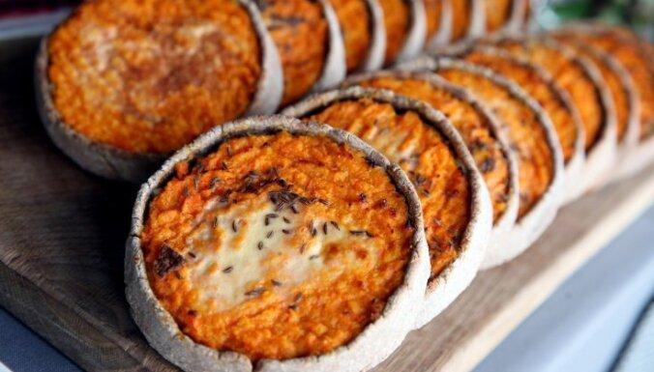
Sklandrausis (Figure 7.1.) is a traditional dish of the Livs, and over time it has been adopted in the Latvian cuisine of Kurzeme. It is a sweet pie, made of unleavened rye dough, sprinkled with caraway and filled with potatoes and carrots. Sklandrausis is usually consumed cold with tea or milk.
Fig. 7.1. Sklandrausis.
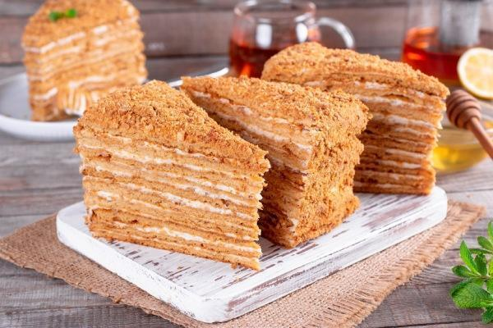
Honey cake (Latvian: Meduskūka) is a true Latvian classic dessert that’s bound to satisfy your sweet tooth cravings (Figure 7.2.).
Fig. 7.2. Honey cake, Meduskūka.
Creamy rhubarb cake (Latvian: Rabarberu maize) is made from soft cake with rhubarb and sweet cream. Traditional Latvian spring cake (Figure 7.3.).
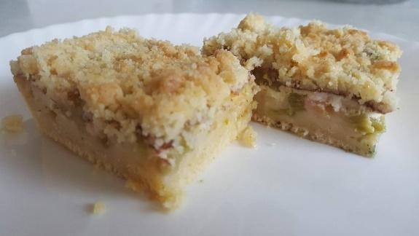
Fig. 7.3. Creamy rhubarb cake, Rabarberu maize.
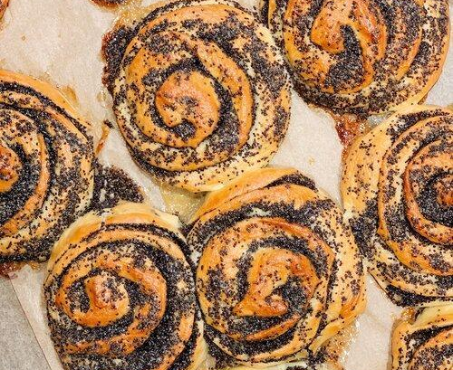
Poppy seeds pastries (Latvian: Magoņmaizītes) are made from wheat yeast dough, filled with poppy seeds, sugar and butter (Figure 7.4.).
Fig. 7.4. Poppy seeds pastries, Magoņmaizīte.
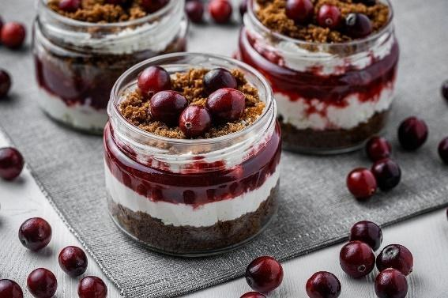
Layered rye bread (Latvian: Rupjmaizes kārtojums) is a traditional Latvian dessert made from rye breadcrumbs, blackcurrant or lingonberry jam, and whipped cream (Figure 7.5.).
Fig. 7.5. Layered rye bread, Rupjmaizes kārtojums.

Materials and Procedures

1. Use a context map and develop a product concept and a development plan for new desserts or cakes using traditional pastries or desserts.
Fig. 7.6. Product context map.
2. Prepare new recipes or use recipes from table 7.1 – 7.3. for innovative desserts or pastries or cakes.
Table 7.1.
Recipe for creamy rhubarb cake with rye soft cake. (Figure 7.7.)
Ingredients | Mass, g | Note
Soft cake
Rye crumbles | 250
Soft butter | 100g
Water | 100g
Rhubarb
Rhubarb | 500
Sugar | 150
Cinnamon | 2
Cream filling

Sour cream or natural yoghurt | 500
Egg | 50
Sugar | 50
Custard cream powder | 50
Procedure:
Soft cake. Mix all ingredients together. Put in to the mould and bake at 180 ⁰C for 15 minutes to partly bake.
Clean the rhubarbs, cut in pieces and sprinkle with sugar. Leave for 15 minutes.
On the partly baked soft cake sprinkle the rhubarbs and continue baking until the cake is ready.
At the end, pour the cream mixture on the top and finish the baking. Bake till the cream sets.
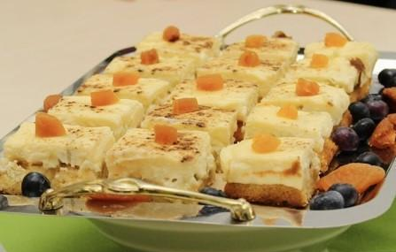
Sprinkle with cinnamon.
Fig.7.7. Creamy rhubarb cake with rye soft cake.

Table 7.2.
Recipe for Rye sponge roll. (Figure 7.8.)
Ingredients | Mass, g | Note
Sponge
Eggs, pc. | 6
Sugar brown | 40
Rye bread crumble | 60
Whipped cream
Cream | 500
Sugar | 100
Vanilla | 2
Procedure
Whip eggs with sugar until you get stiff peaks (approx. 10 min), then add spoon by spoon rye bread crumbles. Spread on a tray with baking paper 30 x 40 cm. Bake at 180 ⁰C till ready.
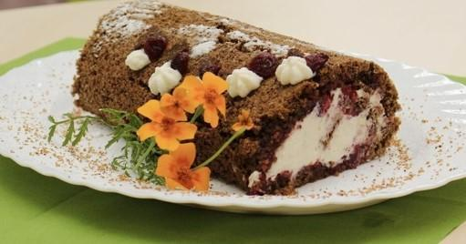
Whipped cream with sugar and vanilla.
Fill the sponge roll with whipped cream and cranberry jam.
Fig. 7.8. Rye sponge roll.
Table 7.3.
Recipe for innovative carrot desert. (Figure 7.9.)
Ingredients | Mass, g | Note
Rye cake base
Rye bread short crust crumbs | 200
Soft butter | 75
Carrot pudding
Boiled carrots | 500
Eggs | 100
Sour cream | 100
Sugar | 100
Vanilla | 1
Cinnamon | 1
Decoration
Whipped cream | 200

Procedure
Chop the carrots, add other ingredients and mix together. Pour the mass into a baking tray covered with baking paper. Bake at 180 ⁰C for 20-25 minutes, till set. Cool down.
Use baked rye bread short crust crumbs, add soft butter and make the cake bases.
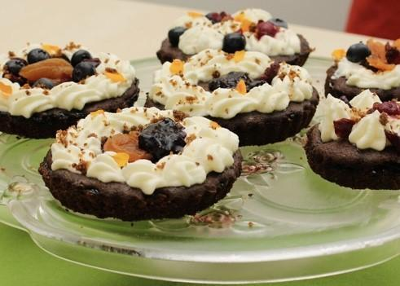
Make a 10cm diameter base, place the carrot pudding on top and decorate with whipped cream.
Fig. 7.9. Innovative carrot desert.
Conclusions

Approved by _________________________________________
Name, surname, signature

Date _________________________________________

Literature Sources
- APPLICATION FOR REGISTRATION OF A TSG COUNCIL REGULATION (EC) No 509/2006 on agricultural products and foodstuffs as traditional specialities guaranteed (2) ‘SALINĀTĀ RUDZU RUPJMAIZE’ EC No: LV-TSG-0007-01043-11.10.12. Available at: https://eur-lex.europa.eu/LexUriServ/LexUriServ.do?uri=OJ:C:2013:177:0012:0017:EN:PDF
- Breadmaking : improving quality / edited by Stanley P. Cauvain. 2nd ed. Cambridge ;Philadelphia, PA : Woodhead Pub., 2012. xxviii, 802 lpp. : il., tab., diagr. ; 24 cm. Woodhead publishing series in food science, technology and nutrition ; no. 229 . ISBN 9780857090607
      - Cheryl Wakerhauser, Modern French Pastry: Innovative Techniques, Tools and Design, Page Street Publishing, 2017, 208p., ISBN-10 ‏ : ‎ 162414437
- Flour production technology, Authors L.E. Aizikovich, B.N. Khortsev, Maskva, Kolos, 1968.
- Francis Webster Oats: Chemistry and Technology 2nd Edition, St.Paul, Minnesota: American Association of Cereal Chemists 2011 eBook ISBN: 9780128104521
- Handbook of cereal science and technology / edited by Karel Kulp, Joseph G. Ponte, Jr. New York: Basel : Marcel Dekker, 2000. IX, 790 p. : ill. Food science and technology ; 99 . ISBN 0824782941
- Kaisa Poutanen Per Åman Rye and Health 1st Edition, St.Paul, Minnesota: American Association of Cereal Chemists 2016 eBook ISBN: 9780128122884
- Khalil Khan, Wheat Wheat: Chemistry and Technology, 4th Edition , St.Paul, Minnesota: American Association of Cereal Chemists 2009 eBook ISBN: 9780128104545
- Kļava, Dace. Traditional Latvian sourdough rye bread / Dace Klava, Daiga Kunkulberga, Gunta Duka, Ruta Murniece // Traditional European breads : An illustrative compendium of ancestral knowledge and cultural heritage. Dublin, 2023. 199.-214.lpp. https://doi.org/10.1007/978-3-031-23352-4 , URL: https://link.springer.com/chapter/10.1007/978-3-031-23352-4_10 , URL: https://www.researchgate.net/publication/370831937_Traditional_Latvian_Sourdough_Rye_Bread , URL: https://www.scopus.com/inward/record.uri?eid=2-s2.0-85169401387&doi=10.1007%2F978-3-031-23352-4_10&partnerID=40&md5=51ebde4a4d46605b1a4d1d791df1ea2e ISBN 9783031233517.
- Kurt A. Rosentrater, Anthony D Evers. 2017. Kent’s Technology of Cereals. An Introduction for Students of Food Science and Agriculture 5th Edition. ISBN: 978-00-810-0529-3.
- Marco Garcia-Vaquero, Kristian Pastor,Gul Ebru Orhun, Anna McElhatton, João Miguel F. Rocha un Handbook on Sourdough Biotechnology, Marco Gobbetti, Michael Gänzle, https://doi.org/10.1007/978-3-031-23084-4
- Peter R Shewry Steven E Ullrich, Barley: Chemistry and Technology, St.Paul, Minnesota: American Association of Cereal Chemists, 2016 eBook ISBN: 9780128123690
- Ron Kill, K.Turnbull, Pasta and Semolina Technology, Wiley-Blackwell; 1st edition, 2001, 242, ISBN-10 ‏ : ‎ 9780632053490
- Sarand, Inga. Traditional breads from the Baltic countries (Estonia, Latvia, Lithuania) / Inga Sarand, Anna Traksmaa, Dace Klava, Daiga Kunkulberga, Evita Straumite, Ruta Galoburda, Ruta Murniece, Grazina Juodeikiene, Vadims Bartkevics, Elena Bartkiene // Traditional European breads: An illustrative compendium of ancestral knowledge and cultural heritage. Dublin, 2023. p. 41-59. https://doi.org/10.1007/978-3-031-23352-4 , URL: https://link.springer.com/chapter/10.1007/978-3-031-23352-4_2 , URL: https://www.researchgate.net/publication/370835134_Traditional_Breads_from_the_Baltic_Countries_Estonia_Latvia_Lithuania , URL: https://www.scopus.com/inward/record.uri?eid=2-s2.0-85169342857&doi=10.1007%2F978-3-031-23352-4_2&partnerID=40&md5=97ba04332dc1bad305aae6d018e6e86b ISBN 9783031233524.
- Solgajová, M. 2014. Technology of Foodstuffs of Plant Origin. Slovak University of Agriculture in Nitra. ISBN 978-80-552-1212-8.
- Surget, A.; Barron, C. Histologie du grain de bl´e. Ind. des C´er´eales 2005, 145, 3–7.
- Technology of grain processing, author Kuprits Y.N., Demidov G.P., Maskva, Kolos, 1977, 372 pp.
- Technology of storage and processing of grain and seeds, author Glukhikh M.A., Lan Publishing House, 2024.
- Ауэрман, Л. Я. Технология хлебопекарного производства; 9-е изд., перераб. и доп. Москва : Пищевая промышленность, 2005. 416 c.

