


Open Food Innovation University (OFINU)

Study module
“FOOD SAFETY MANAGEMENT”
WORKBOOK
for students

2024
Summary

The workbook is elaborated within the project “Open Food Innovation University" (OFINU), being in implementation with support of the European Union Erasmus+ Programme.
Overall objective of the project - to modernise food innovation and technology related higher education in Uzbekistan and Tajikistan, thereby increasing the quality and ensuring relevance of the higher education to the needs of the socio-economic growth of the countries concerned and especially of their regions.

Full partners:
- Lead partner: Latvia University of Life Sciences and Technologies
- Uzbekistan: Samarkand Agro-innovations and Research University, Andijan Institute of Agriculture and Agro-technologies
- Tajikistan: Technological University of Tajikistan, Kulob Institute of Technology and Innovation Management, Isfara Branch of the Technological University of Tajikistan
- Slovakia: Slovak University of Agriculture in Nitra

Associated partners in Uzbekistan:
- A group of companies "AGROMIR"
- "Navigul" MCHJ QK
- “Samarqand don mahsulotlari” JC (Samarkand grain products)

Associated partners in Tajikistan:
- CJSC “Combinati Shiri Dushanbe”
- LTD "Orion Rustam"
- Association of Entrepreneurs of Khatlon

The project implementation period: 01/02/2024 - 31/01/2027.

Funded by the European Union. Views and opinions expressed are however those of the authors only and do not necessarily reflect those of the European Union or the European Education and Culture Executive Agency. Neither the European Union nor the granting authority can be held responsible for them.

Partner universities and their academic staff, involved in the development of the study course:

P1 LBTU. Latvia University of Life Sciences and Technologies
Egita Sproge - HACCAP.
P2 SAMARU. Samarkand Agroinnovations and Research University
Hayitmurod Tilavov - food safety.
Shakhista Ishniyazova - food safety, standardization and certification of livestock and crop products.
P3 AIAA. Andijan Institute of Agriculture and Agro-technologies
P4 TUT. Technological University of Tajikistan
Gafurjon Hakimov - Food Safety Management.
Shuhratjon Nazarov - Food Safety Management.
P5 KITIM. Kulob Institute of Technology and Innovation Management
Bobokhon Qurbonzoda - food safety.
Isso Rajabov - food safety.
Shomuddin Zuhurov - food safety management.
P6 BTUTI. Branch of the Technological University of Tajikistan in the city of Isfara
Sirojiddin Boboev - food safety.
P7 SUA. Slovak University of Agriculture in Nitra
Jozef Čapla - Food safety management system.
Simona Kunová - food hygiene and safety.
Peter Zajác - HACCP system, food safety management system.
Group of companies "AGROMIR" (UZ)
Irina Krasilnikova - Quality management.
CONTENT
Theme of the study course 6
Learning methods 7
1. Lecture-Based Learning - Traditional method in which an instructor delivers content through spoken presentations, often supplemented by visual aids such as slides. 7
2. Interactive Learning - Engages students actively through discussions, Q&A sessions, and interactive activities. This enhances understanding and retention by involving students in the learning process. Techniques include think-pair-share, debates, and group discussions. 7
3. Collaborative Learning - Students work together in small groups to solve problems, complete tasks, or create projects. The method helps to develop teamwork skills, fosters peer learning, and encourages diverse perspectives. Examples include group projects, peer reviews, and study groups. 7
4. Problem-Based Learning - Students learn through the experience of solving open-ended problems. It promotes critical thinking, application of knowledge, and self-directed learning. Typically involves real-world scenarios that require research and collaborative problem-solving. 7
5. Case-Based Learning - Uses detailed scenarios (cases) to stimulate analysis and application of concepts. This helps students apply theoretical knowledge to practical situations, enhancing analytical and decision-making skills. Commonly used in business, law, and medical education. 7
6. Assessment and Feedback - Regular assessments (formative and summative) and feedback to guide learning and improvement. This ensures understanding, tracks progress, and provides actionable feedback. It includes quizzes, peer assessments, and instructor feedback. 7
Course Schedule 8
Theme 1 12
Introduction to food safety 12
Practical work 15
Major challenges of food safety 15
Theme 2 15
Rapid Alert System for Food and Feed (RASFF) 15
Practical work 19
The RASFF Consumers' Portal – working with the portal 19
Biological safety 22
Biological hazard vs. biological contamination 23
Practical work 26
Types of Biological Hazards in food and feed 26
Where are biological hazards commonly found? 26
What can biological hazards in food cause? 26
Which food safety practice will help prevent biological hazards? 26
Theme 4 27
Food Hygiene and safety 27
Practical work 31
Consumer perceptions of risks from food 31
Theme 5 32
Food-borne diseases (Zoonoses) 32
Biological or chemical agents 32
Bacteria 32
Viruses 34
Protozoa 34
Helminths 34
Unconventional agents 35
Prions 35
Mycotoxins1 35
Pesticide residues 36
Veterinary drugs 36
Environmental contaminants 36
Biotechnology 36
Other agents 37
Practical work 38
Challenges in emerging food – borne diseases. 38
Theme 6 39
Food fraud and authenticity 39
Methods for food authentication and adulteration 42
Chromatographic techniques 42
Practical work 43
Food authentication methods – food authenticity databases 43
Theme 7 44
Chemical safety 44
Theme 8 Food labelling 50
Practical work 52
Labelling - food labelling information system 52
Theme 9 53
Novel food 53
The authorisation covers: 53
Practical work 55
Novel Food status Catalogue 55
Theme 10 56
Sanitation in food industry 56
Theme 11 59
Disinfection methods 59
Practical work 62
Examples of disinfection. Choosing the appropriate disinfectant 62
Theme 12 Sanitation program 63
Evidence of effectiveness 65
Step 2. Develop templates for records 65
Step 3. Implement the cleaning and sanitation programme 66
Practical work 67
Preparing of Sanitation program 67
Theme 13 70
Microbial biofilms in food industry 70
Magnetic fields with magneto-materials 72
Chemical addition for biofilm removal 72
Theme 14 73
Genetically modified organisms 73
Potential risks of GM foods 74
Theme 15 Detection of contamination 75
Laboratory work 82
Detection of contamination – swabs 82
Laboratory work 84
Detection of contamination - Petrifilm plates 84
Theme 16 85
Pest control in food industry 85
Theme 17 93
Personal hygiene 93
Theme 18 96
HACCP system 96
Prior to the application of the HACCP-based procedures to any business, the food business operator (FBO) should have implemented the prerequisite programmes. Compliance with the procedures of regulations are the prevention and preparedness pillars of each FSMS and are needed to develop HACCP-based procedures. 96
Fig. 18.1 Food safety management system (ISO 22000:2018) 96
This team, which involves all parts of the food business concerned with the product, should include the whole range of specific knowledge and expertise appropriate to the product under consideration, its production (manufacture, storage, and distribution), its consumption and the associated potential hazards and should also involve, as much as possible, the higher levels of management. The team should get the full support of the management who should consider themselves as the owner of the HACCP plan and the overall FSMS. 97
Where necessary, the team should be assisted by specialists who will help it to solve its difficulties as regards assessment and control of critical points. 97
The team may include specialists and technicians: 97
● who understand the biological, chemical or physical hazards connected with a particular product group, 97
● who have responsibility for, or are closely involved with, the technical process of manufacturing the product under study, 97
● who have a working knowledge of the hygiene and operation of the process plant and equipment, 97
● any other person with specialist knowledge of microbiology, hygiene or food technology. 97
One person may fulfil several or all of these roles, provided that all relevant information is available to the team and is used to ensure that the system developed is reliable. Where expertise is not available in the establishment, advice should be obtained from other sources (consultancy, guides of good hygiene practices, etc. not excluding other companies of the same group (at sectorial or association level) where expertise is available). 97
Theme 19 126
Preparation of the HACCP plan 126
Practical work 1 126
Practical work 2 130
Practical work 3 133
Practical work 4 137
Assignment for students: Creating a universal working checklist for evaluating the HACCP system and its principles 137
Practical work 5 141
Theme 20 145
Food safety management system 145
Theme 21 179
Management systems – documentation 179
Practical work food safety management system – documentation 179
1. First Level: policy and objectives 183
2. Second Level: procedures and guidelines 184
3. Third level: Work instructions and detailed procedures 184
Specific examples of documentation components: 184
Objectives of FSQMS documentation: 184
Key Benefits: 185
Practical work 194
Food safety management system – Solving practical tasks 194
Company food safety and quality policy 199
Theme 22 203
Legislative requirements for food of animal and plant origin 203
Food safety risk associated with foods of plant origin 204
Factors affecting food safety 205
Laboratory works 206
Salt detection test in milk 206
Laboratory works 209
Laboratory examination of meat products 212

Theme of the study course
The study module includes the following topics on food safety, sanitary hygiene in food production enterprises and the HACCP management system. Ensuring the safety and quality of the food supply chain is a complex task that requires robust measures and effective food safety management systems. The food safety management systems protect consumer health and the integrity of the supply chain and ensure constant quality and integrity of the supply chain, therefore several lecturers with different, and specific knowledge are involved in the implementation of the study module.

Learning methods
Creating an effective study module for students involves incorporating a variety of learning methods to cater to different learning styles and to enhance comprehension and retention.
The main pedagogical methods taught are as follows: learner centred approach, competence-based approach, experiential learning, cooperative learning, and interactive learning.
The training includes the practice methods, as well as an introduction to modern learning analytics, to be used to support the engagement and responsibility of a student, and to support assessment.
In order to improve and promote the learning of the study module, it is possible to use different teaching methods in the study course:

Lecture-Based Learning - Traditional method in which an instructor delivers content through spoken presentations, often supplemented by visual aids such as slides.

Interactive Learning - Engages students actively through discussions, Q&A sessions, and interactive activities. This enhances understanding and retention by involving students in the learning process. Techniques include think-pair-share, debates, and group discussions.

Collaborative Learning - Students work together in small groups to solve problems, complete tasks, or create projects. The method helps to develop teamwork skills, fosters peer learning, and encourages diverse perspectives. Examples include group projects, peer reviews, and study groups.

Problem-Based Learning - Students learn through the experience of solving open-ended problems. It promotes critical thinking, application of knowledge, and self-directed learning. Typically involves real-world scenarios that require research and collaborative problem-solving.

Case-Based Learning - Uses detailed scenarios (cases) to stimulate analysis and application of concepts. This helps students apply theoretical knowledge to practical situations, enhancing analytical and decision-making skills. Commonly used in business, law, and medical education.

Assessment and Feedback - Regular assessments (formative and summative) and feedback to guide learning and improvement. This ensures understanding, tracks progress, and provides actionable feedback. It includes quizzes, peer assessments, and instructor feedback.

Course Schedule
Thematic Study Plan for module Food Safety management
Date, Time | Study form | Theme | Lecturer
Theme 1. Introduction to food safety
Day 1 | Lectures  (3 h) | Food Safety  Introduction and historical perspective
Day 1 | Practical work (2 h) | Major challenges of food safety
Theme 2. Rapid Alert System for Food and Feed (RASFF)
Day 2 | Lectures  (2 h) | Rapid Alert System for Food and Feed (RASFF) - How does RASFF work?
Day 2 | Lecture (1 h) | The RASFF Window
Day 2 | Practical work (3h) | The RASFF Consumers' Portal - working with the portal
Theme 3. Biological safety
Day 3 | Lectures  (2 h) | Biological safety - definition
Day 3 | Lectures  (2 h) | Biological hazards in food - dividing of biological hazards, causes, examples
Day 3 | Practical work  (4h) | Types of biological hazards in food and feed
Theme 4. Food hygiene and safety
Day 4 | Lectures  (2h) | Food hygiene  Management of food safety and hygiene
Day 4 | Practical works  (3 h) | Consumer perceptions of risks from food
Theme 5. Food-borne diseases (Zoonoses)
Day 5 | Lectures  (2 h) | Food-borne diseases
Day 5 | Practical work  (2 h) | Challenges in emerging food-borne diseases
Theme 6. Food fraud and food authenticity
Day 6 | Lecture  (1 h) | Food fraud and food authenticity – definitions, examples of food fraud
Day 6 | Practical works  (1 h) | Food authentication methods – food authenticity databases
Theme 7 Chemical safety
Day 7 | Lectures (2 h) | Chemical safety – chemical hazards in food
Day 7 | Lectures (2 h) | Contaminants  Residues of veterinary medicinal products
Day 7 | Lecture (1h) | Food contact materials
Theme 8. Food labelling
Day 8 | Lecture (1h) | Food supplements. Addition of vitamins and minerals
Day 8 | Lecture (1h) | Food information to consumers - legislation
Day 8 | Practical work  (2 h) | Labelling - food labelling information system
Theme 9. Novel food
Day 9 | Lecture (1h) | Novel Food, authorisations and legislation
Day 9 | Lecture  (1 h) | Nanomaterials in food
Day 9 | Practical work  (2h) | Novel Food status Catalogue
Theme 10. Sanitation in food industry
Day 10 | Lectures  (2 h) | Sanitation – introduction, definitions
Day 10 | Lectures  (2 h) | Cleaning and disinfection
Theme 11. Disinfection methods
Day 11 | Lectures (2 h) | Chemical methods of disinfection – application advantages, disadvantages
Day 11 | Lectures (1 h) | Physical methods of disinfection – application advantages, disadvantages
Day 11 | Practical work  (2 h) | Examples of disinfection. Choosing the appropriate disinfectant
Theme 12. Sanitation program
Day 12 | Lectures  (2 h) | Sanitation program - content and methodology of the sanitation program
Day 12 | Practical work  (4 h) | Preparing of Sanitation program
Theme 13. Microbial biofilms in food industry
Day 13 | Lectures  (2 h) | Biofilm risks in food processing  Biofilm formation on food processing surfaces
Day 13 | Lecture (1 h) | Biofilm removal methods
Theme 14. Genetically modified foods
Day 14 | Lectures  (2 h) | Genetically modified foods – safety and risks
Theme 15. Detection of contamination
Day 15 | Lectures  (2 h) | Surface sampling and the detection of contamination
Day 15 | Laboratory work  (3 h) | Detection of contamination - swabs
Day 15 | Laboratory work  (3 h) | Detection of contamination -Petrifilm plates
Theme 16. Pest control in food industry
Day 16 | Lectures  (2h) | Pest control in food industry - rodent control, insect control. Prevention and methods of pest control
Theme 17. Personal hygiene
Day 17 | Lectures  (2h) | Personal hygiene rules
Theme 18. HACCP system
Day 18 | Lectures  (6 h) | HACCP system and implementation
Theme 19. Preparation of the HACCP plan
Day 19 | Practical work  (8 h) | Preparation of the HACCP plan
Day 20 | Practical work  (8 h) | Preparation of the HACCP plan
Theme 20. Food safety management system
Day 21 | Lecture  (1h) | Food safety management system.  Food safety management systems – introduction, basic terms and definitions, process principle
Day 21 | Lecture  (5h) | Food safety management system – context of the organisation, leadership, planning, support, operation, performance evaluation, improvement
Theme 21. Management systems – documentation
Day 22 | Practical work  (4h) | Food safety management system – documentation
Day 23 | Practical work  (8h) | Management systems - documentation  Solving practical tasks
Day 24 | Practical work  (8h) | Management systems - documentation  Solving practical tasks
Theme 22. Legislative requirements for food of animal and plant origin
Day 25 | Lectures (2 h) | Legislative requirements for food of animal and plant origin
Day 26 | Laboratory work  (4 h) | Laboratory examination of milk and dairy products
Day 26 | Laboratory work  (3 h) | Laboratory examination of meat

Theme 1

Introduction to food safety

Theoretical materials
Food safety
Food safety deals with the practical measures and scientific discipline taken to make certain that food products are safe for human consumption, free from contamination and do not pose any risk to public health.
Food safety encompasses a set of practices, procedures, and regulations aimed at ensuring that we are consuming food which is safe for consumption, free from contamination, and poses no harm to human health. This is a global concern, as food is a fundamental necessity, and unsafe food can lead to a wide range of health issues, from mild food poisoning to severe diseases, and even fatalities.
Historical perspectives of food safety
Ancient civilisations - in ancient civilizations like Egypt, Greece and Rome, there were rudimentary food safety practices. People would inspect food for visible signs of spoilage and use preservation methods such as drying, salting, and fermentation to increase the shelf life of perishable foods.
Middle Ages - during the Middle Ages, food safety was a significant concern, especially in densely populated urban areas. There were instances of food adulteration and contamination.
Industrial revolution - in the mid-19th century, scientists such as Louis Pasteur and Robert Koch made ground-breaking discoveries about the role of microorganisms in food spoilage and illness, laying the foundation for modern food microbiology and safety practices.
Twentieth century and beyond - the 20th century witnessed the establishment of regulatory authorities such as the World Health Organisation (WHO) and the U.S. Food and Drug Administration (FDA), which played crucial roles in setting food safety standards and regulations on a global scale. Advances in food science, technology, and inspection methods have allowed for more effective monitoring of food safety, including the development of food safety management systems like Hazard Analysis and Critical Control Points (HACCP).
A public health priority and a global responsibility
Nearly two decades into the 21st century, the challenges of ensuring food security, food safety, and nutrition on a global scale continue to grow in complexity. Recent statistics show that the levels of world hunger, malnutrition, and food- and water-borne diseases are among the most critical global public health issues facing the international community. For example:
- According to FAO of the United Nations, 10.9% of the world's population are undernourished, down from 14.5% in 2005. This percentage still represents roughly 770 million people.
- WHO reports that more than 1000 children under five die every day from diarrhoeal diseases caused by inadequate access to water and sanitation.
- In 2015, foodborne diarrhoeal disease agents alone were the cause of death for more than 230,000 people.
- Worldwide, nearly 1 in 10 people fall ill from all foodborne diseases, which equates to 33 million healthy life years lost and results in the deaths of approximately 420,000 people.
- In the developed countries, one in three consumers get a foodborne disease associated with microbes or their toxins every year.
Rapid globalisation has exposed critical gaps in national and international capabilities to assure adequate levels of food safety and quality. WHO and other food-related international public health, development, and standard-setting bodies have targeted these gaps as priority items and are working together to reinforce the need to use an integrated international food safety regulatory system in the era of “one global market”.
Harmonising global regulations will aid the uptake and application of new technologies and encourage the food industry to invest in technologies to ensure the safety, quality, and security of the global food supply.
Regulatory framework and standards
FDA (Food and Drug Administration)
The FDA is a key regulatory agency that is responsible for ensuring the safety of most food products in the United States. They establish and enforce regulations related to food labelling, additives, contaminants, and manufacturing practices.
USDA (United States Department of Agriculture)
The USDA primarily focuses on the safety of meat, poultry, and egg products in the United States. They regulate and inspect these products from farm to processing and distribution.
CDC (Centers for disease control and prevention)
The CDC is a federal agency responsible for tracking and investigating foodborne outbreaks and diseases. They provide epidemiological expertise and surveillance to identify the source of outbreaks.
WHO (World Health Organisation)
The WHO is a global organisation that sets international food safety standards and guidelines. It works in partnership with the Food and Agriculture Organisation (FAO) through the Codex Alimentarius Commission to develop and harmonise global food safety standards.
These agencies collaborate to develop, implement, and enforce food safety regulations that protect consumers from foodborne hazards. Their roles extend beyond national borders, as international cooperation is essential in ensuring the safety of the global food supply chain.
Food safety regulations
HACCP (Hazard analysis and critical control points)
HACCP is a systematic approach that helps in identifying, controlling and evaluating food safety hazards at critical points during food production, processing, and handling. HACCP principles include conducting hazard analysis, identifying critical control points, establishing critical limits, monitoring, corrective actions, verification, and record-keeping.
Codex Alimentarius
The Codex Alimentarius, often referred to as the Codex, is a collection of worldwide recognised standards, guidelines, and codes of practice for food safety, established by the Food and Agriculture Organisation (FAO) and the World Health Organisation (WHO). It serves as a reference point for international trade and aims to harmonize food safety standards and regulations globally.
International food safety standards
International food safety standards are a set of guidelines and regulations established at the global level to ensure the safety and quality of food products traded across borders. These standards, often developed through organisations like the Codex Alimentarius Commission (a joint initiative of the Food and Agriculture Organisation and the World Health Organisation), provide a common framework for countries to follow. They cover various aspects of food safety, including permissible levels of contaminants, food additives, labelling requirements, and hygiene practices.

Practical work

Major challenges of food safety
Students will work in groups.
1. Students will create questions related to food safety and they will search for solutions related to deficiencies in food safety problematic:
What are the solutions to food safety?
What is the best way to describe food safety?
What is the best way to prevent poor food safety practices?
2. Students will prepare the questionnaire with problematic food safety. Major challenges of food safety.

Theme 2

Rapid Alert System for Food and Feed (RASFF)

Theoretical materials
History of RASFF
RASFF was created in 1979 in response to an incident concerning oranges. The ‘founding members’ were Belgium, Denmark, France, Germany, Ireland, Italy, Luxembourg, the Netherlands and the United Kingdom. Other member countries accessed RASFF as soon as they joined the European Union.
Why RASFF
As part of the food safety tools, the Rapid Alert System for Food and Feed (RASFF) was established to ensure the exchange of information between member countries to support swift reaction by food safety authorities in case of risks to public health resulting from the food chain.
Its legal basis is Article 50 of Regulation (EC) N° 178/2002 also known as the General Food Law.
RASFF was set up to allow food safety authorities to rapidly exchange information on health risks derived from food or feed so that they can take immediate action to avert the risk.
- RASFF provides a round-the-clock service to ensure that urgent notifications are sent, received and responded to collectively and efficiently.
- Vital information exchanged through RASFF can lead to products being recalled from the market.
- Thanks to RASFF, many food safety risks are averted before they can cause harm, from farm to fork.
While access to RASFF is exclusively granted to member countries’ authorities and the European Commission, an interactive, searchable online database, called the RASFF Window, offers public access to summary information about the most recently transmitted RASFF notifications and allows searching for information on any notification issued in the past (currently limited to 2020 and later).
The European Commission created this RASFF database to make information available to consumers, business operators and authorities worldwide. Notifications in the RASFF Window do however, not reveal commercial details such as brands and business operators.
RASFF Window is the main interface for non-member countries to get informed about notifications concerning products that either were produced there or dispatched from there or that had been exported there by a member country.
RASFF Window includes a RASFF consumers' portal, which provides information on recent food recalls and public health warnings in member countries linked to RASFF notifications.
What products does the RASFF warn about?
The RASFF warns against foods, food contact materials and animal feeds that pose a health hazard. For example, in the case of food, the detection of mould toxins, foreign matter, or undeclared allergens can trigger a RASFF notification. Food contact materials include, for example, tableware, cooking utensils such as pots, pans and baking dishes, food packaging or disposable cups. These articles can pose a risk if substances hazardous to health migrate from the container into the food.
Who performs which tasks in the RASFF?
Efficiency through short notification channels and clear hierarchies: RASFF contact points at the surveillance authorities and hubs both in each member state and at the European Commission, including the involved European authorities, allow for a fast flow of information around the clock, even on weekends.
How does the RASFF work?
If a consumer product is found to be objectionable, for example in the course of an official control, during a company's own inspection or on the basis of a consumer complaint, and poses a potential health risk, the competent surveillance authorities will take action. The authorities prepare a notification draft via the iRASFF online platform which contains all essential information on the identification of the product, on possible hazards, product tracing and distribution, but also on already taken measures.
This draft is then sent to the national contact point. At this level, each notification is checked, partly translated and then forwarded for validation to the European Commission. The notification is also reviewed by the European Commission and distributed to all contact points of the network members, so that they can take the necessary measures and carry out further investigations on their part, if necessary.

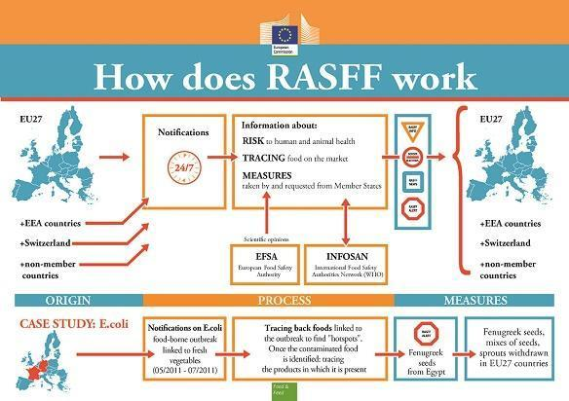Fig. 2.1. Work of RASFF (https://www.eftasurv.int/internal-market/notifications-and-applications/rapid-alert-system)
Different types of notifications
Depending on the severity of the identified risk and the distribution status, the notifications are categorised and prioritised differently:
The highest priority - alert notifications: When a food or feed poses a serious risk to humans, animals, or the environment and therefore requires immediate action in another member state, an alert notification is issued.
Information notifications do not require immediate action in other member countries because the product is not on the market there (information notification for attention) or because the risk associated with the concerned product does not require immediate action (information notification for follow up).
A border rejection notification is transmitted when suspect food or feed has been rejected by a border post or a designated point of entry into the EU. The consignment concerned is returned to the country of origin or destroyed on site.
A news notification is a communication based on information that has not yet been verified or in which the cause of a risk has not yet been identified.
Notifications from the RASFF
RASFF notifications are published on the internet. To provide consumers, businesses or stakeholders with access to notifications from the European Rapid Alert System for Food and Feed, the European Commission hosts the "RASFF Window".

Practical work

The RASFF Consumers' Portal – working with the portal
Work with RASFF Window.
Comparison of RASFF reports between individual countries.
Table 2.1.
Features of the RASFF
Feature | Description
Notification country | Country registering the issue.
Product | The specific name of the product.
Hazard | The hazards or anomalies that have caused the issue.
Origin country | Country of origin of the product. Any country in the world.
Destination country | Country or countries of the product's destination. Any country in the world.
Distribution country | Countries within the transportation chain of the product between the origin and destination. Any country in the world or certain international regulatory organisations.
Results
Table 2.2.
Origin countries
Country | Notifications | Percentage (%)

Table 2.3.
Products
Product | Instances | Percentage (%)

Table 2.4.
Identified hazards
Hazard | Instances | Percentage (%)

Conclusions

Approved by _________________________________________
Name, surname, signature

Date _________________________________________
Theme 3

Biological safety
Theoretical materials
Biological hazards include bacteria, viruses, parasites, prions, biotoxins. Some of these hazards have posed serious risks to public health, such as Salmonella, Listeria monocytogenes, biotoxins in live molluscs or BSE. Exposure of consumers to those through food should thus be prevented.
A comprehensive legal framework has been established by the European Commission to increase the level of food safety in Europe, building European consumers' confidence while preventing food crises. It is based on scientific advice delivered by the European Food Safety Authority (EFSA).
Biological hazards in food are pathogenic organisms or their products that can cause health problems when ingested, such as foodborne illnesses or food poisoning. It is one of the major types of hazards. Biological hazards are a significant concern in the food industry. In fact, major biological hazards caused most of the foodborne illness outbreaks recorded in history.
Because of poor food safety practices, biological hazards become dangerous to public health when they enter the food chain system.
The organisms considered biological hazards can either cause infection or intoxication in humans.
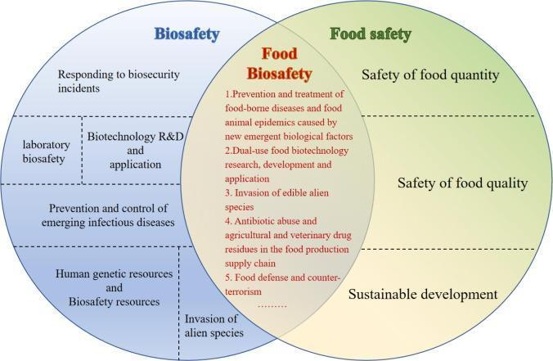
Fig. 3.1. Biosafety/Food Biosafety/Food Safety (Xu et al., 2022)

Biological hazard vs. biological contamination
Biological hazard refers to the organism that causes foodborne illnesses and other risk factors to human health. On the other hand, biological contamination occurs when pathogenic hazards enter the food chain.
Biological contamination is caused by foodborne hazards such as bacteria, viruses, fungi, and parasites, which are all collectively known as biological hazards that make food unsafe for consumption.
Major types of biological hazards
Virus. Foodborne viruses contribute to the most number of cases of foodborne illnesses and communicable diseases in the U.S., with norovirus as the most recognised among them. Other known viruses in the food industry include the following:
  - enterovirus,
  - rotavirus,
  - astrovirus,
  - hepatitis A virus (HAV).
Viruses are very resistant to intense conditions such as high acidity and heat and can be easily transferred from the food handler to the food being prepared.
Viruses are most commonly associated with contaminated water, seafood, vegetables, and food handlers. Some of the most common infectious diseases caused by viruses include gastroenteritis and hepatitis.
Bacteria. Bacteria are single-celled microorganisms that can live on moist food items and cause unwanted changes and hazardous effects. Foodborne bacteria are very common in food businesses as they can be found in the water, air, soil, and the gastrointestinal tract of animals. Some types can cause both intoxication and infection.
The types of foodborne bacteria vary greatly. Some can survive extreme conditions, whereas some bacteria can be eliminated easily and pose minimal threat to human health. Some bacteria can stay inactive in the form of spores and multiply when the conditions are favourable again. This mechanism of bacteria makes them a major concern in food preparation.
Some of the most commonly known foodborne bacteria include the following:
  - Escherichia coli (E. coli; commonly found in water, leafy greens, raw milk, and meat).
  - Bacillus cereus (commonly found in rice and other starchy foods).
  - Salmonella (commonly found in raw meat and poultry products).
  - Staphylococcus (commonly found on the skin of food handlers and poultry products).
  - Listeria (commonly found in unpasteurised milk, ice cream, and vegetables).
  - Campylobacter (commonly found in undercooked poultry).
  - Clostridium (commonly found in undercooked meat products).
Fungi. This type of biological agent includes both yeasts and moulds. Microscopic fungi are known for their ability to survive in very acidic and dry conditions. This makes them a critical concern for intermediate moisture foods and preserved products. Foodborne fungi are also known to have significant economic use. Some types of fungi are used to produce new food products, such as cheeses and wines. Despite this, there are examples of fungi that can cause serious illnesses.
Several fungi are known to produce toxins that are very hard to remove when they have contaminated foods. In such cases, prevention is a better approach to protecting human health. Some of the most common foodborne fungi include the following:
  - Aspergillus sp. (commonly found in grains and nuts).
  - Candida sp. (commonly found in grains, dairy products, and processed meats).
Parasites. Parasites are microorganisms that gain their source of nutrition at the expense of their host. They can live in moist foods and transfer to humans, where they can cause foodborne illness. The Centres for Disease Control and Prevention consider protozoa as the most common foodborne parasites.
Other examples of foodborne parasites include:
  - Trichinella sp. (commonly found in raw meats).
  - Cryptosporidium sp. (commonly found in raw milk and contaminated water).
Among the mentioned types of biological hazards, a few species are recognised to cause the most foodborne illness cases worldwide. The big 6 major pathogens include:
- Norovirus
- Nontyphoidal Salmonella
- Salmonella Typhi
- E. coli
- Shigella
- Hepatitis A

Practical work

Types of Biological Hazards in food and feed
Work in groups.
Students will develop solutions to problems related to biohazards:

Where are biological hazards commonly found?

What can biological hazards in food cause?

Which food safety practice will help prevent biological hazards?

Conclusions

Approved by _________________________________________
Name, surname, signature

Date _________________________________________

Theme 4

Food Hygiene and safety
Theoretical materials
General principles
Food safety and suitability should be controlled using a science-based preventive approach, for example a food hygiene system. Good Hygienic practices (GHPs) should ensure that food is produced and handled in an environment that minimises the presence of contaminants.
Food hygiene systems should be reviewed to determine if modifications are needed. This should be done periodically and whenever there is a significant change that could impact the potential hazards and/or the control measures (e.g. new process, new ingredient, new product, new equipment, new scientific knowledge) associated with the food business.
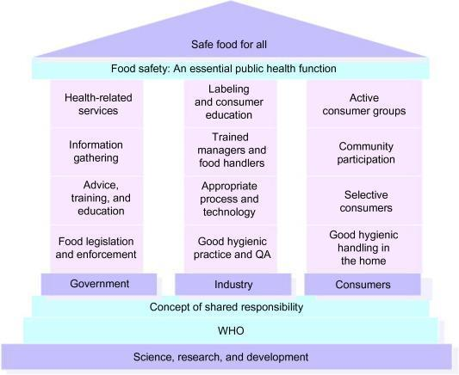
Fig. 4.1. Concept of shared responsibility according to the World Health Organisation
(Motarjemi, 2014)
Good hygiene practices
Control of food hazards
The development, implementation, and maintenance of GHPs provide the conditions and activities that are necessary to support the production of safe and suitable food at all stages of the food chain from primary production through to the handling of the final product. Applied generally, they assist in controlling hazards in food products.
Knowledge of the food and its production process is essential for the effective implementation of GHPs.
GHPs manage many sources of food hazards that could contaminate food products, e.g. persons who handle food during harvest, manufacturing, and preparation; raw materials and other ingredients purchased from suppliers; cleaning and maintaining the work environment; storage and display.
As previously noted, all FBOs should be aware of and understand the hazards associated with their businesses, and the control measures required to manage these hazards, as appropriate. FBOs should consider (using external resources as needed) whether the application of GHPs alone is sufficient to manage some or all of the hazards associated with the operation through control of their sources, such as:
- control of water quality – minimises the presence of many potential hazards (e.g. biological, chemical, and physical);
  - control of faecal contamination – minimises the potential for contamination with many foodborne pathogens such as Salmonella, Campylobacter, Yersinia, pathogenic strains of E. coli;
- control of food handler practices and hygiene – prevents many potential communicable diseases that could be foodborne; and
- control of food contact surfaces by cleaning – removes bacterial contaminants, including foodborne pathogens, and allergens.
After consideration of the conditions and activities in the business, it may be determined that GHPs alone may be sufficient to manage the hazards. However, it may also be determined that it is necessary to place greater emphasis on some GHPs that are particularly important for food safety (e.g. increased stringency of cleaning of a mincer for producing minced meat for raw or lightly cooked consumption compared to equipment used for producing meat to be cooked prior to consumption; increased monitoring and/or verification of disinfection of food contact surfaces).
Hazards that occur or are present at levels such that GHP procedures are not sufficient to provide safe food, should be managed by an appropriate combination of control measures that are capable of preventing the occurrence of the hazards or eliminating or reducing them to an acceptable level. The control measures can be identified in one or more steps throughout the production process.
Primary production should be managed in a way that ensures that food is safe and suitable for its intended use. Where necessary, this will include:
- an assessment of the suitability of water used where it may pose a hazard, for example, crop irrigation, rinsing activities, etc.;
- avoiding the use of areas where the environment poses a threat to the safety of food (e.g. contaminated sites);
- controlling contaminants, pests and diseases of animals and plants, to the extent practicable, to minimise the threat to food safety (e.g. appropriate use of pesticides and veterinary drugs); and
- adopting practices and measures to ensure food is produced under appropriately hygienic conditions (e.g. cleaning and maintaining harvest equipment, rinsing, hygienic milking practices).
The types of activities involved in primary production may make eliminating or reducing some hazards difficult. However, by applying prerequisite programmes such as good agricultural practices (GAPs) and/or GHPs, steps can be taken to minimise the occurrence and level of hazards in the food chain, e.g. at milking for dairy production, steps taken in the hygienic production of eggs, or the controls on irrigation water used for growing salad crops. Not all provisions apply to all primary production situations and consideration will need to be given by the FBO on the appropriateness of the measures to be taken.
Hygienic production
The potential effects of primary production activities on the safety and suitability of food should be considered at all times. In particular, this includes identifying any specific points in such activities where a high probability of contamination may exist and taking specific measures to minimise and, if possible, eliminating that probability.
Producers should as far as practicable, implement measures to:
- control contamination from soil, water, feedstuffs, fertilisers (including natural fertilisers), pesticides, veterinary drugs or any other agent used in primary production;
- protect food sources from faecal and other contamination (e.g. zoonotic foodborne agents);
- control plant and animal health so that it does not pose a threat to human health through food consumption, or adversely affect the suitability of the product (e.g. observe the withdrawal period of veterinary drugs and pesticides, keeping records where applicable); and
- manage waste and store harmful substances appropriately.
Handling, storage and transport
Procedures should be in place to:
- sort food to remove material, which should not be used for human consumption;
- dispose of any rejected material in a hygienic manner; and
- protect food from contamination by pests, or by chemical, physical or microbiological contaminants or other objectionable substances during handling (e.g. sorting, grading, washing), storage and transport.
Care should be taken to prevent deterioration and spoilage through the appropriate measures which may include controlling temperature, humidity, and/or other controls.
Microbiological physical, chemical and allergen specifications
Where microbiological, physical, chemical and allergen specifications are used for food safety or suitability, such specifications should be based on sound scientific principles and state, where appropriate, sampling parameters, analytical methods, acceptable limits, and monitoring procedures. Specifications can help ensure that raw materials and other ingredients are fit for purpose and contaminants have been minimised.

Practical work

Consumer perceptions of risks from food
  - Students will propose how to maintain food safety and hygiene.
  - Students will propose the correct food handling practices for food.

Conclusion

Approved by _________________________________________
Name, surname, signature

Date _________________________________________

Theme 5

Food-borne diseases (Zoonoses)
Theoretical materials
Food-borne diseases are among the most widespread public health problems. These growing problems may be biological or chemical in nature.
The following factors play a role in the epidemiology of emerging food-borne problems:
- Changes in the pathogens. Microbial adaptation through natural selection is a key process in the emergence of pathogens.
- Development. Economic and technical developments have introduced new foods. New production systems or environmental changes increase access to certain foods.
- Poverty and pollution.
- Dietary habits.
- Health sector. Many governments are under increasing pressure to reduce staff and decentralise and privatise their health systems.
- Demographic changes.
- Travel and migration.
- Trade in food, animal feed and animals.
- New food vehicles of transmission. An array of new food vehicles of transmission have been identified, including street food. While undercooked foods of animal or marine origin were traditionally implicated in outbreaks of food-borne illnesses, increasing attention is now being focused on items such as fruit, vegetables and apple cider.

Biological or chemical agents

Bacteria
Escherichia coli O157. Referred to as enterohaemorrhagic E. coli (EHEC), this pathogen produces toxins known as verotoxins. Transmission to humans is principally through the consumption of contaminated foods, such as raw or undercooked meat products and raw milk. Freshly pressed apple juice or cider, yoghurt, cheese, salad vegetables and cooked maize have also been implicated. Faecal contamination of water and foods, as well as cross-contamination during food preparation, can lead to infection, as can person-to-person contact. It is a major cause of bloody and non-bloody diarrhoea and often leads to long-term complications such as haemolytic uraemic syndrome.
Enteroaggregative Escherichia coli. Enteroaggregative E. coli (EAEC) has increasingly been recognised as an agent of a watery mucoid diarrhoea - especially in children - in developing and, recently, industrialised countries. It is particularly associated with persistent diarrhoea (lasting for more than 14 days), a major cause of illness and death.
Listeria monocytogenes. This ubiquitous microorganism has been isolated from various environments, including decaying vegetation, soil, animal feed, sewage and water. It is resistant to diverse environmental conditions and can grow at temperatures as low as 3 °C. It is found in a wide variety of raw and processed foods - such as milk and cheeses, meat (including poultry) and meat products, and seafood and fish products - where it can survive and multiply rapidly during storage. L. monocytogenes is responsible for opportunistic infections, preferentially affecting individuals whose immune systems are weakened, including pregnant women, newborn babies and the elderly. It primarily causes meningitis, encephalitis or septicaemia and, when pregnant women are infected, it can lead to abortion, stillbirth or premature birth.
Multidrug-resistant Salmonella typhi-murium DT 104. This microorganism has been isolated from cattle, poultry, sheep, pigs and horses. Antimicrobial therapy is used extensively to combat S. typhimurium infection in animals, and the evolution of a strain resistant to the commonly used antibiotics has made infections with S. typhimurium in food animals difficult to control. The primary route by which humans acquire the infection is through the consumption of a large range of contaminated foods of animal origin.
Salmonella enteritidis. This bacterium is the dominant cause of human salmonellosis in many parts of the world. Poultry, eggs and egg products, in particular, are contaminated, but the microorganism has also been found in other foodstuffs such as ice cream. Cross-contamination, undercooking and inadequate cooling procedures promote the spread and growth of salmonella during processing and handling. One important characteristic of S. enteritidis is its ability to contaminate the contents of intact egg shells. Manifestation of illness includes invasive disease and reactive arthritis.
Campylobacter jejuni. Most sporadic infections with this pathogen are associated with improper preparation or consumption of mishandled poultry products. Most C. jejuni outbreaks, which are far less common than sporadic illnesses, are associated with the consumption of raw milk or unchlorinated water. Campylobacteriosis may lead to Guillain-Barr syndrome, a cause of flaccid paralysis. The reservoirs of this organism include poultry, cattle, swine, sheep, rodents and birds.
Vibrio vulnificus. The consumption of raw molluscan shellfish that are contaminated with this microorganism, which is a normal inhabitant of some marine environments, often leads to primary septicaemia and death. Individuals most susceptible to infection with this agent include those with chronic liver disease or chronic alcoholism, or those who are immunosuppressed in some way.
Streptococcus parasanguinis. Pure isolates of this bacterium were recovered from two sheep in Spain during a recent bacteriological survey to determine the prevalence of subclinical mastitis. As this bacterium has been associated with the development of experimental endocarditis, its presence at relatively high concentrations in apparently healthy sheep's milk may pose a health risk in persons with predisposing heart lesions.

Viruses
Hepatitis E. The hepatitis E virus (HEV) usually enters the body through water or food, especially raw shellfish that has been contaminated by sewage. Anti-HEV activity has been determined in the serum of a number of domestic animals in areas with a high endemicity of human infection, indicating that this may be an emerging zoonosis.
Norwalk virus and Norwalk-like viruses. These agents cause mild to moderate disease with gastrointestinal symptoms. Outbreaks have been associated with the consumption of contaminated drinking-water and food, especially raw or undercooked shellfish.

Protozoa
Cyclospora cayetanensis. This coccidian parasite occurs in tropical waters worldwide and causes watery, and sometimes explosive, diarrhoea in humans. It was initially associated with water-borne transmission but has also been linked to the consumption of raspberries, lettuce and fresh basil. The incubation period is one week after the ingestion of the contaminated food and the agent is shed in the faeces for more than three weeks.
Toxoplasma gondii. The primary hosts of this protozoan are cats, and human infection takes place when contact is made with their faeces. It can also occur through the ingestion of raw or undercooked meat from intermediate hosts, such as rodents, swine, cattle, goats, chicken and birds. Toxoplasmosis in humans often produces mononucleosis-type symptoms, but transplacental infection can result in foetal death if it occurs early in pregnancy. In immunocompromised individuals infection can cause pneumonitis, myocarditis, meningoencephalitis, hepatitis, chorioretinitis or combinations of these. Cerebral toxoplasmosis is often seen in AIDS patients.
Cryptosporidium parvum. The mode of transmission of this coccidian protozoan is faecal to oral, including water-borne and food-borne means. The reservoirs include humans and domestic animals, including cattle. Oocysts can survive in the environment for long periods; they remain infective and are capable of resisting chemicals used to purify drinking-water. They can, however, be removed from water supplies by filtration. Symptoms of cryptosporosis in humans include fever, diarrhoea, abdominal pain and anorexia. The disease usually subsides within 30 days, but may be prolonged and even fatal in immunodeficient individuals.

Helminths
The genus Anisakis. Anisakiasis is an infection of the human intestinal tract caused by the ingestion of raw or undercooked fish containing larval stages of the nematodes Anisakis simplex or Pseudoterranova decipiens. Infections caused by the latter roundworm are not a serious threat to human health, but those caused by A. simplex are more problematic because this agent penetrates the gastrointestinal tissue and causes disease that is difficult to diagnose. The primary hosts are warm-blooded marine mammals such as seals, walruses and porpoises. Their larvae pass via krill to fish such as cod, pollock, halibut, rockfish, salmon and herring.

Unconventional agents

Prions
Transmissible spongiform encephalopathies in animals and humans are caused by an unconventional virus or prion. These conditions include scrapie in sheep, bovine spongiform encephalopathy (BSE or mad cow disease) in cattle and Creutzfeldt Jacob disease (CJD) in humans. It is commonly accepted that BSE was first caused in the United Kingdom when cattle were fed carcass meal from scrapie-infected sheep. It is also accepted that humans contracted the non-classic form of CJD after consuming cattle meat, in particular nerve tissue.

Mycotoxins¹
Mycotoxins are the toxic products of certain microscopic fungi which, in some circumstances, develop on or in foodstuffs of plant or animal origin. They are ubiquitous and widespread at all levels of the food chain. Hundreds of mycotoxins have been identified and are produced by some 200 varieties of fungi. The most important ones from the food safety point of view are discussed individually in the following sections. In terms of their implications for human health and the economy, mycotoxins are by far the most important contaminants of the food chain.
Of particular importance in current toxicological studies are the combined and possible synergistic effects that some of the mycotoxins may have on human and animal life.
Fumonisins. Fumonisins are a group of fusarium mycotoxins occurring worldwide in maize and maize-based products. Their causal role in several animal diseases has been established. Available epidemiological evidence suggests that there is a link between dietary fumonisin exposure and human oesophageal cancer in some locations with high disease rates. Fumonisins are mostly stable during food processing.
Zearalenone. This fungal metabolite is mainly produced by Fusarium graminearum and F. culmorum, which are known to colonise maize, barley, wheat, oats and sorghum. These compounds can cause hyperoestrogenism and severe reproductive and infertility problems in animals, especially in pigs, but their impact on human health is difficult to evaluate.
Trichothecenes. These mycotoxins are produced by many species of the genus Fusarium. They occur worldwide and infect many different plants, most notable of which are the cereal grains, especially wheat, barley and maize. There are over 40 different trichothecenes, but the best known are deoxynivalenol and nivalenol. In animals they cause vomiting and feed refusal, and also affect the immune system. In humans they cause vomiting, headache, fever and nausea.
Ochratoxins. These compounds are produced by Penicillium verrucosum and by several species of Aspergillus. The major dietary sources are cereals, but significant levels of contamination can be found in grape juice and red wine, coffee, cocoa, nuts, spices and dried fruits. Contamination may also carry over into pork and pig blood products and into beer. Ochratoxin is potentially nephrotoxic and carcinogenic, the potency varying markedly among species and sexes. It is also teratogenic and immunotoxic.

Pesticide residues
Restrictions are now being placed on some of the older organochlorine pesticides because of their environmental persistence and their potential accumulation in fatty tissues. Although exposure to these pesticides is usually below acceptable daily intake (ADI) levels, breastmilk in both developed and developing countries has occasionally been found to contain relatively high levels of organochlorine pesticides. It has also been found that, although there may be a high variability in residue levels of pesticides in individual units of commodities, this is unlikely to cause any direct adverse health effects.

Veterinary drugs
The intake of veterinary drug residues in food at levels below the ADI is also considered to be safe. In recent years, however, growing concern has been expressed about the development of antimicrobial drug resistance. Some important contributing factors to the development of this resistance are the widespread use of veterinary drugs, the misuse of such drugs and the feeding of low doses to animals in order to promote weight gain and improve feed efficiency. Resistant microorganisms may be passed on to humans via food originating from the animals that harboured them. In addition, the development of resistance may also lead to the application of larger and larger therapeutic doses to food producing animals.

Environmental contaminants
Chemicals such as dioxins, chlorinated biphenyls, furans and heavy metals may contaminate the environment as a result of industrial activities. From the environment, these chemicals may enter the food chain via plants or animals and cause a variety of health problems. These are considered as emerging problems in countries that are in the early stages of industrialisation.

Biotechnology
The production of genetically modified foodstuffs offers tremendous opportunities and benefits for future food production. However, the emergence of this new technology has also given rise to a number of problems, although such problems are often regarded as potential or perceived, rather than real. The concerns that have been expressed relate mainly to changes in the nutritional quality of food, an increase in toxicity or hazards with respect to food intolerances or food allergies, and the development of antimicrobial resistance.

Other agents
Other food-related problems or agents, such as cholera, "aeromonas" and rotavirus may be added to the list, but differences of opinion as to what is regarded as emerging will not have any impact on the basic issues at stake.

Practical work

Challenges in emerging food – borne diseases.
Students will work in groups. Students will work with the Internet.

1. Students will search for diseases, assign to them the causative agent and the type of food where the pathogenic microorganism is most often found. They mark the data in the table Ways to prevent against food-borne diseases (table 5.1).
2. Students will look for ways to prevent foodborne illnesses (food handling methods, use of natural/synthetic antimicrobials to protect food) (table 5.2).
Proposal of antimicrobials against food borne pathogens.
Table 5.1. Most often foodborne diseases and causative agents
Microorganism | Food | Disease

Table 5.2. Methods of protection against foodborne diseases
Foodborne disease | Prevention | Antimicrobials  (Synthetic/natural)

Conclusion

Approved by _________________________________________
Name, surname, signature
Date _________________________________________

Theme 6

Food fraud and authenticity
Theoretical materials
The determination of food authenticity and the detection of adulteration have become an important question in quality control and food safety. Indeed, consumer awareness has increased about food quality and safety, geographical origin, and agricultural practices, mainly after the spread of foodborne diseases around the world.
The replacement of original substance partially or completely with more easily available and cheap substance is the most common procedure performed by fraudsters such as the addition of:
- flavours/aromas to improve the value of cheap products;
- and/or cheap substances to the food products.
Types of food fraud
Several types of fraud exist, as it can be seen in the figure below. They can appear alone or in a combination in the food fraud.
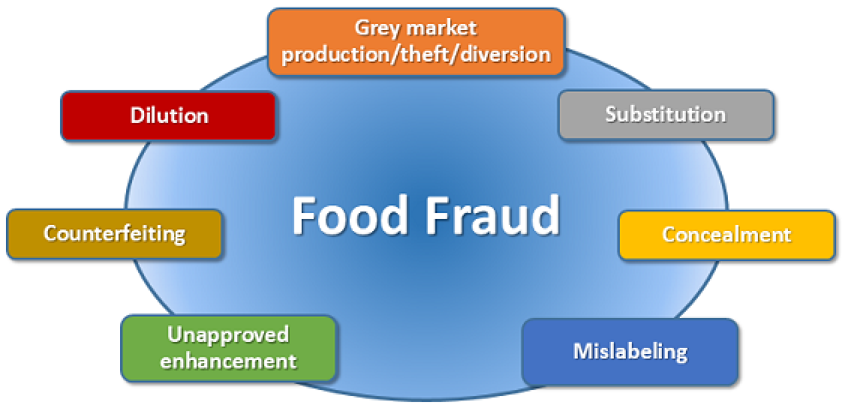
Fig. 6.1. Types of food fraud (Food Fraud | Knowledge for policy (europa.eu))
Dilution - mixing a liquid ingredient of high value with a liquid of lower value.
Substitution - replacing an ingredient, or part of the product, of high value with another ingredient, or part of the product of lower value.
Concealment - hiding the low quality of food ingredients or product.
Mislabelling - placing false claim on packaging for economic gain.
Unapproved enhancement - adding unknown and undeclared materials to food products to enhance the quality attributes.
Counterfeiting - copying the brand name, packaging concept, recipe, processing method, etc. of food products for economic gain.
Grey market production/theft/diversion - sale of excess unreported product.
Products of Plant Origin: Cultivar and Variety Identification
Certain food and feed products may possibly originate from different botanical origin, which influences their applicability in food and feed. For example, dried distillers grains with solubles, which are a by-product from the bioethanol production and mainly used in animal feed, can originate from different cereals, such as maize and wheat. The large variation in the composition can contribute to imbalanced feed formulations.

Products of Animal Origin: Species Identification
Authenticity investigations revealed that in certain countries in 15–39% of the meat products, such as hamburgers and sausages, animal species were not declared on the label. Also, more expensive, more authentic meat can be (partly) substituted with cheaper, less authentic meat tissues or species. For example, different cuts of beef that were interchanged can be analytically distinguished. The horsemeat scandal is a more recent example where beef was (partially) substituted with horsemeat for economic gain.
Food adulteration
An adulterant is a chemical substance, which should not be contained within other substances (e.g. food, beverages) for legal or other reasons. The addition of adulterants is called adulteration.
Adulterated food, according to the Food Code, is food, in which the appearance, taste, composition, or other characters are changed and its quality decreased, but is offered to the consumer as the usual food under a common name or by other false name.
Food is considered adulterated when the food article:
- consists of any filthy, putrid, decomposed or diseased animal or vegetable material;
- is insect infested or unfit for human consumption;
- is prepared, packed or stored under unsanitary conditions;
- contains any poisonous ingredients; has been substituted by any inferior or cheaper substance;
- is packed in a container of any poisonous or deleterious substance;
- has any unpermitted additive or has a permitted additive present in an amount exceeding the prescribed limit.
Notable incidents of adulteration
- In 1987, Beech Nut paid $2.2 million in fines for violating the Federal Food, Drug, and Cosmetic Act by selling artificially flavoured sugar water as apple juice.
- In 1997, ConAgra Foods pled guilty to federal criminal charges that one of its units illegally sprayed water on stored grain to increase its weight and value.
- In 2007, samples of wheat gluten mixed with melamine, presumably to produce artificially inflated results from common tests for protein content, were discovered in many U.S. pet food brands, as well as in human food supply.
- In 2008, significant portions of China's milk supply were found to have been contaminated with melamine. Infant formula produced from melamine-tainted milk killed at least six children and were believed to have harmed thousands of others.
- In 2012, a study in India conducted by the Food Safety Standards Authority of India (FSSAI) across 33 states found that milk in India is adulterated with detergent, fat and even urea, as well diluted with water. Of the 1791 random samples from 33 states, just 31.5% of the samples tested (565) conformed to the FSSAI standards while the rest 1226 (68.4%) failed the test.

Categories of adulteration
- Replacement:
Complete or partial replacement of a food ingredient or a valuable authentic constituent with a less expensive substitute with the intention of circumventing the “origin” and false declaration of the “process”.
- Addition:
Addition of small amounts of non-authenticated substances to mask inferior quality ingredient.
- Removal:
Removal of authentic and valuable constituent without the purchaser’s knowledge.
Reasons of adulteration
When the supply is less than the demand.
To cut down the product costs to meet the market competition.
To earn more profit.
Shortage of authentic ingredients at affordable prices.
Shortage of qualified personnel and lack of modernisation of processing techniques.
Inadequate knowledge of the consequences and associated food safety risks.

Methods for food authentication and adulteration

Chromatographic techniques
Despite their complexity, chromatographic techniques are among the most important methods used in food authentication and adulteration. These techniques are usually classified according to the character of the stationary and the mobile phases, the form of the stationary phase, and the driving forces of separation. Gas chromatography (GC) and high-performance liquid chromatography (HPLC) are the most used techniques.
Spectroscopic techniques
Spectroscopic techniques such as UV-Vis spectrometry, fluorescence, infrared, EN, NMR and stable isotope analysis are widely used in food authentication. These powerful methods, and the computer technology necessary to use them, have only become readily available in recent years, but their use has become a significant feature for the above mentioned techniques.
Enzymes in food authentication
Enzymes are essential constituents of living organisms and are responsible for postharvest and post-mortem changes in foods.
In food products, enzymes have been used in several applications following the release of specific compounds that could characterise the quality of the product. The most relevant examples of enzymes application involved the: (1) determination of the position partition of fatty acids in triglycerides by pancreatic lipase; (2) establishment of the heat treatment intensity used in dairy products by alkaline phosphatase and peroxidase; and (3) quantification of several components in various food products.
DNA-based methods in food authentication
DNA based methods are of increasing importance for the determination of the quality of food products. The polymerase chain reaction (PCR) has been used for the: authentication of meat products, medicinal plant species, fruit juices , milk species in cheeses, and authentication of olive oil; meat species identification; and differentiation of fish species.
Differential scanning calorimetry
Differential scanning calorimetry (DSC) is a thermoanalytical technique in which the difference in the amount of heat required to increase the temperature of a sample and reference is measured as a function of temperature.

Practical work

Food authentication methods – food authenticity databases
Work with authenticity databases (Authenticity databases - FoodAuthenticity document library)
Students will find the most often adulterated food in year 2023 – Students will find 10 adulterated food, they will write authentication method.
Table 6.1. Methods of food adulteration and authenticity
Product | Adulteration | Method

Conclusion

Approved by _________________________________________
Name, surname, signature

Date _________________________________________

Theme 7

Chemical safety
Theoretical materials
Chemical substances play an important role in food production and distribution. As food additives, they prolong the shelf life of foods and, as colours and flavourings, they may make foods more attractive. Other chemicals are pharmacologically active and therefore used to fight diseases in farm animals and on crops.
Many raw food materials contain chemicals, which, if consumed in excess, might lead to health problems. Cooking and processing in general can remove or inactivate many chemicals (e.g. protease inhibitors, lectins) that are either directly toxic or inhibit digestion or absorption of nutrients. However, some chemicals have arisen as problems associated with food processing techniques developed in the last 100 years or so, e.g. trans fatty acids resulting from chemical hydrogenation of unsaturated fats, or 3–monochloropropanediol from the chemical hydrolysis of proteins. One recently publicised example of a process-derived chemical hazard in food is the formation of acrylamide in baked products.
Other hazards are contaminants introduced by accident during the production of the raw food materials - sometimes these are unavoidable and sometimes they are, to a greater or lesser extent, caused by poor growing, post-harvest or processing conditions. Mycotoxins produced by moulds on grain or nut products are one example; nitrate accumulation in leafy vegetables, and heavy metal accumulation in seafood are others.
Chemical hazards can be divided into five broad categories:
Inherent ('Natural') toxins
Natural and environmental contaminants
Process and storage-derived contaminants
Deliberately added contaminants
Pesticides and veterinary residues
Natural toxins
These chemicals occur as regular constituents of the food in question (e.g. lectins in kidney beans), or at increased levels as a response of the foodstuff to some sort of stress (e.g. glycoalkaloids in potatoes, an increased production of which can be stimulated when the tuber is exposed to light), and are inherent to the food raw material. There are also some instances of a processing regime potentially releasing a toxin from a nontoxic starting material (as occurs with cyanogenic glycosides in some canned stone fruit).
Lectins
Lectins occur in a wide variety of plants including beans of the Phaseolus genus (e.g. kidney beans and lima beans), broad beans, castor beans, soya beans, lentils, peas, field beans, peanuts, potatoes and cereals, as well as a range of non-food plants.
Raw kidney beans are significantly toxic due to the presence of lectins and must be cooked adequately before consumption.
Glycoalkaloids
Potato glycoalkaloids are a good example of naturally occurring toxins that can and have caused problems when consumed in large quantities, but which we have learned to avoid without too much difficulty.
Oxalates
Oxalic acid and oxalates are widely distributed in plant foods, with the highest levels being found in spinach (0.3-1.2%), rhubarb (0.2-1.3%), tea (0.3-2.0%) and cocoa (0.5-0.9%). Although there is no question that the ingestion of sufficient oxalic acid as crystals or in solution can be fatal, there is considerable debate as to whether serious food poisoning from oxalate is usually due to food.
Natural and Environmental Contaminants
All plants and animals during their lifetime will accumulate various chemicals from their environment. Some of these chemicals, if they are accumulated at high enough levels, might be of toxicological significance to us when we eat the food. Specific examples that are of concern are nitrates in leafy vegetables, heavy metals in various foods, and specific toxins in shellfish. In many cases, the best way to control levels of these unwanted substances is to control the environment in which the food is produced. However, this is generally a long-term control measure and more immediate steps have to be taken to protect human health. These contaminants are divided below into 'natural' (of biological origin) and 'environmental', but they are linked in that the food plant or animal acquires them from its surroundings during its growth.
'Natural' Contaminants
Mycotoxins
Mycotoxins are a group of chemically diverse and naturally occurring substances produced by a range of filamentous fungi or moulds. They have toxic effects on both humans and animals ranging from acute toxicity and death, through reduced egg and milk production, lack of weight gain, impairment or suppression of immune function to tumour formation, cancers and other chronic diseases. The mycotoxins of greatest concern are produced by mould species from three main genera - Aspergillus, Penicillium and Fusarium.

Aflatoxins
Aflatoxins are produced mainly by some strains of Aspergillus flavus and most, if not all, strains of A. parasiticus. There are four main aflatoxins, B1, B2, G1 and G2, plus two additional ones that are significant, M1 and M2. The aflatoxins are potent liver toxins in most animals and carcinogens in some, with aflatoxin B1 being the most toxic and carcinogenic. Mould growth and aflatoxin production are greatest in warm temperatures and high humidity, particularly in tropical and sub-tropical regions, mainly on corn (maize), peanuts, cottonseed and tree nuts.
Ochratoxins
Ochratoxins are a group of related compounds produced by Aspergillus ochraceus and related species, as well as Penicillium verrucosum. The main toxin in the group is Ochratoxin A, which causes liver damage in rats, dogs and pigs. Ochratoxins are also teratogenic to mice, rats and chicken embryos, and are now thought to be carcinogenic in humans.
Patulin
Patulin is produced by numerous Penicillium and Aspergillu species and by Byssochlamys nivea. However, the most common producer of patulin is Penicillium expansum, which occurs commonly in rotting apples, as a result of which patulin has frequently been found in commercial apple juice. Patulin is toxic to many biological systems, including bacteria, mammalian cell cultures, higher plants and animals. Its role in causing animal and human disease is unclear, but it is believed to be carcinogenic.
Cyclopiazonic acid (CPA)
Cyclopiazonic acid (CPA) is produced by several moulds which occur on agricultural products or are used in some food fermentations. It also occurs naturally in infected corn (maize) and peanuts. It affects rats, dogs, pigs and chickens, where it may cause anorexia, weight loss, diarrhoea, pyrexia, dehydration and other symptoms. Organs affected include liver, spleen, kidneys, and pancreas. It has the ability to chelate metal ions such as calcium, magnesium and iron, which may be an important mechanism of toxicity.
Zearalenone
Zearalenone (also known as F-2 toxin) is produced by several Fusarium species. It occurs naturally in high moisture corn (maize) in late autumn and winter, mainly from the growth of F. culmorum in Northern Europe and F. graminearum in North America. Production of this and other Fusarium toxins is favoured by high humidity and low temperatures, conditions which often occur in temperate regions during the autumn harvest. It has been found in mouldy hay, high-moisture corn (maize), corn infected before harvest and pelleted feed rations, so it is an important contaminant of animal feed. The involvement of zearalenone in human disease is unconfirmed, but it is regarded as an endocrine disruptor and hence a potential hazard.

Tricothecenes
The tricothecenes are a group of over 20 chemically related toxins produced by several Fusarium species. These include deoxynivalenol (DON), T-2 toxin, diacetoxyscirpenal, neosolaniol, nivalenol, diacetylnivalenol, HT2 toxin and fusarenon X. The most commonly occurring of these is deoxynivalenol or DON, which causes vomiting in animals, hence its other name of vomitoxin. It may also be a teratogen and has been found in commodities such as corn (maize) and wheat as well as some processed food products.
Fumonisins
The fumonisins are a group of compounds mainly produced by Fusarium moniliforme and F. proliferatum. They have been linked to several diseases, including liver cancer and oesophageal cancer in humans.
Moniliformin
Moniliformin is so called because it was first thought to be produced by F. moniliforme isolated from corn (maize). However, it has since been shown to be produced mainly by other species of Fusarium. It has been shown to be highly toxic in experimental animals, causing rapid death without severe cellular damage.
Shellfish toxins
There are several types of shellfish poisoning including neurotoxic (NSP), diarrhoeic (DSP), paralytic (PSP), amnesic (ASP), and ciguaterra fish poisoning (CFP). Shellfish toxins are not produced by the shellfish themselves, but are accumulated through the ingestion of planktonic dinoflagellates in the diet of the shellfish. The term shellfish generally refers to both marine crustaceans (lobsters, crab, shrimp etc.), and molluscs.
'Environmental' contaminants
Dioxins/Polychlorinated biphenyls (PCBs)
PCBs and dioxins are persistent contaminants with a wide range of chemical structures. They have been found in soil, water, sediment, plants and animal tissue in all parts of the world. Dioxins and PCBs are heterocyclic organic molecules, with PCBs being chlorinated. They have long half-lives in the environment and many have been reported to have toxicological effects in humans. PCBs and dioxins are man-made chemicals used by industry and their release to the environment is generally through by-products of fires and by some manufacturing processes.
Polycyclic aromatic hydrocarbons
Polycyclic aromatic hydrocarbons (PAHs) are a group of compounds comprising two or more fused aromatic rings. Many individual PAHs exist, the most simple of which is naphthalene. A variety of toxic properties have been related to PAH exposure, including the capacity to produce genotoxic and carcinogenic effects in mammals.

Heavy metals
Heavy metals are those with a high atomic mass, including, for example, mercury, cadmium, arsenic and lead, although other metals (e.g. tin) may also be included within this category of contaminant. They are natural components which originate from the earth's crust and are found all over the world. They are toxic in low amounts and have been recognised as a health hazard for many years. There are other routes for metal contamination of products such as migration from packaging (e.g. antimony from plastic bottles, and tin in canned food).
Process-derived contaminants
The production of toxic chemicals in foodstuffs through processing is a recently discovered phenomenon, although historically these chemicals will have always been present. The first three examples below serve to show how unexpected contaminants may arise. In addition, the contamination of food with chemicals from packaging, pesticide and veterinary medicine applications could also loosely be described as process-derived.
Deliberately added contaminants
There is no limit to what chemical contaminants might be deliberately added to foods during manufacture in order to cause harm to the consumer. In most cases, however, the aim is not to cause harm, but to defraud for financial gain. However, potential harm can still result, as evidenced from two of the examples given below.
Illegal or unauthorised dyes
The Sudan I-IV group of chemicals are synthetic azo dyes which have been historically used in industry to colour products such as shoe polish, automotive paints and petroleum derivatives. They are not permitted food colours.
Melamine
Melamine is an industrial chemical found in plastics. It can be combined with formaldehyde to produce melamine resin, a very durable thermosetting plastic used in Formica, and melamine foam, a polymeric cleaning product. The end products include countertops, dry erase boards, fabrics, glues, housewares, guitar saddles, guitar nuts, and flame retardants. Melamine is one of the major components in Pigment Yellow 150, a colourant in inks and plastics. It is also used in the manufacture of plasticisers for concrete.
Pesticides and veterinary residues
Pesticides
Pesticides include chemical and biological products specifically designed to control pests, weeds and diseases, particularly in the production of food. These include insecticides, fungicides, herbicides, rodenticides and molluscicides.
Pesticides are licensed for use against specific target organisms, and their use and application are strictly regulated to control the risks to the operator involved in applying them, and the surrounding environment, and to prevent significant residues being left in or on the food.
Pesticides can be classified by target organism, chemical structure, and physical state. They can be classed as inorganic, synthetic, or biological (biopesticides). Biopesticides include microbial pesticides and biochemical pesticides. Plant-derived pesticides include the pyrethroids, rotenoids, and nicotinoids.
Veterinary residues
The use of medicines used to treat animals raised for food is regulated in a similar manner to that for pesticides used on food crops. There are a wide variety of chemicals for different uses, including:
- Antimicrobials such as sulphadiazine, enrofloxacin, ciprofloxacin, chlortetracycline, amoxicillin and oxytetracycline used to control bacterial diseases.
- Painkillers and anti-inflammatory medicines such as NSAIDs, including ibuprofen and phenylbutazone.
- Dips to control external parasites, including organochlorine or organophosphorus insecticides (see above).
- Wormers to control internal parasites, such as ivermectin.
- Coccidiostats to control protozoal diseases, particularly in poultry, such as nicarbazin.
- Steroids such as boldenone.
Food contact materials (FCMs)
FCMs can be defined as materials that come into contact with food and beverages during food processing, packaging, transport, storage, cooking, or serving. Different types of FCMs, for example, plastics, paper, glass, metal, adhesives, or printing inks, can be used, solely or in combination, to produce food contact articles (FCAs). A typical FCA is food packaging, such as bottles or wraps. However, food service items (e.g. cutlery) as well as food processing equipment (e.g., conveyor belts) or transport vessels also constitute a significant proportion of FCAs overall.
FCMs and, consequently, FCAs, are made of and contain diverse chemical constituents, which can be both intentionally used and non-intentionally present, here collectively referred to as food contact chemicals (FCCs). Under certain conditions, FCCs can be transferred into food, a phenomenon called migration.
FCCs can be divided into two groups, intentionally added substances (IASs), i.e. substances that are deliberately used to manufacture FCMs or FCAs, and non-intentionally added substances (NIASs), i.e. substances that have not been added on purpose and do not perform any technical function, but are nonetheless present in the final FCMs or FCAs. NIASs can include impurities, contaminants, reaction by-products and side products, and degradation products.

Theme 8 Food labelling
Theoretical materials
The Food Labelling Information System
The Food Labelling Information System provides a user friendly IT solution which enables its users to select the food and automatically retrieve the mandatory EU labelling indications in 23 EU languages.
EU law on food information to consumers
Regulation (EU) No 1169/2011 on the provision of food information to consumers (FIC Regulation) entered into application on 13 December 2014. The obligation to provide nutrition information applies since 13 December 2016.
This regulation provides in particular clearer and harmonised presentation of allergens (e.g. soya, nuts, gluten, and lactose) for prepacked foods (emphasis by font, style or background colour) in the list of ingredients and mandatory allergen information for non-prepacked foods, including in restaurants and cafes. It also foresees certain nutrition information for the majority of prepacked processed foods, the mandatory origin information for fresh meat from pigs, sheep, goats and poultry and the same labelling requirements for online, distance selling or buying in a shop.
Revision of the regulation on food information to consumers
As part of the Farm-to-Fork Strategy, the European Commission announced to revise EU rules on the information provided to consumers. The aim of revising the FIC Regulation is to ensure better labelling information to help consumers make healthier and more sustainable food choices and tackle food waste, by proposing to:
- introduce harmonised mandatory front-of-pack nutrition labelling and set nutrient profiling criteria to restrict claims made on foods;
- extend mandatory origin or provenance information for certain products;
- revise the rules on date marking (‘use by’ and ‘best before’ dates)
Food supplements
As an addition to a normal diet, food business operators market food supplements, which are concentrated sources of nutrients (or other substances) with a nutritional or physiological effect. Such food supplements can be marketed in “dose” form, such as pills, tablets, capsules, liquids in measured doses, etc.
The objective of the harmonised rules on those products in Directive 2002/46/EC is to protect consumers against potential health risks from those products and to ensure that they are not provided with misleading information.
With respect to the safety of food supplements, the Directive lays down a harmonised list of vitamins and minerals that may be added for nutritional purposes in food supplements (in Annex I to the Directive). Annex II of the Directive contains a list of permitted sources (vitamin and mineral substances) from which those vitamins and minerals may be manufactured.
Levels of vitamins and minerals in food supplements
Directive 2002/46/EC on food supplements envisages the setting of the maximum and minimum amounts of vitamins and minerals in supplements via the Standing Committee on Plants, Animals, Food and Feed (PAFF Committee) procedure.

Practical work

Labelling - food labelling information system
Students will work with PC.
Students will work with Food Labelling Information System, they will choose the food category and they will write: name of food, the list of ingredients, the date of minimum durability and special storage conditions.
Work with Food Labelling Information System: Food Labelling Information System (europa.eu).
Table 8.1. Food labelling
Food category | Name of food | List of ingedients | Minimum durability | Storage conditions

Conclusion

Approved by _________________________________________
Name, surname, signature

Date _________________________________________

Theme 9

Novel food
Theoretical materials
Novel food is defined as food that was not consumed to any significant degree in the EU before 15 May 1997 when the first novel food legislation entered into force. Novel food can be newly developed, innovative food or food produced using new technologies and production processes, as well as food traditionally eaten outside of the EU.
Request for a novel food authorisation
Application procedure
Food business operators can place a novel food on the European Union market only after the Commission has processed an application for the authorisation of a novel food, and has adopted an implementing act authorising the placing on the market of a novel food and updating the Union list.
Implementing Regulation (EU) 2017/2469 has also been adjusted by Commission Implementing Regulation (EU) 2020/1772 to accommodate those changes. These new provisions are applicable to applications submitted from 27 March 2021.
If the novel food is liable to have an effect on human health, the Commission will request the European Food Safety Authority (EFSA) to carry out a risk assessment.
EFSA will adopt its opinion in 9 months from the date of receipt of a valid application from the Commission.
Within the seven months from the date of the publication of the EFSA's opinion, the Commission shall submit to the Standing Committee on Plants, Animals, Food and Feed a draft implementing act authorising the placing on the market of a novel food and updating the Union list.
Once the act receives a favourable vote from the Standing Committee and is adopted and published by the Commission, the novel food can be lawfully placed on the European Union market.

The authorisation covers:
The authorisation and entry for a novel food in the Union list includes, where appropriate:
- Specifications,
- Conditions of use,
- Additional specific labelling requirements,
- Post-market monitoring requirements.
Nanomaterials in food
The term ‘nano’ (from the Greek word for ‘dwarf’) is the term use to describe those materials that have at least one external dimension that measures 100 nanometers (1 nanometer = 1 billionth of a meter). As an example, a human hair has approximately between 80 000 and 100 000 nanometers (nm.).
Nanomaterial - “any intentionally produced material that has one or more dimensions of the order of 100 nm or less or that is composed of discrete functional parts, either internally or at the surface, many of which have one or more dimensions of the order of 100 nm or less, including structures, agglomerates or aggregates, which may have a size above the order of 100 nm but retain properties that are characteristic of the nanoscale”.
The fact that nanomaterials may exhibit different characteristics than their non-nano conventional forms may also be indicative of different behaviour in biological systems leading to different hazard profiles and resulting risks for human health and the environment.
The Novel Food nanomaterial definition is similar to the general definition of Commission Recommendation C(2022)3689 but mainly differs in that:
- it specifically refers to and defines ‘engineered nanomaterials’;
- it does not include a percentage threshold for the content in particles of less than 100 nm above which materials are to be classified as nanomaterials. Moreover, Commission Recommendation C(2022)3689 sets that threshold at 50% of the total particles in a given material to have one or more dimension below 100 nm for the material to be classified as a nanomaterial.
Properties that are characteristic of the nanoscale (dimensions measured in nanometres) include:
- those related to the large specific surface area of the materials considered; and/or
- specific physico-chemical properties that are different from those of the non-nanoform of the same material.

Practical work

Novel Food status Catalogue
Work with novel food catalogue (Food and Feed Information Portal Database | FIP (europa.eu))
Searching for novel foods in the catalogue.
Students will work with novel food catalogue - they will look for new foods or food ingredients and characterize them.

Conclusion

Approved by _________________________________________
Name, surname, signature

Date _________________________________________

Theme 10

Sanitation in food industry
Theoretical materials
Definitions
CLEANING: The removal of soil particles from surfaces by mechanical, manual or chemical methods.
SANITISING: The treatment of a cleaned surface with a chemical or physical agent to destroy disease/spoilage causing organisms. Reduces the total vegetative cell population to a safe level.
DISINFECTING: Destruction of all vegetative state organisms.
STERILISING: The complete destruction of all organisms, including spores.
DIRTY: A surface that is not clean.
Sanitation practices in food operating
There are a number of precautions that must be taken before production, during production and at the end of production in order to destroy physical, chemical and biological damages in food. These precautions must be carry out during manufacturing, otherwise hygienic product can't be achievement.
Sanitation before production
There is a need for a structure which is free from physical, chemical and biological pollution sources, with hygienic production conditions and has a suitable technological infrastructure in order to produce reliable and quality food. Before the manufacturing process gets started, all materials which are used for in the manufacturing process and the manufacturing yard must be cleaned periodically.
All "food contact surface areas" including the floor in the environment where food is processed, the processing channels, the walls, all kinds of tools, machinery and equipment that come into contact with foodstuffs must be thoroughly cleaned regularly before the start of each work day to protect food from contamination. The cleanliness of the ambient air should also be controlled in the workplace where microbiological contamination is important.
Equipment that does not have a contact surface with food should also be cleaned periodically. Raw and heat-treated products must be prepared in separate rooms or on benches.
Precautions to be taken during the production
If foodstuffs are not processed using appropriate methods and techniques, the following situations can arise:
● Taste, colour, consistency and appearance become undesirable.
● The nutritional value is lost.
● The hygiene quality is lost. It is a condition that can cause health problems and food poisoning.
● It causes the producer to lose market share and reputation.
Preventive measures should be taken to prevent contamination of foodstuffs in the food processing area. For this purpose, protective clothing should be provided and kept for the visitors who should comply with all rules laid down for employees.
Precautions to be taken after the production
Cleaning is the prevention of tools, equipment and various surface dirt and food debris that come into contact with food and turn them into growth area for microorganisms. Cleaning is the reduction of visible dirt and debris as well as all of the invisible microorganisms to the point where they are not killed or harmful.
All materials which are being used during manufacturing process must be cleaned and disinfected periodically to make sure there is no any particular nor microorganism from the last process for purifying new product from the source of dirtiness. For this purpose, a control chart should be prepared at the end of the work in the field of production, these prepared schedules and forms should be filled in by the relevant persons and checked by supervisors.
Elements of cleaning and sanitising
There are many different ways to clean and sanitise equipment. These include the use of clean-in-place (CIP) systems, foaming, clean-out-of-place (COP), spraying, high pressure and manual systems. No matter which kind of cleaning and sanitising is selected, there are basic issues that must be considered.
These are summarised using the acronym TACT WINS.

T – Time  A – Action  C – Concentration  T – Temperature | W – Water  I – Individual  N – Nature  S – Surface
Time: The time required to properly clean depends on many factors including, but not limited to, the method of cleaning, the dirt and the type of equipment.

Action: This is the energy required to properly clean a surface. Action brings the cleaning compounds into contact with the dirt and enhances their removal.

Concentration: To properly clean surfaces, the processor must use the correct cleaning compound at the proper concentration. What is needed depends upon factors such as the nature of the soil, water hardness and the surface being cleaned.

Temperature: The temperature at which detergents are used affects their efficacy. Each cleaner has an optimum temperature range at which it should be used.

Water: Water is the universal solvent. The first step in cleaning is to rinse with water in order to remove gross dirt from the surface and away from the equipment. Water is also used to carry the detergents on to the surface and to carry away the soil.

Individual: Who will do the cleaning? Each person assigned to cleaning must be properly trained on each and every cleaning procedure that they will be conducting.

Nature: What products are being manufactured in each plant will determine the kind of dirt that must be removed. There are five basic kinds of soils the food industry must deal with: fats/grease, proteins, minerals, sugars and complex carbohydrates.

Surface: What is the equipment that is being cleaned made of? The most common material is stainless steel, but one sees plastics in various shapes and forms, rubber, and other metals.

Theme 11

Disinfection methods
Theoretical materials
The aim of disinfection is therefore to further reduce the surface population of viable microorganisms, by the removal or destruction, and/or to prevent surface microbial growth during the inter-production period.
Whilst there are many chemicals with biocidal properties, some common disinfectants are not used in food applications because of safety or taint problems, e.g. phenolics or metal-ion-based products. In addition, other disinfectants are used to a limited extent only in chilled food manufacture and/or for specific purposes, e.g. peracetic acid, biguanides, formaldehyde, glutaraldehyde, organic acids, ozone, chlorine dioxide, bromine and iodine compounds.
Of the acceptable chemicals, therefore, the most commonly used products for open and closed surface disinfection are:
  - chlorine-releasing components;
  - quaternary ammonium compounds (QACs);
  - amphoteric compounds;
  - alcohols;
  - peracetic acid.
Chlorine is the cheapest disinfectant and is available as hypochlorite (or occasionally as chlorine gas) or in slow-release forms (e.g. chloramines, dichlorodimethylhydantoin). Hypochlorous acid, the disinfectant active, is produced when all of these chlorine sources are added to water.
Hypochlorous acid has a wide range of activity, including against spores, and is relatively inexpensive. However, it is readily inactivated by organic matter, and may be viewed by some as having an adverse effect on the environment. Chlorine compounds in the undiluted form are corrosive to equipment, can be hazardous to health and should always be handled with care and at the correct concentrations.
QACs (or Quats) are amphipolar, cationic detergents, derived from substituted ammonium salts with a chlorine or bromine anion. Although having little effect on spores, they are both relatively environmentally and operative friendly. It should be noted that certain alkaline compounds (anionic wetting agents) can reduce the bactericidal action of QACs.
Amphoterics are based on the amino acid glycine, often incorporating an imidazole group. They share similar activities and benefits with the quaternary ammonium compounds. Amphoterics are known to have good detergent/sterilising properties. They are used for manual cleaning, since they are non-corrosive and non-irritant to skin.
Alcohols are most active in the 60–70% range, rapidly lose effectiveness if diluted out of this range, and can be formulated into wipe and spray-based products. Alcohol products are used on a small, local scale because of their well-recognised health and safety issues.
Peracetic acid, which provides a rapid, broad-spectrum kill, works on the oxidation principle through the reaction with the components of cell membranes. It is particularly effective against spores. It is one of a family of acid disinfectants which are considered to be toxicologically safe and biologically active.
Physical methods of dry sanitation
Dry saturated steam (DSS), superheated steam (SHS), and hot air are examples of dry sanitisation methods. Usually, DSS with moisture content <5.0% at ≤100°C is applied until 85 °C for at least 1 minute, while SHS uses temperatures above the steam saturation point at atmosphere pressure. In fact, longer exposure time may be necessary to sanitise large areas/equipment using dry heat, for example, 170 °C/60 minutes or 150°C/150 minutes. The mechanism of action involves the denaturation of proteins, oxidative damage to free radicals, and dehydration of microbial cells.
Ultraviolet light
UV light is a nonionising radiation with a wavelength (ƛ) shorter than visible light. The range is subdivided into UV-A (315–400 nm), UV-B (280–315 nm), and UV-C (100–280 nm). The most important criterion of UV sanitisation is the total radiation received by the contact surface during treatment, known as the fluence (J/m²). The mechanism of action involves photothermal impact caused by heating of the surface by the absorption of UV energy and the photochemical effect from the absorption of UV light by the pyrimidine and purine bases of the nucleic acid and nucleoprotein. UV-C light (254 nm) has been widely used in the food industry for water, air, and surface sanitisation.
Pulsed light
This technology consists of a sequence of white light pulses (200–1100 nm) with a broad and extremely short spectrum and with high energy, containing approximately 54% of UV (200–400 nm), 20% infrared, and 26% of visible light radiation, which is produced by pulses of xenon lamps. Its mechanism of action is close to that of UV light; it reaches the DNA of micro-organisms and inactivates the repair system, leading to irreversible damage and death. The effectiveness of PL depends on various factors, including the type of micro-organism, the light matrix, the pulse frequency, the distance between the light source and the target, and the arrangement of the PL system.

Practical work

Examples of disinfection. Choosing the appropriate disinfectant

Write 5 chemical disinfectants, give advantages disadvantages and applications
Table 11.1.
Characterisation of selected disinfectants
Disinfectant | Advantages | Disadvantages | Application

Conclusions

Approved by _________________________________________
Name, surname, signature

Date _________________________________________

Theme 12 Sanitation program
Theoretical materials
An effective cleaning and sanitation program prevents contamination of a food from the hazards that can be present on equipment, food contact surfaces, and in the general premises by:
- reducing biological hazards such as pathogenic microorganisms,
- removing physical hazards like glass, plastic or metal,
- removing chemical hazards such as allergens and chemicals used for sanitising and maintenance of the equipment.
Taking steps to reduce the presence of microorganisms also prevents contamination of a food with spoilage microorganisms. This can result in a food of higher quality and a longer shelf life.
The methods of cleaning and sanitation depend on the size and complexity of the food business.
Roles and responsibilities
Food businesses are responsible for complying with the law. They demonstrate compliance by ensuring that the commodities and processes for which they are responsible meet regulatory requirements. If a written Preventive Control Plan (PCP) is required, the food business develops a PCP with supporting documents, monitors and maintains evidence of its implementation, and verifies that all control measures are effective.
Cleaning and sanitation program
There are three steps used in the development of a Cleaning and Sanitation Programme:
- Gather key information
  - this includes: who, where, what, when and how to clean and sanitise. Because this information will form the basis of the Cleaning and Sanitation Programme, the more detailed the information, the more effective the program will be.
- Develop templates for records
  - when completed, these records provide evidence that the cleaning and sanitising activities have been completed and are effective.
Step 1. Gather key information needed to develop the Cleaning and sanitation programme
- What method of cleaning and sanitising is required? For example:
  - for clean-in-place (CIP), equipment is cleaned by an accepted in-line CIP system,
  - for clean-out-of-place (COP), equipment is disassembled for hand cleaning,
  - dry-cleaning, where no water or liquids are used, procedures involve activities such as vacuuming.
- Are special equipment or utensils needed to clean and sanitise? If so, how are they to be used?
- Will gloves, safety goggles, aprons or other personal protective equipment be worn? Are there other protective measures to be taken in to prevent food or food contact surface contamination?
- What are the procedures for taking equipment apart for cleaning and sanitising as well as re-assembling it after cleaning and sanitising? Identify any parts that will require special attention.
- What measures will be taken to protect food or packaging materials from contamination during cleaning and sanitising activities? Is cleaning done during or post processing?
- What types of materials (for example, fat, protein, sugar stone, mineral deposits) will have to be removed from equipment surfaces during cleaning and sanitising activities?

Who?
- Identify all persons or positions that will be responsible for cleaning and sanitising activities.

Where?
- Identify each room or area required to be cleaned and sanitised.

What?
- For the rooms or areas to be cleaned and sanitised, specify:
  - The type and concentration of cleaning compounds and sanitisers and cleaning tools used,
  - All equipment, including utensils, structures and surfaces such as food contact surfaces, walls, floors, drains, ceilings and overhead assemblies to be cleaned and sanitised.

When?
- Choose the frequency of cleaning and sanitising based on the risk of contamination of the food, area, room, type of equipment, food contact surfaces and structures. For instance, will cleaning and sanitising be done daily, weekly, monthly, yearly, or at another frequency?
- If cleaning and sanitation is taking place during production, specify at what point during the production and what precautions are in place to prevent contamination of food.

How?
- Provide step-by-step details on how the cleaning and sanitising is to be performed.
- Identify procedures to be followed to make sure the activities are conducted in a manner so that food or food contact surfaces are not contaminated.
- Identify any general housekeeping, such as sweeping and tidying up that will help in maintaining the establishment, facilities, equipment and conveyances in a clean and sanitary condition.
Include any special instructions required in the cleaning and sanitation process, for example:
- set up instructions for CIP systems, for example, moving piping lines or opening and closing certain valves,
- pre-rinse instructions,
- cleaning and sanitising chemicals to be used and their rotation,
- chemical mixing and handling instructions,
- appropriate chemical concentrations as per product labels,
- temperature of water or cleaning solutions,
- solution pressures,
- surface contact time…

Evidence of effectiveness
Next obtain evidence that the cleaning and sanitising procedures conducted are effective.

Step 2. Develop templates for records
Cleaning and sanitising activities should be recorded on a standardised form that indicates:
- who is responsible for the cleaning and sanitising,
- cleaning and sanitising activities that have to be completed,
- chemicals used, solution temperatures, chemical concentrations,
- date and time,
- verification that activities have been satisfactorily completed.

Step 3. Implement the cleaning and sanitation programme
Once the Cleaning and Sanitation Programme has been determined to be effective and the people who will be doing the cleaning and sanitising have been trained to perform their assigned duties, the sanitation programme is now ready to be put into action.

Practical work

Preparing of Sanitation program
Prepare a cleaning and sanitation programme for food service facilities.

Table 12.1.
List of all cleaning and sanitising agents instructions for mixing
Cleaning or Sanitising Agent and Concentration | Instructions for mixing
Table 12.2.
Cleaning and sanitizing requirements
Item/Area to be Cleaned/Sanitised | Procedure and Concentration Used | Frequency
Table 12.3.
List of pest control measures/pesticides in use
Name Pest Control Measure/ Pesticide | Intended Use | Storage Requirements

Table 12.4.
Cleaning schedule
Cleaning schedule
AREA | Daily | Weekly | Monthly | Annual | Other (specify)
Kitchen
Walls / Ceiling
Storage Areas
Staff Washrooms
Work Surfaces
Floor
Equipment
Walk-in Cooler/Freezer
Inside Fridges/Freezers
Grill/Fume Hood
Under/Behind Equipment
Dishwasher
Miscellaneous
Cutting Boards
Meat Slicers
Microwaves
Garbage Cans
Laundry
Mixers
Dining area
Walls/Ceiling Public
Tables/Chairs
Servers Station
Washroom

Theme 13

Microbial biofilms in food industry
Theoretical materials
Biofilm refers to microorganisms of complex, sessile communities seen affixed to a surface or fixed firmly in an extracellular matrix aggregates. They are a microbial mass on the interfaces, and they remain as microbial contamination origin in medical field and other industries, especially in food processing industry.
Biofilm formation/development
Biofilm is an assemblage of cells of microorganisms, usually embedded in a matrix of bacterial self-produced extracellular polymeric substances (EPSs), which is permanently connected with a surface.
(1) Planktonic microorganisms are initially approaching a surface in an aqueous medium for attachment (Donlan, 2002);
(2) permanent sticking based on the generation of microorganism-mediated EPSs, as polyhydroxy groups in EPSs colonise bacteria to the surface via hydrogen bonding (Kjelleberg et al., 2007);
(3) monolayer microcolonies formation on the surfaces that are fixed as a result of replication by initial colonisers (Guzmán-Soto et al., 2021) and advancement of the biofilm into a three-dimensional disposition by affixing debris from the environment that is adjacent and by exerting new planktonic bacteria (Guzmán-Soto et al., 2021);
(4) lastly expansion or dispersion in which sessile, matrix-encased biofilm cells change to planktonic bacteria that freely swim through quorum sensing (QS) or a cell-to-cell signalling mechanism by active and passive processes (Webb, 2007);
(5) the cycle begins again.
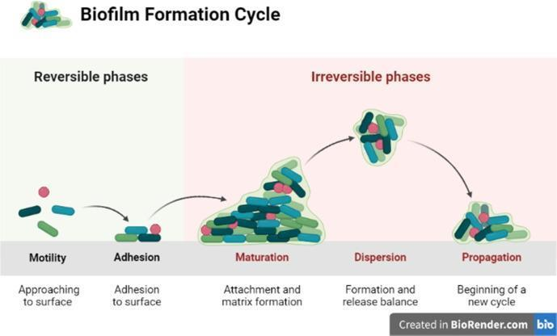
Fig. 1. Biofilm development stages (Olanbiwoninu and Popoola, 2023)
Formation of biofilms in the food industry
In the food industry, usually the surfaces and equipment with food and non-food-contact are regularly colonised by microorganisms that can form biofilms. The extracellular matrix formed during biofilm production is mainly a collection of polysaccharides, such as exogenous DNA or proteins, cellulose. This matrix plays an important role in adhering to hard surfaces (meat, fruit, bones, food industry equipment, etc.). The powerful tenacity of these biofilms in the food industry is as a result of the structural role of the extracellular matrix, which produces complex gradients regarding oxygen diffusion and nutrients, having enzymes (extracellular) used for the purpose of nutrition. This shields the cells embedded against compounds that are toxic and permits for the movement of cell communication molecules.
Control strategies
In the food industry, both physical and chemical approaches have been studied to inhibit bacterial biofilms. Previous studies have proven that mechanical treatment such as clean-in-place cannot remove all of the bacterial cells, while chemical treatment has some contributions to eliminate bacterial cells and inhibit biofilm formation. It was found that sodium hypochlorite (NaClO) acts as a potential disinfectant capable of inhibiting bacteria, while, the bacteria proliferation may happen under higher concentrations of disinfectants, which created conditions for the biofilm formation.

Physical techniques for biofilm cleaning
Ultrasound (US)
As a chemical-free approach, ultrasonic sterilisation presents potential utility for inactivating bacteria and preserving nutritional composition. Furthermore, it is a more environmentally friendly method of cleaning surfaces in the food industry. It was reported that direct-contact low-frequency ultrasound treatment could reduce the biofilm cell density of S.aureus by approximately 70%.
Ultraviolet (UV)
As a conventional technique, ultraviolet irradiation has been used to remove biofilms in the food and medical fields for decades. It has prominent advantages in having broad antimicrobial capability and is free of chemical residues. UV wavelengths from 200 to 300 nm, especially ∼260 nm, could effectively damage cell nucleic acid molecules, leading to cell inactivation and biofilm dispersion.

Magnetic fields with magneto-materials
With the rapid development of biofilm resistance, developing new antimicrobial approaches that are more efficient and faster acting is urgent. Magnetic fields combined with magneto-materials are considered as next-generation technologies for biofilm cleaning. Magneto-materials can easily penetrate the cell membrane and lead to cell lysis under the influence of magnetic fields, which makes them more efficient for biofilm elimination.

Chemical addition for biofilm removal
Compared to various physical methods, the addition of biochemical substances is more convenient and economical. Chemical disinfectants such as surfactins, antibiotics and natural compounds extracted from plants exhibit strong biofilm inhibition capability. Here, we will mainly describe two different chemicals, amino acids and vitamins, as representatives of spices and nutrient fortifiers for biofilm inhibition. These two additives exhibit extraordinary biofilm inhibitory capability and are almost of no harm to food safety compared to other chemical sanitisers.

Table 13.1.
Other food additives and some essential oil inhibit biofilm formation.
Substances | Inhibited microorganism | Source | Application
l-carvone | Hafnia alvei | Caraway | Spices
Cinnamaldehyde | Pseudomonas fluorescens | Cinnamon | Chewing gum
Caffeine | Pseudomonas aeruginosa | Coffee bean | Beverage
Tyrosol | Candida albicans | Olive | Flavouring agent
d-galactose | Fusobacterium nucleatum | Milk | Flavouring agent
Zeaxanthin | Pseudomonas aeruginosa | Corn | Colorant
Lemon essential oil | Klebsiella pneumoniae | Lemon | Promoting digestion
Ginger essential oil | Klebsiella rbinoscleromatis | Ginger | Promoting digestion
Litsea cubeba essential oil | Staphylococcus aureus | Litsea cubeba | Spices

Theme 14

Genetically modified organisms
Theoretical materials
Genetic modification is a biological technique that effects alterations in the genetic machinery of all kinds of living organisms. GMO is defined as follows by WHO (World Health Organisation): “Organisms (i.e. plants, animals or microorganisms) in which the genetic material (DNA) has been altered in a way that does not occur naturally by mating and/or natural recombination”.
There are three major challenges we are facing that motivate our resort to the new technology for help:
1. Expansion of population.
2. Decrease in arable land.
3. Bottleneck of conventional and modern breeding.
Benefits of GM foods
Agronomic benefits
For the period 1996–2013, it is estimated that biotechnology was responsible for additional global production of 138 million tonnes of soybeans, 274 million tonnes of corn, 21.7 million tonnes of cotton lint, and 8 million tons of canola. If those biotechnologies had not been available, to maintain the equivalent production levels would have required an increment of 11% of the arable land in the US, or 32% of the cereal area in the EU.
Economic benefits
From 2006 to 2012, the global increase in farm income from GM food had reached $116 billion, almost triple that of previous 10 years. It is estimated that about 42% of the economic gain was from the increased yield due to advanced genetics and resistance to pests and weeds. The decreased costs of production (e.g. from the reduced pesticide and herbicide usage) contributed the remaining 58%.
Modification of the chemical composition in food
Some genetic modifications are specifically targeted to enrich certain nutrients or substances having high therapeutic and pro-health value, including vitamins A, C, E, unsaturated fatty acids, alimentary cellulose and probiotics. The aforementioned “Golden Rice” is a significant example. It ameliorates malnutrition in an effective and economic way.
Improvement in food processing
The GM technology can also be employed to facilitate food processing. A notable achievement is the “Flavr Savr” tomatoes. They were produced by the Californian company, Calgene, in 1992. The genetic alteration consists of introduction of an antisense gene, which suppresses the enzyme polygalacturonase; the consequence is the slow down in ripening of tomatoes thus allowing for longer shelf life.
Products for therapeutic purposes
Genetic engineering techniques enable the expression of viral or bacterial antigens in the edible portion of plant cells. A variety of crops (e.g. rice, maize, soybean and potatoes) are under study as potential bearers of edible vaccines against different infections, including Escherichia coli toxins, rabies virus, Helicobacter pylori bacteria, and type B viral hepatitis.

Potential risks of GM foods
Health risks associated with GM foods
Three major health risks potentially associated with GM foods are: toxicity, allergenicity and genetic hazards. These arise from three potential sources, the inserted gene and their expressed proteins per se, secondary or pleiotropic effects of the products of gene expression, and the possible disruption of natural genes in the manipulated organism.
Environmental risks
There is evidence that genetically modified plants appear to interconnect with their state. During the last 40 years, investigations have attempted to establish a correlation between the natural tendency of evolving humans and its impact on individuals’ welfare. To look at whether there is a connection requires an investigation of its degree and any hidden components, integrating knowledge and methods from different disciplines.
Resistance to antibiotics
In the processes of genetic modification, antibiotics are frequently used, typically as selection markers, to distinguish successfully transformed bacteria from those in which the transfecting genes did not take hold. Thus, the machinations to genetically modify an organism carries the risk of transferring the genes of antibiotics resistance into the benign bacteria comprising the microflora of human and animal gastrointestinal tracts, or, worse yet, to pathogenic bacteria harboured by the consumer of GM a food, because bacteria, good and bad, are quite capable of shuttling useful genes – like those that protect them from nasty antibiotics – around by horizontal transfer between species.

Theme 15 Detection of contamination
Theoretical materials
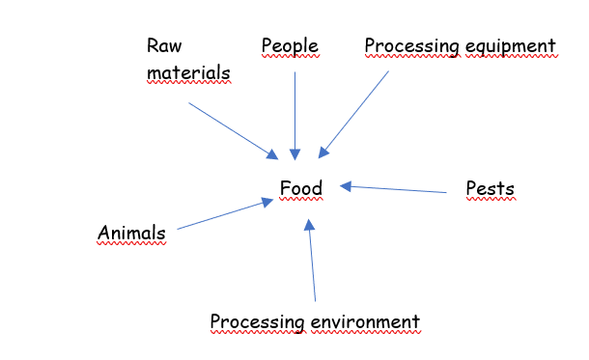
Fig. 15.1. Sources of contamination in food industry (Griffith, 2015).
Cross contamination - the process of contaminating a previously uncontaminated food or food surface,
- prevention of cross-contamination - integration of food safety management procedures,

Table 15.1.
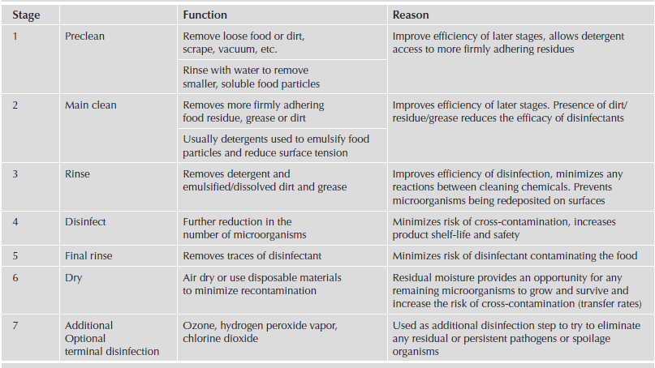
Typical stages in a cleaning programme (Griffith, 2016).

Cleaning - removing of contaminants from surfaces, but it can also reduce the number of microorganisms.
The aim of disinfection is the elimination of disease-causing or spoiling microorganisms - prevention of recontamination.
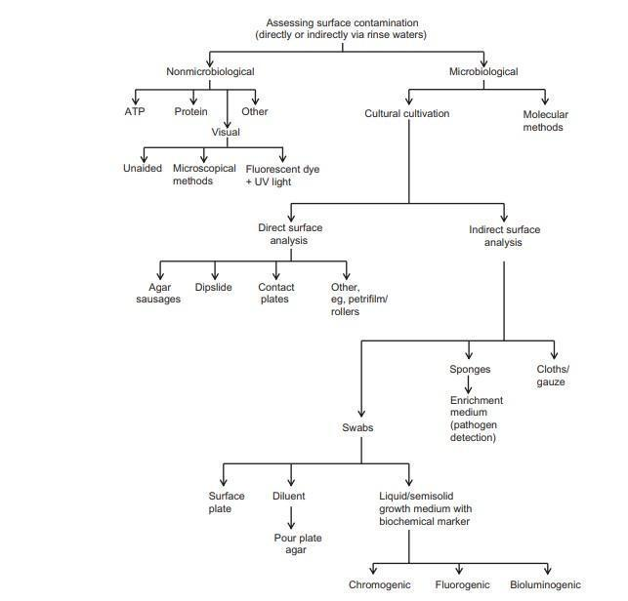
Fig.15.2. Methods for assessing surface cleanliness/contamination (Griffith, 2016).
NON-MICROBIOLOGICAL METHODS
ATP Bioluminescence
Adenosine triphosphate (ATP) is present in all living cells. It is present in viable microorganisms and in most foods and their residues.
ATP can be determined through a bioluminescence reaction using the oxidation of luciferin in the presence of the enzyme luciferase.
The intensity of the emitted light is determined in the luminometer chamber and is expressed in relative luminance units (RLU).
ATP is found in many, but not necessarily all, foods. For example, ATP is present in some fresh food, while other food, especially highly processed foods, contain very little ATP.
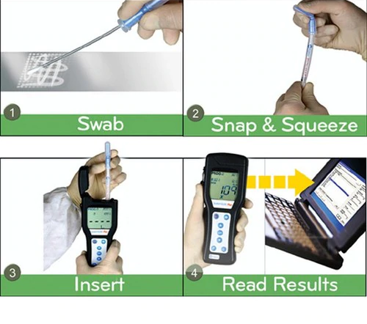

Fig. 15.3. Work with the luminometer (Hygenia SystemSURE Plus ATP Monitor (qasupplies.com)

MICROBIOLOGICAL METHODS
The main microbiological methods used in the food industry include the swab, dipslide, imprint.
Qualitative determination - pathogens.
Semi-quantitative determination - hygiene indicators.
Nutrient medium - solid, liquid.

Table 15.2.
Comparison of the main microbiological methods for hygiene monitoring (Verran and Redfern, 2016)
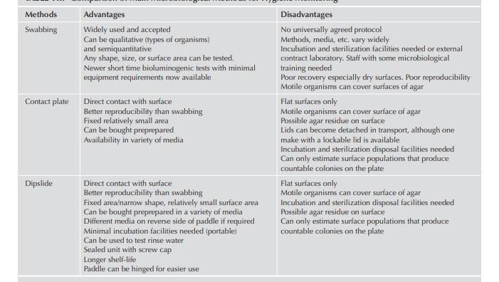

Indirect microbiological methods
Swabbing
The oldest and most commonly used method of controlling the level of hygiene.
Swabbing is widely used in industry to assess surface contamination, although not for larger surface areas and as a reference for comparison with other methods. Overall recovery can be seen as a function of the removal of microorganisms from the test surface, their release from the swab and their subsequent ability to grow.
Techniques/variables that improve one element of the swabbing process may adversely affect another. One study showed protocols that improved removal, and adversely affected release. Optimum overall recovery may therefore be a trade-off or compromise between different components of the whole process.
All-in-one medium
A swab, after testing a surface, is returned to its accompanying culture tube containing a liquid or semisolid agar incorporating an indicator system.
The results are semi-quantitative in that the number of bacteria is not recorded but the time taken for the indicator to change colour is a measure of the original microbial load.
Nonspecific media – determination of general aerobic colonies.
Selective media – determination of indicator microorganism or pathogens.

Sponges
Sponges work on a similar principle to swabbing, in that microorganisms are removed, released, and cultivated.
Recovery is by wiping a compressed sterile sponge (e.g. cellulose acetate) of varying sizes over the test surface.
Sponges may be pre-moistened or require the addition of a wetting agent. After inoculation the sponge is returned to a sterile packet and transported to a laboratory.
After the addition of a suitable diluent to the envelope, usually followed by agitation/stomaching, the released organisms can be counted.
Direct microbiological methods
All direct microbiological methods involve contact of sterile agar with a controlled surface.
Microorganisms are directly transferred to the surface of the agar and after an appropriate incubation period, the microorganisms multiply and form colonies that are visible and can be counted. In general, this approach is best for smooth, flat surfaces.
Contact plates
- they resemble small plastic Petri dishes with a lid,
- dishes contain agar,
- an imprint is made from the surface,
- contact plates are incubated for 24-48 hours depending on the group of microorganisms.
Dipslide
- agar immersion, plating, and contact slides,
- they comprise a double-sided hinged paddle with a neutral or selective agar, attached to both sides,
- the paddle is contained within a transparent cylindrical tube,
- the dipslide is removed, then pressed onto the surface to be tested, replaced back into the tube and resulting colony growth counted.
- they can also be used for counting the number of organisms in liquid samples of food, water, or rinse water.
Petrifilm plates
Small, thin films coated with nutrients and gelling agents. After wetting the film with 1 mL of deionised water to rehydrate the growth medium, it can be used to provide a surface count.
Using Petrifilm plates, an impression is made from the controlled area, and after cultivation, the grown colonies are counted.
Direct agar contact methods have a number of advantages and disadvantages compared with traditional swabbing.
Advantages - ease of use, generally lower costs, and better recovery and repeatability.
Disadvantages - more suited to flat surfaces and on very contaminated surfaces overgrowth can occur.
Molecular methods
Molecular methods amplify specific parts of a microorganism's nucleic acid to a detectable level.
Techniques include polymerase chain reaction (PCR), reverse transcriptase (RT-PCR), and nucleic acid sequence-based amplification (NASBA).
One potential disadvantage is that such techniques often do not distinguish between living microorganisms and noninfective nucleic acid and therefore only indicate that at some stage the organism was present on that surface.

Laboratory work

Detection of contamination – swabs
Supplies: sterile swabs, distilled water, cultivation media for determining total viable counts (TVC) and coliform bacteria (CB), test tubes, automatic pipette.
Procedure
- perform a swab from selected surfaces (plastic, ceramics, and stainless steel),
- the swabs are infused in tubes with distilled water, dilution: 10⁻¹,
- pipette 1 mL from each test tube onto Petri dishes and fill with cultivation media,
- cultivation in thermostat at temperature: TVC - 30 °C, 48 hours, CB - 37 °C, 24 hours,
- after cultivation - colony counting,
- expression of results – in log CFU/cm².
Results
Table 15.3.
Results of microbial contamination of different materials obtained by swabs
Surface | TVC  (log CFU/cm²) | CB  (log CFU/cm²)
Plastic
Stainless steel
Glass …

Conclusions

Approved by _________________________________________
Name, surname, signature

Date _________________________________________

Laboratory work

Detection of contamination - Petrifilm plates
Supplies: Petrifilm plates for determining of TVC and CB, peptone solution, automatic pipette.
Procedure
- activation of Petrifilm plates - pipette 1 mL of peptone solution on each Petrifilm plate,
- let set for 10 minutes at room temperature,
- make an imprint from the tested material using a Petrifilm plate,
- cultivation in thermostat at temperature: TVC - 30 °C, 48 hours, CB - 37 °C, 24 hours,
- after cultivation - colony counting.
Results
Table 15.4.
Results of microbial contamination of different materials obtained by Petrifilm plates
Surface | TVC  (log CFU/cm²) | CB  (log CFU/cm²)
Plastic
Stainless steel
Glass …

Conclusions

Approved by _________________________________________
Name, surname, signature

Date _________________________________________

Theme 16

Pest control in food industry
Theoretical materials
Pest management
The presence of pests in any food handling premises is unacceptable.

The risks posed by pests include:
• The spread of disease – pathogens are transferred from the gut or external surface of the pest.
• Damage to property.
• Contamination of work surfaces and foodstuffs.
• Adverse public opinion and loss of reputation.
• Prosecution and closure.
• Poor staff relations.
The objective of the Pest Management Programme should be to prevent, as far as practicable, the introduction of pests onto the site and to reduce the conditions that may encourage their presence.
Rodents destroy property, spread disease, compete for human food sources, and are aesthetically displeasing. Rodent-associated diseases affecting humans include plague, murine typhus, leptospirosis, rickettsialpox, and rat-bite fever. The three primary rodents of concern to the homeowner are the Norway rat (Rattus norvegicus), roof rat (Rattus rattus), and the house mouse (Mus musculus). The term “commensal” is applied to these rodents, meaning they live at people’s expense.
The first of four basic strategies for controlling rodents is to eliminate food sources. To accomplish this, it is imperative for the homeowner or occupant to do a good job of solid waste management. This requires proper storing, collecting, and disposing of refuse.
The second strategy is to eliminate breeding and nesting places. This is accomplished by removing rubbish from near the home, including excess lumber, firewood, and similar materials.
The third strategy is to construct buildings and other structures using rat-proofing methods. Tactics for rodent exclusion include building or covering doors and windows with metal. Rats can gnaw through wooden doors and windows in a very short time to gain entrance.
The first three strategies—good sanitation techniques, habitat denial, and rat proofing—should be used initially in any rodent management program. Should they fail, the fourth strategy is a killing programme, which can vary from a family cat to the professional application of rodenticides.
Determination of infestation
Rats and mice are nocturnal animals. Because they tend to be inactive during daylight hours, their presence is not always immediately detected. The presence of faecal droppings is one of the obvious signs of rodent infestation.
Control
Control of rodents, especially rats, is difficult because of their ability to adapt to the environment. The most effective method of rodent control is proper sanitation.
Without effective sanitation practices, poisons and traps will provide only a temporary reduction in a rodent population.
Prevention of entry
Protection against rats is accomplished most effectively through the elimination of all possible entrances. Poorly fitting doors and improper masonry around external pipes can be flashed or covered with metal or filled with concrete to block entry of rodents.
Elimination of rodent shelters
Crowded storage rooms with poor housekeeping provide sheltered areas for rodents
to build nests and reproduce. Rodents thrive in areas where garbage and other refuse are placed.
Eradication
The more effective methods of eradicating rodents are poisoning, gassing, trapping, and ultrasonic devices.
Poisoning
Poisoning is an effective method of eradication; however, precautions are necessary
because poison baits are hazardous if ingested by humans. Examples of rodenticides
are the anticoagulants, such as 3-(α acetonylfurfuryl)-4-hydroxycoumarin (fumarin), 3-(α
acetonylbenzyl)-4-hydroxycoumarin (warfarin), 2-pivaloyl-1,3-indandione (pival), brodifacoum, bromodiolone, and chlorophacinone. These multi-dose poisons must be consumed several times before death occurs and accidental consumption of poisoned bait does cause danger.
The multiple-dose anticoagulants (chronic poisons), although safer than most other poisons, should be prepared and applied according to instructions. The ideal locations for application are along rodent runways and near feeding sites. Fresh bait should be put out daily for at least 2 weeks to ensure that the poison is effective.
Tracking powder
These compounds kill rats or, in the case of nontoxic powders, identify their presence and number. These powders may contain an anticoagulant or a single-dose poison.
Gassing
This technique should be used only if other eradication methods are not effective. If this approach is necessary, rodent burrows should be gassed with a compound such as methyl bromide only by a professional exterminator or a thoroughly trained employee. Rodent burrows should not be gassed if they are less than 6 m from a building because burrows can extend under a closely located building.
Trapping
This is a slow but generally safe method of rodent eradication. Traps and bait stations should be tamper resistant so that non-target animals cannot get into them and placed at right angles to rodent runways, with the baited or trigger end toward the wall. Food that appeals to rodents can be used as bait.
Ultrasonic Devices
This eradication method uses sound waves that are supposed to repel the entry of rodents into areas where the device is installed. The most appropriate time to hit rodents with noise is when they first arrive.
INSECT INFESTATION
Arthropod pests are projected to cause post-harvest losses between 8 and 25% in
developed countries and 70 to 75% in developing countries. These losses are attributable to pest consumption and contamination.
Cockroaches
Cockroaches have become well adapted to living with and near humans, and their resilience is legendary. In light of these facts, cockroach control may become a homeowner’s most difficult task because of the time and special knowledge it often involves. The cockroach is considered an allergen source and an asthma trigger for residents. Although little evidence exists to link the cockroach to specific disease outbreaks, it has been demonstrated to carry Salmonella typhimurium, Entamoeba histolytica, and the poliomyelitis virus. Cockroaches are primarily nocturnal. Daytime sightings may indicate potentially heavy infestations.
Detection
Cockroaches may be found in any location where food is being processed, stored, prepared, or served. These insects tend to hide and lay eggs in dark, warm, difficult-to-clean areas. Their favourite harbourages are small spaces in and between equipment and shelves, and under shelf liners. When cockroaches need food that is not in these areas or when they are forced out by other cockroaches, they come out into the light. One of the easiest methods of checking for cockroach infestation is to enter a darkened production or storage area and turn on the lights. Also, a strong, oily odour that arises from a substance given off by certain glands of this insect can indicate the presence of cockroaches.
Control
Control of this pest in food establishments should be a continuous operation through effective sanitation and the use of chemicals. The most important form of control is effective sanitation. These pests require food, water, and a sheltered hiding place.
Infestation is reduced through filling cracks in floors and walls with caulking or other sealants.
The use of chemical control should follow sanitary practices. Chemical control can be handled through a pest control operator, but integrated chemical control and sanitary practices can be more effective and more economical.
Because insects such as cockroaches become inactive at approximately 5 ºC, refrigerated storage and refrigeration of other areas will reduce infestation. Cockroach control is usually based on the use of baits and bait stations, fungi, and possible nematodes. Diazinon offers potential for the control of cockroaches. Amidinohydrozone (Dursban) has been developed and sold as a bait, and can be effective against cockroaches that resist other poisonous compounds, but the use of this insecticide indoors is not acceptable.
A residual insecticide such as diazinon sprayed in hiding places is considered effective if these pests have not developed a resistance to this compound. This compound is sometimes supplemented with a pyrethrin-based non-residual insecticide to force the insects from the hidden areas to the sprayed area, where improved contact with the insecticide can occur.
Other compounds, such as flowable microencapsulated diazinon, are available for the control of cockroaches and other insects through spot, crack, or crevice treatment, but not for application in food handling areas. The liquid pesticide, cyfluthrin, a parathyroid-class chemical is as a nerve toxin that kills insects.
Four management strategies exist for controlling cockroaches. The first is prevention. This strategy includes inspecting items being carried into the home and sealing cracks and crevices in kitchens, bathrooms, exterior doors, and windows. Structural modifications would include weather stripping and pipe collars. The second strategy is sanitation. This denies cockroaches food, water, and shelter. These efforts include quickly cleaning food particles from shelving and floors; timely washing of dinnerware; and routine cleaning under refrigerators, stoves, furniture, and similar areas. If pets are fed indoors, pet food should be stored in tight containers and not left in bowls overnight. Litter boxes should be cleaned routinely. Access should be denied to water sources by fixing leaking plumbing, drains, sink traps, and purging clutter, such as papers and soiled clothing and rags. The third strategy is trapping. Commercially available cockroach traps can be used to capture roaches and serve as a monitoring device. The most effective trap placement is against vertical surfaces, primarily corners, and under sinks, in cabinets, basements, and floor drains. The fourth strategy is chemical control. The use of chemicals typically indicates that the other three strategies have been applied incorrectly.
Other insects
The most common of the seasonal insects in foodservice and food processing plants are
flies. The most populous varieties of flies associated with these establishments are the house fly and the fruit fly. The house fly (Musca domestica), which is found throughout the world, is an even greater pest than the cockroach. It is a pest to all segments of the community, transmitting a variety of pathogenic organisms to humans and their food. Examples are human disease such as typhoid, dysentery, infantile diarrhoea, and streptococcal and staphylococcal infections. Flies transmit diseases primarily because they feed on animal and human wastes and collect these pathogenic microorganisms on the feet, mouth, wings, and gut. These pathogens are deposited when the fly crawls on food or in the fly excrement.
House flies are more abundant in the late summer and fall because the population has
been building rapidly during the warm weather. When adult flies enter buildings for food and shelter, these pests generally remain. Flies are most active in a 12 to 35 ºC environment. Below 6 ºC they are inactive, and below -5 ºC death can occur within a few hours. Heat paralysis sets in at approximately
40 ºC, and death can occur at 49 ºC. Therefore, the most effective means of controlling the fly population is to prevent them from entering processing
INSECT DESTRUCTION
Pesticides
Pests should be destroyed without chemicals, if possible, because of the controversy and potential danger of pesticides. However, if these techniques are ineffective, it is necessary to use pesticides. To ensure the proper and effective application of pesticides, the use of a professional pest control company should be considered. Restricted pesticides should be applied by a commercial applicator.
Residual insecticides are applied to obtain insecticidal effects for an extended period of time. In residual treatment, the chemicals are normally applied in spots or cracks and crevices. Some residual insecticides cannot legally be used in food areas.
Another method of residual application of insecticides is crack and crevice treatment. Small amounts of insecticides are applied to cracks and crevices where insects hide or in areas where these pests may enter buildings for example, expansion joints between the various elements of construction and between equipment and floors.
Non-residual insecticides are applied for the control of insects only during the time of treatment and are applied either as contact or as space treatments. Contact treatment is the application of a liquid spray for an immediate insecticidal effect. Contact refers to the actual touching of the pests. This treatment method should only be used when there is a high probability that the spray will touch the pests. In space treatment, foggers, vapour dispensers, or aerosol devices are used to disperse insecticides into the air. This technique can control flying insects and crawling insects in the exposed area.
The following chemicals are common fumigants for insects:
● Phosphine: The principal active compound in this fumigant is aluminium phosphide, which is usually contained in a permeable package or in pellets. This method of use permits controlled contact
of the phosphine with moisture in the air to release hydrogen phosphide (phosphine), the active ingredient. This gas is very flammable. Instructions provided for use and storage provided by the supplier should be followed.
● Methyl bromide: This nonflammable fumigant is widely used. Methyl bromide penetrates effectively and acts as a respiratory toxin, apparently absorbed through the insect’s cuticle. Regulators have evaluated this fumigant and it appears that it will be phased out in the future.
● Ethylene oxide: This non-residual fumigant is normally mixed with carbon dioxide in a ratio of 1:9 (by weight) to reduce flammability and explosiveness.
This insecticide, most frequently used for stored commodities, should be applied through a professional pest control operator.
● Carbonyl sulfide: This compound has been found to be toxic to a large number of species of stored-product insects. It has been patented as a fumigant for the control of insects and mites in post-harvest commodities. Carbonyl sulphide has many characteristics indicating that it could replace methyl bromide or phosphine, or both, under some circumstances. It is environmentally friendly, with good penetration and aeration characteristics. It is versatile, being toxic in short exposure periods or for a longer exposure time. This fumigant shows no adverse effects on seed germination and is an effective fumigant for other commodities.
Other Chemical Methods of Insect Control
Other potential methods of insect control include the use of baits. Baits are a combination of insect-attracting foods, such as sugar, and an insecticide. Although baits are not always as convenient to use as other methods, they can be effective in controlling inaccessible areas of ant and cockroach infestations and in reducing outside fly populations. Because baits are poisonous food, special precautions should be exercised in their use and storage. Commercial dry granular baits should be scattered thinly over feeding surfaces daily, or as needed, to provide initial knockdown and control of populations. Granular fly baits are satisfactory for outdoor use only. Liquid baits consist of an insecticide in water with an attractant such as sugar, corn syrup, or molasses. They may be applied to walls, ceilings or floors frequented by flies using a sprayer or watering can. Fly bait should be
used regularly during the summer months to control population growth.
Mechanical methods
None of the conventional devices to control insects mechanically is especially effective. Fly swatters are contaminated and spread insect carcasses and parts when being used, so they should not be permitted in food processing, storage, preparation, or sales areas. A viable mechanical device for the control of insects is the air curtain, which not only reduces cold air loss in a refrigerated facility but also protects against insect and dust entry into food establishments.
Air curtains can be used for personnel doors and entrances large enough for loading trucks or for the passage of large equipment. Air curtains are most effective if the area being protected is under positive air pressure. The equipment is normally mounted outside and above the opening to be protected.
Insect light traps
One of the safest and most effective methods of fly control is the use of insect light traps. This technique does not have the potential hazard of toxic sprays.
Sticky traps
These traps can consist of sticky flypaper, pieces of waterproofed cord, or flat pieces of
plastic covered with a slow-drying adhesive. Yellow plastic strips with a sticky coating will catch a wide variety of flying insects. Some sticky traps contain pheromones so that a specific insect species can be caught. Light trap models use a low-voltage electric pulse to stun the insects, which then fall down onto the glue board. This approach reduces the production of insect fragments and does not create the bug zapping sound generated by the electrocution traps.
Biological Control
The use of biological control is frequently incorporated into integrated pest management (IPM) programmes (discussed near the end of this chapter). One of the most widely used biological control schemes for the control of phytophagous insects is the development and incorporation of host plant resistance. Resistance is attained through the use of plant species that are known to be refractory to attack. One of the promising techniques is the incorporation of gene splicing and recombinant DNA manipulation, which is being investigated universally.
Pheromone traps
Pheromones are chemical substances emitted by insects to communicate with others of the same species. Types of pheromones include sex attractant, aggregation, fear, and territorial boundary markers. Natural and synthetic sex attractant pheromones lure male insects into sticky traps where they become permanently trapped and die. Chemical attractants are now being used to control fruit flies.
Pheromones traps can be used in pest management for:
1. Detection and monitoring. Information such as the presence, location, and the amount of species can determine when appropriate action should be taken (i.e. pesticide application).
2. Mass trapping. Larger traps with a larger quantity of pheromone can be incorporated to catch insects.
3. Confusion. Sex pheromones can confuse the mating instincts of male insects preventing them from locating females.
The use of pheromones in pest management offers the following advantages.
1. Economy. A small amount is required and traps are easy to use.
2. Species specific. A pheromone used to attract a specific species does not attract or harm beneficial species.
3. Non-poisonous. No known safety hazards exist to humans or other animals.
4. No insect resistance. Sex attractants.

Theme 17

Personal hygiene
Theoretical materials
Food handlers can transmit bacteria causing illness. In fact, humans are the major source of food contamination. Their hands, breath, hair, and perspiration contaminate food, as can their unguarded coughs and sneezes, which can transmit microorganisms capable of causing illness.
Employee Hygiene
Ill employees should not come into contact with food or equipment and utensils used in the processing, preparation, and serving of food. Human illnesses that may be transmitted through food are diseases of the respiratory tract, such as common cold, sore throat, pneumonia, scarlet fever, tuberculosis, and trench mouth; intestinal disorders; dysentery; typhoid fever; and infectious hepatitis. In many illnesses, the disease-causing microorganisms may remain with the person after recovery. A person with this condition is known as a carrier. When employees become ill, their potential as a source of contamination increases.
Skin
Improper hand washing and infrequent bathing increases the amount of microorganisms dispersed with the dead cell fragments. Contamination results in shortening the product’s shelf life or in foodborne illness.
Foodborne illness may occur if a food handler is a carrier of Staphylococcus aureus or Staphylococcus epidermis, two of the predominant bacterial species normally present on the skin. These organisms are present in the hair follicles and in the ducts of sweat glands. They are capable of causing abscesses, boils, and wound infections following surgical operations. As secretions occur, perspiration from the eccrine gland, as well as sebum (a fatty material seated into hair follicles) contains bacteria from the gland and subsequently deposits them on the skin surface, with subsequent reinfection.
Fingers
Bacteria may be picked up through the hands touching dirty equipment, contaminated food, clothing, or other areas of the body. When this occurs, the employees should use a hand-dip sanitiser to reduce the transfer of contamination. Plastic gloves can be a solution.

Jewellery
To reduce safety hazards in an environment containing machinery, jewellery should not be worn in food processing or foodservice areas. Also, it may be contaminated and fall into food.
Hair
Microorganisms (especially staphylococci) are found on hair. Employees who scratch their heads should use the hand dip before handling food and should wear a head covering. The necessity for wearing hair coverings in food processing areas should be considered a condition of employment for all new employees and should be made known at the time when they are hired.
Mouth
Many bacteria are found in the mouth and on the lips. During a sneeze, some of the bacteria
are transferred to the air and may land on food being handled. Furthermore, smoking should be prohibited while working. Various disease-causing bacteria, as well as viruses, are also found in the mouth, especially if an employee is ill. These microorganisms can be transmitted to other individuals, as well as to food products, when one sneezes.
The intrinsic factors that affect microbial contamination by people are as follows:
1. Location on the body. The composition of the normal microbiota varies depending on the body area. The face, neck, hands, and hair contain a higher proportion of transient microorganisms and a higher bacterial density.
2. Age. The microbial population changes as a person matures.
3. Hair.
4. pH. The pH of the skin is affected through the secretion of lactic acid from the sweat glands, bacterial production of fatty acids, and diffusion of carbon dioxide through the skin.
5. Nutrients.
Carriers are divided into three groups:
1. Convalescent carriers. People who, after recovering from an infectious disease, continue to harbour the causative organism for a variable length of time, usually less than 10 weeks.
2. Chronic carriers. People who continue to harbour the infectious organism indefinitely, although they do not show symptoms of the disease.
3. Contact carriers. People who acquire and harbour a pathogen through close contact with an infected person, but do not develop the disease.
Hand Washing
Microorganisms found on the hand surfaces may be transient bacteria or resident bacteria. Transient bacteria are picked up accidentally by food handlers and are transient in that they are present on the hands only temporarily (e.g., E. coli). Residual microorganisms permanently reside on the hand surfaces and are the normal or resident microflora of the skin (e.g., Staphylococcus
epidermidis).
The first line of defence against disease is frequent and effective hand washing by food handlers. Approximately 38% of food contamination is attributable to improper hand washing. The most effective method to ensure effective hand washing is through motivation, reinforcement, incentives, and modelling through supervisors and managers practicing appropriate hand washing.
These practices should be conducted to ensure personal hygiene:
1. Physical health should be maintained and protected through the practice of proper nutrition and physical cleanliness.
2. Illness should be reported to the employer before working with food so that work adjustments can be made to protect food from the employee’s illness or disease.
3. Hygienic work habits should be developed to eliminate potential food contamination.
4. During the work shift, hands should be washed after using the toilet, handling garbage or other soiled materials, handling uncooked muscle foods, egg products, or dairy products, handling money, smoking, coughing, or sneezing.
5. Personal cleanliness should be maintained by daily bathing and the use of deodorants, washing hair at least twice a week, cleaning fingernails daily, using a hat or hair net while handling food,
and wearing clean underclothing and uniforms.
6. Employees’ hands should not touch foodservice equipment and utensils. Disposable gloves should be used when contact is necessary.
7. Rules such as “no smoking” should be followed, and other precautions related to potential contamination should be taken.
Role of Employees
Food processing and foodservice firms should protect their employees and consumers
from workers with diseases or other microorganisms of public health concern that can affect the wholesomeness or sanitary quality of food.

Theme 18

HACCP system
Theoretical materials
HACCP System implementation
Elements of a Food Safety Management System (FSMS)

Prior to the application of the HACCP-based procedures to any business, the food business operator (FBO) should have implemented the prerequisite programmes. Compliance with the procedures of regulations are the prevention and preparedness pillars of each FSMS and are needed to develop HACCP-based procedures.

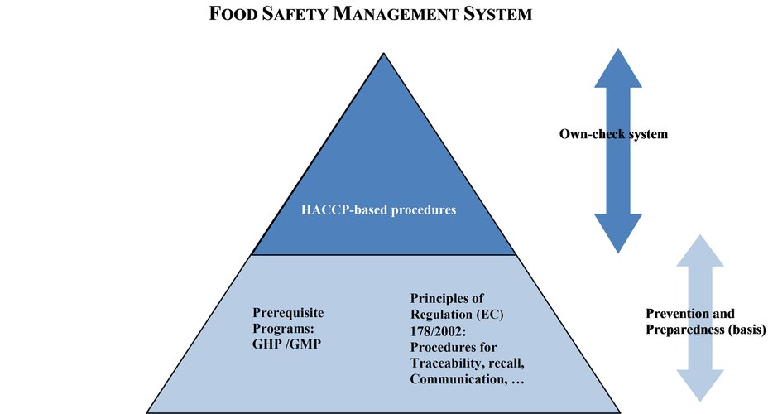

Fig. 18.1 Food safety management system (ISO 22000:2018)
Preliminary activities prior to the implementation of the HACCP plan are as follows:
- Assembly of a multidisciplinary HACCP team,
- Description of the product(s) at the end of process (called hereafter ‘end product’),
- Identification of intended use,
- Construction of a flow diagram (description of manufacturing process),
- On-site confirmation of flow diagram,
- Assembly of a multidisciplinary HACCP team.

This team, which involves all parts of the food business concerned with the product, should include the whole range of specific knowledge and expertise appropriate to the product under consideration, its production (manufacture, storage, and distribution), its consumption and the associated potential hazards and should also involve, as much as possible, the higher levels of management. The team should get the full support of the management who should consider themselves as the owner of the HACCP plan and the overall FSMS.

Where necessary, the team should be assisted by specialists who will help it to solve its difficulties as regards assessment and control of critical points.

The team may include specialists and technicians:

who understand the biological, chemical or physical hazards connected with a particular product group,

who have responsibility for, or are closely involved with, the technical process of manufacturing the product under study,

who have a working knowledge of the hygiene and operation of the process plant and equipment,

any other person with specialist knowledge of microbiology, hygiene or food technology.

One person may fulfil several or all of these roles, provided that all relevant information is available to the team and is used to ensure that the system developed is reliable. Where expertise is not available in the establishment, advice should be obtained from other sources (consultancy, guides of good hygiene practices, etc. not excluding other companies of the same group (at sectorial or association level) where expertise is available).

- Description of the product(s) at the end of process (called hereafter ‘end product’)
A full description of the end product should be drawn up, including relevant safety information such as:
- origin of ingredients/raw materials, which may help identify certain hazards,
- composition (e.g. raw materials, ingredients, additives, possible allergens etc.),
- structure and physico-chemical characteristics (e.g. solid, liquid, gel, emulsion, moisture content, pH, water activity, etc.),
- processing (e.g. heating, freezing, drying, salting, smoking, etc. and to what extent),
- packaging (e.g. hermetic, vacuum, modified atmosphere) and labelling,
- storage and distribution conditions, including transport and handling
- required shelf life (e.g. ‘use by date’ or ‘best before date’),
- instructions for use,
- any microbiological or chemical criteria applicable.
Identification of intended use
The HACCP team should also define the normal or expected use of the product by the customer and by the consumer target groups for which the product is intended. In specific cases, the suitability of the product for particular groups of consumers, such as institutional caterers, travellers, etc. and for vulnerable groups of the population may have to be considered.
Construction of a flow diagram (description of manufacturing process)
Whatever format is chosen, all steps involved in the process should be studied in sequence and presented in a detailed flow diagram.
All processes (from receiving the raw materials to placing the end product on the market) including delays during or between steps, should be mentioned together with sufficient technical data that is relevant for food safety, such as temperature and the duration of heat treatment.
Types of data may include but are not limited to:
- plan of working premises and ancillary premises,
- equipment layout and characteristics,
- sequence of all process steps (including the incorporation of raw materials, ingredients or additives and delays during or between steps),
- technical parameters of operations (in particular time and temperature, including delays),
- flow of products (including potential cross-contamination),
- segregation of clean and dirty areas (or high/low risk areas).
On-site confirmation of flow diagram
After the flow diagram has been drawn up, the HACCP team should confirm it on site during operating hours. Any observed deviation must result in an amendment of the original flow diagram to make it accurate.
In small enterprises, HACCP/FSMS activities might be carried out by one person who is (temporarily or regularly) assisted by external expertise. Where external expertise is used, it is essential that there is sufficient ownership of the FSMS by the food business itself. FBOs using this route should make sure that they know how the system works and how it is being applied to their business and that their staff is suitably trained to ensure effective implementation.
When there is no processing or other manufacturing (e.g. cutting, wrapping), the description of the product can be limited to information available on the label (prepacked food) or other information on the food extracted from reliable websites. Unless specifically targeted to certain consumers (e.g. baby food), the intended use can be considered as consumption by the general public.
The nature of the business will define the complexity of the required flow diagram, which might be very simple in certain businesses.
HACCP System
Hazard analysis and critical control points, or HACCP, is a systematic preventive approach to food safety from biological, chemical, and physical hazards in production processes that can cause the finished product to be unsafe and designs measures to reduce these risks to a safe level. In this manner, HACCP attempts to avoid hazards rather than attempting to inspect finished products for the effects of those hazards. The HACCP system can be used at all stages of a food chain, from food production and preparation processes including packaging, distribution, etc. The Food and Drug Administration (FDA) and the United States Department of Agriculture (USDA) require mandatory HACCP programmes for juice and meat as an effective approach to food safety and protecting public health. Meat HACCP systems are regulated by the USDA, while seafood and juice are regulated by the FDA. All other food companies in the United States that are required to register with the FDA under the Public Health Security and Bioterrorism Preparedness and Response Act of 2002, as well as firms outside the US that export food to the US, are transitioning to mandatory hazard analysis and risk-based preventive controls (HARPC) plans.
It is believed to stem from a production process monitoring used during World War II because traditional "end of the pipe" testing on artillery shells' firing mechanisms could not be performed, and a large percentage of the artillery shells made at the time were either duds or misfiring. HACCP itself was conceived in the 1960s when the US National Aeronautics and Space Administration (NASA) asked Pillsbury to design and manufacture the first foods for space flights. Since then, HACCP has been recognised internationally as a logical tool for adapting traditional inspection methods to a modern, science-based, food safety system. Based on risk-assessment, HACCP plans allow both industry and government to allocate their resources efficiently by establishing and auditing safe food production practices. In 1994, the organisation International HACCP Alliance was established, initially to assist the US meat and poultry industries with implementing HACCP. As of 2007, its membership spread over other professional and industrial areas.
HACCP has been increasingly applied to industries other than food, such as cosmetics and pharmaceuticals. This method, which in effect seeks to plan out unsafe practices based on science, differs from traditional "produce and sort" quality control methods that do nothing to prevent hazards from occurring and must identify them at the end of the process. HACCP is focused only on the health safety issues of a product and not the quality of the product, yet HACCP principles are the basis of most food quality and safety assurance systems. In the United States, HACCP compliance is regulated by 21 CFR part 120 and 123. Similarly, FAO and WHO published a guideline for all governments to handle the issue in small and less developed food businesses.
History
In the early 1960s, a collaborated effort between the Pillsbury Company, NASA, and the U.S. Army Laboratories began with the objective to provide safe food for space expeditions. People involved in this collaboration included Herbert Hollander, Mary Klicka, and Hamed El-Bisi of the United States Army Laboratories in Natick, Massachusetts, Paul A. Lachance of the Manned Spacecraft Center in Houston, Texas, and Howard E. Baumann representing Pillsbury as its lead scientist.
To ensure that the food sent to space was safe, Lachance imposed strict microbial requirements, including pathogen limits (including E. coli, Salmonella, and Clostridium botulinum).[5] Using the traditional end product testing method, it was soon realised that almost all of the food manufactured was being used for testing and very little was left for actual use. Therefore, a new approach was needed.
NASA's own requirements for critical control points (CCP) in engineering management would be used as a guide for food safety. CCP derived from failure mode and effects analysis (FMEA) from NASA via the munitions industry to test weapon and engineering system reliability. Using that information, NASA and Pillsbury required contractors to identify "critical failure areas" and eliminate them from the system, a first in the food industry then. Baumann, a microbiologist by training, was so pleased with Pillsbury's experience in the space programme that he advocated for his company to adopt what would become HACCP at Pillsbury.
Soon, Pillsbury was confronted with a food safety issue of its own when glass contamination was found in farina, a cereal commonly used in infant food. Baumann's leadership promoted HACCP in Pillsbury for producing commercial foods, and applied to its own food production. This led to a panel discussion at the 1971 National Conference on Food Protection that included examining CCPs and good manufacturing practices in producing safe foods. Several botulism cases were attributed to under-processed low-acid canned foods in 1970–71. The United States Food and Drug Administration (FDA) asked Pillsbury to organise and conduct a training programme on the inspection of canned foods for FDA inspectors. This 21-day programme was first held in September 1972 with 11 days of classroom lecture and 10 days of canning plant evaluations.[5] Canned food regulations (21 CFR 108, 21 CFR 110, 21 CFR 113, and 21 CFR 114)[6] were first published in 1969. Pillsbury's training programme, which was submitted to the FDA for review in 1969, entitled "Food Safety through the Hazard Analysis and Critical Control Point System" was the first use of the acronym HACCP.
HACCP was initially set on three principles, now shown as principles one, two, and four in the section below. Pillsbury quickly adopted two more principles, numbers three and five, to its own company in 1975. It was further supported by the National Academy of Sciences (NAS) when they wrote that the FDA inspection agency should transform itself from reviewing plant records into an HACCP system compliance auditor.
Over the period 1986 to 1990, a team consisting of National Sea Products and the Department of Fisheries and Oceans developed the first mandatory food inspection programme based on HACCP principles in the world. Together, these Canadian innovators developed and implemented a Total Quality Management Programme and HACCP plans for all their groundfish trawlers and production facilities.
A second proposal by the NAS led to the development of the National Advisory Committee on Microbiological Criteria for Foods (NACMCF) in 1987. NACMCF was initially responsible for defining HACCP's systems and guidelines for its application and were coordinated with the Codex Alimentarius Committee for Food Hygiene, that led to reports starting in 1992 and further harmonisation in 1997. By 1997, the seven HACCP principles listed below became the standard.
A year earlier, the American Society for Quality offered their first certifications for HACCP Auditors.[8] First known as Certified Quality Auditor-HACCP, they were changed to Certified HACCP Auditor (CHA) in 2004.
HACCP expanded in all realms of the food industry, going into meat, poultry, seafood, dairy, and has spread now from the farm to the fork.
HAZARD ANALYSIS (PRINCIPLE 1)
The steps in creating the risk analysis are as follows:
- Listing of relevant hazards
- Control measures
LISTING OF RELEVANT HAZARDS
A hazard is a biological, chemical or physical agent in, or condition of, food or feed with the potential to cause an adverse health effect (2).
All major potential biological, chemical or physical hazards that may be reasonably expected to occur at each process step (including production, acquisition, storage, transport and handling of raw materials and ingredients and delays during manufacture) should be identified and listed. It may be useful to consult external source of information (e.g. the Rapid Alert System for Food and Feed).
The HACCP team should next conduct a hazard analysis to identify which hazards are of such a nature that their elimination or reduction to acceptable levels is essential to the production of a safe food (end product).
In conducting the hazard analysis, the following should be:
- the likelihood of occurrence of hazards and severity of their adverse health effects;
- the qualitative and/or quantitative evaluation of the presence of hazards;
- the survival or multiplication of pathogenic micro-organisms and unacceptable generation of chemicals in intermediate products, end products, production line or line environment;
- the production or persistence in foods of toxins or other undesirable products of microbial metabolism, chemicals or physical agents or allergens;
- the contamination (or recontamination), of a biological (micro-organisms, parasites), chemical or physical nature, of raw materials, intermediate products or end products.
Example of a hazard analysis – (semi-quantitative) risk evaluation procedure
- Based on FAO/WHO: Risk characterisation of microbiological hazards in food and on Quality management systems in the food industry.
- The risk level is defined by the severity or the effect of the hazard in relation to the probability in which the hazard can occur in the end product if the considered (specific) control measures are not present or are failing – taking into consideration the next steps in the process where an elimination or reduction to an acceptable level is possible, and taking into consideration the already correctly implemented PRPs.
- P = Probability= the probability that the hazard is occurring in the end product, if the considered specific control measures are not present or are failing – taking into consideration the next steps in the process where an elimination or reduction to an acceptable level is possible and taking into consideration the already correctly implemented PRPs.
- E = Effect= the effect or the severity of the hazard related to human health.

Table 18.1.
Example of a hazard analysis – (semi-quantitative) risk evaluation procedure
RISK LEVEL (R = P x E): SCALE 1 TO 7
PROBABILITY | High | 4 | 4 | 5 | 6 | 7
PROBABILITY | Real | 3 | 3 | 4 | 5 | 6
PROBABILITY | Small | 2 | 2 | 3 | 4 | 5
PROBABILITY | Very small | 1 | 1 | 2 | 3 | 4
PROBABILITY |  |  | 1 | 2 | 3 | 4
PROBABILITY |  |  | Limited | Moderate | Serious | Very serious
PROBABILITY |  |  | EFFECT

Probability
1 = very small
- Theoretical chance – the hazard never occurred before;
- There is a next step in the production process which will eliminate or reduce the hazard to an acceptable level (e.g. pasteurization, fermentation);
- The control measure or the hazard are of such a nature that when the control measure is failing, no production is possible any more or no useful end products are produced (e.g. too high a concentration of colorants as additives);
- It is a very limited and/or local contamination.
2 = small
- The probability that due to failing or absence of the PRPs the hazard will occur in the end product is very limited;
- The control measures for the hazard are of a general nature (PRPs) and these are well implemented in practice;
3 = real
- Failing or lacking of the specific control measure does not result in the systematic presence of the hazard in the end product but the hazard can be present in a certain percentage of the end product in the associated batch.
4 = high
- Failure or absence of the specific control measure will result in a systematic error, there is a high probability that the hazard is present in all end products of the associated batch.
Effect (or severity)
1 = limited
- There is no problem for the consumer related to food safety (nature of hazard e.g. paper, soft plastic, large size foreign materials);
- The hazard can never reach a dangerous concentration (e.g. colorants, S. aureus in a frozen food where multiplication to higher counts is highly unlikely or cannot happen because of storage conditions and cooking).
2 = moderate
- No serious injuries and/or symptoms or only when exposed to an extremely high concentration during a long period of time;
- A temporary but clear effect on health (e.g. small pieces).
3 = serious
- A clear effect on health with short-term or long-term symptoms which results rarely in mortality (e.g. gastro-enteritis);
- The hazard has a long-term effect; the maximal dose is not known (e.g. dioxins, residues of pesticides, mycotoxins, …).
4 = very serious
- The consumer group belongs to a risk category and the hazard can result in mortality;
- The hazard results in serious symptoms from which mortality may result;
- Permanent injuries.
Determination of CCPs and oPRPs when considered relevant
Risk levels 1 & 2: no specific actions, control covered by PRPs.
Risk levels 3 & 4: possible oPRPs. Additional question to be answered by the HACCP team: Is the general control measure(s) as described in the Pre Requisite Program’s (PRPs) enough as monitoring for the identified risk?
- If YES: PRP
- If NO: oPRP
Risk levels 5, 6 and 7: CCP or if no measurable critical limit exists this may be an oPRP (e.g. controlling an allergen).
CCPs are the points in a production process where a continuous/batch wise control via a specific control measure is required to eliminate or to reduce the hazard to an acceptable level. The monitoring must be demonstrable and a record must be kept. In the case of a breach of the critical limit, a corrective action towards product and process is necessary.
oPRPs are points in the production process with a smaller food safety risk or where no measurable limits exists. These points can be controlled via more elaborated general basic control measures belonging to the PRPs e.g. more frequent control, recording etc. Due to a regular control and adaptation of the process/product requirements these risks can be considered as controlled. An immediate corrective action towards the product is not required. Examples of oPRPs include:
- Raw material reception → sampling plan for verification of safety/hygiene approaches by suppliers.
- Cross-contamination between batches for allergens → intermediate cleaning and check by adenosine triphosphate (ATP) measurements.
- Contamination of food in high care area → mouth masks and extra protection of personnel, weekly hand hygiene check.
Alternative/simplified approach
The same approach is used in a simpler way, for example:
- Risk levels 1 to 5 instead of 1 to 7 by using 3 instead of 4 subdivisions of the probability and effect (subdivisions 3 and 4 are merged).
- oPRPs are not included when identifying ‘intermediate’ risk, but only differentiation is made between hazards that can be controlled by PRPs only and those requiring a CCP.
CONTROL MEASURES
The FBO should consider and describe what control measures, if any, can be applied for each hazard.
Control measures are those actions and activities that can be used to prevent hazards, eliminate them or reduce their impact or likelihood of occurrence to acceptable levels. Many preventive control measures are part of PRPs and are intended to avoid contamination from the production environment (e.g. personnel, pest, water, maintenance). Other control measures aiming at reduction or elimination of hazards are more specifically linked to particular production process e.g. pasteurisation, fermentation and may result in the establishment of CCPs or operational PRPs.
More than one control measure may be required to control an identified hazard e.g. pasteurisation controlled by time, temperature and flow rate of the fluid and more than one hazard may be controlled by one control measure e.g. pasteurisation or controlled heat treatment may provide sufficient assurance of reduction of the level of several pathogenic micro-organisms such as Salmonella and Listeria.
Control measures should be validated.
Control measures should be supported by detailed procedures and specifications to ensure their effective implementation.
IDENTIFICATION OF CRITICAL CONTROL POINTS (CCP) (Principle 2)
The identification of a CCP requires a logical approach. Such an approach can be facilitated by the use of a decision tree or other methods, according to the knowledge and experience of the HACCP team.
The identification of CCPs has two consequences for the HACCP team which should then:
- ensure that appropriate control measures are effectively designed and implemented. In particular, if a hazard has been identified at a step where control is necessary for product safety and no control measure exists at that step, or at any other further on in the production process, then the product or process should be modified at that step or at an earlier or later stage, to include a control measure;
- establish and implement a monitoring system at each CCP.
Each process step identified in the flow diagram should be considered in sequence. At each step, the decision tree and/or risk evaluation should be applied to each hazard that may be reasonably expected to occur or be introduced and each control measure identified. Application should be flexible, considering the whole manufacturing process in order to avoid, whenever possible, unnecessary CCPs. Training in the application of a method to identify CCPs is recommended.
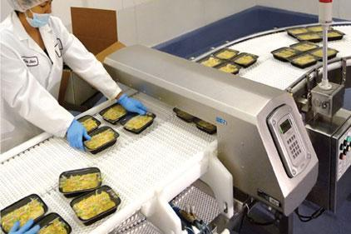
Fig.18.2. Critical control point - detection of foreign bodies

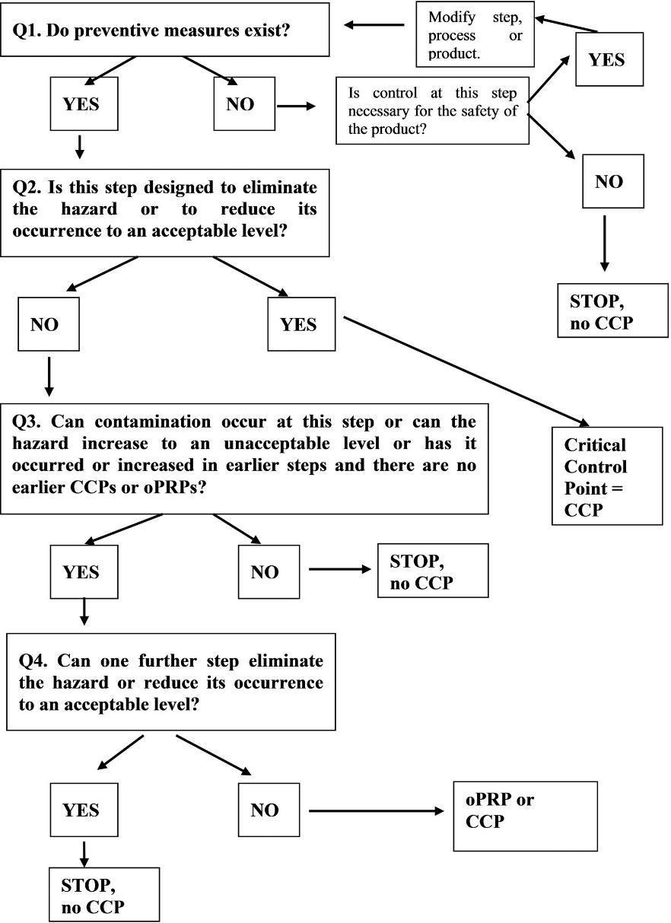

Fig.18.3. Examples of a decision tree to identify critical control points (CCPs).

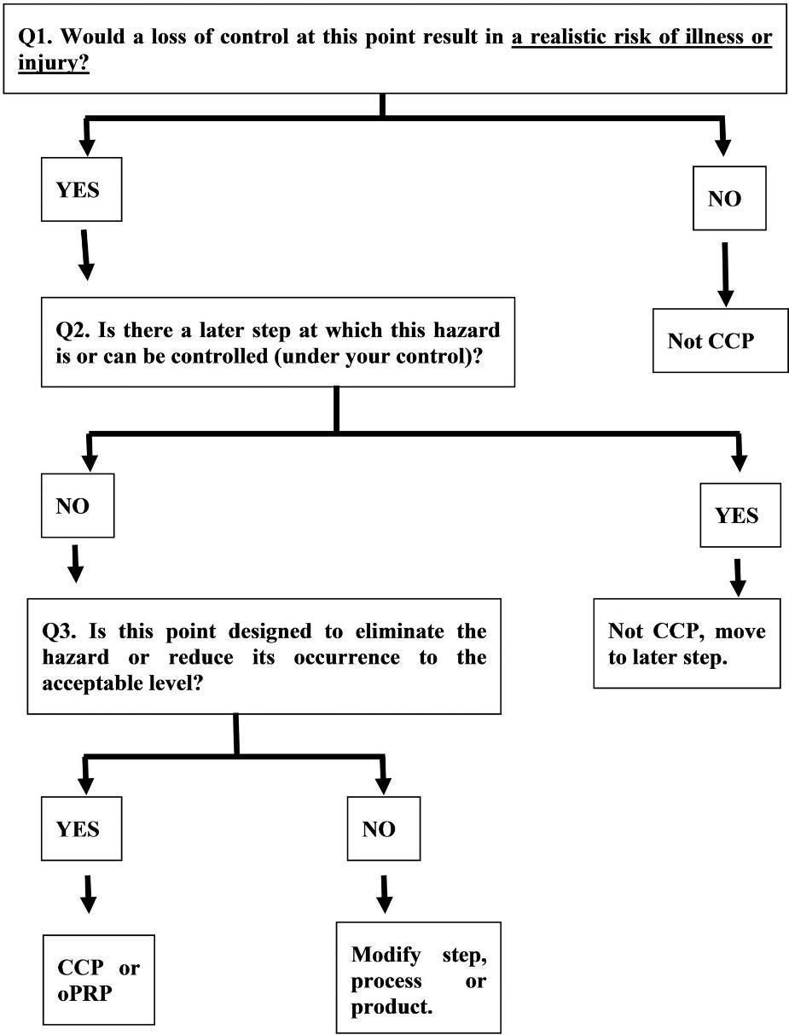

Fig.18.4. Example of simplified decision tree

The hazard analysis may identify different levels of risks for each process step:
- For lower risk levels it can be concluded that, if robust PRPs are in place, these PRPs are sufficient to control the hazards.
- For intermediate levels of risks identified, ‘intermediate’ measures can be proposed, such as operational PRPs.
oPRPs are PRPs that are typically linked to the production process and are identified by the hazard analysis as essential, in order to control the likelihood of the introduction, survival and/or proliferation of food safety hazards in the product(s) or in the processing environment. Similarly to CCPs, operational PRPs include measurable or observable action criteria or action limits (but targets rather than critical limits), monitoring of the implementation of control measures, monitoring records and corrective actions if needed. Examples are:
- Control of washing process of vegetables (e.g. by frequency of wash water refreshment to avoid microbial cross-contamination, mechanical action in the water to remove physical hazards as stones, pieces of wood).
- Control of blanching process for the deep freezing industry (time/temperature).
Washing and blanching processes can usually not be considered as CCPs because neither provides full elimination of the microbial hazards nor reduction to an acceptable level can be achieved or is at the objective. However, they will impact the microbial load of the processed products.
- More intensive cleaning and disinfection in high care areas, more strict personal hygiene in high care areas, for example in packaging areas of ready to eat food.
- More severe incoming check upon reception of raw materials if supplier is not guaranteeing the desired quality/safety level (e.g. mycotoxins in spices).
- Control of allergens by a sanitation programme.

- For high level of risks, which are not controlled by PRPs or oPRPs, CCPs should be established.

Table 18.2.
Comparison of PRPs, oPRPs and CCPs (ISO 22000:2018)
Type of control measure | PRP | OPRP | CCP
Scope | Measures related to creating the environment for safe food: measures impacting food suitability and safety. | Measures related to the environment and/or product (or combination of measures) to prevent contamination, or to prevent, eliminate or reduce hazards to an acceptable limit in the end product.  These measures are implemented after the implementation of PRPs.
Relation to hazards | Not specific to any hazard. | Specific to each hazard or group of hazards.
Determination | Development based on:  ✓ Experience,  ✓ Reference documents (guides, scientific publications, …),  ✓ Hazard or hazard analysis. | Based on the hazard analysis taking PRPs into account.  CCPs and oPRPs are product and/or process specific.
Validation | Not necessarily carried out by FBO.  (i.e.: cleaning products manufacturer has validated the efficiency of the product and determined product spectrum and instructions of use – FBO has to follow instructions and keep technical specifications of product). | Validation has to be carried out  (in many cases, guides to good practice provide guidance on a validation methodology or gives ready to use validation material).
Criteria | / | Measurable or observable criteria. | Measurable critical limit.
Monitoring | Where relevant and feasible. | Monitoring of the implementation of control measures: usually recorded.
Loss of control: Corrections/corrective actions | Corrective actions and/or corrections on the implementation of PRPs where relevant. | Corrective actions on the process.  Possible corrections on the product (case by case).  Records kept. | Pre-set corrections on the product.  Possible corrective actions on the process.  Records kept.
Verification | Scheduled verification of implementation. | Scheduled verification of implementation, verification of achievement of planned hazard control.

Summary of examples on flexibility for certain FBOs
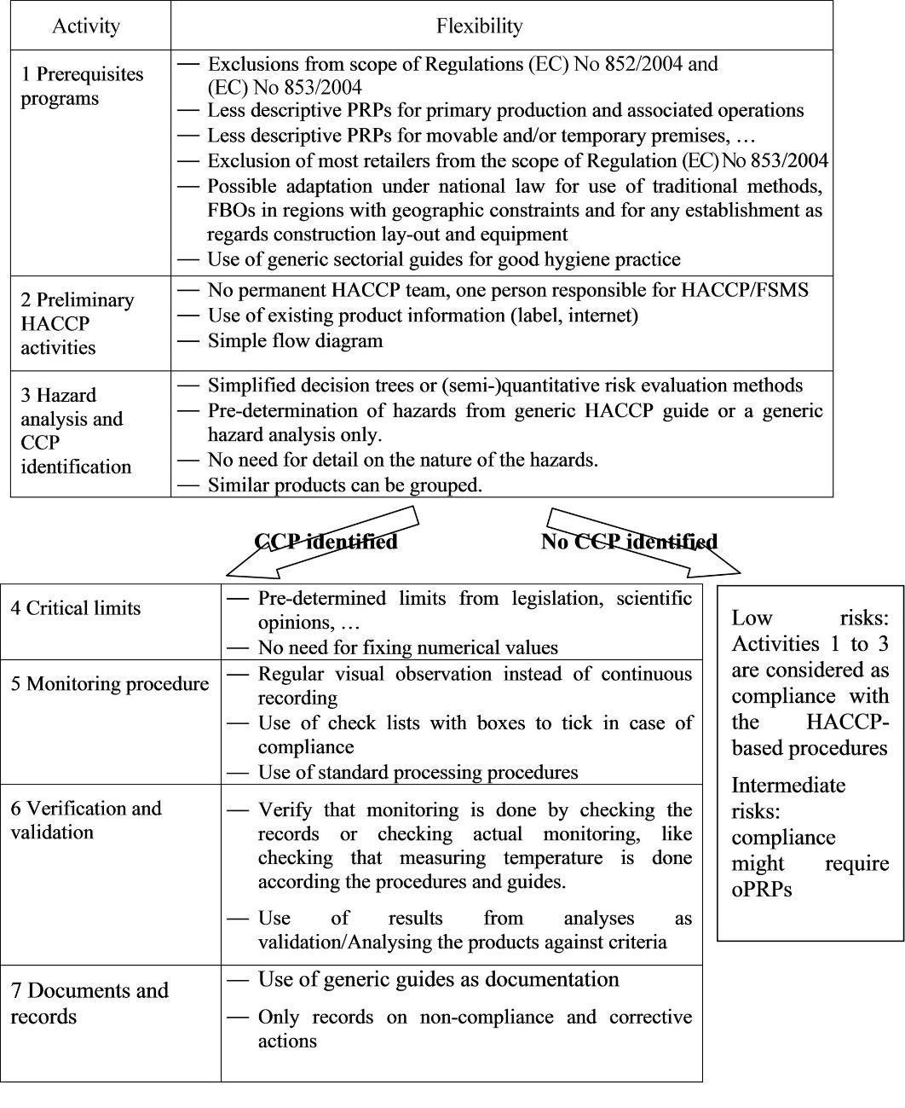
Fig.18.5. Example Hazard analysis and identification of CCPs (ISO 22000:2018).
Several simplified methods have been described to carry out the hazards analysis and identify possible CCPs e.g. simplified decision trees and semi-quantitative risk evaluation methods.
In certain cases, due to the nature of the food business and the food that is handled by it, a (generic) hazard analysis may demonstrate that no very significant hazard has been identified and therefore there is no need for CCPs. In this case all food hazards can be controlled by the implementation of the PRPs only or in combination with the application of certain oPRPs. It must however be stressed that flexibility on the hazard analysis is not directly linked to the size of the establishment and is not appropriate even when the business is small e.g.:
- when there is a high likelihood of failure in the method of processing such as canning, vacuum packing,
- food production for vulnerable groups of consumers,
- allergen controls in products declared to be allergen free.
For certain categories of food businesses with very identical, standardised and limited handling of the food (e.g. retail shops), it may be possible to pre-determine hazards that need to be controlled. Guidance on such hazards and on the control thereof can be addressed in a generic HACCP guide or a generic hazard analysis only.
In certain cases, due to the nature of the food business and the food that is handled by it, the hazard analysis may demonstrate that significant hazards do not exist and there are no control measures, which could be categorised as CCPs. In these cases oPRPs are the control measures.
In small businesses it may suffice that the hazard analysis in the HACCP plan describes in a practical and simple way the methods to control hazards without necessarily entering into detail on the nature of the hazards. Such analysis should nevertheless cover all significant hazards in a business and should clearly define procedures to control these hazards and the corrective action to be taken in case of problems.

CRITICAL LIMITS AT CCPs (Principle 3)
Each control measure associated with a critical control point should give rise to the specification of critical limits.
Critical limits correspond to the extreme values acceptable with regard to product safety. They separate acceptability from unacceptability. They are set for observable or measurable parameters which can demonstrate that the critical point is under control. They should be based on substantiated evidence that the chosen values will result in process control.
Examples of such parameters include temperature, time, pH, moisture content, amount of additive, preservative or salt, sensory parameters such as visual appearance or texture, etc.
In some cases, to reduce the likelihood of exceeding a critical limit due to process variations, it may be necessary to specify more stringent levels (i.e. target levels) to assure that critical limits are observed.
Critical limits should be validated and should have clear, specific values.
Critical limits may be derived from a variety of sources. When not taken from regulatory standards or from guides of good hygiene practices, the HACCP team should ascertain their validity relative to the control of identified hazards at CCPs.
Critical limits at CCPs can be established on the basis of:
- Experience (best practice);
- International documentation for a number of operations, e.g. canning of food, pasteurisation of liquids etc. for which internationally accepted standards (Codex Alimentarius) exist; critical limits can also be established;
- Guides to good practice on this specific issue;
- Scientific publications;
- EU legislation, EFSA opinions.
The requirement to establish a critical limit at a CCP does not always imply that a numerical value must be fixed. This is in particular the case where monitoring procedures are based on visual observation e.g.:
- The faecal contamination of carcases in a slaughterhouse,
- The boiling temperature of liquid food,
- The change of physical properties of food during processing (e.g. cooking of food).
MONITORING PROCEDURES AT CCPs (Principle 4)
An essential part of HACCP-based procedures is a program of observations or measurements performed at each CCP to ensure compliance with specified critical limits.
Observations or measurements must be able to detect loss of control at CCPs and provide information in time for corrective action to be taken.
Where possible, process adjustments should be made when monitoring results indicate a trend towards loss of control at a CCP. The adjustments should be made before a deviation occurs (the critical limit is not met). Data derived from monitoring must be evaluated by a designated and experienced person with knowledge and authority to carry out corrective actions when indicated.
Observations or measurements can be made continuously or intermittently. When observations or measurements are not continuous, it is necessary to establish a frequency of observations or measurements which provides information in time for corrective actions to be taken.
The HACCP plan should describe the methods, the frequency of observations or measurements and the recording procedure for monitoring at CCPs:
- who is to perform monitoring and checking,
- when monitoring and checking is performed,
- how monitoring and checking is performed.
The frequency of monitoring should be risk based e.g. depending on the likelihood of hazard occurrence in the product, the volume of production, the distribution of the product, the potential consumers, the number of workers directly handling the product.
Records associated with monitoring CCPs must be signed by the person(s) doing the monitoring and when records are verified by staff of the company responsible for reviewing.
Monitoring is not only achieved by measuring. Monitoring may, in many cases, be a simple procedure, e.g.:
- A regular visual verification of the temperature of cooling/freezing/heating facilities using a thermometer;
- A visual observation to monitor whether the correct de-hiding procedure is being applied during slaughter where this part of the slaughter process has been identified as a critical control point for preventing carcase contamination;
- A visual observation to verify whether a food preparation submitted to a particular heat treatment has the correct physical properties reflecting the level of heat treatment (e.g. boiling or to making sure food is steaming hot all the way through).
Monitoring should be as frequent as necessary to ensure that critical limits and targets are permanently met. It should confirm that the critical limit or target is not exceeded. The type of CCP determines the frequency of monitoring. Monitoring of a CCP can in some cases occur intermittently, e.g. in a case of reduced frequency of monitoring after prolonged period of good results.
Standard processing procedures can be used:
- Certain foods may sometimes be processed in a standard way using standard calibrated equipment, e.g. certain cooking operations, roasting chicken etc. Such equipment ensures that the correct time/temperature combination is respected as a standard operation. The cooking temperature of the product then needs not to be systematically measured if it is ensured that the equipment is functioning properly, that the required time/temperature combination is respected and that the necessary controls for that purpose are carried out (and corrective action taken where necessary).
- In restaurants, food is prepared in accordance with well-established culinary procedures. This implies that measurements (e.g. food temperature measurements) need not be carried out systematically if the established procedures are followed.

CORRECTIVE ACTIONS (Principle 5)
For each CCP, corrective actions should be planned in advance by the HACCP team, so that they can be taken without hesitation when monitoring indicates a deviation from the critical limit.
Such corrective actions should include:
- proper identification of the person(s) responsible for the implementation of the corrective action,
- means and action required to correct the observed deviation,
- action(s) (sometimes called ‘corrections’ to differentiate from other corrective actions) to be taken with regard to products that have been manufactured during the period when the process was out of control,
- written record of measures taken indicating all relevant information (for example: date, time, type of action, actor and subsequent verification check).
Monitoring may indicate that preventive measures (PRPs or their robustness) or the process and its CCPs shall have to be reviewed if corrective actions for the same procedure have to be taken repeatedly.

VERIFICATION (AND VALIDATION) PROCEDURES (Principle 6)
The HACCP team should specify the methods and procedures to be used for determining if the HACCP-based procedures are working correctly. Methods for verification may include in particular random sampling and analysis, reinforced analysis or tests at selected critical points, intensified analysis of intermediate or end products, surveys on actual condition during storage, distribution and sale and on actual use of the product.
The frequency of verification should be sufficient to confirm that HACCP-based procedures are working effectively. The frequency of verification shall depend on the characteristics of the business (output, number of employees, nature of the food handled), the monitoring frequency, the accuracies of the employees, the number of deviations detected over time and the hazards involved.
Verification procedures may include:
- Audits of HACCP-based procedures and their records,
- Inspection of operations (people compliance),
- Confirmation that CCPs monitoring is implemented and maintained,
- Review of deviations and product dispositions; corrective actions taken with regard to the product.
The frequency of verification will greatly influence the amount of recheck or recall required in case a deviation exceeding the critical limits has been detected. Verification should comprise all of the following elements, but not necessarily all at the same time:
- check on the correctness of the records and analysis of deviations,
- check on the person monitoring processing, storage and/or transport activities,
- physical check on the process being monitored,
- calibration of instruments used for monitoring.
Verification should be carried out by someone other than the person who is responsible for performing the monitoring and corrective actions. Where certain verification activities cannot be performed in house, verification should be performed on behalf of the business by external experts or qualified third parties.
At the start of a process or in case of a change, validation activities should be carried out and should gather evidence to confirm the efficacy of all elements of the HACCP plan. Such evidence includes scientific publications, in-house testing, predictive microbiology, demonstrating that the critical limits set, will, if adhered to, result in the intended effect on the hazard (no growth, reduction). Additional guidance and examples of validation activities are in CAC/GL 69-2008.
Examples of changes that may require re-validation include:
- change in raw material or in product, processing conditions (factory layout and environment, process equipment, cleaning and disinfection programme),
- change in packaging, storage or distribution conditions,
- change in consumer use,
- receipt of any information on a new hazard associated with the product.
Where necessary, such a review must result in the amendment of the procedures laid down. The changes should be fully incorporated into the documentation and record-keeping system in order to ensure that accurate up-to-date information is available.
Validation, verification or monitoring?
- Validation: evidence before the start (or change) of a process demonstrating that the considered control measures (PRPs, oPRPs or CCPs) are effective when correctly applied and will be protective of human health e.g. evidence that the targeted hazard does not grow to an unacceptable level at the proposed critical limit of storage temperature.
- Monitoring: ongoing (real-time) collection of information at the step where the control measure is applied e.g. the continuous or intermittent monitoring of the storage temperature.
- Verification: periodic activity to demonstrate that the desired outcome has indeed been reached e.g. sampling and testing of the food to evaluate the presence of the targeted hazard below the acceptable threshold by storage at a certain temperature.
Example 1: milk pasteurisation
- Validation: before production activities: Experimental proof that the process used will heat milk to 72 °C for 15 seconds and will destroy Coxiella burnetti. Calibrated probes, microbiological tests and predictive microbiology can be used.
- Monitoring: during production activities: System (time – temperature – pressure – volume throughput) which will enable the companies to see that the critical limit
(72 °C for 15 seconds) is attained during process.
- Verification: fixed frequency per year: Periodic microbiological tests on the end product, regular check of temperature of the pasteuriser with calibrated probes.
Example 2: Fermentation of dry cured sausages
- Validation: pH, water activity, time/temperature combination, not allowing Listeria monocytogenes to grow by predictive modelling or by challenge testing;
- Monitoring during fermentation: measurement of pH, weight loss, time period, temperature, humidity of fermentation chamber, L. monocytogenes sampling in fermentation environment;
- Verification: L. monocytogenes sampling plan in the end product.
Verification may in many cases be a simple procedure by which it is possible to check that monitoring is done in a proper way in order to achieve a required food safety level.
Simple verification procedures may include:
- physical audit or check on the monitoring;
- physical audit or check on the monitoring records including the checking of corrective actions whenever a non-compliance or exception reporting has been recorded.
Generic HACCP guides should include examples of necessary verification procedures, and when standard processes are concerned, there should be a validation of the considered control measures on the targeted hazards as well. The validation of the HACCP plan and activities of the FBO can focus on the sampling and testing of the food to evaluate the presence of the targeted hazards.
DOCUMENTATION AND RECORD KEEPING (Principle 7)
Efficient and accurate record keeping is essential to the application of HACCP-based procedures. HACCP-based procedures should be documented in the HACCP-plan and continuously supplemented by records on findings.
Documentation and record keeping should be appropriate to the nature and size of the operation and sufficient to assist the business to verify that the HACCP-based procedures are in place and being maintained.
Documents and records should be kept for a sufficient period of time beyond the shelf life of the product for traceability purposes, for the regular revision of the procedures by the FBO and to allow the competent authority to audit the HACCP-based procedures.
Expert developed HACCP guidance materials (e.g. sector-specific HACCP guides) may be utilised as part of the documentation, provided that those materials reflect the specific food operations of the business. Documents should be signed by a responsible reviewing official of the company.
Recommended documentation includes:
- PRPs applied, working instructions, standard operational procedures, control instructions;
- Description of the preparatory stages (before 7 principles);
- Hazard analysis;
- CCP (+/- oPRPs) identification;
- Critical limit determination;
- Validation activities;
- Corrective actions anticipated;
- Description of planned monitoring and verification activities (what, who, when);
- Record forms;
- Modifications to the HACCP-based procedures;
- Supporting documents (generic guides, scientific evidence).
A systematic, integrated approach can be taken by using worksheets for the development of the HACCP plan as provided in the Annex to CAC/RCP 1-1969, Diagram 3. Starting from the flow diagram, at each step of processing the potential hazards are described, relevant control measures (PRPs) listed, CCPs identified (if appropriate based on the hazards analysis) along with their critical limits, monitoring procedures, corrective actions and available records.
Record examples are:
- Outcome of CCP monitoring activities;
- Observed deviations and executed corrective actions;
- Outcome of verification activities.
Records should be kept for an appropriate period of time. That period should be long enough to ensure information to be available in case of an alert that can be traced back to the food in question. For certain foods the date of consumption is certain. For instance, in food catering, consumption takes place shortly after the time of production. For food for which the date of consumption is uncertain, records should be kept for a reasonably short period after the expiry date of the food. Records are an important tool for the competent authorities to allow verification of the proper functioning of the food businesses' FSMS.
A simple record-keeping system can be effective and easily communicated to employees. It may be integrated into existing operations and may use existing paperwork, such as delivery invoices and checklists to record, for example, product temperatures.
This section refers to HACCP related documentation only and not to other documentation on issues such as stock management, traceability etc.
HACCP-based procedures, documents and records must be commensurate to the nature and the size of the food business.
As a general rule, the need for HACCP-related record keeping should be well-balanced and can be limited to what is essential with regard to food safety. It is important to consider that recording is necessary but not the goal in itself.
HACCP related documentation includes:
- Documents on the HACCP-based procedures appropriate for a particular food business, and
- Records on measurements and analysis carried out.
Taking into account the above, the following general guidelines could be used:
- Where generic HACCP guides exist, documentation on hazard analysis, CCP determination, critical limit determination, possible modification of the FSMS and validation activities can be substituted for individual documentation on HACCP-based procedures. Such guides could also clearly indicate where there is a need for records and the period of time during which records must be kept.
- In particular in the case of visual monitoring procedures, it may be considered to limit the need for establishing a record only to measurements of non-compliance (e.g. failure of equipment to maintain the correct temperature) that are detected.
- Carrying out monitoring effectively is in general more important than recording it. Therefore, flexibility on the recording could be more easily accepted than flexibility concerning the monitoring itself (e.g. its frequency).
- In particular for small businesses keeping the right temperature is far more important than actually recording it.
Taking into account the above, the following general guidelines could be used:
- Where generic HACCP guides exist, documentation on hazard analysis, CCP determination, critical limit determination, possible modification of the FSMS and validation activities can be substituted for individual documentation on HACCP-based procedures. Such guides could also clearly indicate where there is a need for records and the period of time during which records must be kept.
- In particular in the case of visual monitoring procedures, it may be considered to limit the need for establishing a record only to measurements of non-compliance (e.g. failure of equipment to maintain the correct temperature) that are detected.
- Carrying out monitoring effectively is in general more important than recording it. Therefore, flexibility on the recording could be more easily accepted than flexibility concerning the monitoring itself (e.g. its frequency).
- In particular for small businesses keeping the right temperature is far more important than actually recording it.
Taking into account the above, the following general guidelines could be used:
- The records of non-compliance should include the corrective action that has been taken. The use of a diary or a checklist might be a suitable way of record keeping in such cases. FBOs can simply tick boxes to indicate how they act or provide more detailed information by writing in text boxes how they comply with a control point. Daily record-keeping is based on confirming opening and closing checks with a tick and a signature to confirm that safe methods have been followed. When a box ticking approach is used, only problems or changes to procedures are recorded in more detailed additional writing (i.e. exception reporting).
- (Generic) models regarding auto-control documents should be provided by stakeholders' organisations or competent authorities. These should be easy to use, understandable and simple to implement.
- A x-weekly review of methods only requires completing a check list of activities and possible impact on safe methods.
Although EU legislation does not provide for critical limits at critical control points, microbiological criteria can be used in validation and verification of HACCP-based procedures and other food hygiene control measures, as well as for the verification of the correct functioning of these control measures. For a particular operation or type of food, the guides to good practice can refer to these limits and the HACCP-based procedure can be formatted in such a way as to ensure that these limits are met.

Theme 19

Preparation of the HACCP plan

Practical work 1
1. Assignment for students: Product description (specification) as part of the HACCP plan
Objective of the assignment:
Prepare a detailed product description (specification) that will be part of the HACCP (Hazard Analysis and Critical Control Points) plan. This description is essential for ensuring food safety and product quality.
Instructions:
- Product selection:
  - Choose a specific food product to describe. This can be any product, such as dairy products, meat and meat products, baked goods, beverages, etc.
- Basic information:
  - Product name.
  - Product description (characteristics, appearance, taste, smell).
  - Photo of the product (if possible).
- Ingredients:
  - Detailed list of all ingredients in the product, including additives and preservatives.
  - Proportion of each ingredient.
- Nutritional information:
  - Energy value (kJ/kcal).
  - Content of proteins, fats, carbohydrates, fibre, salt, and other relevant components.
- Allergens:
  - List of potential allergens present in the product.
- Production process:
  - Brief description of the production process.
  - Key steps in the production process, including Critical Control Points (CCPs).
- Packaging:
  - Type and material of the packaging.
  - Size and weight of the package.
  - Labelling – what the label must include.
- Storage and distribution:
  - Storage conditions (temperature, humidity, etc.).
  - Shelf life.
  - Distribution method (transport conditions, logistics).
- Target group:
  - Intended consumer group (children, adults, people with food intolerances, etc.).
- Risks and preventive measures:
  - Identification of possible risks associated with the product (biological, chemical, physical).
  - Description of preventive measures to minimise these risks.
Report format:
- Prepare the report using a text editor (e.g. Microsoft Word, Google Docs).
- Follow the structure and order of points listed above.
- The total length of the report should be at least 5 pages (A4), font Times New Roman, size 12, line spacing 1.5.
Evaluation criteria:
- Completeness and detail of information.
- Clarity and comprehensibility of the description.
- Accuracy and relevance of the provided data.
- Creativity and presentation (including photos and visual elements).
Submit your work electronically to [email address] or through the platform [name of the platform] by the specified deadline.
2. Assignment for students: creating a flowchart for a selected food product
Objective of the Assignment:
Develop a flowchart for a selected food product based on the provided technological process using symbols according to ISO 9004 – 4.
Instructions:
- Selection of a food product:
  - Choose a specific food product that will be the subject of your flowchart. This can be any product, such as bread, dairy products, meat and meat products, beverages, etc.
- Technological process:
  - Study the provided technological process for the selected product. Identify all the main steps and sub-steps in the production process.
- Use of symbols according to ISO 9004 – 4:
  - Use appropriate symbols from ISO 9004 – 4 to denote each step in the technological process. The symbol set includes:
    - Oval: Start and end of the process
    - Parallelogram: Input control
    - Rectangle: Process operation
    - Hexagon: Decision point
    - Wavy line: Storage
    - Circle with a red border: Inspection
- Creating the flowchart:
  - Create the flowchart using suitable software (e.g. Microsoft Visio, Google Drawings, Lucidchart) or manually on paper.
  - Ensure correct use of symbols according to ISO 9004 – 4.
  - Make the flowchart clear and unambiguous.
- Design of the flowchart:
  - The flowchart should include all key steps from the receipt of raw materials to the final product.
  - Each step should be labelled with the appropriate symbol and a brief description (e.g., “Receipt of raw materials,” “Mixing ingredients,” “Baking,” “Quality control”).
Format and Submission:
- Format: The flowchart can be submitted in PDF, JPEG, or PNG format, or as a physical drawing (in case of a hand-drawn chart).
- Submission: Upload the file to the platform [name of the platform] or submit the physical drawing in class.
- Submission deadline: [Provide a specific date]
Evaluation criteria:
- Correct use of symbols according to ISO 9004 – 4.
- Completeness and detail of the flowchart.
- Clarity and aesthetics of the flowchart.
- Logical sequence of steps and clarity of descriptions.

Conclusion
This assignment will help you understand the importance of flowcharts in the food industry and their role in ensuring product quality and safety according to ISO standards.

Approved by _________________________________________
Name, surname, signature

Date _________________________________________

Practical work 2
Assignment for students: risk analysis/preventive measures and risk management level determination
Objective of the assignment:
Prepare a risk analysis and determine preventive measures and the level of risk management for the following items according to the specified methodology.
Items for risk analysis:
- Disinfectants used in operation (chlorine-based):
  - Objective: Assess the risks associated with the use of chlorine-based disinfectants in the operation.
  - Preventive measures: Identify and describe preventive measures to control the risks.
    - Proper storage of disinfectants in labelled, secure containers.
    - Use of personal protective equipment (PPE) by staff.
    - Regular training on the safe handling and use of disinfectants.
    - Emergency procedures for spills or accidental exposure.
  - Risk management level: Determine the appropriate level of control for handling and using disinfectants.
    - High level of control: Frequent audits, strict adherence to safety protocols, and comprehensive training.
- Wooden pallets for packing finished product (powdered sugar):
  - Objective: Analyse the risks associated with using wooden pallets for packing powdered sugar.
  - Preventive measures: Suggest preventive measures to manage risks.
    - Regular inspection and maintenance of pallets to ensure they are clean and free from contaminants.
    - Use of pallet covers to protect the product from dust and debris.
    - Storing pallets in dry, clean areas to prevent mould growth.
  - Risk management level: Assess the level of control needed to manage risks.
    - Moderate level of control: Routine checks, proper storage practices, and cleanliness standards.
- Packaging and labelling of vegetable mix (celery, carrot):
  - Objective: Evaluate the risks in the packaging and labelling process of the vegetable mix.
  - Preventive Measures: Identify measures to mitigate risks.
    - Accurate labelling to include all ingredients and allergens.
    - Ensuring that packaging materials are clean and food-safe.
    - Training staff on proper packaging and labelling techniques to avoid cross-contamination.
  - Risk management level: Define the level of control required to ensure safety and compliance.
    - High level of control: Regular verification of labels, stringent hygiene protocols, and training.
- Production personnel of baby food:
  - Objective: Assess the risks related to the personnel involved in the production of baby food.
  - Preventive measures: Propose preventive measures.
    - Regular health checks and hygiene training for all staff.
    - Implementation of strict personal hygiene protocols (e.g. handwashing, use of hairnets and gloves).
    - Monitoring compliance with hygiene standards through regular inspections.
  - Risk management level: Determine the level of control needed for ensuring the safety of baby food production.
    - High level of control: Continuous monitoring, frequent training sessions, and strict enforcement of hygiene rules.
Format and submission:
- Format: The analysis should be prepared in a structured report format (e.g. Microsoft Word, Google Docs).
- Submission: Upload the document to the platform [name of the platform] or submit a printed copy in class.
- Submission Deadline: [Provide a specific date].
Evaluation Criteria:
- Completeness and detail of the risk analysis.
- Appropriateness and effectiveness of the preventive measures.
- Accuracy in determining the risk management level.
- Clarity and organisation of the report.

Conclusion
This assignment will help you understand the importance of risk analysis and management in the food industry, ensuring the safety and quality of food products.

Approved by _________________________________________
Name, surname, signature

Date _________________________________________

Practical work 3
Assignment for students: Incorporate monitored indicators into the HACCP plan (part A, part B)
Objective of the assignment:
Incorporate the monitored indicators into the final HACCP plan (part A, part B) for the following processes:
- Shock freezing to a temperature of -18°C or below.
- Receiving pork halves into the meat processing plant.
- Detection of foreign particles in baby food products.
Instructions:
- Shock freezing to -18 °C or below:
  - Process: Shock freezing
  - Monitored indicators: Temperature during the freezing process
  - Critical limits: Temperature must be maintained at -18 °C or below
  - Monitoring:
    - What: Temperature of the freezing chamber
    - How: Use of a calibrated thermometer
    - Frequency: Continuous monitoring with a data logger, manual checks every 4 hours
    - Who: Designated quality control staff
  - Corrective actions:
    - Adjust settings of the freezer if temperature rises above -18 °C
    - Investigate and document the cause of the deviation
    - Reprocess or discard affected products if necessary
  - Record keeping: Temperature logs
  - Verification procedures: Regular calibration of thermometers, review of temperature logs
- Receiving pork halves into the meat processing plant:
  - Process: Receiving pork halves
  - Monitored indicators: Temperature of pork halves upon receipt, visual inspection
  - Critical limits: Temperature must be at or below 4 °C
  - Monitoring:
    - What: Temperature of pork halves
    - How: Use of a calibrated thermometer
    - Frequency: At the time of delivery
    - Who: Receiving staff
  - Corrective actions:
    - Reject pork halves if temperature is above 4 °C
    - Document the non-compliance and notify the supplier
  - Record keeping: Delivery temperature logs, non-compliance reports
  - Verification procedures: Periodic review of delivery logs, calibration of thermometers
- Detection of foreign particles in baby food products:
  - Process: Detection of foreign particles
  - Monitored indicators: Presence of foreign particles
  - Critical limits: Zero tolerance for foreign particles
  - Monitoring:
    - What: Baby food products
    - How: Use of metal detectors and visual inspections
    - Frequency: Continuous monitoring with metal detectors, visual inspections at packaging
    - Who: Quality control staff
  - Corrective actions:
    - Halt production if foreign particles are detected
    - Investigate and remove the source of contamination
    - Reprocess or discard affected products
  - Record keeping: Detection logs, corrective action reports
  - Verification procedures: Regular testing of metal detectors, review of detection logs
Format and submission:
- Format: Complete the provided HACCP plan templates (Part A and Part B) with the information above.
- Submission: Upload the completed templates to the platform [name of the platform] or submit a printed copy in class.
- Submission deadline: [Provide a specific date].
Evaluation Criteria:
- Completeness and accuracy of the information in the HACCP plan templates.
- Appropriateness and effectiveness of the monitoring procedures and corrective actions.
- Clarity and organisation of the completed templates.

Conclusion:
This assignment will help you understand the critical aspects of incorporating monitored indicators into the HACCP plan to ensure food safety and compliance with regulatory standards.

Approved by _________________________________________
Name, surname, signature

Date _________________________________________

Practical work 4

Assignment for students: Creating a universal working checklist for evaluating the HACCP system and its principles

Objective of the assignment:
Create a universal working checklist to evaluate the HACCP (Hazard Analysis and Critical Control Points) system and all its principles. Then, use this checklist to audit an existing HACCP system.

Instructions:
- Understanding HACCP principles:
  - Review the seven principles of HACCP:
    - Conduct a hazard analysis.
    - Determine critical control points (CCPs).
    - Establish critical limits.
    - Establish monitoring procedures.
    - Establish corrective actions.
    - Establish verification procedures.
    - Establish record-keeping and documentation procedures.
- Creating the checklist:
  - Design a comprehensive checklist that covers all seven principles of HACCP.
  - Include specific questions and criteria for each principle to ensure a thorough evaluation.
  - Ensure the checklist is detailed enough to cover various aspects of the HACCP system, such as documentation, process controls, and corrective actions.
- Components of the checklist:
  - Section 1: Hazard analysis
    - Are potential hazards identified for each step of the process?
    - Is there a risk assessment for each identified hazard?
    - Are preventive measures in place for each hazard?
  - Section 2: Critical control points (CCPs)
    - Are CCPs identified correctly in the process?
    - Are the CCPs documented and clearly defined?
    - Are there control measures in place for each CCP?
  - Section 3: Critical limits
    - Are critical limits established for each CCP?
    - Are the critical limits measurable and specific?
    - Are the limits based on scientific data or regulatory standards?
  - Section 4: Monitoring procedures
    - Are monitoring procedures defined for each CCP?
    - Is the frequency of monitoring adequate to ensure control?
    - Are the monitoring records maintained properly?
  - Section 5: Corrective actions
    - Are corrective actions defined for deviations from critical limits?
    - Are staff trained on how to implement corrective actions?
    - Are corrective actions documented and reviewed?
  - Section 6: Verification procedures
    - Are verification activities defined and performed regularly?
    - Is there a review of records and monitoring data?
    - Are validation activities conducted to ensure the HACCP plan is effective?
  - Section 7: Record-keeping and documentation
    - Are all records and documents related to the HACCP plan maintained?
    - Are records easily accessible and properly stored?
    - Is there a documentation procedure in place?
- Using the checklist:
  - Select an existing HACCP system to evaluate.
  - Use the created checklist to conduct a thorough audit of the HACCP system.
  - Document the findings of the audit, noting any areas of compliance and non-compliance.
- Report preparation:
  - Prepare a report summarising the audit findings.
  - Include an assessment of the overall effectiveness of the HACCP system.
  - Provide recommendations for improvements based on the audit results.

Format and submission:
- Format: The checklist should be prepared in a structured format (e.g. Microsoft Word, Google Docs) and the audit report should follow a formal report structure.
- Submission: Upload the checklist and audit report to the platform [name of the platform] or submit printed copies in class.
- Submission Deadline: [Provide a specific date].

Evaluation criteria:
- Completeness and detail of the checklist.
- Thoroughness and accuracy of the audit using the checklist.
- Clarity and organisation of the audit report.
- Practicality and effectiveness of the recommendations provided.

Conclusion
This assignment will help you understand the critical aspects of evaluating and auditing HACCP systems, ensuring food safety and compliance with regulatory standards.

Approved by _________________________________________
Name, surname, signature

Date _________________________________________

Practical work 5
Assignment for students: Creating a record template for HACCP
Objective of the assignment:
Create a record template for two monitoring activities as part of the HACCP (Hazard Analysis and Critical Control Points) plan. The activities are:
- Measurement of temperature and humidity in a dry storage.
- Receiving and inspection of food items in the operation.
Instructions:
- Measurement of temperature and humidity in a dry storage:
  - Record title: Measurement of Temperature and Humidity in Dry Storage
  - Document number: [Assign a unique number]
  - Subject of monitoring: Temperature and humidity levels
  - Monitoring procedure:
    - Use a calibrated thermometer and hygrometer to measure temperature and humidity.
    - Record readings at the specified times.
  - Frequency of monitoring: Twice daily (morning and afternoon)
  - Limit:
    - Temperature: 10 °C to 21 °C
    - Humidity: 50% to 60%
  - Procedure in case of non-compliance:
    - If temperature or humidity is outside the limits, notify the supervisor immediately.
    - Take corrective actions such as adjusting the HVAC system.
    - Document the corrective actions taken.
  - Recorded data:
    - Date
    - Time
    - Temperature reading
    - Humidity reading
    - Initials of the person who recorded the data
  - Approval:
    - Date of approval
    - Name and signature of the person who approved the record
- Receiving and inspection of food items:
  - Record title: Receiving and Inspection of Food Items
  - Document number: [Assign a unique number]
  - Subject of monitoring: Quality and safety of received food items
  - Monitoring procedure:
    - Inspect food items upon arrival for any signs of spoilage, damage, or contamination.
    - Check the temperature of perishable items using a calibrated thermometer.
    - Verify the items against the purchase order and delivery note.
  - Frequency of monitoring: Every delivery
  - Limit:
    - Perishable items should be at or below 5 °C.
    - No signs of spoilage, damage, or contamination.
  - Procedure in case of non-compliance:
    - Reject items that do not meet the quality and safety standards.
    - Document the issues and notify the supplier.
    - Record the corrective actions taken.
  - Recorded Data:
    - Date
    - Time
    - Supplier name
    - Items received
    - Temperature of perishable items
    - Condition of items (pass/fail)
    - Initials of the person who recorded the data
  - Approval:
    - Date of approval
    - Name and signature of the person who approved the record

Template format:
- Prepare the template using a text editor (e.g. Microsoft Word, Google Docs).
- Follow the structure and details provided above.
- Include tables or sections for recording data, ensuring clarity and ease of use.
Evaluation Criteria:
- Completeness and accuracy of the template.
- Clarity and usability of the template.
- Adherence to the provided structure and details.

Approved by _________________________________________
Name, surname, signature

Date _________________________________________

Theme 20

Food safety management system
Theoretical materials
Food safety management systems – introduction, basic terms and definitions, process principle (1 h)
Introduction
0.1 General
The adoption of a food safety management system (FSMS) is a strategic decision for an organisation that can help to improve its overall performance in food safety. The potential benefits to an organisation of implementing a FSMS based on this document are: a) the ability to consistently provide safe foods and products and services that meet customer and applicable statutory and regulatory requirements; b) addressing risks associated with its objectives; c) the ability to demonstrate conformity to specified FSMS requirements.
This document employs the process approach (see 0.3), which incorporates the Plan-Do-Check-Act (PDCA) cycle (see 0.3.2) and risk-based thinking (see 0.3.3). This process approach enables an organisation to plan its processes and their interactions. The PDCA cycle enables an organisation to ensure that its processes are adequately resourced and managed, and that opportunities for improvement are determined and acted on. Risk-based thinking enables an organisation to determine the factors that could cause its processes and its FSMS to deviate from the planned results, and to put in place controls to prevent or minimise adverse effects.
In this document, the following verbal forms are used: — “shall” indicates a requirement; — “should” indicates a recommendation; — “may” indicates a permission; — “can” indicates a possibility or a capability.
“NOTES” provide guidance in understanding or clarifying the requirements in this document.
0.2 FSMS Principles
Food safety is related to the presence of food safety hazards at the time of consumption (intake by the consumer). Food safety hazards can occur at any stage of the food chain. Therefore, adequate control throughout the food chain is essential. Food safety is ensured through the combined efforts of all the parties in the food chain. This document specifies the requirements for a FSMS that combines the following generally recognized key elements: — interactive communication; — system management; — prerequisite programmes; — hazard analysis and critical control point (HACCP) principles.
In addition, this document is based on the principles that are common to ISO management system standards. The management principles are: — customer focus; — leadership; — engagement of people; — process approach; — improvement; — evidence-based decision making; — relationship management.
0.3 Process approach
0.3.1 General
This document adopts a process approach when developing and implementing a FSMS and improving its effectiveness to enhance production of safe products and services while meeting applicable requirements. Understanding and managing interrelated processes as a system contributes to the organisation’s effectiveness and efficiency in achieving its intended results. The process approach involves the systematic definition and management of processes, and their interactions, so as to achieve the intended results in accordance with the food safety policy and strategic direction of the organisation. Management of the processes and the system as a whole can be achieved using the PDCA cycle, with an overall focus on risk-based thinking aimed at taking advantage of opportunities and preventing undesirable results. The recognition of the organisation’s role and position within the food chain is essential to ensure effective interactive communication throughout the food chain.
0.3.2 Plan-Do-Check-Act cycle
The PDCA cycle can be described briefly as follows:
Plan: establish the objectives of the system and its processes, provide the resources needed to deliver the results, and identify and address risks and opportunities; Do: implement what was planned; Check: monitor and (where relevant) measure processes and the resulting products and services, analyse and evaluate information and data from monitoring, measuring, and verification activities, and report the results; Act: take actions to improve performance, as necessary.
In this document, and as illustrated in Figure 1, the process approach uses the concept of the PDCA cycle at two levels. The first covers the overall frame of the FSMS (Clause 4 to Clause 7 and Clause 9 to Clause 10). The other level (operational planning and control) covers the operational processes within the food safety system as described in Clause 8. Communication between the two levels is therefore essential.
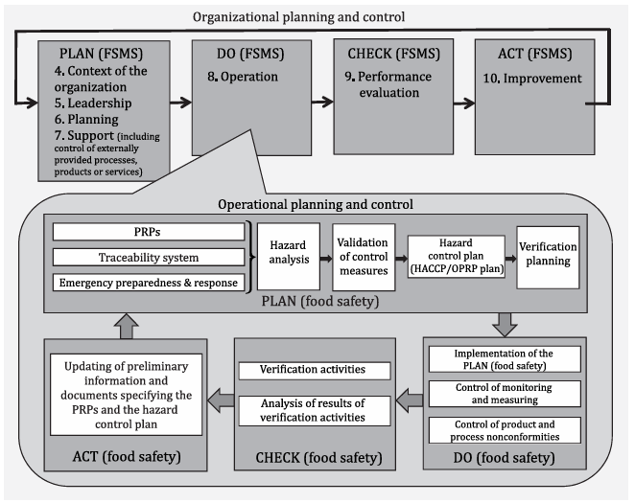
Fig. 20.1. Illustration of the Plan-Do-Check-Act cycle at the two levels (ISO 22000:2018)
0.3.3 Risk-based thinking
0.3.3.1 General
Risk-based thinking is essential for achieving an effective FSMS. In this document, risk-based thinking is addressed on two levels, organisational (see 0.3.3.2) and operational (see 0.3.3.3), which is consistent with the process approach described in 0.3.2.
0.3.3.2 Organisational risk management
Risk is the effect of uncertainty, and any such uncertainty can have positive or negative effects. In the context of organisational risk management, a positive deviation arising from a risk can provide an opportunity, but not all positive effects of risk result in opportunities. To conform to the requirements of this document, an organisation plans and implements actions to address organisational risks (Clause 6). Addressing risks establishes a basis for increasing the effectiveness of the FSMS, achieving improved results, and preventing negative effects.
0.3.3.3 Hazard analysis — operational processes
The concept of risk-based thinking based on the HACCP principles at the operational level is implicit in this document. The subsequent steps in HACCP can be considered as the necessary measures to prevent hazards or reduce hazards to acceptable levels to ensure food is safe at the time of consumption (Clause 8). Decisions taken in the application of HACCP should be based on science, free from bias and documented. The documentation should include any key assumptions in the decision-making process.
0.4 Relationship with other management system standards
This document has been developed within the ISO high-level structure (HLS). The objective of the HLS is to improve alignment between ISO management system standards. This document enables an organisation to use the process approach, coupled with the PDCA cycle and risk-based thinking, to align or integrate its FSMS approach with the requirements of other management systems and supporting standards. This document is the core principle and framework for FSMSs and sets out the specific FSMS requirements for organisations throughout the food chain. Other guidance related to food safety, specifications and/or requirements specific to food sectors can be used together with this framework. In addition, ISO has developed a family of associated documents. These include documents for: — prerequisite programmes (ISO/TS 22002 series) for specific sectors of the food chain; — requirements for auditing and certification bodies; — traceability.
ISO also provides guidance documents for organisations on how to implement this document and related standards. Information is available on the ISO website.
Food Safety Management Systems — requirements for any oOrganisation in the food chain
1. Scope
This document specifies requirements for a food safety management system (FSMS) to enable an organisation that is directly or indirectly involved in the food chain: a) to plan, implement, operate, maintain and update a FSMS providing products and services that are safe, in accordance with their intended use; b) to demonstrate compliance with applicable statutory and regulatory food safety requirements; c) to evaluate and assess mutually agreed customer food safety requirements and to demonstrate conformity with them; d) to effectively communicate food safety issues to interested parties within the food chain; e) to ensure that the organisation conforms to its stated food safety policy; f) to demonstrate conformity to relevant interested parties; g) to seek certification or registration of its FSMS by an external organisation, or make a self-assessment or self-declaration of conformity to this document.
All requirements of this document are generic and are intended to be applicable to all organisations in the food chain, regardless of size and complexity. Organisations that are directly or indirectly involved include, but are not limited to, feed producers, animal food producers, harvesters of wild plants and animals, farmers, producers of ingredients, food manufacturers, retailers, and organisations providing food services, catering services, cleaning and sanitation services, transportation, storage and distribution services, suppliers of equipment, cleaning and disinfectants, packaging materials and other food contact materials.
This document allows any organisation, including small and/or less developed organisations (e.g. a small farm, a small packer-distributor, a small retail or food service outlet) to implement externally-developed elements in their FSMS.
Internal and/or external resources can be used to meet the requirements of this document.
2. Normative references
There are no normative references in this document.
3. Terms and definitions
For the purposes of this document, the following terms and definitions apply. ISO and IEC maintain terminological databases for use in standardisation at the following addresses: — ISO Online browsing platform: available at https://www.iso.org/obp — IEC Electropedia: available at http://www.electropedia.org
- Acceptable level: of a food safety hazard not to be exceeded in the end product provided by the organisation.
- Action criterion measurable or observable specification for the monitoring of an OPRP.
- Note 1 to entry: An action criterion is established to determine whether an OPRP remains in control, and distinguishes between what is acceptable (criterion met or achieved means the OPRP is operating as intended) and unacceptable (criterion not met nor achieved means the OPRP is not operating as intended).
- Audit: systematic, independent and documented process for obtaining audit evidence and evaluating it objectively to determine the extent to which the audit criteria are fulfilled Note 1 to entry: An audit can be an internal audit (first party) or an external audit (second party or third party), and it can be a combined audit (combining two or more disciplines).
- Note 2 to entry: An internal audit is conducted by the organisation itself, or by an external party on its behalf.
- Note 3 to entry: “Audit evidence” and “audit criteria” are defined in ISO 19011.
- Note 4 to entry: Relevant disciplines are, for example, food safety management, quality management or environmental management.
- Competence: ability to apply knowledge and skills to achieve intended results conformity fulfilment of a requirement.
- Contamination: introduction or occurrence of a contaminant including a food safety hazard in a product or processing environment continual improvement recurring activity to enhance performance.
- Control measure: action or activity that is essential to prevent a significant food safety hazard or reduce it to an acceptable level.
- Note 1 to entry: See also significant food safety hazard.
- Note 2 to entry: Control measure(s) is (are) identified by hazard analysis.
- Correction action: to eliminate a detected nonconformity
- Note 1 to entry: A correction includes the handling of potentially unsafe products and can therefore be made in conjunction with a corrective action.
- Note 2 to entry: A correction may be, for example, reprocessing, further processing and/or elimination of the adverse consequences of the nonconformity (such as disposal for other use or specific labelling).
- Corrective action: action to eliminate the cause of a nonconformity and to prevent recurrence.
- Note 1 to entry: There can be more than one cause for a nonconformity.
- Note 2 to entry: Corrective action includes cause analysis.
- Critical control point CCP: step in the process at which control measure(s) is (are) applied to prevent or reduce a significant food safety hazard to an acceptable level, and defined critical limit(s) and measurement enable the application of corrections.
- Critical limit: measurable value which separates acceptability from unacceptability Note 1 to entry: Critical limits are established to determine whether a CCP remains in control. If a critical limit is exceeded or not met, the products affected are to be handled as potentially unsafe products. [SOURCE: CAC/RCP 1-1969, modified — the definition has been modified and Note 1 to entry has been added].
- Documented information: information required to be controlled and maintained by an organisation and the medium on which it is contained
- Note 1 to entry: Documented information can be in any format and media, and from any source.
- Note 2 to entry: Documented information can refer to: — the management system, including related processes; — information created in order for the organisation to operate (documentation); — evidence of results achieved (records).
- Effectiveness: extent to which planned activities are realized and planned results achieved.
- End product: product that will undergo no further processing or transformation by the organisation.
- Note 1 to entry: A product that undergoes further processing or transformation by another organisation is an end product in the context of the first organisation and a raw material or an ingredient in the context of the second organisation.
- Feed single or multiple product(s), whether processed, semi-processed or raw, which is (are) intended to be fed to food-producing animals
- Note 1 to entry: Distinctions are made in this document between the terms food, feed, and animal food:
— food is intended for consumption by humans and animals, and includes feed and animal food;
— feed is intended to be fed to food-producing animals;
— animal food is intended to be fed to non-food-producing animals, such as pets.
- Flow diagram: schematic and systematic presentation of the sequence and interactions of steps in the process.
- Food substance: (ingredient), whether processed, semi-processed or raw, which is intended for consumption, and includes drink, chewing gum and any substance which has been used in the manufacture, preparation or treatment of “food” but does not include cosmetics or tobacco or substances (ingredients) used only as drugs
- Note 1 to entry: Distinctions are made in this document between the terms food, feed and animal food:
— food is intended for consumption by humans and animals, and includes feed and animal food;
— feed is intended to be fed to food-producing animals; — animal food is intended to be fed to non-food-producing animals, such as pets. [SOURCE: CAC/GL 81-2013, modified
— The word “human” has been deleted.].
- Animal food: single or multiple product(s), whether processed, semi-processed or raw, which is (are) intended to be fed to non-food-producing animals Note 1 to entry: Distinctions are made in this document between the terms food, feed and animal food:
— food is intended for consumption by humans and animals, and includes feed and animal food;
— feed is intended to be fed to food-producing animals;
— animal food is intended to be fed to non-food-producing animals, such as pets
- Food chain: sequence of the stages in the production, processing, distribution, storage and handling of a food and its ingredients, from primary production to consumption.
Note 1 to entry: This includes the production of feed and animal food.
Note 2 to entry: The food chain also includes the production of materials intended to come into contact with food or raw materials.
Note 3 to entry: The food chain also includes service providers.
- Food safety: assurance that food will not cause an adverse health effect for the consumer when it is prepared and/or consumed in accordance with its intended use
- Note 1 to entry: Food safety is related to the occurrence of food safety hazards in end products and does not include other health aspects related to, for example, malnutrition.
- Note 2 to entry: It is not to be confused with the availability of, and access to, food (“food security”).
- Note 3 to entry: This includes feed and animal food. [SOURCE: CAC/RCP 1-1969, modified — the word “harm” has been changed to “adverse health effect” and notes to entry have been added].
- Food safety hazard: biological, chemical or physical agent in food with the potential to cause an adverse health effect.
- Note 1 to entry: The term “hazard” is not to be confused with the term “risk” which, in the context of food safety, means a function of the probability of an adverse health effect (e.g. becoming diseased) and the severity of that effect (e.g. death, hospitalisation) when exposed to a specified hazard.
- Note 2 to entry: Food safety hazards include allergens and radiological substances.
- Note 3 to entry: In the context of feed and feed ingredients, relevant food safety hazards are those that can be present in and/or on feed and feed ingredients and that can through animal consumption of feed be transferred to food and can thus have the potential to cause an adverse health effect for the animal or the human consumer. In the context of operations other than those directly handling feed and food (e.g. producers of packaging materials, disinfectants), relevant food safety hazards are those hazards that can be directly or indirectly transferred to food when used as intended.
- Note 4 to entry: In the context of animal food, relevant food safety hazards are those that are hazardous to the animal species for which the food is intended. [SOURCE: CAC/RCP 1-1969, modified — the phrase “or condition of” has been deleted from the definition and notes to entry have been added].
- Interested party: (preferred term) stakeholder (admitted term) person or organisation that can affect, be affected by, or perceive itself to be affected by a decision or activity 3.24 lot defined quantity of a product produced and/or processed and/or packaged essentially under the same conditions.
- Note 1 to entry: The lot is determined by parameters established beforehand by the organisation and may be described by other terms, e.g. batch.
- Note 2 to entry: The lot may be reduced to a single unit of product. [SOURCE: CODEX STAN 1, modified — Reference to “and/or processed and/or packaged” has been included in the definition and notes to entry have been added].
- Management system: set of interrelated or interacting elements of an organisation to establish policies and objectives and processes to achieve those objectives.
- Note 1 to entry: A management system can address a single discipline or several disciplines. - Note 2 to entry: The system elements include the organisation's structure, roles and responsibilities, planning and operation.
- Note 3 to entry: The scope of a management system may include the whole of the organisation, specific and identified functions of the organisation, specific and identified sections of the organisation, or one or more functions across a group of organisations.
- Note 4 to entry: Relevant disciplines are, for example, a quality management system or an environmental management system.
- Measurement process: to determine a value.
- Monitoring: determining the status of a system, a process or an activity.
- Note 1 to entry: To determine the status, there may be a need to check, supervise or critically observe.
- Note 2 to entry: In the context of food safety, monitoring is conducting a planned sequence of observations or measurements to assess whether a process is operating as intended.
- Note 3 to entry: Distinctions are made in this document between the terms validation, monitoring and verification:
— validation is applied prior to an activity and provides information about the capability to deliver intended results;
— monitoring is applied during an activity and provides information for action within a specified time frame;
— verification is applied after an activity and provides information for confirmation of conformity.
- Nonconformity: non-fulfilment of a requirement.
- Objective: result to be achieved.
- Note 1 to entry: An objective can be strategic, tactical, or operational.
- Note 2 to entry: Objectives can relate to different disciplines (such as financial, health and safety, and environmental goals) and can apply at different levels (such as strategic, organisation-wide, project, product and process).
- Note 3 to entry: An objective can be expressed in other ways, e.g. as an intended outcome, a purpose, an operational criterion, as a FSMS objective, or by the use of other words with similar meaning (e.g. aim, goal, or target).
- Note 4 to entry: In the context of FSMS, objectives are set by the organisation, consistent with the food safety policy, to achieve specific results.
- Operational prerequisite programme OPRP: control measure or combination of control measures applied to prevent or reduce a significant food safety hazard to an acceptable level, and where action criterion and measurement or observation enable effective control of the process and/or product.
- Organisation: person or group of people that has its own functions with responsibilities, authorities and relationships to achieve its objectives.
- Note 1 to entry: The concept of organisation includes, but is not limited to sole-trader, company, corporation, firm, enterprise, authority, partnership, charity or institution, or part or combination thereof, whether incorporated or not, public or private.
- Outsource:, verb make an arrangement where an external organisation performs part of an organisation’s function or process.
- Note 1 to entry: An external organisation is outside the scope of the management system, although the outsourced function or process is within the scope.
- Performance: measurable result.
- Note 1 to entry: Performance can relate either to quantitative or qualitative findings.
- Note 2 to entry: Performance can relate to the management of activities, processes, products (including services), systems or organisations.
- Policy: intentions and direction of an organisation as formally expressed by its top management.
- Prerequisite programme PRP: basic conditions and activities that are necessary within the organisation and throughout the food chain to maintain food safety.
- Note 1 to entry: The PRPs needed depend on the segment of the food chain in which the organisation operates and the type of organisation. Examples of equivalent terms are: good agricultural practice (GAP), good veterinary practice (GVP), good manufacturing practice (GMP), good hygiene practice (GHP), good production practice (GPP), good distribution practice (GDP) and good trading practice (GTP).
- Process: set of interrelated or interacting activities that transform inputs to outputs.
- Product: output that is a result of a process.
- Note 1 to entry: A product can be a service.
- Requirement: need or expectation that is stated, generally implied or obligatory.
- Note 1 to entry: “Generally implied” means that it is custom or common practice for the organisation and interested parties that the need or expectation under consideration is implied.
- Note 2 to entry: A specified requirement is one that is stated, for example in documented information.
- Risk: effect of uncertainty.
- Note 1 to entry: An effect is a deviation from the expected – positive or negative.
- Note 2 to entry: Uncertainty is the state, even partial, of deficiency of information related to, understanding or knowledge of, an event, its consequence, or likelihood.
- Note 3 to entry: Risk is often characterised by reference to potential “events” (as defined in ISO Guide 73:2009, 3.5.1.3) and “consequences” (as defined in ISO Guide 73:2009, 3.6.1.3), or a combination of these.
- Note 4 to entry: Risk is often expressed in terms of a combination of the consequences of an event (including changes in circumstances) and the associated “likelihood” (as defined in ISO Guide 73:2009, 3.6.1.1) of occurrence.
- Note 5 to entry: Food safety risk is a function of the probability of an adverse health effect and the severity of that effect, consequential to (a) hazard(s) in food, as specified in the Codex Procedural Manual.
- Significant food safety hazard: food safety hazard, identified through the hazard assessment, which needs to be controlled by control measures.
- Top management: person or group of people who directs and controls an organisation at the highest level.
- Note 1 to entry: Top management has the power to delegate authority and provide resources within the organisation.
- Note 2 to entry: If the scope of the management system covers only part of an organisation, then top management refers to those who direct and control that part of the organisation.
- Traceability: ability to follow the history, application, movement and location of an object through specified stage(s) of production, processing and distribution
- Note 1 to entry: Movement can relate to the origin of the materials, processing history or distribution of the food.
- Note 2 to entry: An object can be a product, a material, a unit, equipment, a service, etc. [SOURCE: CAC/GL 60-2006, modified — Notes to entry have been added].
- Update: immediate and/or planned activity to ensure application of the most recent information.
- Note 1 to entry: Update is different from the terms “maintain” and “retain”:
— “maintain” is to keep something on-going/to keep in good condition;
— “retain” is to keep something that is retrievable.
- Validation: obtaining evidence that a control measure (or combination of control measures) will be capable of effectively controlling the significant food safety hazard.
- Note 1 to entry: Validation is performed at the time a control measure combination is designed, or whenever changes are made to the implemented control measures.
- Note 2 to entry: Distinctions are made in this document between the terms validation, monitoring and verification:
— validation is applied prior to an activity and provides information about the capability to deliver intended results;
— monitoring is applied during an activity and provides information for action within a specified time frame;
— verification is applied after an activity and provides information for confirmation of conformity
- Verification: confirmation, through the provision of objective evidence, that specified requirements have been fulfilled.
- Note 1 to entry: Distinctions are made in this document between the terms validation, monitoring and verification:
— validation is applied prior to an activity and provides information about the capability to deliver intended results;
— monitoring is applied during an activity and provides information for action within a specified time frame;
— verification is applied after an activity and provides information for confirmation of conformity.
Food safety management system – Context of the organisation, leadership, planning, support, operation, performance evaluation, improvement (5 h)
4. Context of the organisation
4.1 Understanding the organisation and its context
The organisation shall determine external and internal issues that are relevant to its purpose and that affect its ability to achieve the intended result(s) of its FSMS. The organisation shall identify, review and update information related to these external and internal issues.
NOTE 1: Issues can include positive and negative factors or conditions for consideration.
NOTE 2: Understanding the context can be facilitated by considering external and internal issues, including, but not limited to, legal, technological, competitive, market, cultural, social and economic environments, cybersecurity and food fraud, food defence and intentional contamination, knowledge and performance of the organisation, whether international, national, regional or local.
4.2 Understanding the needs and expectations of interested parties
To ensure that the organisation has the ability to consistently provide products and services that meet applicable statutory, regulatory and customer requirements with regard to food safety, the organisation shall determine: a) the interested parties that are relevant to the FSMS; b) the relevant requirements of the interested parties of the FSMS.
The organisation shall identify, review and update information related to the interested parties and their requirements.
4.3 Determining the scope of the food safety management system
The organisation shall determine the boundaries and applicability of the FSMS to establish its scope. The scope shall specify the products and services, processes and production site(s) that are included in the FSMS. The scope shall include the activities, processes, products or services that can have an influence on the food safety of its end products.
When determining this scope, the organisation shall consider: a) the external and internal issues referred to in 4.1; b) the requirements referred to in 4.2.
The scope shall be available and maintained as documented information.
4.4 Food Safety Management System
The organisation shall establish, implement, maintain, update, and continually improve a FSMS, including the processes needed and their interactions, in accordance with the requirements of this document.
5. Leadership
5.1 Leadership and commitment
Top management shall demonstrate leadership and commitment with respect to the FSMS by: a) ensuring that the food safety policy and the objectives of the FSMS are established and are compatible with the strategic direction of the organisation; b) ensuring the integration of the FSMS requirements into the organisation’s business processes; c) ensuring that the resources needed for the FSMS are available; d) communicating the importance of effective food safety management and conforming to the FSMS requirements, applicable statutory and regulatory requirements, and mutually agreed customer requirements related to food safety; e) ensuring that the FSMS is evaluated and maintained to achieve its intended result(s) (see 4.1); f) directing and supporting persons to contribute to the effectiveness of the FSMS; g) promoting continual improvement; h) supporting other relevant management roles to demonstrate their leadership as it applies to their areas of responsibility.
NOTE: Reference to “business” in this document can be interpreted broadly to mean those activities that are core to the purposes of the organisation’s existence.
5.2 Policy
5.2.1 Establishing the food safety policy
Top management shall establish, implement, and maintain a food safety policy that: a) is appropriate to the purpose and context of the organisation; b) provides a framework for setting and reviewing the objectives of the FSMS; c) includes a commitment to satisfy applicable food safety requirements, including statutory and regulatory requirements and mutually agreed customer requirements related to food safety; d) addresses internal and external communication; e) includes a commitment to continual improvement of the FSMS; f) addresses the need to ensure competencies related to food safety.
5.2.2 Communicating the Food Safety Policy
The food safety policy shall: a) be available and maintained as documented information; b) be communicated, understood, and applied at all levels within the organisation; c) be available to relevant interested parties, as appropriate.
5.3 Organisational roles, responsibilities, and authorities
5.3.1 Top management shall ensure that the responsibilities and authorities for relevant roles are assigned, communicated, and understood within the organisation. Top management shall assign the responsibility and authority for: a) ensuring that the FSMS conforms to the requirements of this document; b) reporting on the performance of the FSMS to top management; c) appointing the food safety team and the food safety team leader; d) designating persons with defined responsibility and authority to initiate and document action(s).
5.3.2 The food safety team leader shall be responsible for: a) ensuring the FSMS is established, implemented, maintained, and updated; b) managing and organising the work of the food safety team; c) ensuring relevant training and competencies for the food safety team (see 7.2); d) reporting to top management on the effectiveness and suitability of the FSMS.
5.3.3 All persons shall have the responsibility to report problem(s) with regards to the FSMS to identified person(s).
6. Planning
6.1 Actions to address risks and opportunities
6.1.1 When planning for the FSMS, the organisation shall consider the issues referred to in 4.1 and the requirements referred to in 4.2 and 4.3 and determine the risks and opportunities that need to be addressed to: a) give assurance that the FSMS can achieve its intended result(s); b) enhance desirable effects; c) prevent, or reduce, undesired effects; d) achieve continual improvement.
NOTE: In the context of this document, the concept of risks and opportunities is limited to events and their consequences relating to the performance and effectiveness of the FSMS. Public authorities are responsible for addressing public health risks. Organisations are required to manage food safety hazards (see 3.22) and the requirements related to this process that are laid down in Clause 8.
6.1.2 The organisation shall plan: a) actions to address these risks and opportunities; b) how to:
- integrate and implement the actions into its FSMS processes;
- evaluate the effectiveness of these actions.
6.1.3 The actions taken by the organisation to address risks and opportunities shall be proportionate to: a) the impact on food safety requirements; b) the conformity of food products and services to customers; c) requirements of interested parties in the food chain.
NOTE 1: Actions to address risks and opportunities can include: avoiding risk, taking risk in order to pursue an opportunity, eliminating the risk source, changing the likelihood or consequences, sharing the risk, or accepting the presence of risk by informed decision.
NOTE 2: Opportunities can lead to the adoption of new practices (modification of products or processes), using new technology and other desirable and viable possibilities to address the food safety needs of the organisation or its customers.
6.2 Objectives of the Food Safety Management System and planning to achieve them
6.2.1 The organisation shall establish objectives for the FSMS at relevant functions and levels. The objectives of the FSMS shall: a) be consistent with the food safety policy; b) be measurable (if practicable); c) take into account applicable food safety requirements, including statutory, regulatory and customer requirements; d) be monitored and verified; e) be communicated; f) be maintained and updated as appropriate.
The organisation shall retain documented information on the objectives for the FSMS.
6.2.2 When planning how to achieve its objectives for the FSMS, the organisation shall determine: a) what will be done; b) what resources will be required; c) who will be responsible; d) when it will be completed; e) how the results will be evaluated.
6.3 Planning of changes
When the organisation determines the need for changes to the FSMS, including personnel changes, the changes shall be carried out and communicated in a planned manner. The organisation shall consider: a) the purpose of the changes and their potential consequences; b) the continued integrity of the FSMS; c) the availability of resources to effectively implement the changes; d) the allocation or re-allocation of responsibilities and authorities.
7. Support
7.1 Resources
7.1.1 General
The organisation shall determine and provide the resources needed for the establishment, implementation, maintenance, update, and continual improvement of the FSMS. The organisation shall consider: a) the capability of, and any constraints on, existing internal resources; b) the need for external resources.
7.1.2 People
The organisation shall ensure that persons necessary to operate and maintain an effective FSMS are competent (see 7.2). Where the assistance of external experts is used for the development, implementation, operation, or assessment of the FSMS, evidence of agreement or contracts defining the competency, responsibility, and authority of external experts shall be retained as documented information.
7.1.3 Infrastructure
The organisation shall provide the resources for the determination, establishment, and maintenance of the infrastructure necessary to achieve conformity with the requirements of the FSMS.
NOTE: Infrastructure can include: — land, vessels, buildings, and associated utilities; — equipment, including hardware and software; — transportation; — information and communication technology.
7.1.4 Work Environment
The organisation shall determine, provide, and maintain the resources for the establishment, management, and maintenance of the work environment necessary to achieve conformity with the requirements of the FSMS.
NOTE: A suitable environment can be a combination of human and physical factors such as: a) social (e.g. non-discriminatory, calm, non-confrontational); b) psychological (e.g. stress-reducing, burnout prevention, emotionally protective); c) physical (e.g. temperature, heat, humidity, light, air flow, hygiene, noise).
These factors can differ substantially depending on the products and services provided.
7.1.5 Externally developed elements of the Food Safety Management System
When an organisation establishes, maintains, updates, and continually improves its FSMS by using externally developed elements of an FSMS, including PRPs, the hazard analysis, and the hazard control plan (see 8.5.4), the organisation shall ensure that the provided elements are: a) developed in conformance with the requirements of this document; b) applicable to the sites, processes, and products of the organisation; c) specifically adapted to the processes and products of the organisation by the food safety team; d) implemented, maintained, and updated as required by this document; e) retained as documented information.
7.1.6 Control of externally provided processes, products, or services
The organisation shall: a) establish and apply criteria for the evaluation, selection, monitoring of performance, and re-evaluation of external providers of processes, products, and/or services; b) ensure adequate communication of requirements to the external provider(s); c) ensure that externally provided processes, products, or services do not adversely affect the organisation's ability to consistently meet the requirements of the FSMS; d) retain documented information of these activities and any necessary actions as a result of the evaluations and re-evaluations.
7.2 Competence
The organisation shall: a) determine the necessary competence of person(s), including external providers, doing work under its control that affects its food safety performance and effectiveness of the FSMS; b) ensure that these persons, including the food safety team and those responsible for the operation of the hazard control plan, are competent on the basis of appropriate education, training, and/or experience; c) ensure that the food safety team has a combination of multi-disciplinary knowledge and experience in developing and implementing the FSMS (including, but not limited to, the organisation’s products, processes, equipment, and food safety hazards within the scope of the FSMS); d) where applicable, take actions to acquire the necessary competence, and evaluate the effectiveness of the actions taken; e) retain appropriate documented information as evidence of competence.
NOTE: Applicable actions can include, for example, the provision of training to, the mentoring of, or the re-assignment of currently employed persons; or the hiring or contracting of competent persons.
7.3 Awareness
The organisation shall ensure that all relevant persons doing work under the organisation’s control shall be aware of: a) the food safety policy; b) the objectives of the FSMS relevant to their task(s); c) their individual contribution to the effectiveness of the FSMS, including the benefits of improved food safety performance; d) the implications of not conforming with the FSMS requirements.
7.4 Communication
7.4.1 General
The organisation shall determine the internal and external communications relevant to the FSMS, including: a) on what it will communicate; b) when to communicate; c) with whom to communicate; d) how to communicate; e) who communicates.
The organisation shall ensure that the requirement for effective communication is understood by all persons whose activities have an impact on food safety.
7.4.2 External communication
The organisation shall ensure that sufficient information is communicated externally and is available for interested parties of the food chain. The organisation shall establish, implement, and maintain effective communications with: a) external providers and contractors; b) customers and/or consumers, in relation to:
- product information related to food safety, to enable the handling, display, storage, preparation, distribution, and use of the product within the food chain or by the consumer;
- identified food safety hazards that need to be controlled by other organisations in the food chain and/or by consumers;
- contractual arrangements, enquiries, and orders, including their amendments;
- customer and/or consumer feedback, including complaints; c) statutory and regulatory authorities; d) other organisations that have an impact on, or will be affected by, the effectiveness or updating of the FSMS.
Designated persons shall have defined responsibility and authority for the external communication of any information concerning food safety. Where relevant, information obtained through external communication shall be included as input for management review (see 9.3) and for updating the FSMS (see 4.4 and 10.3). Evidence of external communication shall be retained as documented information.
7.4.3 Internal Communication
The organisation shall establish, implement, and maintain an effective system for communicating issues having an impact on food safety. To maintain the effectiveness of the FSMS, the organisation shall ensure that the food safety team is informed in a timely manner of changes in the following: a) products or new products; b) raw materials, ingredients, and services; c) production systems and equipment; d) production premises, location of equipment, and surrounding environment; e) cleaning and sanitation programmes; f) packaging, storage, and distribution systems; g) competencies and/or allocation of responsibilities and authorisations; h) applicable statutory and regulatory requirements; i) knowledge regarding food safety hazards and control measures; j) customer, sector, and other requirements that the organisation observes; k) relevant enquiries and communications from external interested parties; l) complaints and alerts indicating food safety hazards associated with the end product; m) other conditions that have an impact on food safety.
The food safety team shall ensure that this information is included when updating the FSMS (see 4.4 and 10.3). Top management shall ensure that relevant information is included as input to the management review (see 9.3).
7.5 Documented information
7.5.1 General
The organisation’s FSMS shall include: a) documented information required by this document; b) documented information determined by the organisation as being necessary for the effectiveness of the FSMS; c) documented information and food safety requirements required by statutory, regulatory authorities, and customers.
NOTE: The extent of documented information for an FSMS can differ from one organisation to another due to: — the size of the organisation and its type of activities, processes, products, and services; — the complexity of processes and their interactions; — the competence of persons.

7.5.2 Creating and updating
When creating and updating documented information, the organisation shall ensure appropriate: a) identification and description (e.g. a title, date, author, or reference number); b) format (e.g. language, software version, graphics) and media (e.g. paper, electronic); c) review and approval for suitability and adequacy.
7.5.3 Control of documented information
7.5.3.1 Documented information required by the FSMS and by this document shall be controlled to ensure: a) it is available and suitable for use, where and when it is needed; b) it is adequately protected (e.g. from loss of confidentiality, improper use, or loss of integrity).
7.5.3.2 For the control of documented information, the organisation shall address the following activities, as applicable: a) distribution, access, retrieval, and use; b) storage and preservation, including preservation of legibility; c) control of changes (e.g. version control); d) retention and disposition.
Documented information of external origin determined by the organisation to be necessary for the planning and operation of the FSMS shall be identified, as appropriate, and controlled. Documented information retained as evidence of conformity shall be protected from unintended alterations.
NOTE: Access can imply a decision regarding the permission to view the documented information only, or the permission and authority to view and change the documented information.
8. Operation
8.1 Operational planning and control
The organisation shall plan, implement, control, maintain, and update the processes needed to meet requirements for the realisation of safe products, and to implement the actions determined in 6.1, by: a) establishing criteria for the processes; b) implementing control of the processes in accordance with the criteria; c) keeping documented information to the extent necessary to have the confidence to demonstrate that the processes have been carried out as planned.
The organisation shall control planned changes and review the consequences of unintended changes, taking action to mitigate any adverse effects, as necessary. The organisation shall ensure that outsourced processes are controlled (see 7.1.6).

8.2 Prerequisite programmes (PRPs)
8.2.1 The organisation shall establish, implement, maintain, and update PRP(s) to facilitate the prevention and/or reduction of contaminants (including food safety hazards) in the products, product processing, and work environment.
8.2.2 The PRP(s) shall be: a) appropriate to the organisation and its context with regard to food safety; b) appropriate to the size and type of the operation and the nature of the products being manufactured and/or handled; c) implemented across the entire production system, either as programmes applicable in general or as programmes applicable to a particular product or process; d) approved by the food safety team.
8.2.3 When selecting and/or establishing PRP(s), the organisation shall ensure that applicable statutory, regulatory, and mutually agreed customer requirements are identified. The organisation should consider: a) the applicable part of the ISO/TS 22002 series; b) applicable standards, codes of practice, and guidelines.
8.2.4 When establishing PRP(s) the organisation shall consider: a) construction, layout of buildings, and associated utilities; b) layout of premises, including zoning, workspace, and employee facilities; c) supplies of air, water, energy, and other utilities; d) pest control, waste and sewage disposal, and supporting services; e) the suitability of equipment and its accessibility for cleaning and maintenance; f) supplier approval and assurance processes (e.g. raw materials, ingredients, chemicals, and packaging); g) reception of incoming materials, storage, dispatch, transportation, and handling of products; h) measures for the prevention of cross contamination; i) cleaning and disinfecting; j) personal hygiene; k) product information/consumer awareness; l) others, as appropriate.
Documented information shall specify the selection, establishment, applicable monitoring, and verification of the PRP(s).
8.3 Traceability system
The traceability system shall be able to uniquely identify incoming material from the suppliers and the first stage of the distribution route of the end product. When establishing and implementing the traceability system, the following shall be considered as a minimum: a) relation of lots of received materials, ingredients, and intermediate products to the end products; b) reworking of materials/products; c) distribution of the end product.
The organisation shall ensure that applicable statutory, regulatory, and customer requirements are identified. The organisation shall verify and test the effectiveness of the traceability system.
NOTE: Where appropriate, the verification of the system is expected to include the reconciliation of quantities of end products with the quantity of ingredients as evidence of effectiveness.
8.4 Emergency preparedness and response
8.4.1 General
Top management shall ensure procedures are in place to respond to potential emergency situations or incidents that can have an impact on food safety which are relevant to the role of the organisation in the food chain. Documented information shall be established and maintained to manage these situations and incidents.
8.4.2 Handling of emergencies and incidents
The organisation shall: a) respond to actual emergency situations and incidents by:
- ensuring applicable statutory and regulatory requirements are identified;
- communicating internally;
- communicating externally (e.g. suppliers, customers, appropriate authorities, media); b) take action to reduce the consequences of the emergency situation, appropriate to the magnitude of the emergency or incident and the potential food safety impact; c) periodically test procedures where practical; d) review and, where necessary, update the documented information after the occurrence of any incident, emergency situation, or tests.
NOTE: Examples of emergency situations that can affect food safety and/or production are natural disasters, environmental accidents, bioterrorism, workplace accidents, public health emergencies, and other accidents, e.g. interruption of essential services such as water, electricity, or refrigeration supply.
8.5 Hazard control
8.5.1 Preliminary steps to enable hazard analysis
8.5.1.1 General
To carry out the hazard analysis, preliminary documented information shall be collected, maintained, and updated by the food safety team. This shall include, but not be limited to: a) applicable statutory, regulatory, and customer requirements; b) the organisation’s products, processes, and equipment; c) food safety hazards relevant to the FSMS.
8.5.1.2 Characteristics of raw materials, ingredients, and product contact materials
The organisation shall ensure that all applicable statutory and regulatory food safety requirements are identified for all raw materials, ingredients, and product contact materials. The organisation shall maintain documented information concerning all raw materials, ingredients, and product contact materials to the extent needed to conduct the hazard analysis (see 8.5.2), including the following, as appropriate: a) biological, chemical, and physical characteristics; b) composition of formulated ingredients, including additives and processing aids; c) source (e.g. animal, mineral, or vegetable); d) place of origin (provenance); e) method of production; f) method of packaging and delivery; g) storage conditions and shelf life; h) preparation and/or handling before use or processing; i) acceptance criteria related to food safety or specifications of purchased materials and ingredients appropriate to their intended use.
8.5.1.3 Characteristics of End Products
The organisation shall ensure that all applicable statutory and regulatory food safety requirements are identified for all the end products intended to be produced. The organisation shall maintain documented information concerning the characteristics of end products to the extent needed to conduct the hazard analysis (see 8.5.2), including information on the following, as appropriate: a) product name or similar identification; b) composition; c) biological, chemical, and physical characteristics relevant for food safety; d) intended shelf life and storage conditions; e) packaging; f) labelling relating to food safety and/or instructions for handling, preparation, and intended use; g) method(s) of distribution and delivery.
8.5.1.4 Intended Use
The intended use, including reasonably expected handling of the end product and any unintended use but reasonably expected mishandling and misuse of the end product, shall be considered and shall be maintained as documented information to the extent needed to conduct the hazard analysis (see 8.5.2). Where appropriate, groups of consumers/users shall be identified for each product. Groups of consumers/users known to be especially vulnerable to specific food safety hazards shall be identified.
8.5.1.5 Flow diagrams and process steps
8.5.1.5.1 Flow diagrams
The food safety team shall prepare flow diagrams that provide an overview of the processes within the scope of the FSMS. These diagrams shall include: a) the sequence and interaction of the steps in the operation; b) any outsourced processes and outsourced product or service providers; c) the functions and processes, including PRPs, that occur within the scope of the FSMS; d) where raw materials, ingredients, intermediate products, and end products enter and leave the system; e) where end products, intermediate products, by-products, and waste are released or removed.
8.5.1.5.2 On-site confirmation of flow diagrams
The food safety team shall confirm on-site the accuracy of the flow diagrams, update the flow diagrams where appropriate, and retain them as documented information.
8.5.1.5.3 Description of processes and process environment
The food safety team shall describe, to the extent needed to conduct the hazard analysis: a) the layout of premises, including food and non-food handling areas; b) processing equipment and contact materials, processing aids, and flow of materials; c) existing PRPs, process parameters, control measures (if any) and/or the strictness with which they are applied, or procedures that can influence food safety; d) external requirements (e.g. from statutory and regulatory authorities or customers) that can impact the choice and the strictness of the control measures.
The variations resulting from expected seasonal changes or shift patterns shall be included as appropriate. The descriptions shall be updated as appropriate and maintained as documented information.
8.5.2 Hazard analysis
8.5.2.1 General
The food safety team shall conduct a hazard analysis, based on the preliminary information, to determine the hazards that need to be controlled. The degree of control shall ensure food safety and, where appropriate, a combination of control measures shall be used.
8.5.2.2 Identification of Hazards
8.5.2.2.1 The organisation shall identify and list the food safety hazards reasonably expected to occur in relation to the type of product, type of process, and actual processing conditions. The organisation shall seek information from staff and external experts who are familiar with the product and/or processes in other facilities.
NOTE 1: This may include information from the sources referred to in 8.5.1.
NOTE 2: Statutory and regulatory requirements can include food safety objectives (FSOs). The Codex Alimentarius Commission defines FSOs as “The maximum frequency and/or concentration of a hazard in a food at the time of consumption that provides or contributes to the appropriate level of protection (ALOP).”
8.5.2.2.2 The organisation shall identify step(s) (e.g. receiving raw materials, processing, distribution, and delivery) at which each food safety hazard can be present, be introduced, increase, or persist. When identifying hazards, the organisation shall consider: a) the stages preceding and following in the food chain; b) all steps in the flow diagram; c) the process equipment, utilities/services, process environment, and persons.
8.5.2.2.3 The organisation shall determine the acceptable level in the end product of each food safety hazard identified, whenever possible. When determining acceptable levels, the organisation shall: a) ensure that applicable statutory, regulatory, and customer requirements are identified; b) consider the intended use of end products; c) consider any other relevant information.
The organisation shall maintain documented information concerning the determination of acceptable levels and the justification for the acceptable levels.
8.5.2.3 Hazard assessment
The organisation shall conduct, for each identified food safety hazard, a hazard assessment to determine whether its prevention or reduction to an acceptable level is essential. The organisation shall evaluate each food safety hazard with regard to: a) the likelihood of its occurrence in the end product prior to application of control measures; b) the severity of its adverse health effects in relation to the intended use (see 8.5.1.4).
The organisation shall identify any significant food safety hazards. The methodology used shall be described, and the result of the hazard assessment shall be maintained as documented information.
8.5.2.4 Selection and categorization of control measure(s)
8.5.2.4.1 Based on the hazard assessment, the organisation shall select an appropriate control measure or combination of control measures that will be capable of preventing or reducing the identified significant food safety hazards to defined acceptable levels. The organisation shall categorise the selected identified control measure(s) to be managed as OPRP(s) (see 3.30) or at CCPs (see 3.11). The categorisation shall be carried out using a systematic approach. For each of the control measures selected, there shall be an assessment of the following: a) the likelihood of failure of its functioning; b) the severity of the consequence in the case of failure of its functioning; this assessment shall include:
- the effect on identified significant food safety hazards;
- the location in relation to other control measure(s);
- whether it is specifically established and applied to reduce the hazards to an acceptable level;
- whether it is a single measure or is part of a combination of control measure(s).
8.5.2.4.2 In addition, for each control measure, the systematic approach shall include an assessment of the feasibility of: a) establishing measurable critical limits and/or measurable/observable action criteria; b) monitoring to detect any failure to remain within critical limit and/or measurable/observable action criteria; c) applying timely corrections in case of failure.
The decision-making process and results of the selection and categorisation of the control measures shall be maintained as documented information. External requirements (e.g. statutory, regulatory, and customer requirements) that can impact the choice and the strictness of the control measures shall also be maintained as documented information.
8.5.3 Validation of control measure(s) and combinations of control measures
The food safety team shall validate that the selected control measures are capable of achieving the intended control of the significant food safety hazard(s). This validation shall be done prior to implementation of control measure(s) and combinations of control measures to be included in the hazard control plan (see 8.5.4) and after any change therein (see 7.4.2, 7.4.3, 10.2, and 10.3). When the result of validation shows that the control measure(s) is (are) not capable of achieving the intended control, the food safety team shall modify and re-assess the control measure(s) and/or combination(s) of control measure(s).
The food safety team shall maintain the validation methodology and evidence of capability of the control measure(s) to achieve the intended control as documented information.
NOTE: Modification can include changes in control measure(s) (i.e. process parameters, rigour and/or their combination) and/or change(s) in the manufacturing technologies for raw materials, end product characteristics, methods of distribution, and intended use of the end products.
8.5.4 Hazard control plan (HACCP/OPRP plan)
8.5.4.1 General
The organisation shall establish, implement, and maintain a hazard control plan. The hazard control plan shall be maintained as documented information and shall include the following information for each control measure at each CCP or OPRP: a) food safety hazard(s) to be controlled at the CCP or by the OPRP; b) critical limit(s) at CCP or action criteria for OPRP; c) monitoring procedure(s); d) correction(s) to be made if critical limits or action criteria are not met; e) responsibilities and authorities; f) records of monitoring.
8.5.4.2 Determination of critical limits and action criteria
Critical limits at CCPs and action criteria for OPRPs shall be specified. The rationale for their determination shall be maintained as documented information. Critical limits at CCPs shall be measurable. Conformance with critical limits shall ensure that the acceptable level is not exceeded. Action criteria for OPRPs shall be measurable or observable. Conformance with action criteria shall contribute to the assurance that the acceptable level is not exceeded.
8.5.4.3 Monitoring systems at CCPs and for OPRPs
At each CCP, a monitoring system shall be established for each control measure or combination of control measure(s) to detect any failure to remain within the critical limits. The system shall include all scheduled measurements relative to the critical limit(s). For each OPRP, a monitoring system shall be established for the control measure or combination of control measure(s) to detect failure to meet the action criterion. The monitoring system, at each CCP and for each OPRP, shall consist of documented information, including: a) measurements or observations that provide results within an adequate time frame; b) monitoring methods or devices used; c) applicable calibration methods or, for OPRPs, equivalent methods for verification of reliable measurements or observations (see 8.7); d) monitoring frequency; e) monitoring results; f) responsibility and authority related to monitoring.
8.6 Updating the information specifying the PRPs and the hazard control plan
Following the establishment of the hazard control plan, the organisation shall update the following information, if necessary: a) characteristics of raw materials, ingredients, and product-contact materials; b) characteristics of end products; c) intended use; d) flow diagrams and descriptions of processes and process environment.
The organisation shall ensure that the hazard control plan and/or the PRP(s) are up to date.
8.7 Control of monitoring and measuring
The organisation shall provide evidence that the specified monitoring and measuring methods and equipment in use are adequate for the monitoring and measuring activities related to the PRP(s) and the hazard control plan. The monitoring and measuring equipment used shall be: a) calibrated or verified at specified intervals prior to use; b) adjusted or re-adjusted as necessary; c) identified to enable the calibration status to be determined; d) safeguarded from adjustments that would invalidate the measurement results; e) protected from damage and deterioration.
The results of calibration and verification shall be retained as documented information. The calibration of all the equipment shall be traceable to international or national measurement standards; where no standards exist, the basis used for calibration or verification shall be retained as documented information. The organisation shall assess the validity of the previous measurement results when the equipment or process environment is found not to conform to requirements. The organisation shall take appropriate action in relation to the equipment or process environment and any product affected by the non-conformance. The assessment and resulting action shall be maintained as documented information. Software used in monitoring and measuring within the FSMS shall be validated by the organisation, software supplier, or third party prior to use. Documented information on validation activities shall be maintained by the organisation and the software shall be updated in a timely manner. Whenever there are changes, including software configuration/modifications to commercial off-the-shelf software, they shall be authorized, documented, and validated before implementation.
NOTE: Commercial off-the-shelf software in general use within its designed application range can be considered to be sufficiently validated.
8.8 Verification related to PRPs and the hazard control plan
8.8.1 Verification
The organisation shall establish, implement, and maintain verification activities. The verification planning shall define purpose, methods, frequencies, and responsibilities for the verification activities. The verification activities shall confirm that: a) the PRP(s) are implemented and effective; b) the hazard control plan is implemented and effective; c) hazard levels are within identified acceptable levels; d) input to the hazard analysis is updated; e) other actions determined by the organisation are implemented and effective.
The organisation shall ensure that verification activities are not carried out by the person responsible for monitoring the same activities. Verification results shall be retained as documented information and shall be communicated. Where verification is based on testing of end product samples or direct process samples and where such test samples show nonconformity with the acceptable level of the food safety hazard (see 8.5.2.2), the organisation shall handle the affected lot(s) of product as potentially unsafe (see 8.9.4.3) and apply corrective actions in accordance with 8.9.3.
8.8.2 Analysis of results of verification activities
The food safety team shall conduct an analysis of the results of verification that shall be used as an input to the performance evaluation of the FSMS (see 9.1.2).
8.9 Control of product and process non-conformities
8.9.1 General
The organisation shall ensure that data derived from the monitoring of OPRPs and at CCPs are evaluated by designated persons who are competent and have the authority to initiate corrections and corrective actions.
8.9.2 Corrections
8.9.2.1 The organisation shall ensure that when critical limits at CCP(s) and/or action criteria for OPRPs are not met, the products affected are identified and controlled with regard to their use and release. The organisation shall establish, maintain, and update documented information that includes: a) a method of identification, assessment, and correction for affected products to ensure their proper handling; b) arrangements for review of the corrections carried out.
8.9.2.2 When critical limits at CCPs are not met, affected products shall be identified and handled as potentially unsafe products (see 8.9.4).
8.9.2.3 Where action criteria for an OPRP are not met, the following shall be carried out: a) determination of the consequences of that failure with respect to food safety; b) determination of the cause(s) of failure; c) identification of the affected products and handling in accordance with 8.9.4.
The organisation shall retain results of the evaluation as documented information.
8.9.2.4 Documented information shall be retained to describe corrections made on non-conforming products and processes, including: a) the nature of the non-conformity; b) the cause(s) of the failure; c) the consequences as a result of the non-conformity.
8.9.3 Corrective actions
The need for corrective actions shall be evaluated when critical limits at CCP(s) and/or action criteria for OPRPs are not met. The organisation shall establish and maintain documented information that specifies appropriate actions to identify and eliminate the cause of detected non-conformities, to prevent recurrence, and to return the process to control after a non-conformity is identified. These actions shall include: a) reviewing nonconformities identified by customer and/or consumer complaints and/or regulatory inspection reports; b) reviewing trends in monitoring results that can indicate loss of control; c) determining the cause(s) of non-conformities; d) determining and implementing actions to ensure that non-conformities do not recur; e) documenting the results of corrective actions taken; f) verifying corrective actions taken to ensure that they are effective.
The organisation shall retain documented information on all corrective actions.
8.9.4 Handling of potentially unsafe products
8.9.4.1 General
The organisation shall take action(s) to prevent potentially unsafe products from entering the food chain, unless it can demonstrate that: a) the food safety hazard(s) of concern is (are) reduced to the defined acceptable levels; b) the food safety hazard(s) of concern will be reduced to identified acceptable levels prior to entering the food chain; or c) the product still meets the defined acceptable level(s) of the food safety hazard(s) of concern despite the nonconformity.
The organisation shall retain products that have been identified as potentially unsafe under its control until the products have been evaluated and the disposition has been determined. If products that have left the control of the organisation are subsequently determined to be unsafe, the organisation shall notify relevant interested parties and initiate a withdrawal/recall (see 8.9.5). The controls and related responses from relevant interested parties and authorisation for dealing with potentially unsafe products shall be retained as documented information.
8.9.4.2 Evaluation for release
Each lot of products affected by the nonconformity shall be evaluated. Products affected by failure to remain within critical limits at CCPs shall not be released, but shall be handled in accordance with 8.9.4.3.
8.9.4.3 Disposition of Nonconforming Products
Products that are not acceptable for release shall be: a) reprocessed or further processed within or outside the organisation to ensure that the food safety hazard is reduced to acceptable levels; or b) redirected for other use as long as food safety in the food chain is not affected; or c) destroyed and/or disposed as waste.
Documented information on the disposition of nonconforming products, including the identification of the person(s) with approving authority, shall be retained.
8.9.5 Withdrawal/Recall
The organisation shall be able to ensure the timely withdrawal/recall of lots of end products that have been identified as potentially unsafe, by appointing competent person(s) having the authority to initiate and carry out the withdrawal/recall. The organisation shall establish and maintain documented information for: a) notifying relevant interested parties (e.g. statutory and regulatory authorities, customers and/or consumers); b) handling withdrawn/recalled products as well as products still in stock; c) performing the sequence of actions to be taken.
Withdrawn/recalled products and end products still in stock shall be secured or held under the control of the organisation until they are managed in accordance with 8.9.4.3. The cause, extent, and result of a withdrawal/recall shall be retained as documented information and reported to top management as input for the management review (see 9.3). The organisation shall verify the implementation and effectiveness of withdrawals/recalls through the use of appropriate techniques (e.g. mock withdrawal/recall or practice withdrawal/recall) and retain documented information.
9 Performance evaluation
9.1 Monitoring, measurement, analysis, and evaluation
9.1.1 General
The organisation shall determine: a) what needs to be monitored and measured; b) the methods for monitoring, measurement, analysis, and evaluation, as applicable, to ensure valid results; c) when the monitoring and measuring shall be performed; d) when the results from monitoring and measurement shall be analysed and evaluated; e) who shall analsze and evaluate the results from monitoring and measurement.
The organisation shall retain appropriate documented information as evidence of the results. The organisation shall evaluate the performance and the effectiveness of the FSMS.
9.1.2 Analysis and evaluation
The organisation shall analyse and evaluate appropriate data and information arising from monitoring and measurement, including the results of verification activities related to PRPs and the hazard control plan (see 8.8 and 8.5.4), the internal audits (see 9.2), and external audits. The analysis shall be carried out: a) to confirm that the overall performance of the system meets the planned arrangements and the FSMS requirements established by the organisation; b) to identify the need for updating or improving the FSMS; c) to identify trends which indicate a higher incidence of potentially unsafe products or process failures; d) to establish information for planning of the internal audit programme related to the status and importance of areas to be audited; e) to provide evidence that corrections and corrective actions are effective.
The results of the analysis and the resulting activities shall be retained as documented information. The results shall be reported to top management and used as input to the management review (see 9.3) and the updating of the FSMS (see 10.3).
NOTE: Methods to analyse data can include statistical techniques.
9.2 Internal audit
9.2.1 The organisation shall conduct internal audits at planned intervals to provide information on whether the FSMS: a) conforms to:
- the organisation’s own requirements for its FSMS;
- the requirements of this document; b) is effectively implemented and maintained.
9.2.2 The organisation shall: a) plan, establish, implement, and maintain (an) audit programme(s), including the frequency, methods, responsibilities, planning requirements, and reporting, which shall take into consideration the importance of the processes concerned, changes in the FSMS, and the results of monitoring, measurement, and previous audits; b) define the audit criteria and scope for each audit; c) select competent auditors and conduct audits to ensure objectivity and the impartiality of the audit process; d) ensure that the results of the audits are reported to the food safety team and relevant management; e) retain documented information as evidence of the implementation of the audit programme and the audit results; f) make the necessary correction and take the necessary corrective action within the agreed time frame; g) determine if the FSMS meets the intent of the food safety policy (see 5.2) and objectives of the FSMS (see 6.2).
Follow-up activities by the organisation shall include the verification of the actions taken and the reporting of the verification results.
NOTE: ISO 19011 provides guidelines for auditing management systems.
9.3 Management review
9.3.1 General
Top management shall review the organisation’s FSMS at planned intervals to ensure its continuing suitability, adequacy, and effectiveness.
9.3.2 Management review input
The management review shall consider: a) the status of actions from previous management reviews; b) changes in external and internal issues that are relevant to the FSMS, including changes in the organisation and its context (see 4.1); c) information on the performance and the effectiveness of the FSMS, including trends in:
- result(s) of system updating activities (see 4.4 and 10.3);
- monitoring and measurement results;
- analysis of the results of verification activities related to PRPs and the hazard control plan (see 8.8.2);
- nonconformities and corrective actions;
- audit results (internal and external);
- inspections (e.g. regulatory, customer);
- the performance of external providers;
- the review of risks and opportunities and of the effectiveness of actions taken to address them (see 6.1);
- the extent to which objectives of the FSMS have been met; d) the adequacy of resources; e) any emergency situation, incident (see 8.4.2) or withdrawal/recall (see 8.9.5) that occurred; f) relevant information obtained through external (see 7.4.2) and internal (see 7.4.3) communication, including requests and complaints from interested parties; g) opportunities for continual improvement.
The data shall be presented in a manner that enables top management to relate the information to stated objectives of the FSMS.
9.3.3 Management review output
The outputs of the management review shall include: a) decisions and actions related to continual improvement opportunities; b) any need for updates and changes to the FSMS, including resource needs and revision of the food safety policy and objectives of the FSMS.
The organisation shall retain documented information as evidence of the results of management reviews.
10. Improvement
10.1 Nonconformity and corrective action
10.1.1 When a nonconformity occurs, the organisation shall: a) react to the nonconformity and, as applicable:
- take action to control and correct it;
- deal with the consequences; b) evaluate the need for action to eliminate the cause(s) of the nonconformity, in order that it does not recur or occur elsewhere, by:
- reviewing the nonconformity;
- determining the causes of the nonconformity;
- determining if similar nonconformities exist, or could potentially occur; c) implement any action needed; d) review the effectiveness of any corrective action taken; e) make changes to the FSMS, if necessary.
Corrective actions shall be appropriate to the effects of the nonconformities encountered.
10.1.2 The organisation shall retain documented information as evidence of: a) the nature of the nonconformities and any subsequent actions taken; b) the results of any corrective action.
10.2 Continual improvement
The organisation shall continually improve the suitability, adequacy, and effectiveness of the FSMS. Top management shall ensure that the organisation continually improves the effectiveness of the FSMS through the use of communication (see 7.4), management review (see 9.3), internal audit (see 9.2), analysis of results of verification activities (see 8.8.2), validation of control measure(s) and combination(s) of control measure(s) (see 8.5.3), corrective actions (see 8.9.3), and FSMS updating (see 10.3).
10.3 Update of the Food Safety Management System
Top management shall ensure that the FSMS is continually updated. To achieve this, the food safety team shall evaluate the FSMS at planned intervals. The team shall consider whether it is necessary to review the hazard analysis (see 8.5.2), the established hazard control plan (see 8.5.4), and the established PRPs (see 8.2). The updating activities shall be based on: a) input from communication, external as well as internal (see 7.4); b) input from other information concerning the suitability, adequacy, and effectiveness of the FSMS; c) output from the analysis of results of verification activities (see 9.1.2); d) output from management review (see 9.3).
System updating activities shall be retained as documented information and reported as input to the management review (see 9.3).

Theme 21

Management systems – documentation

Practical work food safety management system – documentation
Documentation of the integrated food safety management system
- Integrated management system: A management system created by integrating two or more management systems.
- It is possible to integrate the following management systems: a) Quality Management System (ISO 9001: 2015), b) Quality Management System of Testing and Calibration Laboratories (ISO 17025: 2017), c) Food Safety Management System (ISO 22000: 2018, or another), d) Environmental Management System (ISO 14001: 2015), e) Occupational Health and Safety Management System (STN ISO 45001: 2019).
Within the integrated management system, each system must function not only independently but also in relation to each other and in the context of the company's strategy and policy. PAS 99:2012 – Specification of common management system requirements as a framework for integration serves as a tool for integrating management systems. This standard is based on the PDCA cycle principle.
Objectives of integrating management systems:
- Streamlining processes.
- Clarifying processes.
- Preventing process duplication.
- Creating a comprehensive documentation structure.
Procedure for creating and integrating management systems
- Comparing ISO standard requirements.
- Identifying common requirements.
- Identifying organisational processes.
- Creating a process map.
- Creating a documentation structure.
- Creating first-level documents (company policy, company objectives, integrated management system manual).
- Creating second-level documents (rules, guidelines, record templates, etc.).
- Creating rules (organisational rules, work rules, wage rules).
- Creating guidelines (e.g. production process management, personnel, maintenance, procurement, marketing, etc.).
- Creating third-level documents (plans, procedures, etc.).
Comparing ISO standard requirements
ISO standard requirements often overlap; thus, they can be integrated and further developed in a single common documentation to prevent duplicate documents with the same content.
When comparing ISO standards, it is necessary to identify: a) common requirements, b) different requirements.
Some ISO standards contain cross-references between common elements of other ISO standards. These requirements can be developed in one place in the documentation. However, there is not always full agreement between common elements of ISO standards. It is necessary to consider specific requirements of each ISO standard used and integrate them into the documentation.
When integrating multiple management systems, it is appropriate to create an integrated management system manual. Creating a management system manual according to ISO 9001 is no longer mandatory, but it may be a specific requirement of some technical standards or private standards (e.g., BRC Global Standard for Food Safety).
Integrated management system manual
The manual should include the following sections:
- Title page (logo, address, code, document number and name, prepared by, reviewed by, approved by with dates and signatures, issue effective date, copy number)
- Content
- Purpose of the document
- Terms
- Abbreviations
- Company profile
  - Company history
  - Information from the business register
  - Production assortment
- Description of processes occurring in the company
  - Process map
  - Management processes
  - Support processes
  - Main (key) processes
- Coverage of standard requirements (tables for each standard)
- Attachments
- Distribution list
- Change list
The header of each page should include: logo, company address, document type, document name, document code and number, issue number, page number out of total pages, document validity.
Integration of Management Systems
This involves creating a uniform documentation structure for different management systems. Documentation can contain references and can refer to other documents. When creating references to other documents, it is necessary to avoid document duplication.
Identifying Organisational processes
- Managerial (control): Elements of corporate governance or decisions by corporate management.
- Key (main, executive): Activities serving to create added value.
Creating a process map.

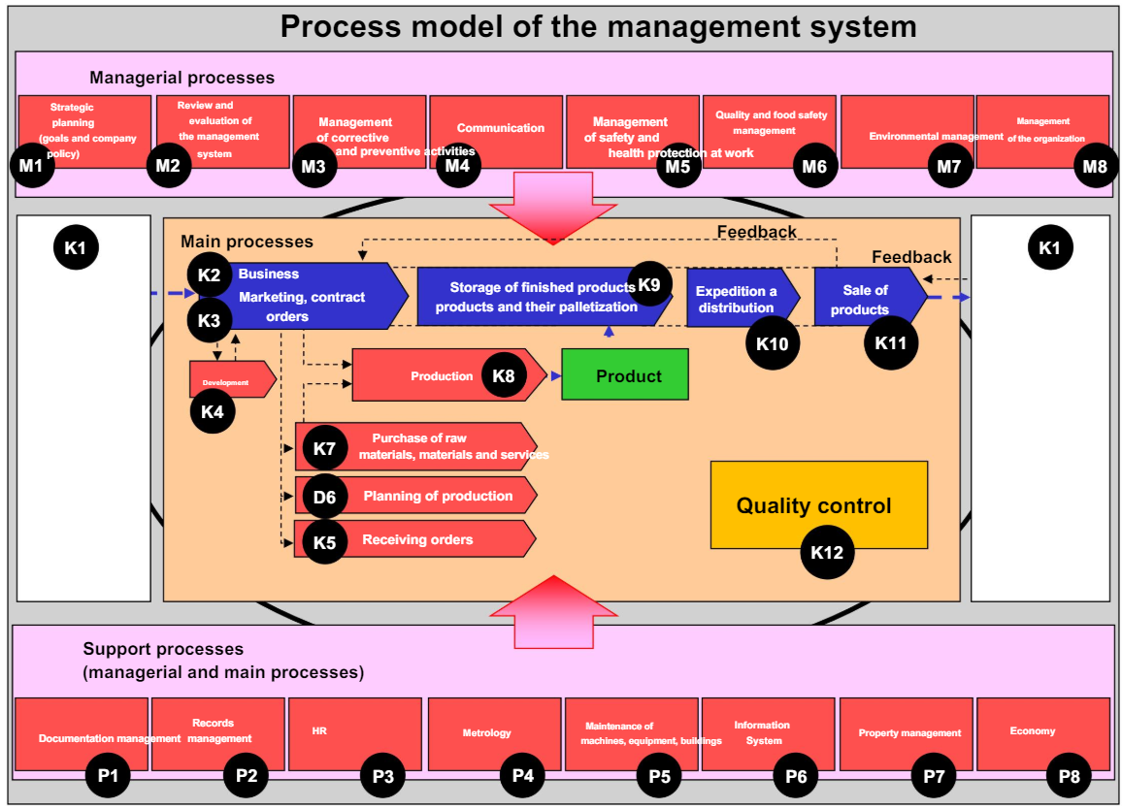
Fig.21.1 Process model of the management system (Zajác, 2020)
Processes can be arranged in a table or illustrated using a flowchart and included in the integrated management system manual. The process structure varies in different types of food businesses. Examples of processes are listed below. It is recommended to label and number individual processes and sub-processes:
Managerial processes
- M1 Organisational management,
- M2 Planning,
- M3 Communication management,
- M4 Occupational health and safety management,
- M5 Food safety management,
- M6 Environmental management,
- M7 Quality management,
- M8 Corrective and preventive actions management,
- M9 Verification and evaluation of the integrated management system.

Support Processes
- P1 Documentation management,
- P2 Record management,
- P3 Human resources,
- P4 Metrology,
- P5 Maintenance,
- P6 Information system management,
- P7 Property management,
- P8 Economics (accounting, orders management),
- P9 Transport (subcontracted); own transport can also be classified among main processes.
Key (Main) processes
- K1 Customer orientation and customer satisfaction survey,
- K2 Commercial activity and marketing,
- K3 Contracting and sales,
- K4 Development,
- K5 Order receipt,
- K6 Production planning,
- K7 Procurement,
- K8 Production,
- K9 Product storage,
- K10 Dispatch and distribution,
- K11 Product sales,
- K12 Quality control.
Process representation in documents
Processes are recommended to be processed in documents in the form of flowcharts, indicating all steps, decisions, and references to documents, forms, and records.
The documentation of a Food Safety and Quality Management System (FSQMS) is a comprehensive set of documents that define and guide the processes, procedures, and policies necessary to ensure food safety and quality within an organisation. The documentation serves as a framework for implementing, maintaining, and improving food safety and quality practices. It typically includes the following levels and types of documentation:

1. First Level: policy and objectives
- Company policy: This is a high-level document outlining the organisation’s commitment to food safety and quality, including objectives and strategic direction.
- Quality and food safety policy: This document states the organisation's commitment to producing safe and high-quality food products.
- Management system manual: A comprehensive document that describes the structure of the management system, its scope, processes, and interactions.

2. Second Level: procedures and guidelines
- Organisational guidelines: Detailed documents that provide specific instructions on how various processes should be conducted to ensure food safety and quality.
- Standard operating procedures (SOPs): These outline the step-by-step instructions for performing routine operations in compliance with safety and quality standards.
- Records: Documents that record the results of various processes and activities, such as inspection records, maintenance logs, and training records.
- Laws and regulations: Documentation of applicable legal and regulatory requirements that the organisation must comply with.
- Technical standards and functional diagrams: Documents and diagrams that provide technical details and specifications relevant to food safety and quality.

3. Third level: Work instructions and detailed procedures
- Technical documentation: Includes contracts, technical documents, and specific standards relevant to food safety and quality.
- Plans: Detailed plans such as marketing plans, financial plans, investment plans, and production plans.
- Procedures: Specific procedures related to technological processes, work activities, control measures, and calibration methods.

Specific examples of documentation components:
- Hazard Analysis and Critical Control Points (HACCP) Plan: A detailed plan that identifies critical control points in the food production process and outlines measures to control food safety hazards.
- Good Manufacturing Practices (GMP): Documentation that defines the practices required to conform to guidelines recommended by agencies that control the authorisation and licensing of the manufacture and sale of food.
- Corrective and Preventive Actions (CAPA): Procedures and records for identifying and addressing any deviations from food safety and quality standards.

Objectives of FSQMS documentation:
- Ensure compliance: To meet statutory, regulatory, and customer-specific requirements.
- Improve processes: To streamline and clarify processes, avoiding duplication and enhancing efficiency.
- Facilitate communication: To provide a clear communication framework within the organisation and with external stakeholders.
- Support audits and certification: To facilitate internal and external audits and help achieve certification or registration of the FSQMS.

Key Benefits:
- Consistency: Ensures consistent production of safe and high-quality food products.
- Accountability: Establishes clear responsibilities and authorities within the organisation.
- Continuous improvement: Provides a basis for continuous improvement through regular review and updating of the system.
By maintaining comprehensive documentation, organisations can effectively manage food safety and quality, ensuring that all processes are well-defined, monitored, and continuously improved. This ultimately helps in protecting consumer health, complying with legal requirements, and maintaining customer trust and satisfaction.

Example of document structure

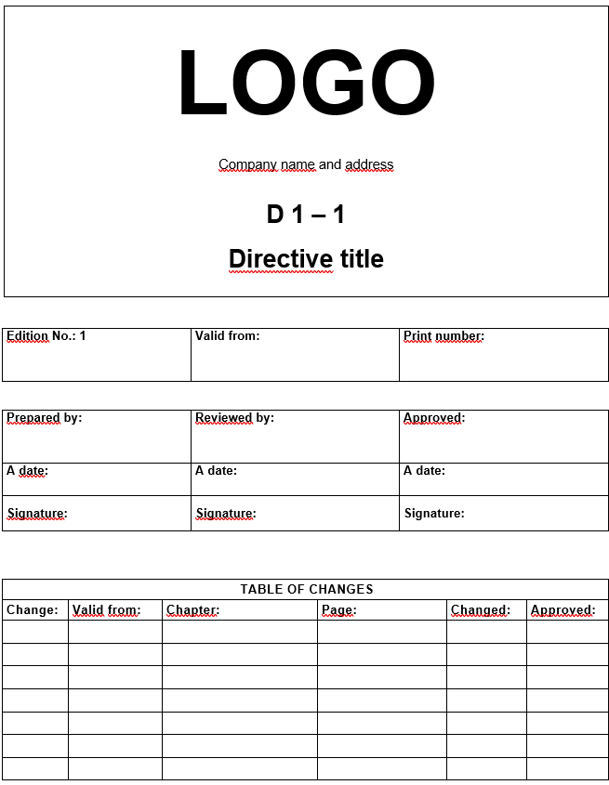
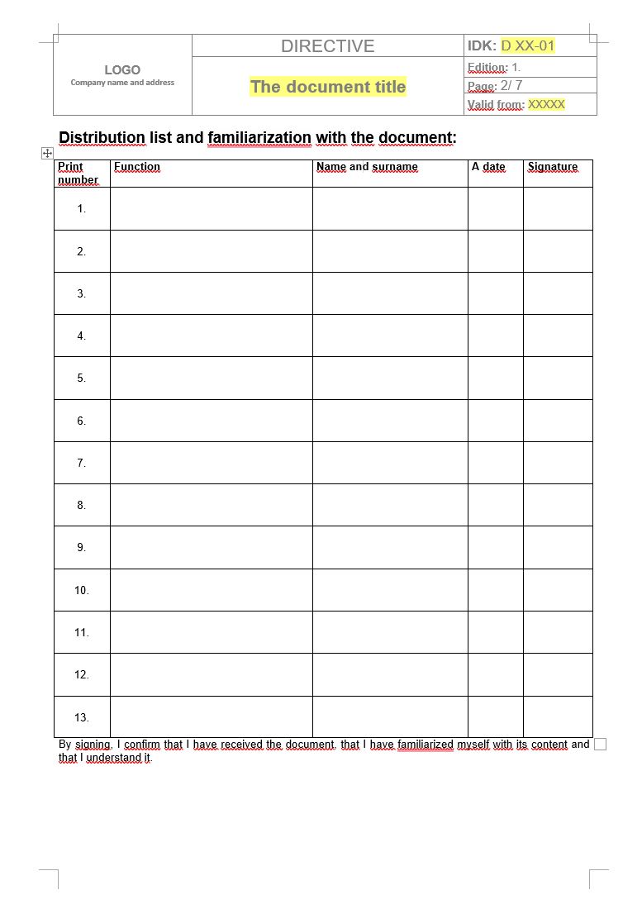
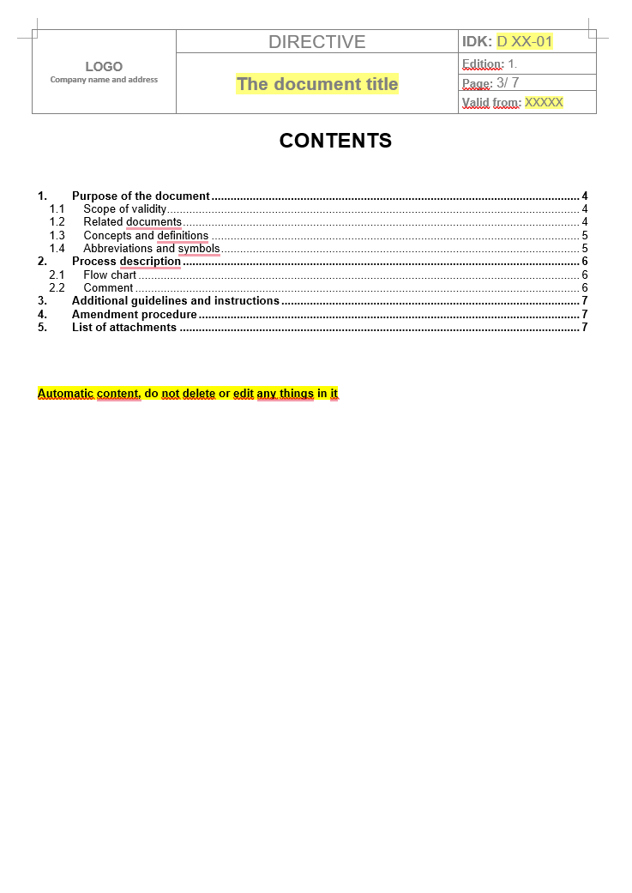
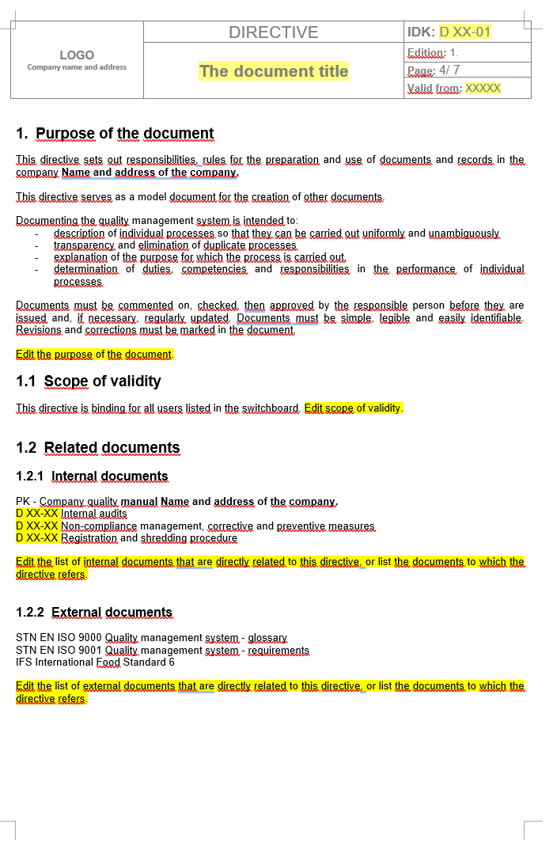
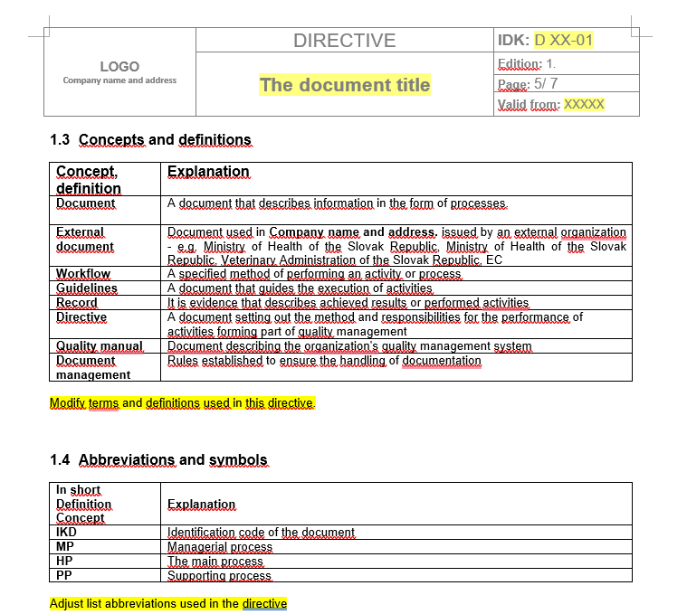
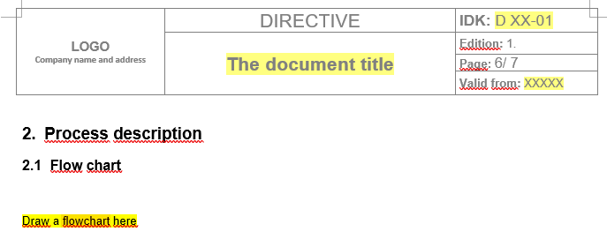

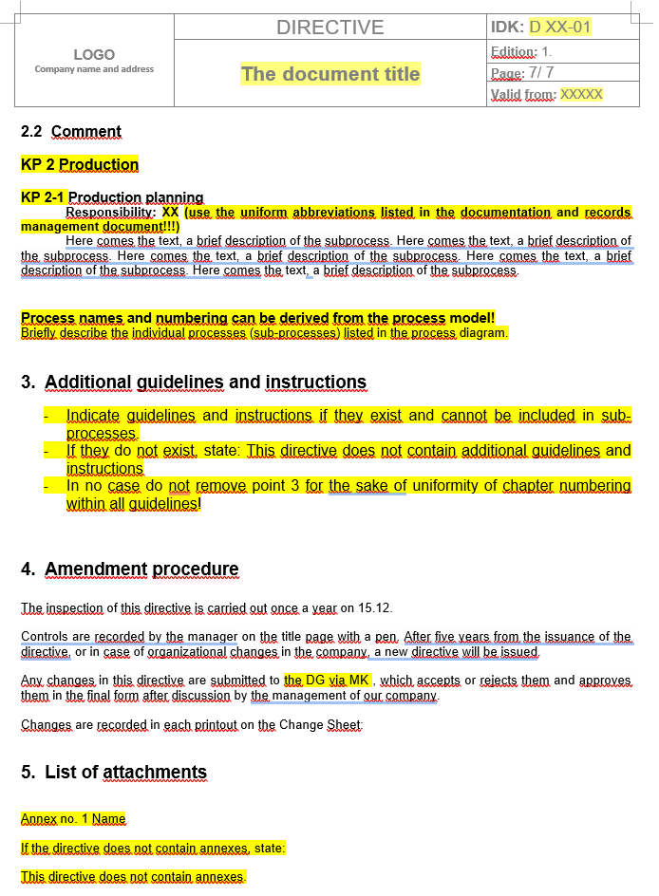

Practical work

Food safety management system – Solving practical tasks
Task No. 1: Analysis of the processes in a food company.
Create a process model of the management system with the indication of managerial, main, and supporting processes according to the requirements of norms and standards: ISO 9001, ISO 22000, IFS, BRC, and TFMS. Students work in pairs and create a process model for a designated food operation that follows the principles of the PDCA process approach and the requirements of technical norms and standards. The exercise is intended for students to understand the organisation's context and think about the relationships between individual processes.
Output: Process model of the food company management system. Picture: A diagram consisting of several processes.

Process model of the food company management system
Fig. 21.2 Process model of the food company management system (Zajác, 2020)

1. Managerial Processes
These are processes that involve strategic planning, leadership, and overall management of the food safety and quality management systems.
- Strategic planning and leadership (M1)
  - Establishing company policies, objectives, and strategic direction.
  - Ensuring commitment to food safety and quality standards.
  - Periodic review and updating of policies and objectives.
- Risk management (M2)
  - Identifying, assessing, and managing risks related to food safety and quality.
  - Implementing preventive measures and corrective actions.
- Management review (M3)
  - Regular review of the FSQMS by top management.
  - Evaluating performance and effectiveness of the management systems.
  - Decision-making for continuous improvement.
- Internal audits (M4)
  - Planning and conducting internal audits.
  - Reporting audit findings and implementing corrective actions.

2. Main processes
These are core activities directly related to the production and delivery of safe and high-quality food products.
- Product development (K1)
  - Research and development of new food products.
  - Ensuring new products meet safety and quality standards.
- Procurement (K2)
  - Sourcing and purchasing raw materials and ingredients.
  - Supplier evaluation and approval.
- Production (K3)
  - Manufacturing processes to produce safe and high-quality food.
  - Implementation of HACCP plans and GMP.
- Quality control (K4)
  - Inspection and testing of raw materials, in-process products, and finished goods.
  - Ensuring products meet predefined quality standards.
- Storage and distribution (K5)
  - Proper storage of raw materials, in-process items, and finished products.
  - Ensuring safe and hygienic transportation and distribution.
- Customer service and feedback (K6)
  - Handling customer inquiries and complaints.
  - Collecting and analysing customer feedback for continuous improvement.

3. Supporting processes
These processes support the main and managerial processes by providing necessary resources and infrastructure.
- Human resources (P1)
  - Recruitment, training, and development of employees.
  - Ensuring staff competencies in food safety and quality.
- Documentation and record control (P2)
  - Managing and maintaining documentation related to FSQMS.
  - Ensuring records are accurate and up-to-date.
- Maintenance (P3)
  - Maintaining equipment and facilities to ensure they are in good working condition.
  - Preventive maintenance and calibration of equipment.
- Information technology (P4)
  - Managing IT infrastructure and systems.
  - Ensuring data security and integrity.
- Finance and budgeting (P5)
  - Financial planning and management.
  - Allocating resources for food safety and quality initiatives.
- Marketing and sales (P6)
  - Promoting food products.
  - Managing sales and distribution channels.

2. To create the company policy.
Read the requirements in ISO standards and private food safety standards. Prepare a company policy document. Integrate the requirements of different standards into this policy.
Output: Company policy
Standard requirements related to the company policy
ISO 9001:2015
5.2 Policy
5.2.1 Development of quality policy
Top management must develop, implement, and maintain a quality policy that: i) is suitable for the purpose, for the context of the organisation, and its strategic direction; j) provides a framework for setting quality objectives; k) contains a commitment to comply with applicable requirements; l) contains a commitment to continuous improvement of the quality management system.
5.2.2 Quality Policy Communication
The quality policy must be: g) available and maintained as documented information; h) communicated, understood, and applied in the organisation; i) if necessary, available to the relevant interested parties.
ISO 22000
5.2 Food safety policy
The organisation's top management must define, document, and communicate its food safety policy. Top management of the organisation must ensure that the food safety policy: e) is appropriate to the organisation's role in the food chain; f) meets the requirements of technical standards and laws, as well as the safety requirements mutually agreed with the customer; k) is communicated, implemented, and maintained at all levels of the organisation; l) is reviewed for its continuing suitability (see 5.8); m) adequately addresses communication (see 5.6); n) is supported by measurable targets.
IFS 8
1. Governance and commitment
1.1 Policy
1.1.1* The senior management shall develop, implement, and maintain a corporate policy, which shall include, at a minimum:
- food safety, product quality, legality, and authenticity;
- customer focus;
- food safety culture;
- sustainability.
This corporate policy shall be communicated to all employees and shall be broken down into specific objectives for the relevant departments. Objectives about food safety culture shall include, at a minimum, communication about food safety policies and responsibilities, training, employee feedback on food safety-related issues, and performance measurement.
1.1.2 All relevant information related to food safety, product quality, legality, and authenticity shall be communicated effectively and in a timely manner to the relevant personnel.
BRC 8
1.1 Senior management commitment and continuous improvement
Essential requirements
Higher management must prove that it is fully committed to performance requirements of global safety standards for food and processes that will facilitate continuous improvement in food safety and quality management.
Provisions of the requirement
1.1.1 The workplace must have documented principles supporting its intention to fulfil obligations of producing safe and legal products with the prescribed quality and a responsible approach to customers. These principles shall be:
- signed by the person with the main responsibilities for the workplace,
- communicated to all workers.
The company shall have a documented policy which states the company's intention to meet its obligation to produce safe and legal products to the specified quality and its responsibility to its customers. This shall be:
- signed by the person with overall responsibility for the site,
- communicated to all staff.

Company food safety and quality policy
1. Introduction
- Purpose: Briefly state the purpose of the policy, emphasising the organisation's commitment to food safety and quality.
- Scope: Define the scope of the policy, including the areas of the business it covers (e.g. production, processing, distribution).
2. Commitment to food safety and quality
- Statement of commitment: A clear statement from top management expressing the commitment to maintaining high standards of food safety and quality.
- Legal and regulatory compliance: Commitment to comply with all relevant food safety and quality regulations, standards, and customer requirements.
3. Food safety and quality objectives
- Objectives: Outline specific, measurable objectives aimed at ensuring food safety and quality (e.g. reducing incidents of contamination, achieving customer satisfaction).
- Continuous improvement: Commitment to the continuous improvement of the food safety and quality management system.
4. Roles and responsibilities
- Top management: Define the roles and responsibilities of top management in supporting and implementing the policy.
- Food safety and quality team: Outline the roles of the food safety and quality team, including the Food Safety Team Leader.
- Employees: Highlight the responsibilities of all employees in maintaining food safety and quality standards.
5. Implementation and maintenance
- Training and competence: Ensure that all employees are adequately trained and competent in food safety and quality practices.
- Communication: Describe the methods for communicating the food safety and quality policy and objectives within the organisation and to relevant stakeholders.
- Documentation and records: Commitment to maintaining up-to-date documentation and records to support food safety and quality activities.
6. Hazard Analysis and Critical Control Points (HACCP)
- HACCP Implementation: Outline the implementation of the HACCP plan to identify, evaluate, and control food safety hazards.
- Critical Control Points: Define the critical control points (CCPs) and the measures taken to monitor and control these points.
7. Good Manufacturing Practices (GMP)
- GMP Standards: Commitment to adhering to Good Manufacturing Practices to ensure the production of safe and high-quality food products.
8. Corrective and preventive actions
- Nonconformities: Procedures for handling nonconformities related to food safety and quality.
- Corrective actions: Steps to identify, document, and address the root cause of nonconformities.
- Preventive actions: Measures to prevent the recurrence of nonconformities.
9. Review and Evaluation
- Management review: Regular review of the food safety and quality policy by top management to ensure its continued suitability and effectiveness.
- Performance evaluation: Monitoring, measurement, analysis, and evaluation of the performance of the food safety and quality management system.
10. Conclusion
- Reaffirmation of commitment: A closing statement reaffirming the organisation’s commitment to food safety and quality.
- Approval: Signature of the top management representative responsible for the policy.
Example policy statement:
Introduction: Our company is dedicated to producing safe, high-quality food products. This policy outlines our commitment to food safety and quality, the scope of our management system, and the responsibilities of all employees in maintaining these standards.
Commitment: We are committed to complying with all relevant food safety and quality regulations, standards, and customer requirements. Our top management supports this policy and ensures that adequate resources are provided for its implementation and maintenance.
Objectives: Our food safety and quality objectives include achieving zero contamination incidents, ensuring customer satisfaction, and continuously improving our management system.
Responsibilities: All employees are responsible for adhering to food safety and quality standards. The Food Safety Team Leader coordinates the implementation of our HACCP plan, and top management oversees the overall effectiveness of our management system.
Implementation: We provide regular training to our employees, maintain up-to-date documentation, and communicate our policy to all stakeholders. Our HACCP plan identifies critical control points, and we follow Good Manufacturing Practices to ensure product safety and quality.
Review: This policy is reviewed annually by top management to ensure its effectiveness and relevance. Performance evaluations are conducted regularly to monitor and improve our food safety and quality management system.

3. Create the selected directive for the food safety management system
Students will create a directive for the management of the production process. As part of this task, they must adhere to the principles of creating documentation creation and the formal structure of the documentation of the quality and food safety management system. When developing the directive, they analyse the sub-processes of the production management process, such as (production planning, provision of employees, raw materials, packaging material, preparation of the technological line, start of production, inter-operation control, output control, and end of production). When creating the directive, they follow an already created process model. They describe how individual sub-processes will be performed, considering and integrating the requirements of technical norms and standards. The exercise is intended for students to learn how to create a quality and food safety management system.
Output: Document - management system directive: Management of the production process.

Approved by _________________________________________
Name, surname, signature

Date _________________________________________

Theme 22

Legislative requirements for food of animal and plant origin
Theoretical materials
Hygiene rules for food of animal origin
Food business operator general obligations
Operators must use only potable water (or ‘clean water’ in some circumstances) to remove surface contamination, unless alternatives are approved by the European Commission.
Products must be prepared and handled in establishments which need to be at least registered, but often approved.
Products must have a health mark or other approved identification mark.
Products from outside the EU must satisfy at least EU requirements, demonstrated by the listing of authorised countries and establishments; in addition, products must be accompanied by certificates.
Meat, including domestic ungulates (bovine, porcine, ovine and caprine species); poultry and lagomorphs (farmed birds, rabbits, hares and rodents); farmed and wild game; minced meat, meat preparations and mechanically separated/recovered meat; and meat products. The rules include requirements for:
- transporting live animals to slaughterhouses;
- slaughterhouses and cutting plants;
- slaughter hygiene and hygiene during cutting and boning;
- emergency slaughter (outside slaughterhouses) and slaughter on the farm;
- temperature requirements during processing and storage;
- training of hunters in health and hygiene;
- handling of wild game (large and small).
Fishery products, seawater and freshwater fish, including crustaceans and molluscs, whether wild or farmed. The rules apply to thawed, unprocessed fishery products and fresh fishery products. Among others, products must meet requirements for:
- fishing, freezer and factory vessels;
- hygienic and careful handling and landing procedures;
- control of parasites;
- cooking, cooling, shelling and shucking of crustaceans and molluscs;
- health standards and freshness;
- toxins harmful to humans; and
- wrapping, packaging, storage and transport.
Raw milk and milk products must come from animals that are:
- in good general health;
- showing no symptoms of infectious diseases communicable to humans through milk; and
- from herds free from brucellosis and tuberculosis.
There are also requirements for:
- premises and equipment;
- hygiene during milking, collection and transport;
- temperature and heat treatment; and
- wrapping, packaging, labelling and identification marking.

Eggs and egg products must be:
- kept clean, dry, in an odour-free environment, protected from shocks and direct sun;
- stored and transported at a temperature suitable for optimal conservation;
- delivered to the consumer within 21 days of laying.

Food safety risk associated with foods of plant origin
Consumers include foods of plant origin in their diet because they want to eat healthy. However, what many consumers do not realise is that consumption of these foods may pose a food safety risk. Foods contaminated with unacceptable levels of pathogenic micro-organisms, chemicals, or physical hazards can result in severe health and economic effects for consumers and society. Foods of plant origin are those derived from plants which include:
• produce (fruits and vegetables),
• sprouts,
• culinary herbs,
• nuts,
• edible fungi,
• maple and honey products,
• grain products.

Factors affecting food safety
Environment: Foods of plant origin are typically grown in fields exposed to organisms that are present naturally in the environment (excluding: from soil, irrigation water, wildlife, etc.). Good agricultural practices (GAPs) help reduce the risks associated with these products but cannot guarantee a product free from pathogenic micro-organisms.
Post harvesting: Improper post-harvest handling may contribute further contamination. Inadequate product storage conditions may also allow pathogenic micro-organisms that are present to multiply.
Processing: There is an increased demand for fresh cut produce including fruit trays, bagged salads and cut vegetables. Processing (peeling or cutting) fruits and vegetables increases the risk of contamination by breaking the natural outer barrier of the fruit and releasing juices which provides nutrients for pathogenic micro-organisms to grow, if present. These processes also involve product handling by personnel and/or equipment that if not hygienic can be a source of contamination.
Inappropriate storage: Sales and consumption of ready-to-eat grain products has also increased. These grains rarely have a treatment to reduce the microbial load and may be a concern if stored or used under conditions that promote the growth of pathogenic micro-organisms (excluding: mould producing mycotoxins).
The safety of food products must be ensured by using a preventative approach, including the implementation of good agriculture and manufacturing practices (GAP, GMP) and hazard analysis critical control point (HACCP).

Laboratory works
Laboratory examination of milk and dairy products

Salt detection test in milk
Salt or sugar is used to mask extraneous water added to milk or to elevate total solids in milk. it is important to detect presence of salt in milk.
Method
Apparatus and reagents required
• Test tubes
• 5% potassium chromate
• 0.1N silver nitrate
• Milk sample
Procedure
Take 2.0 mL of milk in a test tube
Add 1.0 mL of 5% potassium chromate to the milk
Add 2.0 mL of 0.1N silver nitrate to the test tube
Results
Appearance of red precipitate indicates the absence of dissolved chloride in milk.
Appearance of yellow colour indicates presence of dissolved chloride.
Starch detection test in milk
Starch is sometimes added to adulterate milk. Starch being cheaper, is sometimes added in the milk by adulterators.
Apparatus and reagents required
• Test tube
• 1% Iodine solution
• Milk sample
Procedure
Take 3 mL milk in a test tube, boil and cool under tap water.
Add a drop of 1% Iodine solution.
Results
Presence of starch is indicated by the appearance of a blue colour, which disappears when the sample is boiled and re-appears on cooling.

Microbiological analysis
Total viable count (TVC) in milk
Total plate count results reflect the number of colonies that can emerge under the given physical and chemical conditions (atmosphere, temperature, pH, available nutrients, and presence of growth inhibitory compounds).
Materials Required
• Diluent: 0.1% Peptone or Phosphate buffer (90 or 99 mL, 9 mL)
• Media: Plate count agar (PCA) medium (pH 7.0 at 25 °C); autoclaved at 121 °C for 15 minutes
• Pestle and mortar, Petri dishes, pipettes, incubator
Procedure
Sampling: Collect the sample randomly from entire lot. According to FSSAI sampling, 5 sachets (500 mL) of samples will be collected from entire lot. Sample will be stored at refrigeration temperature (2-7 °C) until analysis.
Preparation of the test sample: 100-150 mL of the sample will be poured into the sterile sample bottle from each sachet. Opened sachets will be sealed and kept at refrigeration temperature (2-7 °C).
Serial dilution and plating
Mark the tubes and Petri dishes for batch no., sample no., parameter, dilution etc.
Pipette out 10 or 11 mL of sample from sample bottle into 90 or 99 mL
of diluent bottle (1:10 dilution).
Pipette out 1 mL of diluted sample from 1:10 dilution bottle into 9 mL of diluent tube.
Subsequently go for further dilutions if required by pipetting out from previous dilution into 9 mL of diluent tube.
Pour the PCA (50 °C) medium into the plates and allow it to solidify.
Incubate the plates at 35 ± 2 °C for 48–72 hrs.
Counting and calculation
After incubation, retain dishes containing not more than 300 colonies at two consecutive dilutions. It is necessary that one of these dishes contains at least 15 colonies. Calculate the number N of micro-organisms per millilitre or per gram of product, depending on the case, using the following equation:

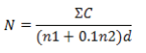

Where,
- ∑C is the sum of colonies counted on all the dishes retained;
- n1 is the number of dishes retained in the first dilution;
- n2 is the number of dishes retained in the second dilution;
- d is the dilution factor corresponding to the first dilution.
Round the result calculated to two significant figures. Take as the result the number of micro-organisms per millilitre or per gram of product, expressed as a number between 1.0 and 9.9 multiplied by 10 x where x is the appropriate power of 10.
Results
Table 22.1.
Results of microbiological analysis of milk
Sample | TVC  (log CFU/ml)
Milk

Conclusion

Approved by _________________________________________
Name, surname, signature

Date _________________________________________

Laboratory works

Laboratory examination of meat products
Determination of salt content in the meat products
Apparatus and reagents required:
- water,
- potassium chromate (K₂CrO₄),
- silver nitrate (AgNO₃),
- beaker,
- burette.
Procedure
Weigh 2 g of the sample, cut into small pieces.
Pour 100 mL of warm water, mix for 5 minutes.
Add 5 mL of potassium chromate to the solution.
Pour AgNO₃ into the burette.
Titrate to a pale pink permanent colour. You should read off the used ml of AgNO₃.
Calculation:
Content of NaCl (%)
$X= \frac{a}{2}$
where,
a – consumption of AgNO₃
Determination of the total viable counts (TVC) of coliform bacteria (CB) in meat products
Materials Required:
- distilled water,
- pipette,
- cultivation media,
- Petri dishes
Procedure
- weigh 5 g of the sample,
- add 45 mL of distilled water, a dilution of 10-1 is created.
- prepare a 10⁻² dilution.
- pipette + mL from both dilution to Petri dishes
- pour the PCA (50 °C) medium to determination of TVC and VRBL medium to determination of CB into the plates and allow it to solidify.
Incubate the plates at 30 ± 2 °C for 48–72 hrs (determination of TVC) and at 37 ± 2 °C for 24–48 hrs (determination of CB)
Counting and Calculation
After incubation, retain dishes containing not more than 300 colonies at two consecutive dilutions. It is necessary that one of these dishes contains at least 15 colonies. Calculate the number N of micro-organisms per millilitre or per gram of product, depending on the case, using the following equation:
$N= \frac{ΣC}{\left(n1+0.1n2\right)×d}$
where,
- ∑C is the sum of colonies counted on all the dishes retained;
- n₁ is the number of dishes retained in the first dilution;
- n₂ is the number of dishes retained in the second dilution;
- d is the dilution factor corresponding to the first dilution.
Results
Table 22.2. Results of microbiological analysis of meat products
Sample | TVC  (log CFU/g) | CB  (log CFU/g)
Ham
Sausages
Pate…

Conclusion

Approved by _________________________________________
Name, surname, signature
Date _________________________________________

