


Open Food Innovation University (OFINU)

Study module
“New Food Product Development”
WORKBOOK
for students

2024

Summary

The workbook is elaborated within the project “Open Food Innovation University" (OFINU), being in implementation with support of the European Union Erasmus+ Programme.
Overall objective of the project - to modernise food innovation and technology related higher education in Uzbekistan and Tajikistan, thereby increasing the quality and ensuring relevance of the higher education to the needs of the socio-economic growth of the countries concerned and especially of their regions.

Full partners:
- Lead partner: Latvia University of Life Sciences and Technologies
- Uzbekistan: Samarkand Agro-innovations and Research University, Andijan Institute of Agriculture and Agro-technologies
- Tajikistan: Technological University of Tajikistan, Kulob Institute of Technology and Innovation Management, Isfara Branch of the Technological University of Tajikistan
- Slovakia: Slovak University of Agriculture in Nitra

Associated partners in Uzbekistan:
- A group of companies "AGROMIR"
- "Navigul" MCHJ QK
- “Samarqand don mahsulotlari” JC (Samarkand grain products)

Associated partners in Tajikistan:
- CJSC “Combinati Shiri Dushanbe”
- LTD "Orion Rustam"
- Association of Entrepreneurs of Khatlon

The project implementation period: 01/02/2024 - 31/01/2027.

Funded by the European Union. Views and opinions expressed are however those of the authors only and do not necessarily reflect those of the European Union or the European Education and Culture Executive Agency. Neither the European Union nor the granting authority can be held responsible for them.

Partner universities and their academic staff, involved in the development of the study course:

P1 LBTU. Latvia University of Life Sciences and Technologies
Dace Klava Dr. sc. ing. Asoc. professor.
Emīls Kozlinskis - Orkla Biscuit Production, Product and Development department manager.
Evita Straumite Dr. sc. ing. Assoc. professor.
P2 SAMARU. Samarka and Agroinnovations and Research University
Khusniddin Pardaev PhD.
Shukrullo Muratov PhD.
Ravshan Kalandarov MSc. Senior Lecturer.
Fotima Saydullaeva MSc. Senior Lecturer.
Iroda Baymuradova MSc.
Elnara Devletshaeva MSc. Assistant teacher.
RahmatilloTashmanov PhD.
Temurbek Mikhliev MSc, Assistant teacher.
Babur Eshonkulov PhD.
Anvar Shamsiev PhD.
P3 AIAA. Andijan Institute of Agriculture and Agro-technologies
Muhammad Zahiriddin Zaynobiddinov MSc, Senior Lecturer.
Mashhurbek Tojidinov .
Kholdarov Shukhratjon MSc, Assistant teacher.
Dekhkonova Shakhnozaxon MSc, Assistant teacher.
P4 TUT. Technological University of Tajikistan
Shuhratjon Nazarov PhD in Tech. Sc., Assistant Professor.
Azimjon Khushmatov PhD in Tech. Sc., Assistant Professor.
Sitora Sodiqova Senior Lecturer.
P5 KITIM. Kulob Institute of Technology and Innovation Management
Bobokhon Qurbonzoda PhD in Tech. Sc., Assistant Professor.
Bahrom Nabotov Senior Lecturer.
P6 BTUTI. Branch of the Technological University of Tajikistan in the city of Isfara
Sirojiddin Boboev Senior Lecturer.
Mirzomaruf Boboev Senior Lecturer.
Hoshimjon Abdulloev PhD in agriculture.
Navoiddin Nosirov PhD in jurisprudence.
Taskina Karomaddinova Assistant.
P7 SUA. Slovak University of Agriculture in Nitra
Eva Ivanišová Ing. PhD.

Contents

COURSE SCHEDULE 6
Theme 1 10
Role of innovation in science and entrepreneurship 10
Theoretical materials 10
Practical work 12
Trends in food industries and food science 12
Theme 2 13
Idea Generation 13
Theoretical materials 13
Practical work 18
Develop Product Concept 18
Practical work 20
Consumer profile development 20
Date ______________________________________ 21
Practical work Ideas generation techniques 21
Practical work 25
Evaluation and Selection of ideas 26
Home Work (HW) -new product architecture and design (picture, colour palate, size etc.) 29
Practical work 29
Sensory evaluation methods used in consumer studies 30
Worksheet 2.5. 36
7-point Hedonic scale 36
Theme 3 38
Product development 38
Theoretical materials 38
Practical work 40
Developing technological documentation 40
Practical work 43
Label and packaging design for the new product 43
Practical work 46
The prototype evaluation phase. Developing, testing and finalising prototypes 46
Theme 4 50
Commercialisation 50
Theoretical materials 50
Practical work 55
Communication elements for marketing 55
Practical work 57
Content of marketing communication 57
Practical work 58
Marketing activities plan 58
Theme 5 59
Evaluation of new product development process 60
Theoretical materials 60
Practical work SWOT analysis for project evaluation 62
Theme 6 64
Hackathon “InnoFood” 64
Theoretical materials 64
Literature Sources 70

Theme of the study course
The study module includes three parts: Idea Generation, Prototype Development and Commercialisation. To ensure the full implementation of the module, lecturers with knowledge in new product development management, food technologies and processes, as well as marketing and sales specialists participate in it.

Learning methods
In the implementation of the module, the teachers use the learner-centred approach, which empowers students to take charge of their own learning, leading to increased engagement and motivation. The use of digital tools for interactive learning has made classes more dynamic and accessible - students can access learning materials from anywhere, leading to increased flexibility and convenience. Interactive methods, such as seminars, methods used for providing laboratory and practical work (individually, group work, discussions, and re–training). An innovative method - Hackathon - will be used to consolidate the acquired knowledge and to create prototypes of new products - for the problems raised by food production.
During the study of the module, student groups work practically and follow the new product development process from idea concept to sales plan. New product development pilots are carried out by each student team in the product group of their interest, which is agreed upon at the beginning of the implementation of the module.

COURSE SCHEDULE
Thematic Study Plan for module “New Food Product Development”
Date, Time | Study form | Topic | Lecturer
Theme 1. Role of innovation in science and entrepreneurship
Day 1 | Lecture  (1h) | Introduction to the course, participants and awareness of innovation.
Day 1 | Lecture  (3h) | Innovation, types of innovation and their differences. Innovation in a European and global context. Role of development of new products in food industry and research institutes.  Development of new products in research centres and their role in the development of the food production sector. The European Union support system for innovation development, differences with local market approach. Transfer of knowledge and technology in a collaborative model science - production - science.  Process of developing new products in a food production company. Role of innovation in product life cycle and business development. Strategic and conceptual modelling of new products in a company.  HW Tendencies in Food industries and Food science – each student finds and describes 5 new trends and creates a presentation.
Theme 2. Idea generation
Day 2 | Seminar  (4h) | Discussion about new trends in food industries in a European and global context.
Day 2 | Lecture  (1h) | New product development process - idea, prototype, development, and commercialisation. Creative thinking methods and their application in new product development. Implementing a conceptual approach to new product development.
Day 2 | Practical work  (2h) | Group work - develop a product concept.
Day 3 | Lecture  (1h) | Consumer role in the new product development process. Business Model Canva as tools for idea development.
Day 3 | Practical work  (2h) | Consumer profile development.  Evaluate consumer need and value of new products using Business Model Canva.
Day 3 | Practical work  (4h) | Ideas generation techniques.  Using Ideas generation techniques e.g. brainstorming, analogical reasoning, random name, etc. for new ideas.
Day 4 | Practical work  (4h) | Evaluation and selection of ideas. Description of ideas.
Day 4 | Lecture  (2h) | Architecture and design of the new idea, appropriately of actuality in the food industry.  Prototyping techniques and methods used in development stages.  HW New product architecture and design development.
Day 5 | Seminar (1h) | Presentation and discussion of new product design.
Day 5 | Lecture  (2h) | Food product sensory properties (appearance, aroma, taste, consistency / structure) as food design elements. Identification of consumer expectations, needs and benefits. Consumer methods for food product sensory evaluation (line scale, hedonic scale, CATA, RATA, Just about Right, Mapping/Napping u.c.).
Day 5 | Practical work  (2h) | Sensory evaluation methods used in consumer studies.  HW - Study of scientific articles about sensory evaluation methods used in consumer studies.
Day 5 | Seminar (1h) | A discussion about sensory evaluation methods used in consumer studies.
Day 5 | Lecture  (1h) | Emotions in creating and choosing new products. Principles of organisation of sensory evaluation (definition of aim, selection of samples, selection of panellists, etc.). Sensory claims as a provider of information to the consumer. Food Pairing.
Theme 3. Product development
Day 6 | Lecture  (3h) | Product development process. Developing the required documentation for the new product.  Intellectual property rights protection.
Day 6 | Practical work  (5h) | Developing technology documents.
Day 7 | Practical work  (5h) | Develop a label and packaging sample for the new product.
Day 7 | Seminar  (2h) | Presentation of packaging and label sample.
Day 8 | Practical work  (4h) | The prototype evaluation phase. Developing, testing and finalising prototypes.
Day 8 | Seminar (2h) | A discussion about the product’s technological documentation.
Theme 4. Commercialisation
Day 9 | Lecture  (4h) | The commercialisation phase of new products. Product sales strategy. Integrated marketing for sales.
Day 9 | Practical work  (3h) | Communication elements for marketing.  HW Development of a plan of sales activities for the new product.
Day 10 | Practical work  (4h) | Content of marketing communication.  Marketing activities plan.
Day 10 | Seminar (3h) | A discussion about marketing activities plan.
Theme 5. Evaluation of new product development process.
Day 11 | Lecture  (2h) | SWOT analysis for new product development. Risk identification and evaluation. Using criticism to improve your product.
Day 11 | Practical work  (4h) | SWOT analysis for project evaluation.
Day 11 | Seminar (2h) | A discussion about SWOT analysis.
Theme 6. Hackathon “InnoFood”
Day 12  (24h) | Hackathon “InnoFood” - to solve a problem or identify new opportunities for food industry.

Theme 1

Role of innovation in science and entrepreneurship

Theoretical materials
Innovation — a new development introduced into civil circulation or used for one's own needs, the application of which in practice ensures the achievement of a significant socio-economic effect.
Innovative infrastructure — a set of enterprises, organisations, institutions, their associations of any form of ownership, carrying out material and technical, financial, organisational and methodological, information, consulting and other support for innovative activity.
An innovative project — a set of measures that provide for deadlines, performers, sources of funding and the formation of an appropriate infrastructure for the creation of new developments.
Innovative activity — activity aimed at the creation of new developments, as well as ensuring their transfer and implementation in the production sector.
State order for the creation of innovations — an assignment for the performance of an innovative project at the expense of the State budget of the Republic of Uzbekistan and other sources not prohibited by law.
Transfer of technologies — a set of measures aimed at transferring a new development from the sphere of its reception (development) to the sphere of practical application.
A new product development — is the result of intellectual activity (new or improved technology, service and organisational and technical solution of a production, administrative, commercial or other nature), which has signs of novelty compared to existing analogues, practical applicability and the ability to ensure the achievement of a significant socio-economic effect when use in practice.
Product development is both an exciting and difficult endeavour. From initial ideation to research and prototyping, no two product launches are the same. However, there’s a general process that can help you get started with the product development process.
The product development process describes the six steps needed to take a product from initial concept to final market launch. This includes identifying a market need, researching the competition, ideating a solution, developing a product roadmap, and building a minimum viable product (MVP).
The product development process has evolved in recent years and is now commonly used by dividing each step into six separate phases. This helps to better organise the process and break individual deliverables into smaller tasks.

Basic principles of innovative activity
The basic principles of innovative activity are:
- freedom of innovative activity,
- ensuring equal access to state support for innovative activity,
- publicity and targeting of state support for innovative activity,
- promoting the development of competition,
- free exchange of information,
- legal protection of intellectual property objects created as a result of innovative activity,
- no harm to the life and health of citizens, and the environment.

Practical work

Trends in food industries and food science
The aim of the practical work is to pay attention to the latest trends in the overall food ecosystem. Look in more detail at the latest scientific research directions and find 3-5 insights for future work.

Task. Each student finds and describes 5 new tendencies and creates a presentation (max. 7 slides). At the end, select 3 insights for new product development.

Materials
Where to find information:
https://www.scopus.com/search/form.uri?display=basic#basic
https://www.sciencedirect.com/
https://www.effost.org/default.aspx
https://www.innovamarketinsights.com/trends/top-food-trends-2024

Results
1.
2.
3.
4.
5.
Conclusion (3 insights from trends for new product development)

Approved by _________________________________________
Name, Surname, signature

Date _________________________________________

Theme 2

Idea Generation

Theoretical materials
Development of new products is a process that consists of several stages (Fig. 2.1.). The basic stages are strategy of innovation, idea generation, prototyping, product development, and commercialisation. Food companies’ capacity for innovation stems from an innovation system: a coherent set of interdependent processes and structures that dictates how the company searches for novel problems and solutions, synthesises ideas into a business concept and product designs, and selects which projects get funded. Individual best practices involve trade-offs.

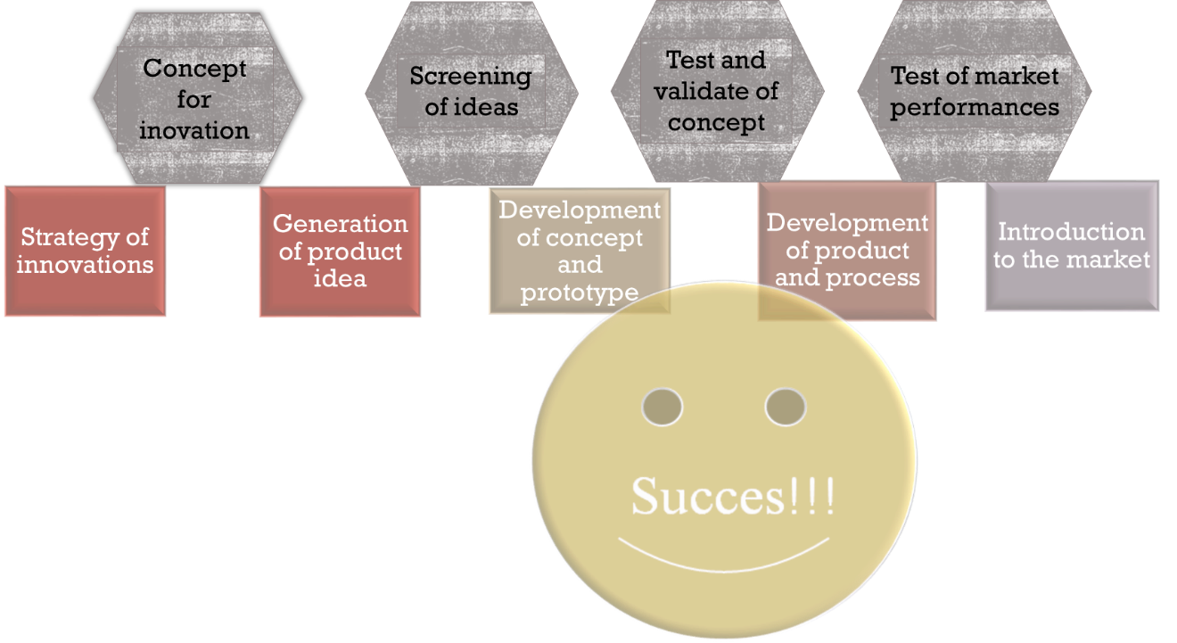
Figure 2.1. New product development process.

Strategy of Innovations - development of an innovation strategy involves the deliberate development of a plan for the development of new products, including market analysis, customer preferences, competitors, technological progress, in order to achieve business goals. The initial stage of the product development process begins by generating new product ideas. This is the product innovation stage, where you brainstorm product concepts based on customer needs, concept testing, and market research.
It’s a good idea to consider the following factors when initiating a new product concept:
- Target market: your target market is the consumer profile you’re building your product for. These are your potential customers. It is important to identify this at the beginning so you can build your product concept around your target market from the start.
- Existing products: when you have a new product concept, it’s a good idea to evaluate your existing product portfolio. Are there existing products that solve a similar problem? Or does a competitor offer a product that doesn’t allow for market share? And if yes, is your new concept different enough to be viable? Answering these questions can ensure the success of your new concept.
- Functionality: while you don’t need a detailed report of the product functionality just yet, you should have a general idea of what functions it will serve. Consider the look and feel of your product and why someone would be interested in purchasing it.
- SWOT analysis: analysing your product strengths, weaknesses, opportunities, and threats early in the process can help you build the best version of your new concept. This will ensure your product is different from the competitors’ products and solves a market gap.
- SCAMPER method: to refine your idea, use brainstorming methods like SCAMPER, which involves substituting, combining, adapting, modifying, putting to another use, eliminating, or rearranging your product concept.

To validate a product concept, consider documenting ideas in the form of a business case. This will allow all team members to have a clear understanding of the initial product features and the objectives of the new product launch.
Once you’ve completed the business case and discussed your target market and product functionality, it’s time to define the product. This is also referred to as scoping or concept development, and focuses on refining the product strategy.
During this stage, it’s important to define specifics including:
- Business analysis: a business analysis consists of mapping out distribution strategy, ecommerce strategy, and a more in-depth competitor analysis. The purpose of this step is to begin building a clearly defined product roadmap.
- Value proposition: the value proposition is what problem the product is solving. Consider how it differs from other products in the market. This value can be useful for market research and for developing your marketing strategy.
- Success metrics: it’s essential to clarify success metrics early so you can evaluate and measure success once the product is launched. Are there key metrics you want to look out for? These could be basic KPIs like average order value, or something more specific like custom set goals relevant to your organisation.
- Marketing strategy: once you’ve identified your value proposition and success metrics, begin brainstorming a marketing strategy that fits your needs. Consider which channels you want to promote your product on—such as social media or a blog post. While this strategy may need to be revised depending on the finished product, it’s a good idea to think about this when defining your product to begin planning ahead of time.
Once these ideas have been defined, it’s time to begin building your minimum viable product (MVP) with initial prototyping.
Every company must develop procedures that provide for how new products are introduced so that it is a planned process. In the development of new products, special Research and Development services are created in companies, or a new product development team is formed in smaller companies. The team includes:
- Technologist,
- Engineering,
- Marketing specialist,
- Financial specialist,
- Managing director.

Development of a concept for a new product - concept design is to illustrate how to turn an idea into scalable and pragmatic business opportunities. A concept defines, from a business perspective, how the idea can be realised by considering technical solutions, organisational and business changes and ecosystem implications. Concept development process (Fig. 2.2.).
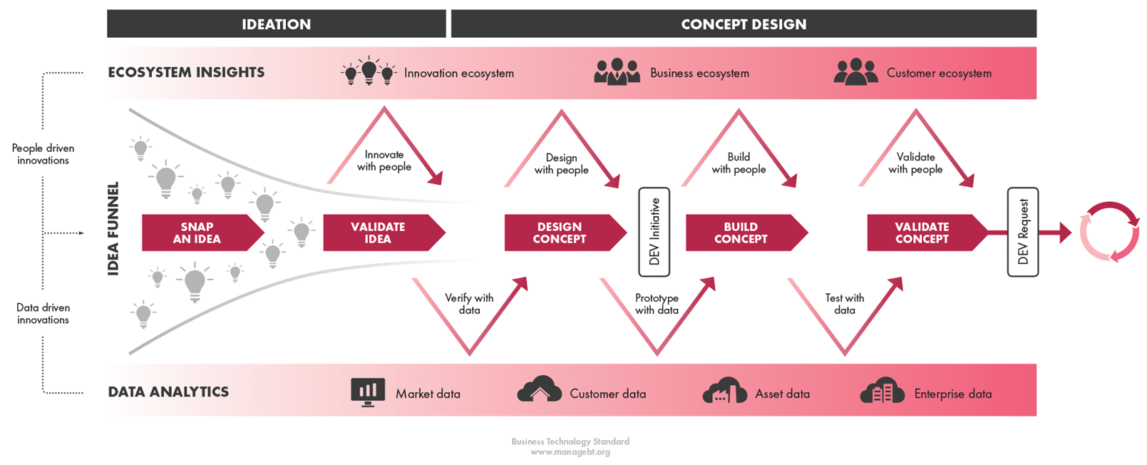
Figure 2.2. Concept development process for new product development. https://www.managebt.org/book/demand/innovations-and-concepts

Sensory analysis and consumer research are important tools in innovation and new product development (NPD), from design to commercialisation. Innovation is necessary for companies to maintain their market position and attract new consumers. Sensory analysis techniques have evolved considerably in recent decades, from more traditional techniques (discriminator and descriptive analysis or preference and hedonic tests) towards more novel and faster techniques (check-all-that apply, napping, flash profile, temporal dominance of sensations, etc.), with outstanding application at the different stages of NPD. In addition to the application of these techniques, knowing how the consumer interacts with a food product in the different stages (purchase, ingestion, etc.) is essential to better understand and be able to measure consumer attitudes, emotions, and behaviour. Important practical applications have been reported on the development of different novel, functional and enhanced products (meat, fish, biscuits, yogurt, porridge, hybrid meat, molecular products, etc.), which helps to increase knowledge in this field.
Sensory analysis determines the properties (appearance, aroma, taste, flavour, texture, etc.) of a product or food through the senses (sight, smell, taste, touch and hearing) of the humans. This type of analysis has been used for centuries for the purpose of accepting or rejecting food products. Historically, it was considered a methodology that complements technological and microbiological safety when assessing the quality of food. However, its important evaluation and impact in recent decades has placed it as one of the most important methodologies for innovation and application to ensure final product acceptance by consumers.
Key components of new food product sensory design are:
- Visual appearance (Sight)
Colour: the colour of food can influence perceived flavour and freshness. For instance, bright colours are often associated with fresh and ripe produce.
Presentation: the arrangement and garnishing of food can enhance its visual attractiveness.
2. Aroma (Smell)
Aroma: the smell of food plays a crucial role in flavour perception. Aroma compounds should be carefully selected and balanced to evoke the desired response.
Freshness indicators: aroma can indicate freshness and quality, especially in products like meat, milk, fish, baked goods, coffee, and herbs.
3. Flavour (Taste)
Flavour balance: the good balance of sweet, sour, salty, bitter, umami, spice and other is very important. Complex flavour profiles can be crafted to provide a satisfying taste and aftertaste experience.
Flavour release: Understanding how flavours are released during consumption can help in designing products that have a lasting and evolving taste.
4. Texture / Consistency (touch)
Mouthfeel: the physical sensation of food in the mouth, including creaminess, crunchiness, temperature, pain, and chewiness, affects overall satisfaction.
Consistency: Consistent texture from batch to batch ensures reliable quality.
5. Sound
Sound of consumption: the sound food makes when consumed, such as the crunch of a crisp snack, can enhance the eating experience and signal freshness or quality.
Sensory methods in consumer research are crucial for understanding how consumers perceive and interact with food products. These methods help in gathering insights into consumer preferences, acceptance, and behaviour, which in turn guide product development, marketing strategies, and quality control. Traditional sensory techniques, such as discrimination, descriptive, preference, and hedonic tests, which are still widely used today, have evolved into newer, faster, and more complete techniques:
- Just about Right (JAR) method - helps in product optimization by identifying attributes that need adjustment to meet consumer expectation.
- Check-all-that-Apply (CATA) - provides a quick and broad understanding of consumer perceptions and product characteristics.
- Rate-all-that-Apply (RATA) - provides a quick and broad understanding of consumer perceptions of product sensory properties intensity and product characteristics.
- Mapping (M) and Napping (N).
- Temporal dominance of sensations (TDS) - the time series data used in sensory analysis and give information about temporal characteristics of a food product.
- Time intensity test - it captures the dynamic changes in the perception of a sensory attribute over time.
- Preference ranking test - consumers need to rank a set of products based on their preference.
- Home use tests (HUT) - to evaluate product performance in a real-life setting. Consumers use the product in their own homes for a specified period and provide feedback on their experience. This test provides realistic insights into product acceptance, usage patterns, and potential improvements.

Practical work

Develop Product Concept

Task. Using a context map and developing a product concept and development plan.

Methods
Using the context map, in each part write key words about new product concept. Discuss and develop concept description (Fig.2.3).

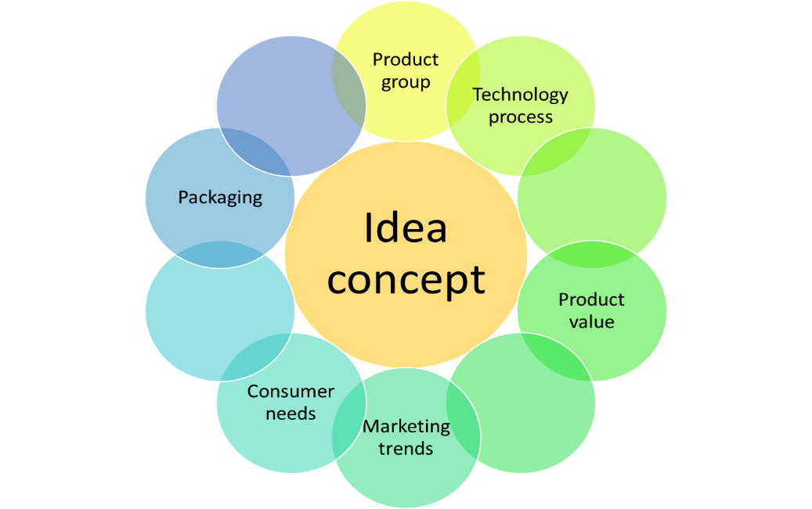
Figure 2.3. Product Context map

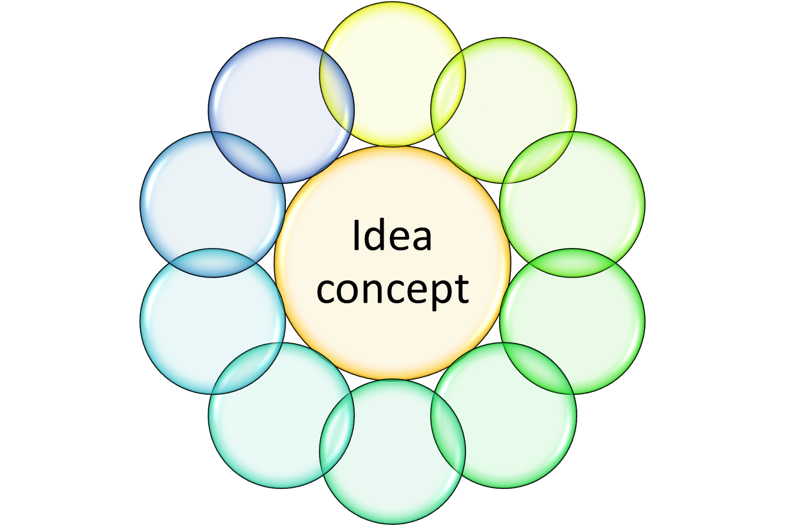
Results

Description of product development concept

Approved by _________________________________________
Name, Surname, signature

Date _________________________________________

Practical work

Consumer profile development
Task. Consumer profile development for a new product development. Evaluate consumer needs and value of new products using Business Model Canva.

Methods
https://jamboard.google.com/d/1Oig4vUtbYgJOXoUZP2ty25SNBM4U7SCsQRwHHn8RDxU/viewer?f=7 or https://miro.comor PDF documents Consumer profile

Results
Consumer portfolio.

Approved by _________________________________________
Name, Surname, signature

Date ______________________________________

Practical work Ideas generation techniques

Task. Using ideas generation techniques (also creative thinking methods) e.g. brainstorming, analogical reasoning, random name, etc. for new ideas generation.
Important!
- No criticism
- Unusual ideas are welcome
- Combine and improve ideas

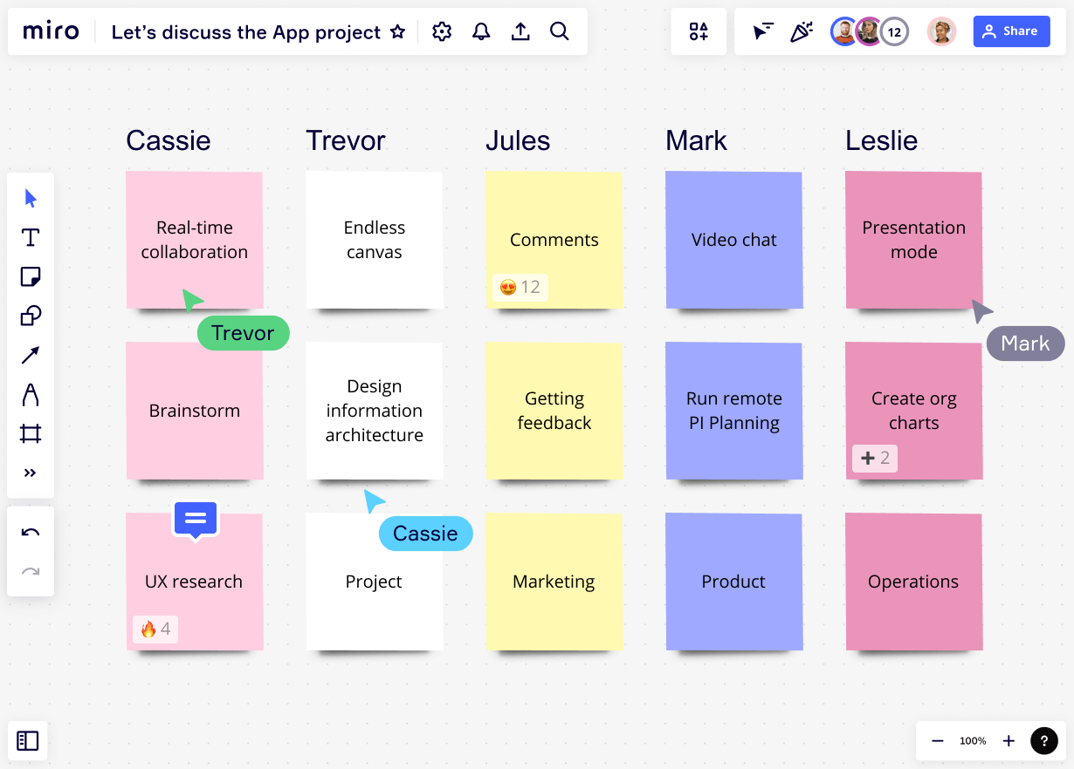
Methods

Brainstorm
Rules for brainstorm method:
Defined problem -
- Generate ideas (time 5 min)
- Form criteria for solving ideas
- Estimate ideas

A list of ideas (min. 20 ideas)

Analogies
Rules for analogies method:
- Define the problem
- Choose a natural object or picture that you will use to search for analogies
- Make associations and ideas
- Generate Ideas

Use this picture for Ideas Generation.

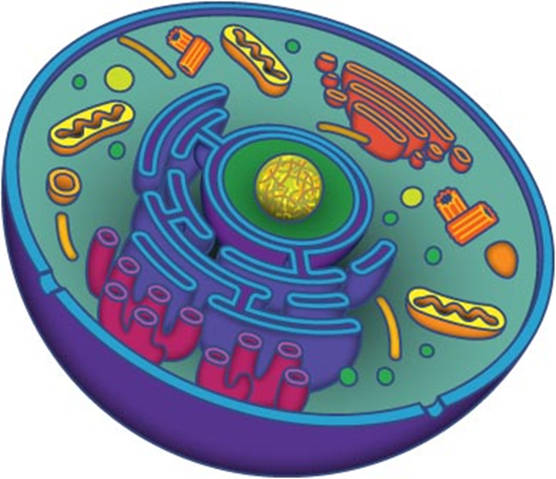

Write down what associations arise when looking at the picture.

A list of Ideas (min 10)

Random word

Rules for Analogies method:
  - Define the problem
  - Choose a poet book for a random word search
  - Make associations and generate ideas
  - Create min 10 ideas

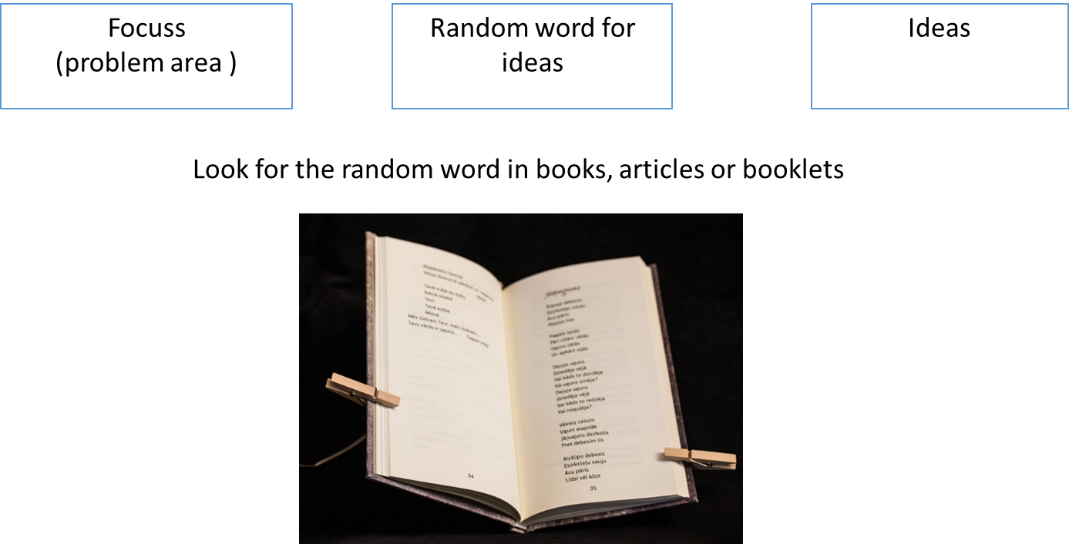

Write down what associations arise when you hear or read the chosen word.

A list of Ideas (min 10)

Results
Collect all ideas in a table 2.1.
Table 2.1.
List of Ideas (Min 40)
No. | Idea (short title) | Description of Idea

Approved by _________________________________________
Name, Surname, signature
Date ______________________________________

Practical work

Evaluation and Selection of ideas
1. Evaluation and selection of ideas 1 stage. Describe the ideas according to the previously developed concept.

Methods
HOW - NOW - WOW
Ideas from Table 2.1 – evaluate them in four categories using 4 categories from Figure 2.4.
Impossible – not able to realise
HOW - Ideas for the future, we can plan for next year
WOW - really innovative, creative ideas, but not implemented in our company
NOW - Ideas for development at this time

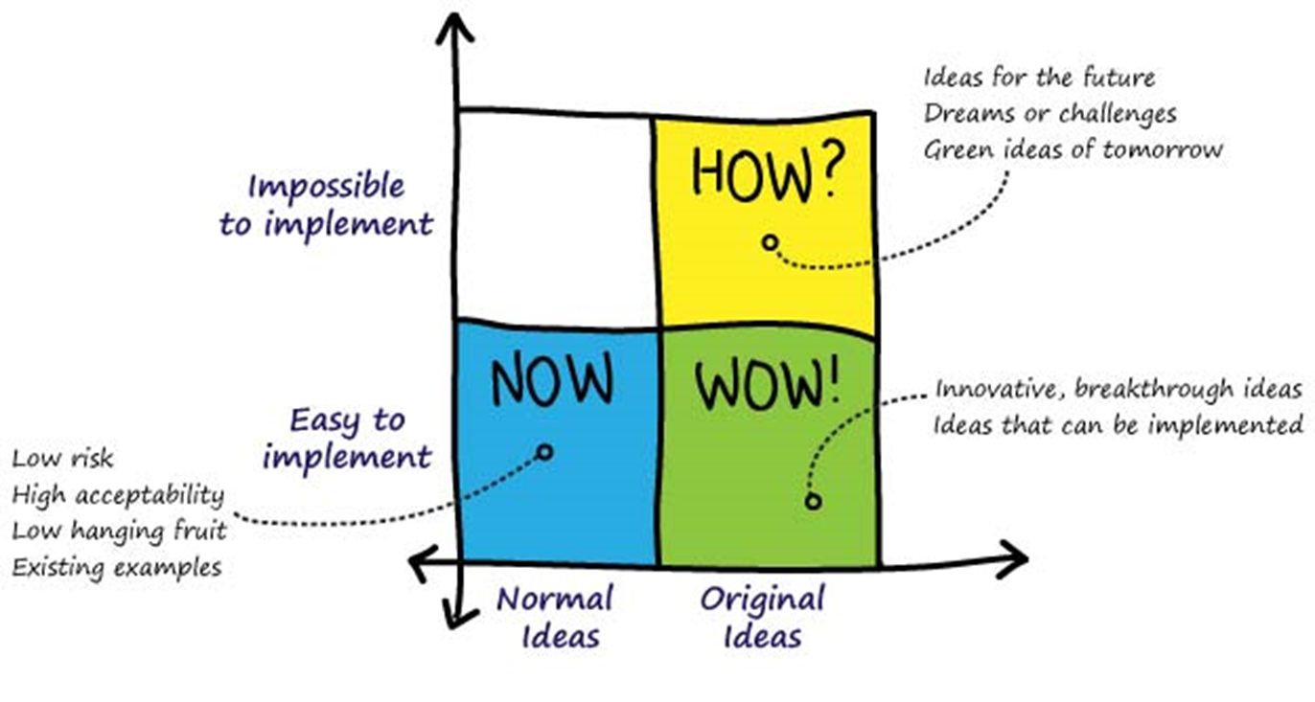
Figure 2.4. Method How – Now – Wow
https://gamestorming.com/how-now-wow-matrix/

Results Collect no more than 5 ideas for next evaluation step from NOW or WOW categories.

2. Evaluation and selection of ideas from the last task using the score sheet screening method. Describe the best idea according to the previously developed concept.

Score sheets for screening of ideas
In order to evaluate ideas using the scoring method (Table 2.2.), you need to set criteria and choose a scoring scale. The criteria are set by the product development team, choosing the most important ones, for example - technological possibilities, innovation aspect, engineering solutions, market capacity, etc. The rating scale can be chosen from 1 to 10 points; however, it should be noted that the value of each point must be defined. For example, 1- not relevant, 2- almost not relevant, 3- partially relevant, 4- relevant, 5- current;

Table 2.2
Score sheets for screening of ideas
Selection criteria | Idea 1 | Idea 2 | Idea 2 | Idea 3
Product innovation
Technical capability
Development time/ development cost
Marketability

Competition
Total Score

If you cannot get one super idea for product development, you can vote in the new product development team.

Conclusion
Description of Idea__________________________________________________________

________________________________________________________________________

_________________________________________________________________________

_________________________________________________________________________

Specific description of Idea fill table 2.3.

Table 2.3.
Specific description of table
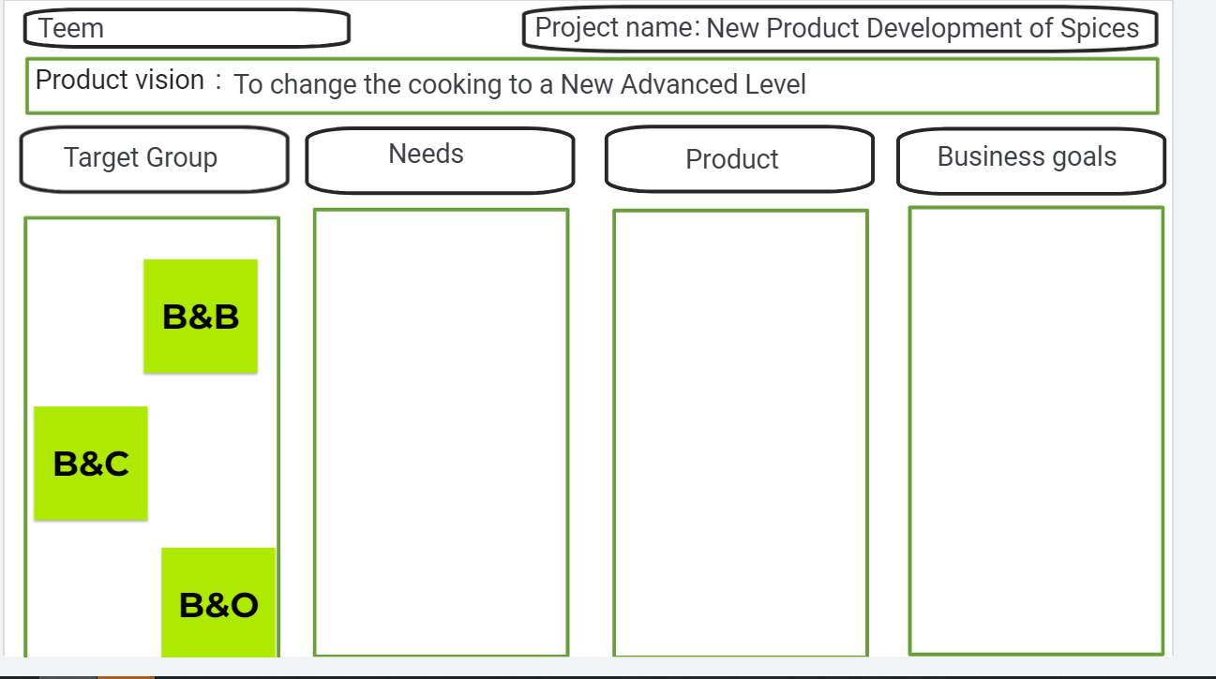

Description of Project Target
Name of product
Description of idea
Design of product
Mass/volume of product
Size of product
Structure of product
Form or shape of product
Tasty and aroma
Packaging
Shelf life of product
Important factors for new product development
Product advantage from consumer viewpoint
Competition of product
Consumer target group
Strategy of price

Home Work (HW) -new product architecture and design (picture, colour palate, size etc.)

Approved by _________________________________________
Name, Surname, signature
Date ______________________________________

Practical work

Sensory evaluation methods used in consumer studies
Practical work task - to test the ability of evaluators using the smell and basic taste test.
1. To recognise the sample's aroma and fill worksheet 2.1. Aroma test.
Worksheet 2.1.
Aroma test
NAME, SURNAME__________________________________
DATE ____________________________________
TRAY NO. ____________________________________

Check the test samples presented by smelling them and write the sample code to the corresponding aroma description.
Do not repeat the smelling process more than 3 times!!!
Sample code | Aroma | Right / Wrong |  | Sample code | Aroma | Right / Wrong
 | caraway |  |  |  | bitter almond
 | vinegar |  |  |  | apple
 | mint |  |  |  | smoked products
 | mushrooms |  |  |  | peach
 | coffee |  |  |  | mustard
 | cinnamon |  |  |  | nuts
 | vanillin |  |  |  | garlic
2. To recognise the basic tastes (sweet, sour, salty, bitter and umami) in water solutions and fill worksheet 2.2.
Worksheet 2.2
Basic taste test
NAME, SURNAME__________________________________
DATE ____________________________________
TRAY NO. _____________________________________
With this test, we want to find out if you can identify five basic tastes – sweet, salty, sour, bitter and umami.
Take the sample in the mouth so that the liquid covers the surface of the tongue. Determine the taste.
The mouth should be rinsed with distilled water after tasting each sample.
Take your time when tasting the samples!
Sample code | Taste | Right / Wrong
3. To evaluate the intensity of sensory properties for food products and fill worksheet 2.3.
Worksheet 2.3.
12 cm LINE SCALE (INTENSITY OF SENSORY PROPERTIES)
NAME, SURNAME___________________________________
DATE _____________________________________
TRAY NO. ______________________________________
Select and write in the rectangles (on the right hand side of the scale) the sensory properties that are specific to these products.
Please mark the intensities of the presented product samples on the Line scale and write the sample number below the marking.
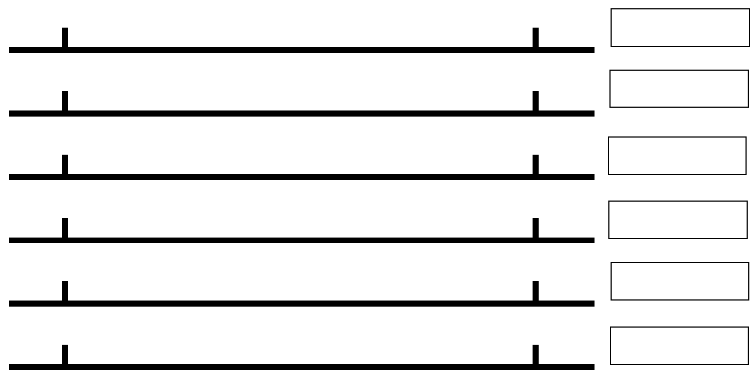
Results
Prepared sensory properties profile of analysed food products.

Example
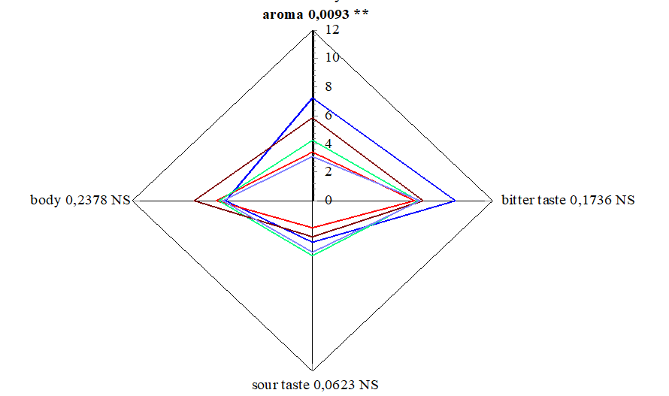

4. To evaluate the acceptability of sensory properties for food products using Just about Right method and 7-point Hedonic scale and fill worksheet 2.4 and 2.5.
Worksheet 2.4.
JAR (Just about Right) test
NAME, SURNAME____________________________________
DATE _____________________________________
TRAY NO. _____________________________________
Select and write in the introduction part and from left to right-hand side of the scale the sensory properties that are specific to these products.
Please, evaluate the sensory properties (___________________, __________________, _______________________, _______________________, ___________________) of ___________________ samples using JAR (Just About Right) test.
Please, indicate your opinion about __________________ sensory properties, marking the squared box that matches your preference and liking.
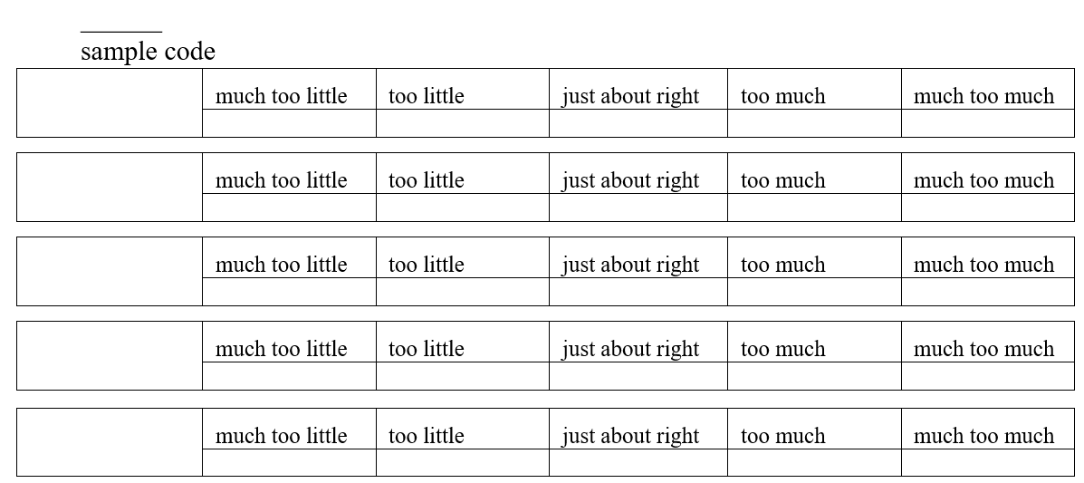

Worksheet 2.5.

7-point Hedonic scale

Please, evaluate overall liking of ___________________ samples!
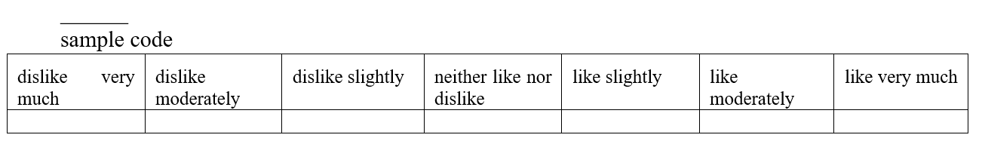
Results
- Collect the obtained data from the JAR method (worksheet 2.4.) - much too little (-2), too little (-1), just about right (0), too much (1), much too much (2).
- Collect the obtained data from the 7-point Hedonic scale (worksheet 2.5.)- dislike very much (1), dislike moderately (2), dislike slightly (3), neither like nor dislike (4), like slightly (5), like moderately (6) and like very much (7).
- Prepare a graph with obtained data from 7-point Hedonic scale!

Example:
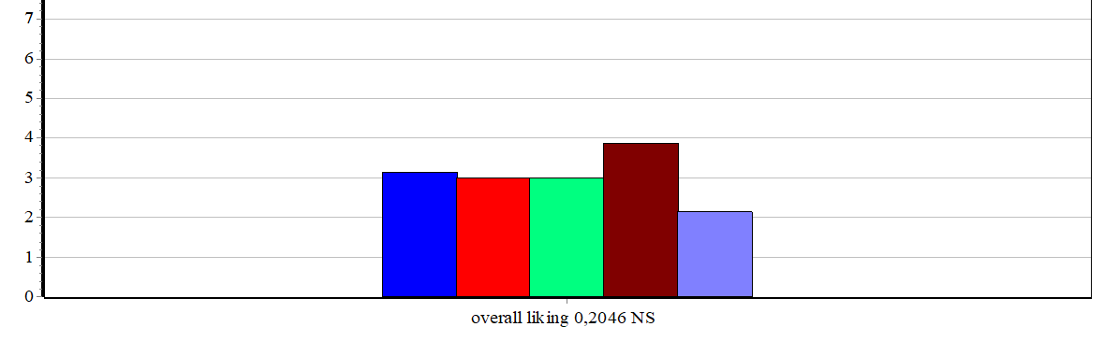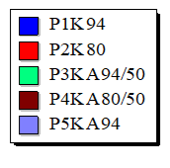

Conclusions

Approved by _________________________________________
Name, Surname, signature
Date ______________________________________

Theme 3

Product development

Theoretical materials
After a product idea, the next step is to better prototype and develop the idea. During the prototyping stage, your team will intensively research and document the product by creating a more detailed business plan and constructing the product.
These early-stage prototypes might be as simple as a drawing or a more complex computer render of the initial design. These prototypes help you identify areas of risk before you create the product.
During the prototyping phase, you will work on specifics like:
- Feasibility analysis- the next step in the process is to evaluate your product strategy based on feasibility. Determine if the workload and estimated timeline are possible to achieve. If not, adjust your dates accordingly and request help from additional stakeholders.
- Market risk research- it’s important to analyse any potential risks associated with the production of your product before it’s physically created. This will prevent the product launch from being derailed later on. It will also ensure you communicate risks to the team by documenting them in a risk register.
- Development strategy- Next, you can begin working through your development plan. In other words, know how you’ll be assigning tasks and the timeline of these tasks. One way you can plan tasks and estimate timeline is by using the critical path method.
During the initial design phase, project stakeholders work together to produce first prototype of the product. The design should be created with the target audience in mind and complement the key functions of your product.
A successful product design may take several iterations to get just right, and may involve communicating with distributors in order to source necessary materials.
To produce the initial design, you will need:
- Ingredients - raw materials play an important role in designing the first prototype. Raw materials in the development of new products must be specially evaluated, as they must be available regularly, also in large quantities. The value and seasonality of local products, as well as food safety issues, should be taken into account.
- Recipes and technologies - technologies must correspond to the latest trends and be economically available to both producers and consumers.
- Connect with stakeholders - it’s important to keep tight communication during the design phase to verify your initial design is on the right track. Share weekly or daily progress reports to share updates and get approvals as needed.
- Receive initial feedback: when the design is complete, ask senior management and project stakeholders for initial feedback. You can then revise the product design as needed until the final design is ready to be developed and implemented.
Once the design is approved and ready to be handed off, move on to the validation phase for final testing before launching the product.

Validation and testing
To go live with a new product, you first need to validate and test it. This ensures that every part of the product—from development to marketing—is working effectively before it’s released to the public.
To ensure the quality of your product, complete the following:
- Concept development and testing - you may have successfully designed your prototype, but you’ll still need to work through any issues that arise while developing the concept. This could involve software development or the physical production of the initial prototype. Test functionality by enlisting the help of team members and beta testers to ensure the quality of the development.
- Front-end testing- during this stage, test the front-end functionality for risks with development code or consumer-facing errors. This includes checking the ecommerce functionality and ensuring it’s stable for launch.
- Test marketing - before you begin producing your final product, test your marketing plan for functionality and errors. This is also a time to ensure that all campaigns are set up correctly and ready to launch.
Once your initial testing is complete, you’re ready to begin producing the final product concept and launch it to your customer base.

Practical work

Developing technological documentation
1. Prepare recipe and technology process for new product production.
Description of technology process and quality control of new product.
Develop a recipe and technological documentation for______________________________, calculate for 10 pcs. of the finished product.
Recipes and technological documentation should be made in the given forms. Describe in detail the preparation of the product, as well as represent it in the form of a technological scheme.

Results

TECHNOLOGICAL DOCUMENTATION

RECIPE

Losses, % |  | Ingredients, their characteristics | Amount of raw materials  10 pieces of the finished product, g
technical | heat treatment | Ingredients, their characteristics | Gross | Net
Product
St/p outcome, y
 | Roast, %
Product output, kg
Filling
St/p outcome, y
Product decoration
St/p outcome, y
Total output of product st/p, y
Dry loss, %
Total gross income, y
Output of 1 piece, g

TECHNOLOGICAL INSTRUCTION

Pre-treatment
Processing
Implementation
Quality indicators of the product

Approved by _________________________________________
Name, Surname, signature
Date ______________________________________

Practical work

Label and packaging design for the new product
The purpose of the work is to develop a label and packaging design for a new type of food product. Practical tasks - to develop a sample label and packaging for the new product.
Recommendations for analysis and development of a new product label and packaging
To create a food packaging design, you need to have knowledge in many areas of food production. Without knowledge of the properties of raw materials and the product, its production technology, the characteristics of packaging materials and consumer preferences, it is difficult to count on creating an attractive packaging design.
The positive impact of packaging on product perception is recognised by most manufacturers. Therefore, the company management is now allocating significant funds to improve the packaging of their product. And these costs pay off in a short period of time.
In order for food packaging to help make the product more unique and recognisable, you should take care of its design. Having entrusted the design of food packaging to professionals, the manufacturers themselves need to clearly understand what they want from the designer, and the specific direction in which they expect the new product to be promoted. This includes the creation of a completely new brand, the development of new packaging for the food products, and its creative design - everything that is so necessary for a domestic manufacturer and seller in the process of maintaining their brand.
When paying attention to the design of food packaging, we must not forget about its shape. It is known that the original form of packaging plays an important role in attracting buyers. The knowledge in the field of technical production and the intricacies of industrial design allows us to develop just such packaging for food products, the shape of which will correspond to both the characteristics of the product and the style of the company itself.
Another significant point in packaging design is corporate identity, including a logo and brand name. This tool for establishing contact with the consumer helps to effectively position the product and its manufacturer.
The logo plays a significant role in creating a food brand. When creating a logo, it is important not only to take into account the customer’s desire to stand out from competitors, but to play on the association with the brand in such a way as to emphasise the nature of the product being produced.
A brand today is not just a legally registered symbol of a manufacturer or product, containing comprehensive information about it. It is a living image of a product or company. The more vivid and immediate a given image becomes, the more likely it is that it will penetrate the minds of consumers and stand out among competing brands.
To create a label design and a product as a whole, you can use various methods and tools. Original and generally accepted techniques for organising shape and colour, drawing, computer modelling and analysis based on general approaches and principles of design. The main thing is a creative approach to the implementation of a visual representation of your product idea.
The packaging must contain the necessary information for the consumer, taking into account its placement in accordance with the requirements of legislation on the safety of product and packaging materials.
Good packaging and label design is a sign of a quality product that can sell itself. A well-developed design can provoke a purchase in a few minutes. At the same time, development should be carried out not only in strict accordance with the ideology and corporate style of the brand. Understanding the price niche, the belonging of the created image to the product category, and the certainty of the place of sale for the developer is necessary.
Methods
1. Conduct an analytical review of the literature and legislation in different countries on advances in the field of industrial design of labels and packaging for food products.
2. Based on the review of the main characteristics of the new product and your aesthetic ideas, develop a creative label design for your product.
3. Develop a packaging layout for a new product, taking into account the placement of necessary information for the consumer in accordance with legislation requirements.
Results
Prepared food product packaging design according to legislation and added sensory product claims.

Description of the proposed packaging design solution.

Offers (design image).

Approved by _________________________________________
Name, Surname, signature
Date ______________________________________

Practical work

The prototype evaluation phase. Developing, testing and finalising prototypes
1. Developed evaluation protocols for prototype tests.
2. Evaluate prototypes using developed tests – examples in worksheet 3.1. and 3.2.
3. Developed samples of prototype.

Results
Table 3.1.
Recipe’s evaluation protocol
Ingredients | Amount of ingredients, kg
Ingredients | Prototype 1 | Prototype 2 | Prototype 3 | Prototype 4 | Final

Table 3.2
Prototype evaluation protocol
 | Sensory properties |  |  | Textural properties |  | Picture
 | Taste | Aroma | Visual | Texture | Viscosity | Picture
Prototype 1
Prototype 2
Prototype 3
Prototype 4
Final Version

Worksheet 3.1.
CATA (Check all that Apply)
Please write words that describe_______________________________!
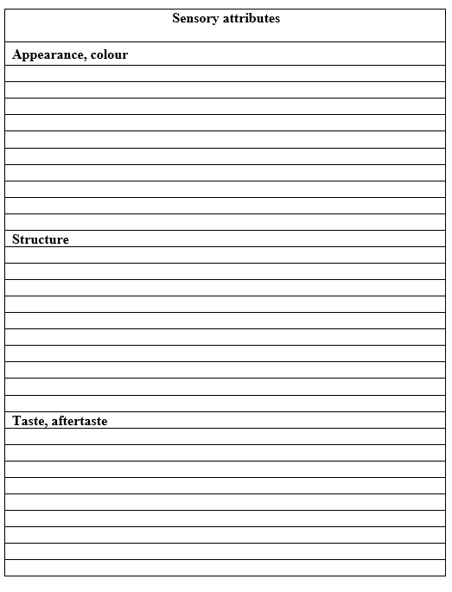
Please check the sensory attributes which are characteristics of the __________________________ sample.
Worksheet 3.2.
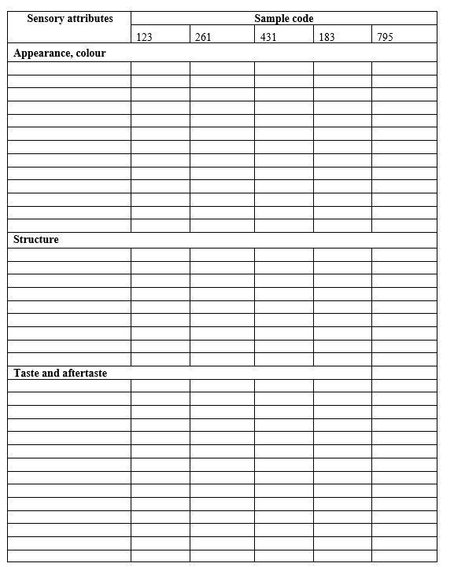

Conclusion

1. Final recipe

2. Workflow of technological processing

3. Quality parameters of products

4. Design of packaging and labelling

Approved by _________________________________________
Name, Surname, signature
Date ______________________________________

Theme 4

Commercialisation

Theoretical materials
The commercialisation process of a new product involves several stages from its conceptualisation to its launch into the market. Here's a general overview of the typical steps involved:
- Market research: market research is conducted to gather insights into customer needs, preferences, and buying behaviour. This helps in refining the product concept and identifying target market segments.
- Business analysis: a thorough analysis of the potential financial viability of the product is conducted. This includes assessing costs, pricing strategies, sales forecasts, and potential returns on investment.
- Prototype development and testing: a prototype of the product is developed to test its functionality, design, and usability. Feedback from testing is used to make necessary improvements and refinements.
- Marketing strategy development: a comprehensive marketing strategy is formulated to create awareness, generate interest, and drive demand for the new product. This may include branding, advertising, promotions, and distribution channels.
- Sales and distribution: channels for distributing the product are identified and partnerships with retailers, distributors, or online platforms are established. Sales strategies and tactics are developed to reach target customers effectively.
- Launch: the product is officially launched into the market. This may involve a launch event, press releases, and other promotional activities to create buzz and generate initial sales.
- Post-launch evaluation and iteration: after the product is launched, its performance is monitored closely. Feedback from customers, sales data, and market trends are analysed to evaluate the product's success and identify areas for improvement. Iterations and adjustments may be made based on this feedback to optimise the product and its marketing strategy.
Each of these steps requires careful planning, coordination, and execution to ensure a successful commercialization process and a smooth transition from product development to market launch.
The content of marketing communication refers to the specific messages and information conveyed to the target audience through various communication channels. Effective marketing communication content should be relevant, compelling, and tailored to resonate with the audience's needs, preferences, and interests. Here are some key components of marketing communication content:
- Value proposition: clearly communicate the unique value proposition of the product or service—what sets it apart from competitors and why it's valuable to the target audience.
- Product features and benefits: highlight key features and benefits of the product or service, emphasising how it solves a problem or fulfils a need for the customer.
- Brand storytelling: share the brand's story, values, and mission to create an emotional connection with the audience and differentiate the brand in the market.
- Visual elements: incorporate visually appealing elements such as images, graphics, videos, and infographics to enhance engagement and convey information more effectively.
- Call to action (CTA): include a clear and compelling call to action prompting the audience to take the desired action, whether it's making a purchase, signing up for a newsletter, or contacting the company.
- Targeted messaging: tailor the messaging to different segments of the target audience based on demographics, psychographics, behaviour, or other relevant criteria to ensure relevance and resonance.
- Customer testimonials and reviews: incorporate testimonials, reviews, case studies, or success stories from satisfied customers to build credibility and trust in the brand.
- Social proof: showcase social proof indicators such as user-generated content, social media followers, or industry awards to reinforce the brand's credibility and popularity.
- Educational content: Provide valuable information, tips, or educational content related to the industry, product usage, or solving customer problems to position the brand as a trusted authority and resource.
- Personalisation: use personalisation techniques to address the audience by name, tailor content based on past interactions or preferences, and create a more personalised and relevant experience.
- Consistency across channels: ensure consistency in messaging, tone, and branding across different communication channels—whether it's social media, email marketing, website content, or advertising—to maintain brand coherence and recognition.
- Feedback and engagement: encourage two-way communication by inviting feedback, responding to comments and inquiries, and fostering engagement with the audience to build relationships and loyalty over time.
Creating a marketing activities plan involves outlining the specific tactics and strategies that will be implemented to achieve the marketing objectives outlined in the overall marketing plan. Here's a general framework for developing a marketing activities plan:
- Set clear objectives: define specific, measurable objectives that align with the overall marketing goals. These objectives should be realistic, time-bound, and relevant to the target audience.
- Identify target audience: clearly define the target audience segments based on demographics, psychographics, behaviour, or other relevant criteria. Understanding the audience's needs, preferences, and pain points is crucial for tailoring marketing activities effectively.
- Choose marketing channels: select the most appropriate marketing channels to reach the target audience based on their preferences and behaviour. This may include a mix of online and offline channels such as social media, email marketing, content marketing, advertising, events, public relations, and more.
- Develop messaging and content: create compelling messaging and content that resonates with the target audience and communicates the brand's value proposition effectively. Tailor the messaging and content to each marketing channel and audience segment for maximum impact.
- Allocate budget and resources: determine the budget and resources required for each marketing activity, taking into account factors such as channel costs, production expenses, personnel, and any other associated costs.
- Timeline and schedule: establish a timeline and schedule for implementing each marketing activity, ensuring that deadlines are realistic and achievable. Consider seasonal trends, industry events, and other external factors that may impact timing.
- Implementation plan: Outline the specific steps and tasks required to execute each marketing activity, including responsibilities, deadlines, and dependencies. Assign roles and responsibilities to team members or external partners as needed.
- Measurement and evaluation: define key performance indicators (KPIs) and metrics to track the success of each marketing activity. Establish benchmarks and targets for each KPI, and regularly monitor and evaluate performance to identify areas for improvement.
- Optimisation and adjustment: continuously optimise and refine marketing activities based on performance data and feedback from the target audience. Adjust strategies, messaging, and tactics as needed to improve results and achieve marketing objectives.
- Integration and alignment: ensure that marketing activities are integrated and aligned with other departments and initiatives within the organisation, such as sales, product development, customer service, and branding, to maximize effectiveness and consistency.
- Risk management: identify potential risks and challenges that may impact the success of marketing activities, and develop contingency plans to mitigate these risks proactively.
- Review and reporting: regularly review and report on the progress and results of marketing activities to stakeholders and decision-makers. Use insights gained from performance data to inform future marketing strategies and activities.
Detailed actions aimed for achieving the optimal position in the market should be understood in the company marketing plan. It affects the company's performance, product sales and profits, not production.
The purpose of the marketing plan
- Maintaining the company's position in the market.
- New product development and introduction.
- Coverage of new niches and segments (diversification), etc.
Advantages of developing a marketing plan for the company:
- It determines what part of its funds should be spent on marketing activities.
- Forms the policy of promotion of specific types of goods and services in the market.
- Develops a strategy and tactics for working with the target market, including pricing procedures.
- It helps to increase the income and profit from the sale of certain goods.

Types of the company's marketing plan and the purpose of their preparation.

Marketing plans are classified as follows:
- Duration - strategic (more than 3 years), tactical (up to 3 years), operational (up to 1 month).
- Depth of study - detailed or general.
- Area of operation - target plan, pricing policy, product policy, marketing communications, control and revision, finance.

The structure and content of the company's marketing plan.

A marketing plan is an internal document used by the company’s management to make decisions. However, it may take several months to compile, as it requires:
- Collect information about customers.
- Study supply and demand in the market.
- Competitive advantages.
- Competitive Ratings, etc.

Three to four months are spent on creating a marketing plan: 50% of the time is spent on collecting all the necessary information, 40% on analysis and evaluation, and only 10% is spent on creating the document itself.
When creating a marketing plan, it is recommended to focus on the following structure:
- Summary. This section includes a description of the main points outlined in the marketing plan. Here the goal, the ways to achieve it, and the expected results of the implementation of the plan are determined.
- Market overview and forecast. This section describes the market (size, growth opportunities, trends, characteristics) and shows the specific behaviour of consumers and the competitors in it. Here it is important to show how many competitors there are in the selected segment, what shares they cover and what opportunities exist for the market growth.
- SWOT analysis and competitive advantages. This section analyses the company's strengths and weaknesses, threats and opportunities for its activities.
According to the results of the SWOT analysis, the marketer should determine the following:
- The main competitive advantage of the company.
- Placement of the product in relation to consumers (preferably with a forecast for 3-5 years).
- Tactical measures to take advantage of opportunities and reduce the impact of threats.
- Strategy to fight competitors and increase customer loyalty.
- The purpose and tasks of the marketing plan. The marketing plan should contribute to the development of the business, so it includes business goals for the selected planning period (a month, a year, three years). Only after that, tasks of marketing activities are created.
- Marketing mix (marketing-mix). The basis of any marketing plan is called the marketing mix, which is based on the 5P model for goods and the 7P model for services.
The 5P model. Any marketing activity is built on five components:
- Product - product or product policy - logo and form style, appearance and physical characteristics of the product, product assortment, product quality.
- Price - price or price policy - wholesale and retail price, the procedure for determining the cost of goods, discounts and promotions, price discrimination.
- Place - place of sale or sales policy - selling goods in markets, stores, distribution bases, display of goods, inventory management and logistics.
- Promotion - promotion or advertising policy - advertising strategy, advertising activity, PR activity, event marketing, communication channels, media strategy.
- People - employee motivation policy – motivation, corporate culture, working with loyal customers and VIP customers, feedback.
Thus, when developing a marketing plan, each of the above positions is developed in detail, which allows to form a complete picture of the company's activities in the market.
- Operating budget. Contains a detailed list of costs for marketing activities, which can be presented in tabular form.
- Risk assessment. This part describes the risks that the company may face during the implementation of the marketing plan.

Practical work

Communication elements for marketing
Communication elements are crucial components of a marketing plan and play a significant role in conveying the brand message to the target audience. Here are some key communication elements that can be included in a marketing plan:
- Brand Identity,
- Advertising,
- Public Relations (PR),
- Digital Marketing,
- Content Marketing,
- Sales Promotion,
- Direct Marketing,
- Word-of-Mouth Marketing,
- Internal Communication,
- Feedback and Customer Service.

1. Identify the line that correctly explains the following terms (Table 4.1.).

Table 4.1.
Communication elements
T/r | Communication elements |  | Explanation of terms
1 | Brand Identity | A | It encompasses a range of online tactics to engage with consumers, including email marketing, content marketing, social media marketing, influencer marketing, and search engine optimization.
2 | Advertising | B | This can include blog posts, articles, videos, infographics, whitepapers, e -books, and more.
3 | Public Relations (PR) | C | Its tactics are used to stimulate immediate sales or encourage customer loyalty. Examples include discounts, coupons, rebates, contests, giveaways, and loyalty programs.
4 | Digital Marketing | C | It can include various channels such as television, radio, print media, outdoor advertising, online advertising (including social media ads, display ads, and search engine marketing), and more.
5 | Content Marketing | E | This may include press releases, media interviews, event sponsorships, and community involvement.
6 | Sales Promotion | F | This can include direct mail, telemarketing, SMS marketing, and personalised email marketing campaigns.
7 | Direct Marketing | G | This includes elements such as the brand name, logo, tagline, and brand colours that help create a distinct identity in the minds of consumers.
8 | Word-of-Mouth Marketing | H | This includes responding to customer inquiries, addressing complaints, and soliciting feedback through surveys or social media listening.
9 | Internal Communication; | I | This can be achieved through exceptional customer service, referral programs, and user-generated content.
10 | Feedback and Customer Service | J | This may include internal newsletters, meetings, training sessions, and employee recognition programs.

2. Divide the students into 3 groups and assign each group to sell some kind of product and give them the task of using the communication elements of marketing. The assessment is based on the correct use of the communication elements of the requirements and the ability to persuade the customer to buy it.

Methods
Brainstorming, case studies, cooperative learning
Students interpret the marketing communication terms given in task 1 in order to strengthen their theoretical knowledge. Then, while performing the tasks given in the 2nd task, they directly test how to sell the product and the effective use of communication elements in a practical exercise based on theoretical knowledge, like a marketer.

Results
Marketing communication elements for a new product commercialisation.

Approved by _________________________________________
Name, Surname, signature
Date ______________________________________

Practical work

Content of marketing communication
Task. Each student will write down in their notebook which communication methods they intend to use to sell the new product which they believe will be effective, and a group discussion will be held. Students will be evaluated on this basis.

Methods
Flipped classroom method can be used in this lesson. Depending on the rules of the offline classes, 5 or 6 students will give a presentation during the class on what actions can be taken in each marketing communication direction for the new product to move.

Results
Channels of communications

Content of communications

Key words of communications

Approved by _________________________________________
Name, Surname, signature
Date ______________________________________

Practical work

Marketing activities plan
Creating a marketing activities plan involves outlining the specific tactics and strategies that will be implemented to achieve the marketing objectives outlined in the overall marketing plan.

Methods
Each student team using brainstorming, case studies, cooperative learning will be taught the structure and methods of creating a marketing plan for new product, the 5P marketing-mix model.
Below is a template for writing a marketing plan.

Template for writing a marketing plan.

1. Analysis of market trends and comparison with the 1st homework on trends.
2. Product analysis – value of products, location for sales, price, packaging design.Compare with competitors’ products (3-5 products).
3. Choosing a target market. Considering the features of the product and its price, and the main target audience, which will be middle class professionals who monitor their health.

4. Competitive advantages. Analyse competitor’s company offers and activities and communication channels, and find different channels and tactics for your marketing activities.
5. Create a strategy for marketing activities.
6. Tactical marketing activities plan. Plan and describe marketing communications channels, activities targeted at consumers, and develop content for the marketing plan.

Results

Marketing plan includes:
- Summary
- Description of the company and product
- Goal of the marketing plan (include strategy – Why and How?)
- Target customers
- Selling proposition (include competitor analysis)
- Distribution plan
- Marketing activities and plan (Table 4.2.)

Table 4.2.
Marketing activities plan
Tasks | Activities | Time sheet / week no.
Tasks | Activities | 1 | 2 | 3 | 4 | 5 | 6 | 7 | 8 | 9 | 10 | 11 | 12 | 13 | 14

You can use also digital planner https://miro.com/

Approved by _________________________________________
Name, Surname, signature
Date ______________________________________

Theme 5

Evaluation of new product development process

Theoretical materials
SWOT stands for Strengths, Weaknesses, Opportunities, and Threats. It is a simple management tool, but it really helps you to grow your business, whether you are just starting a business or growing your company even better.

Strengths are the advantages or strengths of an idea that is owned, which can provide an advantage over competitors. Strengths can be simply mean “What do you currently do or have which is good?”

Weaknesses are characteristics related to the weakness of the company, comparable to competitors, can also be a weakness that is currently considered internal. Defining your weaknesses can be done with the question “What could you do better?”

Opportunities can be classified as opportunities that can be used for an idea to develop.

Threats can be classified as threats that will be faced by project that can hinder its development.

Strengths or Weaknesses evaluation using control questions and a 5-point scale.

Evaluation of value propositions:
- Our value proposition is based on customer research,
- Our value proposition is based on customer needs,
- Our customers are very satisfied,
- Our value proposition is based on our own assumptions,
- Our value proposition partially meets customer needs,
- We have had complaints or returned purchases.

Evaluation of key resources:
- Our main resources are difficult for competitors to replace,
- Resource needs are easily predictable,
- We can get the resources at the right time and in the right amount,
- For competitors, our main resources are easily substitutable,
- Resource needs are difficult to predict,
- It is difficult for us to get the right amount of resources at the right time.

Evaluation of main activities:
- Our main activities are well planned,
- Our main activities are completed on time,
- Activities are delegated to the team as needed,
- Our main activities are spontaneous,
- There are often difficulties in meeting deadlines,
- Execution of activities is based on one person in a team.

Evaluation of key partners:
- We work with partners effectively,
- We have good relationships with key partners,
- Our cooperation is weak and ineffective,
- We tend to be in conflict with key partners.

Customer segment evaluation:
- The outflow of customers to competitors is low,
- Customers are well segmented,
- More and more customers are interested in our product,
- The outflow of customers from competitors is high,
- Customers are not segmented,
- New customers are not interested in our product.

Customer relationship evaluation:
- We have strong customer relationships,
- The selected activities perfectly match the customer segment,
- We pay great attention to attracting new customers,
- We have weak customer relationships,
- The selected activities do not correspond well to the customer segment,
- We do not pay much attention to attracting new customers.

Opportunity evaluation using control questions and a 5-point scale:
- Is there a possibility that an additional service or product can be created for the product?
- Are there opportunities that we can meet the customer's additional needs?
- Is it possible to add value to the product?

Opportunities for resources and activities:
- Is it possible to use cheaper resources?
- Are there any resources that have not yet been used:
- Can we standardise or automate any activities?
- Is it possible to increase the efficiency of activities?
- Could the partner provide additional opportunities in the value proposition?

Opportunities for customer segments and relationships:
- Can we serve new customer segments?
- Can we segment customers more precisely to perform activities more efficiently?
- Can we better align information channels to attract more customers?
- Have we identified non-profit customers?

Threats to value evaluation using control questions and a 5-point scale.
- Are substitute products available on the market?
- Can competitors offer a lower price or better value?

Threats to resources, activities and partners:
- Could we face any barriers to the supply of resources?
- Is the quality of our resources deteriorating?
- Are there any activities that we may have difficulty implementing?
- Is there a risk of losing a partner?
- Is there a risk that the partner will cooperate with competitors?

Threats to customer segments and relationships:
- Is there a possibility that the market will be saturated in the near future?
- Is there increasing competition in the market?
- Is there a possibility that customers will choose the value proposition of the competitors?
- Is there a possibility that any of our customer relationships are compromised?

Practical work SWOT analysis for project evaluation
Determine the strengths, weaknesses, threats and opportunities of the project, evaluate their importance on a 0 - 5 scale and write in the table 4.3.

Results
Table 4.3.
SWOT analysis
Strength | Weakness
Opportunities | Threats

Conclusion

Approved by _________________________________________
Name, Surname, signature
Date ______________________________________

Theme 6

Hackathon “InnoFood”

Theoretical materials
Hackathon is an innovative and engaging way to empower people with the skills and knowledge needed to succeed in the food industry. These intensive, multi-day collaborative workshops provide an immersive learning experience that encourages creativity, critical thinking, and problem-solving skills. By working together on real-world challenges, participants gain hands-on experience with the principles and practices of STEM and STEAM fields while learning to communicate their ideas effectively and work in interdisciplinary teams.
The hacking track is for participants to dive into problems. Often groups of 2-5 individuals form around a project, such as building a new data visualisation, writing a document, or collaboratively investigating a problem. Participants take out their laptops, connect to power and Wi-Fi, and get working.
Hacking begins with project introductions. Participants that bring projects to the event have an opportunity to briefly (1 minute max) explain what they are working on at the very start of the event so that other participants can join that project. At the end of the event, a wrap-up session gives each project a chance to demonstrate some accomplishments.

Identifying the purpose and goals of the Hackathons.
Working out the reasons for your Hackathons and what you'd like to get out of it is an essential first step in planning a successful event. Here are some steps you can take to help you identify the purpose and goals of your Hackathons:
Determine the audience: the first step in identifying the purpose and goals of your Hackathons is to determine who the event is for. Will it be for students, educators, professionals, or a combination of these groups? Knowing your audience (or your class!) will help you determine the specific goals and objectives of the event.
Identify the problem or challenge: next, you'll need to identify the problem or challenge that your Hackathons will focus on. This should be a real-world issue that is relevant to your audience and can be solved using the skills and knowledge of the participants. You may decide that students should be able to select a challenge that is important to them rather than have one assigned to them, but it is important to provide a structure and framework, such as the UN Sustainable Development Goals, so that they are not paralysed by infinite options.
Define the objectives: once you've identified the problem or challenge, you'll need to define the objectives of your Hackathons. What specific skills or knowledge do you want participants to gain from the event? Do you want them to develop new products or solutions, learn new technologies, or improve their collaboration and communication skills?
Establish the criteria for success: to ensure that your Hackathons is successful, you'll need to establish criteria for success. What are the specific outcomes you're hoping to achieve? Will you measure success based on the number of new solutions developed, the quality of the solutions, or some other metric? MTF always prioritises personal development in this regard, rather than a scoring system or competitive approach. Success is not when one group of students ‘wins’, but when all students progress and grow.
Create a timeline: finally, you'll need to create a timeline for your Hackathons. This should include specific milestones, such as the date by which participants must register, the date of the event itself, and the deadline for submitting final solutions. A well-planned timeline will help you stay on track and ensure that your Hackathons runs smoothly.
Once you've done your planning, it's time to design your program, challenges and activities for the participants to engage in during your hackathons. It's not enough to simply provide some technology and ask the students to simply make something - it's important to create a collaborative and fun culture, get the creative juices flowing, and encourage the students to help each other to create the best possible project they can.
Providing opportunities for brainstorming, ideation, and prototyping
Setting up creative opportunities is crucial to the success of the hackathons. Here are some great ways to create opportunities for these activities:
Brainstorming sessions - conduct brainstorming sessions with participants to generate ideas and solutions for the challenge. Encourage participants to think outside the box and come up with as many ideas as possible. Provide a safe and non-judgmental environment for participants to share their ideas.
Design thinking workshops - organise design thinking workshops that help participants understand the problem, empathise with the user, define the challenge, come up with possible solutions, prototype, and test. Design thinking workshops can help participants think creatively and systematically about the problem and come up with innovative solutions. Even an introduction to just the very basic principles of design thinking can have a significant impact on how students creatively approach their challenge.
Idea Stations - set up Idea Stations where participants can use different creative thinking methods for ideation and share their ideas and get feedback from others. Provide tools such as whiteboards, sticky notes, and markers to facilitate idea generation and sharing. Prototyping areas - set up areas where participants can use tools to build and test their ideas.
Collaboration spaces - create collaboration spaces where participants can work together on their ideas. Provide comfortable seating, tables, and power outlets to facilitate collaboration and productivity. Having a breakout room or quiet workspace can be very helpful for some students.
Mentor sessions - provide mentoring sessions where participants can get feedback and guidance from experts, coaches and facilitators. Mentors can help participants refine their ideas, troubleshoot technical challenges, and provide insights into the industry.
Work in progress presentations - organise ‘show-and-tell’ sessions where participants can showcase their prototypes and ideas to the rest of the group. This can be a great way to foster collaboration, inspire others, and get feedback on ideas.
By setting up these opportunities, you can create a collaborative and supportive environment that fosters creativity, ideation, and prototyping, and helps participants develop innovative solutions to their challenge.

Methods
Our pedagogical approach is based on the principles of experiential learning, which emphasise the importance of active engagement, reflection, and integration of knowledge. Hackathons are grounded in constructivist learning theory, which posits that learning is an active and collaborative process that involves the construction of knowledge and understanding through interaction with the environment and peers.

Results
Create a check list (6.1. table) for Hackathons planning and executing.
Table 6.1.
Check list for Hackathons planning and executing
Activities | Works | Done | Not

Conclusions

Approved by _________________________________________
Name, Surname, signature
Date ______________________________________

Literature Sources
- Biró, B.; Sipos, M.A.; Kovács, A.; Badak-Kerti, K.; Pásztor-Huszár, K.; Gere, A. Cricket-Enriched Oat Biscuit: Technological Analysis and Sensory Evaluation. Foods 2020, 9, 1561.
- Głuchowski, A.; Czarniecka-Skubina, E.; Kostyra, E.; Wasiak-Zys, G.; Bylinka, K. Sensory Features, Liking and Emotions of Consumers towards Classical, Molecular and Note by Note Foods. Foods 2021, 10, 133.
- Grasso, S.; Jaworska, S. Part Meat and Part Plant: Are Hybrid Meat Products Fad or Future? Foods 2020, 9, 1888.
- Guzek, D.; Gł ˛abska, D.; Sajdakowska, M.; Gutkowska, K. Analysis of Association between the Consumer Food Quality Perception and Acceptance of Enhanced Meat Products and Novel Packaging in a Population-Based Sample of Polish Consumers. Foods 2020, 9, 1526.
- How to run a successful Hackathon https://hackathon.guide
- Kalumbi, M.; Matumba, L.; Mtimuni, B.; Mwangwela, A.; Gama, A.P. Hydrothermally Treated Soybeans Can Enrich Maize Stiff Porridge (Africa’s Main Staple) without Negating Sensory Acceptability. Foods 2019, 8, 650.
- Kumar, R.; Chambers, E.; Chambers, D.; Lee, J. Generating New Snack Food Texture Ideas Using Sensory and Consumer Research Tools: A Case Study of the Japanese and South Korean Snack Food Markets. Foods 2021, 10, 474.
- Project planning tool, www.miro.com;
- Ruiz-Capillas, C.; Herrero, A.; Pintado, T.; Delgado-Pando, G. Sensory Analysis and Consumer Research in New Meat Products Development. Foods 2021, 10, 429.
- Silva, F.; Duarte, A.M.; Mendes, S.; Borges, P.; Magalhães, E.; Pinto, F.R.; Barroso, S.; Neves, A.; Sequeira, V.; Vieira, A.R.; et al. Adding Value to Bycatch Fish Species Captured in the Portuguese Coast—Development of New Food Products. Foods 2020, 10, 68.
- Swiader, K.; Florowska, A.; Konisiewicz, Z.; Chen, Y.-P. Functional Tea-Infused Set Yoghurt Development by Evaluation of Sensory Quality and Textural Properties. Foods 2020, 9, 1848.
- Swiader, K.; Marczewska, M. Trends of Using Sensory Evaluation in New Product Development in the Food Industry in Countries That Belong to the EIT Regional Innovation Scheme. Foods 2021, 10, 446.
- Szymandera-Buszka, K.; Waszkowiak, K.; J ˛edrusek-Goli ´nska, A.; H ˛e´s, M. Sensory Analysis in Assessing the Possibility of Using Ethanol Extracts of Spices to Develop New Meat Products. Foods 2020, 9, 209.
- Tao, R.; Cho, S. Consumer-Based Sensory Characterization of Steviol Glycosides (Rebaudioside A, D, and M). Foods 2020, 9, 1026.
- The Makeathon Manua https://makeathon.mtflabs.net/designing-a-makeathon/brainstorming-and-prototyping
- Актуальный дизайн: Упаковка 01. –М.: РИП-холдинг/Rotovision, 2009. – 192 с.
- Джон Т. Дрю, Сара А. Мейер. Управление цветом в Упаковке. –М.: РИП- холдинг/Rotovision, 2009. – 222 с.
- Казарцев Д.А. Тара и упаковка: Учеб.пособие. - Воронеж: Воронеж. госуд.технолог.акад. , 2007. – 127 с.
- Слесарчук В. А. Упаковка продукции пищевых производств. /В. А. Слесарчук, Е. К. Хамитова. – М.: РИПО, 2019. – 237 с.
- Тимоти Самара. Структура дизайна. Стильное руководство. - М.: РИП- холдинг, 2008. – 272 с.
- Тимоти Самара. Эволюция дизайна. От теории к практике. - М.: РИП- холдинг, 2008. – 272 с.
- Упаковка пищевых продуктов [Текст] / под ред. Ричарда Коулза, Дерека МакДауэлла, Марка Дж. Кирвана; пер. с англ. яз. под науч. ред. Л. Г. Махотиной. - Санкт-Петербург: Профессия, 2008. - 408 с.
- Упаковка. Библиотека дизайна. Пер. с англ. – М.: Арт-Родник, 2004. - 79 с.
- Эрл М. Примеры разработки пищевых продуктов. Анализ кейсов. – СПб.: Профессия, 2010. – 464 с.

