


Open Food Innovation University (OFINU)

Study module
“Academic Writing”
WORKBOOK
for students

2024
Summary

The workbook is elaborated within the project “Open Food Innovation University" (OFINU), being in implementation with support of the European Union Erasmus+ Programme.
Overall objective of the project - to modernise food innovation and technology related higher education in Uzbekistan and Tajikistan, thereby increasing the quality and ensuring relevance of the higher education to the needs of the socio-economic growth of the countries concerned and especially of their regions.

Full partners:
- Lead partner: Latvia University of Life Sciences and Technologies
- Uzbekistan: Samarkand Agro-innovations and Research University, Andijan Institute of Agriculture and Agro-technologies
- Tajikistan: Technological University of Tajikistan, Kulob Institute of Technology and Innovation Management, Isfara Branch of the Technological University of Tajikistan
- Slovakia: Slovak University of Agriculture in Nitra

Associated partners in Uzbekistan:
- A group of companies "AGROMIR"
- "Navigul" MCHJ QK
- “Samarqand don mahsulotlari” JC (Samarkand grain products)

Associated partners in Tajikistan:
- CJSC “Combinati Shiri Dushanbe”
- LTD "Orion Rustam"
- Association of Entrepreneurs of Khatlon

The project implementation period: 01/02/2024 - 31/01/2027.

Funded by the European Union. Views and opinions expressed are however those of the authors only and do not necessarily reflect those of the European Union or the European Education and Culture Executive Agency. Neither the European Union nor the granting authority can be held responsible for them.

TEACHERS

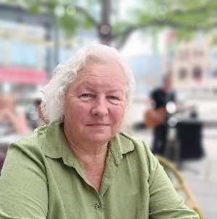 |  | 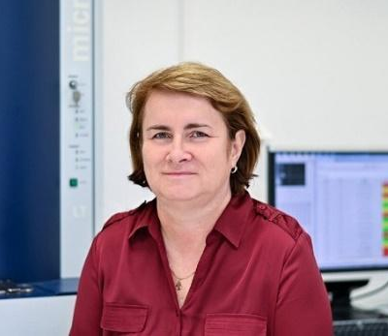
RUTA  GALOBURDA | ZANDA  KRUMA | MIROSLAVA  KAČÁNIOVÁ

CONTENT

Theme of the study course 6
Learning methods 8
Course schedule 9
Theme 1 1
Introduction to article types and publishing 1
Theoretical materials 1
Practical work 8
Materials 8
Methods 8
Results 9
Conclusion 10
Theme 2 12
The structure of a scientific article (IMRaD) 12
Theoretical materials 12
Practical work 17
Materials 18
Methods 18
Results 18
Conclusion 18
Theme 3 19
Selection and critical analysis of articles 19
Theoretical materials 19
Practical work / seminar 19
Materials 19
Methods 20
Results 20
Conclusion 20
Theme 4 21
Elements of academic language 21
Theoretical materials 21
Practical work / seminar 29
Materials 29
Methods 29
Results 29
Conclusion 30
Theme 5 32
Visual elements for statistically based data presentation in manuscript 32
Theoretical materials 32
Practical work 34
Materials 34
Methods 34
Results 34
Conclusion 36
Theme 6 37
Preparing, editing, and submitting manuscripts 37
Theoretical materials 37
Practical work 77
Materials 77
Methods 77
Results 77
Conclusion 78
Theme 7 79
Presenting scientific results 79
Theoretical materials 79
Practical work 95
Materials 95
Methods 95
Results 95
Conclusion 96
References 98

Theme of the study course
The study course is focused on provision of knowledge and development of skills needed for writing and publishing scientific papers, especially for a peer-reviewed scientific journals. The course provides knowledge on types or articles, methods to be used for their elaboration, structure, use of academic vocabulary, as well develops skills to analyse articles, prepare and submit manuscripts, and to present scientific results.

Partner universities and their academic staff, involved in the development of the study course:

P1 Latvia University of Life Sciences and Technologies
Ruta Galoburda - professor.
Zanda Kruma - tenure professor.
P7 Slovak University of Agriculture in Nitra
Miroslava Kačániová - professor.
P2 SAMARU. Samarkand Agroinnovations and Research University
Shavkat Hasanov - professor.
Sherzod Babakholov - PhD.
Azamat Ismailov - MSc, Senior Lecturer.
Shakhista Ishniyazova - professor.
Yigitali Tashpulatov - PhD.
Kamoliddin Bozorov - PhD.
P3 AIAA. Andijan Institute of Agriculture and Agro-technologies
Bahodirjon Nosirov - Associated Professor.
Murodjon Atajanov - Associated Professor.
Sanjarbek Iskandarov - Associated Professor.
Muhammad Zahiriddin Zaynobiddinov - MSc Senior Lecturer.
Turgunbay Khalmatov - MSc, Senior Lecturer.
P4 TUT. Technological University of Tajikistan
Khurshed Ikromi - professor.
Muhabbat Ikromi - assoc.professor.
P6 BTUTI. Branch of the Technological University of Tajikistan in the city of Isfara
Zokirkhoja Soliev - professor.

Learning methods
No. | Themes | Possible methods to be used
1. | Lectures | Presentation of theoretical material by the teacher in front of the audience. Lectures include a theoretical background of academic writing.
2. | Practical works | Use of visual and interactive materials: Presentations, video tutorials, interactive websites. Drafting manuscript following practical guidance of teacher.
3. | Seminars | Presenting prepared poster and oral presentation. Discuss with classmates and teacher.
4. | Independent work | Assignments for independent studies are described with each topic.

Course schedule
Date, Time | Study form | Theme | Lecturer
1. Introduction to article types and publishing
1st day | Lectures (3 h) | Types of scientific articles. Citation and impact factors. Criteria and tools for journal selection. Thematic area of the journal. Publication costs, funding sources. Instructions for authors. Copyright and its transfer. Article authorship and sequence of authors. Scientific ethics and acknowledgments.
1st day | Practical work (2 h) | - Choice of journal for manuscript submission.  - Searchable journal databases available.
2. The structure of a scientific article (IMRaD)
2nd day | Lectures (2 h) | Writing process. The structure of a scientific article (IMRaD). Use of other authors' works. Automatic reference management tools.
2nd day | Practical work (4 h) | - Analysis of scientific articles. Automatic reference management tools.
3. Selection and critical analysis of articles
3rd day | Lectures (2 h) | Working with databases. Critical analysis of articles.
3rd day | Practical work / seminar (3 h) | - Preparation of background information for scientific article, making library with possible references.  - Presentation of the selected journals.
4. Elements of academic language
4th day | Lectures (2 h) | The key elements of academic writing. Word choice. English terms and phrases commonly used in academic writing. Paragraph unity and coherence. The most common errors in cases where the language of the manuscript is not the native language of the author.
4th day | Practical work / seminar(4 h) | - The use of different terms in English. Error recognition.  - Presentation of the manuscript outline.
5. Visual elements for data presentation in manuscript
5th day  6th day | Lectures (4 h) | Preparation and design of visual material.
5th day  6th day | Practical work (12 h) | - Analysis of possible visual elements from literature. Drafting and preparation of visual elements.
6. Preparing, editing, and submitting manuscripts
7th day | Lectures (3 h) | Preparing, editing, and submitting manuscripts. Editing the manuscript before submission. Language editing.  Communication with editors and reviewers. Communication with scientific editor and reviewers. Preparation of the article, CREDiT, back matter, selection of possible reviewers, and cover letter. Second cover letter. Responses to reviewers. Revision, resubmission of manuscript. Language editing, language improvement services. Proofreading approval.
7th day | Practical work (4 h) | - Formatting manuscripts according to the publisher’s requirements.  - Preparation of cover letter.  - Responding to the reviewer.  - Reviewing manuscripts submitted by other students.
7. Presenting scientific results
8th day | Lectures (2 h) | Poster presentation. Oral presentation.
8th day | Practical work / seminar(4 h) | - Poster preparation based on the manuscript.  - Preparation of oral presentation based on the manuscript.  - Presentations.

Theme 1

Introduction to article types and publishing

Theoretical materials
Writing and publishing a scientific paper in a peer-reviewed academic journal is a crucial component of research. It offers professional career benefits and provides a significant level of personal satisfaction. According to Meo (2018), there can be various reasons for publishing (Fig. 1.1).

Publishing rules according to Zaumanis (2021):
- publish a lot;
- publish high impact papers;
- co-author efficiently;
- build and online presence;
- prioritise journals over conferences;
- publish open access;
- review others’ work.
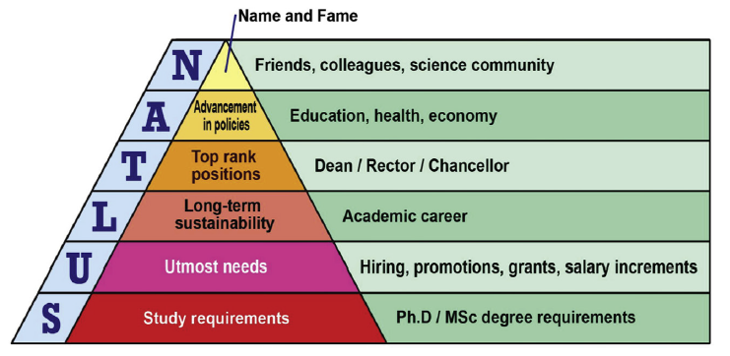
Fig. 1.1 SULTAN’S pyramid: Why researchers publish. (Meo, 2018).

Pre-requisites for a scientific paper
- a well-designed study;
- thorough knowledge about the data and findings;
- early settling of authorship;
- selecting the appropriate journal.

Your manuscript most likely will be accepted if it is within the scope of the journal; describes the research that advances the field; adds to an active research field; is carefully prepared and follows the journal’s submission guidelines; uses clear and concise language; follows ethical standards.

There are various types of paper publications (Fig. 1.2), each varying in content, audience, purpose, length, and scope. These include original research, review articles, invited articles, conference proceedings, comments/errata, and press releases (Monavarian, 2021).

Types of scientific journals
- Specific scientific journals. The specific scientific journals are about certain very specific topics or subfields, for example, an astrophysics journal or a journal about cell biology.
- General scientific journals.
- Open-access journals.
- Subscription-based journals.
- Pre-print Journals.

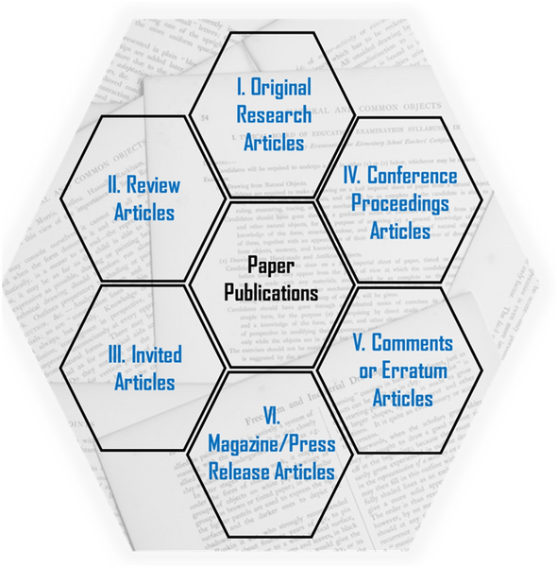

Fig. 1.2 Six major types of paper publications (Monavarian, 2021).

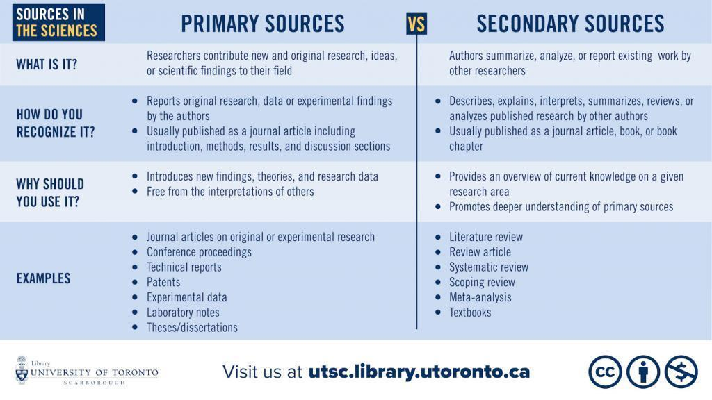

Fig. 1.3 Primary vs. secondary sources in the sciences infographic

Several citation databases exist for the evaluation of journals and researchers (Fig. 1.4).

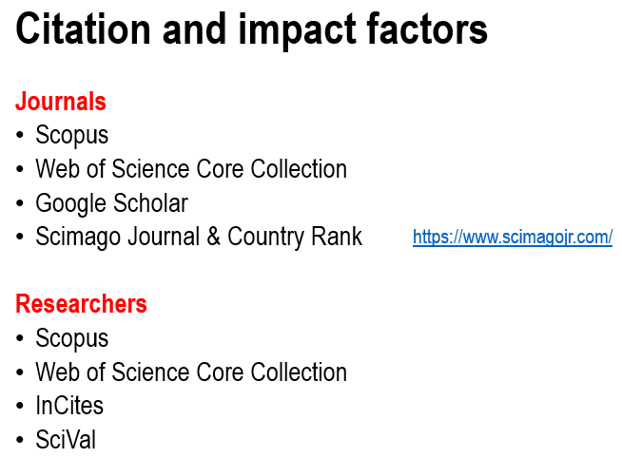

Fig. 1.4 Citation databases with scores for journal and researcher evaluation.

Measuring a journal impact factor
The following metrics are used to understand the impact of a journal:
- “CiteScore metrics – helps to measure journal citation impact. Free, comprehensive, transparent and current metrics calculated using data from Scopus®, the largest abstract and citation database of peer-reviewed literature.
- SJR – or SCImago Journal Rank, is based on the concept of a transfer of prestige between journals via their citation links.
- SNIP – or Source Normalised Impact per Paper, is a sophisticated metric that accounts for field-specific differences in citation practices.
- JIF – or Journal Impact Factor is calculated by Clarivate Analytics as the average of the sum of the citations received in a given year to a journal’s previous two years of publications, divided by the sum of “citable” publications in the previous two years.
- H-index – Although originally conceived as an author-level metric, the H-index has been being applied to higher-order aggregations of research publications, including journals.”
For more information please visit Research metrics and publishing at Monash University library at https://guides.lib.monash.edu/research-metrics-publishing/home.

Researchers’ metrics
Researcher’s output is measured by number of publications and number of citations, which often is described by Hirsh index (h index). The h-index is defined as the highest number h such that the author or journal has published h papers, each of which has been cited at least h times (Hirsch, 2005).
Additional tools for benchmarking author against peers and evaluating institutional productivity worldwide:
- InCites (based on your publications in the Web of Science core collection)
- SciVal (based on your publications in Scopus)³
Besides h index h index the following metrics are used:
- FWCI (Field Weighted Citation Impact);
- total number of publications;
- total citations, average citations;
- % of documents cited;
- documents in the top 1%, top 10%;
- % first author publications;
- citer analysis (who is citing you?);
- how quickly are you being cited?

Check if the journal is right for you
Submitting manuscripts to an unsuitable journal is one of the most common reasons for early rejection and publication delays (Ali, 2010). Therefore check the following before submission:
- read the aims and scope on the Journal website;
- consider if researchers in a related field might be interested in your study. If so, a journal that covers a broad range of topics may be best. If only researchers in your field are likely to want to read your study, then a field-specific journal may be best;
- verify if your target journal accepts the type of manuscript you want to publish;
- look beyond the Impact Factor - it’s just one measure of a Journal's reputation;
- consider the impact of other work published in the journal and whether your research is of a similar level;
- check if the "time to publication" is suitable to your needs.

Always check the guidelines of your target journal to understand the publishing model and the fees (APC – article processing charge).
Consider the following questions when selecting journal to avoid predatory journals.
- Is the journal visible and recognised?
- Visit the journal’s website and read all of it, following every link and noting every claim or the lack thereof.
- Find and read papers published by the journal.
Additionally check Beall's list of potential predatory journals and publishers at https://beallslist.net/.

Open access and subscription publishing model
The primary difference between open access and subscription publications lies in how readers access the content and how the publication is funded. Some subscription journals have an embargo period, after which free access to articles is provided. Some journals are hybrid journals, providing both publication models.
Table 1.1
Open Access vs. subscription publications
 | Open Access Publications | Subscription Publications
Accessibility | Content is freely available to the public. Anyone with internet access can read, download, and share the articles without a subscription or payment. | Content is available only to subscribers. Readers, or their institutions, must pay for a subscription or purchase individual articles to access the content.
Funding | Often funded through article processing charges (APCs) paid by the authors, their institutions, or funding bodies. Sometimes, open access journals are funded by academic institutions or grants. | Funded primarily through subscription fees paid by individuals or institutions (such as libraries).
Licensing | Articles are typically published under a Creative Commons license, which allows for various degrees of reuse and redistribution. | Articles are generally under more restrictive copyright, limiting how they can be redistributed or reused without permission.

Ethics and copyright
Whether you are just starting your career or are an experienced researcher, you undoubtedly recognise the critical importance of ethical conduct. Issues such as plagiarism, research fraud, and undisclosed conflicts of interest can threaten both scientific integrity and your reputation within the scientific community. Adhering to ethical guidelines is essential for ensuring your work and career stay on the right track. For more details see Elsevier publication “Ethics in Research & Publication” (available at: https://researcheracademy.elsevier.com/uploads/2018-02/ethics_a5_booklet_update260617_web.pdf).

Ethics topics to consider when publishing include the following:
- “Authorship of the paper: Authorship should be limited to those who have made a significant contribution to the conception, design, execution or interpretation of the reported study. Transparency about the contributions of authors is encouraged, for example, in the form of a CRediT author statement.
- Originality and plagiarism: The authors should ensure that they have written entirely original works, and if the authors have used the work and/or words of others that this has been appropriately cited or quoted.
- Data access and retention: Authors may be asked to provide the raw data in connection with a paper for editorial review, and should be prepared to provide public access to such data.
- Multiple, redundant or concurrent publication: An author should not, in general, publish manuscripts describing essentially the same research in more than one journal or primary publication. Elsevier does not view the following uses of a work as prior publication: publication in the form of an abstract; publication as an academic thesis; publication as an electronic preprint. Note: some society-owned titles and journals that operate double-blind review have different policies on prior publication. Information on prior publication is included within each Elsevier journal’s guide for authors.
- Acknowledgement of sources: Proper acknowledgment of the work of others must always be given.
- Disclosure and conflicts of interest: All submissions must include disclosure of all relationships that could be viewed as presenting a potential conflict of interest.
- Fundamental errors in published works: When an author discovers a significant error or inaccuracy in his/her own published work, it is the author's obligation to promptly notify the journal editor or publisher, and cooperate with the editor to retract or correct the paper.
- Reporting standards: Authors of reports of original research should present an accurate account of the work performed, as well as an objective discussion of its significance.
- Hazards and human or animal subjects: Statements of compliance are required if the work involves chemicals, procedures or equipment that have any unusual hazards inherent in their use, or if it involves the use of animal or human subjects.
- Use of patient images or case details: Studies on patients or volunteers require ethics committee approval and informed consent, which should be documented in the paper.”

Policies and Guidelines by various publishers can be found using the following links.
- Elsevier
https://beta.elsevier.com/researcher/author/policies-and-guidelines
- John Wiley & Sons
https://onlinelibrary.wiley.com/page/journal/10970037/homepage/forauthors.html#_4._EDITORIAL_POLICIES
- Taylor and Francis
https://authorservices.taylorandfrancis.com/editorial-policies/
- Springer
https://www.springer.com/us/editorial-policies/authorship-principles
- Sage
https://us.sagepub.com/en-us/nam/publishing-policies

Copyright is a legal entitlement designed to safeguard the interests of creators of diverse works (such as original literary, dramatic, musical, or artistic creations, as well as published editions). It ensures the moral and economic rights of authors, publishers, and other creators. Exceptions to copyright infringement include instances where copying occurs within the scope of fair dealing, under the terms of a licensing agreement, or with the written consent of the copyright holder. Everyone is obligated to adhere to copyright laws and the conditions specified in licenses. Types of Creative Commons Licences are listed in Fig. 1.5. The licences tend to be “more permissive” than licences from commercial publishers, and their basic idea is to permit, and almost encourage, the copying of the works as long as due acknowledgment is given to the original author as its source.

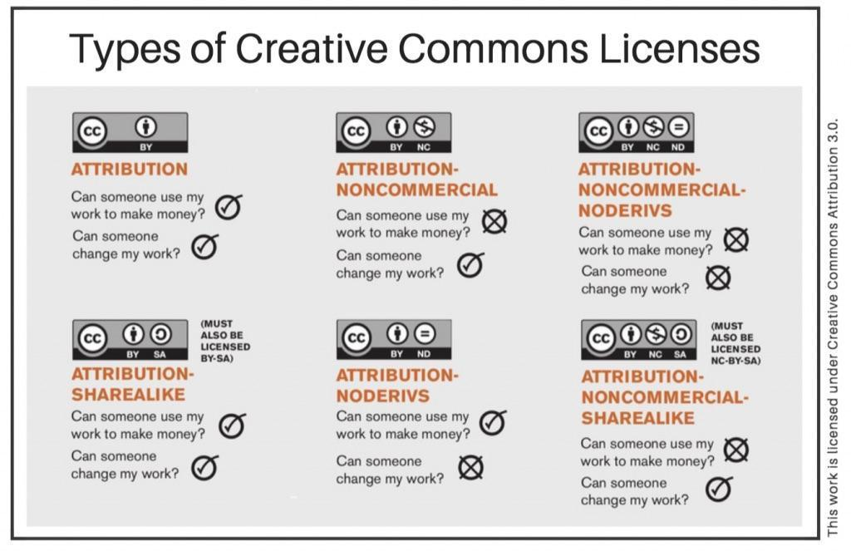

Fig. 1.5 Types of Creative Commons Licences

The extent of fair dealing is not specified by the legislation. Generally guidelines are whichever is the greater than one chapter or 5% of a book; one article or 5% of an issue of a journal; one paper or 5% of a set of conference proceedings; one case or 5% of a law report.
Creative Commons Licences are pre-prepared licences intended to help copyright holder distribute their work, defining how it can be used by others whilst the authors retain their rights, particularly their copyright, in the work.

Practical work
Start writing abstract of your work to be published.
Select five scientific articles and save them for further reading.

Learn about tools for journal selection. Check available journal suggesters:
https://journalfinder.elsevier.com/
https://journalsuggester.springer.com/
https://journalfinder.wiley.com/search?type=match
https://authorservices.taylorandfrancis.com/publishing-your-research/choosing-a-journal/journal-suggester/
https://www.mdpi.com/about/journalselector
https://researcher.life/

- Analyse the selected article
- Is it original (primary) article, published after peer review?
- Does it give clear methods description? Is sample size sufficient?
- Is the aim reached and described in conclusions based on evidence reported in the results and discussion part?
- Are references up to date?
- If all above are yes, then go on with active reading.

- Active reading! Select one of the five articles, most relevant to your study.
- See the construction of paragraphs (highlight the topic sentence in introduction and results and discussion part). Write 1-4 word phrases to demonstrate what paragraph is about.
- Take a note of significant concepts, key terms, questions you may have, contradictions etc.)

Materials
Available searchable databases.

Methods
Define key words to find scientific publications on your topic.

Results
- Glossary with useful terms and phrases.

Example. Continue with a list of verbs for definition of aim, adding at least ten verbs.
To establish
To evaluate
To assess ….

Example. For Academic Phrasebook organisation following subheadings may be used. Add your own phrases found from scientific articles.
- Establishing research territory
1.1. Considerable research attention has been devoted to ________
1.2. A number of recent studies have focused on ________
1.3.

- Describing research gaps
2.1. There is limited research investigating _____
2.2. Few attempts have been made to investigate the role of _____
2.3.

- Stating the aim of the research/study
3.1. This study was carried out to examine _____
3.2. This study offers an analysis of _____
3.3. The aim of this study was to determine the effect of _____
3.4.

- Literature review
4.1. A number of scholars have conducted research on _____
4.2. It is generally agree that _____
4.3. Current research seems to indicate that _____
4.4. Numerous researchers have written extensively about _____
4.5.

- Referencing
5.1. Smith et al. (2015) argued that ____
5.2. The study carried out by Smith et al. (2015) revealed that ____
5.3. Smith et al. (2015) established a link between _____ and _____
5.4.

- Sampling and data collection
6.1. The survey included a variety of questions on _____
6.2. The sample for this study was randomly drawn from _____
6.3. For the purpose of this study _____ was measure with _____
6.4.

7. Data analysis and discussion
7.1. The correlation between ____ was calculated to evaluate ____
7.2. Means and standard deviations of _____ are presented in table {X}.
7.3. A positive correlation was obtained between ____ and ____
7.4. A possible interpretation of this finding is that _____
7.5. Future studies will have to focus on _____
7.6.

- Journal list for the manuscript submission

Create a table with three potential journal names for your publication with various publishers, and give key points and rating for your selection (for ideas see a publication at https://digitalcommons.lmu.edu/cgi/viewcontent.cgi?article=1041&context=librarian_pubs). Add more rows if required.

Selection criteria | Journal titles
Selection criteria | Title 1 | Title 2 | Title 3
Web search for the journal
…

Conclusion
After completing practical and independent work, list the selected journals and justify why you have made this selection.

Approved by _____________________
Name, Surname, signature
Date ______________

Theme 2

The structure of a scientific article (IMRaD)

Theoretical materials

The structure of a scientific article
In scientific article typically there is front matter, article body, and back matter (Fig. 2.1).

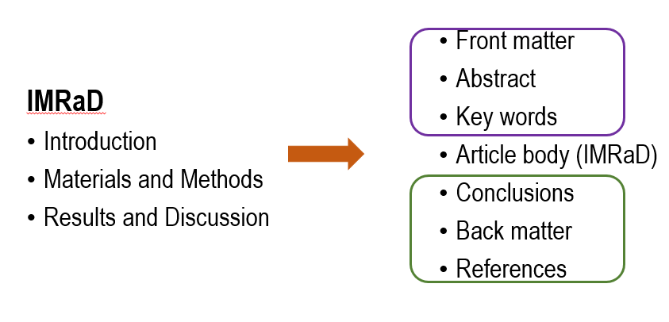

Fig. 2.1 The structure of a scientific article.

Writing research papers involves understanding the structure and roles of different sections. Although the standard format – introduction, methods, results, discussion, and conclusions – provides a framework, it doesn't prevent writers from facing challenges and getting stuck. Therefore it is important to understand the basic components of a scientific paper, which are presented in Fig. 2.2.

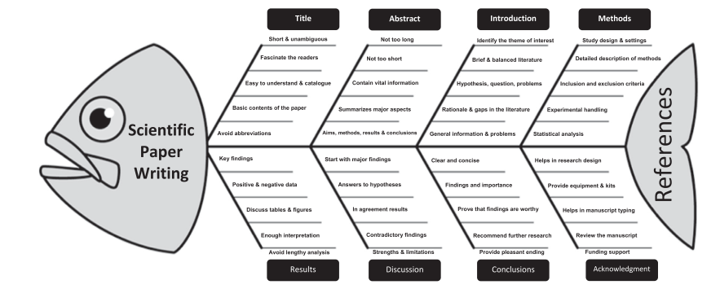

Fig. 2.2 MEO’S Fish Bone Model: Basic components of a scientific paper (Meo, 2018).

Structure of the academic article has been described in many publications, therefore several pictures presenting it have been included in this work book (Fig. 2.3 A, B).
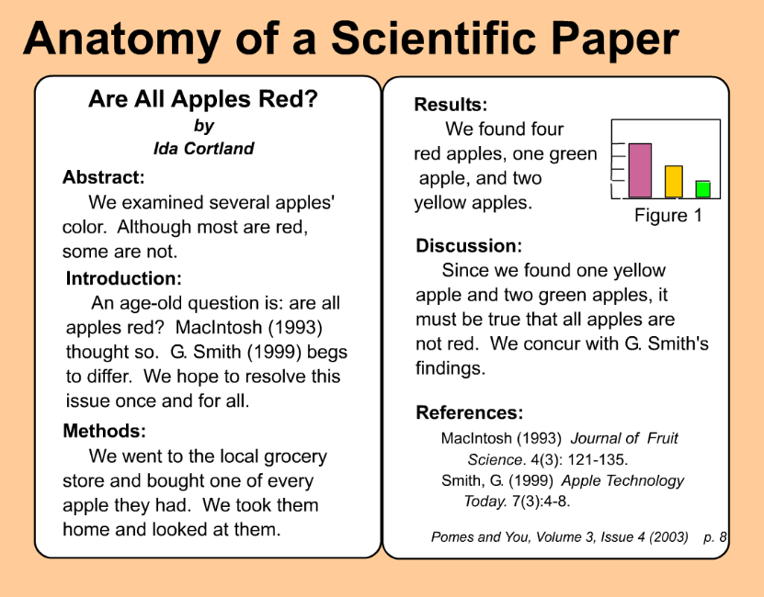 (A)

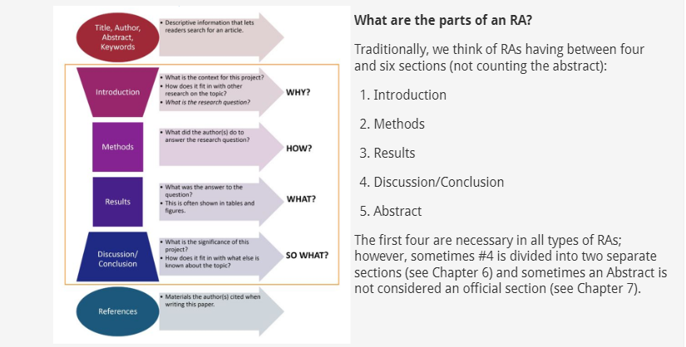 (B)

Fig. 2.3 Example of the scientific article parts (A) and explanation of
the research article parts (B) (Huffman et al., 2023).

The Title of the paper provides a concise first impression. The abstract provides a brief, clear, and concise summary of the entire paper. The introduction explains the paper’s purpose, starting broadly and narrowing down to a specific research question. The materials and methods sections, sometimes divided into two parts, detail how the study was conducted. The results section presents key findings objectively, using text, tables, graphs, and statistics in a logical sequence without interpretation. The discussion interprets the results in the context of existing knowledge and explains new insights gained from the study. The conclusion reinforces the main claims or interpretations and emphasises their significance beyond the paper’s scope.
See also Research Paper Outline with Key Sentence Skeleton described by M. Zaumanis https://peerrecognized.com/research-paper-outline-with-key-sentence-skeleton-paper-template/.

Authorship
Authors can be listed:
- in the order of overall contribution of authors to the manuscript,
- often the senior author is the last regardless of his/her contribution,
- in alphabetical order, then the text on equal contribution is added.
One author has to be indicated as the corresponding author. All authors have to agree with the author order and most typically it cannot be changed after manuscript submission (follow COPE protocol, letter signed by all authors).

Unacceptable authorship is misrepresenting a scientist’s relationship to their work. Examples of unacceptable authorship:
- ‘ghost’ authors – article written by somebody not acknowledged as an author (may be paid for writing);
- ‘Guest’ authors – somebody listed to help increase the chances of publication;
- ‘Gift’ or ‘honorary’ authors – their contribution is based solely on a tenuous affiliation with a study;
- mutual support authorship;
- denial of authorship.

In 2015, Learned Publishing featured an article introducing the Contributor Role Taxonomy (CRediT), advocating a broader approach to defining authors' contributions in scholarly publications beyond traditional authorship. The taxonomy proposed a straightforward yet comprehensive framework, enabling authors to transparently and systematically describe their contributions during article submissions, thereby capturing the diversity and specifics of their scholarly output (Allen et al., 2019).
For additional details on credit role taxonomy visit Elsevier at https://www.elsevier.com/researcher/author/policies-and-guidelines/credit-author-statement.

Paraphrasing
When writing a paper, you often incorporate information from books, journals, the Internet, and other sources. Your supervisor might advise you to use your own words. This means that even though you are using someone else's information, you cannot use their exact wording. Instead, you must express the same idea differently. This process is known as paraphrasing. For examples of paraphrasing, visit blogspot at https://englishreadingwriting.blogspot.com/p/paraphrasing.html.

Example: If the book you are reading from says, "John Adams, who was involved in winning independence for the United States, was the second President." You cannot write those words in your paper. You cannot even write, "John Adams, a man involved in winning independence for the United States, was its second President." One way that you could re-write it is to say, "The second American President, John Adams, was also influential in gaining freedom for the country."

Copyright
- Copyright is a property right intended to protect the rights of those who create works of various kinds (original literary, dramatic, musical or artistic works, published editions).
- Copyright protects the moral and economic rights of writers, publishers and other creators.
- Copyright exceptions: it is not infringed where limited copying is carried out within the concept of fair dealing, the terms of licensing scheme, written permission from the copyright holder.
- Everybody have obligations to observe copyright law and the terms associated to licences.

Plagiarism
Pun (2021) reported that plagiarism is an increasing issue in academia, especially in colleges and universities. With the internet and technology, it has become easier for authors and students to replicate previous studies instead of creating original content. Many do not realise that using another person's work without proper acknowledgment is plagiarism, effectively stealing or copying someone else's work. This can result in serious repercussions such as disciplinary actions, revocation of academic degrees, job termination, damaged reputations, and loss of research funding. Therefore, it is essential for authors to avoid plagiarism to uphold integrity and achieve a successful academic career.

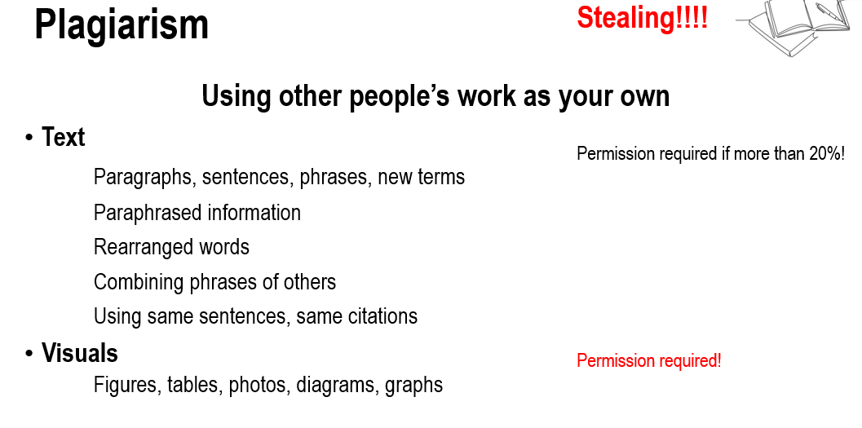

Fig. 2.4 Advise on using other people’s work.

To obtain permission to use figures, tables, or long texts, follow these steps.
Identify the copyright holder: Determine who owns the rights to the material. This could be the original author, publisher, or a third party.
Locate contact information: Find the contact details for the copyright holder. This information is often available in the publication itself or on the publisher's website.
Draft a permission request: Write a formal request for permission.
Send the request: Email or mail your permission request to the copyright holder. Some publishers may have an online form for permissions.
Follow up: If you don’t receive a response within a reasonable time frame (e.g. two to four weeks), follow up with a polite reminder.
Keep records: Maintain a copy of your request and any correspondence, including the permission granted, for future reference.
Acknowledge the source: Once permission is granted, ensure you correctly cite the original source and include any specific wording required by the copyright holder.

Example of permission request.

[Your Name]
[Your Address]
[City, State, ZIP Code]
[Email Address]
[Date]

[Copyright Holder's Name]
[Title/Position]
[Company/Organisation Name]
[Address]
[City, State, ZIP Code]

Dear [Copyright Holder's Name],
I am writing to request permission to use the following material from your publication:
- Title of the Work: [Title]
- Author: [Author]
- Material to be Used: [Specify figures, tables, long text passages, etc., with page numbers if applicable]
The material will be used in [describe your work, such as a thesis, article, book, or presentation] which will be [describe how it will be published/distributed, e.g., printed, distributed online, etc.].
I will ensure that full credit is given to the original source as per your requirements. Please let me know if there are any specific conditions or acknowledgments you require.
Thank you for considering my request. I look forward to your response.
Sincerely,
[Your Name]

Reasons for plagiarism according to Šprajc et al. (2017).
- Not aware of plagiarism.
- Desire to get good grade or recognition.
- Forget why we use evidence.
- Do not believe in own writing.
- Insufficient time.
- Belief they will not get caught.

Ways to avoid plagiarism according to Pun (2021).
- Paraphrase and cite the source.
- Summarise and cite the source.
- Quote and cite the source.
- Cite own materials.
- Always follow the rules.

Academic publishing’s ethical policies demand that anything we take from any other paper, even our own, must be correctly sourced and cited. Everything! What counts as self-plagiarism? It is repeating own writing or data; presenting old data as new (duplication); adding new data to already published material; and publisher copyright - your own words may not belong to you.

Tips to avoid self-plagiarism
- Always correctly cite your previously published material in any new work.
- Ensure that any of previously published text or data is used to support new material and arguments in the new work, with the sufficient original content to warrant a new publication.
- Whenever possible, publish your findings as a unified whole to avoid fragmentation data, unless there are valid reasons for doing so.
- Always inform journal editors if the work you are submitting includes previously published material.

There are various systems in place to check for plagiarism
- Cross Check, iThenticate, Turnitin
- Grammarly
- Manual search (phrases of more than 5 words)

Writing tool examples
- Managing citations (Mendeley, Zotero, RefWorks, End Note and other)
- Language editing (MS Word, Grammarly, real person, artificial intelligence)
- Writing tools for collaboration (Google docs, MS Word online)
- Backup!!

Practical work
Analyse the scientific articles.
Set up of automatic reference management tool.
Do active reading, highlighting the useful terms and phrases for future use.

Materials
Laptop.
Access to scientific databases.

Methods
Practical application of reference manager tools.
Creating and editing library.
Inserting citations and reference lists in the document.

Results
Five relevant articles added to the reference manager library and cited here.

Conclusion
Write conclusions about your experience working with databases and reference manager tool.

Approved by _____________________
Name, Surname, signature
Date _____________________________

Theme 3

Selection and critical analysis of articles

Theoretical materials
The major considerations when selecting articles:
- relevance, new knowledge;
- study design, sample size, methods;
- statistical analysis;
- clarity from the hypothesis through results and discussion till conclusions.

Important points to consider when critically evaluating published research papers are described at https://www.open.edu/openlearn/mod/oucontent/view.php?id=64126&section=1. Simple review articles (also known as ‘narrative’ or ‘selective’ reviews), systematic reviews, and meta-analyses offer quick overviews of progress in a field, summarising specific topics or research areas. They serve as guides, comprehensive information sources, and reference points for primary research studies. These reviews are often the first step toward a detailed investigation, specific inquiry, or understanding a rapidly evolving field. At the postgraduate level, demonstrating this understanding is essential for assignments, essays, or dissertations.

Key questions to ask when appraising a research paper:¹¹
- “Is the study’s research question relevant?
- Does the study add anything new to current knowledge and understanding?
- Does the study test a stated hypothesis?
- Is the design of the study appropriate to the research question?
- Do the study methods address key potential sources of bias?
- Were suitable ‘controls’ included in the study?
- Were the statistical analyses appropriate and applied correctly?
- Is there a clear statement of findings?
- Does the data support the authors’ conclusions?
- Are there any conflicts of interest or ethical concerns?”

Practical work / seminar
Working with databases.
Preparation of background information for scientific article, making library with possible references.
Presentation of the selected journals.

Materials
Laptop.
Access to scientific databases.

Methods
Use of searchable databases.
Presentation and discussion.
Application of Scopus Artificial Intelligence (AI) or other AI tools for the first overview of the topic.

Results
Background information for the scientific article on your selected topic.
List the research gaps, why your study is important.

Conclusion
Write conclusions about the available scientific literature on your topic.

Approved by _____________________
Name, Surname, signature
Date ______________________________

Theme 4

Elements of academic language

Theoretical materials
Writing academic texts involves three key elements: audience, purpose, and material. Keeping all research material organised in one place allows for quick reading and identification of relevant content using various highlighting techniques. Using different coloured highlighters helps distinguish main ideas from evidence and align appropriate arguments with the topic. The key elements of writing are presented in Fig. 4.1.

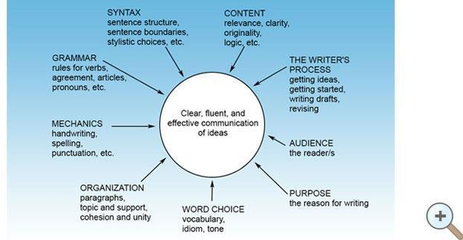

Fig. 4.1 The key elements of writing.

Academic language - key features:
- Objectivity,
- Formality,
- Precision,
- Hedging (to express caution and avoid strong, unqualified statements).

In academic writing, it is essential to be clear, evidence-based, and grammatically correct. The writing should be impersonal, objective, and specific. In academic language, it is important to avoid conjunctions, idiomatic expressions, incomplete sentences, and slang. Conjunctions can create overly complex sentences, while idiomatic expressions may not be understood universally. Incomplete sentences fail to convey complete thoughts and ideas, and slang lacks the formality and precision required in scholarly writing. Clear and precise language ensures effective communication of ideas.

Types of paragraphs
A paragraph consists of a series of sentences that revolve around a central idea known as the topic. It's essential to ensure thematic unity in paragraphs, meaning each paragraph supports one coherent idea that contributes to your overall argument. Achieving paragraph unity is best done through a clear topic sentence, which encapsulates the main point of the paragraph, similar to a mini thesis statement. While a thesis statement guides the entire essay, the topic sentence guides the paragraph. However, unity isn't guaranteed solely by a topic sentence or thesis statement; for an essay to be unified, all paragraphs must relate to the thesis, whereas a paragraph achieves unity when all sentences align with the topic sentence. It's important to note that not all paragraphs require topic sentences; opening and closing paragraphs often serve different functions. In academic writing, placing the topic sentence at the beginning of a paragraph is typically most effective because it prepares the reader for what follows. Maintaining focus on the topic sentence helps ensure a paragraph remains unified by avoiding irrelevant information. To develop ideas within a paragraph, one can employ various techniques to logically expand upon and illustrate the topic sentence.
There are different types of paragraphs:
- illustration;
- definition;
- analysis or classification;
- comparison or a contrast;
- qualification;
- process;
- combination of methods.

Paragraph unity and coherence
“Paragraphs should have both coherence and unity. A paragraph with unity develops a single idea thoroughly and links it to the rest of the paper. Paragraph coherence is achieved when sentences are ordered in a logical manner and when clear transitions link sentences.”
Paragraph unity¹⁶
- Develop a paragraph around a major idea. Express this idea in the topic sentence.
- Make the relationship between the main idea of the paragraph and the thesis of the paper clear. Don’t assume that the reader will “get it.” Spell it out for him/her.
- Support the main idea of the paragraph with details.
- Create separate paragraphs for those details that explore your topic from different perspectives.
- Eliminate sentences that do not support the main idea. Alternately, you may revise the main idea to include those sentences.

Paragraph coherence¹⁶
Decide on an order for your sentences that will best develop the paragraph’s main idea. Your supporting sentences are raw materials. They will not make sense to a reader unless they are put in order. This order could be based on several factors:
- Chronological sequence. This is useful for describing a sequence of events.
- Modified chronology. Sometimes a major idea presented early in a paragraph can be supplemented with necessary background information.
- Spatial position of different objects. This method is useful for description.
- ‘Conversation’ between different experts. By moving between a series of key positions, a writer can establish a sense of dialogue and develop a complex argument. Logical form of argument. Some form of logical proof, like a syllogism, can serve as the basis for order.
Once you have put your sentences in order, express the connections between them with transitional words or phrases. Think of these as signposts to guide the reader through your paragraph. They should be clear.

Active versus passive voice, subject and verb agreement, verb tense
The choice between active and passive voice depends on the emphasis you want to place on either the doer of the action (active voice) or the action itself (passive voice). For most clear and direct communication, active voice is preferred, while passive voice can be used strategically depending on the context and intention of the writing.
Most books on good writing advocate preferring the active form to the passive form. Also, software applications that automatically check a text for grammar and style, will usually highlight any usages of the passive and recommend using the active as an alternative. However, in research manuscripts, the passive is often a much better option (Wallwork, 2013).
The passive is generally used in preference to the active in all the cases below. The active equivalent might be preferential when giving oral presentations or in other more informal contexts:
1. To describe processes. In such cases the main interest is not in who or what carried out the actions; the most important item is the subject of the sentence. Typically this is found in the methods section. Only use ‘we’ in the methods if it is not clear who carried out the action.
2. When making general references to the literature or to what is happening in the world in general.
3. When it is unnecessary, difficult, or impossible to identify the originator of the action.
4. To report what is commonly believed to be true.
5. To report formal decisions or to make announcements (Wallwork, 2013).

Use of articles
Articles: «A» «An»
- Use with unspecified, singular, countable noun
Examples
A sample density .... (not specified, any sample)
Use lemon juice in water to remove rust ( not a countable)
- «An» precedes a vowel sound
Examples: an uncommon, but a unique or a European

Articles: «The»
- When item has already been specified
- When item is about to be specified
- When item is otherwise known to the reader
- When a countable is unique

Articles: «no article»
- No articles for both, noon, midnight, winter, childhood, biology. History, oxygen, Ireland, Monday, June, fifteen, Table 1, Figure 2
- None in above sea level, below zero, by accident, at once, at present, in case, by chance, in addition, in brief, in contract, in detail, in effect, in full, in fact, on time, on purpose, within reach, without doubt, without warning

Space
- Always between number and unit of measurement (sometimes except number and per cent, check with the journal)
- Sometimes between number and various signs (−; ±; =; >; ≤; ≤) the space is added (check with the journal)

Word choice
Examples of preposition problems are listed in Fig. 4.2.

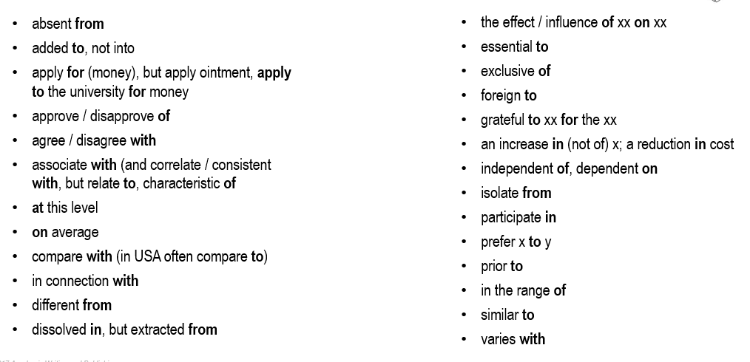
Fig. 4.2 Prepositions in English language.

Hedging (signposting) words and phrases
Consider different approaches to effectively guide your reader through your writing. Here are tips for using signposting language.
- Choose judiciously: Signposting words vary in their nuances and can confuse readers if misused. Ensure you select the appropriate word to accurately convey the relationship you aim to express.
- Use intentionally: It's unnecessary to include a signposting word in every sentence. Before adding one, assess whether it enhances clarity or unnecessarily complicates your writing.
- Edit thoughtfully: When reducing word count, the temptation may be to remove signposting words to retain more information. However, omitting signposts can obscure your message, making it challenging for readers to grasp your intended meaning. Effective signposting aids in maintaining coherence and understanding.
Academic writing often employs introductory verbs such as "seem," "tend," "look like," "appear to be," "think," "believe," "doubt," "be sure," "indicate," and "suggest." Certain lexical verbs, including "believe," "assume," and "suggest," are also commonly used. Modal adverbs like "possibly," "perhaps," and "conceivably" help convey uncertainty or possibility. Additionally, "that" clauses, such as "It could be the case that…," "it might be suggested that…," and "there is every hope that…," are frequently used to introduce tentative statements or hypotheses.
Signposting words serve a valuable role in introductions by indicating your structure, and they are reiterated in the opening lines of paragraphs to show their connections. At the sentence level, they clarify the links between ideas. Given the variety of links and relationships, it's important to select the appropriate signposting word for each context. For examples see the material provided by Newcastle University at https://www.ncl.ac.uk/academic-skills-kit/writing/academic-writing/signposting/.

Punctuation
- No comma ever goes before «that», but a comma does go before «which»
- A comma always accompanies «whereas»
- The comment requires surrounding punctuation: commas, parentheses, or dashes. The label for commas that surround comments is «fetal parentheses». They can «grow up» to become parentheses or even dashes.
- Punctuate after, never before, parentheses, unless they contain a complete sentence.
- Semicolons link closely related, but independent clauses.

Chief Uses of the Comma
- List-commas, Final commas before «and», often comma before «or»
A, b, c, and d
A, b, c, or d
- Introductory word or phrase (Does an oral pause follow?)
First, ...
Finally, ...
In May, ...
- Dependent clause (always use if initial). Is the clause dependent?
If you wish, you can go.
- Adjective series A comma goes where and could appear.
Clean, sterile, expensive instruments.
- Apposition (paired) Identical, not defining.
Paula, our director, arrived.
But: our director Paula arrived.

Dash vs. Hyphen

Hyphen (-) |  | Used for compound words | Freeze-dried
En-dash (–) | Width of the letter n | Used as the symbol for ranges | 10–12%
Em-dash (—) | Width of the letter m | A punctuation mark to set apart parenthetic statements | The gene expression—after normalisation, of course—showed enrichment in the…

British vs. American English spelling
Majority of journals accept both British and American spelling, but not in the same article!

Table 4.1
Examples describing differences in British and American spelling
British | American
colour, flavour, odour | color, flavor, odor
fibre, centre | fiber, center
sulphur | sulfur
analyse | analyze
aesthetic, anaemia | esthetic, anemia
distil, fulfil | distill, fulfill
defence, licence(noun) | defense, license
programme, tonne | program, ton
diarrhoea | diarrhea
grey | gray

Measurement units
- Metric system
- Two ways of writing (m/s or m s⁻¹). Both are correct, consult the author guidelines and examples of published articles. Be consistent!
- To compare results convert values in the same measurement units

Common mistakes non-native authors make when writing in English
Mohebi et al. (2018) in their study found 4,322 errors across 50 articles, with grammatical errors being the most frequent. Punctuation errors were the most common, totalling 989 instances, while errors involving auxiliary verbs were the least frequent, with only 19 instances. The errors ranked in descending order as follows: grammatical, mechanical, lexical, and discoursal.

Table 4.1
The frequency and percentage of errors in descending order (Mohebi et al., 2018).
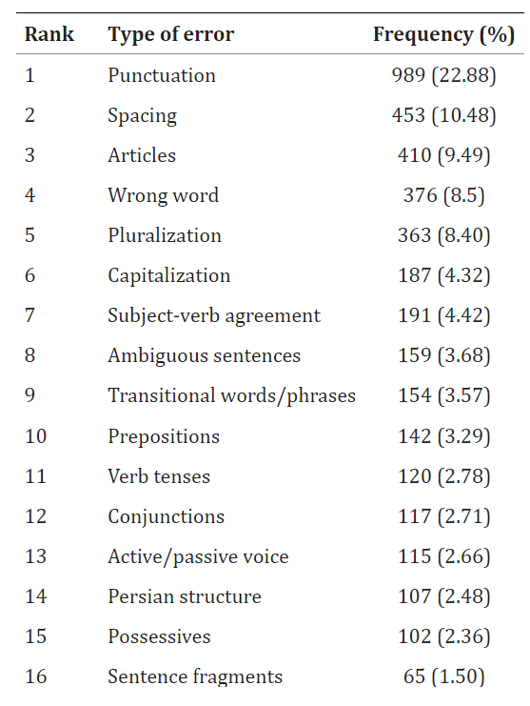

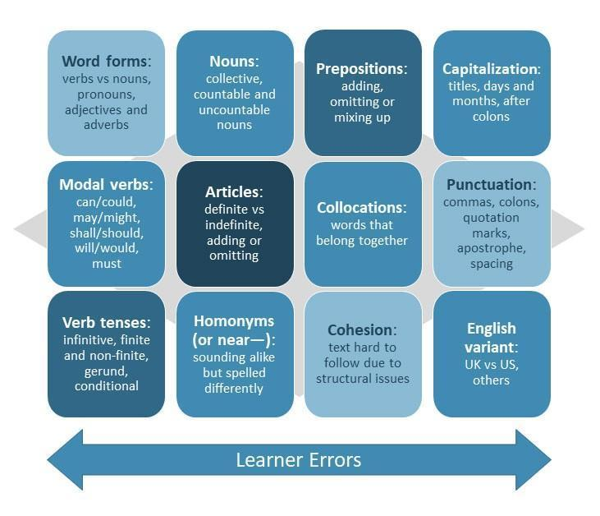
Fig. 4.3 Mistakes non-native speakers often make when writing in English (Berquin, 2021).
For examples of typical grammar errors in English writing visit also https://blog.wordvice.com/common-grammar-mistakes-writing/.
- 21% of all writing errors.
- Determiners: words that come before a noun or noun phrase and tell us if the noun is general or specific and often specify a quantity.
- Articles (a, an, the).
- Determiner words (this, that, every, each, which, that).
- Prepositions: words that precede a noun or pronoun and show that word’s relationship to another word in the same sentence or clause.
- Subject-verb agreement: a concept that requires a subject and verb to agree in number (singular/plural).
- Verb form (6 in total): the base (dictionary form), the infinitive (to + base), the 3rd person singular (verb + s), the present participle (verb + ing), the past simple, and the past participle (different verb tenses).
- Verb tense shifts: always use one tense or start a new clause or sentence to avoid verb tense shifting.

For commonly confused words and misused phrases in English see the Wordvice blog at https://blog.wordvice.com/commonly-confused-words-phrases/.
Check your wording with:
- Google Scholar (https://scholar.google.com/);
- the Merriam-Webster online dictionary (https://www.merriam-webster.com/);
- list of common expressions in research papers (https://blog.wordvice.com/useful-phrases-for-writing-academic-papers/);
- the most useful verbs for the different parts of a paper (https://blog.wordvice.com/recommended-verbs-for-research-writing/);
- check your use of prepositions (https://blog.wordvice.com/common-research-paper-writing-mistakes-prepositions/).

Practical work / seminar
The use of different terms in English. Error recognition.
Presentation of the manuscript outline.
Complete the task on English term use in the Moodle platform.

Practical work on paragraph unity
- Read the provided paragraph (in the Moodle platform). Find and cross out sentences that are off the topic.
- The given sentences are a scrambled paragraph (task in the Moodle platform). Put the sentences in order according to the diagram. This is how to proceed. Step 1: Find the topic sentence. Step 2: Find the concluding sentence. Step 3: Then decide which sentences are supporting points and put them in order. Look for the words “First,” “In addition” etc. Step 4: Decide which examples support which points. Step 5: Copy the sentences into the correct order.
Independent work
- Collect the data, which will be used in the manuscript (be ready to use it in the practical work next week).
- Draft an outline for the results and discussion part (content, subsections).
- You are welcome to do more of pre-writing for results and discussion part.
- Do not be afraid of language or content mistakes. You will fix those later in the revision and editing steps.

Materials
Laptop.
Access to scientific databases.
Access to Moodle platform.

Methods
Use of language elements in academic writing,

Results
The first draft of scientific manuscript, keeping in mind paragraph unity, using proper verb tenses and hedging words.

Fill in the table with synonyms to make verb meaning more specific
to look at | to compare | to show | to find out

Conclusion
Write conclusions about the most important language elements used in academic writing.

Approved by _____________________
Name, Surname, signature
Date ______________

Theme 5

Visual elements for statistically based data presentation in manuscript

Theoretical materials
Visuals are becoming an essential component of science communication. Different visual elements could be used in scientific writing for better presentation of results (Fig. 5.1).

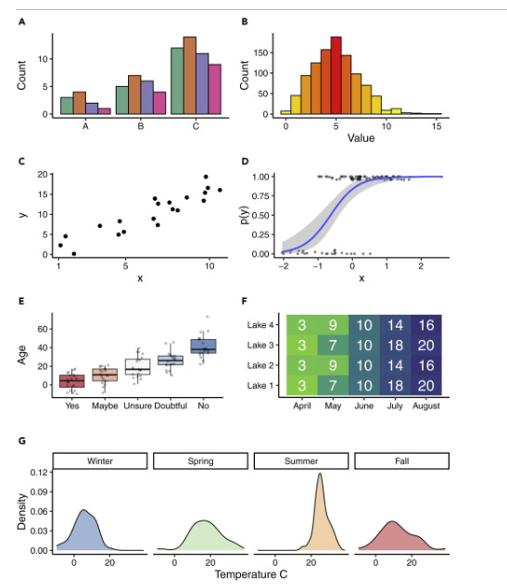
Fig. 5.1 Examples of visual design (Midway, 2020).

Descriptive statistics is the most commonly used tool for evaluation dataset. Microsoft Excel Data Analyses Toolpack could be used to perform it. The standard deviation should be presented for tables and figures. A low, or small, standard deviation means that the data points are closely clustered around the mean, while a high, or large, standard deviation indicates that the data points are more dispersed. Examples of standard deviation presentation and results of ANOVA analyses followed by Tukey test are presented in Fig. 5.2 and Fig. 5.3.
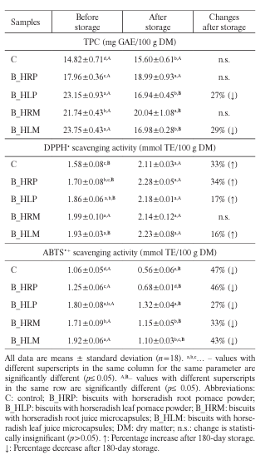

Fig. 5.2 Presentation of standard deviation in tables (Tomsone et al., 2020).

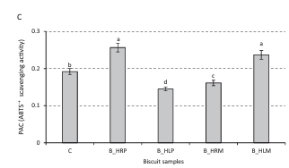
Fig. 5.3 Presentation of standard deviation in figures (Tomsone et al., 2020).

Creating tables and figures for a scientific article involves several key steps to ensure they are clear, accurate, and effectively convey your data.

Practical work
- Descriptive statistics as tool for data presentation in article. Calculation of parameters based on own data or dataset provided by teacher.
- Analyses of visual elements found in scientific articles based on concluding statistics methods.
- Selection and preparation of appropriate visual elements for article using formatting guidelines (own data or dataset provided by teacher).

Materials
- Scientific databases such as sciencedirect.com, scopus.com and webofscience.com
- Dataset obtained in scientific research or dataset provided by teacher.

Methods
Microsoft Excel software, free online software such as Canvas, Heatmapper etc.
For Microsoft excel – Functions and Data Analyses Toolpack.

Results
5.1. Calculate the following parameters for provided dataset: Mean, Median, Mode, Range, Standard Deviation, Minimum, Maximum, Quartiles (Q1, Q2, and Q3), and Percentiles. Present data in a self-made table.
5.2. Analyses of the visual elements of article. Please fill the table by adding brief descriptions.

Questions | Visual element 1 | Visual element 2 | Visual element 3
Clarity
Are the titles clear?
Are the values properly labelled with units of measurement?
Is the font size of the text and labels correct?
Are the data represented accurately?
Are error bars or confidence intervals included?
Design
Is the design of the visual elements clear?
Are legends provided?
Are different data series clearly distinguishable through the use of colours, patterns, or markers?
Are the chosen visualisation types appropriate for the data being presented?
Are the visualisations of high resolution and quality, suitable for publication?
Do the visual elements provide additional insights that complement the textual content?
Is there enough information provided about how the visualisations were created for others to reproduce them?

5.3. Prepare a table or figure showing significant differences between the analysed samples. Give conclusion about the dataset.

Conclusion
Please write conclusions about the importance of visual elements in the scientific articles.

Approved by _____________________
Name, Surname, signature
Date ______________

Theme 6

Preparing, editing, and submitting manuscripts

Theoretical materials

6.1 Preparation of the manuscript

6.1.1 Selecting a topic and conducting research

Selecting an appropriate topic is the first crucial step in preparing an academic manuscript. This decision shapes the entire research and writing process. To begin, identify broad areas of interest by reflecting on subjects that genuinely intrigue you within your academic field. These should be areas you are passionate about and eager to explore further. Consider current trends and debates in your discipline, which might spark ideas for your research.
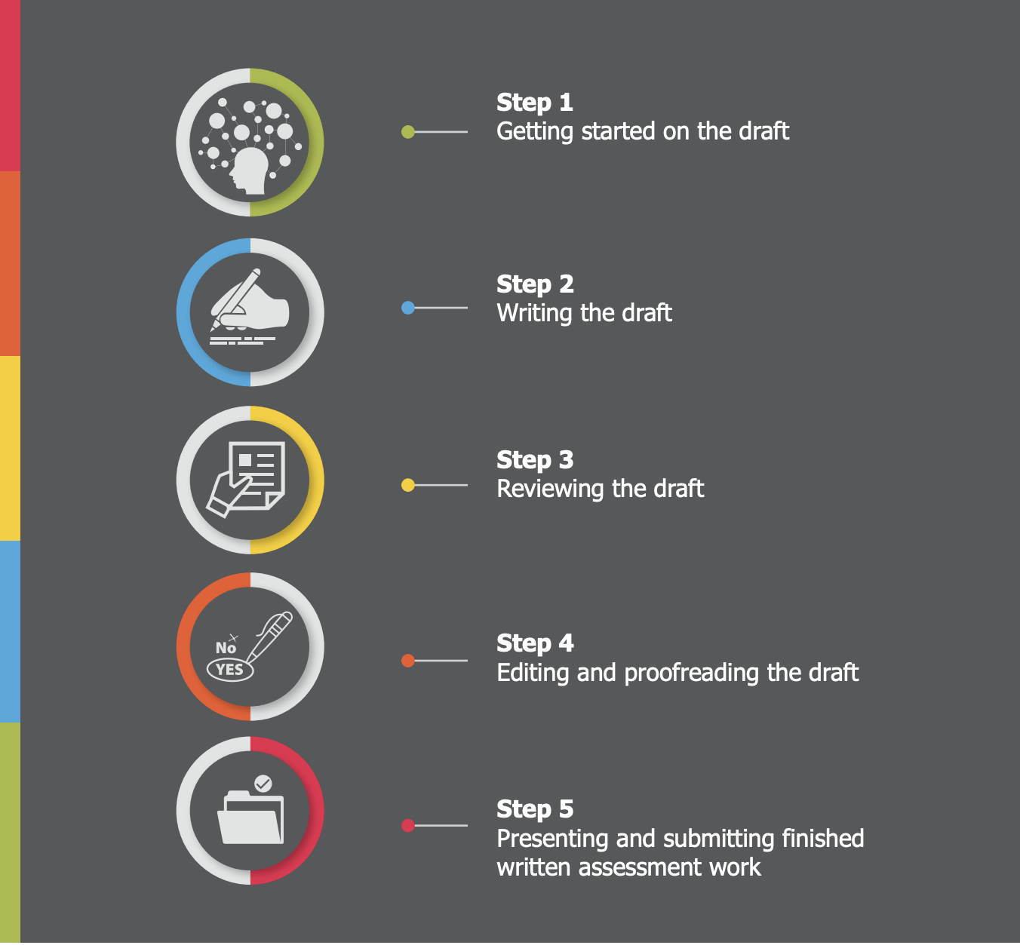
Fig. 6.1 Steps in the creation of manuscripts (Sheehy et al., 2019).

Conduct preliminary research to refine your broad interests into a specific topic. Review recent publications, such as journal articles, conference papers, and books, to identify emerging issues and gaps in the existing literature. Academic databases like JSTOR, PubMed, and Google Scholar are excellent resources for this purpose. By exploring these sources, you can get a comprehensive overview of the current state of research and identify areas that require further investigation.
Once you have a broad area of interest, narrow it down to a specific aspect or question. A focused topic is easier to manage and allows for more in-depth exploration and analysis. Ensure that your chosen topic is not too broad, which can make the research overwhelming, nor too narrow, which might limit the availability of resources and data. To further refine your topic, discuss your ideas with mentors, advisors, or colleagues. Their feedback can help you assess the feasibility of your research, considering factors such as access to data, resources, and ethical considerations.
After selecting a topic, conducting thorough research is essential to build a strong foundation for your manuscript. A comprehensive literature review is critical to understanding the existing body of work on your chosen topic. Summarise key theories, findings, and methodologies from previous studies to situate your research within the broader academic conversation. Identify gaps, inconsistencies, or areas that require further exploration, as this will help you position your research to contribute new insights to the field.
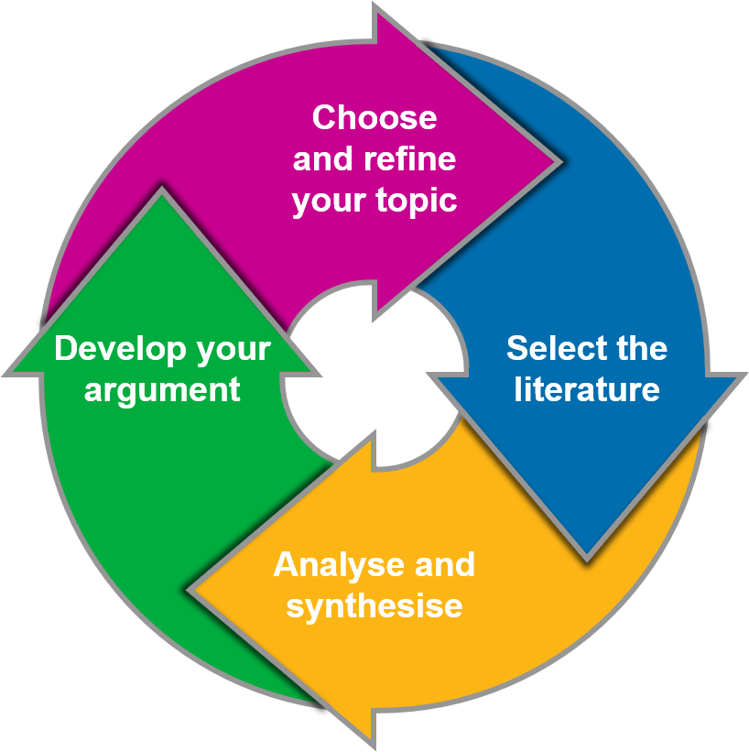
Fig. 6.2 Selecting a topic and conducting research.

Gather original materials such as research articles, historical documents, and statistical data. Depending on your field, primary sources might include experimental results, survey data, or archival records. Evaluate the authenticity and reliability of primary sources to ensure they are credible and relevant to your research question. Utilise secondary sources such as reviews, analyses, and interpretations of primary data to gain broader perspective and contextualise your research. Critically evaluate the credibility, relevance, and quality of secondary sources to ensure that they come from reputable publishers and authors.
If your research involves collecting new data, develop a clear and robust methodology. This might include designing experiments, conducting surveys, or performing fieldwork. Ensure that your methods are rigorous, ethical, and appropriate for your research question. Obtain the necessary approvals from institutional review boards (IRBs) or ethics committees if human or animal subjects are involved. Document your process meticulously to ensure reproducibility, keeping detailed records of your methods, data collection procedures, and any changes made during the research.
To organise your research effectively, use digital tools such as reference management software like Zotero or EndNote. These tools help you manage citations and create bibliographies efficiently. Keep detailed notes on each source, including bibliographic information, summaries of key points, and relevance to your research. Consider using digital note cards or spreadsheets to organise this information systematically.



Fig. 6.3 Zotero: reference programme.

Use academic databases like JSTOR, PubMed, Google Scholar, and IEEE Xplore to access a wide range of scholarly articles and publications. These databases offer advanced search features to help you find relevant literature quickly. Use university and public library systems to find books, theses, and other valuable resources. Many libraries offer interlibrary loan services to access materials not available in your institution’s collection. Tools like Zotero, Mendeley, and EndNote can help you manage and cite your sources efficiently. These tools allow you to store, organise, and format your references in various citation styles. Many universities and libraries also provide online guides to assist with research methods and resource selection. These guides often include tips for finding and evaluating sources, as well as subject-specific resources.
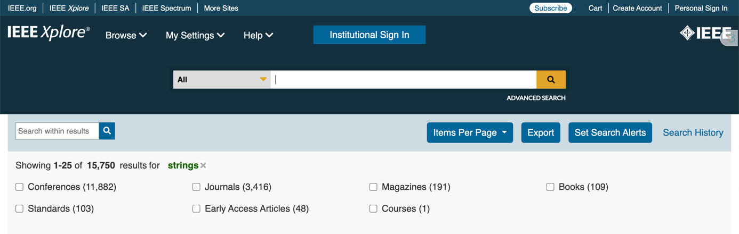


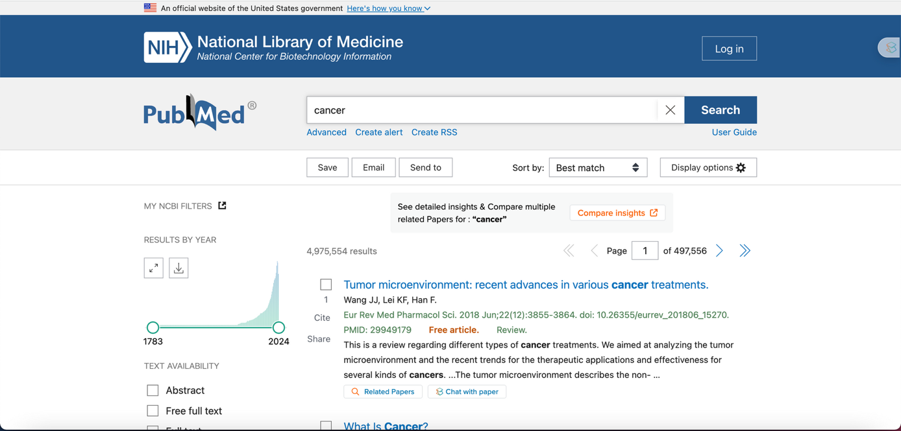

Fig. 6.4 Academic databases.

Throughout the research process, stay organised by keeping your research materials and notes well-organised. Create folders and subfolders for different aspects of your research, and maintain a consistent naming system for your files. Critically evaluate the credibility, relevance, and quality of each source, distinguishing between high-quality, peer-reviewed articles and less reliable materials. Stay current with the latest research developments in your field by regularly checking academic journals, attending conferences, and participating in relevant online forums. Follow ethical guidelines for conducting research, especially when dealing with human or animal subjects. Ensure that you have the necessary approvals and that your research adheres to ethical standards, respecting confidentiality and obtaining informed consent when required.
By carefully selecting a topic and conducting thorough research, you lay a solid foundation for your manuscript. This preparation phase is crucial to ensuring that your subsequent writing is well-informed, focused, and relevant to your academic field. Taking the time to properly prepare will make the writing process smoother and increase the likelihood of producing a high-quality manuscript.

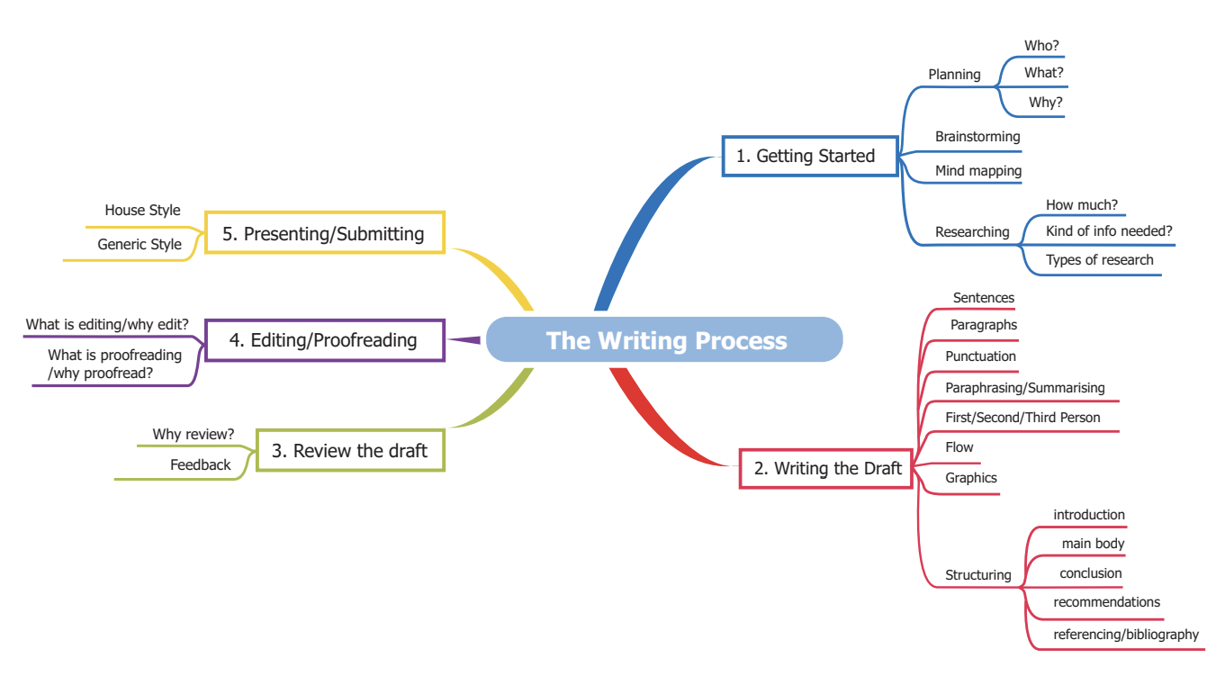

Fig. 6.5 Map of the academic process (Sheehy et al., 2019).

6.1.2 Developing a thesis statement

Developing a strong thesis statement is essential for guiding the direction and focus of your manuscript. Your thesis statement should clearly articulate the main argument or central idea of your research, providing a roadmap for both you and your readers.
To develop an effective thesis statement, start by reflecting on the primary question or problem your research addresses. Consider what you aim to discover, prove, or argue through your study. A well-crafted thesis statement should be specific, concise, and arguable, presenting a clear stance that can be supported with evidence.

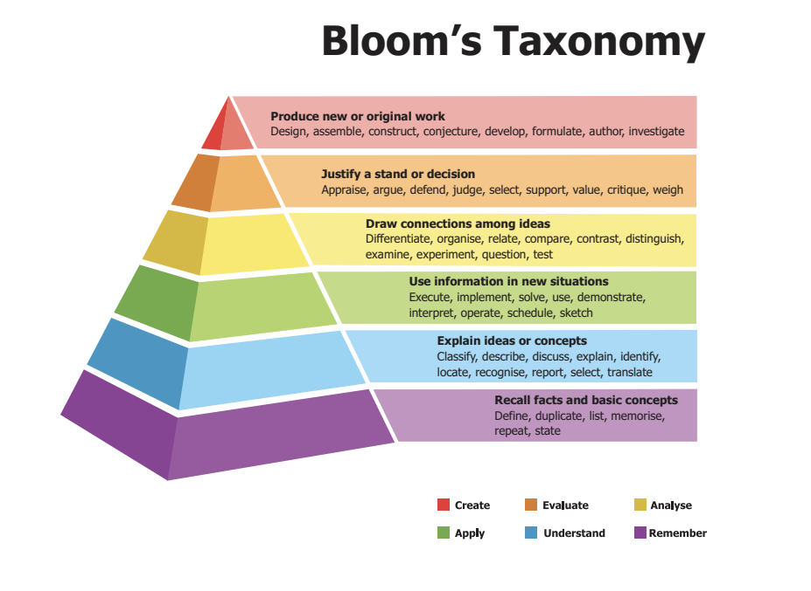
Fig. 6.6 Bloom's taxonomy (Sheehy et al., 2019).

Begin by drafting a preliminary thesis statement that summarises your main argument. As you conduct further research and refine your ideas, revisit and revise your thesis statement to ensure it accurately reflects the scope and focus of your work. Your thesis statement should evolve as your understanding of the topic deepens and new insights emerge.
Ensure that your thesis statement is clearly stated in the introduction of your manuscript. This helps readers understand the purpose and direction of your research from the outset. Additionally, revisit your thesis statement throughout the writing process to ensure that your argument remains consistent and aligned with your initial goals.
A strong thesis statement not only guides your research but also helps you stay focused and organised. It serves as a reference point for evaluating the relevance and significance of the information you include in your manuscript. By developing a clear and compelling thesis statement, you create a solid foundation for constructing a coherent and persuasive argument.

6.1.3 Creating an outline

Creating an outline is a crucial step in organising your manuscript and ensuring a logical flow of ideas. An effective outline helps you structure your research and writing, making the process more efficient and manageable.
Start by identifying the main sections of your manuscript, typically including the introduction, literature review, methodology, results, discussion, and conclusion. Each section should have a clear purpose and contribute to the overall argument of your manuscript.
Within each section, break down the content into key points and subpoints. For example, in the literature review, identify the major themes and studies you will discuss, and organise them in a logical order. In the methodology section, outline the steps you will take to conduct your research, including data collection and analysis methods.
Use your outline as a roadmap to guide your writing. Begin with a broad overview of each section and gradually add more detail as you develop your manuscript. This helps ensure that your argument progresses logically and that each point builds on the previous one.
An outline also helps you identify any gaps or weaknesses in your argument, allowing you to address them before you begin writing in earnest. It provides a clear framework for organising your thoughts and ensures that you stay focused on your main argument.
As you write, refer back to your outline regularly to stay on track. Be flexible and willing to revise your outline as needed, based on new insights or changes in the direction of your research. A well-structured outline is an invaluable tool for producing a coherent, well-organised manuscript.
In summary, the preparation of an academic manuscript involves selecting a topic and conducting thorough research, developing a clear thesis statement, and creating a detailed outline. These steps provide a strong foundation for your writing, ensuring that your manuscript is focused, organised, and well-supported by evidence. By taking the time to carefully prepare, you increase the likelihood of producing a high-quality manuscript that makes a meaningful contribution to your academic field.

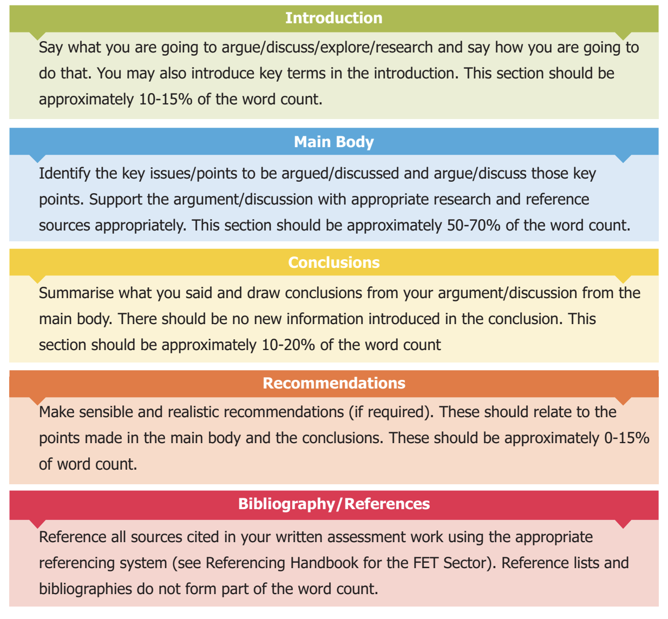
Fig. 6.7 Structure of the manuscript (Sheehy et al., 2019).

6.2 Writing the manuscript

6.2.1 Structuring the manuscript

Structuring your manuscript meticulously is crucial to effectively communicate your research findings in food technology. Each section plays a distinct role in presenting your study's objectives, methodologies, results, interpretations, and implications with precision and clarity.

Author information
Begin your manuscript with a section dedicated to author information, which should include the full names of all contributing authors, their respective affiliations (including department, institution, city, and country), and contact details such as email addresses. Clearly identify the corresponding author, who will serve as the primary point of contact for correspondence regarding the manuscript. This section establishes transparency and accountability in academic publishing, ensuring proper attribution of contributions and facilitating communication between authors and readers.

Title
Crafting an effective title is paramount, as it serves as the first point of engagement for readers and determines the discoverability and relevance of your manuscript in academic databases. Your title should succinctly encapsulate the essence of your research while enticing readers to delve deeper into your study. It should be informative, concise, and accurately reflect the scope and focus of your investigation. Employ keywords strategically to optimise search engine visibility and enhance the accessibility of your work to the scholarly community.



Author Information

Title

Fig. 6.8 Structure of the manuscript – title and author information (Ben Akacha et al., 2024).

Abstract
The abstract is a concise summary of your entire manuscript, providing a snapshot of the study's background, objectives, methods, results, and conclusions. It serves as a critical entry point for readers, enabling them to quickly grasp the significance and implications of your research. Structure your abstract into distinct sections, including a brief introduction to the research topic, a statement of the research objectives or hypotheses, a summary of the methods employed, a synopsis of key findings, and a succinct conclusion highlighting the study's implications and contributions to the field. Keep your abstract within 250-300 words to maintain consciousness while conveying essential information effectively.
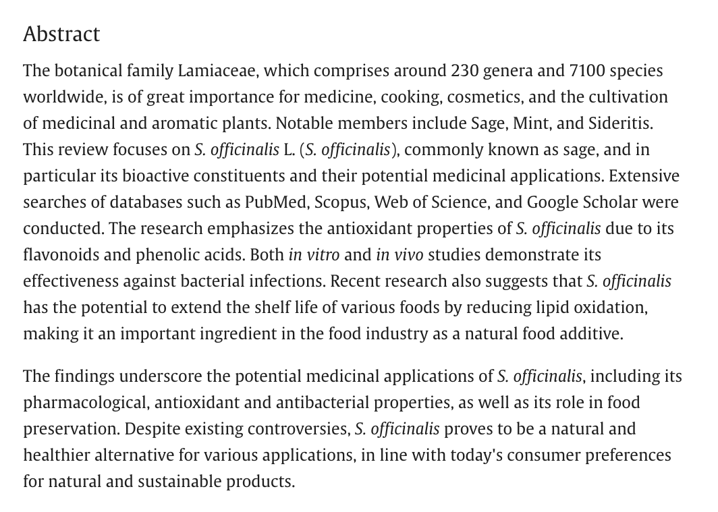
Fig. 6.9 Example of abstract (Ben Akacha et al., 2024).

Keywords
Keywords are pivotal for enhancing the discoverability and indexing of your manuscript in academic databases and search engines. They should encompass the core concepts, variables, or themes addressed in your study, enabling researchers to locate your work efficiently. Select keywords that are specific, relevant, and representative of the main content of your manuscript. Aim for a balance between breadth and specificity, incorporating terms that capture the breadth of your research while remaining focused on its primary objectives and outcomes. Limit your keyword list to 3-6 terms to ensure clarity and relevance.

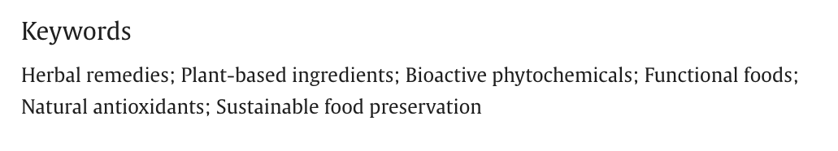
Fig. 6.10 Example of keywords (Ben Akacha et al., 2024).

Highlights
Some journals require a “Highlights” section that summarises the most exciting, interesting points from your manuscript. This is a great opportunity to emphasise the impact and importance of your work! However, it requires a different writing strategy than the one you use.
Highlights are typically written as 3–5 bullet points, each a complete sentence that describes a main result or conclusion of the study. The most common length seems to be approximately 85 characters maximum; although, some journals routinely publish highlights that are slightly longer or may request a short paragraph instead of bullet points. Here are the questions to answer before you start writing your highlights.
After you have written highlights based on your completed manuscript, you might realise that your manuscript doesn’t focus enough on the most exciting findings. This is a great opportunity to substantially edit your manuscript to shift its focus toward the most important or innovative findings. In the end, the highlights and the most emphasised points in the manuscript should match or overlap considerably.
When facing strict word or character limits, it is essential to write concisely. Even if you are well within the journal’s limits, keeping the highlights brief will encourage potential readers to look at your work. Ways to reduce word or character count include replacing longer phrases with shorter ones, removing unnecessary words (especially at the beginning of a sentence), and using active voice.
Even if you are writing the highlights for experts in your field, use the simplest, clearest words possible to describe your findings. It can be tempting to choose more interesting terms, but complex language may discourage readers from reading the rest of your article. If you choose to use any uncommon abbreviations in your highlights, be sure to define them at first use. Write with your reader in mind, and make it easy for them to learn what you have discovered.
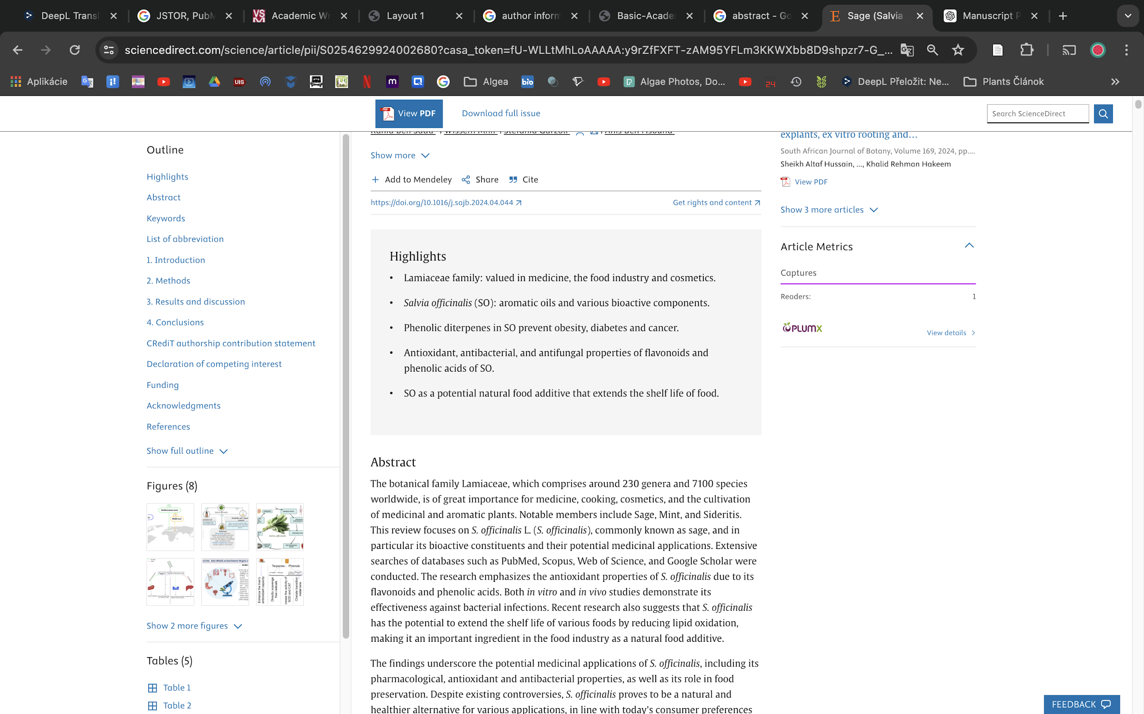
Fig. 6.11 Example of highlights (Ben Akacha et al., 2024).
Introduction
The introduction serves as the foundation upon which your research is built, providing readers with a comprehensive understanding of the context, rationale, and significance of your study in food technology. Begin by delineating the broader research area and elucidating the key issues or gaps in knowledge that your study seeks to address within the realm of food technology. Conduct a thorough review of relevant literature, highlighting seminal works, theoretical frameworks, empirical findings, and debates pertinent to your research topic in the field of food technology. Clearly articulate the research question or hypothesis driving your investigation, emphasising its novelty, relevance, and potential contributions to the food technology field. Provide a roadmap for the manuscript, outlining the structure and organisation of subsequent sections to guide readers through the logical progression of your argument.
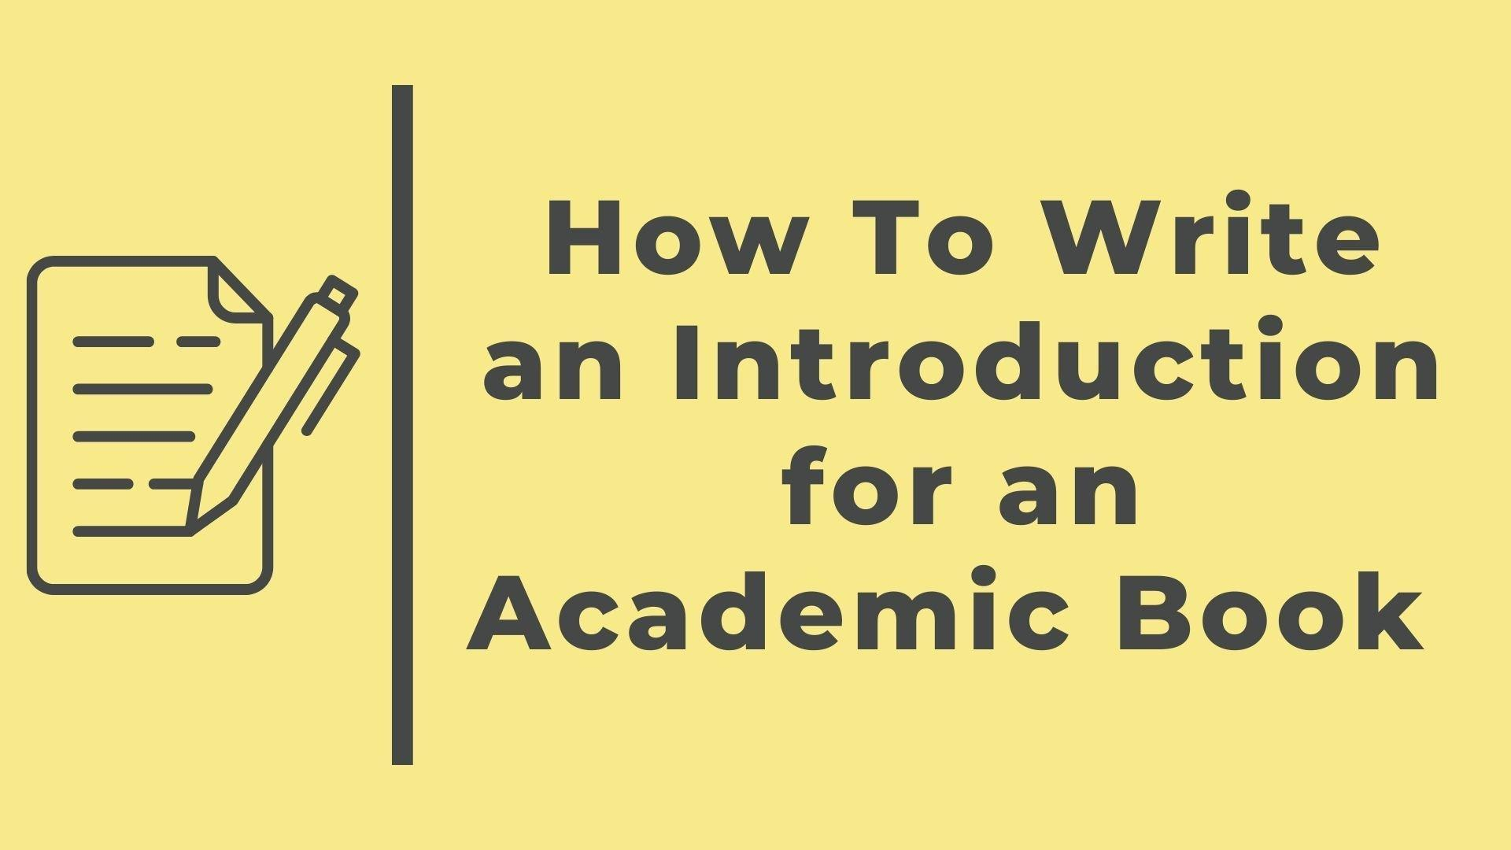
Fig. 6.12 How to write an Introduction (Portwood-Stacer, 2019).
Example:
"In recent years, there has been a growing interest in the utilization of edible coatings as a sustainable solution for enhancing the shelf life and quality of fresh produce. While edible coatings offer promising benefits in reducing postharvest losses and preserving food freshness, there remains a need for comprehensive research to evaluate their efficacy and application in various food products. This study seeks to address this gap by investigating the impact of edible coatings enriched with natural antimicrobial agents on the shelf life and quality of strawberries during storage. Drawing on existing literature on edible coatings and postharvest preservation, we hypothesize that incorporating natural antimicrobial agents into edible coatings will effectively inhibit microbial growth and extend the shelf life of strawberries. The following sections will detail the research methodology, present the findings of the study, and discuss their implications for food preservation practices and future research."
Materials and Methods
The methods section offers a detailed exposition of the procedural framework, methodologies, and techniques employed to conduct your study in food technology. Provide a comprehensive description of the research design, including its conceptual underpinnings and operationalisation within the context of food technology. Specify the characteristics and selection criteria of materials, samples, or food products used in the study, along with the rationale for their inclusion or exclusion. Detail the procedures, protocols, or interventions implemented during food processing, coating application, storage, and quality evaluation, ensuring clarity, accuracy, and replicability. Discuss any ethical considerations, institutional approvals, or safety measures implemented to ensure the integrity and safety of food products and research participants. Provide justification for the chosen methodologies, addressing their suitability, validity, reliability, and potential limitations in assessing the effectiveness of edible coatings in food preservation.

Example:
"This study employed a randomized controlled trial design to investigate the efficacy of edible coatings enriched with natural antimicrobial agents in preserving the quality and extending the shelf life of strawberries during storage. Freshly harvested strawberries were obtained from local farms and randomly assigned to three treatment groups: (1) strawberries coated with an edible coating enriched with cinnamon essential oil, (2) strawberries coated with an edible coating enriched with oregano extract, and (3) untreated control strawberries. The coating formulations were prepared using food-grade ingredients and applied to the surface of strawberries using a dipping method.
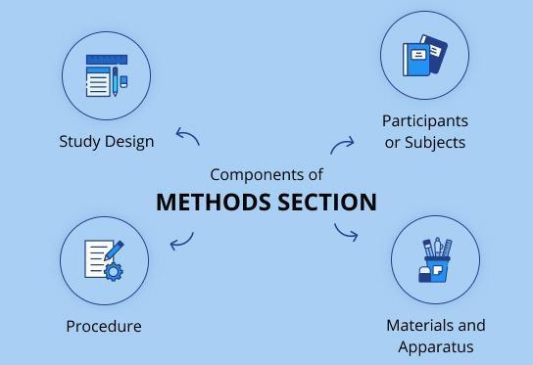
Fig. 6.13 How to write a methods section (Nova, 2024).
The treated and control strawberries were then stored under controlled environmental conditions (temperature, humidity) simulating commercial storage conditions for fresh produce. Sampling was conducted at regular intervals (e.g., every three days) during the storage period, and various quality parameters, including microbial counts, colour attributes, texture, and sensory characteristics, were evaluated using standardised methods. Statistical analyses, including analysis of variance (ANOVA) and Tukey's post-hoc test, were performed to compare the efficacy of different coating treatments in preserving strawberry quality and extending shelf life."
Results
The results section presents the empirical findings and outcomes of your study in a clear, concise, and systematic manner, focusing on the impact of edible coatings on the shelf life and quality of strawberries. Organise the presentation of results logically, adhering to the sequence of research objectives or hypotheses outlined in the introduction. Utilise tables, figures, graphs, or charts to visually represent quantitative data, trends, patterns, or relationships identified in your analysis. Provide textual descriptions and interpretations of key findings, highlighting their significance, magnitude, and implications for food preservation practices and future research in food technology.

Example:
"The quantitative analysis revealed significant differences in microbial growth inhibition among strawberries treated with different edible coatings enriched with natural antimicrobial agents. Both cinnamon essential oil and oregano extract coatings demonstrated superior antimicrobial efficacy compared to the untreated control group (p < 0.05). Specifically, strawberries coated with cinnamon essential oil exhibited a 50% reduction in total microbial counts, including aerobic bacteria and fungal pathogens, compared to the control group. Similarly, strawberries coated with oregano extract showed a 40% reduction in microbial counts, indicating a significant antimicrobial effect.
Furthermore, colour, texture, and sensory evaluations demonstrated that strawberries coated with edible coatings maintained their visual appearance, firmness, and flavour attributes significantly longer than the untreated control strawberries. Coatings enriched with cinnamon essential oil and oregano extract exhibited greater retention of colour brightness and firmness, as well as reduced development of off-flavours and odours during storage. These findings underscore the potential of edible coatings enriched with natural antimicrobial agents in preserving the quality and extending the shelf life of strawberries, offering a sustainable solution for reducing postharvest losses and enhancing food safety in the food industry."
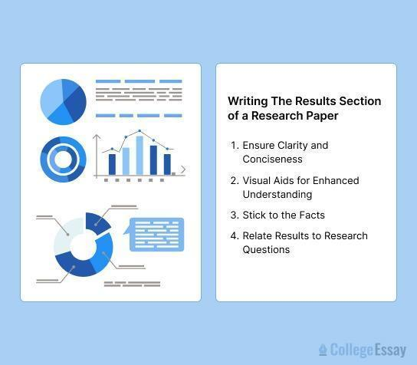
Fig. 6.14 How to write a results (Betty, 2024).
Discussion
The discussion section offers a critical analysis and interpretation of the results, contextualising them within the broader theoretical, empirical, and practical landscape of food technology. Begin by synthesising the key findings and insights derived from your analysis, emphasising their alignment or deviation from existing literature and theoretical frameworks in food technology. Interpret the observed patterns, trends, or associations in light of your research objectives, hypotheses, or theoretical perspectives, addressing their theoretical, methodological, or practical implications for food preservation practices. Compare and contrast your findings with previous studies, identifying areas of convergence, divergence, or unresolved questions that warrant further investigation in food technology. Acknowledge any limitations or constraints inherent in your study design, data collection, or analysis, offering reflections on their potential impact and avenues for future research refinement or extension. Conclude the discussion by summarising the key takeaways and contributions of your study, emphasising their significance for advancing knowledge, informing practice, or shaping policy in the field of food technology.
Example:
"The findings of this study provide compelling evidence of the efficacy of edible coatings enriched with natural antimicrobial agents in preserving the quality and extending the shelf life of strawberries during storage. The significant reductions in microbial growth, maintenance of colour, texture, and sensory attributes observed in coated strawberries underscore the potential of this technology to revolutionise post harvest preservation practices in the food industry. These findings are consistent with previous research on the antimicrobial properties of essential oils and plant extracts, highlighting their broad applicability in food preservation applications.”

Figures and tables with captions
Figures and tables are essential visual aids that complement the textual presentation of your research findings, enhancing clarity, accessibility, and interpretability for readers. Select figures and tables judiciously to illustrate key concepts, trends, or relationships identified in your data analysis. Ensure that each figure and table is accompanied by a clear and informative caption that succinctly describes its content and significance. Use descriptive titles and labels to facilitate understanding and interpretation, avoiding excessive jargon or technical terminology. Arrange figures and tables sequentially and reference them appropriately in the text to maintain coherence and continuity in the presentation of your findings.
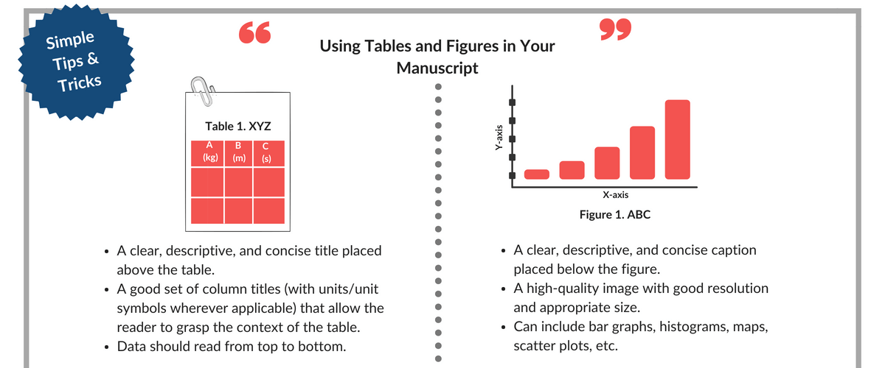

Fig. 6.15 Using tables and figures (Enago Academy, 2018).

Funding Information:
Disclose any sources of funding, financial support, or sponsorship that contributed to the conduct of your research. Provide details about funding agencies, grant numbers, and the role of funders in the study design, data collection, analysis, interpretation, and dissemination. Acknowledge the financial contributions that enabled the execution of the study while ensuring transparency and accountability in reporting potential conflicts of interest or biases.
Author Contributions:
Transparently delineate the contributions of each author to the conception, design, execution, and interpretation of the study. Specify the roles and responsibilities undertaken by each author in drafting and revising the manuscript, analysing data, conducting experiments, and interpreting findings. Acknowledge individual contributions to literature review.
6.2.2 Writing the first draft

Crafting the initial draft of your manuscript is an essential step in transforming your research into a coherent narrative. This phase involves translating your research notes, data analyses, and interpretations into written form, providing the groundwork for subsequent revisions and refinement.
Begin by reviewing your research notes, data transcripts, and analysis outputs to become familiar with the key findings and insights derived from your study. Create a rough outline or sketch of the manuscript structure, organising your content into logical sections based on the standard IMRAD (Introduction, Methods, Results, and Discussion) format or any other relevant structure prescribed by your target journal or publication venue.
Introduction
Start the introduction section by providing a succinct overview of your research topic's significance and relevance within the field. Clearly articulate the research question or objective driving your study, emphasising its novelty, importance, and potential implications. Summarise relevant literature, highlighting key findings, theoretical frameworks, and debates to contextualise your research. Conclude the introduction by outlining the subsequent sections' organisation to guide readers through the manuscript.
Methods
Describe the research design, materials, procedures, and analytical techniques used in your study with clarity and precision. Provide a detailed account of the sampling strategy, sample size calculation, and participant or sample selection criteria. Outline the specific steps and protocols followed during data collection, processing, and analysis to ensure transparency and reproducibility. Discuss any potential sources of bias, confounding, or limitations associated with your chosen methodologies and propose strategies to mitigate these challenges.
Results
Present your study's findings systematically, focusing on key outcomes, trends, or patterns observed in your data analysis. Utilise tables, figures, graphs, or charts to visually represent quantitative results, ensuring clarity and readability. Provide textual descriptions and interpretations of significant findings, highlighting their implications for addressing the research question or hypothesis. Avoid extensive interpretation in this section, as the discussion will provide a more in-depth analysis and interpretation of the findings.
Discussion
Critically analyse and interpret your study's findings within the broader context of existing literature and theoretical frameworks. Synthesise key findings and insights, emphasising their significance and implications for theory, practice, or policy. Compare and contrast your results with previous studies, identifying areas of agreement, divergence, or ambiguity requiring further investigation. Discuss the theoretical, methodological, and practical implications of your findings, addressing any limitations or constraints inherent in your study design or data analysis. Propose directions for future research, highlighting avenues for extending or refining your study's findings.
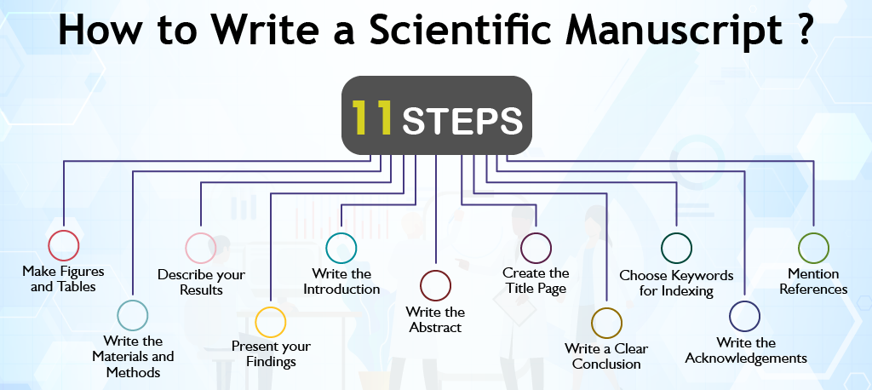
Fig. 6.16 Writing the first draft.

6.3 Editing the manuscript before submission
6.3.1 Revising for content and structure
Revising for content and structure is the first step in refining your manuscript. It involves critically evaluating the organisation, coherence, and logical flow of your writing. Start by reviewing the overall structure to ensure a logical progression from introduction to conclusion. Consider whether each section effectively contributes to the overall argument or narrative of your manuscript. Pay attention to the clarity of content within each section, ensuring that the research objectives, methodology, findings, and conclusions are clearly articulated. Seek feedback from colleagues or mentors to identify any gaps or weaknesses in your manuscript's content and structure. Incorporate constructive feedback to refine and strengthen your manuscript further.
6.3.2 Language editing
Language editing focuses on refining the clarity, conciseness, and effectiveness of your writing. Clarify sentences and phrases to improve readability and comprehension. Avoid technical jargon and convoluted language that may hinder understanding. Enhance grammar and syntax by ensuring correctness in sentence structure, verb agreement, and punctuation. Choose precise and appropriate words to convey your ideas effectively. Maintain consistency in writing style, tone, and voice throughout the manuscript. Address language bias by using inclusive and gender-neutral language where applicable. Engage with language specialists or professional editors to further refine the language and style of your manuscript.
6.3.3 Proofreading
Proofreading is the final step in the editing process, focusing on identifying and correcting errors in spelling, grammar, punctuation, and formatting. Review spelling and grammar using spell-checking tools and proofread the manuscript carefully to catch grammatical mistakes, typos, and syntax errors. Check punctuation and formatting for consistency and accuracy, including headings, font styles, and indentation. Verify the accuracy of references against the original sources, ensuring that all in-text citations correspond to entries in the reference list and follow the prescribed citation style. Confirm compliance with guidelines by referring back to the publisher's requirements and ensuring adherence to formatting and submission instructions.
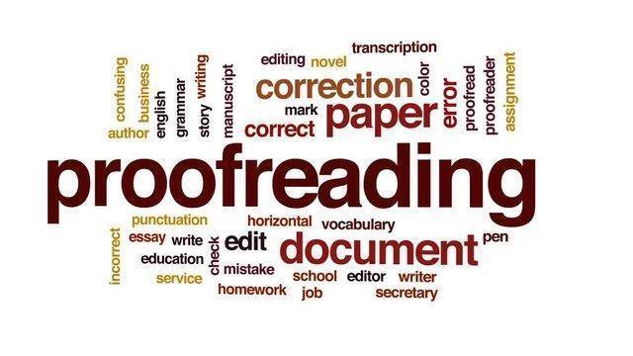
Fig. 6.17 What is proofreading?

6.4 Formatting manuscript according to publisher’s requirements
Ensuring your manuscript adheres to the publisher's guidelines is crucial for presenting your research professionally and facilitating the review process. Below are detailed steps on formatting your manuscript according to publisher requirements, including examples for various citation styles and variations in referencing styles within the text.

Review publisher guidelines

Carefully examine the publisher's submission guidelines for specific instructions on formatting, manuscript length, file format, font size, and citation style. Each publisher may have distinct requirements that authors must follow.
Example:
- Publisher A requires manuscripts to be submitted in Microsoft Word format, using 12-point Times New Roman font, with 1.5 line spacing, and APA citation style.
- Publisher B prefers manuscripts to be submitted in LaTeX format, with single line spacing, and IEEE citation style.
Use standard formatting guidelines
Employ standard formatting guidelines for academic manuscripts to ensure consistency and readability. Guidelines typically include font type, size, line spacing, and margin specifications.
Example:
- Font: Times New Roman
- Font Size: 12 points
- Margins: 1 inch on all sides
- Line Spacing: Double-spaced
Title page
Craft a title page containing the manuscript title, author names, affiliations, corresponding author details, and any acknowledgments or funding disclosures. Maintain consistency in author names and affiliations across all documents.
Example:
- Title: "The Impact of Renewable Energy on Climate Change Mitigation"
- Authors: John Smith, Jane Doe
- Affiliations: Department of Environmental Science, University of XYZ
- Corresponding Author: John Smith (email: john.smith@example.com)
Abstract and keywords
Compose an abstract summarising the key findings and implications of your research. Include a list of keywords that capture the essence of the manuscript to facilitate discoverability.
Example:
- Abstract: "This study explores the effectiveness of renewable energy initiatives in mitigating climate change..."
- Keywords: Renewable Energy, Climate Change, Mitigation Strategies, Sustainability
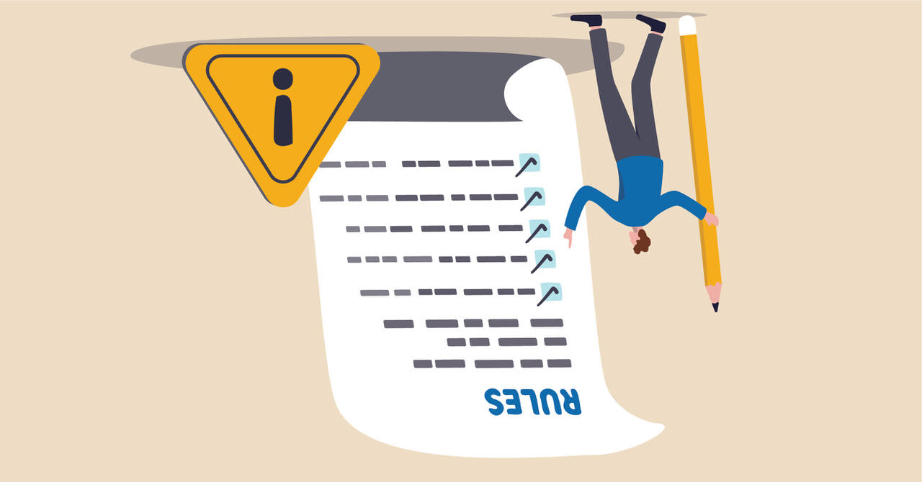
Fig. 6.18 Guideline (Frenté, 2023).
Main text
Organise the main text into sections such as Introduction, Methods, Results, Discussion, and Conclusion. Utilise subheadings to delineate subsections within each main section.
Example:
- Introduction: Provides background information and research objectives.
- Methods: Describes the research design and methodology.
- Results: Presents the research findings.
- Discussion: Analyses the results and their implications.
- Conclusion: Summarises the main findings and suggests future research directions.
Figures and tables
Ensure all figures and tables are clear, legible, and appropriately labelled. Include descriptive captions for each figure and table to elucidate their content and significance.
Example:
- Figure 1: Global Distribution of Renewable Energy Sources
- Table 1: Summary of Survey Responses
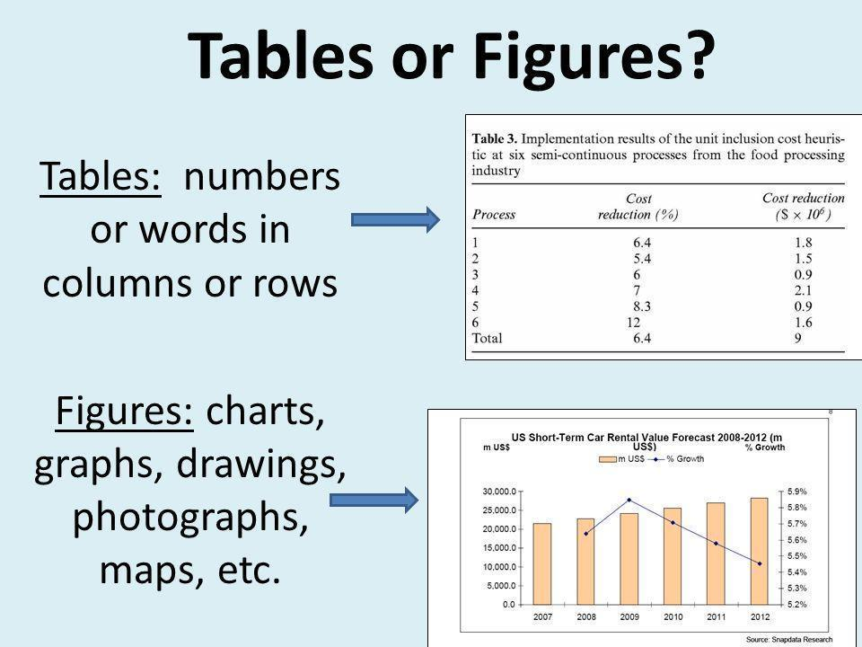
Fig. 6.19 Tables or figures? (Franz, n.d.).
References
Format citations and references according to the designated citation style specified by the publisher. Use citation management tools to ensure consistency and accuracy. In some journals, references may be listed in the text using the author's surname and year of publication in brackets (e.g. Smith, 2020) and then in the list of references used, authors will be listed alphabetically. In others, numerical citations may be required in the text, for example [1], and in the list of references they will be ordered in the order in which they were used in the text.
Example References:
APA Style:
- Book: Smith, J. (2020). The Art of Writing. Publisher.
- Journal Article: Johnson, A., & Doe, B. (2019). The Impact of Technology. Journal of Science, 10(2), 123-135.
- Website: National Institute of Health. (2020). Understanding Health. Retrieved from https://www.nih.gov/understanding-health
MLA Style:
- Book: Smith, John. The Art of Writing. Publisher, 2020.
- Journal Article: Johnson, Alice, and Brian Doe. "The Impact of Technology." Journal of Science, vol. 10, no. 2, 2019, pp. 123-135.
- Website: National Institute of Health. "Understanding Health." National Institute of Health, 2020, https://www.nih.gov/understanding-health.

Chicago Style:
- Book: Smith, John. The Art of Writing. Publisher, 2020.
- Journal Article: Johnson, Alice, and Brian Doe. "The Impact of Technology." Journal of Science 10, no. 2 (2019): 123-135.
- Website: National Institute of Health. "Understanding Health." https://www.nih.gov/understanding-health. Accessed Date.
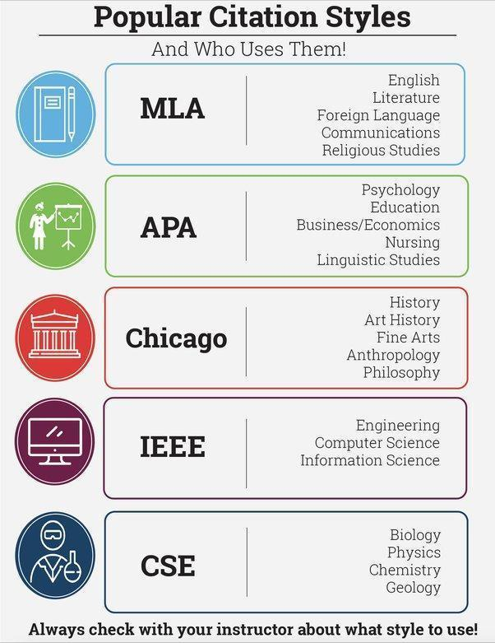
Fig. 6.20 Citation styles (Jain, n.d.).

Supplementary materials
Include supplementary materials such as additional data, figures, tables, or appendices, if necessary, following the publisher's guidelines.
Example:
- Supplementary Figure S1: Additional Results
- Supplementary Table S1: Detailed Data Analysis
Proofreading
Thoroughly proofread the manuscript for grammar, spelling, punctuation, and formatting errors. Consider seeking feedback from colleagues or mentors to enhance clarity and coherence.
Example:
- Proofreading Tip: Utilise spelling and grammar check tools to identify and correct errors.
Compliance with ethical standards
Ensure compliance with ethical standards, including obtaining permissions for copyrighted materials.
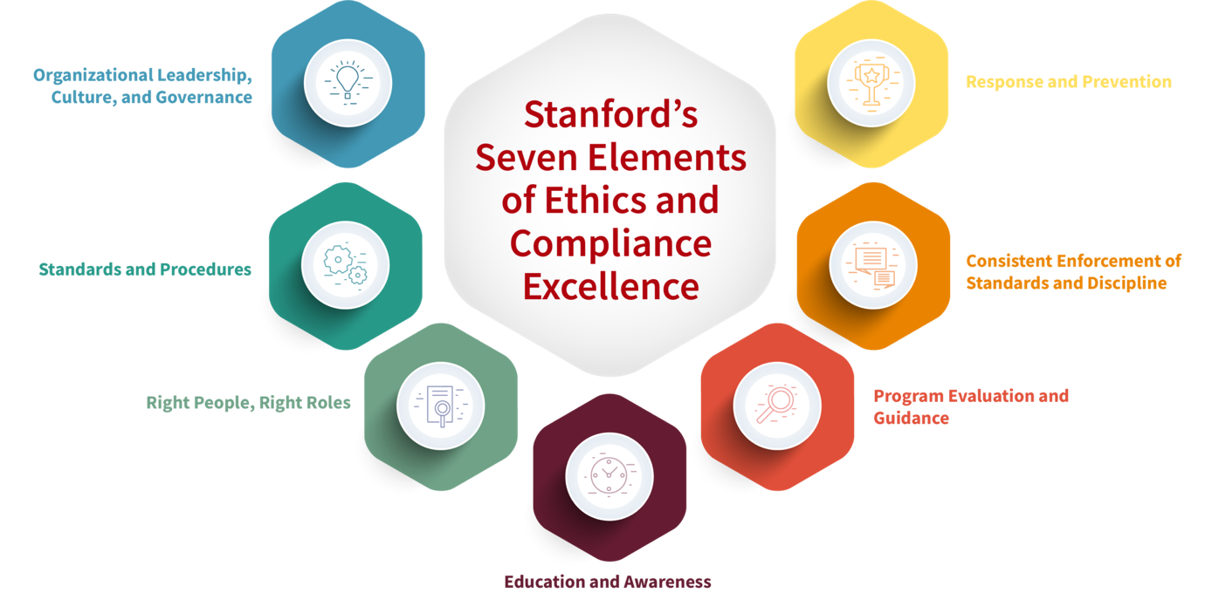
Fig. 6.21 Ethical standards.
6.4.1 Using Zotero for citation management
Zotero is a powerful citation management tool that can streamline the process of managing references in your manuscript. By utilising Zotero, you can efficiently collect, organise, and cite sources while writing your manuscript. Here's how to use Zotero effectively for citation management:
- Installation and setup: Start by downloading and installing Zotero on your computer. Create an account to sync your library across multiple devices for seamless access.
- Adding references: Use Zotero's browser extension or desktop application to add references from academic databases, websites, or PDFs. Organise your references into folders or collections based on the topic or theme of your manuscript.
- Citing sources: When writing your manuscript, use Zotero's citation plugin for word processors (e.g. Microsoft Word or Google Docs) to insert in-text citations and generate a bibliography automatically. Choose the citation style specified by the publisher to ensure consistency and accuracy.
- Formatting bibliography: Customise the bibliography formatting style within Zotero to match the requirements of the publisher. Adjust citation styles, fonts, and spacing as needed to comply with the publisher's guidelines.
- Updating references: Regularly update your Zotero library to ensure that all references are accurate and up-to-date. Check for any changes in author names, publication dates, or URLs to maintain the integrity of your citations.
Getting started
- Download and install Zotero from the official website (https://www.zotero.org/).
- Install the Zotero Connector browser extension for easy saving of web pages and online resources.
- Create a Zotero account to sync your library across multiple devices.
Adding sources to your library
- Use the Zotero Connector to save references from web pages, journal articles, books, and other online sources directly to your Zotero library.
- Manually add sources by entering the bibliographic information into Zotero.
Organizing your library
- Create collections to organise your sources by topic, project, or any other relevant category.
- Use tags to further classify and categorise your sources within collections.
- Arrange sources within collections manually or automatically by date, author, or title.
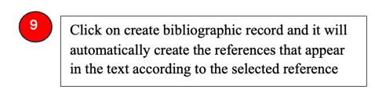
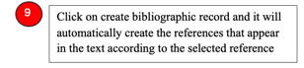
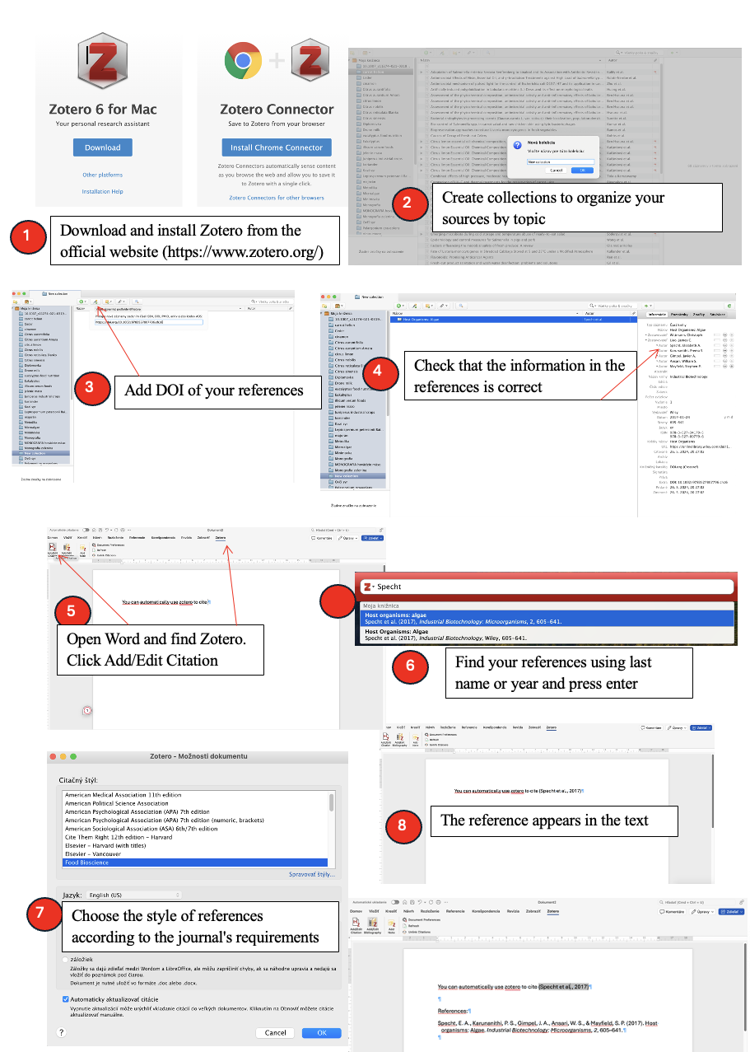

Fig. 6.22 How to use Zotero?
Managing citations and bibliographies
- Use Zotero to generate citations and bibliographies in a variety of citation styles, including APA, MLA, Chicago, and more.
- Install the appropriate word processor plugin (e.g. Zotero for Word) to easily insert citations and bibliographies into your documents.
- Customise citation styles and manage citation formatting options according to your preferences.
Collaborating and sharing
- Share your Zotero library with collaborators to facilitate collaborative research projects.
- Set permissions to control who can view and edit your shared library.
- Use group libraries to collaborate with specific teams or research groups.
6.4.2 Adhering to specific formatting guidelines
Each publisher may have specific formatting guidelines for manuscripts, including requirements for margins, fonts, spacing, headings, and reference styles. It's essential to carefully review and adhere to these guidelines to ensure that your manuscript meets the publisher's expectations. Here's how to adhere to specific formatting guidelines effectively:
- Review publisher's instructions: Start by carefully reviewing the publisher's instructions for authors, which typically outline formatting requirements for manuscript submission. Pay close attention to details such as page layout, font size, line spacing, and citation style.
- Formatting text: Format the text of your manuscript according to the specified font, size, and style. Use standard fonts such as Times New Roman or Arial, and adjust the font size as instructed by the publisher.
- Setting margins and spacing: Set the margins and spacing of your document to meet the publisher's requirements. Ensure that there is adequate space between paragraphs, headings, and sections for readability.
- Including headings and subheadings: Use consistent formatting for headings and subheadings throughout the manuscript. Follow the publisher's guidelines for the hierarchy of headings and the formatting of each level.
- Formatting tables and figures: Format tables and figures according to the publisher's specifications regarding size, alignment, and labelling. Provide clear captions and ensure that tables and figures are referenced appropriately within the text.
- Finalising references: Double-check the formatting of your references to ensure compliance with the publisher's preferred citation style. Make any necessary adjustments to citation formatting, bibliography layout, and reference list entries.
By meticulously adhering to the publisher's specific formatting guidelines, you can ensure that your manuscript meets the required standards for submission and publication.

6.5 Submitting the manuscript
Submitting your manuscript to a journal is the final step in the publication process. This section covers preparing the submission package and navigating the submission process effectively.
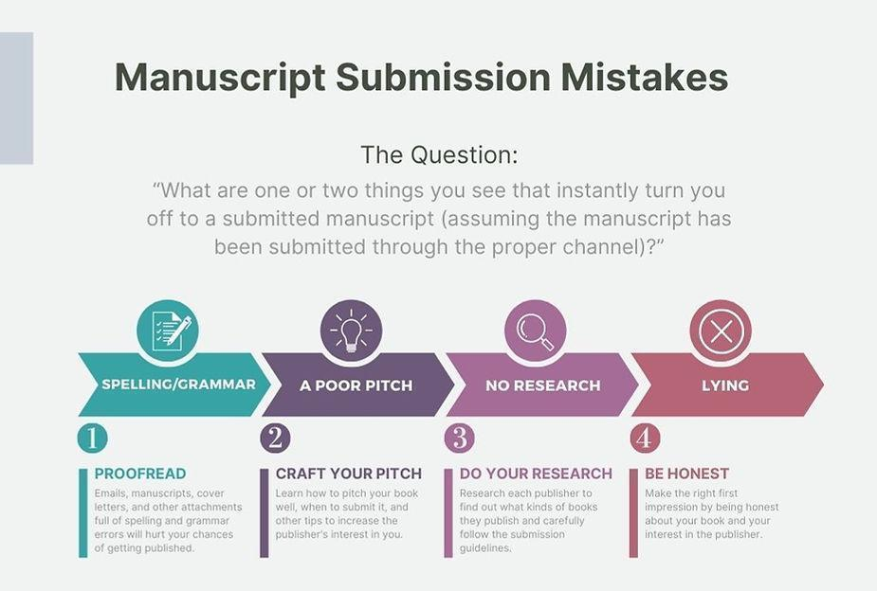
Fig. 6.23 Manuscript submission mistakes (Young, 2023).
6.5.1 Preparing the submission package
Preparing a comprehensive submission package ensures that your manuscript is ready for a review by the journal's editorial team. Here's how to assemble a complete submission package:
- Manuscript: Your manuscript should be the central component of the submission package. Ensure that it is the final version, polished and free of errors. Format your manuscript according to the journal's guidelines, including margins, font size, line spacing, and citation style. Pay attention to details such as the title page, abstract, main text, figures, tables, and references.
- Cover letter: Craft a well-written cover letter addressed to the editor-in-chief or handling editor of the journal. The cover letter serves as your introduction to the editor and provides an opportunity to highlight the significance of your research. Clearly state the purpose of your submission, summarise the key findings of your manuscript, and explain why it is a good fit for the journal. Include any additional information requested by the journal, such as conflicts of interest, funding sources, or ethical considerations.
- Author information: Provide complete author information for all contributors to the manuscript. Include full names, affiliations, email addresses, and ORCID identifiers for each author. Ensure that the order of authors reflects their contributions to the research and that all authors have approved the final version of the manuscript for submission.
- Supplementary materials: If your manuscript includes supplementary materials such as data sets, figures, tables, or multimedia files, ensure that they are properly organised and clearly labelled. Include a separate file or folder for supplementary materials and provide instructions for reviewers on how to access and interpret these materials.
- Ethical statements: Include any required ethical statements as specified by the journal. Declarations of conflicts of interest, funding sources, or adherence to ethical guidelines for research involving human or animal subjects should be clearly stated. Ensure that all ethical considerations are addressed transparently and accurately.
- Permissions: If your manuscript includes copyrighted materials such as figures, tables, or excerpts from other publications, obtain permission from the copyright holder to reproduce these materials in your manuscript. Include documentation of permissions obtained or indicate that materials are used with permission.
- Checklist: Use a submission checklist to ensure that all required components of the submission package are included and that all formatting and ethical guidelines have been followed. Double-check each item before finalising your submission to avoid delays or rejection due to missing information.
6.5.2 Navigating the submission process
Navigating the submission process can vary depending on the journal's submission system and editorial workflow. Here are detailed steps to follow when submitting your manuscript:
- Selecting a journal: Choose a journal that is a good fit for your research based on factors such as scope, audience, impact factor, and editorial policies. Review the journal's author guidelines and submission instructions carefully to ensure that your manuscript meets their requirements.
- Creating an account: If you haven't already done so, create an account on the journal's submission system. Provide accurate information and follow the prompts to set up your author profile. This account will allow you to track the progress of your submission and communicate with the editorial team.
- Uploading manuscript: Use the submission system to upload your manuscript and any accompanying files. Follow the instructions provided to enter metadata such as title, abstract, keywords, and author information. Verify that all information is accurate and up-to-date before proceeding.
- Reviewing submission details: Before finalising your submission, review all submission details carefully. Ensure that all components of the submission package are included and that formatting requirements have been met. Make any necessary corrections or additions to the submission package.
- Submitting manuscript: Once you are satisfied with the submission details, submit your manuscript through the journal's submission system. Take note of any confirmation or tracking numbers provided by the system for future reference. Some journals may require payment of an article processing charge (APC) at this stage.
- Tracking submission status: Monitor the status of your submission through the journal's submission system. Check for updates on the editorial review process, such as manuscript assignment, peer review, and editorial decision. Be prepared to respond promptly to any requests for revisions or additional information from the editorial team.
- Communicating with Editors: Maintain open communication with the journal's editorial team throughout the submission process. Respond promptly to any enquiries or requests for clarification, and meet any deadlines set by the editors. Be professional and courteous in all communications, and provide any requested revisions or additional information in a timely manner.
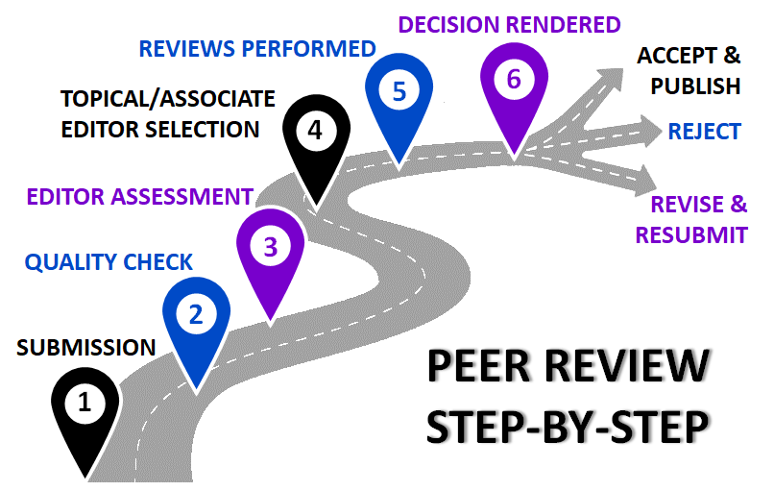
Fig. 6.24 Peer review step-by-step.

6.6 Communication with editors and reviewers
6.6.1 Initial communication
When reaching out to editors and reviewers, ensure your email is professional, informative, and personalised. Here's a more detailed breakdown with examples:
Email Subject Line: "Submission of Manuscript for Consideration: [Title of Manuscript]"
Salutation: Dear Dr Smith,
Introduction: Dear Dr Smith,
I hope this email finds you well. My name is Emily Johnson, and I am a postdoctoral researcher at the Department of Neuroscience, University of XYZ. I am writing to submit our manuscript entitled "Neuroplasticity Mechanisms in Alzheimer's Disease" for consideration for publication in Brain Research.
Manuscript details: The manuscript is a research article comprising 6000 words. It includes an abstract and covers topics such as the role of neuroplasticity in Alzheimer's disease progression and potential therapeutic interventions.
Rationale for submission: Our manuscript presents novel findings on the neuroplasticity mechanisms underlying Alzheimer's disease pathology. We believe it will make a significant contribution to the field by advancing our understanding of disease mechanisms and identifying potential targets for intervention.
Relevance to journal scope: Given Brain Research's focus on neuroscience research and its impact on clinical practice, we believe our manuscript aligns well with the journal's aims and objectives. It builds upon previous work published in Brain Research by integrating neuroimaging data with clinical outcomes to provide a comprehensive analysis of neuroplasticity in Alzheimer's disease.
Closing: Thank you for considering our manuscript for publication. Please find attached the manuscript for your review. Should you require any further information or have any questions, please do not hesitate to contact me at emily.johnson@email.com or +1234567890.
Best regards,
Emily Johnson
6.6.2 Writing a cover letter for submission
Crafting a comprehensive cover letter provides context and highlights the significance of your manuscript. Here's a more detailed example:
Header: Emily Johnson Postdoctoral Researcher Department of Neuroscience University of XYZ emily.johnson@email.com Date: [Insert Date]
Dr Jane Smith Editor-in-Chief Brain Research Journal Address
Salutation: Dear Dr Smith,
Introduction: I am pleased to submit our manuscript entitled "Neuroplasticity Mechanisms in Alzheimer's Disease" for consideration for publication in Brain Research. As the corresponding author, I attest that all co-authors have approved the manuscript for submission.
Rationale for submission: Our manuscript presents original research findings on the neuroplasticity mechanisms underlying Alzheimer's disease pathology. Through a combination of neuroimaging analyses and clinical assessments, we demonstrate significant alterations in brain plasticity associated with disease progression.
Relevance to journal scope: Given Brain Research's focus on neuroscience research and its translation into clinical practice, we believe our manuscript will be of interest to your readership. It builds upon previous work published in Brain Research by providing novel insights into the neurobiology of Alzheimer's disease and its implications for therapeutic interventions.
Suggested reviewers: (Optional) Based on their expertise in neuroplasticity and Alzheimer's disease research, we suggest the following potential reviewers for our manuscript:
- Dr Michael Brown, Professor of Neuroscience, University of ABC Justification: Dr Brown's research focuses on neuroplasticity mechanisms in neurodegenerative diseases, making him well-suited to evaluate our manuscript.
- Dr Sarah Johnson, Associate Professor of Neurology, XYZ Hospital Justification: Dr Johnson has expertise in clinical neuroimaging techniques and has published extensively on Alzheimer's disease, making her an ideal reviewer for our study.
Closing: Thank you for considering our manuscript for publication in Brain Research. We look forward to your feedback and the opportunity to contribute to the journal.
Sincerely,
Emily Johnson
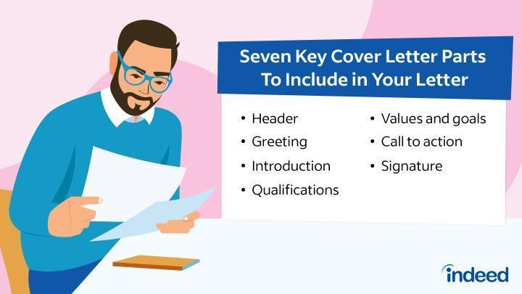
Fig. 6.25 Cover letter (Herrity, 2023).
6.6.3 Suggesting possible reviewers
While optional, suggesting potential reviewers can facilitate the peer review process. Here's a more detailed example:
Example: Based on their expertise and impartiality, we recommend the following potential reviewers for our manuscript:
- Dr Michael Brown Professor of Neuroscience University of ABC Email: michael.brown@email.com Justification: Dr Brown's research focuses on neuroplasticity mechanisms in neurodegenerative diseases, including Alzheimer's disease. He has published extensively in this area and has served as a reviewer for similar manuscripts in Brain Research.
- Dr Sarah Johnson Associate Professor of Neurology XYZ Hospital Email: sarah.johnson@email.com Justification: Dr Johnson has expertise in clinical neuroimaging techniques and has conducted research on neuroplasticity alterations in Alzheimer's disease patients. Her impartiality and experience make her a suitable candidate for reviewing our manuscript.
- Dr David Lee Senior Scientist National Institute of Neurological Disorders and Stroke (NINDS) Email: david.lee@email.com Justification: Dr Lee's research interests include synaptic plasticity and neurodegenerative diseases. His expertise in the field and previous experience as a reviewer make him a valuable addition to the peer review process.
6.6.4 Preparing responses to reviewer comments
Responding to reviewer comments requires careful consideration and thorough responses to address each point raised. Here's a detailed approach to preparing responses:
Review the comments: Carefully read through each reviewer's comments and suggestions, noting any areas of agreement or disagreement.
Organise responses: Group similar comments together and prioritise them based on their significance to the manuscript's revision.
Address each point: Provide clear, detailed responses to each comment, indicating whether you agree with the suggestion and explaining the changes made or the rationale for maintaining certain aspects of the manuscript.
Provide supporting evidence: When appropriate, provide additional data, references, or explanations to support your responses to reviewer comments.
Be concise: Keep your responses concise and focused, avoiding unnecessary repetition or overly technical language.
Express appreciation: Express gratitude to the reviewers for their time and feedback, even if you may disagree with some of their comments.
Example response:
Reviewer Comment: "The methodology section needs clarification regarding the sample size calculation and statistical analysis methods."
Response: Thank you for your comment. We have revised the methodology section to provide more clarity on the sample size calculation, including the rationale for the chosen sample size and the statistical analysis methods employed. We have also added references to relevant literature supporting our approach.

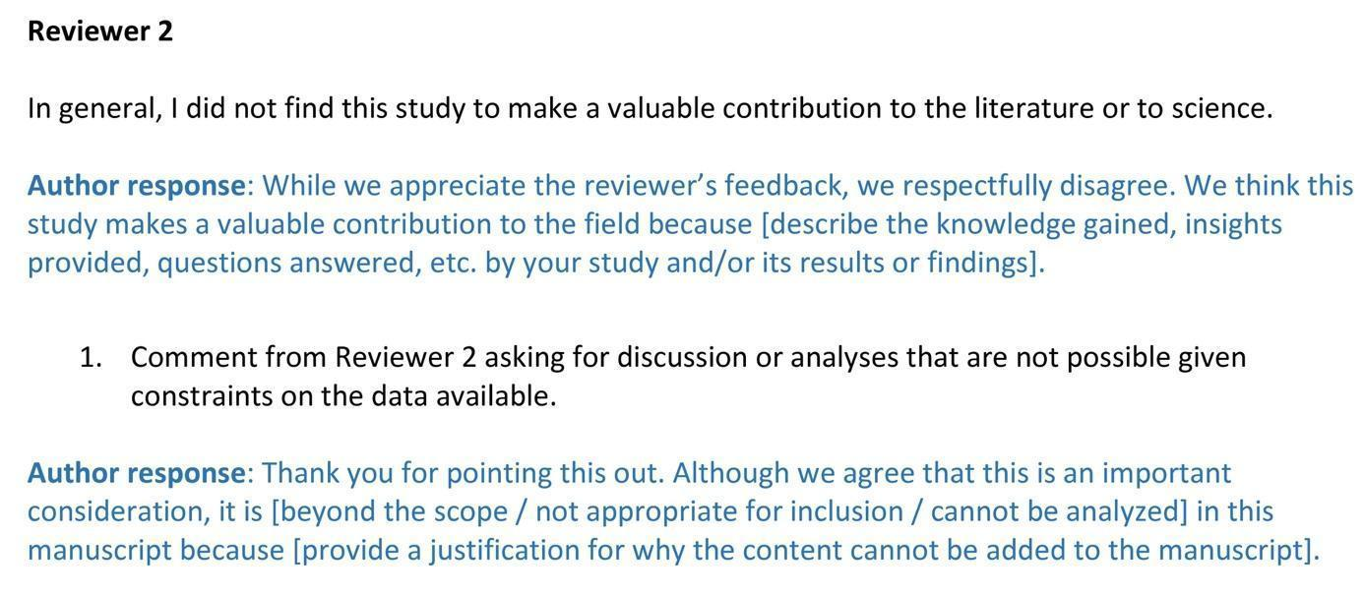
Fig. 6.26 Responses to Reviewer (Bahnik, 2019).
6.6.5 Revising the manuscript based on feedback
Revising the manuscript based on reviewer feedback is a critical step in the publication process. Here's how to approach the revision process:
Review feedback: Carefully review the feedback provided by the reviewers, noting areas where revisions are needed and considering how to address each comment effectively.
Make revisions: Implement changes to the manuscript as suggested by the reviewers, ensuring that each revision improves the clarity, accuracy, and overall quality of the manuscript.
Maintain consistency: Ensure that revisions are consistent throughout the manuscript, maintaining a coherent narrative and logical flow of information.
Seek clarification: If you have any questions or uncertainties about specific reviewer comments, seek clarification from the reviewers or the journal's editorial team.
Example revision:
Reviewer Comment: "The results section would benefit from additional data visualisation to enhance understanding of the findings."
Revision: We have revised the results section to include additional data visualisation, including bar graphs and scatter plots, to enhance the presentation of our findings. These visualisations provide a clearer representation of the data and facilitate interpretation by the reader.

6.6.6 Writing a second cover letter for resubmission
When submitting a revised manuscript, it's important to provide a second cover letter to accompany the resubmission. Here's how to structure the cover letter:
Header: Include your contact information and the date of resubmission.
Salutation: Address the editor-in-chief or handling editor by name.
Introduction: Briefly reintroduce the manuscript and summarise the revisions made in response to reviewer feedback.
Highlight changes: Provide a detailed overview of the changes made to the manuscript, including specific sections that were revised and the rationale for the revisions.
Express gratitude: Express gratitude to the reviewers for their constructive feedback and to the editorial team for the opportunity to revise and resubmit the manuscript.
Example second cover letter:
[Your Name] [Your Affiliation] [Your Email Address] [Date of Resubmission]
Dr Jane Smith Editor-in-Chief Brain Research Journal Address
Dear Dr Smith,
I am writing to resubmit our manuscript entitled "Neuroplasticity Mechanisms in Alzheimer's Disease" following revisions based on the feedback provided by the reviewers. We appreciate the opportunity to revise and resubmit the manuscript for further consideration.
In response to the reviewers' comments, we have made several revisions to the manuscript to address their concerns and improve the clarity and quality of the presentation. Specifically, we have revised the methodology section to provide additional clarification on the sample size calculation and statistical analysis methods. We have also enhanced the results section with additional data visualisation to facilitate understanding of the findings.
We would like to express our gratitude to the reviewers for their constructive feedback and to the editorial team for their consideration of our manuscript. We believe that the revisions made have strengthened the manuscript and addressed the concerns raised by the reviewers.
Thank you for considering our revised manuscript for publication in Brain Research.
Sincerely,
[Your Name]

6.7 Further communication
6.7.1 Addressing additional reviewer feedback

After resubmitting the revised manuscript, reviewers may provide additional feedback or request further revisions. Here's how to address this feedback:
Review feedback: Carefully review any additional feedback provided by the reviewers, noting any new comments or suggestions for revision.
Prioritise revisions: Prioritise revisions based on the significance of the feedback and its potential impact on the manuscript's quality and clarity.
Communicate with editors: If you have questions or concerns about specific reviewer comments, communicate with the editors to seek clarification or guidance.
Revise manuscript: Implement revisions to the manuscript as needed, ensuring that each revision improves the clarity, accuracy, and overall quality of the manuscript.

Example response:
Reviewer Comment: "The discussion section lacks critical analysis of the study limitations and potential implications for future research."
Response: Thank you for your feedback. We have revised the discussion section to include a more comprehensive analysis of the study limitations and the potential implications for future research. We have highlighted areas where further investigation is warranted and discussed the potential impact of our findings on clinical practice.
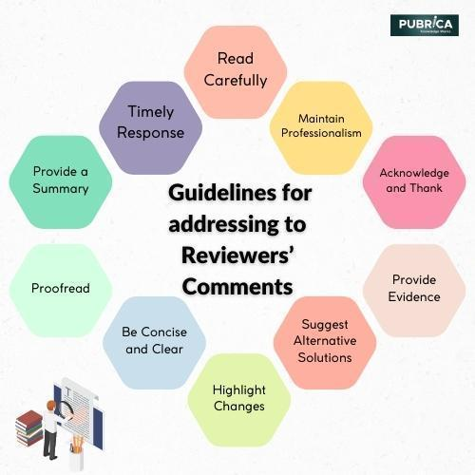
Fig. 6.27 Reviewer feedback.
6.7.2 Resubmitting the manuscript
When resubmitting the manuscript after addressing additional reviewer feedback, follow these steps:
Prepare resubmission: Ensure that all revisions have been completed and that the manuscript is ready for resubmission.
Write cover letter: Provide a brief cover letter accompanying the resubmission, summarising the revisions made in response to reviewer feedback.
Submit manuscript: Resubmit the revised manuscript through the journal's submission system, following the instructions provided by the editors.

Example cover letter:
[Your Name] [Your Affiliation] [Your Email Address] [Date of Resubmission]
Dr Jane Smith Editor-in-Chief Brain Research Journal Address
Dear Dr Smith,
I am writing to resubmit our manuscript entitled "Neuroplasticity Mechanisms in Alzheimer's Disease" following revisions based on additional feedback provided by the reviewers. We appreciate the opportunity to address their comments and further improve the manuscript for consideration for publication.
In response to the reviewers' additional feedback, we have made further revisions to the manuscript to address their concerns and enhance the clarity and quality of the presentation. Specifically, we have revised the discussion section to provide a more comprehensive analysis of the study limitations and the potential implications for future research.
We would like to express our gratitude to the reviewers for their continued engagement with our manuscript and to the editorial team for their consideration of our work. We believe that the revisions made have strengthened the manuscript and addressed the concerns raised by the reviewers.
Thank you for considering our revised manuscript for publication in Brain Research.
Sincerely,
[Your Name]
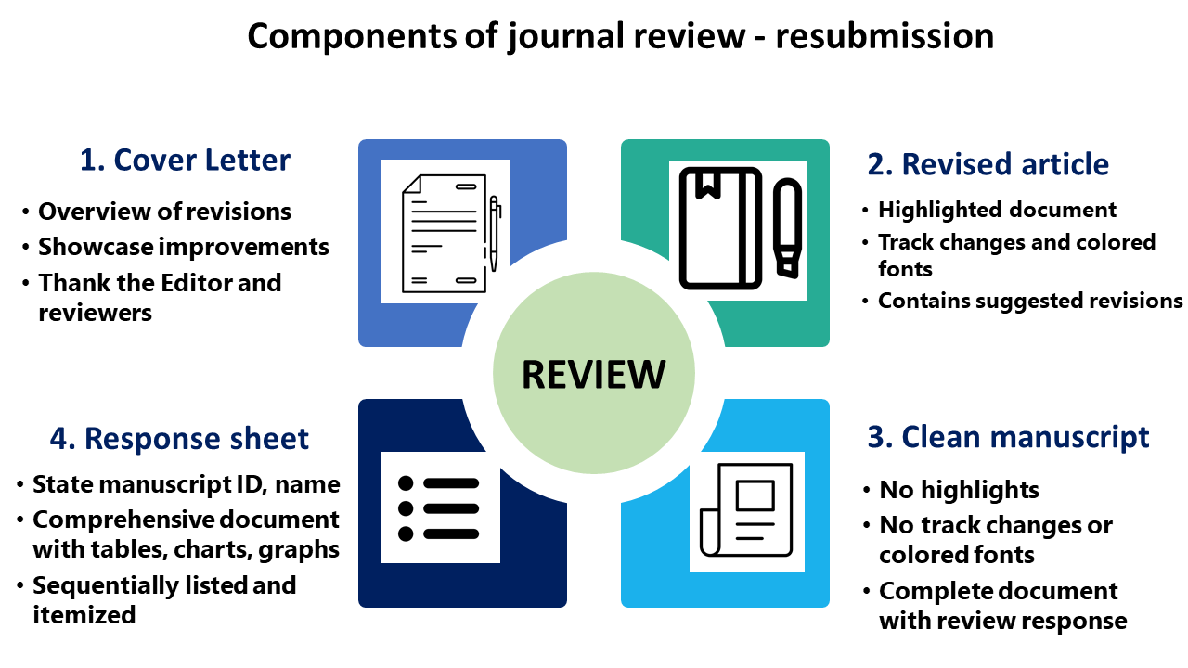
Fig. 6.28 Components of journal review (Bhowmik, 2021).
6.7.3 Final proofreading and approval
Before the manuscript is accepted for publication, it undergoes a final proofreading and approval process. Here's how to ensure the manuscript is ready for publication:
Proofread carefully: Thoroughly proofread the manuscript for any typos, grammatical errors, or formatting inconsistencies.
Check figures and tables: Ensure that all figures, tables, and captions are correctly labelled and formatted according to the journal's guidelines.
Review author information: Double-check author names, affiliations, and contact information for accuracy.
Verify references: Check all references for accuracy and consistency, ensuring they are formatted according to the journal's citation style.
Submit final manuscript: Once you are satisfied that the manuscript is error-free and meets all requirements, submit the final version through the journal's submission system.
Example acknowledgement:
"We acknowledge the support of our research team and funding agencies for their contributions to this work."
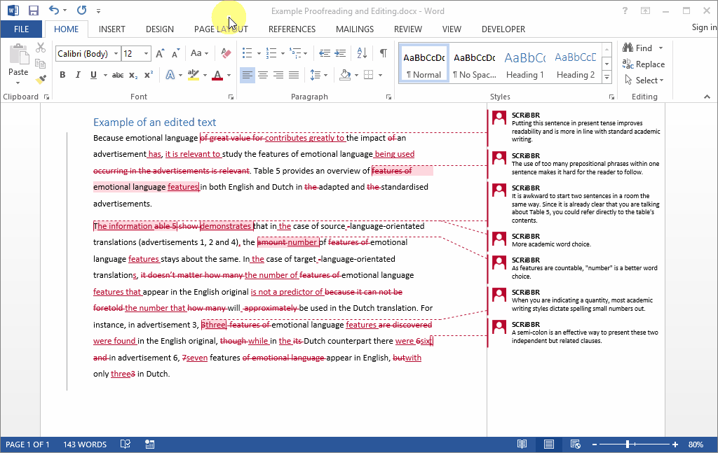
Fig. 6.29 Final proofreading and approval.

6.8 Language improvement services
6.8.1 Utilising professional language editing services
Language editing services can help improve the clarity, readability, and overall quality of your manuscript. Here's how to utilise professional language editing services effectively:
Research service providers: Conduct research to identify reputable language editing services that specialise in academic writing and have experience in your field of study.
Select the right service level: Choose the appropriate service level based on your needs and budget. Most editing services offer different levels of editing, ranging from basic proofreading to substantive editing.
Submit manuscript for editing: Once you've selected a service provider and service level, submit your manuscript for editing. Be sure to follow the provider's guidelines for submission and provide any specific instructions or preferences you may have.
Review edited manuscript: Carefully review the edited manuscript to ensure that all edits are acceptable and consistent with your intended meaning. Address any queries or suggestions provided by the editor.
Incorporate changes: Incorporate the suggested changes and revisions into your manuscript, making sure to maintain the integrity of your research and arguments while improving clarity and readability.
Example: "After completing the initial draft of my manuscript, I decided to utilise the services of XYZ Editing, a reputable language editing service with expertise in the field of [Your Field]. I selected their premium editing package, which included comprehensive language editing and formatting services. The editing process was smooth and efficient, and the editor provided valuable feedback and suggestions for improving the clarity and coherence of my writing. After reviewing the edited manuscript, I incorporated the suggested changes and revisions into the final version of my manuscript, confident that it was now polished and ready for submission to a journal."
6.8.2 Tools for language improvement
In addition to professional editing services, there are several tools and resources available to help improve the language and readability of your manuscript. Here are some useful tools:
Grammarly: Grammarly is an AI-powered writing assistant that can help identify and correct grammar, punctuation, and spelling errors. It also provides suggestions for improving sentence structure and clarity.

Fig. 6.30 Grammarly tool.
Microsoft Word's Spelling and Grammar Check: Microsoft Word's built-in spelling and grammar check feature can help catch basic errors and inconsistencies in your writing. However, it's important to remember that this tool may not catch all errors or provide suggestions for improving clarity.
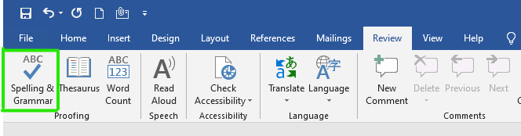
Fig. 6.31 Microsoft Word's Spelling and Grammar Check
Style guides: Consult reputable style guides such as the Publication Manual of the American Psychological Association (APA), the Chicago Manual of Style (CMS), or the Modern Language Association (MLA) Handbook for guidance on formatting, citation style, and language usage.
Peer review: Seek feedback from colleagues, mentors, or peers in your field to identify areas for improvement in your writing. Peer review can provide valuable insights and perspectives to help strengthen your manuscript.
Example: "In addition to professional language editing services, I also utilised several tools and resources to improve the language and readability of my manuscript. I regularly used Grammarly, a writing assistant tool, to catch grammar and punctuation errors and improve sentence structure. I also consulted the Publication Manual of the American Psychological Association (APA) for guidance on formatting and citation style. Additionally, I sought feedback from colleagues and mentors in my field through peer review, which helped me identify areas for improvement and refine my writing further."
By utilising professional language editing services and leveraging tools and resources for language improvement, you can enhance the clarity, readability, and overall quality of your manuscript, increasing its chances of acceptance for publication.

6.9 Reviewing manuscripts submitted by other students
6.9.1 Guidelines for providing constructive feedback
When reviewing manuscripts submitted by other students, it's essential to provide thorough and constructive feedback that helps the authors improve their work. Here are detailed guidelines to follow:
Be specific and detailed: Provide specific comments on different sections of the manuscript, including the introduction, methods, results, discussion, and conclusion. Offer detailed feedback on the clarity of writing, organisation of ideas, coherence of arguments, and accuracy of information.
Address strengths and weaknesses: Highlight both the strengths and weaknesses of the manuscript. Acknowledge what the author has done well, such as clear research objectives or thorough literature review, while also pointing out areas that need improvement, such as ambiguous methodology descriptions or incomplete data analysis.
Offer suggestions for improvement: Provide constructive criticism by offering suggestions for how the author can improve their manuscript. This could include recommending additional references to support their arguments, suggesting alternative research methodologies, or proposing ways to enhance the interpretation of results.
Provide examples and evidence: Support your feedback with specific examples and evidence from the manuscript. Quote relevant passages to illustrate your points or refer to specific figures, tables, or data points to clarify your comments.
Be respectful and professional: Maintain a respectful and professional tone in your feedback, even if you disagree with certain aspects of the manuscript. Avoid using harsh or derogatory language and focus on providing constructive criticism that helps the author improve their work.
Example feedback: "In the methods section, you have provided a clear description of the study design and data collection procedures, which is commendable. However, I noticed that you did not specify the inclusion and exclusion criteria for participant selection, which could impact the validity of your findings. I recommend adding this information to ensure transparency and reproducibility in your study."
6.9.2 Ethical considerations in peer review
Peer review is a cornerstone of academic publishing, and it's crucial to approach it with integrity and ethical considerations. Here are detailed ethical guidelines to follow:
Maintain confidentiality: Treat all manuscripts and peer review correspondence as confidential documents. Do not discuss or share any confidential information without explicit permission from the journal and the authors.
Declare conflicts of interest: Disclose any potential conflicts of interest that could bias your review, such as personal relationships with the authors, professional collaborations, or competing research interests. If you feel unable to provide an unbiased review due to a conflict of interest, recuse yourself from the review process.
Provide honest and fair feedback: Offer honest, fair, and constructive feedback based on the quality of the manuscript. Avoid bias or prejudice based on factors such as the authors' reputation, institutional affiliation, or personal beliefs.
Avoid plagiarism and unethical practices: Refrain from plagiarising ideas, content, or data from the manuscript under review. Ensure that your feedback is original and does not infringe on the authors' intellectual property rights. Report any suspected instances of plagiarism or unethical practices to the journal's editorial office.
Respect authorship rights: Respect the authorship rights of the manuscript's authors and acknowledge their contributions appropriately. Do not use or disclose any ideas, findings, or data from the manuscript without proper attribution.
Example ethical consideration: "As a peer reviewer, it is imperative to uphold the highest ethical standards throughout the review process. This includes maintaining strict confidentiality regarding all manuscript materials and peer review correspondence, disclosing any potential conflicts of interest that could compromise the integrity of your review, providing honest and fair feedback based solely on the quality of the manuscript, avoiding plagiarism or unethical practices, and respecting the authorship rights of the manuscript's authors. By adhering to these ethical guidelines, you contribute to the integrity, credibility, and fairness of the peer review process."

Practical work
  - Preparation, editing examples of manuscripts.
  - Learn how can be submitting manuscripts in different journals.
  - Editing the manuscript examples before submission.
  - Language editing, tried preparing sentence in different forms.
  - Preparing cover letter examples.
  - Formatting manuscripts according to the publisher’s requirements in different journals.
  - Reviewing manuscripts submitted by other students.

Materials
Text editing in a Word document. Prepare all parts of manuscript with some hypothesis of the study, which will be described in the example manuscript.

Methods
Available searchable journals in all databases. Some journals show examples of the process for correcting manuscripts. Find an example of a cover letter on the internet and write one yourself.

Results
Prepared example of the manuscript, editing in the same template from a journal.

Conclusion
After completing practical and independent work, find optimal journals for publishing and prepare all points in this module theme.

Approved by _____________________
Name, Surname, signature
Date ______________

Theme 7

Presenting scientific results

Theoretical materials

7.1 Poster presentation
7.1.1 Preparing a poster based on the manuscript

Creating an effective academic poster involves summarising the key elements of your research in a visually appealing and concise format. Here's a detailed guide on what to do, what not to do, common mistakes, and recommended design programs.

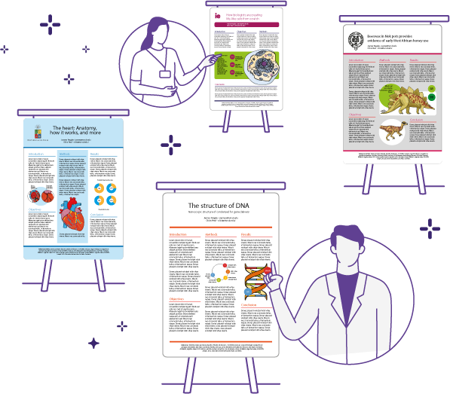
Fig. 7.1 Poster presentation (Pamplona, 2021).

7.1.2 What to do
1. Identify key content: Select the most important aspects of your manuscript to feature on your poster. Focus on your research question, objectives, methods, results, and conclusions. Aim to present the essence of your research without overwhelming the audience with too much information.
Example: For a manuscript on the effects of a new drug on hypertension, your poster should highlight the background of hypertension, the research hypothesis, the experimental design, key findings, and the implications of these findings.
2. Create a structured outline: Organise your content into clear sections, typically including the title, authors and affiliations, introduction, objectives, methods, results, discussion, and conclusions. Ensure each section is succinct and directly related to your central research question.
3. Use clear and concise language: Avoid long paragraphs and use bullet points, short sentences, and simple language to convey your message. Aim for clarity and brevity to make your poster easily readable from a distance.
4. Visualise data: Incorporate charts, graphs, tables, and images to visually represent your data. Visuals should be high-quality, clearly labelled, and relevant to your findings. Ensure that the text accompanying the visuals explains them effectively.
5. Design and layout considerations: Choose an appropriate size and format. Check the specific size requirements and guidelines provided by the conference or event. Common poster sizes include A0 (84.1 cm x 118.9 cm) and A1 (59.4 cm x 84.1 cm). Ensure your poster fits within the allotted space.
Title and headings: The title should be large and easy to read from a distance. Use a clear, bold font and ensure the title captures the essence of your research. Headings for each section should be distinct and help guide the viewer through your poster.
Font and text size: Use a legible font such as Arial or Times New Roman. Titles should be at least 85 pt., section headings at least 50 pt., and body text at least 24 pt. This ensures readability from a distance.
Colour scheme: Choose a colour scheme that enhances readability and is visually appealing. Use contrasting colours for background and text to ensure the text stands out. Avoid using too many colours, which can be distracting.
Balance and spacing: Ensure your poster has a balanced layout with adequate spacing between sections. Avoid cluttering the poster with too much text or too many images. White space helps in maintaining a clean and organised look.
Consistency: Maintain consistency in fonts, colours, and styles throughout the poster. This helps in creating a professional and cohesive appearance.
Example layout: For a research study on climate change impacts on coastal ecosystems:
- Title: "Assessing the Impacts of Climate Change on Coastal Ecosystems",
- Authors and affiliations: John Doe, Jane Smith - University of XYZ,
- Introduction: Brief background on climate change and coastal ecosystems,
- Objectives: To assess the impacts of rising sea levels on coastal biodiversity,
- Methods: Description of study area, data collection, and analysis methods,
- Results: Key findings with supporting graphs and images,
- Discussion: Interpretation of results and implications for conservation,
- Conclusions: Summary of key takeaways and recommendations for future research.
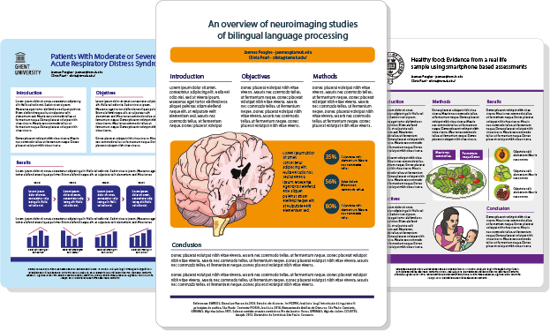
Fig. 7.2 Different types of posters (Pamplona, 2021).

7.1.3 Tips for effective poster presentation

Prepare your pitch: Prepare a brief (3-5 minute) summary of your poster that you can present to interested viewers. Focus on the key points and be ready to answer questions.
Example pitch: "Our study investigates the impact of rising sea levels on coastal ecosystems. We found significant changes in species composition and habitat loss, highlighting the urgent need for conservation measures. This research provides critical insights into how climate change is affecting our coastal environments."
Engage your audience: Be approachable and ready to engage with viewers. Smile, make eye contact, and show enthusiasm for your research. Be open to questions and feedback.
Use visual aids: Use a pointer or your hands to guide viewers through your poster. Highlight key sections and visuals to make your explanations clearer.
Practice: Rehearse your pitch and explanations multiple times. Practice answering potential questions and explaining your methods and results concisely.
Be prepared for auestions: Anticipate common questions about your research and prepare concise, clear answers. Be honest if you don't know the answer to a question and offer to follow up if needed.
Bring handouts: Provide handouts or business cards with your contact information and a brief summary of your research. This allows interested viewers to follow up with you later.
Stay by your poster: Remain near your poster during the designated presentation times. This shows your commitment and willingness to discuss your work with others.
Example interaction: When a viewer approaches, greet them with a smile and a brief introduction: "Hello, my name is [Your Name], and I'm excited to share my research on the impacts of climate change on coastal ecosystems with you. Please feel free to ask any questions as we go through the poster."
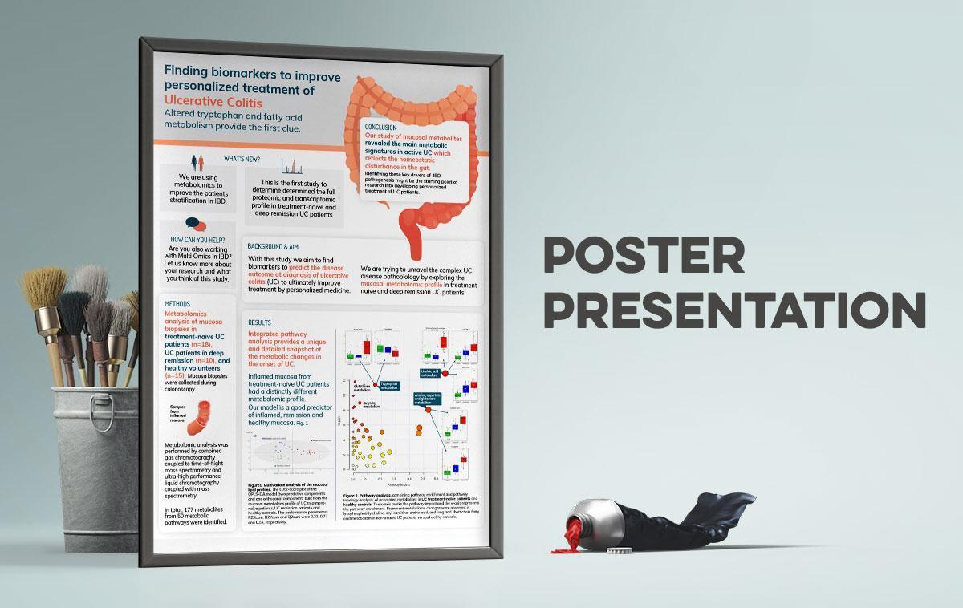

Fig. 7.3 Poster.

7.1.4 What not to do
Avoid clutter: Do not overload your poster with too much text or too many visuals. This can overwhelm viewers and make it difficult to grasp the main points of your research.

Do not use small fonts: Avoid using small fonts that are difficult to read from a distance. Ensure that all text is legible and easy to read.

Avoid jargon: Do not use excessive jargon or technical language that may be unfamiliar to your audience. Aim for clarity and simplicity in your language.

Do not ignore design principles: Avoid using clashing colours, inconsistent fonts, or a chaotic layout. Follow basic design principles to create a visually appealing and professional poster.

Example of what not to do: A poster with tiny text, cluttered visuals, and clashing colours will likely fail to communicate your research effectively. For instance, using multiple font types and colours indiscriminately can make your poster look unprofessional and hard to read.

7.1.5 Common mistakes

Too much text: Including too much text can make your poster overwhelming and difficult to read. Focus on the key points and use bullet points or short sentences to convey your message.
Poor quality images: Using low-resolution images can make your poster look unprofessional. Ensure all visuals are high-quality and clearly labelled.
Lack of focus: A poster that tries to cover too much ground can be confusing. Stick to the most important aspects of your research and present them clearly.
Ignoring audience: Failing to consider your audience can result in a poster that is either too technical or too simplistic. Tailor your content to the knowledge level of your expected audience.
Example of common mistakes: A poster that tries to present every detail of the research study with dense paragraphs and low-resolution images is likely to lose the audience's interest quickly.
7.1.6 Programs to use
Microsoft PowerPoint: PowerPoint is widely used for creating academic posters. It offers a range of design tools and templates to help you create a professional poster.
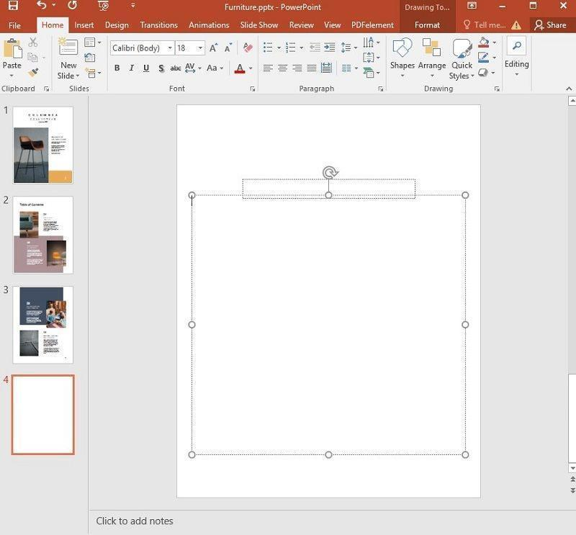
Fig. 7.4 Microsoft PowerPoint posters (Williams, 2024).

Adobe Illustrator: Illustrator is a powerful design tool that allows for precise control over the layout and design elements of your poster. It's ideal for creating high-quality visuals and complex designs.
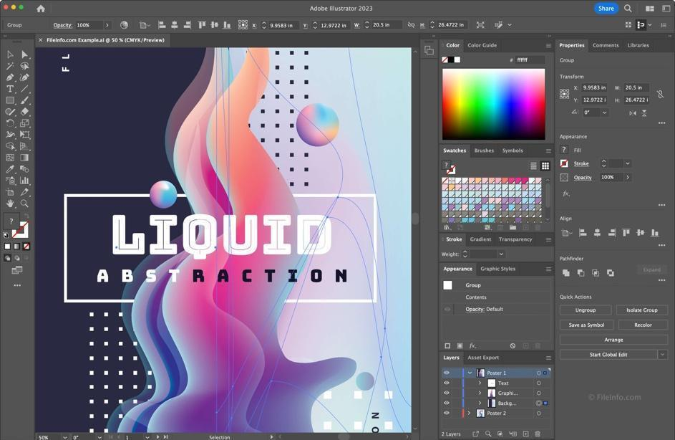

Fig. 7.5 Adobe Illustrator.
Canva: Canva is an online design tool that provides user-friendly templates and design elements. It's a good option for those with limited design experience.

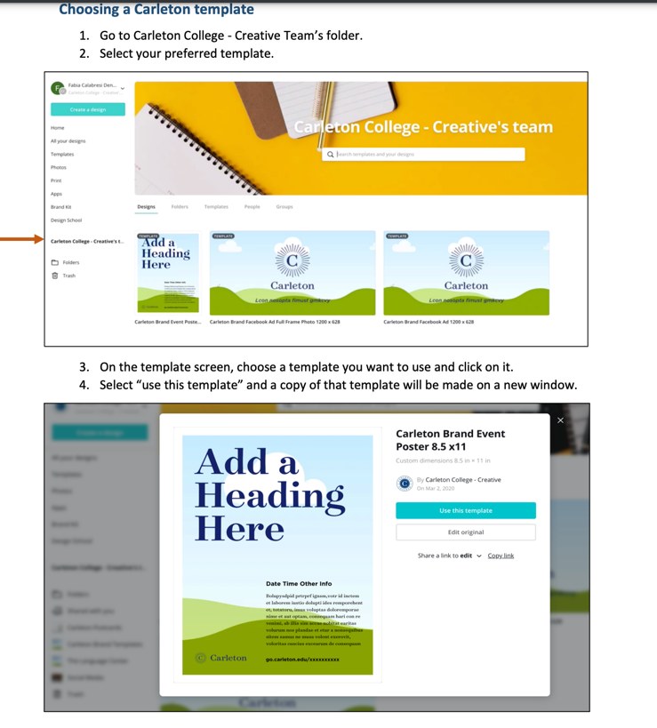
Fig. 7.6 Canva.
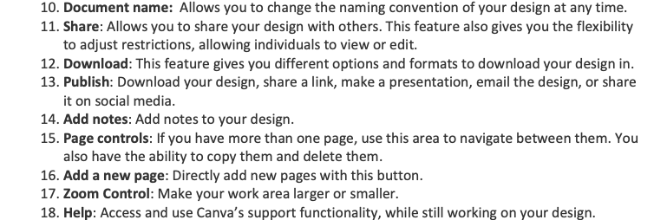
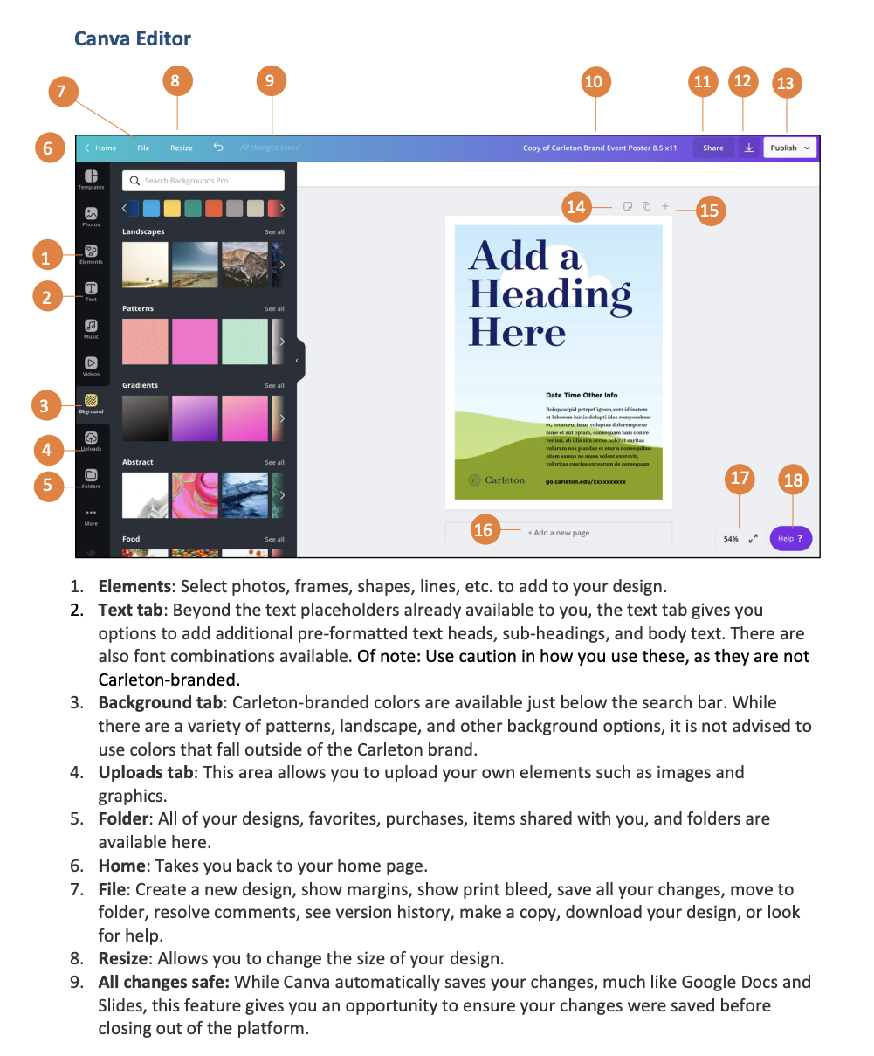

Figure 38. Manual for canva

Postersmith: Postersmith offers a specialised platform for designing and printing academic posters. It provides templates and design tools tailored to scientific posters.
Example of Program Use: Using PowerPoint, you can start with a blank slide and set custom dimensions for your poster. Use the drawing and text tools to create sections, add images, and insert text boxes. Save the final poster as a PDF for printing or digital submission.

7.2 Oral presentation
7.2.1 Preparing an oral presentation based on the manuscript
Presenting your research orally involves transforming the detailed information from your manuscript into a concise, engaging, and clear presentation. Here’s a detailed guide to help you prepare effectively:
1. Understand our audience: Identify who your audience will be and tailor your presentation to their level of expertise and interest. This will help you decide how much background information to provide and which aspects of your research to emphasize.
Example: If presenting to a general audience, simplify complex technical terms and provide more background information. For a specialized audience, focus on the novel aspects and implications of your research.
2. Highlight key points: Select the main points from your manuscript that you want to convey. Typically, these include the research question, hypothesis, methods, key results, and implications of your findings. Aim to tell a compelling story about your research.
Example: For a study on the impact of dietary interventions on obesity, focus on the rationale behind the study, the methodology, the most significant findings, and their implications for public health.
3. Create visual aids: Develop slides to visually support your oral presentation. Use PowerPoint, Keynote, or similar software to create slides that highlight your key points. Ensure your slides are not text-heavy and include visuals such as graphs, charts, and images to make your data more accessible.
Example: A slide summarising your results might include a bar graph showing the differences in obesity rates before and after the dietary intervention.
7.2.2 Structuring the presentation
An effective oral presentation should have a clear structure that guides the audience through your research. Here’s a typical structure:
1. Introduction
- Greet your audience and introduce yourself.
- Provide a brief overview of the topic and its importance.
- State your research question or hypothesis.
Example Introduction: "Good morning, everyone. My name is Dr Jane Smith, and today I will be presenting my research on the impact of dietary interventions on reducing obesity rates. Obesity is a major public health issue, and finding effective strategies to combat it is crucial. Our study aims to assess whether specific dietary changes can significantly reduce obesity."
2. Background and objectives
- Offer some background information to set the context.
- Clearly state the objectives of your research.
Example background: "Obesity rates have been increasing globally, leading to a rise in related health conditions such as diabetes and cardiovascular diseases. Our objective was to evaluate the effectiveness of a low-carb, high-protein diet in reducing obesity in a sample population over six months."
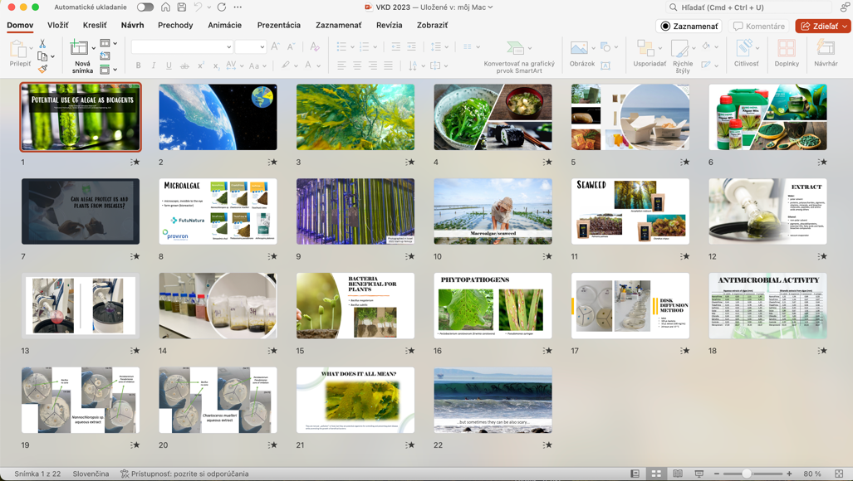
Fig. 7.7 How the presentation should look like.

3. Methods
- Describe the methods and experimental design.
- Explain how the data was collected and analysed.
Example Methods: "We conducted a randomised controlled trial with 200 participants divided into two groups. One group followed the low-carb, high-protein diet, while the control group maintained their usual diet. We measured participants' weight, BMI, and other health indicators at the start and end of the study."
4. Result
- Present the key findings of your research.
- Use visuals to make the data clear and engaging.
Example Results: "Our results showed a significant reduction in weight and BMI in the intervention group compared to the control group. Specifically, the intervention group lost an average of 7 kg, while the control group lost only 2 kg."
5. Discussion and conclusion:
- Interpret the results and discuss their implications.
- Summarise the main takeaways and suggest future research directions.
Example discussion: "These findings suggest that a low-carb, high-protein diet can be an effective strategy for reducing obesity. However, further research is needed to explore the long-term sustainability and health impacts of this diet. We recommend future studies to include larger sample sizes and longer follow-up periods."
6. Q&A session
- Invite questions from the audience and provide clear, concise answers.
- Be prepared for critical questions and provide thoughtful responses.
Example Q&A invite: "Thank you for your attention. I would now be happy to take any questions you might have about our research."
7.3.3 Tips for effective oral delivery
Delivering your presentation effectively is as important as the content itself. Here are some tips to ensure you engage your audience and communicate your research clearly:
1. Practice: Rehearse your presentation multiple times to become comfortable with the material and the flow. Time yourself to ensure you stay within the allotted time.
2. Engage with your audience: Maintain eye contact, use expressive body language, and speak with enthusiasm. Engage your audience by asking rhetorical questions and encouraging interaction.
Example engagement: "Imagine being able to reduce obesity rates significantly with a simple dietary change. This is what our study aimed to explore."
3. Speak clearly and pacing: Speak clearly and at a moderate pace. Avoid speaking too quickly, which can make it hard for your audience to follow, or too slowly, which can cause them to lose interest.
4. Use visual aids effectively: Ensure your slides are clear, not overcrowded with text, and that visuals complement your spoken words. Refer to your visuals as you present to help illustrate your points.
Example visual aid use: "As you can see in this graph, the intervention group showed a significant reduction in BMI over the six-month period."
5. Handle questions gracefully: Listen carefully to questions, take a moment to think if needed, and provide clear, concise answers. If you don't know the answer, it's okay to admit it and offer to follow up later.
Example handling questions: "That's a great question. While our study did not explore long-term effects, it is something we are planning to investigate in future research."
6. Stay professional: Dress appropriately, arrive early to set up, and ensure all technical equipment works. Maintain a professional demeanour throughout the presentation.
7. Use notes wisely: Use notes or cue cards if necessary, but avoid reading from them directly. They should serve as prompts rather than a script.
Example of notes use: Have bullet points on your cue cards to remind you of key points rather than full sentences.
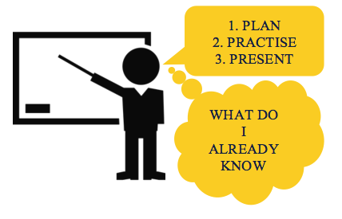
Fig. 7.8 Tips for effective oral delivery (Donnelly, 2023).

7.3 Presentations
7.3.1 Engaging your audience
Engaging your audience is crucial for an effective presentation. It helps maintain their interest and ensures that your message is understood and remembered. Here are detailed strategies for engaging your audience:
1. Connect with your audience: Begin your presentation by establishing a connection with your audience. Introduce yourself and your topic in a way that highlights its relevance and importance. Use anecdotes or real-world examples to make your research relatable.
Example: "Good afternoon, everyone. I'm Dr Alex Johnson, and today I'll be sharing my research on sustainable farming practices. Growing up on a farm, I saw firsthand the challenges farmers face, which inspired this study on how we can improve agricultural sustainability."
2. Use stories and analogies: Stories and analogies can simplify complex concepts and make your presentation more engaging. They help the audience relate to your research on a personal level.
Example: "Imagine trying to water your garden with a leaky hose. No matter how much water you use, most of it is wasted. This is similar to the inefficiencies we found in traditional irrigation systems, which led us to explore more sustainable alternatives."
3. Encourage interaction: Encourage your audience to participate by asking questions, seeking their opinions, or inviting them to share their experiences. This makes your presentation more dynamic and keeps the audience engaged.
Example: "How many of you have experienced issues with soil erosion on your farms? Please raise your hands. Great, I see quite a few hands. Our research addresses this common problem by introducing new soil conservation techniques."
4. Maintain eye contact: Eye contact helps build a connection with your audience and makes your presentation more personal. It shows confidence and helps you gauge the audience's reactions.
5. Vary your tone and pace: Monotone speeches can be dull. Vary your tone, pitch, and pace to emphasise key points and maintain interest. Use pauses effectively to allow important information to sink in.
Example: "After implementing our new irrigation method, we observed a dramatic 40% reduction in water usage. [Pause] This significant improvement underscores the potential of sustainable practices."
6. Use humour appropriately: Appropriate humour can make your presentation more enjoyable and memorable. Be mindful of your audience and the context to avoid offending anyone.
Example: "When I first started this research, I didn't realize I'd be spending so much time with worms. But as it turns out, they are excellent indicators of soil health!"

Fig. 7.9 Engaging your audience.
7.3.2 Handling questions and feedback

Handling questions and feedback effectively is a vital part of any presentation. It demonstrates your expertise and willingness to engage with your audience.
1. Anticipate questions: Before your presentation, think about potential questions your audience might ask and prepare concise, thoughtful answers. This helps you respond confidently and promptly.
Example: "If you're asked about the scalability of your sustainable farming practices, you might respond: 'While our initial study was conducted on small plots, we are currently working on scaling these practices to larger agricultural areas.'"

2. Listen carefully: When a question is asked, listen carefully without interrupting. This shows respect for the questioner and ensures you fully understand the question before responding.
3. Clarify if necessary: If a question is unclear, politely ask the person asking the question to clarify. This helps you provide a more accurate and relevant answer.
Example: "Could you please clarify what you mean by 'long-term impacts'?"
4. Stay calm and professional: Maintain a calm and professional demeanour, even if the questions are challenging or critical. Take a moment to think before responding if needed.
Example: "That's an excellent point. While we did not investigate that aspect in this study, it is certainly a valuable direction for future research."
5. Acknowledge limitations: Be honest about the limitations of your study. Acknowledging limitations shows humility and an understanding of the scientific process.
Example: "Our study focused on a specific region, and we acknowledge that results might vary in different climatic conditions. Future research should explore these practices in diverse environments."
6. Engage the entire audience: When answering a question, address your response to the entire audience, not just the questioner. This keeps everyone involved and ensures that the information benefits all.
7. Follow up if necessary: If you don't know the answer to a question, it's okay to admit it. Offer to follow up after the presentation or suggest resources where the questioner might find the information.
Example: "That's a great question, but I'm not sure of the exact answer at the moment. I'll look into it and get back to you."

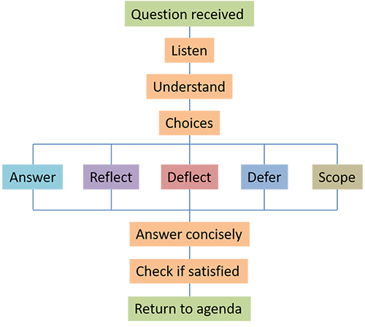
Fig. 7.10 Handling questions and feedback (Tapsai et al., 2021).
7.3.3 Using visual aids effectively
Visual aids can greatly enhance your presentation by illustrating your points and making complex data more understandable.
1. Choose the right visuals: Select visuals that clearly support and enhance your message. These can include graphs, charts, images, videos, and diagrams.
Example: For a presentation on crop yield improvements, use bar graphs to compare yields before and after implementing new farming techniques.
2. Keep slides simple: Avoid cluttering your slides with too much text or too many images. Each slide should convey one main idea. Use bullet points, short sentences, and relevant images to keep it clear.
Example: A slide might include:
- A title: "Improved Crop Yields"
- A bar graph showing yield data
- A brief bullet point summary
3. Use high-quality visuals: Ensure all visuals are high resolution and professionally presented. Blurry images or poorly designed graphs can detract from your presentation.
4. Consistent design: Maintain a consistent design throughout your slides. Use the same fonts, colours, and layout styles to create a cohesive look.
Example: If you use blue and green for your graphs and text highlights, stick to those colours throughout your presentation.
5. Label visuals clearly: All visuals should have clear labels and captions. This helps the audience understand what they are looking at without confusion.
Example: A graph should include labelled axes, a legend, and a descriptive title.
6. Practice with your visuals: Rehearse your presentation using your visual aids. Ensure that you can smoothly transition between slides and use the visuals to support your spoken words.
Example: Practice pointing out specific data points on a graph as you discuss them.
7. Use animations sparingly: Animations can help highlight important information, but overuse can be distracting. Use them sparingly and only when they enhance your message.
Example: Use an animation to highlight the difference between two data sets, but avoid excessive transitions and effects.
8. Backup plan: Always have a backup plan in case of technical difficulties. Bring printed handouts of your slides and have your presentation saved on multiple devices.
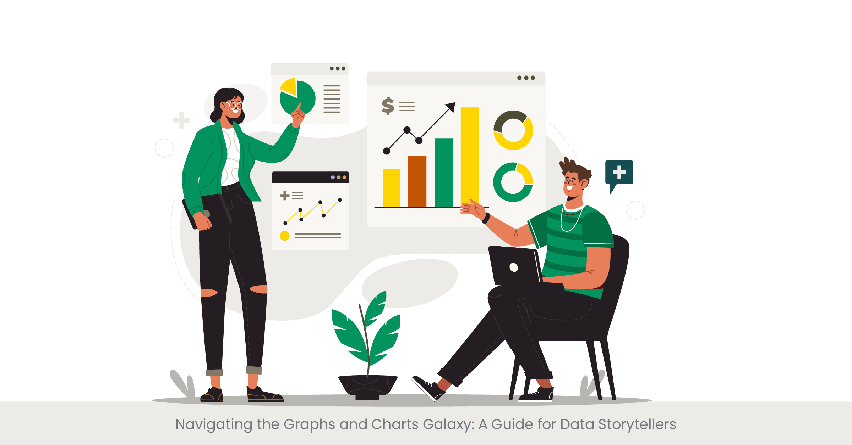
Fig. 7.11 Using visual aids effectively.

Practical work
    - Poster preparation based on the manuscript.
    - Preparation of oral presentation based on the manuscript.
    - Presentations.

Materials
Study of different tools for preparing the presentation. Different available databases for preparing presentations and posters.

Methods
The best choice for first preparing a presentation and poster is PowerPoint, it is easy. Then you can prepare the poster and presentation using other tools.

Results
Example of the presentation. Example of the poster.

Conclusion
Various tools are used to ensure an interesting presentation or poster on one side. The basis of every presentation and poster is to impress the audience, both with basic knowledge and results, as well as with a visual display of the results.

Approved by _____________________
Name, Surname, signature
Date ______________

References
- Ali, J. (2010). Manuscript rejection: Causes and remedies. Journal of Young Pharmacists, 2(1), 3–6. https://doi.org/10.4103/0975-1483.62205
- Allen, L., O’Connell, A., & Kiermer, V. (2019). How can we ensure visibility and diversity in research contributions? How the Contributor Role Taxonomy (CRediT) is helping the shift from authorship to contributorship. Learned Publishing, 32(1), 71–74. https://doi.org/10.1002/leap.1210
- Bahnik, S. (2019). APA has a sample response to reviewers on their website and Reviewer 2 is exactly who you would expect them to be. https://x.com/bahniks/status/1201605162068008962/photo/1
- Ben Akacha, B., Kačániová, M., Generalić Mekinić, I., Kukula-Koch, W., Koch, W., Erdogan Orhan, I., Čmiková, N., Taglieri, I., Venturi, F., Samartin, C., Taieb Bouteraa, M., Ben Saad, R., Mnif, W., Garzoli, S., & Ben Hsouna, A. (2024). Sage (Salvia officinalis L.): A botanical marvel with versatile pharmacological properties and sustainable applications in functional foods. South African Journal of Botany, 169, 361–382. https://doi.org/10.1016/J.SAJB.2024.04.044
- Berquin, I. (2021). Common Mistakes Non-Native Authors Make When Writing in English. https://www.linkedin.com/pulse/common-mistakes-non-native-authors-make-when-writing-isabelle/
- Betty, P. (2024). How to Write the Results Section of a Research Paper - Structure and Tips. https://collegeessay.org/blog/how-to-write-a-research-paper/research-paper-results-section
- Bhowmik, B. (2021). How to respond to ‘Revise and Resubmit’ from a journal: 5 sure steps. Medium. https://basurajbhowmik.medium.com/how-to-respond-to-revise-and-resubmit-from-a-journal-5-sure-steps-2bd329206228
- Donnelly, S. (2023). Considerations for Effective Use of PowerPoint in Teaching. Medium. https://seanog1982.medium.com/considerations-for-effective-use-of-powerpoint-in-teaching-fa630d6efbe
- Enago Academy. (2018). Simple Tips on Using Tables and Figures Effectively in Your Manuscript. Enago Academy. https://www.enago.com/academy/simple-tips-on-using-tables-and-figures-effectively-in-your-manuscript/
- Franz, G. (n.d.). Citing Tables and Figures in APA, 6th Edition. Retrieved June 16, 2024, from https://slideplayer.com/slide/1649784/
- Frenté, S. (2023). Data Governance Framework: 5 Key Elements. https://www.dataversity.net/5-key-elements-of-a-data-governance-framework/
- Herrity, J. (2023). 7 Key Components of an Effective Cover Letter. Indeed. https://www.indeed.com/career-advice/resumes-cover-letters/parts-of-cover-letter
- Hirsch, J. E. (2005). An index to quantify an individual’s scientific research output. Proceedings of the National Academy of Sciences of the United States of America, 102(46), 16569–16572. https://doi.org/10.1073/pnas.0507655102
- Huffman, S., Cotos, E., & Becker, K. (2023). Exploring the Anatomy of a Research Article. Preparing to Publish. https://iastate.pressbooks.pub/preparingtopublish/chapter/exploring-the-anatomy-of-a-research-article/
- Jain, R. (n.d.). Demystifying Academic English. Advanced Integrated Skills for Translingual Students of English. Retrieved June 16, 2024, from https://pressbooks.pub/drrashijain/chapter/citing-from-reliable-sources-in-text-citations-and-list-of-references/
- Meo, S. A. (2018). Anatomy and physiology of a scientific paper. Saudi Journal of Biological Sciences, 25(7), 1278–1283. https://doi.org/10.1016/j.sjbs.2018.01.004
- Midway, S. R. (2020). Principles of Effective Data Visualization. Patterns, 1(9), 100141. https://doi.org/10.1016/j.patter.2020.100141
- Mohebi, S., Parham, M., Sharifirad, G., & Gharlipour, Z. (2018). Social Support and Self ‑ Care Behavior Study. January, 1–6. https://doi.org/10.4103/jehp.jehp
- Monavarian, M. (2021). Basics of scientific and technical writing. MRS Bulletin, 46(3), 284–286. https://doi.org/10.1557/s43577-021-00070-y
- Nova, A. (2024). How To Write The Methods Section of a Research Paper Step-by-Step. https://collegeessay.org/blog/how-to-write-a-research-paper/research-paper-methods-section
- Pamplona, F. (2021). How to Create a Poster For Research Presentation. Mind the GRAPH. https://mindthegraph.com/blog/poster-for-research-presentation/
- Portwood-Stacer, L. (2019). how to write an introduction for an academic book (p. https://manuscriptworks.com/blog/intro-template).
- Pun, M. (2021). Plagiarism in Scientific Writing: Why It Is Important to Know and Avoid. Journal of Political Science, 21, 109–118. https://doi.org/10.3126/jps.v21i0.35269
- Sheehy, M., Wray, C., Fay, F., Laoghaire, D., Lynch, M., Neylon, J., O’Donnell, T., O’Donovan, C., & Quinlan, C. (2019). Academic writing handbook for learners in the further education and training (FET) sector. Further Education Support Service.
- Šprajc, P., Urh, M., Jerebic, J., Trivan, D., & Jereb, E. (2017). Reasons for plagiarism in higher education. Organizacija, 50(1), 33–45. https://doi.org/10.1515/orga-2017-0002
- Tapsai, C., Unger, H., & Meesad, P. (2021). Introduction BT - Thai Natural Language Processing: Word Segmentation, Semantic Analysis, and Application (C. Tapsai, H. Unger, & P. Meesad (eds.)). Springer International Publishing. https://doi.org/10.1007/978-3-030-56235-9_1
- Tomsone, L., Galoburda, R., Kruma, Z., & Majore, K. (2020). Physicochemical properties of biscuits enriched with horseradish (Armoracia rusticana L.) products and bioaccessibility of phenolics after simulated human digestion. Polish Journal of Food and Nutrition Sciences, 70(4), 419–428. https://doi.org/10.31883/pjfns/130256
- Wallwork, A. (2013). English for Research: Usage, Style, and Grammar. Springer Science+Business Media. http://link.springer.com/10.1007/978-3-319-59379-1%0Ahttp://dx.doi.org/10.1016/B978-0-12-420070-8.00002-7%0Ahttp://dx.doi.org/10.1016/j.ab.2015.03.024%0Ahttps://doi.org/10.1080/07352689.2018.1441103%0Ahttp://www.chile.bmw-motorrad.cl/sync/showroom/lam/es/
- Williams, E. (2024). How to Make a Poster in PowerPoint. Power Point Tips. https://pdf.wondershare.com/powerpoint/make-a-poster-in-ppt.html
- Young, E. (2023). Manuscript Submission Mistakes. Erica Young Editing Services. https://eyoungedits.com/manuscript-submission/comment-page-1/
- Zaumanis, M. (2021). Write an impactful research paper: A scientific writing technique that will shape your academic career. Peer Recognized.

Get your manuscript ready for journal editors. Springer Nature. Accessed on June 16, 2024. Available at: https://beta.springernature.com/pre-submission/what-editors-look-for?journalId=13197
Types of Sources. University of Toronto, Scarborough. Accessed on June 16, 2024. Available at: https://utsc.library.utoronto.ca/sites/default/public/users/user244/sources_sciences.jpg
What is journal Impact Factor? Elsevier Author Services. Accessed on June 16, 2024. Available at: https://scientific-publishing.webshop.elsevier.com/research-process/what-journal-impact-factor/
Policies and Guidelines. Accessed on June 16, 2024. Available at: https://www.elsevier.com/researcher/author/policies-and-guidelines
Copyright & Plagiarism: Copyright Basics. Shaw University Libraries - James E. Cheek Learning Resources Center. Accessed on June 16, 2024. Available at: https://shawu.libguides.com/c.php?g=809408&p=7515551.
Anatomy of a scientific paper, Human Nutrition: Reading Scientific Articles. Windward Community College. Accessed on June 16, 2024. Available at: https://library.wcc.hawaii.edu/nutrition/reading.
Anatomy of a scientific article. CHEM: Intro to Scientific Literature. The Citadel Daniel Library. Accessed on June 16, 2024. Available at: https://library.citadel.edu/c.php?g=615326&p=4280193.
Factsheet. Authorship. (2017) Elsevier. Ethics in Research & Publication. Accessed on June 16, 2024. Available at: https://researcheracademy.elsevier.com/uploads/2018-02/2017_ETHICS_AUTH02.pdf.
Academic English Reading and Writing. Paraphrasing. Accessed on June 16, 2024. Available at: https://englishreadingwriting.blogspot.com/p/paraphrasing.html
Avoiding Self-plagiarism in academic writing. Charlesworth Author Services. Accessed on June 16, 2024. Available at: https://www.cwauthors.com/article/WhatIsSelf-Plagiarism.
OpenLearn. The Open University is incorporated by Royal Charter (RC 000391), an exempt charity in England & Wales and a charity registered in Scotland (SC 038302). . Accessed on June 16, 2024. Available at: https://www.open.edu/openlearn/mod/oucontent/view.php?id=64126&section=1.
The key elements of writing. Accessed on June 16, 2024. Available at: https://pdfweb.truni.sk/e-ucebnice/eap/dat. 6e-a68b-37b05785b0d8.html?ownapi=1#.
Explore the key features that make up academic style. The University of Melbourne. Accessed on June 16, 2024. Available at: https://students.unimelb.edu.au/academic-skills/resources/reading,-writing-and-referencing/writing-effectively/academic-style.
Language Used in Academic Writing. Study Smarter. Accessed on June 16, 2024. Available at: https://www.studysmarter.co.uk/explanations/english/5-paragraph-essay/language-used-in-academic-writing/.
Paragraphs. University College, University of Toronto. Accessed on June 16, 2024. Available at: https://www.uc.utoronto.ca/paragraphs.
Paragraph unity and coherence. American University, Academic Support Center, Writing Lab, updated 2009. Accessed on June 16, 2024. Available at: https://www.american.edu/provost/academic-access/upload/paragraph-unity-and-coherence.pdf
Duke Graduate School Scientific Writing Resource. Accessed on June 16, 2024. Available at: https://sites.duke.edu/scientificwriting/dash-v-hyphen/.
A basic guide to writing a literature review. Avidnote. Accessed on June 16, 2024. Available at: https://avidnote.com/basic-guide-writing-literature-review/
Zotero: Managing Research Materials in a Better Way. The University of Hong Kong. Libraries. Accessed on June 16, 2024. Available at: https://blog-sc.hku.hk/zotero-managing-research-materials-in-a-better-way-2/
National Library of Medicine. Accessed on June 13, 2024. Available at: https://pubmed.ncbi.nlm.nih.gov/
11 Steps on How to write a Scientific Manuscript. Accessed on June 16, 2024. Available at: https://www.wordsdoctorate.com/blog-details/11-steps-on-how-to-write-a-scientific-manuscript/
Revising, Editing, and Proofreading. Writingservice ae. Accessed on June 16, 2024. Available at: https://writingservice.ae/blog/revising-editing-proofreading/
The Office of Ethics and Compliance. Stanford University. Accessed on June 16, 2024. Available at: https://oec.stanford.edu/seven-elements-ethics-and-compliance-excellence
How to navigate the peer-review process? Academic Writing and Authentic Publication for Medical Professionals. Accessed on June 16, 2024. Available at: https://www.linkedin.com/pulse/how-navigate-peer-review-process-academic-writing-and-authentic-pub
Guidelines for Addressing to Reviewers’ Comments. Pubrica Knowledge Works. Accessed on June 16, 2024. Available at: https://pubrica.com/academy/manuscript-editing/guidelines-for-addressing-to-reviewers-comments/
Responsible AI that ensures your writing and reputation shine. Grammarly. Accessed on June 16, 2024. Available at: https://www.grammarly.com/
Poster Presentations. International Pharmaceutical Federation Accessed on June 16, 2024. Available at: https://fip.eventsair.com/ppr-summer-meeting/poster-presentations
Adobe Illustrator Software. Accessed on June 16, 2024. Available at: https://fileinfo.com/software/adobe/illustrator
Canva User Guide. Accessed on June 16, 2024. Available at: https://d31kydh6n6r5j5.cloudfront.net/uploads/sites/158/2020/06/Canva-Userguide.pdf
Business conference flat. Marketing training. Coach near projector screen. Freepick. Accessed on June 16, 2024. Available at: https://www.freepik.com/premium-vector/business-conference-flat-marketing-training-coach-near-projector-screen_15209708.htm
Marketing Illustrations. Freepick. Accessed on June 16, 2024. Available at: https://www.freepik.com/premium-vector/marketing-illustrations_36464938.htm

